01 / THE RESEARCH STORY
Wind and outage consequences
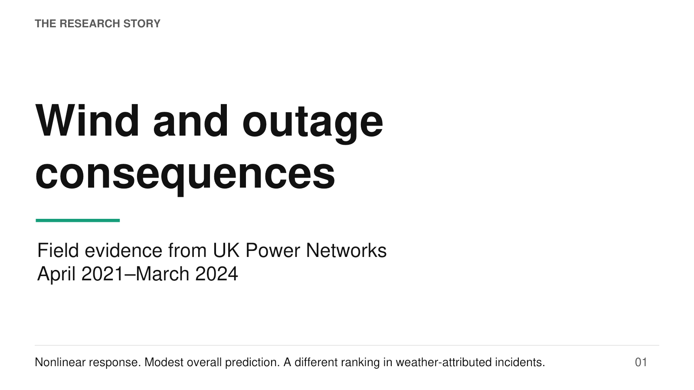
Speaker script
This presentation follows the full story of a study of wind and power-outage consequences across UK Power Networks. The study covers London, the South East, and the East of England over three years, from April 2021 through March 2024. Its central question is how gust intensity relates to the number of customers affected and the time span of restoration once an outage has occurred. The argument has three parts.
First, reconstructing complete incidents changes what we measure. Second, both outcomes show a nonlinear association with gust, although the exact location of a fitted minimum is less stable. Third, the predictive contribution of gust depends on the incident population. In the combined sample, customer scale contributes much more to recovery prediction; among weather-attributed incidents, the ranking reverses. I will move from the research gap and data to these findings, then examine their limits and implications.
Source: Draft_revised(5), Abstract and Sections 1–5; Appendix_revised(5). Descriptive presentation title.

02 / MOTIVATION
Two questions connect the paper
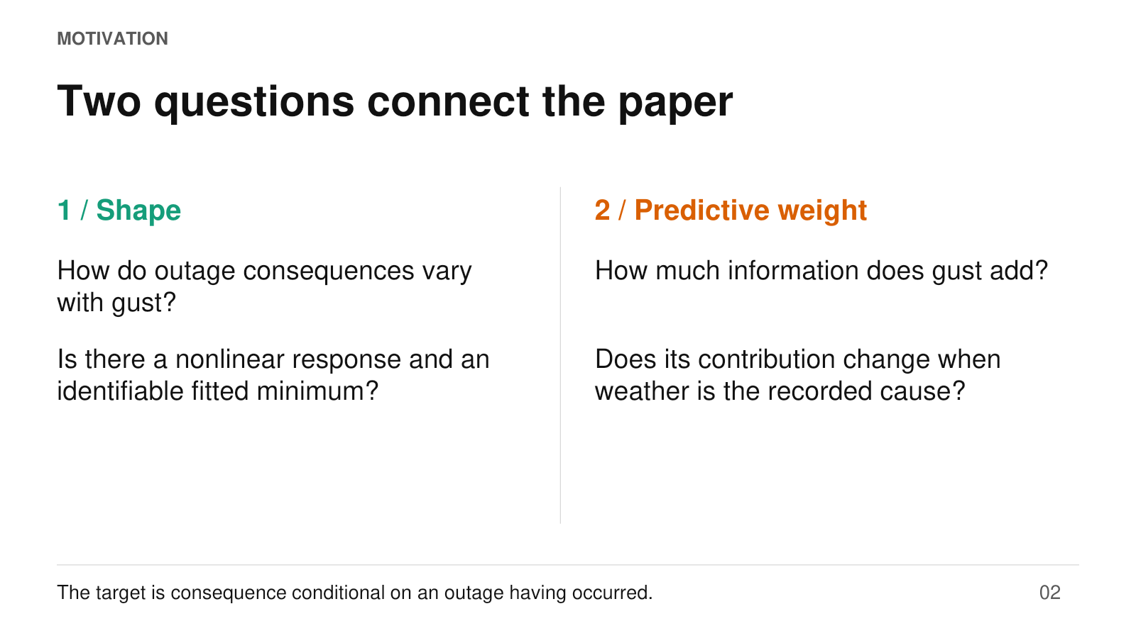
Speaker script
The paper connects two questions that should be kept separate throughout the presentation. The first concerns shape: does the relationship between gust and outage consequences bend, and can we identify a fitted minimum? The second concerns predictive weight: how much additional variation does gust explain relative to other predictors? The motivation comes from a gap between engineering fragility studies of individual structures and operational evidence from a heterogeneous distribution network.
However, this study does not estimate a structural fragility curve. It contains incidents, rather than a complete set of both outage and no-outage observations. Its outcomes therefore describe consequences conditional on an outage having occurred. A strongly estimated nonlinear coefficient need not imply strong overall prediction. That distinction explains why the paper first establishes the response shape and then asks how much gust contributes to prediction across different incident populations.
Source: Draft_revised(5), Introduction; Sections 3.1 and 4.1.

03 / DATA / SECTION 2
Three years across one network operator
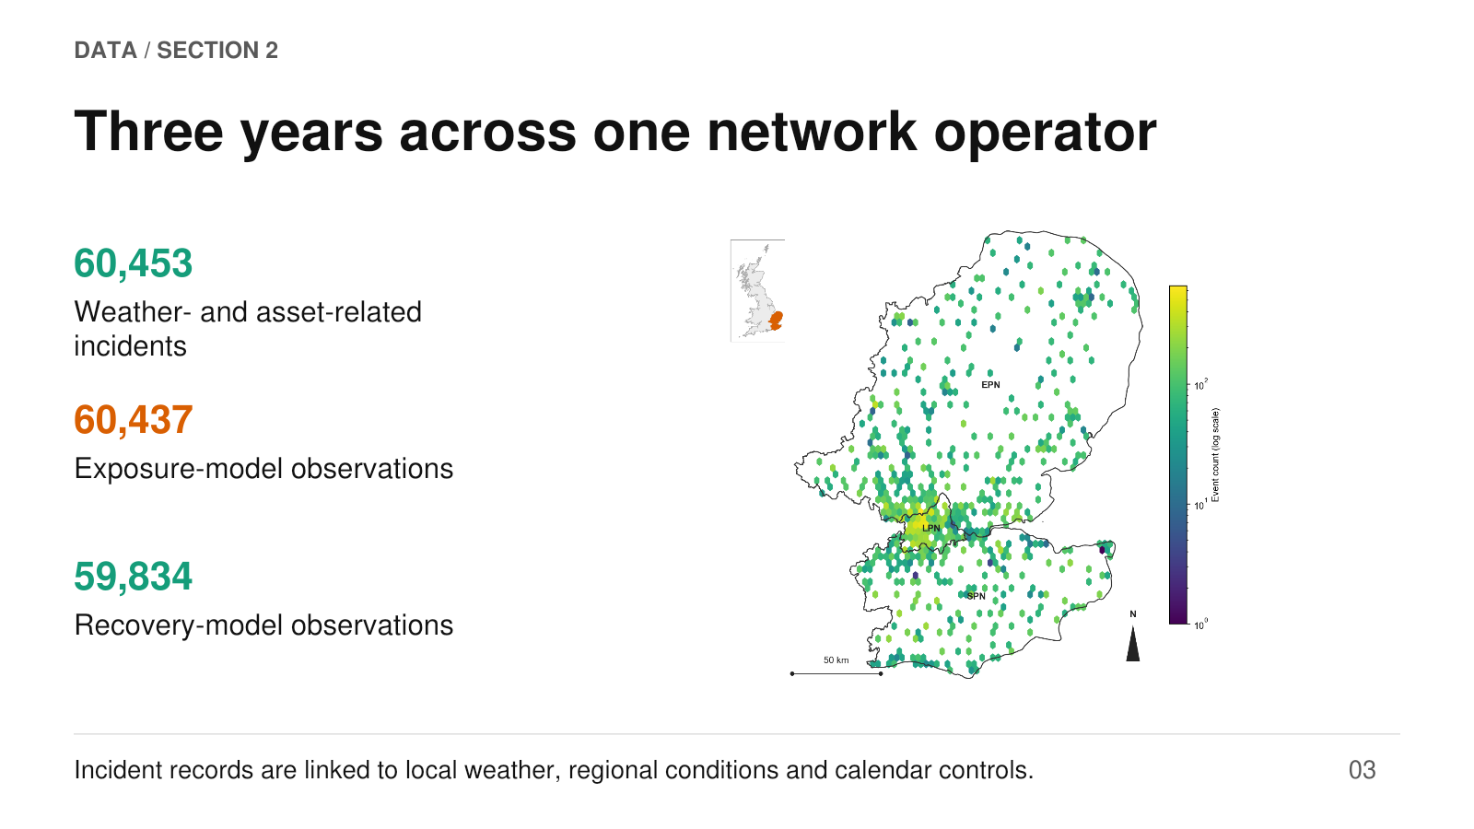
Speaker script
The empirical setting is UK Power Networks, covering three licence areas: London, the South East, and the East of England. The map shows incident locations aggregated into hexagonal bins. Its colour scale is logarithmic: brighter bins indicate larger incident counts, not a greater estimated probability of failure. The inset locates the service territory within Great Britain. The assembled data contain 60,453 weather- and asset-related incidents.
After matching and exclusions, the exposure model uses 60,437 observations and the recovery model uses 59,834. The smaller recovery sample reflects unavailable or invalid durations and exclusion above the duration distribution's ninety-ninth percentile. Each incident is linked to start-time weather and regional information. This provides broad operational coverage, but it also means the study pools incidents with different causes, asset conditions and restoration processes. That heterogeneity later becomes central to interpreting gust's predictive contribution.
Source: Draft_revised(5), Sections 2.1 and 2.4; Figure 1.

04 / MEASUREMENT / SECTION 2.2
Complete incidents must be reconstructed
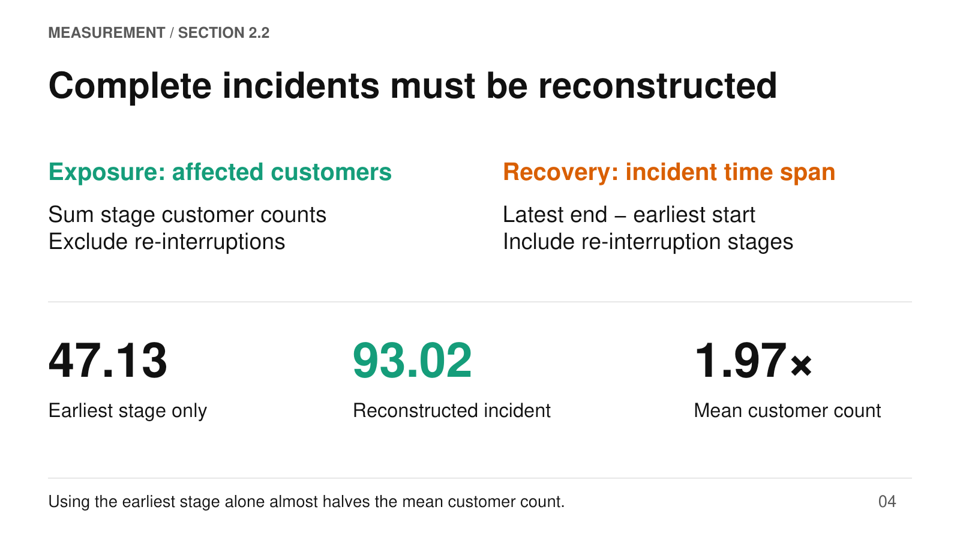
Speaker script
The first contribution is measurement. Regulatory records describe restoration stages, so an incident must be reconstructed before its consequences can be analysed. For affected customers, the study sums customer counts across stages while excluding stages flagged as re-interruptions, following the relevant aggregation logic. For restoration duration, it takes the latest recorded end time minus the earliest recorded start time, including re-interruption stages.
These rules intentionally produce two different measures. Duration is the complete recorded incident span; it is not customer-weighted minutes lost, and it can include gaps between stages. The practical effect on exposure is substantial: mean affected customers increase from 47.13 under an earliest-stage-only measure to 93.02 after reconstruction, a factor of 1.97. An independent check of 500 incidents supports the implementation. The substantive analysis therefore begins with a correction to the unit of observation, rather than with a regression fitted directly to raw stage records.
Source: Draft_revised(5), Section 2.2, Equations 1–2; Appendix B.

05 / MEASUREMENT / SECTION 2.3
The outcomes are distinct and skewed
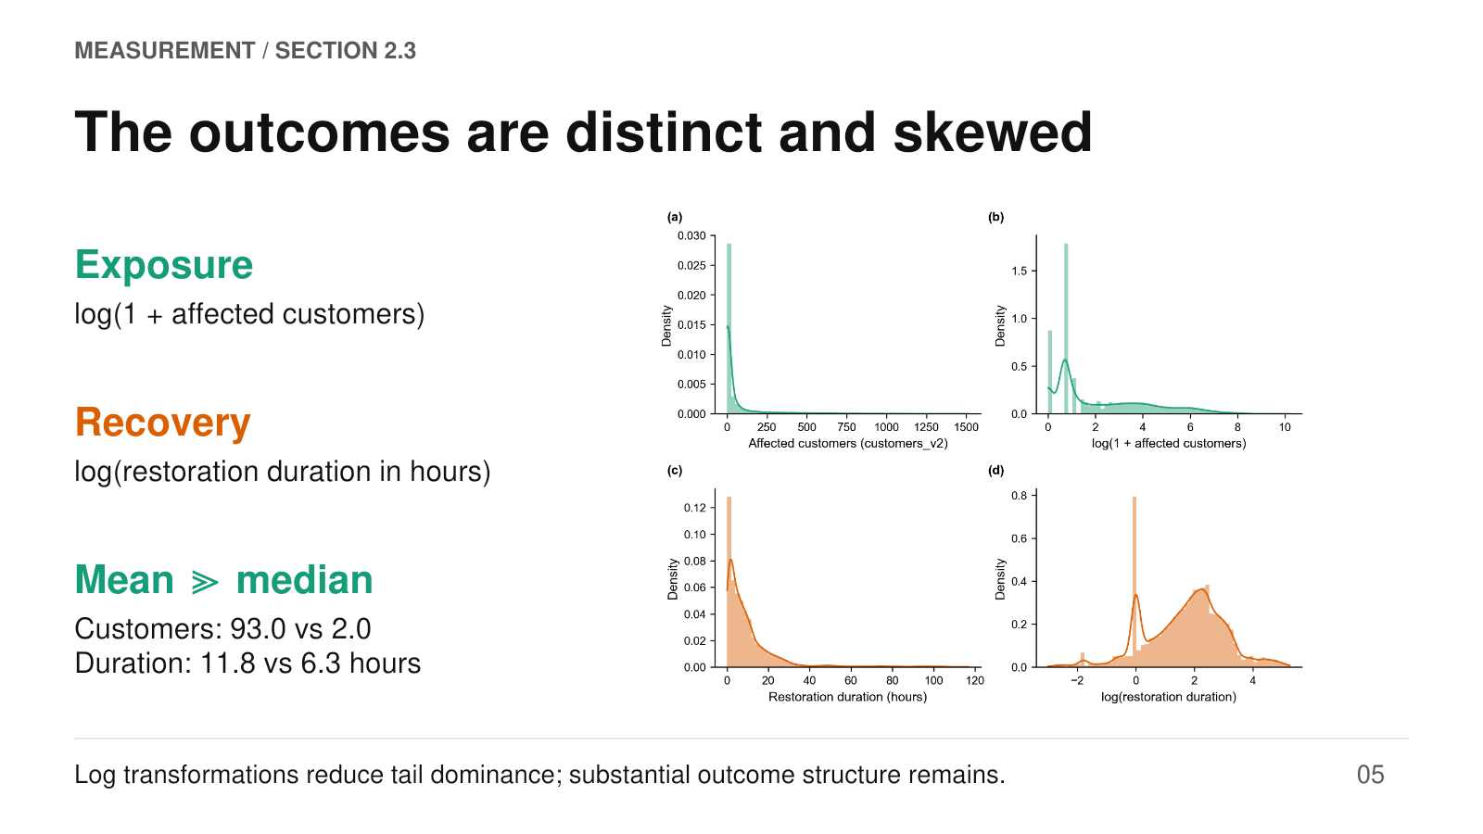
Speaker script
The paper then separates exposure from recovery. Exposure is the logarithm of one plus the number of affected customers; adding one accommodates recorded zeros. Recovery is the natural logarithm of restoration duration in hours. In this figure, the upper panels show customers before and after transformation, and the lower panels show duration. The horizontal axes identify the outcome scale, while the vertical axes show density.
Both original outcomes have long right tails. Mean customers are about ninety-three, compared with a median of two; mean duration is about twelve hours, compared with a median of roughly six. Log transformation reduces the dominance of extreme observations, but it does not make the distributions fully symmetric. The customer distribution retains structure from small integer counts, and duration remains visibly multimodal. These features remind us that transformation is a modelling choice, not a guarantee that all heterogeneity has disappeared.
Source: Draft_revised(5), Table 1 and Figure 2.

06 / DESIGN / SECTION 3.2
A retrospective temporal design
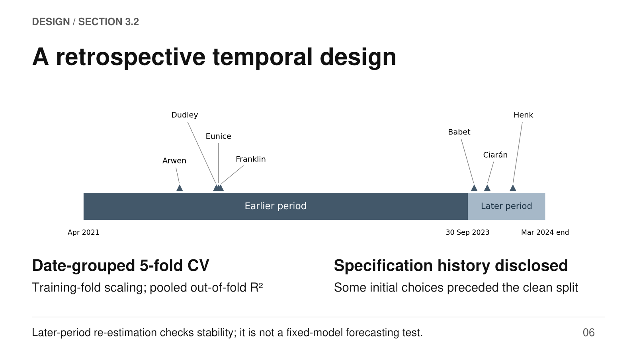
Speaker script
The design combines date-grouped cross-validation with a later-period stability check. The development period runs from April 2021 to 29 September 2023; the confirmation period runs from 30 September 2023 to the end of March 2024. Four named storms fall in the earlier period and three in the later period, as the timeline shows. Within cross-validation, incidents from the same date remain together, and standardisation is learned from each training fold. The reported predictive comparisons use pooled out-of-fold predictions.
For temporal confirmation, the final specification is re-estimated on the later sample. This tests whether its relationships recur, rather than whether earlier fitted coefficients forecast the future accurately. There is also a documented retrospective limitation: several initial measurement and design choices preceded the clean split. Appendix E records that history. The confirmation exercise is useful evidence of stability, but it should not be presented as an untouched prospective test.
Source: Draft_revised(5), Section 3.2 and Figure 3; Appendix E.

07 / METHOD / SECTION 3.3
One framework, two outcome models
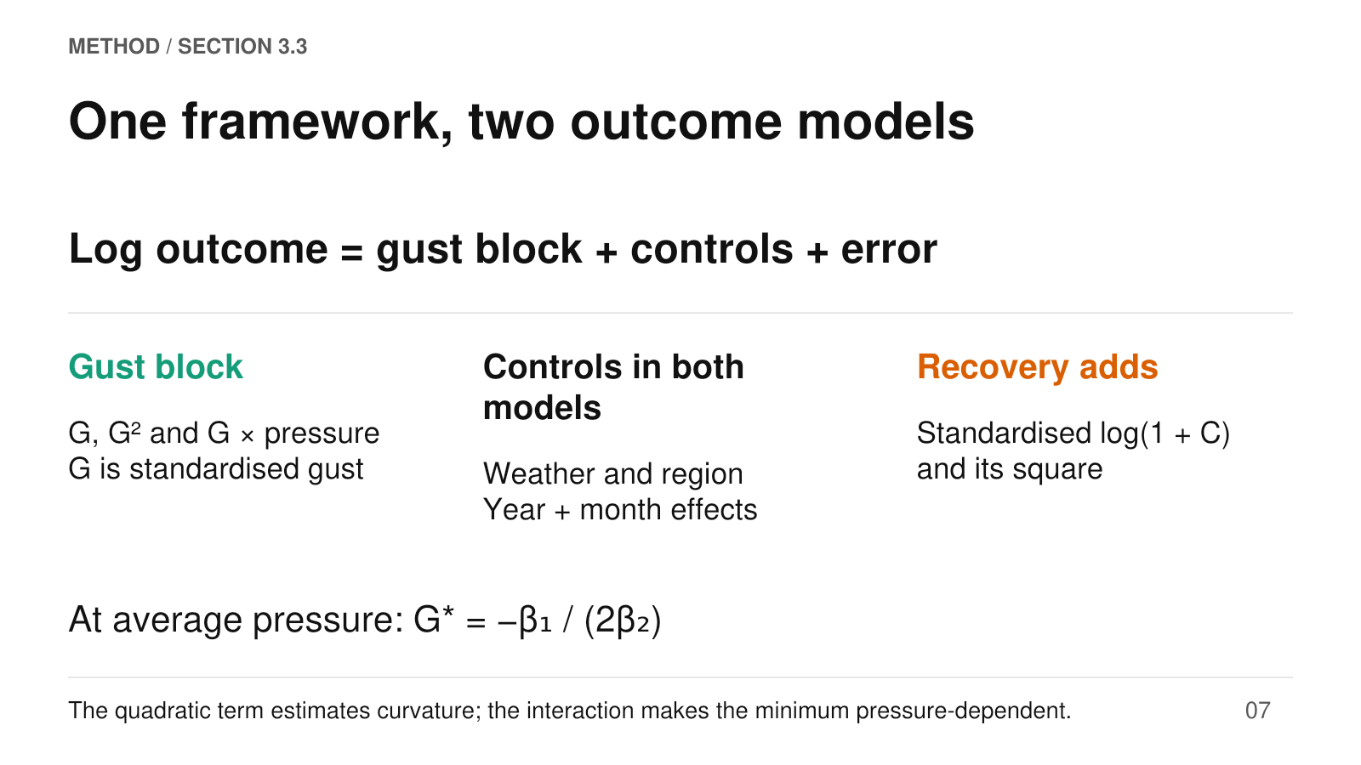
Speaker script
Both models use a common log-scale regression framework. The gust block contains standardised gust, its square, and an interaction between gust and standardised pressure. Other controls include pressure itself, precipitation and temperature, regional characteristics, and separate year and month effects. The recovery model also includes standardised log-one-plus customers and its square. This allows customer scale to have a nonlinear association with duration.
Standardisation matters because a gust value of zero means average gust, rather than calm weather. The squared coefficient determines curvature. At average pressure, the fitted minimum is minus the linear gust coefficient divided by twice the quadratic coefficient; at other pressure levels, the interaction also enters that expression. The main standard errors are clustered by district, with district-and-date clustering used as a robustness check. The goal is an interpretable conditional association, not identification of a causal wind effect or a physical failure mechanism.
Source: Draft_revised(5), Equation 4 and Table 2; Appendix A.

08 / FINDING 1 / SECTION 4.1
Both outcomes show positive curvature
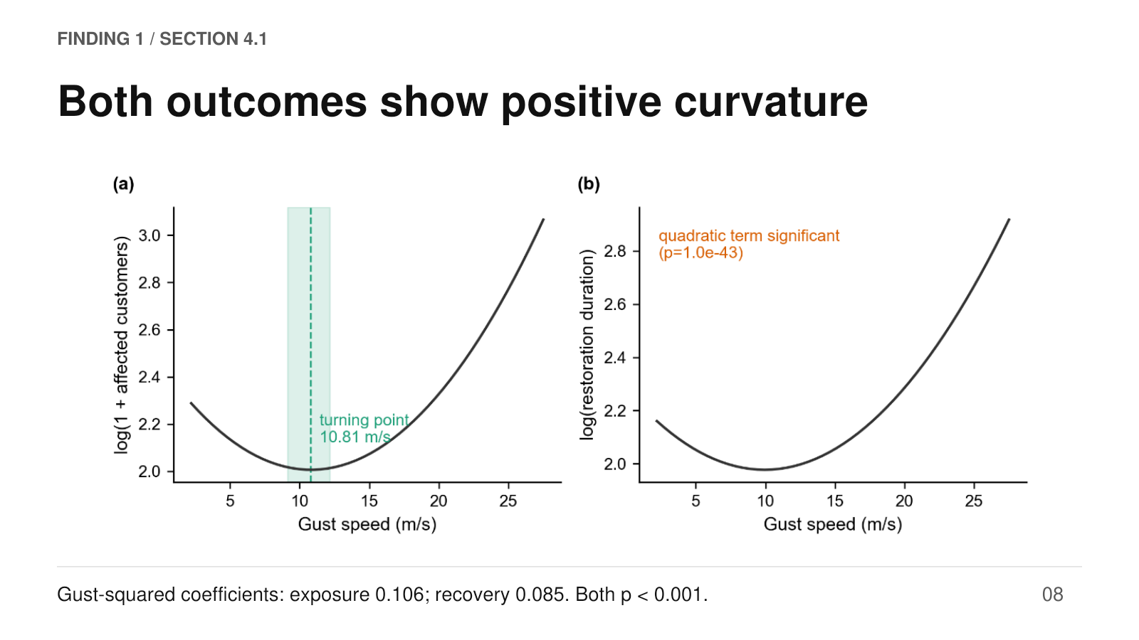
Speaker script
The first main result is positive curvature for both outcomes. The horizontal axis in each panel is gust speed in metres per second. The left vertical axis is fitted log-one-plus customers, while the right is fitted log duration. Other covariates are fixed at reference values. Both curves decline slightly before rising at higher gusts. The estimated quadratic coefficients are 0.106 for exposure and 0.085 for recovery, both statistically significant at conventional levels.
For exposure, the fitted minimum at average pressure is approximately 10.81 metres per second. The paper does not report a similarly specific threshold for recovery. Two qualifications are essential. A quadratic is symmetric around its own minimum; the plotted right arm extends farther because the observed gust range is asymmetric. Also, the declining low-gust segment is an association in a mixed incident population. It does not establish that mild wind protects the network.
Source: Draft_revised(5), Table 3 and Figure 4.

09 / INTERPRETATION / SECTIONS 4.1 AND 4.4
The shape is steadier than the minimum
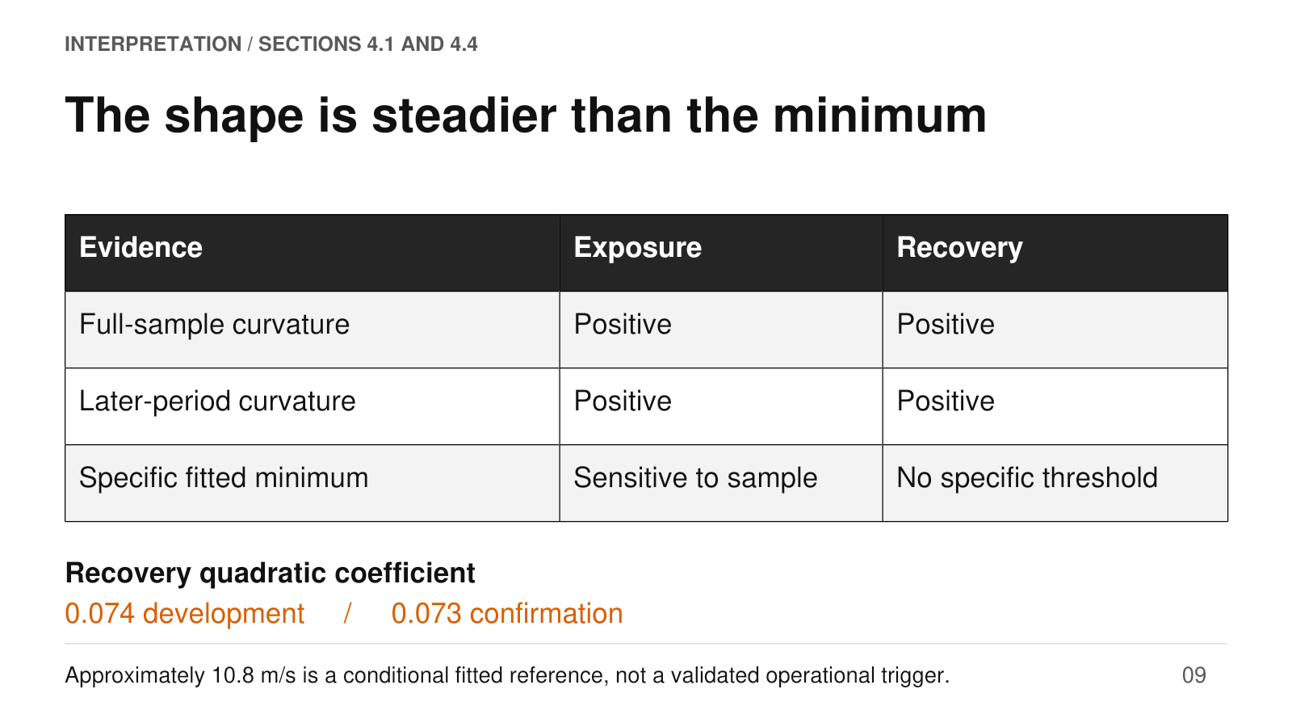
Speaker script
The next step is to separate a stable qualitative finding from a less stable numerical estimate. Positive gust curvature recurs in the development and confirmation samples. For recovery, the quadratic coefficients are especially close: 0.074 and 0.073 respectively. The exposure minimum is more sensitive. In the development analysis it is about 12.13 metres per second, compared with 10.81 in the combined sample.
In the later sample, the linear gust term changes sign and the minimum shifts relative to that sample's mean gust. Resampling also shows why precision matters: the day-bootstrap interval for the standardised exposure minimum includes zero, which means the sample-mean gust, not zero metres per second. Taken together, these results support curvature more consistently than an exact threshold location. The reported ten-point-eight value is conditional on the model, sample and average-pressure reference. It does not mark a proven damage threshold or a ready-to-use dispatch rule.
Source: Draft_revised(5), Sections 4.1 and 4.4; Appendix E. Numerical summary follows text, not the embedded Figure 10.

10 / FINDING 2 / SECTION 4.2
Gust adds modest predictive information
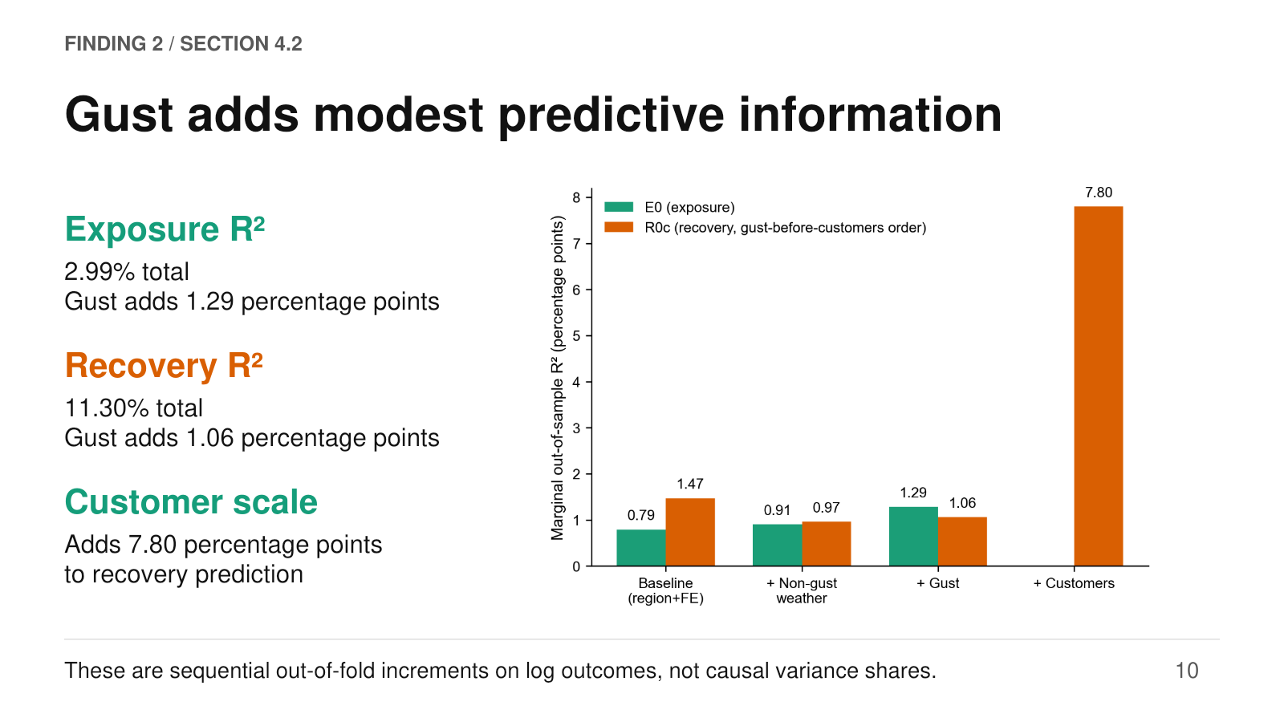
Speaker script
The second main finding concerns predictive weight. The figure adds groups of predictors in sequence: regional and calendar controls first, non-gust weather next, then gust, and finally customer scale for recovery. The vertical axis shows the increase in out-of-sample R-squared in percentage points. Green bars represent exposure and orange bars recovery. Gust adds 1.29 percentage points for exposure and 1.06 for recovery.
The full models achieve R-squared values of only 2.99 percent and 11.30 percent respectively. Customer scale adds 7.80 percentage points to recovery prediction, much more than gust in this combined sample. This reconciles the earlier curvature result with limited overall prediction: a relationship can be estimated precisely while explaining only a small portion of heterogeneous outcomes. The increments also depend on the order of entry, and they concern transformed outcomes. They should not be read as an order-free allocation of physical or causal responsibility.
Source: Draft_revised(5), Section 4.2 and Figure 5.

11 / CONTEXT / SECTION 4.2
Regional baselines differ by outcome
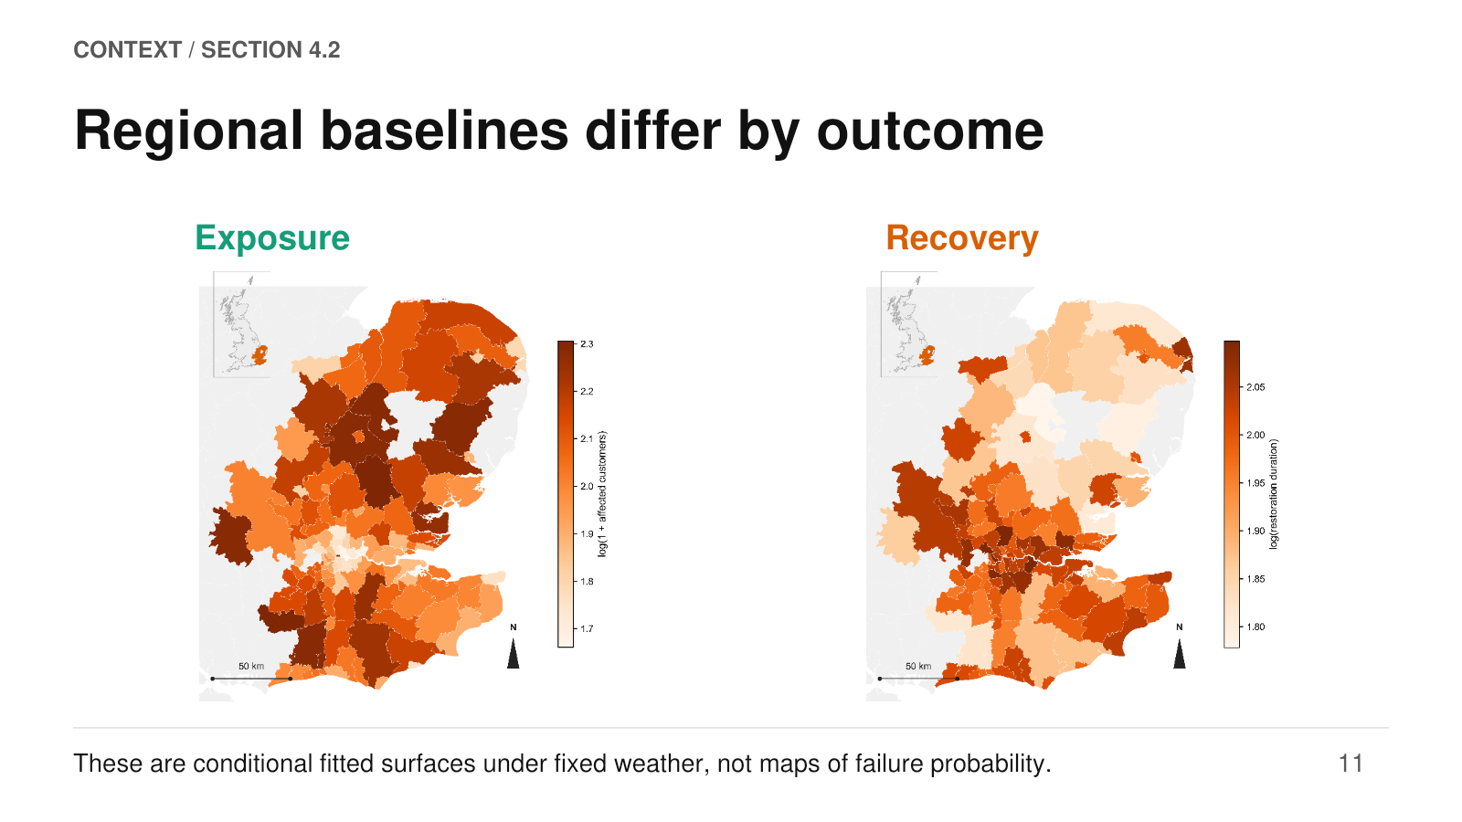
Speaker script
The regional maps provide another view of heterogeneity. Weather is fixed at the reference scenario, and customer scale is also fixed for the recovery model. Only the regional covariates vary between districts. The left map shows fitted log-one-plus customers, and the right shows fitted log duration. Darker orange corresponds to a higher fitted value on each map's own scale, so colours should not be numerically compared across panels.
The districts with high fitted exposure do not simply coincide with those with high fitted duration. This helps motivate treating customer impact and recovery as separate outcomes. It also clarifies the scope of the maps: they show variation associated with the included regional characteristics under a common scenario. They do not estimate outage frequency, individual asset vulnerability or causal effects of deprivation. Their purpose in the story is to show that the operational context varies across the network, even when weather is held constant.
Source: Draft_revised(5), Figure 6 and Section 4.2.

12 / CONTEXT / SECTION 4.2
Response range is a different question
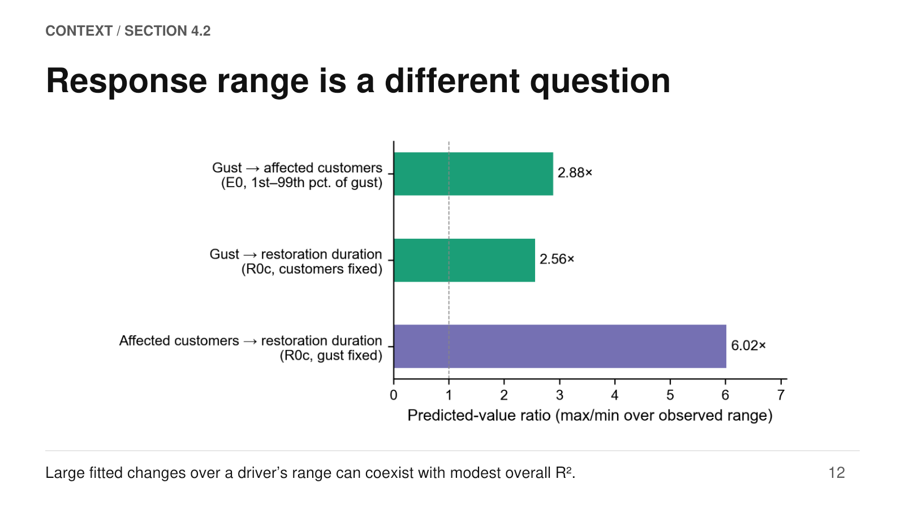
Speaker script
The paper also compares the range of fitted responses while varying one driver at a time. Each horizontal bar is the ratio of the largest to the smallest fitted value as the driver moves across its first-to-ninety-ninth-percentile range, with other inputs held fixed. Gust produces ratios of 2.88 for exposure and 2.56 for recovery. Customer scale produces a ratio of 6.02 for recovery.
The dashed line at one means no fitted variation. Because a minimum can occur inside the range, these ratios are not necessarily comparisons between its two endpoints. They are based on exponentiated log fits; in the exposure model that scale corresponds to one plus customers, and the values should not automatically be interpreted as arithmetic conditional means. This comparison answers how much the fitted response varies across a selected range. It does not answer how much real-world outcome variation a predictor explains, which is what the previous R-squared analysis addressed.
Source: Draft_revised(5), Figure 7 and Section 4.2.

13 / FINDING 3 / SECTION 4.3
Weather attribution changes the ranking
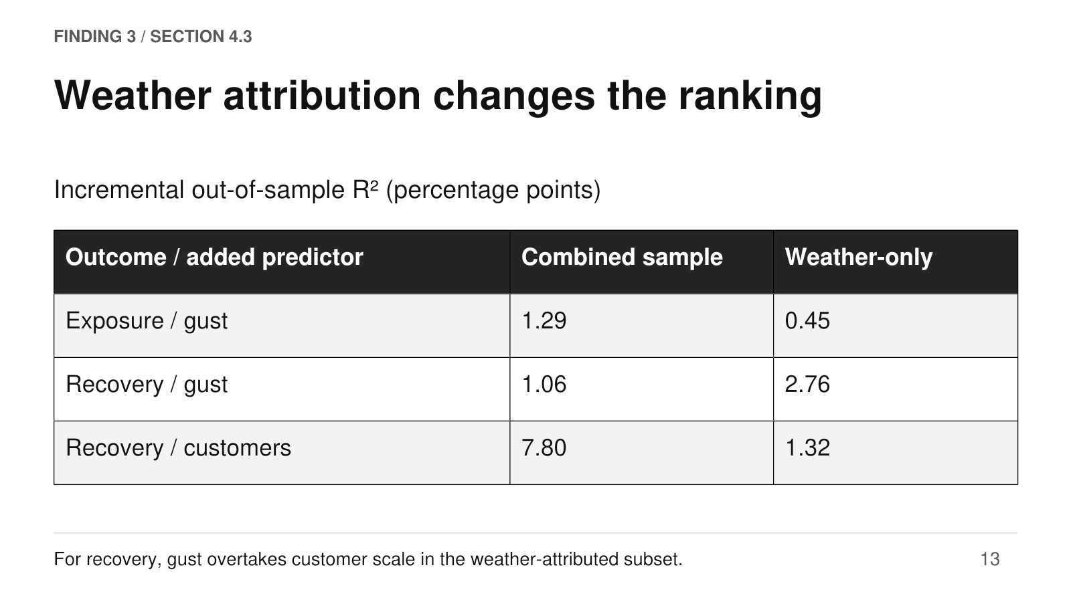
Speaker script
The population comparison is the turning point of the paper's story. In the full weather-and-asset sample, customer scale contributes much more than gust to recovery prediction. When the analysis is restricted to weather-attributed incidents, gust's incremental R-squared rises from 1.06 to 2.76 percentage points, while the customer contribution falls from 7.80 to 1.32. The ranking therefore reverses for recovery.
Exposure behaves differently: its gust contribution falls from 1.29 to 0.45 percentage points. This is a comparison between analysis populations, not evidence that wind becomes physically stronger. Recorded weather attribution selects disproportionately from higher-gust conditions, reducing low-gust support. In addition, the weather-only recovery duration cutoff and cross-validation folds are re-derived for that subset. The result is therefore best stated narrowly: the relative predictive value of gust and customer scale depends on the incidents being analysed.
Source: Draft_revised(5), Table 4 and Section 4.3; Appendix G. Rebuilt from Table 4 because embedded Figure 8 retains different values.

14 / MECHANISM CHECK / APPENDIX D
Stage composition helps explain recovery
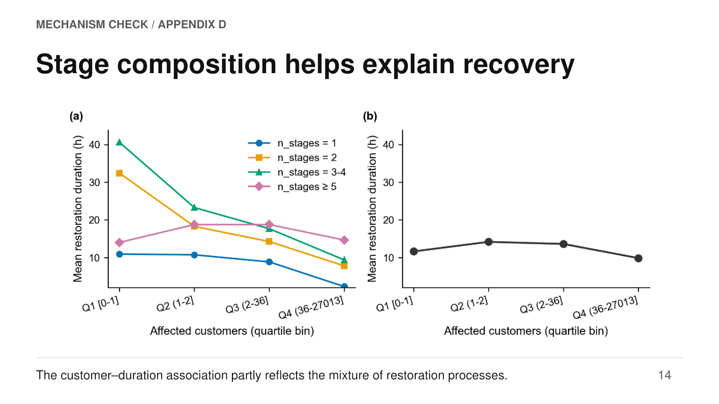
Speaker script
Why does the customer-duration relationship have its observed shape? Appendix D examines restoration-stage composition. The horizontal axis groups incidents into customer-count quartiles, while the vertical axis shows mean duration in hours. The left panel separates incidents by their number of stages, as indicated by the coloured legend; the right combines them. The pooled relationship is nonmonotonic, whereas several within-stage groups show a declining pattern across customer bins.
This means the aggregate curve partly reflects changing mixtures of restoration processes. The regression check reinforces this interpretation: adding log stage count changes the linear customer coefficient from positive to negative in the development sample, while the gust result remains stable. However, stage count is recorded through the restoration process itself and can be endogenous to duration. This is evidence about composition, not proof that crews deliberately prioritise larger incidents. Sparse bins also limit how literally every individual line segment should be interpreted.
Source: Appendix_revised(5), Appendix D, Figure D1 and Table D2; Draft Section 4.1.

15 / EVENT CHECK / SECTION 4.3
Seven storms concentrate the burden
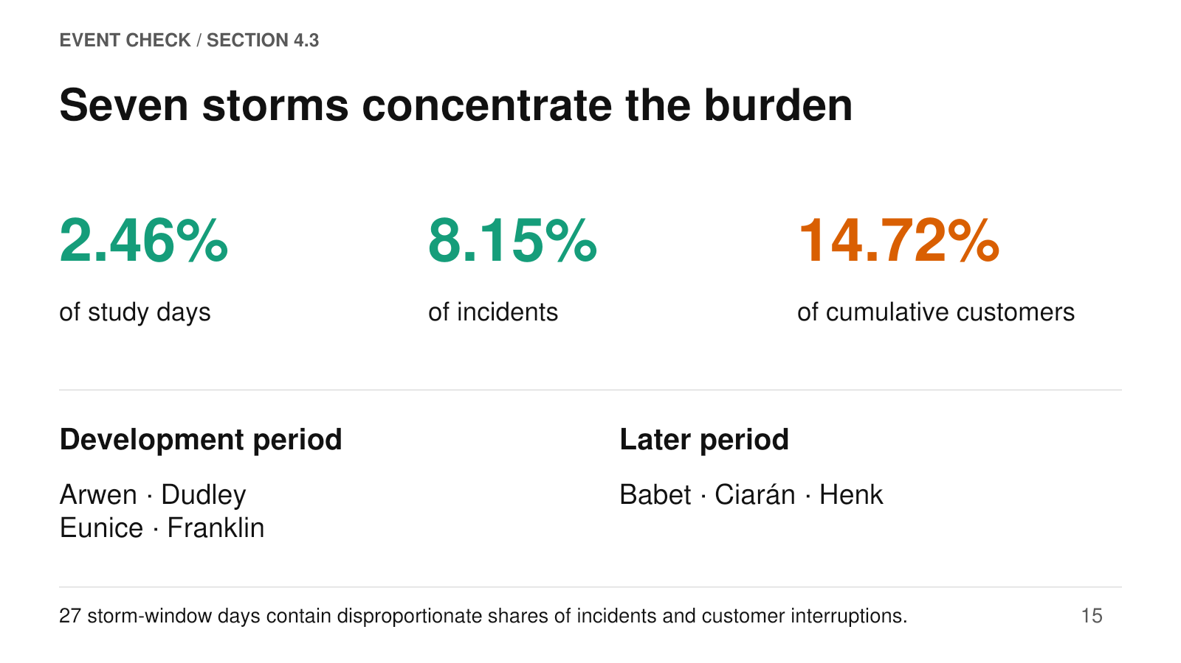
Speaker script
The named-storm analysis provides a complementary way to focus on severe weather without relying only on recorded cause codes. The seven storms are Arwen, Dudley, Eunice and Franklin in the development period, followed by Babet, Ciarán and Henk in the later period. Their combined windows cover twenty-seven days, or 2.46 percent of the study period. Those days account for 8.15 percent of incidents and 14.72 percent of cumulative affected customers.
Relative to the average daily burden across the whole study period, that is roughly 3.3 times the incident concentration and six times the customer concentration. These are descriptive concentrations, not causal excesses relative to a matched non-storm counterfactual. The customer total also aggregates interruptions across incidents and does not identify unique people over the period. The role of this block is to establish that a small set of severe-weather windows carries a disproportionate operational burden before examining how the fitted models behave within those events.
Source: Draft_revised(5), Section 4.3 and Figure 3.

16 / EVENT CHECK / SECTION 4.3
Storm fit exposes prediction limits
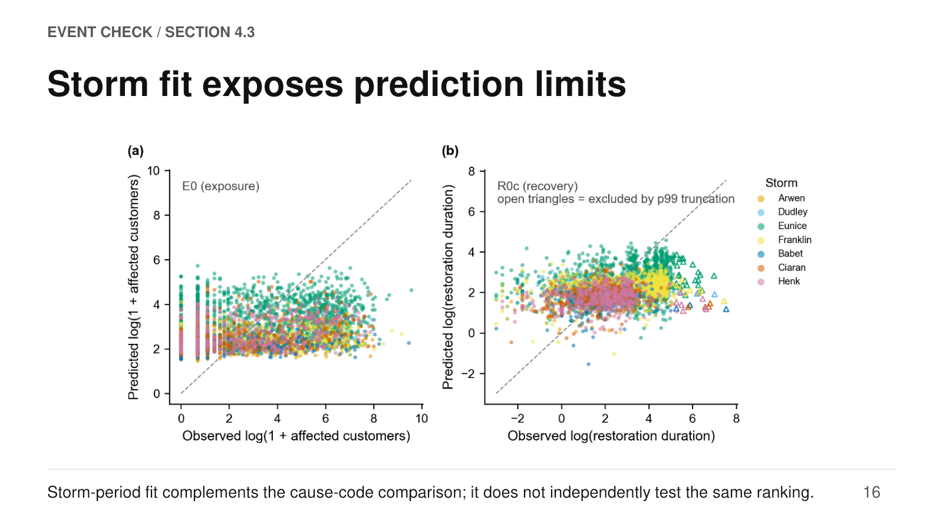
Speaker script
The storm scatterplots compare observed outcomes on the horizontal axis with fitted outcomes on the vertical axis. The left panel concerns log-one-plus customers; the right concerns log duration. Colours identify the seven storms, and the dashed diagonal represents perfect agreement. A point below the diagonal is underpredicted, while one above is overpredicted.
Predictions are visibly compressed relative to the observed range, especially for customer impacts, so the model captures only part of the variation within storms. Open triangles in the recovery panel mark exceptionally long incidents excluded by the duration cutoff; these reveal a particularly important tail limitation. This is not an independent forecasting evaluation: many storm incidents also contribute to estimation of the full-sample model. Nor does the figure recompute gust-versus-customer contributions within storms. Its value is complementary and diagnostic, showing where the fitted relationship aligns with real extreme events and where it misses their severity.
Source: Draft_revised(5), Figure 9 and Section 4.3.

17 / ROBUSTNESS / SECTION 4.4 AND APPENDICES
Curvature survives several checks
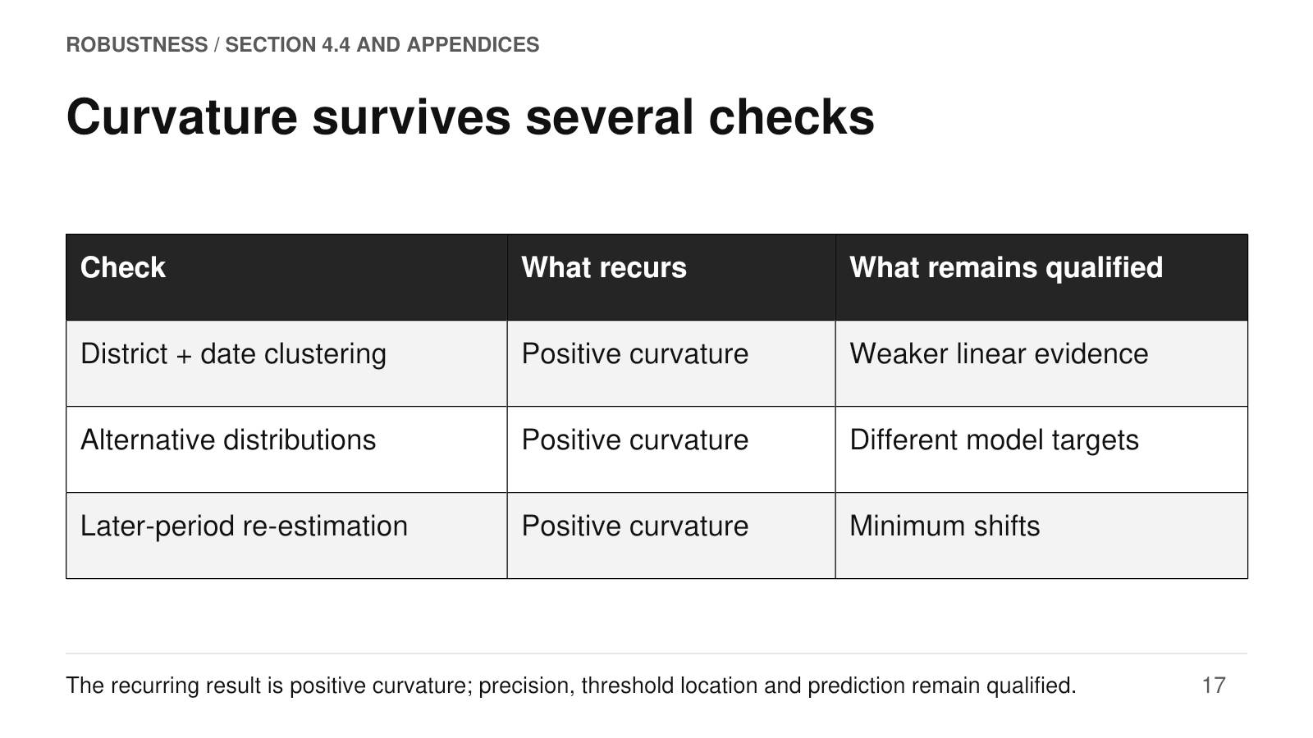
Speaker script
The robustness checks ask whether the main shape is an artefact of a particular estimation choice. First, allowing dependence within both districts and dates leaves the point estimates unchanged but alters their uncertainty. The positive quadratic terms remain significant, while evidence for the smaller exposure linear term weakens. Second, alternative distributional models retain positive gust-squared coefficients. These checks address sensitivity to the log-OLS outcome specification, although their coefficients and fit statistics should not be compared as if all models had identical targets.
Third, the later-period analysis again finds positive curvature in both outcomes, despite instability in the exposure minimum. The weather-only analysis adds another population check. Collectively, these exercises support a recurring nonlinear association. They do not remove observational confounding or deliver high predictive accuracy. Robustness here means that a specific qualitative feature survives several perturbations, not that every numerical estimate or operational interpretation has been validated.
Source: Draft_revised(5), Sections 3.1 and 4.4; Appendices E, F and H.

18 / FUNCTIONAL FORM / APPENDIX H
Flexible curves add nuance, not one winner
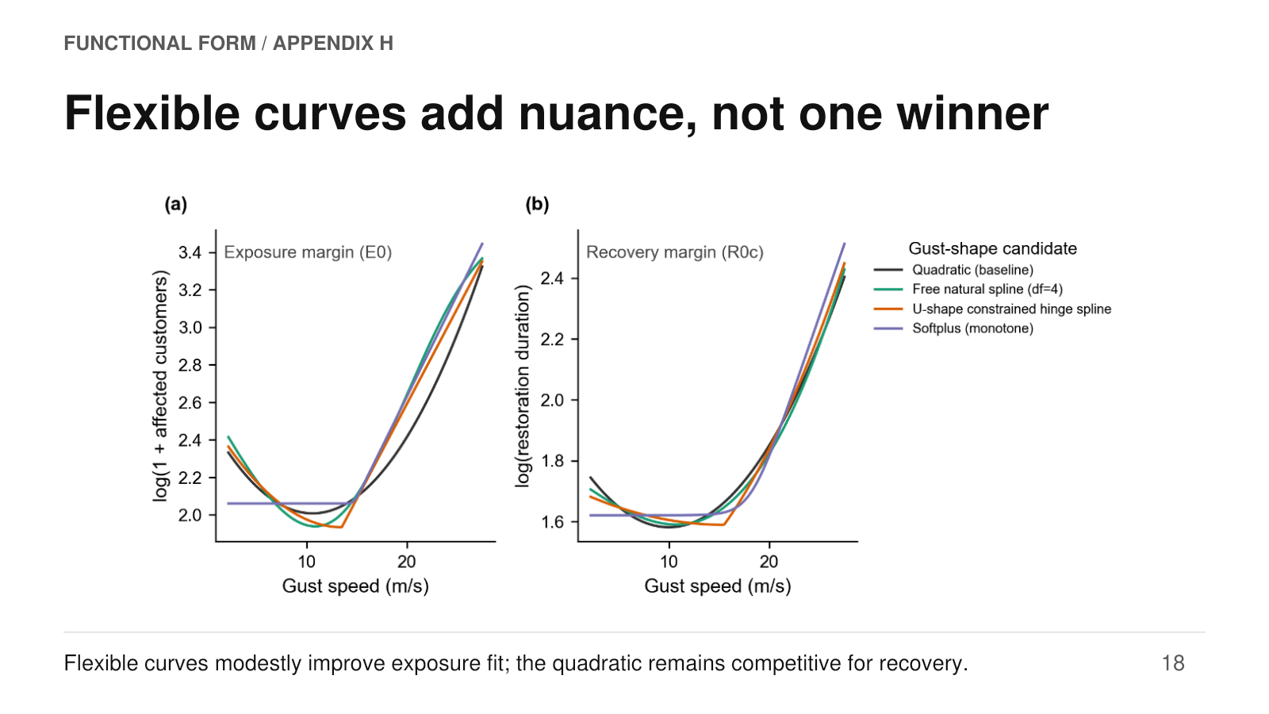
Speaker script
Appendix H tests whether the quadratic is forcing the story. It compares the baseline with a free natural spline, a U-shaped hinge spline, and a monotone softplus curve. The horizontal axis is gust speed and the vertical axes are fitted log outcomes. The legend identifies the four candidate shapes. Several curves look similar over much of the observed range, although they differ more at high gusts and near the minimum.
In cross-validation, the free and hinge splines modestly improve exposure R-squared, from about 0.030 to about 0.033. For recovery, the quadratic remains slightly ahead, with differences small and uncertain. These comparisons omit the gust-pressure interaction to isolate shape, so they are not numerically identical to the main model. The hinge knot was also chosen using the full sample, which qualifies its predictive comparison. The evidence supports a useful parsimonious approximation, while leaving room for alternative shapes rather than establishing a universally optimal curve.
Source: Appendix_revised(5), Appendix H, Figure H1 and Tables H1–H4.

19 / DISCUSSION / SECTION 5
What the evidence supports
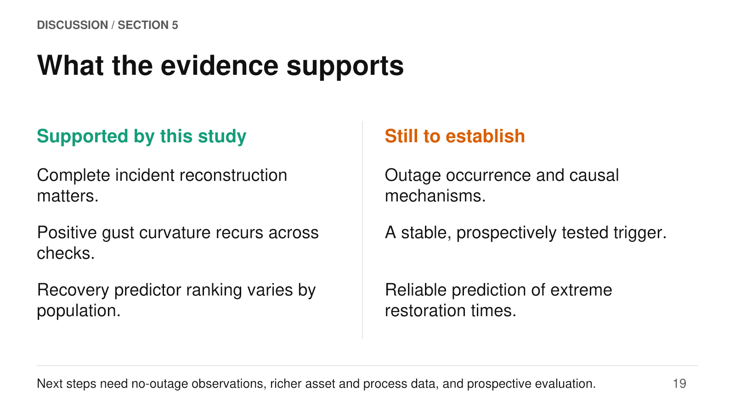
Speaker script
The discussion should preserve the distinction between the study's contribution and what remains open. The evidence supports careful incident reconstruction, a recurring positive gust curvature, and population-dependent predictive ranking for recovery. It does not estimate the probability of an outage, establish the causal mechanisms behind the fitted curves, or validate an operational wind trigger.
The limited out-of-sample R-squared values and the behaviour of extreme-duration cases are especially relevant for applications. A logical next stage would add observations of periods without outages to study occurrence, richer asset and restoration-process information to investigate mechanisms, and genuinely prospective evaluation to assess decisions or forecasts. These are extensions suggested by the documented limitations, rather than results already established. The paper is therefore best positioned as field evidence about network-level outage consequences and their heterogeneity, with a clear distinction between descriptive association, predictive usefulness and operational readiness.
Source: Draft_revised(5), Sections 4.1–4.4 and 5; Appendices D, E and H. Next steps are a synthesis of the documented limitations.

20 / CONCLUSION
The story in three conclusions
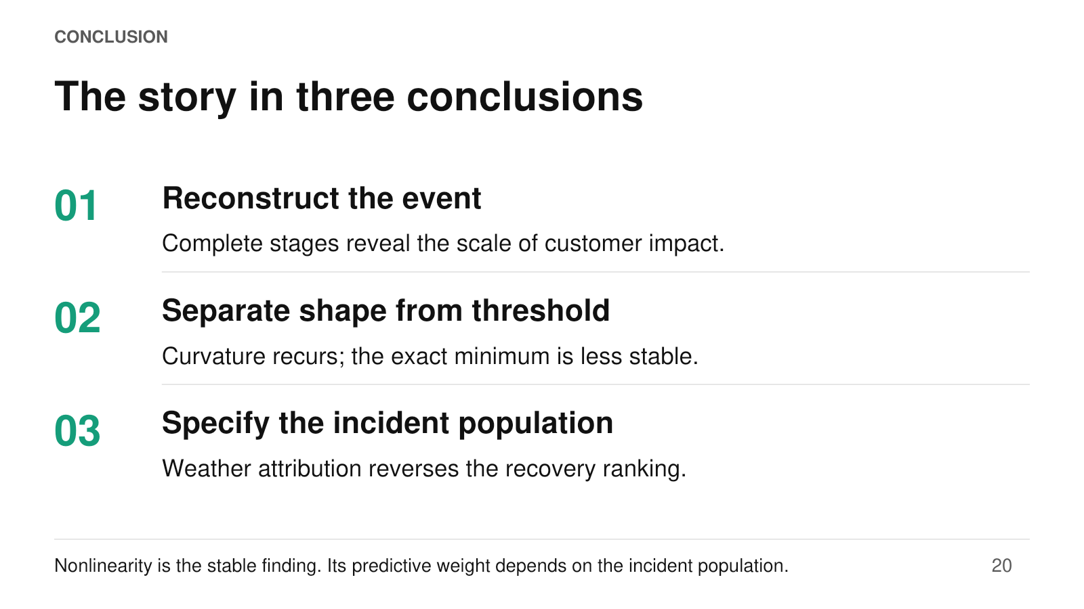
Speaker script
The full story can be brought together in three conclusions. First, the unit of analysis matters: reconstructing complete incidents almost doubles the mean customer impact relative to an earliest-stage-only measure. Second, the operational record contains a recurring nonlinear association between gust and both customer impact and restoration span. The positive curvature is more stable than the particular exposure minimum near ten-point-eight metres per second.
Third, statistical shape and predictive weight are different questions. Gust adds modest predictive information in the combined incident population, where customer scale dominates recovery prediction. Within weather-attributed incidents, gust becomes the larger of those two contributors. The named storms demonstrate concentrated burden and expose prediction limits; they complement rather than duplicate the population comparison. The paper's contribution is thus a network-level account of conditional outage consequences, grounded in reconstructed records and qualified by explicit limits on thresholds, causality and forecasting.
Source: Draft_revised(5), Abstract and Sections 4–5; Appendix_revised(5).

