Abstract
UK Power Networks records 60,453 weather- and asset-related outage incidents across London, the South East, and the East of England between April 2021 and March 2024, including seven named storms. Stage-level records are reconstructed into incident-level affected-customer counts and total restoration spans. Aggregating customer counts across eligible stages gives a mean almost twice that obtained from the earliest recorded stage alone. Quadratic regressions of log-transformed outcomes show positive gust curvature in both margins. For affected customers, the full-sample fitted minimum is approximately 10.7 m/s at mean pressure; this is a conditional feature of the response curve, not a physical damage threshold. Positive quadratic terms also appear in alternative distributional specifications and retrospective temporal analyses, but the temporal comparison is not a previously untouched validation because early model development used observations from both periods. Across the combined sample, gust contributes modestly to out-of-sample predictive fit. In the recovery model, its incremental contribution is smaller than that of affected customers; within weather-attributed incidents, this pairwise ordering reverses. Comparisons during the seven storms describe fitted performance and do not independently establish that reversal. The results characterise nonlinear variation in the consequences of recorded outages across a heterogeneous distribution network, complementing component-level fragility research while estimating a different quantity.

Keywords
Power outage; gust response; restoration duration; distribution network; predictive contribution; extreme weather

1. Introduction
Storms and other extreme weather events are the most common cause of power disruptions in Great Britain [1]. In November 2021, Storm Arwen alone left more than one million customers without power [2]. Three months later, three named storms struck the United Kingdom within five days: Dudley, Eunice, and Franklin. Within the service area of UK Power Networks (UKPN), which covers London, the South East, and the East of England, Storm Eunice produced a peak observed gust of 39.4 m/s in Lewes, East Sussex, on 18 February 2022. This value is the highest gust recorded across the entire study period examined in this paper. The storm was associated with 1,601 weather-related outage events across 101 Local Authority Districts, a cumulative estimate of 376,712 affected customers, and a mean restoration time of 52.7 hours. Two days later, Storm Franklin affected the same network and produced a further 1,187 events.
Outage impact can be measured by the number of customers affected, referred to hereafter as the exposure margin, or by the time needed for restoration, referred to hereafter as the recovery margin. These outcomes need not vary in fixed proportion to gust intensity. An increase in gust speed may be associated with different changes in outage consequences at different points in the observed range. Characterising that response can inform understanding of network performance, while any use in advance resource allocation requires separate assessment of predictive accuracy and decision costs.
Existing empirical work on power outage duration and customer impact under severe weather has established regression- and machine-learning-based approaches for hurricane- and ice-storm-affected US utilities [3–6]. A separate line of engineering research addresses the wind vulnerability of individual distribution and transmission structures. It derives fragility curves, expressing the probability of structural failure as a function of wind speed, from finite element simulation or physical testing of particular structure types [7–10]. These studies motivate examining nonlinear wind response, but a component failure probability and the consequences of an observed network outage are different outcomes.
Component-level fragility curves describe a specified structure under controlled or simulated loading conditions. Network outage records instead represent heterogeneous assets, locations and restoration circumstances. Field data can therefore provide complementary evidence about the scale and duration of recorded incidents, without identifying the same failure-probability function as a component fragility analysis.
This study addresses two questions within that operational setting. First, is there a consistent nonlinear association between gust intensity and the consequences of recorded outages, and how stable is the location of any fitted minimum? Second, does the predictive contribution of gust relative to affected-customer scale in a restoration-duration model change when attention is restricted to weather-attributed incidents? Prior work has investigated influential hazard and infrastructure predictors [6]; the comparison here concerns these two particular variable groups within the same network under different cause-based sample definitions.
Addressing both questions requires an observational record long enough, and varied enough, to include both routine operating conditions and a number of distinct severe wind events within the same network. The UKPN dataset examined in this paper spans three years of continuous operation, from April 2021 to March 2024, and includes seven officially named storms, among them Storm Eunice described above. This combination of duration and event coverage makes it possible to estimate a continuous response function across the full range of observed wind conditions, and to examine that function specifically under the seven storm events, rather than relying on a single simulated structure or a short observation window.
The analysis uses UKPN outage records from April 2021 to March 2024. Separate quadratic specifications describe affected customers and restoration duration conditional on an incident having occurred. The exposure model’s fitted minimum is evaluated at a stated pressure reference, and nested-model comparisons assess the incremental predictive contribution of gust and affected customers to recovery duration. Retrospective temporal analyses examine sample sensitivity, while seven named storms provide a descriptive assessment of fitted performance during severe weather. The development history limits the independence of the temporal evidence, as explained in Section 3.2 and Appendix E.
Section 2 describes the data, incident-level outcome construction and sample. Section 3 presents the regression specifications, model-development history and evaluation procedures. Section 4.1 reports gust curvature and conditional fitted minima; Sections 4.2 and 4.3 examine predictive contributions and storm-period fitted performance; Section 4.4 reports retrospective temporal and clustering checks. Section 5 discusses interpretation, limitations and further work.

2. Data and Study Setting

2.1 Study setting and data sources
UKPN operates the electricity distribution network across London, the South East, and the East of England, and reports outage incidents to Ofgem, the energy regulator for Great Britain, under the regulatory reporting framework set out in the RIIO-ED1 and RIIO-ED2 Annex F guidance [11, 12]. RIIO-ED1 and RIIO-ED2 are successive multi-year price control periods during which Ofgem sets the revenue and performance requirements for UK electricity distribution network operators. This paper draws on UKPN’s outage incident records covering 1 April 2021 to 31 March 2024, a period of three complete regulatory years spanning both the RIIO-ED1 and RIIO-ED2 price control periods. Each record corresponds to a restoration stage rather than a complete outage incident. An incident that requires more than one restoration action, for example because power is restored to part of the affected area before the remainder, is represented by more than one stage-level record sharing a common incident reference. Section 2.2 describes how event-level outcome variables are constructed from these stage-level records.
Weather variables are matched to each incident using hourly reanalysis data from the Open-Meteo historical weather API [13], which is based on the ERA5 global reanalysis dataset [14]. Data are indexed to the latitude and longitude reported for each incident and the hour in which it began. The primary wind variable used throughout this paper is instantaneous gust speed rather than sustained wind speed. This choice follows the convention in structural wind engineering, where design wind loads are based on a short-duration (3-second) gust rather than a longer-averaged sustained speed, because peak instantaneous loading determines structural response and failure [15]. This convention has been applied specifically to wind-induced damage in electrical grid infrastructure [16]. In the final analysis sample, gust speed has a mean of 9.87 m/s and a standard deviation of 5.22 m/s, referenced in Section 4.1 when reporting the exposure margin’s turning point in physical units.
Regional covariates are drawn from Office for National Statistics (ONS) data at the Local Authority District (LAD) level and merged to each incident by its reported location. These comprise resident population from ONS local authority population estimates [17], and income deprivation rate, the gap between local and national income deprivation, and spatial clustering of income deprivation measured by Moran’s I, all drawn from the ONS dataset mapping income deprivation at a local authority level [18]. Moran’s I follows the spatial autocorrelation statistic introduced by Moran [19]. An urban-rural classification is drawn from the same ONS local statistics resource used for the population and deprivation data [17]. LAD boundaries as at December 2021 are taken from the ONS Open Geography Portal [20].
Figure 1 shows the three UKPN licence areas and the spatial density of incidents across the study period. Incident density is not uniform across the service area. It is concentrated around London, which sits at the boundary between the South East and East of England licence areas. A smaller, secondary concentration is visible near the north-east coast of the East of England licence area. The remainder of the service area shows a comparatively even, lower density of incidents.
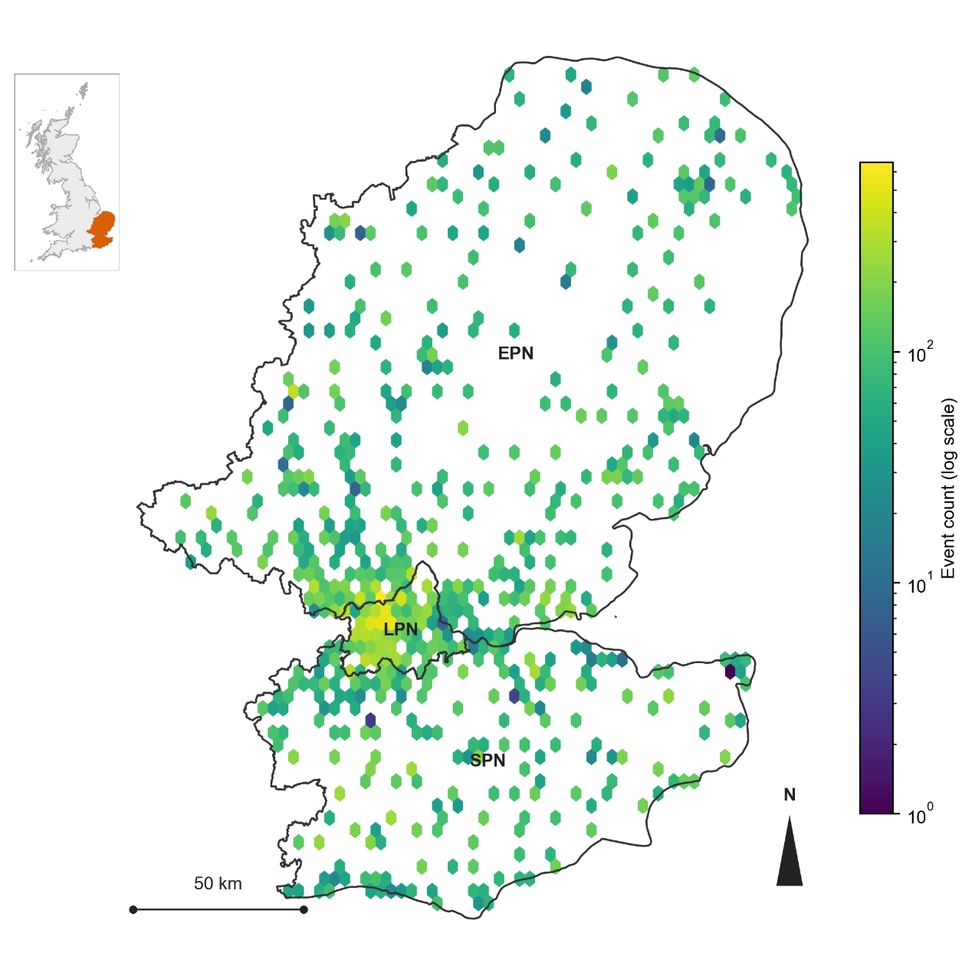
Figure 1. Study area and event density. The map shows the three UKPN licence areas (London, South East, East of England) and the spatial density of all incidents in the final analysis sample, rendered as a hexagonal binning of incident coordinates on a logarithmic count scale. The inset shows the location of the UKPN service area within Great Britain.

2.2 Outcome variable construction
Ofgem’s Annex F guidance distinguishes Customer Interruptions (CI) from Customer Minutes Lost (CML) [11, 12]. Customer counting excludes stages flagged as re-interruptions to avoid counting the same customers again, whereas interruption-time accounting includes repeat interruptions. This paper follows the customer-count aggregation logic when constructing affected customers. Its recovery outcome is a separate incident-level measure: the elapsed span from the earliest recorded start to the latest recorded end. This total incident span is not CML or the customer-weighted mean interruption duration.
The exposure margin is measured by the number of customers affected by an incident, referred to hereafter as affected customers, and constructed as
Ci=r∈Ri, r∉Ii​Ni,r (1)
where $C_{i}$ is affected customers for incident $i$, $R_{i}$ is the set of restoration stages recorded for incident $i$, $I_{i}⊂R_{i}$ is the subset of those stages flagged as re-interruptions, and $N_{i,r}$ is the customer count reported at stage $r$.
The recovery margin is measured by the total duration of the incident, referred to hereafter as restoration duration, and constructed as
$$D_{i}=\max_{r ∈ R_{i}}T_{i,r}^{\text{end}}−\min_{r ∈ R_{i}}T_{i,r}^{\text{start}}\text{ (2)}$$
where $D_{i}$ is restoration duration for incident $i$, and $T_{i,r}^{\text{start}}$ and $T_{i,r}^{\text{end}}$ are the start and end times recorded at stage $r$.
Constructing affected customers by aggregating across stages, rather than taking the customer count reported in the earliest stage of each incident, changes the sample mean from 47.13 to 93.02 customers, a difference of a factor of 1.97, within the same final analysis sample reported in Table 1. This difference reflects incidents with more than one restoration stage, in which the earliest stage alone does not capture the full extent of the customers affected as the incident evolves. Appendix B reports the full data processing pipeline underlying Equations 1 and 2, including the handling of a small number of boundary cases not covered by the general definitions above.

2.3 Descriptive statistics and visualization
Table 1 reports descriptive statistics for affected customers and restoration duration in the final analysis sample, on the original scale and after log transformation. Both variables are heavily right-skewed on the original scale, with the mean well above the median (93.0 versus 2.0 for affected customers, 11.8 versus 6.3 hours for restoration duration). Figure 2 shows the distribution of each variable before and after transformation. The log transformations substantially reduce this skew, but they do not produce a fully symmetric distribution in either case. The transformed affected-customers variable shows a sawtooth pattern at low values, reflecting the fact that many incidents affect a small integer number of customers. The transformed restoration-duration variable shows two distinct modes, one near one hour and one near seven to twelve hours, separated by a clear trough. Restoration-stage composition is examined separately in Section 4.1 and Appendix D; those analyses describe associations and do not by themselves identify the source of the bimodal duration distribution. Despite this remaining structure, the log transformation is still used for both variables, because it reduces the influence of very large observations on a least-squares fit.
Table 1. Descriptive statistics for affected customers and restoration duration, final analysis sample.
Statistic | Affected customers (n=60,437) | log(1+affected customers) | Restoration duration, hours (n=59,834) | log(restoration duration)
Mean | 93.02 | 2.138 | 11.84 | 1.656
Median | 2.00 | 1.099 | 6.27 | 1.835
SD | 410.96 | 2.019 | 19.96 | 1.349
Min | 0.00 | 0.000 | 0.05 | -2.996
25th pct. | 1.00 | 0.693 | 2.03 | 0.710
75th pct. | 35.00 | 3.584 | 12.67 | 2.539
Max | 27,013.00 | 10.204 | 192.08 | 5.258
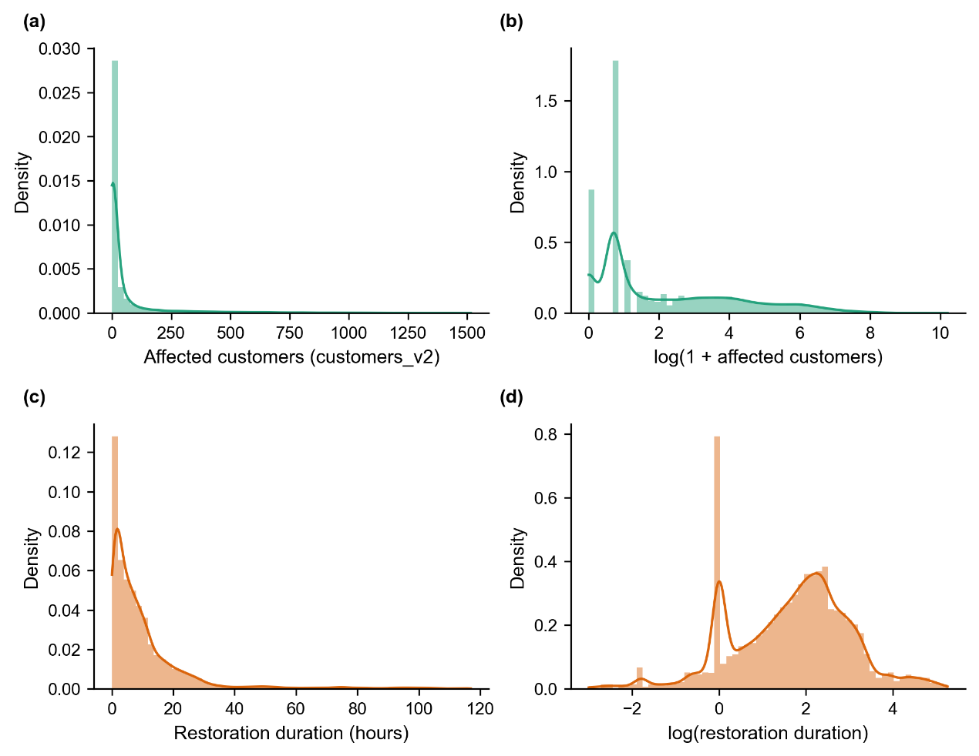
Figure 2. Distribution of affected customers and restoration duration, original scale and after log transformation. (a) Affected customers, original scale. (b) log(1+affected customers). (c) Restoration duration, original scale (hours). (d) log(restoration duration).
Affected customers and restoration duration are treated as separate outcome margins because they measure different aspects of an incident. Small linear or rank correlations, where observed, would not establish independence. Appendix D examines the association using restoration-stage strata and additional regression controls. The pooled and stratified patterns differ, indicating sensitivity to event composition; they do not by themselves identify a direct causal effect of customer scale on duration.

2.4 Sample construction and predictor variables
UKPN records a Cause Code for each incident. This paper groups the original codes into six analytical categories, with the mapping reported in Appendix A.2. The main sample retains the weather-related and asset-related groups to examine incidents attributed to weather or network asset condition. Other groups cover no fault found or unknown causes, third-party interference, human error, and external or customer causes. These labels do not establish statistical independence from gust, and weather may affect restoration even when it is not the recorded initiating cause. A six-category sensitivity comparison is reported in Appendix C. Across five folds, the recovery model’s mean quadratic gust coefficient is 0.0608 in the six-category sample (n = 116,064) and 0.0792 in the two-category sample (n = 59,834), with positive significant quadratic terms in all folds. The mean linear coefficient changes from 0.0257 to 0.0002 and is significant in five versus zero folds. This shows sensitivity of the linear term to sample definition, rather than proving that its signal in the wider sample is non-physical. The restriction was originally chosen before temporal separation, as documented in Section 3.2.
The resulting sample comprises 60,453 incidents. After matching weather data and excluding incidents with missing regional covariates, 60,437 incidents are available for the exposure model and 59,834 for the recovery model, the difference reflecting incidents for which restoration duration could not be computed or fell above the 99th percentile of the restoration duration distribution.
The full covariate set comprises gust speed and its square, an interaction between gust speed and mean sea level pressure, 24-hour cumulative precipitation, temperature, mean sea level pressure, log population, income deprivation rate, the gap between local and national income deprivation, Moran’s I, an urban-rural indicator, and calendar year and month fixed effects. The recovery model additionally includes standardised log(1 + affected customers) and its square as covariates, discussed further in Section 4.1.
Variance inflation factors for all continuous covariates in the final model specification are below 4, with the highest value, 3.76, corresponding to the gap between local income deprivation and the national average. Values of 5 and 10 are commonly cited as informal thresholds for concern regarding multicollinearity, although O’Brien [21] cautions that these thresholds are heuristic rather than absolute, and that a given VIF value should be interpreted alongside the sample size and the strength of the effect under study rather than treated as a fixed cutoff. The VIF values obtained here are below both commonly cited thresholds regardless of this qualification.

3. Empirical Framework

3.1 Modelling approach and rationale
A parametric quadratic model is used to describe how log-transformed outage consequences vary with gust. The quadratic form provides an interpretable curvature coefficient and a closed-form stationary point. Before adding the remaining covariates, the fitted log-scale response can be represented as
$$η\left(G\right)=α+β_{1}G+β_{2}G^{2}\text{ (3)}$$
where $η\left(G\right)$ denotes the fitted log-scale response, $G$ is standardised gust and $α$ is an intercept. Setting its derivative to zero gives $G^{*}=−β_{1}/\left(2β_{2}\right)$ when $β_{2}≠0$; this is a minimum when $β_{2}>0$. A GLM with a log link and the same quadratic predictor has the same stationary-point condition, since the derivative of its inverse link, the exponential function, is strictly positive. The chosen log-OLS specification therefore offers a consistent descriptive framework for both margins, rather than a unique way to estimate a minimum. The sign or significance of the linear coefficient alone does not determine whether a minimum exists or has an interpretable location.
Ordinary least squares is applied to log(1 + affected customers) and log(restoration duration). Both outcomes are strongly right-skewed on their original scales, as shown in Figure 2. Negative binomial, gamma and Tweedie generalised linear models offer alternative distributional specifications for such outcomes [22]. Log-OLS is retained for a common modelling framework and transparent coefficient interpretation; it does not require normally distributed raw outcomes, and residual non-normality alone does not establish that coefficient estimation is invalid. Conditional-mean specification and appropriate treatment of error dependence remain necessary considerations.
Exploratory specification checks re-estimated the exposure model using negative binomial and Tweedie alternatives and the recovery model using gamma and Tweedie alternatives. The project audit reports positive quadratic gust terms across these checks. They are treated as supplementary sensitivity evidence rather than independent validation. A complete comparison of model settings, coefficients and residual diagnostics remains necessary for a fully reproducible assessment. The main estimates and clustering checks are reported in Table 3 and Appendix F.

3.2 Model development and retrospective evaluation
Choosing outcome definitions, sample restrictions and model terms using the same data later used for inference can make reported evidence optimistic. Separating data before exploration is one approach to this problem [23]. In this project, however, the temporal separation was established after several foundational decisions had already used observations from both periods. The subsequent temporal comparison is therefore retrospective and does not constitute validation on a previously untouched sample.
The period 1 April 2021 to 29 September 2023 is called the development period, and 30 September 2023 to 31 March 2024 the later period. For continuity with the project records and figure labels, the latter is also called the confirmation sample, but that label does not imply independence from model development. The local audit identified six earlier analysis steps covering outcome reconstruction and duration choice, the first turning-point analysis, Cause Code restriction and its supporting checks, and the initial predictive-contribution analysis; all used data containing the later period. Subsequent re-estimation on separated or recombined samples corrected sample allocation without undoing this earlier information use. The historical duration-measure comparison was not repeated on separated data. Appendix E records these limits. Figure 3 places four storms in the earlier period and three in the later period.
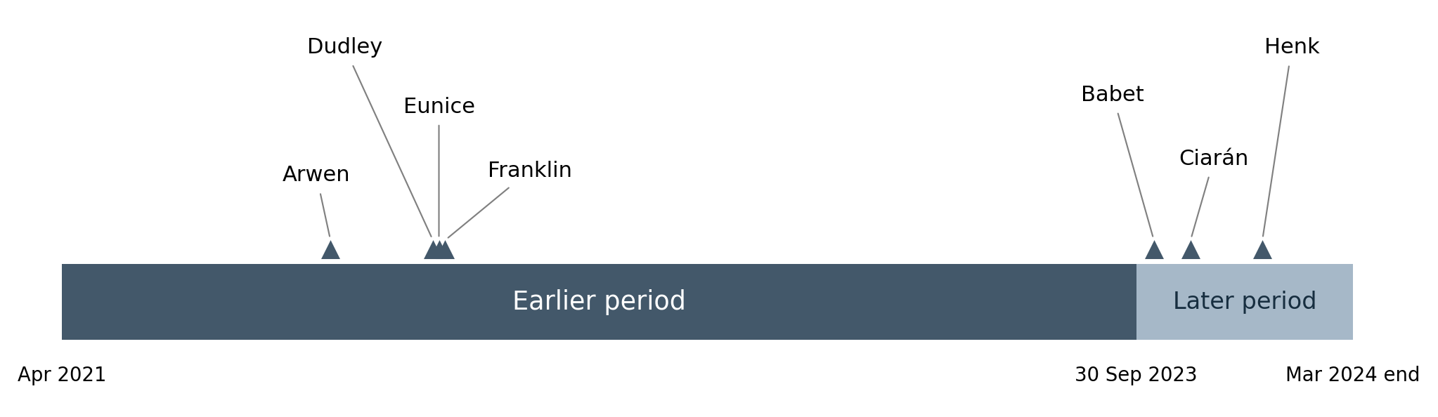
Figure 3. Study period and retrospective temporal partition. Storm markers indicate their months of occurrence; the diagram is schematic within each month. The later-period label does not denote a previously untouched validation sample.
Five-fold cross-validation groups incidents by start date, so all incidents starting on a given day enter the same fold. For each comparison, models are fitted on four folds and evaluated on the remaining fold, and fold-level R-squared values are averaged. Sections 4.2 and 4.3 report these predictive comparisons for the combined sample and the weather-attributed subset respectively. The development-only coefficient summaries used in Section 4.4 are separately identified. These evaluations are out of fold for coefficient fitting, but not independent of earlier model selection. Grouping by date also does not guarantee separation of all days belonging to the same storm.
The exposure minimum was first estimated as 10.69 m/s before temporal separation. Restricting the analysis to the earlier-period exposure sample (n = 48,323) changed the estimate to 12.13 m/s. The final combined exposure sample (n = 60,437) gave 10.69 m/s again. These estimates refer to different sample constructions; the repeated rounded value is not an independent replication. Table E2 records this sequence. Sections 4.1 to 4.3 use the final combined sample unless a subset is explicitly identified.

3.3 Model specification
Continuous predictors are standardised using the estimation sample’s means and standard deviations. In cross-validation, scaling is estimated on the training fold and applied to its validation fold. For the separate temporal analyses, each sample has its own scaling; bootstrap fits likewise recompute scaling within each resample. Thus $G=0$ denotes the mean gust for the relevant fit, not calm conditions. Gust and pressure enter as standardised variables, with gust squared and the gust-pressure product constructed from those variables. In the recovery model, the customer predictor is first transformed as $ln\left(1+C_{i}\right)$, then standardised; both this standardised predictor and its square enter the model. Appendix H distinguishes the reference scales used for fitted minima and uncertainty.
The final model specification is the same for both outcome margins, except that the recovery model includes two additional terms. This is the full version of Equation 3, with the additional covariates included, given by
$$ln\left(Y_{i}\right)=α+β_{1}G_{i}+β_{2}G_{i}^{2}+β_{3}G_{i}P_{i}+X_{i}^{′}γ+δ_{y\left(i\right)}+θ_{m\left(i\right)}+ε_{i}\text{ (4)}$$
where $Y_{i}$ is $1+C_{i}$ for the exposure margin and $D_{i}$ for the recovery margin; $G_{i}$ and $P_{i}$ are standardised gust and pressure; $X_{i}$ contains the other continuous and categorical covariates in Table 2; and $δ_{y\left(i\right)}$ and $θ_{m\left(i\right)}$ are additive year and month effects. The intercept is $α$, and $ε_{i}$ is the error term. For recovery, $X_{i}$ additionally contains standardised $ln\left(1+C_{i}\right)$ and its square.
Year and month effects enter as separate dummy-variable sets, not year-by-month interactions. The exposure and recovery equations describe conditional log-scale responses. Let ${\hat{η}}_{i}$ denote a fitted value on that scale. Figures 4 and 6 display $exp\left({\hat{η}}_{i}\right)$ without a retransformation correction: for exposure this refers to $1+C_{i}$, and for recovery to duration. These are exponentiated fitted log outcomes, not estimates of conditional arithmetic means. The exposure displays also do not subtract one. Figure 7 retains ratios on this same exponentiated-log scale.
Table 2 lists the covariates and fixed effects included alongside gust, its square and the gust-pressure interaction. Appendix A describes their sources and transformations.
Table 2. Other covariates and temporal fixed effects in Equation 4.
Variable | Category | Model
Mean sea level pressure | Weather | Both
24-hour cumulative precipitation | Weather | Both
Temperature | Weather | Both
Log population | Regional | Both
Income deprivation rate | Regional | Both
Gap between local and national income deprivation | Regional | Both
Moran’s I (income deprivation) | Regional | Both
Urban-rural indicator | Regional | Both
Standardised log(1 + affected customers), and its square | Event-level | Recovery only
Year fixed effects | Temporal | Both
Month fixed effects | Temporal | Both
The main standard errors are clustered by Local Authority District (LAD) [24]. Appendix F also reports two-way clustering by LAD and date for the same final combined-sample coefficients. Changing the covariance estimator changes standard errors and confidence intervals, not the OLS point estimates. These checks address specified patterns of error dependence; they do not remove omitted-variable bias or establish independence across all multi-day storm events.

4. Results

4.1 Nonlinear gust–outage response and conditional fitted minima
This section reports the fitted gust-response shape and the location of the exposure minimum under stated reference conditions. Sections 4.2 to 4.4 then examine predictive contributions, storm-period fitted performance and retrospective temporal sensitivity.
Table 3 reports the final combined-sample gust coefficients. The quadratic terms are positive in both margins (p < 0.001 under LAD clustering). The linear term is negative for exposure (p = 0.022) and close to zero for recovery (p = 0.982). The quadratic terms also retain a positive sign in the reported alternative-distribution and temporal checks. These results support positive curvature within the fitted specifications. They do not establish a physical damage threshold, and the significance of a linear term is not a criterion for deciding whether a fitted minimum exists.
Table 3. Gust coefficients, final model specification.
Term | Exposure margin | Recovery margin
Gust (linear) | -0.032 (p = 0.022) | 0.000 (p = 0.982)
Gust squared | 0.103 (p < 0.001) | 0.079 (p < 0.001)
n | 60,437 | 59,834
For exposure, the fitted linear gust coefficient is negative and small relative to the quadratic coefficient. It describes the local slope at mean gust and mean pressure, rather than a constant slope across wind conditions. Its sign should not be interpreted as evidence that mild wind protects the network. Sample composition and unobserved incident characteristics offer alternative explanations for the low-gust part of the fitted relationship.
Because Equation 4 includes a gust-pressure interaction, the stationary point depends on pressure. At mean pressure on the relevant estimation scale, it is
$$G^{*}\left(P=0\right)=−\frac{β_{1}}{2β_{2}}\text{ (5)}$$
where $β_{1}$ and $β_{2}$ are the fitted linear and quadratic gust coefficients. At another pressure level the location is $G^{*}\left(P\right)=−\left(β_{1}+β_{3}P\right)/\left(2β_{2}\right)$. Using full-precision combined-sample coefficients gives $G^{*}\left(0\right)=0.157286$ and a physical gust of 10.694 m/s, reported as 10.69 m/s. The corresponding algebraic estimates at pressure one standard deviation below and above its mean are 9.656 and 11.732 m/s (Appendix H). These are conditional fitted locations; the interaction is not significant under two-way clustering, so the pressure contrast is not presented as an established operational effect.
A quadratic function is symmetric around its own turning point by construction: equal standardised distances on either side of $G^{*}$ correspond to identical fitted values, regardless of whether the linear coefficient is zero. The relevant difference between the two margins is therefore not the shape of the curve around its own turning point, which cannot itself be asymmetric, but where that turning point is located relative to the sample mean gust speed, and how precisely that location can be estimated.
A local audit reproduced the original 500 day-bootstrap fits and examined their coefficients. The quadratic coefficient remained positive, ranging from 0.03659 to 0.16138; the explanation that the interval widened because the denominator approached zero is therefore unsupported. The resampled standardised locations had empirical 2.5th and 97.5th percentiles of -0.1281 and 0.4189. Scaling was re-estimated in every resample, so these locations are measured relative to each resample’s own mean gust and pressure reference. They cannot be treated without further checking as a physical-unit interval at one fixed pressure reference. The previously reported 9.2–12.1 m/s interval is consequently withheld. Appendix H documents the resampling diagnostics and the required conversion. Differences from the Delta approximation [25] may reflect nonlinear estimation and dependence or scaling choices; this audit does not isolate their relative contributions.
For recovery, the near-zero linear term places the fitted minimum close to the sample mean gust under average pressure. That minimum exists mathematically even though the linear coefficient is not significant. We emphasise the positive curvature and do not assign operational meaning to a particular recovery minimum. At other pressure levels, the interaction term shifts its location in the same way as in Equation 5’s generalisation.
Figure 4 displays the exponentiated fitted log responses under the reference covariates used for the original curves. The asymmetry of the plotted wind range around each minimum makes the high-wind arm extend farther from the minimum; it does not make the fitted function asymmetric about its own vertex. The exponentiated curves are not themselves quadratic on the displayed scale, although their log-scale predictors are quadratic. For exposure the plotted quantity is exp(fitted log(1 + customers)), so it includes the added one and is not a conditional arithmetic mean of customers.
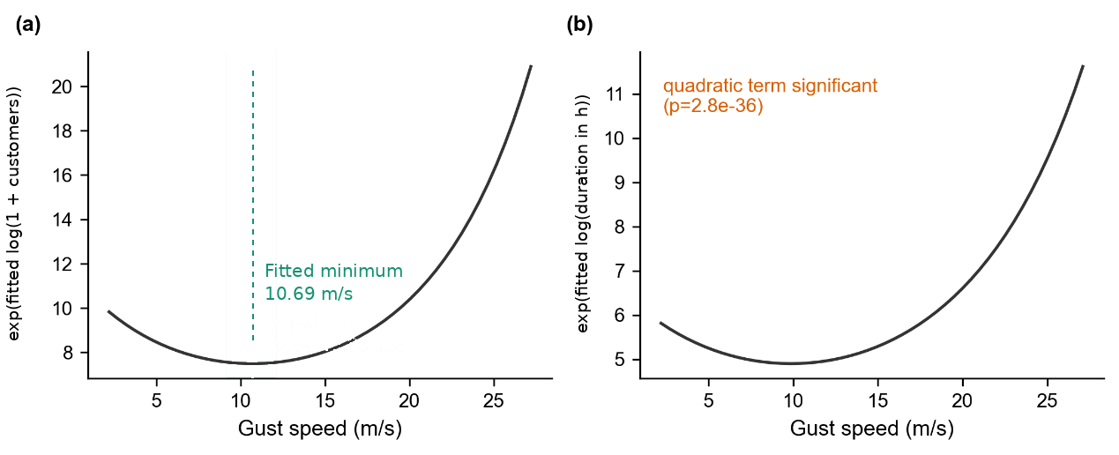
Figure 4. Exponentiated fitted log responses under the original reference-covariate settings, with pressure at its standardised mean. (a) exp(fitted log(1 + affected customers)); the vertical marker identifies the point estimate 10.69 m/s. (b) exp(fitted log(restoration duration in hours)). No retransformation correction is applied, and panel (a) does not subtract one. The earlier physical-unit bootstrap band is omitted pending a consistent resample-level conversion (Appendix H).
The recovery model includes standardised log(1 + affected customers) and its square. Their association with duration depends on the sample and on restoration-stage controls. Appendix D reports a positive linear coefficient without stage controls in the main sample, a negative coefficient in the weather-attributed subset, and a sign change after adding a stage control in the development-only analysis. These findings show sensitivity to event composition. A linear coefficient alone does not establish monotonicity across the full customer range, and these regressions do not identify a mediation or dispatch-priority mechanism. Gust curvature was reported to remain positive in the stage-control checks.
The exposure minimum marks a zero slope in the fitted response. Its existence does not demonstrate a structural failure threshold or a change in mechanism. The model conditions on a recorded outage and does not estimate the probability of an outage at a given wind speed. Establishing a response trigger would require additional predictive validation and a decision analysis accounting for the consequences of false alarms and missed events.

4.2 Population-level weight of wind
A statistically detectable gust coefficient need not provide substantial predictive information. This section assesses the incremental out-of-fold fit associated with gust and other variable groups. The R-squared measures refer to log-transformed outcomes, rather than to variation in raw customer counts or hours.
Nested models add non-gust weather variables to a baseline of regional covariates and additive calendar effects, followed by gust terms. For recovery, affected-customer terms are added in either order relative to gust. Changes in mean fold-level out-of-sample R-squared measure conditional predictive increments, which can depend on the order of addition. In the combined exposure sample, gust contributes 1.07 percentage points to a total R-squared of 2.81 percent. In the combined recovery sample, gust contributes 0.62–0.75 percentage points and customer terms contribute 7.73–7.87 percentage points, with a full-model R-squared of 11.05 percent. Figure 5 shows the gust-before-customers order, in which 7.87/0.62 is approximately 12.7. These increments are descriptive predictive comparisons, not shares of a causal effect or an order-invariant variance decomposition.
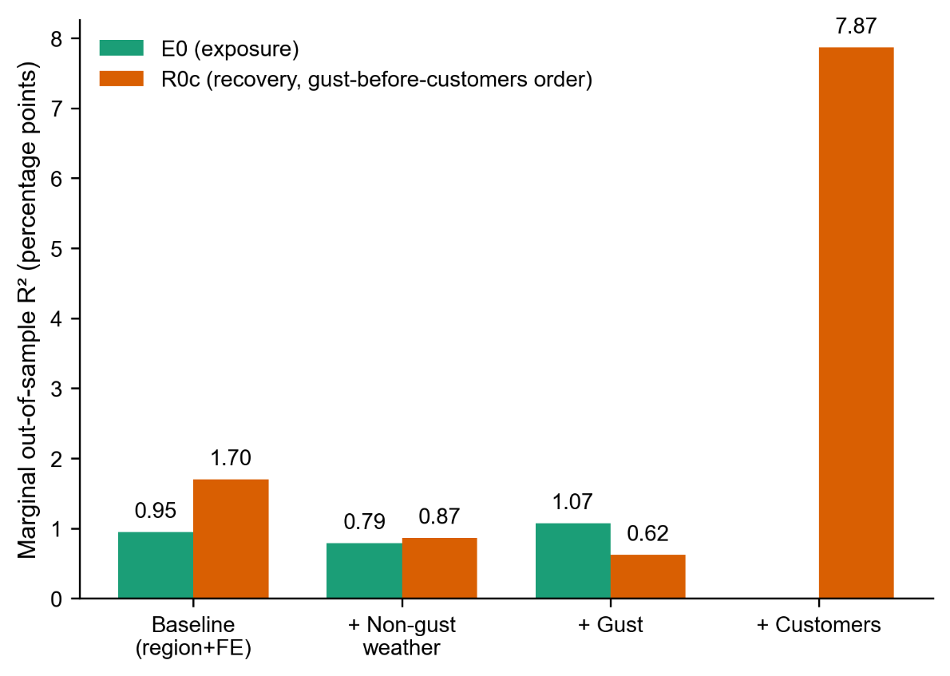
Figure 5. Incremental mean out-of-fold R-squared on the log-outcome scale, final combined samples. Groups are added in the displayed order; the recovery panel adds gust before customer terms. “Customers” denotes standardised log(1 + affected customers) and its square.
Figure 6 compares regional variation in exponentiated fitted log responses, holding the non-regional predictors at the reference settings used in the original map calculation. The exposure and recovery maps do not identify the same high-value districts: their cross-district correlations are -0.780 (Pearson) and -0.758 (Spearman). These are correlations between two model-generated surfaces under fixed reference conditions, not correlations between observed district-level outage outcomes. Both maps use exp(fitted log outcome) without a retransformation correction; the exposure surface therefore refers to 1 + affected customers.
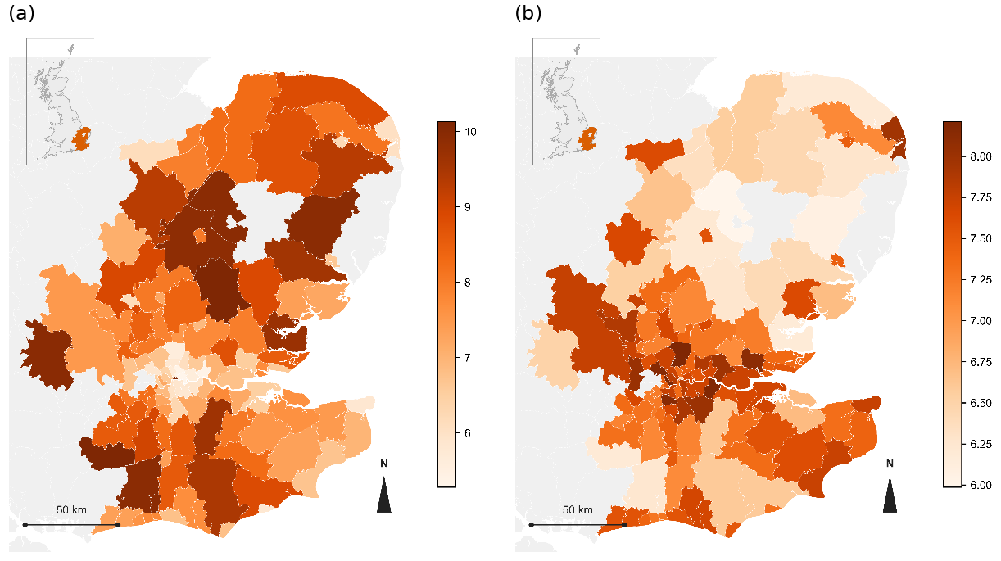
Figure 6. Regional variation in exponentiated fitted log outcomes under fixed reference settings for non-regional predictors. (a) exp(fitted log(1 + affected customers)). (b) exp(fitted log(restoration duration in hours)). Only the five regional covariates vary across LADs. Colour scales are not conditional arithmetic means; panel (a) includes the added one.
Figure 7 reports the highest divided by the lowest exponentiated fitted value on a 50-point grid spanning the driving variable’s 1st to 99th percentiles. This grid-extrema ratio is not the ratio of predictions at the two percentile endpoints. The reported ratios are 2.79 for gust on the exposure response, 2.37 for gust on recovery, and 5.99 for customer scale on recovery. For the gust curves the minima lie inside the range; for the customer curve the maximum is internal. The exposure ratio describes exp(fitted log(1 + customers)), so it should not be read as a fold change in arithmetic-mean customer counts. Each ratio is a reference-scenario contrast and does not quantify a population variance share.
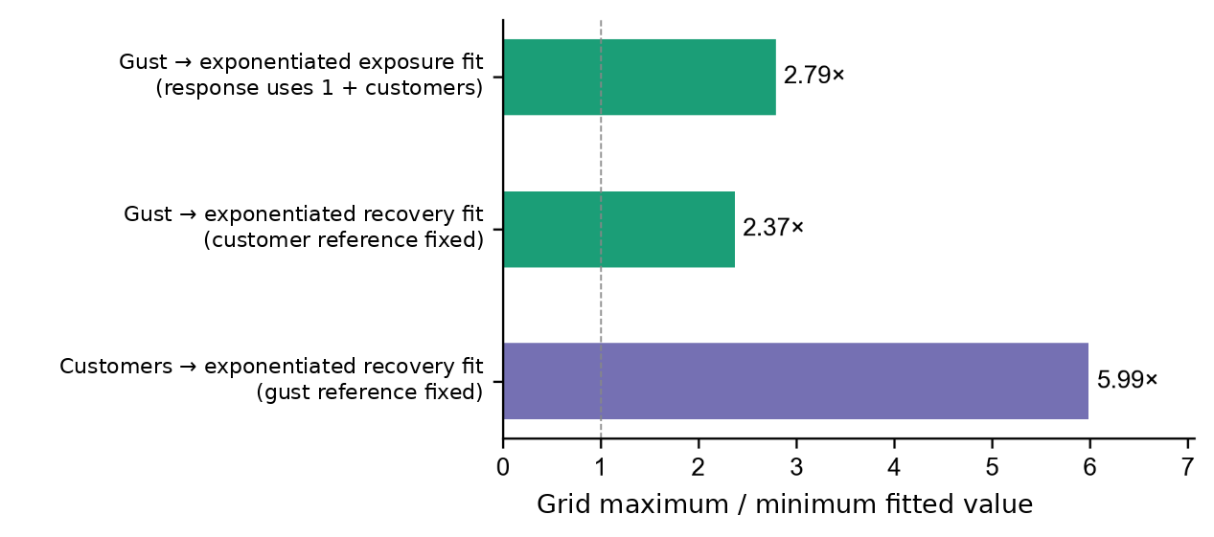
Figure 7. Maximum/minimum exponentiated fitted value over the 50-point plotting grid (1st–99th percentile range of the driving variable). Ratios are 2.79, 2.37 and 5.99 for gust–exposure, gust–recovery and customers–recovery respectively. The exposure response is on the 1 + customers scale; customer terms in the recovery model use standardised log(1 + customers).
The regional-map ranges in Figure 6 give maximum/minimum ratios of 1.96 for the exponentiated exposure fit and 1.41 for recovery. These are of the same broad order as the gust-driven grid ratios, and smaller than the customer-driven recovery ratio. The comparisons describe fitted variation under different reference scenarios; they do not establish a universal ranking of regional conditions, gust and customer scale.
The combined-sample recovery comparisons therefore assign a larger predictive increment to customer terms than to gust terms. The exposure model also gains a small positive increment from gust. Section 4.3 examines how these increments change under a weather-attributed sample restriction.

4.3 Weather-attributed incidents and storm-period evidence
This section first restricts the analytical sample to the weather-related Cause Code group and repeats the predictive-contribution comparison. Cause attribution defines a different observed population; it is not assumed to be independent of wind conditions or incident development. A separate descriptive analysis then examines the combined-sample model during seven named storms.
The recovery model described in Section 3.3 was re-estimated on the subset of incidents for which the Cause Code identifies weather as the direct cause, rather than the combined weather- and asset-related sample used elsewhere in this paper. This subset contains 9,758 incidents, about 16 percent of the main sample. Table 4 compares the two samples directly. The quadratic gust term is close to the same magnitude in both samples and remains significant in both. The marginal contribution of gust to out-of-sample R-squared more than doubles, from between 0.62 and 0.75 percentage points in the main sample to between 1.43 and 1.71 percentage points in the weather-only subset, and now exceeds the marginal contribution of affected customers, which falls to between 1.00 and 1.28 percentage points in this subset. Figure 8 shows this comparison. Figure 8a reports the exposure margin, where the marginal contribution of gust falls from a positive value in the main sample to a small negative value in the weather-only subset, the only instance of a negative bar among all of the figures reported in this paper. Figure 8b reports the recovery margin, where the relative height of the gust and affected-customers bars is reversed between the two samples, from affected customers roughly 12.7 times the height of gust in the main sample to gust slightly exceeding affected customers in the weather-only subset. The weather-attributed recovery sample contains 9,758 incidents; the corresponding exposure sample shown in Figure 8 contains 9,857. Since each sample has its own outcome variance and covariate distribution, the change in R-squared increment is not evidence that a physical wind effect has doubled. The comparison establishes an ordering of reported point estimates between these two variable groups, rather than dominance over all possible predictors.
Table 4. Marginal out-of-sample R-squared, main sample versus weather-only subset.
Margin | Variable | Main sample | Weather-only subset
Exposure | Gust | +1.07 pp | -0.15 pp
Recovery | Gust | 0.62-0.75 pp | 1.43-1.71 pp
Recovery | Affected customers | 7.73-7.87 pp | 1.00-1.28 pp
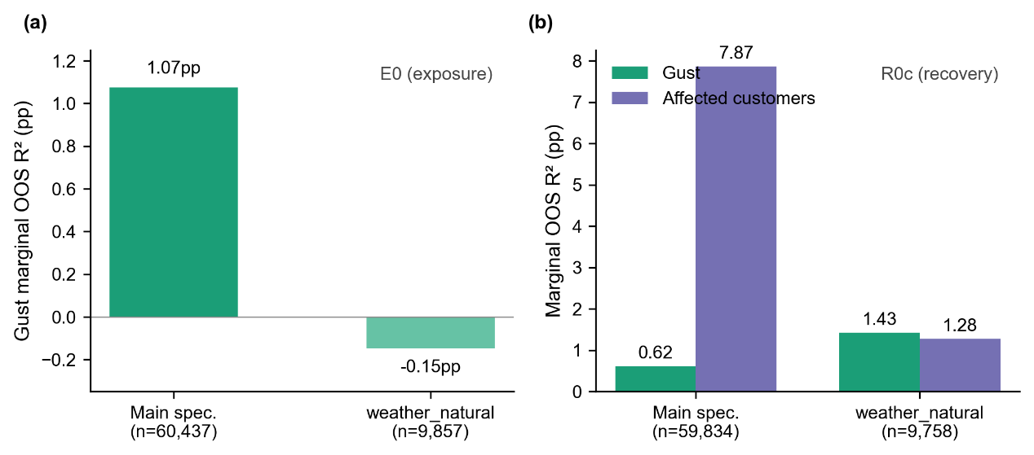
Figure 8. Marginal out-of-sample R-squared, main sample versus weather-only subset. (a) Exposure margin. (b) Recovery margin, gust and affected customers shown separately.
For exposure, adding gust reduces mean out-of-fold R-squared by 0.15 percentage points in the weather-attributed sample. This is an unfavourable predictive result for that comparison, although it does not by itself negate a positive fitted quadratic coefficient. Appendix G documents an association between cause classification and gust: the weather-related share rises from 6.89 percent in the lowest gust decile to 56.10 percent in the highest. The share of observations below 10.69 m/s is 63.70 percent in the full exposure sample and 36.83 percent in the weather-attributed subset. This reduced low-gust coverage is a plausible contributor to the exposure result. The descriptive evidence does not establish it as the sole cause, and restricted covariate support can also affect recovery-model estimates.
Storm periods provide a complementary view of fitted performance. Previous outage research has used named storms for model evaluation [5], but the comparison here is descriptive because the fitted model includes these incidents. The seven storms are Arwen, Dudley, Eunice, Franklin, Babet, Ciarán and Henk. Their selected windows span 27 days, or 2.46 percent of the study period, and contain 8.15 percent of final-sample incidents and 14.72 percent of affected-customer counts. Relative to the whole-period daily average, incident and customer-count concentrations are approximately 3.3 and 6 times as high respectively.
The finalised exposure and recovery models, unchanged from Section 4.1, were then used to predict outcomes for the incidents recorded during each of the seven storms, using the gust and other covariate values actually observed during that storm. Figure 9 compares these predictions against the observed outcomes. For the exposure margin, Figure 9a, the predicted values are systematically higher than the observed values for incidents with a low observed customer count, visible as vertical clusters of points sitting well above the reference line at the low end of the horizontal axis. Predictions come closer to the reference line only among incidents with a comparatively high observed customer count. For the recovery margin, Figure 9b, the points are more evenly distributed around the reference line, without the same one-sided pattern, although two of the seven storms, Eunice and Franklin, each form a distinct local cluster: Eunice’s cluster sits slightly above the reference line, and Franklin’s sits below it.
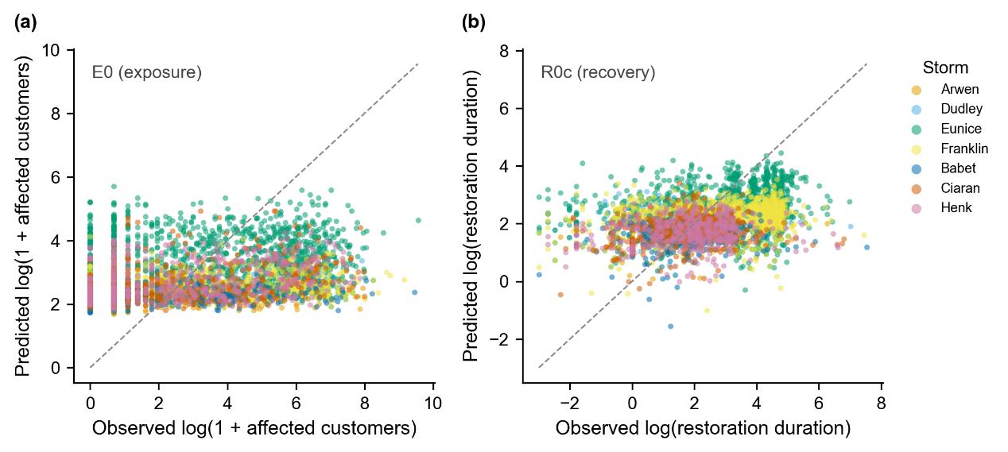
Figure 9. Combined-sample fitted versus observed log outcomes during the seven named storms, with a 45-degree reference line. (a) log(1 + affected customers). (b) log(restoration duration). These events also contributed to fitting the model; the plot is not an out-of-sample storm validation.
The fitted-observed correlation for each margin was also computed separately within each storm and compared against the correlation for the full sample. For the exposure margin, the full-sample correlation is 0.179, and the seven storm-specific correlations range from 0.116 to 0.341, without a consistent direction relative to the full-sample value. For the recovery margin, the full-sample correlation is 0.343, and all seven storm-specific correlations fall below this value, ranging from 0.084 to 0.317. The weakest of these, for Storm Dudley, is not statistically distinguishable from zero.
The lower within-storm recovery correlations show that the model describes only a limited part of event-to-event variation during these periods. Possible explanations include restricted covariate ranges and unmeasured restoration demands, such as concurrent incidents or crew availability. These mechanisms are not tested here. Weak storm-period fitted performance is compatible with limited overall fit, but it is not logically implied by the population-level gust increment and does not establish a change in gust’s relative contribution.
The reversal in Table 4 is supported by the cause-based predictive comparisons. The storm analysis provides complementary evidence about fitted performance during named events and does not independently compute the same contribution reversal. An out-of-sample storm-level ablation comparison would be needed to examine that question directly.

4.4 Retrospective temporal and clustering checks
Sections 4.1 to 4.3 use the final combined sample or explicitly identified cause subsets. This section compares earlier- and later-period estimates and examines alternative standard errors for the combined-sample fits. Because both periods informed early model development (Appendix E), the temporal results are retrospective sensitivity evidence, not confirmation on a previously untouched sample.
The reported exposure quadratic term is positive in both periods, while the linear term changes sign relative to each period’s own mean gust and pressure. The earlier-period exposure minimum is 12.13 m/s, compared with 10.69 m/s in the combined sample. For recovery, the development row in Figure 10 is an inverse-variance-weighted summary of five cross-validation fits, with a value of 0.0660; it is not a single full-development-sample regression. The reported later-period coefficient is approximately 0.064, and the combined-sample coefficient is 0.079237. These results are consistent in sign, but the differing estimation procedures must be recognised. Since cross-validation training sets overlap, the nominal interval previously attached to their weighted summary is omitted rather than treated as an independent-fit confidence interval.
Figure 10 distinguishes the development-fold summaries from the later-period fits and combined-sample clustering results. Mean gust is approximately 9.65 m/s in the earlier period and 10.77 m/s in the later period; standard deviations are approximately 5.21 and 5.17 m/s. The standard-deviation difference is small, but direct comparison of standardised coefficients is still approximate, and the linear terms refer to different physical wind and pressure reference conditions. Appendix H reports the available scaling values. The two combined-sample rows for each outcome have identical point estimates; only the covariance estimator differs.
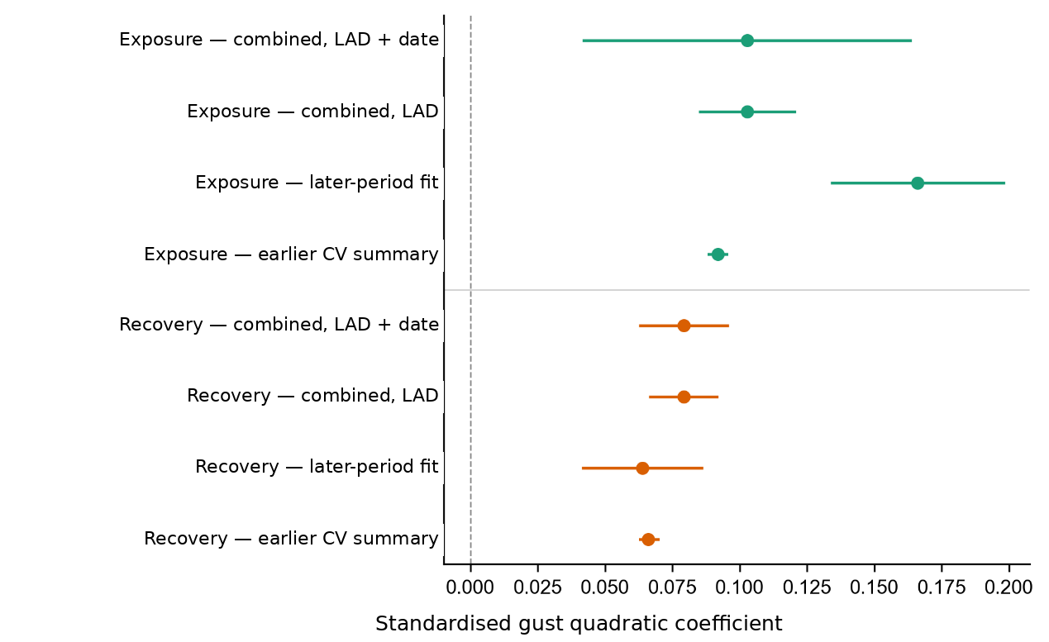
Figure 10. Gust quadratic-coefficient summaries and estimates. Development rows are descriptive summaries of overlapping cross-validation fits and are shown without inferential intervals. Later-period rows retain the reported model intervals; the other two rows use the final combined sample with LAD or LAD-and-date clustered standard errors. Scaling is sample-specific. These are retrospective checks, not four independent validations.
The later period spans six months within autumn and winter rather than a full annual cycle. Sample size, seasonal composition and sample-specific scaling can affect precision and coefficient comparisons, but these observations do not establish the cause of a changed estimate. The temporal analyses provide evidence of a consistently positive quadratic term within the fitted specifications. They do not verify a stable physical minimum, an unchanged full response function or external predictive validity.
For the final combined sample, the recovery quadratic term remains significant under two-way clustering ($p=5.4×{10}^{−22}$, compared with $2.8×{10}^{−36}$ under LAD clustering). The exposure quadratic term also remains significant. The exposure linear term and both gust-pressure interactions are no longer significant under two-way clustering; the recovery linear term remains non-significant. Appendix F gives the reported non-calendar coefficients. Re-estimation on earlier versions of substantially overlapping data is not counted as independent corroboration.

5. Conclusion
The analysis finds positive quadratic gust terms in models of log-transformed customer counts and restoration spans among recorded weather- and asset-related outages. The sign of this curvature recurs in the reported sensitivity checks, whereas fitted minima depend on the reference conditions and sample. The exposure point estimate is approximately 10.69 m/s at average pressure in the combined sample. Its physical-unit uncertainty requires a consistent resample-level treatment, and the temporal evidence is retrospective rather than independent.
Gust adds modest predictive information on the log-outcome scale. In the combined recovery sample its increment is below that of customer terms, while the reported ordering reverses in the weather-attributed subset. This comparison concerns two specified variable groups and depends on the population and evaluation setup; it does not show that wind dominates all determinants or identify causal variance shares. Storm-period plots describe fitted performance and provide no second independent test of that ordering.
The fitted minimum describes a smooth response-function feature, not the onset of structural failure or a validated operational trigger. Translating it into a response rule would require evaluation on previously unused events, an appropriately defined physical-unit uncertainty interval and an assessment of decision costs. The present estimates therefore support descriptive understanding of recorded outage consequences rather than a recommended wind-speed trigger.
The customer–duration association changes with restoration-stage controls and cause restriction (Appendix D). Prior work has also examined the relation between outage scale and recovery [26]. Differences in network conditions, incident definitions and restoration processes may contribute to different patterns across studies. Crew prioritisation is one possible explanation, but the present regressions do not identify it.
Several limitations remain. Early modelling used observations from both temporal periods, and the later period covers only one autumn–winter window. The original-code-to-category mapping and the meaning of zero-customer records require fuller documentary verification. Stage-count stratification does not identify the causal origin of the customer–duration relationship. Figure 4 and Figure 6 show uncorrected exponentiated log fits rather than conditional arithmetic means, and the available global residual retransformation factors do not establish a valid conditional-mean correction across all covariate values. These boundaries limit interpretation of both absolute predictions and generalisation.
Further work should reconstruct bootstrap minima in physical units at a consistent pressure reference, obtain directly comparable temporal fits, and evaluate predictive performance on unused storm events or future data. Additional checks should assess cause-based support differences, missing first-stage records, concurrent restoration demand and alternative model specifications. A complete residual-diagnostic and alternative-distribution comparison should accompany that work.
Reconstructing incident-level outcomes from stage-level records and separating curve description from predictive evaluation can be applied to other operators with comparable reporting systems. Transfer requires verification of each operator’s field definitions and reporting conventions, as well as fresh evaluation of model behaviour in that setting.

References
[1] Institute for Government. Energy resilience [Internet]. [date unverified]. Available from: https://www.instituteforgovernment.org.uk/explainer/energy-resilience
[2] Ofgem. Storm Arwen report [Internet]. [title, date unverified]. Available from: https://www.ofgem.gov.uk/research/storm-arwen-report
[3] Guikema SD, Quiring SM, Han SR. Prestorm estimation of hurricane damage to electric power distribution systems. Risk Analysis. 2010;30(12):1744-1752.
[4] Liu H, Davidson RA, Apanasovich TV. Statistical forecasting of electric power restoration times in hurricanes and ice storms. IEEE Transactions on Power Systems. 2007;22(4):2270-2279.
[5] Nateghi R, Guikema SD, Quiring SM. Comparison and validation of statistical methods for predicting power outage durations in the event of hurricanes. Risk Analysis. 2011. [volume, pages unverified]
[6] Mukherjee S, Nateghi R, Hastak M. A multi-hazard approach to assess severe weather-induced major power outage risks in the U.S. Reliability Engineering & System Safety. 2018;175:283-305.
[7] Dikshit S, Alipour A. Characterizing probability of failure of transmission tower systems under multiple climatic hazards: wind and ice. Engineering Structures. 2025;342:120720.
[8] Zhu X, Ou G. Wind fragility modeling of transmission tower-line system based on threat-dependent structural robustness index. Structural Safety. 2025;114:102571.
[9] Ma L, Khazaali M, Bocchini P. Component-based fragility analysis of transmission towers subjected to hurricane wind load. Engineering Structures. 2021;242:112586.
[10] Kabre WW, Weimar MR. Fragility functions resource report: documented sources for electricity and water resilience valuation. PNNL-33587. Richland (WA): Pacific Northwest National Laboratory; 2022.
[11] Office of Gas and Electricity Markets. RIIO-ED1 regulatory instructions and guidance: Annex F. London: Ofgem. [date unverified].
[12] Office of Gas and Electricity Markets. RIIO-ED2 regulatory instructions and guidance: Annex F – interruptions. London: Ofgem; 2023.
[13] Open-Meteo. Historical weather API [Internet]. [date unverified]. Available from: [URL unverified]
[14] Hersbach H, Bell B, Berrisford P, Hirahara S, Horanyi A, Munoz-Sabater J, et al. The ERA5 global reanalysis. Quarterly Journal of the Royal Meteorological Society. 2020;146:1999-2049.
[15] American Society of Civil Engineers. Minimum design loads and associated criteria for buildings and other structures. ASCE/SEI 7. [edition unverified].
[16] [authors unverified]. The risk of cascading failures in electrical grids triggered by extreme weather events. arXiv:2107.00829. [publication status unverified].
[17] Office for National Statistics. Explore local statistics [Internet]. 2025. Available from: [URL unverified]
[18] Office for National Statistics. Mapping income deprivation at a local authority level [Internet]. 2021. Available from: [URL unverified]
[19] Moran PAP. Notes on continuous stochastic phenomena. Biometrika. 1950;37(1-2):17-23.
[20] Office for National Statistics. Local Authority Districts (December 2021) boundaries UK BGC [Internet]. Available from: https://open-geography-portalx-ons.hub.arcgis.com/datasets/ons::local-authority-districts-december-2021-boundaries-uk-bgc
[21] O’Brien RM. A caution regarding rules of thumb for variance inflation factors. Quality & Quantity. 2007;41(5):673-690.
[22] McCullagh P, Nelder JA. Generalized linear models. 2nd ed. London: Chapman and Hall; 1989.
[23] Cox DR. A note on data-splitting for the evaluation of significance levels. Biometrika. 1975;62(2):441-444.
[24] Cameron AC, Miller DL. A practitioner’s guide to cluster-robust inference. Journal of Human Resources. 2015;50(2):317-372.
[25] Oehlert GW. A note on the delta method. The American Statistician. 1992;46(1):27-29.
[26] Wu H, Meng X, Danziger MM, Cornelius SP, Tian H, Barabási AL. Fragmentation of outage clusters during the recovery of power distribution grids. Nature Communications. 2022;13:7372.

