Abstract
UK Power Networks records 60,453 weather- and asset-related outage incidents across London, the South East, and the East of England between April 2021 and March 2024, including seven officially named storms. Event-level exposure and recovery outcomes are reconstructed from stage-level regulatory records according to Ofgem’s official definitions, correcting a systematic undercount that results from using the earliest recorded stage alone. A quadratic specification identifies a nonlinear relationship between gust speed and both outcomes, including a critical wind speed of approximately 10.7 m/s for the exposure margin. The quadratic shape underlying this relationship is confirmed under alternative distributional assumptions, within an independent temporal holdout, and within a subsample restricted to incidents for which weather is the recorded cause. Predicted outcomes from this model are also compared against observed outcomes during the seven named storms. The specific numerical value of the exposure margin’s threshold is not confirmed under the same holdout and is reported as an approximate reference rather than an externally validated figure. Gust accounts for a modest share of total variation in outage outcomes across the full population of incidents, well below the share accounted for by the number of affected customers. Within the subset of incidents for which weather is the recorded cause, however, gust’s contribution more than doubles and exceeds that of affected customers. Two independent lines of evidence, one based on recorded cause and one based on real storm events, point to the same conclusion. These results provide field-level evidence of a nonlinear wind-outage response at the scale of a full distribution network, complementing fragility curves derived from simulation or testing of individual structures.

Keywords: Power outage, wind fragility, critical wind speed, distribution network, variance decomposition, extreme weather.

Introduction
Storms and other extreme weather events are the most common cause of power disruptions in Great Britain [1]. In November 2021, Storm Arwen alone left more than one million customers without power [2]. Three months later, three named storms struck the United Kingdom within five days: Dudley, Eunice, and Franklin. Within the service area of UK Power Networks (UKPN), which covers London, the South East, and the East of England, Storm Eunice produced a peak observed gust of 39.4 m/s in Lewes, East Sussex, on 18 February 2022. This value is the highest gust recorded across the entire study period examined in this paper. The storm was associated with 1,601 weather-related outage events across 101 Local Authority Districts, a cumulative estimate of 376,712 affected customers, and a mean restoration time of 52.7 hours. Two days later, Storm Franklin affected the same network and produced a further 1,187 events.
These events illustrate a general pattern in electricity distribution networks. Outage impact can be measured either by the number of customers affected, referred to hereafter as the exposure margin, or by the time needed for restoration, referred to hereafter as the recovery margin. Neither margin scales in a fixed proportion with wind intensity. A given increase in gust speed can correspond to a small change in outcome under some conditions and a disproportionately large change under others. Identifying whether this relationship follows a specific functional form, and whether it contains an identifiable threshold, is directly relevant to how distribution network operators (DNOs) set weather-related response thresholds and allocate restoration resources in advance of a forecast storm.
Existing empirical work on power outage duration and customer impact under severe weather has established regression- and machine-learning-based approaches for hurricane- and ice-storm-affected US utilities [3–6]. A separate line of engineering research addresses the wind vulnerability of individual distribution and transmission structures directly. This work typically derives fragility curves, which express the probability of structural failure as a function of wind speed. These curves come from finite element simulation or scaled physical testing of a specific structure type, such as a transmission tower or a distribution pole [7–10]. These fragility curves are commonly expressed as threshold-based functions in which failure probability remains near a baseline level below a critical wind speed and increases sharply once this threshold is exceeded [10]. This threshold structure is consistent with the general expectation that wind-induced damage to electrical infrastructure is nonlinear rather than proportional to wind intensity.
Fragility curves of this kind describe the vulnerability of a single, well-defined structure under controlled or simulated loading conditions. They do not by themselves indicate whether a comparable nonlinear, threshold-like response is observable in the operational record of a full distribution network, where outage outcomes reflect a heterogeneous population of structures, ages, and local conditions rather than a single modelled component. This gap, together with a further limitation in the outage-modelling literature, motivates the present study.
First, neither the statistical outage literature nor the structural fragility literature provides field-level evidence of a threshold response at the network scale. Statistical outage studies [3–6] generally report a single fitted relationship between weather intensity and outage outcomes without testing whether that relationship contains a distinguishable threshold. Fragility curves [7–10] identify thresholds explicitly, but only for a single simulated or tested structure, not from the observed operational record of a network with many structures in varying condition. Second, this paper also asks whether the relative importance of wind conditions against the scale of the affected customer base specifically changes between the full population of outages and the subset of events for which weather is the recorded cause. Prior work, including one of the studies cited above [6], identifies the most important predictors of outage risk among a broad set of hazard and infrastructure factors. It does not, however, report this specific pairwise comparison between wind conditions and event scale, nor does it examine whether such a comparison changes between the full population of outages and a subsample restricted to confirmed weather-driven events.
Addressing both gaps requires an observational record long enough, and varied enough, to include both routine operating conditions and several distinct severe wind events within the same network. The UKPN dataset examined in this paper spans three years of continuous operation, from April 2021 to March 2024, and includes seven officially named storms, among them Storm Eunice described above. This combination of duration and event coverage makes it possible to estimate a continuous response function across the full range of observed wind conditions, and to examine that function specifically under the seven storm events, rather than relying on a single simulated structure or a short observation window.
This paper addresses these two gaps using outage records from UKPN covering April 2021 to March 2024. The first gap is addressed by characterising the exposure and recovery response to gust intensity using a quadratic specification, and by identifying a critical wind threshold for the exposure margin. This provides field-level evidence at the network scale that complements structure-specific fragility curves obtained from simulation or testing. The second gap is addressed by quantifying the explanatory weight of gust relative to the affected-customer scale, both across the full population of weather- and asset-related outages and within the subset of events for which weather is the recorded cause. Both findings are examined against an independent temporal holdout not used during model development, and against the seven named storms. This establishes the extent to which each result can be confirmed independently of the exploratory modelling process.
The remainder of this paper is organised as follows. Section 2 describes the UKPN dataset, the construction of event-level exposure and recovery metrics from stage-level regulatory records, and the descriptive properties of the resulting sample. Section 3 presents the empirical framework, including the model specification and the two-stage development-confirmation design used to assess the results independently of the exploratory analysis. Section 4 reports the results in four parts. ection 4.1 establishes the shape of this relationship and its critical threshold for the exposure margin. Sections 4.2 and 4.3 quantify its explanatory weight, across the full population and within the weather-attributed subset respectively. Section 4.4 confirms these findings against the independent temporal holdout. Section 5 discusses the implications, boundaries, and limitations of these findings, and outlines directions for future work.

Data and Study Setting

Study setting and data sources
UKPN operates the electricity distribution network across London, the South East, and the East of England, and reports outage incidents to Ofgem, the energy regulator for Great Britain, under the regulatory reporting framework set out in the RIIO-ED1 and RIIO-ED2 Annex F guidance [11, 12]. RIIO-ED1 and RIIO-ED2 are successive multi-year price control periods during which Ofgem sets the revenue and performance requirements for UK electricity distribution network operators. This paper draws on UKPN’s outage incident records covering 1 April 2021 to 31 March 2024, a period of three complete regulatory years spanning both the RIIO-ED1 and RIIO-ED2 price control periods. Each record corresponds to a restoration stage rather than a complete outage incident. An incident that requires more than one restoration action, for example because power is restored to part of the affected area before the remainder, is represented by more than one stage-level record sharing a common incident reference. Section 2.2 describes how event-level outcome variables are constructed from these stage-level records.
Weather variables are matched to each incident using hourly reanalysis data from the Open-Meteo historical weather API [13], which is based on the ERA5 global reanalysis dataset [14]. Data are indexed to the latitude and longitude reported for each incident and the hour in which it began. The primary wind variable used throughout this paper is instantaneous gust speed rather than sustained wind speed. This choice follows the convention in structural wind engineering, where design wind loads are based on a short-duration (3-second) gust rather than a longer-averaged sustained speed, because peak instantaneous loading determines structural response and failure [15]. This convention has been applied specifically to wind-induced damage in electrical grid infrastructure [16]. In the final analysis sample, gust speed has a mean of 9.87 m/s and a standard deviation of 5.22 m/s, referenced in Section 4.1 when reporting the exposure margin’s turning point in physical units.
Regional covariates are drawn from Office for National Statistics (ONS) data at the Local Authority District (LAD) level and merged to each incident by its reported location. These comprise resident population, drawn from ONS local authority population estimates [17]. They also comprise income deprivation rate, the gap between local and national income deprivation, and spatial clustering of income deprivation measured by Moran's I, all drawn from the ONS dataset mapping income deprivation at a local authority level [18]. Moran’s I follows the spatial autocorrelation statistic introduced by Moran [19]. An urban-rural classification is drawn from the same ONS local statistics resource used for the population and deprivation data [17]. LAD boundaries as at December 2021 are taken from the ONS Open Geography Portal [20].
Figure 1 shows the three UKPN licence areas and the spatial density of incidents across the study period. Incident density is not uniform across the service area. It is concentrated around London, which sits at the boundary between the South East and East of England licence areas. A smaller, secondary concentration is visible near the north-east coast of the East of England licence area. The remainder of the service area shows a comparatively even, lower density of incidents.
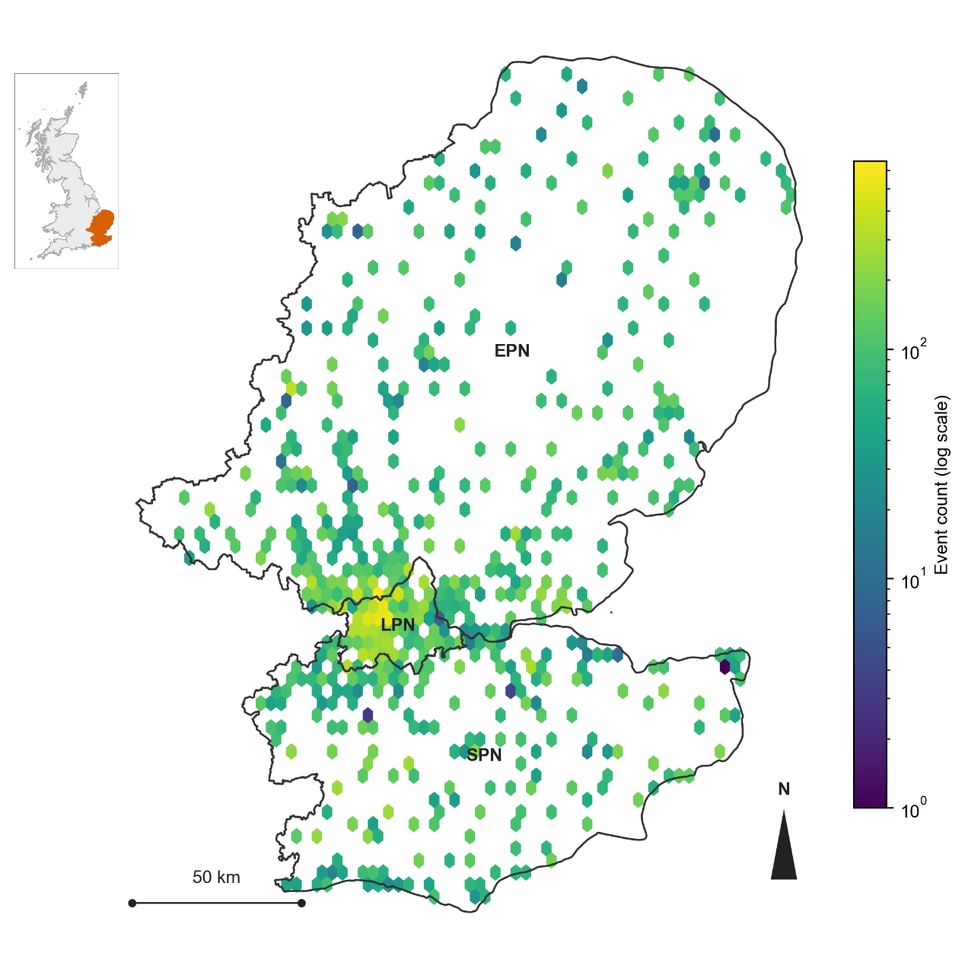
      - Study area and event density.
Note: The map shows the three UKPN licence areas (London, South East, East of England) and the spatial density of all incidents in the final analysis sample, rendered as a hexagonal binning of incident coordinates on a logarithmic count scale. The inset shows the location of the UKPN service area within Great Britain.

Outcome variable construction
Ofgem’s Annex F guidance defines two outcome measures for outage reporting [11, 12]. Customer Interruptions (CIt) counts the number of customers affected by an incident, summed across restoration stages and excluding stages flagged as re-interruptions to avoid double-counting the same customers. Customer Minutes Lost (CMLt) measures the duration of interruption, summed across all restoration stages including re-interruptions, because each additional interruption stage represents further time without supply for the customers affected at that stage. Both CIt and CMLt are regulatory aggregates indexed by reporting period t. This paper constructs two incident-level variables following the same aggregation logic, denoted C_i and D_i and indexed by incident i rather than by reporting period.
The exposure margin is measured by the number of customers affected by an incident, referred to hereafter as affected customers, and constructed as:
Ci=r ∈ Ri ∖ Ii​Ni,r
where $C_{i}$ is affected customers for incident $i$, $R_{i}$ is the set of restoration stages recorded for incident $i$, $I_{i}⊂R_{i}$ is the subset of those stages flagged as re-interruptions, and $N_{i,r}$ is the customer count reported at stage $r$.
The recovery margin is measured by the total duration of the incident, referred to hereafter as restoration duration, and constructed as:
$$D_{i}=\max_{r ∈ R_{i}}T_{i,r}^{\text{end}}-\min_{r ∈ R_{i}}T_{i,r}^{\text{start}}$$
where $D_{i}$ is restoration duration for incident $i$, and $T_{i,r}^{\text{start}}$ and $T_{i,r}^{\text{end}}$ are the start and end times recorded at stage $r$.
The sample mean for affected customers is 93.02 when computed by aggregating across stages, rather than 47.13 when using only the customer count reported in the earliest stage of each incident. This is a difference of a factor of 1.97, within the same final analysis sample reported in Table 1. This difference reflects incidents with more than one restoration stage, in which the earliest stage alone does not capture the full extent of the customers affected as the incident evolves. Appendix B reports the full data processing pipeline underlying Equations 1 and 2, including the handling of a small number of boundary cases not covered by the general definitions above.

Descriptive statistics and visualization
Table 1 reports descriptive statistics for affected customers and restoration duration in the final analysis sample, on the original scale and after log transformation. Both variables are heavily right-skewed on the original scale, with the mean well above the median (93.0 versus 2.0 for affected customers, 11.8 versus 6.3 hours for restoration duration). Figure 2 shows the distribution of each variable before and after transformation. The log transformations substantially reduce this skew, but they do not produce a fully symmetric distribution in either case. The transformed affected-customers variable shows a sawtooth pattern at low values, reflecting the fact that many incidents affect a small integer number of customers. The transformed restoration-duration variable shows two distinct modes, one near one hour and one near seven to twelve hours, separated by a clear trough. This pattern is consistent with the composition effect linked to the number of restoration stages per incident, described further in Section 4.1 and Appendix D. Despite this remaining structure, the log transformation is still used for both variables, because it removes the extreme right tail that would otherwise dominate ordinary least squares fit.
          - Descriptive statistics for affected customers and restoration duration, final analysis sample.
Statistic | Affected customers (n=60,437) | log(1+affected customers) | Restoration duration, hours (n=59,834) | log(restoration duration)
Mean | 93.02 | 2.138 | 11.84 | 1.656
Median | 2.00 | 1.099 | 6.27 | 1.835
SD | 410.96 | 2.019 | 19.96 | 1.349
Min | 0.00 | 0.000 | 0.05 | -2.996
25th pct. | 1.00 | 0.693 | 2.03 | 0.710
75th pct. | 35.00 | 3.584 | 12.67 | 2.539
Max | 27,013.00 | 10.204 | 192.08 | 5.258
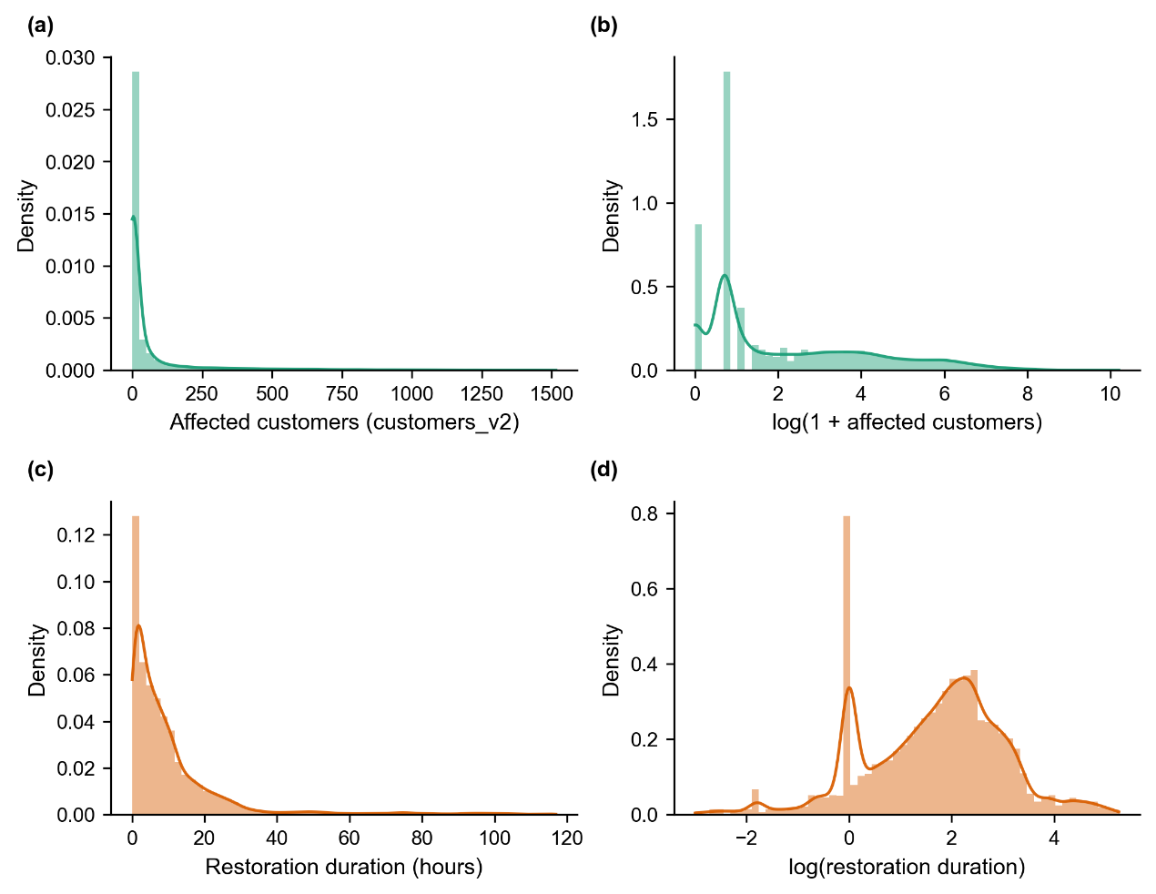
      - Distribution of affected customers and restoration duration, original scale and after log transformation: (a) Affected customers, original scale. (b) log(1+affected customers). (c) Restoration duration, original scale (hours). (d) log(restoration duration).
The Pearson correlation between affected customers and restoration duration in the final analysis sample (n = 60,437) is -0.016 on the original scale and -0.011 on the log scale. The Spearman correlation is 0.110. Both linear and monotonic measures of association are small in magnitude. A nonlinear dependence measure gives a different picture: the distance correlation between the two variables is 0.199, and a mutual information test rejects independence at a very high level of significance (permutation test, z = 160.4). Affected customers and restoration duration are therefore not statistically independent at the event level, although the form of their association is not captured by a simple linear or monotonic measure. Section 4.1 and Appendix D trace this association to the number of restoration stages recorded for each incident, rather than to a direct relationship between the scale of an incident and its duration. This is also why affected customers and restoration duration are treated as two separate outcome margins in this paper, modelled with their own covariates, rather than combined into a single severity index or assumed to be independent of one another.

Sample construction and predictor variables
UKPN classifies each outage incident into one of six cause categories, recorded in a field referred to hereafter as the Cause Code. Two of these six categories correspond respectively to incidents attributed directly to weather and to incidents attributed to the condition of network assets, referred to hereafter as the weather-related and asset-related categories. The remaining four categories cover incidents with no fault found on investigation, third-party interference, human error, and causes attributed to the customer or an external party. Incidents in these four categories are unrelated to wind conditions by construction, and no-fault-found incidents alone account for approximately 39 percent of all recorded incidents in the study period. Including them in the analysis sample would mix events with no expected relationship to gust intensity into the estimation of that relationship. This restriction to two Cause Code categories was originally decided on a sample that predates the development-confirmation split introduced in Section 3.2 and is therefore not itself an instance of that protocol. The restriction was subsequently re-examined on the fully separated development and confirmation samples described in Section 3.2 and produced the same conclusion. The comparison reported here uses the resulting final combined sample: The recovery model described in Section 3.3 was also estimated on all six Cause Code categories (n = 116,064), rather than the weather-related and asset-related subset used elsewhere in this paper (n = 59,834). The quadratic gust term remains of the same order of magnitude and significant in all five cross-validation folds under both samples (0.061 for the six-category sample, versus 0.079 for the two-category subset). The linear gust term, however, is significant in all five folds under the six-category sample (mean coefficient 0.026), but becomes indistinguishable from zero under the two-category subset (mean coefficient 0.0002, significant in none of the five folds). This indicates that part of the linear-term signal observed when pooling all six categories reflects composition effects from categories unrelated to weather-driven failures, rather than a physically robust wind effect, and supports restricting the main specification to the weather-related and asset-related categories.
The resulting sample comprises 60,453 incidents. After matching weather data and excluding incidents with missing regional covariates, 60,437 incidents are available for the exposure model and 59,834 for the recovery model, the difference reflecting incidents for which restoration duration could not be computed or fell above the 99th percentile of the restoration duration distribution.
The full covariate set spans weather, regional, and temporal fixed-effect variables, in addition to gust and its interaction with pressure, listed in full in Table 2. The recovery model additionally includes affected customers and its square as covariates, discussed further in Section 4.1.
Variance inflation factors for all continuous covariates in the final model specification are below 4, with the highest value, 3.76, corresponding to the gap between local income deprivation and the national average. Values of 5 and 10 are commonly cited as informal thresholds for concern regarding multicollinearity, although O’Brien [21] cautions that these thresholds are heuristic rather than absolute, and that a given VIF value should be interpreted alongside the sample size and the strength of the effect under study rather than treated as a fixed cutoff. The VIF values obtained here are below both commonly cited thresholds regardless of this qualification.

Empirical Framework

Modeling approach and rationale
This paper uses a parametric regression model, not a machine learning model. The reason is straightforward. The shape of the relationship between gust intensity and outage outcomes needs to be identified. So does whether this relationship contains a threshold, and if so, at what wind speed. In its simplest form, before the covariates described in Section 3.3 are added, this relationship is written as:
$$Y=β_{1}G+β_{2}G^{2}$$
where Y denotes the outcome margin (affected customers or restoration duration, in the log scale described in Section 3.3), and G denotes gust speed. A regression model of this form provides both directly. The two coefficients describe the shape of the curve. When the linear coefficient is itself different from zero, the ratio of the two coefficients gives the location of a threshold with a direct physical interpretation. When the quadratic term dominates and the linear term is close to zero, this ratio no longer identifies a meaningful location. The quadratic coefficient is then reported on its own, describing an outcome that increases with the squared distance from typical gust conditions rather than a threshold with a specific position. Both cases arise in Section 4.1, for the exposure and recovery margins respectively.
The same model type is used throughout this paper. Ordinary least squares is applied to a log-transformed dependent variable, for both the exposure margin and the recovery margin, and for every sample examined in Section 4. Affected customers and restoration duration are both non-negative and right-skewed, as shown in Figure 2. Count-based or duration-based alternatives, such as a negative binomial, gamma, or Tweedie generalised linear model, are a common choice for outcomes of this kind [22]. Ordinary least squares on the log scale is used here instead, because it is the simplest model that gives a directly interpretable turning point from two coefficients.
This choice has been checked directly, rather than assumed. The exposure model was re-estimated using negative binomial and Tweedie specifications, and the recovery model was re-estimated using gamma and Tweedie specifications, on the same final sample described in Section 2.4. In every case, the quadratic gust term retained the same sign and remained significant at a similar or stronger level than under the log-OLS specification. This includes the recovery model, where the quadratic term is the central finding of this paper. Residual diagnostics for the log-OLS specification are reported in Appendix [编号待定]. Residuals depart from normality in both models, which is expected at this sample size and does not affect the validity of the coefficient estimates under ordinary least squares. The exposure model’s residuals show a distinct pattern linked to the share of incidents with zero recorded customers, rather than a general problem with the model. Taken together, these checks support the use of the log-OLS specification, while also showing that the central findings of this paper do not depend on this specification alone. A machine learning model, such as a random forest, can often predict outcomes more accurately. It does not, however, give a simple, interpretable threshold value in the same way. For this reason, machine learning is not used as the main method in this paper. A machine learning comparison could still be a useful robustness check in future work. This point is revisited in Section 5.

Validation protocol
Building this model involved many choices. A decision was needed on which Cause Code categories to include. A decision was needed on how to define customer counts and outage duration from the raw stage-level records. A decision was needed on how to handle a small number of unusual events. Each of these choices could, in principle, be adjusted until the results looked as clean as possible. This is a known risk in applied statistics. Cox [23] proposed a simple way to guard against it. The data are split into two parts before any exploration begins. One part is used to make all the modelling choices. The other part is set aside and not examined until the modelling choices are final. Once the model is finalised on the first part, it is applied once to the second part, without further adjustment.
This approach is followed here. The first part of the data, referred to as the development sample, covers 1 April 2021 to 29 September 2023. With one documented exception, discussed in Section 2.4, all the choices described in Section 2, and all of the model specification described in Section 3.3, were made using only this development sample. The second part, referred to as the confirmation sample, covers 30 September 2023 to 31 March 2024. This six-month period was not examined at any point while the model was being developed. Section 4.4 reports what happens when the finalised model, unchanged, is applied to this confirmation sample. Figure 3 shows this split alongside the seven named storms described in Section 4.3. Four of these storms (Arwen, Dudley, Eunice, and Franklin) occurred within the development sample, and three (Babet, Ciarán, and Henk) occurred within the confirmation sample, so the confirmation sample is not a period free of severe weather of its own.
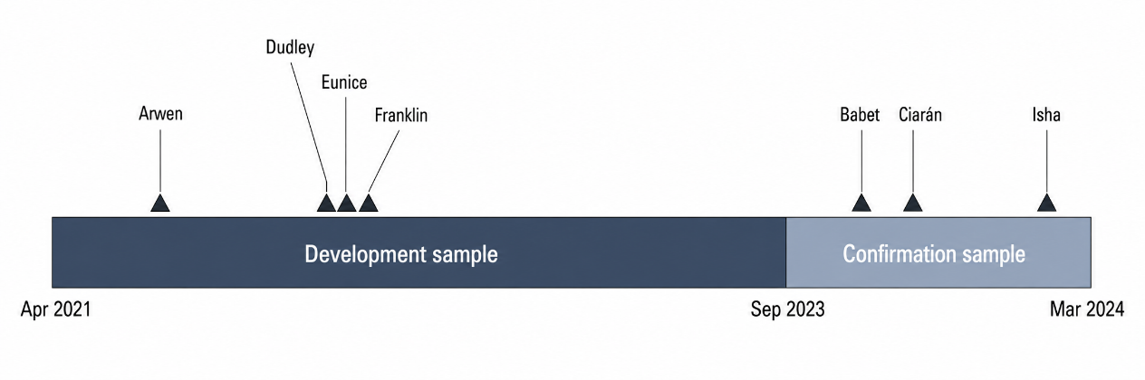
      - Study period timeline (April 2021 to March 2024), showing the development and confirmation samples and the position of the seven named storms within each.
Within the development sample itself, five-fold cross-validation is also used to check that the coefficient estimates are stable. The folds are built by date, not by individual record, so that all records from a given day fall into the same fold. This matters because a single storm can generate many outage records on the same day. These records are not independent of each other. The same five folds are also used to compute an out-of-sample R-squared for each model, reported in Section 4.2: the model is fitted on four folds at a time, predictions are made for the fifth, held-out fold, and R-squared is computed on these held-out predictions rather than on the data used to fit the model. This is repeated across all five folds and averaged, so that the reported R-squared reflects predictive accuracy on data not used to estimate the coefficients, rather than the fit of the model to its own training data.
One specific number illustrates why the confirmation sample matters. Early in the development process, the critical wind speed for the exposure margin was estimated at 12.13 m/s. This estimate came from an early version of the development sample that later turned out to include a data construction error, described further in Appendix E. Once this error was corrected, and once the corrected development sample was combined with the confirmation sample to produce the largest possible final estimate, the critical wind speed became 10.69 m/s. This is the number reported in Section 4.1. This history is reported because it shows why a single estimate, produced early in an exploratory process, should not be treated as final. The confirmation step described above, and the correction described in Appendix E, are both part of how the reported number was reached.

Model specification
All continuous covariates, including gust speed, mean sea level pressure, precipitation, temperature, and the regional covariates listed in Section 2.4, are standardised to zero mean and unit variance before entering the model. Gust speed in Equations 3 and 4 therefore denotes standardised gust, and a value of zero corresponds to the sample mean gust speed rather than to calm conditions. This standardisation is applied consistently across estimation and reporting, including the turning point and its confidence intervals reported in Section 4.1.
The final model specification is the same for both outcome margins, except that the recovery model includes two additional terms. This is the full version of Equation 3, with the additional covariates included, given by:
$$ln\left(Y_{i}\right)=β_{1}G_{i}+β_{2}G_{i}^{2}+β_{3}\left(G_{i}×P_{i}\right)+X_{i}'γ+δ_{y\left(i\right)}+θ_{m\left(i\right)}+ε_{i}$$
where $Y_{i}$ denotes the outcome for incident $i$ (one plus affected customers for the exposure margin, or restoration duration for the recovery margin), $G_{i}$ denotes gust speed, $P_{i}$ denotes mean sea level pressure, $X_{i}$ denotes the remaining weather and regional covariates listed below, $δ_{y\left(i\right)}$ and $θ_{m\left(i\right)}$ denote year and month fixed effects, and $ε_{i}$ is the error term. For the recovery margin, $X_{i}$ additionally includes affected customers and its square.
Year and month fixed effects are additive, entered as separate sets of dummy variables rather than as a year-by-month interaction. The gust-pressure interaction term is the direct product of the two standardised variables. For the exposure margin, the dependent variable is the natural logarithm of one plus affected customer. For the recovery margin, the dependent variable is the natural logarithm of restoration duration.
Table 2 lists the covariates denoted $X_{i}$ in Equation 4, beyond gust speed, its square, and the gust-pressure interaction, which are reported separately in Section 4.1. Appendix A reports the source and processing of each variable in full.
          - Covariates included in $X_{i}$, in addition to gust speed, its square, and the gust-pressure interaction.
Variable | Category | Model
Mean sea level pressure | Weather | Both
24-hour cumulative precipitation | Weather | Both
Temperature | Weather | Both
Log population | Regional | Both
Income deprivation rate | Regional | Both
Gap between local and national income deprivation | Regional | Both
Moran’s I (income deprivation) | Regional | Both
Urban-rural indicator | Regional | Both
Affected customers (linear and squared) | Event-level | Recovery only
Year fixed effects | Temporal | Both
Month fixed effects | Temporal | Both
Standard errors are clustered by Local Authority District, following standard practice for regression models with grouped data [24]. A given storm can affect many incidents in the same district on the same day, so errors within a district are unlikely to be independent of each other. Section 4.4 also reports what happens when standard errors are clustered by both district and date at the same time. This is a more conservative check, and the full results are given in Appendix F.

Results

Nonlinear gust–outage response and critical thresholds
This section establishes the shape of the gust-outage relationship for each margin, then examines how far this shape can be refined into a single, specific value. Sections 4.2 to 4.4 then examine how much this relationship matters, and how well it holds up outside the sample used to estimate it.
Table 3 reports the gust coefficients from the final model specification, estimated on the full analysis sample described in Section 2.4. For both outcome margins, the quadratic gust term is significant at a much stronger level than the linear term (p < 0.001 in both cases). The linear term, by contrast, is significant for the exposure margin (p = 0.022) but not for the recovery margin (p = 0.982). The quadratic term is also the consistent feature of the relationship reported throughout this paper: it remains stable in significance under alternative distributional assumptions (Section 3.1), within an independent temporal holdout (Section 4.4), and within a subsample restricted to weather-attributed incidents (Section 4.3). The quadratic term is therefore established first, as the dominant and more robust feature of the relationship in both margins, before either relationship is examined for a specific numerical threshold. The two margins differ in whether the linear gust term is also different from zero, and this difference determines how far each relationship can be refined beyond the quadratic term into a specific value.
          - Gust coefficients, final model specification.
Term | Exposure margin | Recovery margin
Gust (linear) | -0.032 (p = 0.022) | 0.000 (p = 0.982)
Gust squared | 0.103 (p < 0.001) | 0.079 (p < 0.001)
n | 60,437 | 59,834
For the exposure margin, the linear gust term is negative and significant, so the two coefficients jointly determine the shape of the curve. This negative linear term is small in magnitude relative to the quadratic term, and Section 4.4 reports that it is less stable across samples and clustering methods than the quadratic term. Most incidents at low gust levels are unrelated to weather, as reported in Section 2.4, so this small negative slope may reflect factors other than wind conditions in this part of the range, rather than a direct physical relationship between mild wind and fewer affected customers. Its small size is also consistent with ordinary estimation variability, and it is not treated as a finding requiring a specific mechanistic explanation. The point at which the curve turns is given by
$$G^{*}=-\frac{β_{1}}{2β_{2}}$$
where $β_{1}$ and $β_{2}$ are the linear and quadratic gust coefficients from Table 3. Because this turning point is a ratio of two estimated coefficients, its uncertainty cannot be read directly from the standard errors of $β_{1}$ and $β_{2}$ alone. Section 4.4 shows that this same ratio is more sensitive to sample and specification than the quadratic term on its own, including under a clustering method that affects the significance of $β_{1}$ specifically. Two methods are used to construct a confidence interval for $G^{*}$: the delta method [25], and a bootstrap procedure that resamples entire days rather than individual incidents, to preserve the fact that incidents on the same day are not independent. For the exposure margin, the two methods give different results when applied to the standardised (z-score) turning-point statistic. The delta method produces a 95 percent confidence interval for the standardised turning point that does not cross zero. The bootstrap procedure produces a wider interval that does cross zero, meaning the data cannot statistically rule out the turning point coinciding with the sample-mean gust speed (9.87 m/s) rather than lying strictly above or below it. This difference arises because a ratio of two random coefficients does not follow a normal distribution in general. The delta method relies on a first-order approximation, which understates the width of the true sampling distribution when the denominator coefficient is close to zero in some resamples. A standardised interval crossing zero does not imply that the corresponding physical-unit interval crosses 0 m/s: because a standardised value of zero corresponds to the sample-mean gust speed rather than calm conditions, the same bootstrap resamples translate into a strictly positive physical-unit range of 9.2 to 12.1 m/s. The bootstrap interval is used here as the more conservative estimate. The resulting turning point, 10.69 m/s, falls at the 63.7th percentile of the observed gust distribution, within the range covered by the data rather than at its extreme.
This turning point corresponds to a real asymmetry in the fitted curve, not only to its location. Evaluated at matched standardised distances on either side of the turning point (one, two, and three standard deviations), the exposure margin’s fitted values differ by 19 to 48 percent between the two sides, well beyond what the small non-zero linear term alone would produce by chance. The language of a critical wind speed is appropriate for this margin: it identifies an estimated minimum in a curve whose two arms have genuinely different slopes.
For the recovery margin, by contrast, the linear gust term is not significantly different from zero, and the fitted curve is, to a close approximation, a symmetric function of standardised gust speed. Evaluated at the same matched standardised distances, values on either side of the turning point differ by no more than half of one percent, consistent with the small non-zero linear coefficient rather than with any systematic asymmetry. A specific critical wind speed is not reported for this margin. Its relationship to gust is instead described by the quadratic term on its own: an outcome that grows with the squared distance from typical gust conditions, in either direction, rather than a threshold located at a specific wind speed.
Figure 4 shows the fitted response curve for each margin, with the other covariates held at their sample means. In both panels, the curve falls and then rises, and the rise to the right of the minimum is visually steeper than the fall to its left, more markedly so in Figure 4a than in Figure 4b. This visual pattern is largely a property of the observed gust distribution rather than of the fitted function. Gust speed cannot be negative, so the low end of the observed range is bounded to within about two standard deviations of the sample mean, while the right-skewed distribution allows the high end to extend past three standard deviations. Because each turning point falls close to the sample mean, the right-hand end of the plotted range sits substantially farther from the turning point, in standardised units, than the left-hand end. Because the fitted curve is approximately quadratic in this distance, this asymmetry in the observed range alone produces several-fold differences in fitted values between the two arms. For the recovery margin, whose fitted function is itself symmetric, this geometric property of the observed data accounts for the full visual difference between the two arms of Figure 4b. For the exposure margin, the same geometric property accounts for most of the visual difference in Figure 4a; the real asymmetry in the fitted function, reported above, works in the opposite direction and only partly offsets it.
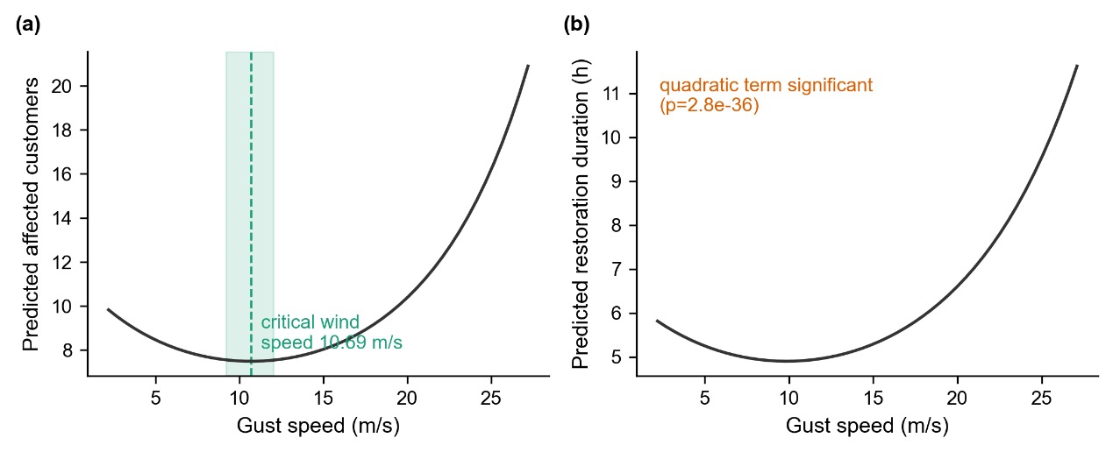
      - Fitted gust-outcome response curves, other covariates held at sample means. (a) Exposure margin: predicted affected customers against gust speed, with the turning point at 10.69 m/s and its 95 percent bootstrap confidence interval shown as a shaded band. (b) Recovery margin: predicted restoration duration against gust speed, affected customers held at its sample mean.
The recovery model also includes affected customers and its square as covariates. Affected customers is one of the most stable coefficients estimated in this paper, in the sense that its sign and significance do not change across the different samples examined in Sections 4.2 to 4.4. A closely related, more detailed question is why the coefficient on affected customers takes the particular sign and shape that it does. Appendix D shows that this shape is linked to the number of restoration stages recorded for each incident, rather than to the scale of the incident on its own. This does not affect the coefficient on gust, which is stable whether the number of restoration stages is considered, but it does mean that affected customers and gust should be read as two separate predictors of restoration duration, rather than one working through the other.

Population-level weight of wind
The results in Section 4.1 establish that gust has a real, stable relationship with both outcome margins. They do not establish how much of the variation in these outcomes gust explains, relative to other factors. These are separate questions. A coefficient can be estimated precisely and remain stable across many samples while still accounting for only a small share of the total variation in the outcome. This section addresses the second question directly.
Nested models are used to decompose the explained variance for each margin. Starting from a baseline of regional covariates and calendar fixed effects, non-gust weather variables are added first, and gust is added last. The increase in out-of-sample R-squared at each step, measured using the five-fold cross-validation described in Section 3.2, gives the marginal contribution of each group of variables. Figure 5 shows this decomposition for both margins. For the exposure margin, gust contributes 1.07 percentage points, out of a total out-of-sample R-squared of 2.81 percent for the full model. For the recovery margin, gust contributes between 0.62 and 0.75 percentage points, depending on whether affected customers are added before or after gust in the sequence. Affected customers itself contributes between 7.73 and 7.87 percentage points regardless of the order in which it is added. The full recovery model has a total out-of-sample R-squared of 11.05 percent. The bar for affected customers is close to eight times the height of the bar for gust in the recovery model, and this difference is the single most visible feature of Figure 5. A second, smaller pattern is also visible in Figure 5: for the baseline and non-gust weather groups, the recovery-model bar is taller than the exposure-model bar, but for the gust group this ordering reverses, and the exposure-model bar becomes the taller of the two.
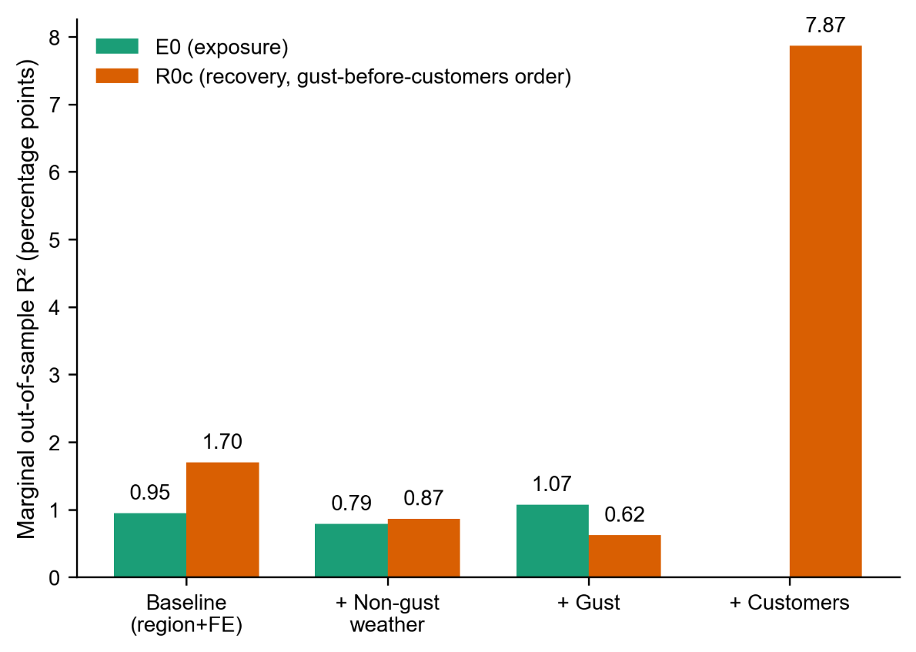
      - Marginal out-of-sample R-squared by variable group, exposure and recovery margins.
Note: Bars show the increase in out-of-sample R-squared from adding each group of variables in sequence: regional covariates and calendar fixed effects, non-gust weather, gust, and, for the recovery margin only, affected customers.
Figure 6 provides a further point of comparison, using the observed variation in regional covariates rather than in gust or affected customers. Weather conditions and affected customers are both held fixed at their sample means, and only the five region-level covariates described in Section 2.4 are allowed to vary across Local Authority Districts. Figure 6a shows the resulting predicted affected customers by district, and Figure 6b shows predicted restoration duration. In Figure 6a, a ring of districts immediately surrounding central London shows higher predicted values than the London core itself, with a further contiguous band of higher values extending north from this ring. In Figure 6b, the London core is again low, but the surrounding pattern is more scattered, and the northward band visible in Figure 6a is largely absent. The two panels do not share the same set of high-value districts. This is consistent with a negative correlation, reported separately as -0.780 (Pearson) and -0.758 (Spearman) between the two predicted surfaces across districts, which is discussed further in Appendix E.
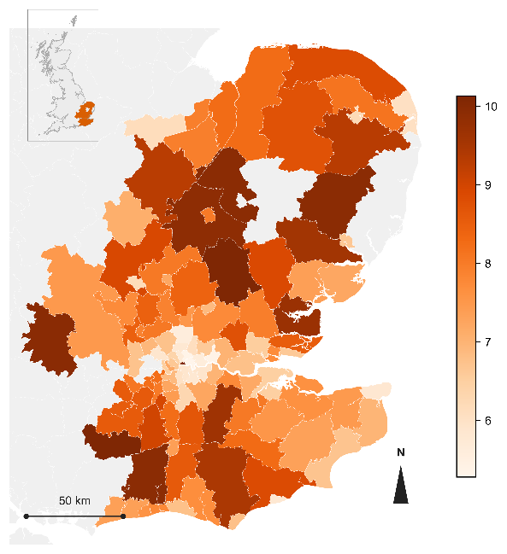 | 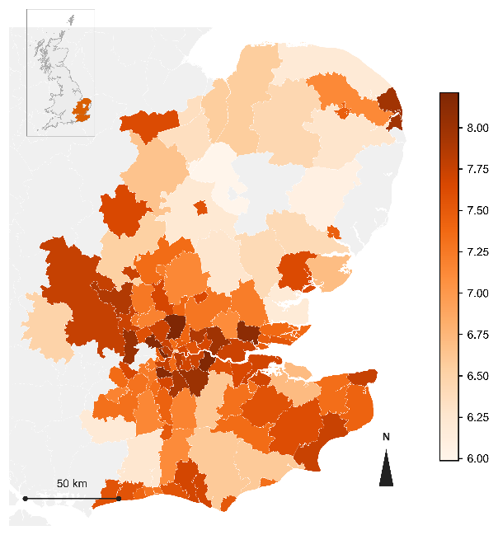
(a) | (b)
      - Baseline regional variation in predicted outcomes under a fixed reference weather scenario. (a) Predicted affected customers by Local Authority District. (b) Predicted restoration duration by Local Authority District.
Note: In both panels, weather conditions and affected customers are held at their sample means, and only the five region-level covariates listed in Section 2.4 vary across districts.
The same comparison can also be made directly in terms of predicted outcomes, rather than in terms of variance shares. Figure 7 compares three ratios. Holding other covariates fixed and moving gust across its observed range, from the 1st to the 99th percentile, changes the predicted exposure margin by a factor of 2.79 and the predicted recovery margin by a factor of 2.37. Holding gust fixed and moving affected customers across the same percentile range changes the predicted recovery margin by a factor of 5.99. This third ratio is more than twice either of the first two. All three ratios are well above one, meaning that none of the three variables leaves the predicted outcome unchanged across its observed range, but the ratio for affected customers is clearly the largest of the three.
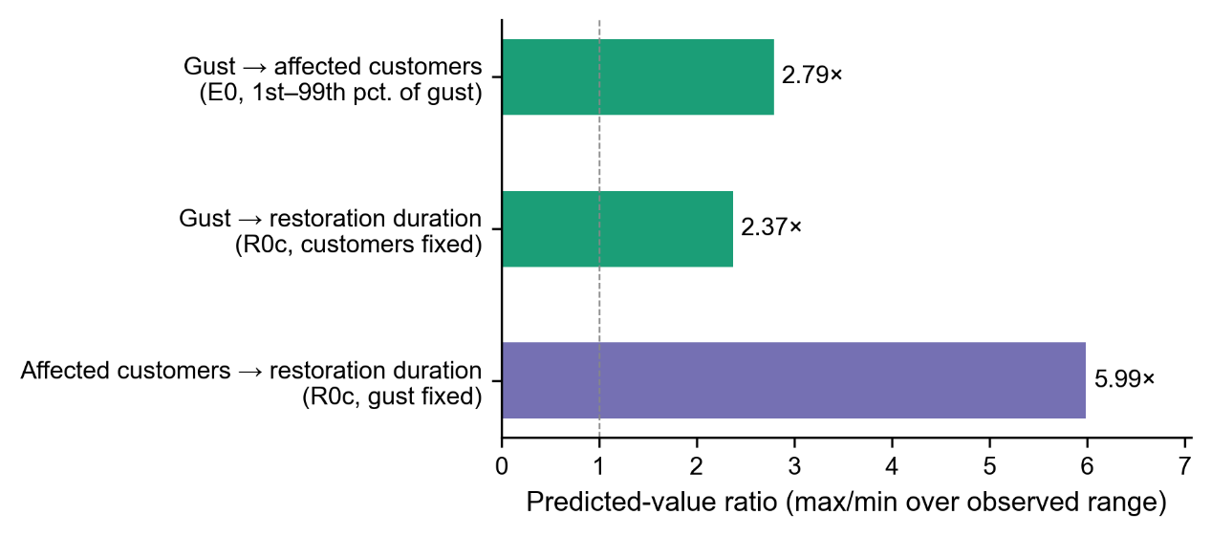
      - Ratio of predicted outcome at the 99th percentile to the 1st percentile of the driving variable.
Note: Three ratios are shown: gust on the exposure margin (2.79), gust on the recovery margin (2.37), and affected customers on the recovery margin (5.99). A dashed reference line marks a ratio of one, corresponding to no change in the predicted outcome.
The predicted values in Figure 6 vary by a factor of 1.96 for affected customers and 1.41 for restoration duration across the range of districts observed. Both ratios are of a similar order of magnitude to the gust-driven ratios reported above (2.79 and 2.37), and neither approaches the ratio associated with affected customers itself (5.99). Figure 6 therefore does not show that regional characteristics matter more than gust. It shows that the observed variation in these five regional covariates is comparable in scale to the observed variation in gust, and that both are considerably smaller in their effect on predicted outcomes than the observed variation in affected customers.
Taken together, the results in this section support two conclusions rather than one. Gust accounts for a modest share of the total variation in outage outcomes at the population level. Among the variables considered here, affected customers accounts for a substantially larger share. Section 4.3 asks whether this ordering still holds once the sample is restricted to incidents for which weather is the recorded cause.

Storm evidence: two converging lines on the conditional dominance of wind
Section 4.2 describes the full population of weather- and asset-related incidents, most of which have nothing to do with weather. This section asks a narrower question: among incidents that can be identified, independently of the outcome, as weather-driven, does gust still account for only a small share of the variation, or does it account for more? Two independent ways of identifying weather-driven incidents are used to answer this question. The first uses the Cause Code recorded for each incident. The second uses seven real storms with an independently documented date and identity.
The recovery model described in Section 3.3 was re-estimated on the subset of incidents for which the Cause Code identifies weather as the direct cause, rather than the combined weather- and asset-related sample used elsewhere in this paper. This subset contains 9,758 incidents, about 16 percent of the main sample. Table 4 compares the two samples directly. The quadratic gust term is close to the same magnitude in both samples and remains significant in both. The marginal contribution of gust to out-of-sample R-squared more than doubles, from between 0.62 and 0.75 percentage points in the main sample to between 1.43 and 1.71 percentage points in the weather-only subset. It now exceeds the marginal contribution of affected customers, which falls to between 1.00 and 1.28 percentage points in this subset. Figure 8 shows this comparison. Figure 8a reports the exposure margin, where the marginal contribution of gust falls from a positive value in the main sample to a small negative value in the weather-only subset, the only instance of a negative bar among all the figures reported in this paper. Figure 8b reports the recovery margin, where the relative height of the gust and affected-customers bars is reversed between the two samples, from affected customers roughly 12.7 times the height of gust in the main sample to gust slightly exceeding affected customers in the weather-only subset.
          - Marginal out-of-sample R-squared, main sample versus weather-only subset.
Margin | Variable | Main sample | Weather-only subset
Exposure | Gust | +1.07 pp | -0.15 pp
Recovery | Gust | 0.62-0.75 pp | 1.43-1.71 pp
Recovery | Affected customers | 7.73-7.87 pp | 1.00-1.28 pp
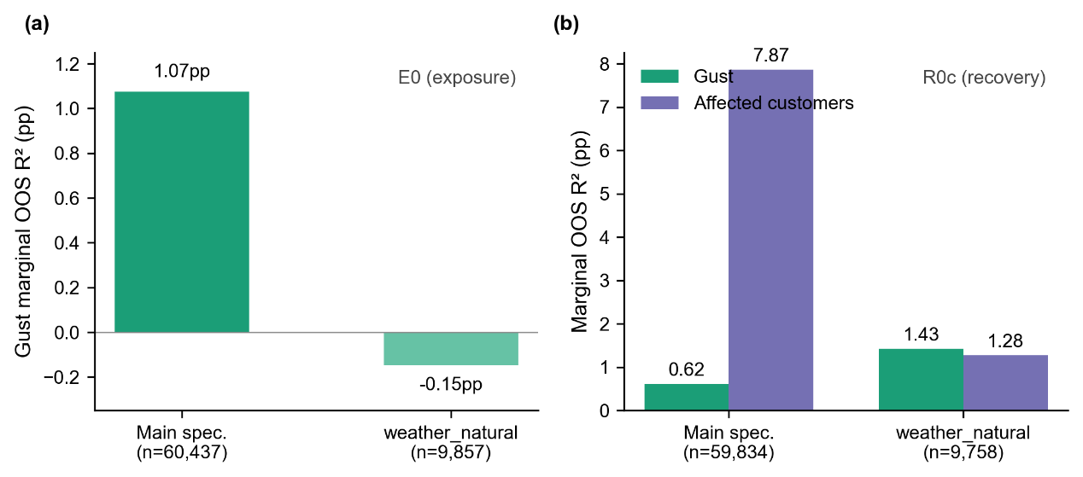
      - Marginal out-of-sample R-squared, main sample versus weather-only subset. (a) Exposure margin. (b) Recovery margin, gust and affected customers shown separately.
The negative result for the exposure margin in the weather-only subset is not treated here as evidence against the finding in Section 4.1. Appendix D shows that Cause Code is not assigned independently of gust speed. An incident occurring in calm weather is unlikely to be classified as weather-driven, so the weather-only subset is systematically depleted of low-gust observations. This is a problem for the exposure margin specifically, because its turning point, reported in Section 4.1, depends on having enough observations below the turning point to identify the falling part of the curve. It is less of a problem for the recovery margin, because the quadratic coefficient reported there does not depend on locating a precise turning point.
A second, independent way of restricting attention to weather-driven incidents is to examine periods of documented severe storms directly, rather than relying on a recorded cause. This follows a similar logic to prior work that validates a fitted outage model against a small number of distinct, named storms not used to fit the model [5]. Seven storms with an officially recorded name and date fall within the study period: Arwen, Dudley, Eunice, Franklin, Babet, Ciarán, and Henk. Together, these seven storms span 27 days, or 2.46 percent of the total study period. Within these 27 days, 8.15 percent of all incidents in the final sample occurred, accounting for 14.72 percent of total affected customers. Incident density during these seven storms is therefore around 3.3 times the average incident density across the study period, and the concentration of affected customers during these storms is around six times the study-period average.
The finalised exposure and recovery models, unchanged from Section 4.1, were then used to predict outcomes for the incidents recorded during each of the seven storms, using the gust and other covariate values observed during that storm. Figure 9 compares these predictions against the observed outcomes. For the exposure margin, Figure 9a, the predicted values are systematically higher than the observed values for incidents with a low observed customer count, visible as vertical clusters of points sitting well above the reference line at the low end of the horizontal axis. Predictions come closer to the reference line only among incidents with a comparatively high observed customer count. For the recovery margin, Figure 9b, the points are more evenly distributed around the reference line, without the same one-sided pattern, although two of the seven storms, Eunice and Franklin, each form a distinct local cluster: Eunice’s cluster sits slightly above the reference line, and Franklin’s sits below it.
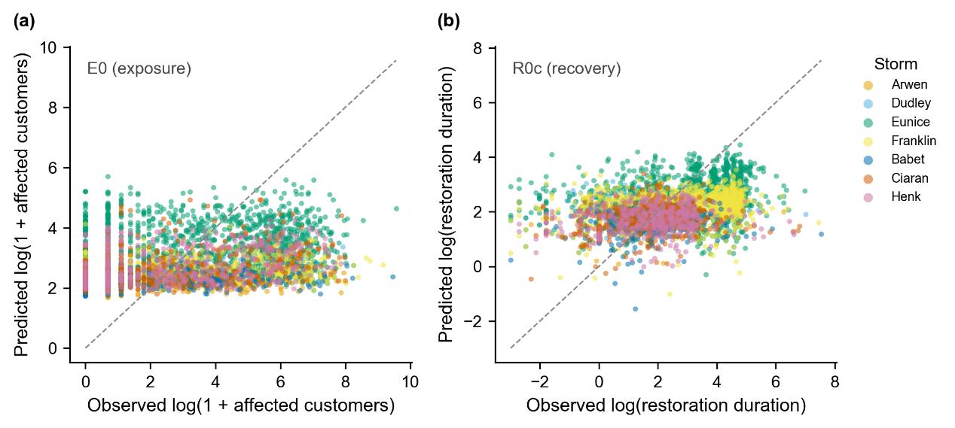
      - Fitted against observed outcomes during the seven named storms, coloured by storm, with a 45-degree reference line. (a) Exposure margin. (b) Recovery margin.
The fitted-observed correlation for each margin was also computed separately within each storm and compared against the correlation for the full sample. For the exposure margin, the full-sample correlation is 0.179, and the seven storm-specific correlations range from 0.116 to 0.341, without a consistent direction relative to the full-sample value. For the recovery margin, the full-sample correlation is 0.343, and all seven storm-specific correlations fall below this value, ranging from 0.084 to 0.317. The weakest of these, for Storm Dudley, is not statistically distinguishable from zero.
This weaker performance during storms is not read here as evidence against the results reported in Section 4.1. It follows instead from the modest population-level weight of gust already reported in Section 4.2: a model that explains only a small share of total variation is not expected to track individual incidents closely once storms concentrate unmodelled sources of variation, such as competition for restoration crews, into a short period. Weaker individual-incident tracking during storms and a modest population-level share of explained variance describe the same underlying limitation, not two separate findings.
The two approaches used in this section, restricting the sample by recorded cause and restricting attention to documented storm periods, identify weather-driven incidents in different ways and are affected by different sources of error. The Cause Code approach is affected by the selection problem described above for the exposure margin. The storm-period approach draws on a comparatively small number of incidents and is not designed to isolate a clean subsample in the way the Cause Code approach is. Despite these differences, both approaches point toward the same conclusion for the recovery margin: gust accounts for more of the variation in restoration duration once attention is restricted to incidents that are more clearly weather-driven, to the point of exceeding the contribution of affected customers within this narrower population.

Robustness: independent temporal confirmation
The results reported in Sections 4.1 to 4.3 were all obtained using the development sample described in Section 3.2, covering 1 April 2021 to 29 September 2023. This section applies the same, unchanged model specification to the confirmation sample, covering 30 September 2023 to 31 March 2024, which was not examined at any point while the model was being developed.
For the exposure margin, the linear gust term changes sign between the two samples, from negative in the development sample to positive in the confirmation sample, and the turning point moves from a position above the sample mean gust speed to a position below it. The 95 percent bootstrap confidence interval for the turning point, which excludes zero in the development sample, includes zero in the confirmation sample. The quadratic term itself remains positive and significant in both samples and is in fact larger in the confirmation sample than in the development sample. For the recovery margin, the quadratic gust term is positive and significant in both samples, with a similar magnitude in each (0.079 in the development sample and 0.064 in the confirmation sample). The linear gust term is not significant in either sample.
Figure 10 compares the quadratic gust coefficient across four settings: the development sample, the confirmation sample, and the main development-sample estimate under single and two-way clustered standard errors. For the recovery margin, all four confidence intervals are narrow and overlap closely, and the four point estimates fall within a range of 0.015. For the exposure margin, the confirmation-sample point estimate is visibly higher than the other three, which are themselves close to one another, and its confidence interval is the widest of the four shown for this margin.
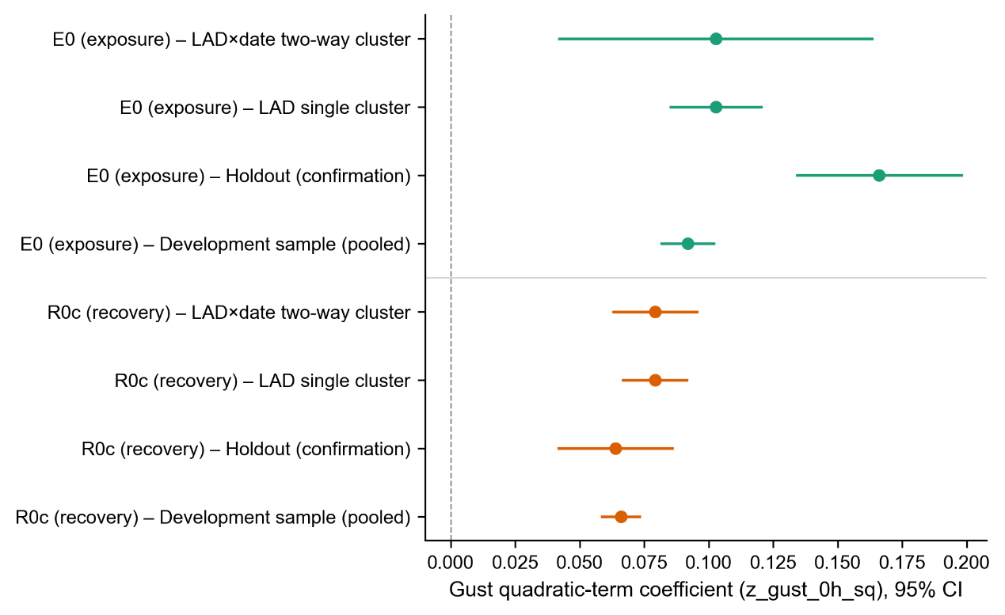
      - Quadratic gust coefficient, exposure and recovery margins, under four settings: development sample, confirmation sample, single clustering by Local Authority District, and two-way clustering by district and date. Points show coefficient estimates and horizontal lines show 95 percent confidence intervals.
The confirmation sample covers six months within a single autumn and winter period, rather than a full annual cycle, and is about one fifth of the size of the development sample. Both differences are expected to widen confidence intervals and to make a single point estimate less stable, independently of whether the underlying relationship has changed. A change in the exposure margin’s specific turning point value is therefore not read here as a failure of the exposure model. The quadratic shape of the exposure response, and the full quadratic response of the recovery margin, are both confirmed in the sense used throughout this section: the same sign, and a similar or greater level of significance, in a sample that played no part in developing the model. The specific numerical value of the exposure margin’s turning point is not confirmed in this same sense and is reported in Section 4.1 with this qualification in mind.
Standard errors clustered by both Local Authority District and date, rather than by district alone, were also checked for the main development-sample specification, as a further check on inference given the spatial clustering of incidents during a single storm. The quadratic gust term for the recovery margin remains significant under two-way clustering, with a p-value of 5.4 times ten to the power of minus 22, compared with 2.8 times ten to the power of minus 36 under single clustering. The quadratic gust term for the exposure margin also remains significant under two-way clustering. The linear gust term for the exposure margin, and the interaction between gust and pressure in both margins, lose significance under two-way clustering. This same pattern, in which the quadratic terms remain significant while the linear term and the interaction term do not, was also reported for the original dataset described in Appendix B, providing an independent point of comparison for the pattern observed here.

Conclusion
The two central findings of this paper concern the shape of the gust-outage relationship and the weight of gust relative to other explanatory variables. A pattern recurs across Sections 4.1, 4.3, and 4.4 concerning the first of these. A result that depends on a ratio of two estimated coefficients, such as a turning point, changes more between samples than a result that depends on a single coefficient, such as a quadratic term on its own. The recovery margin, for which no turning point is reported, is confirmed consistently throughout this paper. The exposure margin’s turning point value is the one number that moves between samples. Readers using the results in this paper should place more weight on the quadratic terms on their own and treat any specific turning-point value with the same qualifications reported in the section where it first appears.
The second finding, reported in Sections 4.2 and 4.3, is that gust’s weight relative to affected customers is not fixed. Across the full population of incidents, gust accounts for a modest share of total variation, well below the share accounted for by affected customers. Within the subset of incidents for which weather is the recorded cause, this ordering reverses, and gust’s contribution exceeds that of affected customers. Two independent ways of identifying weather-driven incidents, one based on recorded cause, and one based on the seven named storms, point toward this same reversal. This means that the practical relevance of gust conditions depends on the population being considered: gust is not the dominant explanatory factor for outages in general, but it is the dominant factor once an outage has already been attributed to weather.
The critical wind speed identified for the exposure margin may be useful as an approximate reference point for storm-response planning, marking the gust level above which affected customer numbers begin to rise sharply. Because this specific value was not confirmed in Section 4.4, it is better treated as an approximate operational reference than as a precise design threshold. This distinction matters because the exposure model explains a modest share of total variation, as reported in Section 4.2. The threshold describes a statistically robust change in the shape of the response function, not a tool for predicting the outcome of an individual incident.
Section 4.1 reports that affected customers, once the number of restoration stages per incident is considered, is associated with shorter restoration duration. This is broadly consistent with a dispatch-priority explanation, in which larger incidents receive earlier attention from restoration crews. Prior work using outage data from United States utilities has instead reported that the recovery duration of an outage is independent of the number of customers affected [26]. The direction of this relationship may depend on factors not examined in this paper, such as differences in network density between service areas, or differences in how restoration stages are defined and reported across utilities and regulatory frameworks.
Several limitations affect how far these results can be generalised. As noted in Section 4.4, the confirmation sample does not span a full annual cycle. A longer holdout period, covering more than one full year, would give a stronger test of whether the exposure margin's turning point is stable across seasons. A method that uses the geographic coordinates of each incident directly, rather than grouping incidents into districts for clustering standard errors, was not attempted here and is left for future work. The exact meaning of incidents recorded with zero affected customers was not confirmed at the level of Ofgem’s underlying data dictionary. One further open question, reported in Appendix D, was not fully resolved: within the weather-only subsample examined in Section 4.3, the sign of the affected-customers coefficient changes in a way not fully explained by the number of restoration stages, unlike in the main sample. This does not affect the gust coefficients reported for that subsample.
This paper treats the affected-customers and restoration-duration margins as outcomes to be explained, without asking whether the relationship between them changes according to the type of hazard involved, or whether concurrent outages on the same network interact with each other. Both questions are left for future work, along with a comparison between the parametric approach used here and a machine learning approach of the kind introduced in Section 3.1.
This paper reconstructs event-level outcome measures from stage-level regulatory records according to their official definitions, confirming the resulting model against both an independent time period and a set of real storm events. This general approach is not specific to UK Power Networks, and could be applied to any distribution network operator that reports outage incidents at the level of individual restoration stages, under a comparable regulatory framework. The same approach could be applied to any distribution network operator that reports outage incidents at the level of individual restoration stages, under a comparable regulatory framework.

References
[1] Institute for Government. Energy resilience [Internet]. [date unverified]. Available from: https://www.instituteforgovernment.org.uk/explainer/energy-resilience
[2] Ofgem. Storm Arwen report [Internet]. [title, date unverified]. Available from: https://www.ofgem.gov.uk/research/storm-arwen-report
[3] Guikema SD, Quiring SM, Han SR. Prestorm estimation of hurricane damage to electric power distribution systems. Risk Analysis. 2010;30(12):1744-1752.
[4] Liu H, Davidson RA, Apanasovich TV. Statistical forecasting of electric power restoration times in hurricanes and ice storms. IEEE Transactions on Power Systems. 2007;22(4):2270-2279.
[5] Nateghi R, Guikema SD, Quiring SM. Comparison and validation of statistical methods for predicting power outage durations in the event of hurricanes. Risk Analysis. 2011. [volume, pages unverified]
[6] Mukherjee S, Nateghi R, Hastak M. A multi-hazard approach to assess severe weather-induced major power outage risks in the U.S. Reliability Engineering & System Safety. 2018;175:283-305.
[7] Dikshit S, Alipour A. Characterizing probability of failure of transmission tower systems under multiple climatic hazards: wind and ice. Engineering Structures. 2025;342:120720.
[8] Zhu X, Ou G. Wind fragility modeling of transmission tower-line system based on threat-dependent structural robustness index. Structural Safety. 2025;114:102571.
[9] Ma L, Khazaali M, Bocchini P. Component-based fragility analysis of transmission towers subjected to hurricane wind load. Engineering Structures. 2021;242:112586.
[10] Kabre WW, Weimar MR. Fragility functions resource report: documented sources for electricity and water resilience valuation. PNNL-33587. Richland (WA): Pacific Northwest National Laboratory; 2022.
[11] Office of Gas and Electricity Markets. RIIO-ED1 regulatory instructions and guidance: Annex F. London: Ofgem. [date unverified].
[12] Office of Gas and Electricity Markets. RIIO-ED2 regulatory instructions and guidance: Annex F – interruptions. London: Ofgem; 2023.
[13] Open-Meteo. Historical weather API [Internet]. [date unverified]. Available from: [URL unverified]
[14] Hersbach H, Bell B, Berrisford P, Hirahara S, Horanyi A, Munoz-Sabater J, et al. The ERA5 global reanalysis. Quarterly Journal of the Royal Meteorological Society. 2020;146:1999-2049.
[15] American Society of Civil Engineers. Minimum design loads and associated criteria for buildings and other structures. ASCE/SEI 7. [edition unverified].
[16] [authors unverified]. The risk of cascading failures in electrical grids triggered by extreme weather events. arXiv:2107.00829. [publication status unverified].
[17] Office for National Statistics. Explore local statistics [Internet]. 2025. Available from: [URL unverified]
[18] Office for National Statistics. Mapping income deprivation at a local authority level [Internet]. 2021. Available from: [URL unverified]
[19] Moran PAP. Notes on continuous stochastic phenomena. Biometrika. 1950;37(1-2):17-23.
[20] Office for National Statistics. Local Authority Districts (December 2021) boundaries UK BGC [Internet]. Available from: https://open-geography-portalx-ons.hub.arcgis.com/datasets/ons::local-authority-districts-december-2021-boundaries-uk-bgc
[21] O’Brien RM. A caution regarding rules of thumb for variance inflation factors. Quality & Quantity. 2007;41(5):673-690.
[22] McCullagh P, Nelder JA. Generalized linear models. 2nd ed. London: Chapman and Hall; 1989.
[23] Cox DR. A note on data-splitting for the evaluation of significance levels. Biometrika. 1975;62(2):441-444.
[24] Cameron AC, Miller DL. A practitioner’s guide to cluster-robust inference. Journal of Human Resources. 2015;50(2):317-372.
[25] Oehlert GW. A note on the delta method. The American Statistician. 1992;46(1):27-29.
[26] Wu H, Meng X, Danziger MM, Cornelius SP, Tian H, Barabási AL. Fragmentation of outage clusters during the recovery of power distribution grids. Nature Communications. 2022;13:7372.

