CLASS DIAGRAMS
Each graduate have a unique student ID to log into the school system, and related to the ID, his/her name, gender, major, college, the date of graduation and the courses have taken in university have be recorded in the database. One graduate attended many courses and one courses have many students. A course need its name, ID, capacity in int, and contents, a course must have one teacher，but a teacher can conduct 0 to many courses. The teacher class have its members of name, ID, gender and college, too. One graduate could only study in one major, and a major have 0 to many students, and many course compose one major. The major class has its name, ID, student number and teacher number. One graduate just take one job at a time, and in job class, the job name, the graduates’ salary and position need to be recorded, and the promotion should be updated during the working period.
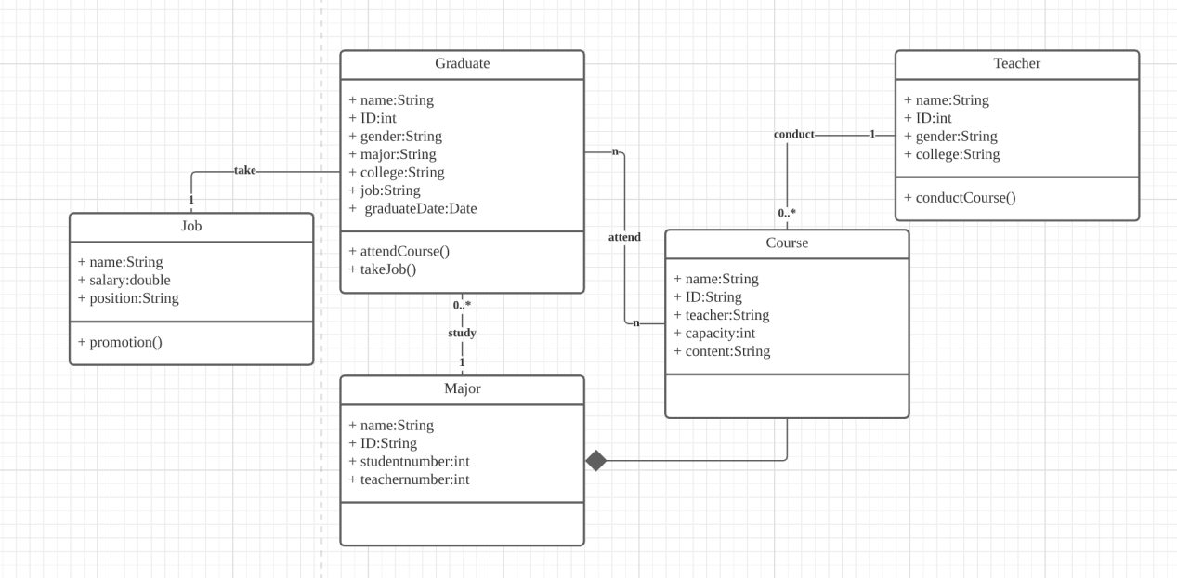

Sequence diagrams
- graduation input their job information
The graduations need to log in with their student ID, and the homepage will return back the success message. And then, the information of the graduate related to the student ID, such as name, major, course history can be search and return from the database to the job information page. When the user input his/her job information, assuming the lowest position in his/her company is zero, and the parameter of promotion is not promotion times but the level between current position and the lowest one. Among students of one course, the salary and promotion parameter will be put together and calculate the arithmetic means, the means will be rank by their values and recorded along with details of job information.
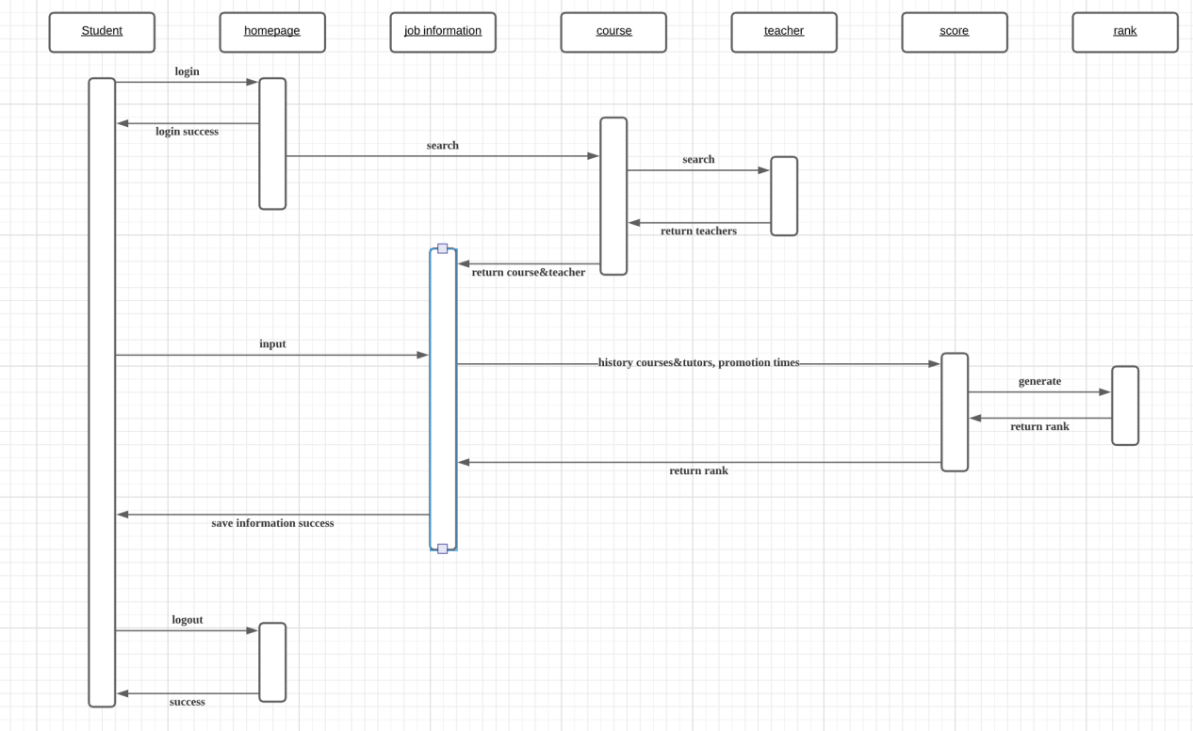

- teacher view the promotion rank and the relation between course and job
When the teacher log in with teacher ID, they can select a course and the database will search and return the rank, score and details of graduation job, these information will be shown on the interface. And teachers can view what courses are more helpful for the students and which are not, and the mentor of these courses can also be viewed. It will bee clear for teacher and college to make some improvements to conduct more useful contents.
