Personal Information Management
  - Design Document
COMP3211 Software Engineering
Group 149 | Version 1.2 handoff clarification | 20 October 2026

1 Purpose and design baseline
This document defines the object-oriented design of the command-line Personal Information Management system. It translates the SRS into Python packages, classes, method contracts, file data and collaborating operations. Developers can use it to implement the system, and reviewers can trace the design to the requirements.
The system uses Model-View-Controller (MVC). Domain objects, search evaluation, collection state and persistence belong to the model package. The controller coordinates commands and confirmations, while the view owns terminal input and output. The runtime uses only Python standard libraries and operates offline on Windows.

1 1 References and scope
[R1] Course Project Description, COMP3211 Software Engineering, Fall 2026, Deliverable 2 and Appendix B. [R2] Group 149 PIM SRS v1.4 handoff clarification, derived from the user-selected Group149_PIM_SRS_v1.3.docx. FR1–FR36, NFR1–NFR5 and the user-approved permanent-EOF clarification form the requirements baseline. [R3] The team Design Document supplied as a 15-page PDF. [R4] Group 149 Design v1.0. Section 13 records their comparison and the resolved design decisions.
Alarm assumption: an Event alarm is a stored date-time field supporting creation, modification, display, persistence and search. It must be no later than the event start. No automatic notification, scheduler or background service is included. This is a provisional scope decision, subject to instructor confirmation; notification requirements would require a later revision.

1 2 Reading guide
Sections | Design content
2–3 | MVC architecture, package allocation and record class structure.
4–6 | Public model interfaces, criteria composition and expression grammar.
7–9 | Terminal contracts, controller coordination and .pim persistence.
10–11 | Search-and-update collaboration and failure-safe state transitions.
12–13 | Requirement traceability, source comparison and conflict resolutions.

Python type notation is used throughout. Parameters exclude self. Callable signatures show return types; constructor notation denotes the object produced, not the return of Python __init__. Raises lists expected exceptions; Python does not require checked exception declarations. Underscore fields and helpers are private. There are no protected methods in this design. Figures show the main relationships; the accompanying contracts specify the complete designed public interfaces.

2 Architecture and package allocation
MVC separates interactive concerns from operations that must be unit tested independently. PIMController invokes PIMService and passes returned values to PIMView. The model never imports cli and never calls input or print. For this small synchronous CLI, the controller explicitly refreshes the view after each operation; an observer framework is unnecessary.
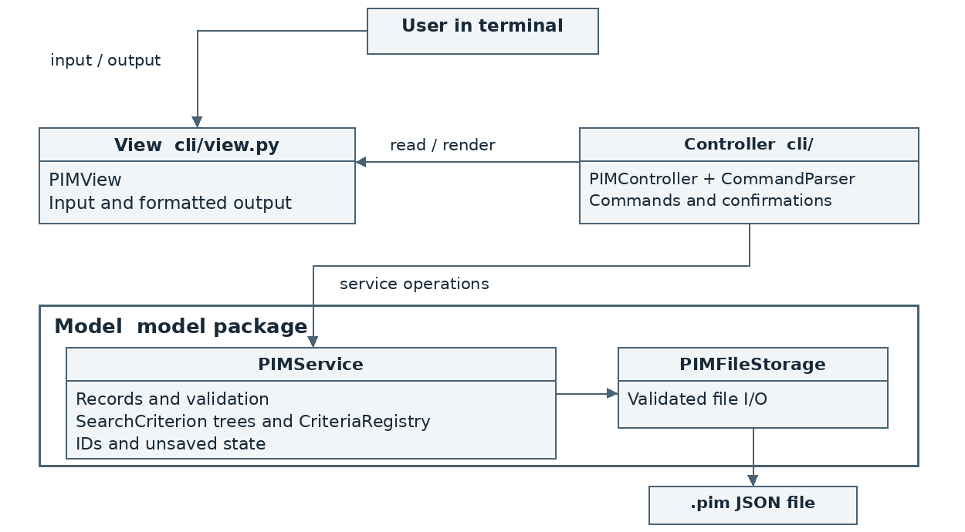
Figure 1. MVC architecture. The controller calls view and model operations. Model code never calls the view. Responses return to the caller.
Module | Responsibility
main.py | Construct the service, store, registry, parser and view; run the controller.
cli/controller.py; cli/parser.py | Coordinate commands and confirmation flow; parse command syntax.
cli/view.py | Read input and format full records, criteria, prompts and ERROR messages.
model/records.py; model/validation.py | Immutable record types, field rules, normalization and record construction.
model/service.py; model/errors.py | Collection state, identifiers, operations and domain exceptions.
model/criteria.py; model/search.py | SearchCriterion objects, recursive-descent expression parser and saved registry.
model/persistence.py | JSON schema, encoding, complete file validation and staged file writes.

main.py is the composition root. PIMService owns one CriteriaRegistry and uses one PIMFileStorage. CommandParser depends on command syntax only; ExpressionParser is in model because validation and meaning of criteria are domain behaviour. Dependencies point from cli to model, never back. Standard-library dependencies include dataclasses, enum, datetime, json, pathlib, re, tempfile and os.
MVC makes model tests independent of the terminal and centralizes command coordination. A layered design could also work; MVC names these responsibilities more directly. Client-server deployment is unnecessary for an offline single-user tool. No GUI or notification subsystem is planned. Changing the UI could also require controller changes, so replacing the view alone is not assumed sufficient.

2 1 Main component dependencies
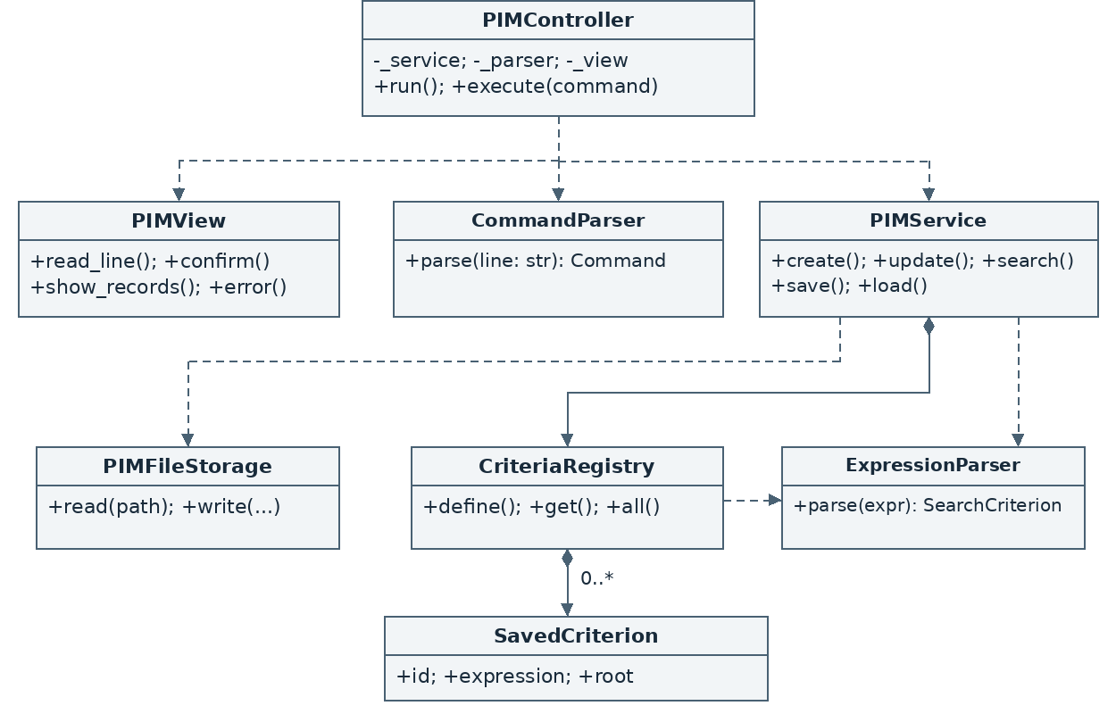
Figure 2. Main component dependencies. Dashed arrows indicate calls; filled diamonds indicate owned session objects. Method names are abbreviated here; Sections 4–9 specify typed public contracts.
PIMController uses PIMView, CommandParser and PIMService. Only the service invokes PIMFileStorage. The service and registry share one stateless ExpressionParser supplied by main.py; the registry retains saved expression trees. PIMService owns the live collection and is the only mutation entry point. Records and criteria are immutable values that can safely be returned to callers.
Relationship | Allocation and reason
Inheritance | PlainText, Task, Event and Contact inherit PIR. Six concrete search classes implement SearchCriterion.
Composition | The service owns 0..* current records and one registry; the registry owns 0..* SavedCriterion entries. Each entry retains one root tree.
Recursive composition | AndCriterion and OrCriterion own left/right operands. NotCriterion owns one operand. Any operand can be a leaf or composite criterion.
Dependency | Criteria inspect PIR fields. Validators construct valid records. Storage converts records to and from the versioned file schema.

All domain modules stay inside model. CLI modules contain no record mutation logic. main.py constructs PIMFileStorage, ExpressionParser and CriteriaRegistry, injects them into PIMService, then constructs CommandParser, PIMView and PIMController. It invokes run() and has no other public application function.

3 Record structure and relationships
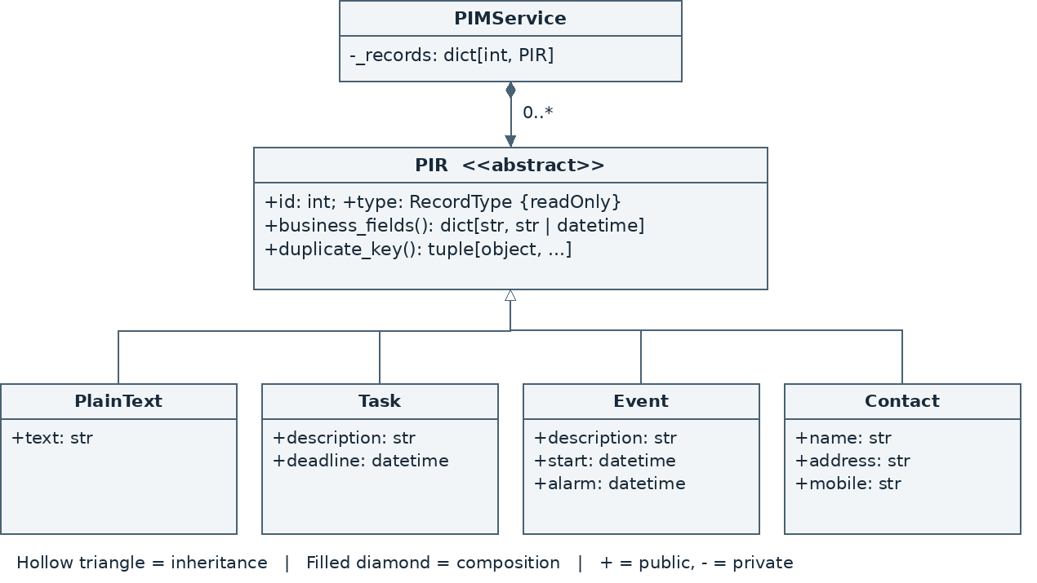
Figure 3. Record class structure. Each current PIR has one owning PIMService; the four concrete types inherit the common PIR interface.
PIR is an abstract frozen data class. Concrete classes are frozen data classes with an immutable positive id and a fixed RecordType enum value. Fields shown with + are publicly readable, not publicly writable. PIMService replaces a whole validated object on edit, so callers cannot bypass validation or modify the collection through a returned reference.
Type | Business fields and constructor
PlainText | PlainText(id: int, text: str) -> PlainText
Task | Task(id: int, description: str, deadline: datetime) -> Task
Event | Event(id: int, description: str, start: datetime, alarm: datetime) -> Event
Contact | Contact(id: int, name: str, address: str, mobile: str) -> Contact

Constructors return the named object and raise ValidationError for invalid IDs, field values or the alarm/start relationship. RecordType has PLAIN_TEXT, TASK, EVENT and CONTACT; its value is fixed by the concrete class. All datetimes are naive local times with seconds and microseconds zero. No timezone conversion occurs. Record values are normalized before storage, including direct construction.
PIR.business_fields() -> dict[str, str | datetime]
Returns a fresh mapping of the concrete type’s fields, excluding id and type. Raises: none for a valid record. Used for display, validation, serialization and comparison.
PIR.duplicate_key() -> tuple[object, ...]
Returns type followed by business values in the field order above. Excludes id and compares text case-sensitively. Raises: none. The key supports exact duplicate detection across all four record types.

4 Model contracts and validation

4 1 Shared validation functions
normalize_text(value: str) -> str
Reject line breaks before trimming leading and trailing whitespace. Reject empty values and values consisting solely of whitespace and underscores; preserve internal spaces and underscores. Raises ValidationError.
parse_time(value: str) -> datetime
Require exact YYYY-MM-DD HH:MM syntax and a valid calendar date in years 0001–9999. Past times are allowed. Use a full syntax check followed by datetime construction; do not rely on permissive parsing alone. Raises ValidationError.
normalize_mobile(value: str) -> str
Trim outer whitespace and require an optional + followed by 1–15 ASCII digits. Preserve leading zeroes and +. Raises ValidationError; does not check subscriber existence.
build_record(record_id: int, kind: RecordType,
fields: dict[str, str]) -> PIR
Require exactly the business fields for kind, normalize strings, parse time values and construct the concrete record. Reject Boolean or non-positive IDs. Raises ValidationError. Loading uses this same validation path and additionally requires canonical saved values to prevent silent changes.

4 2 Service state and construction
PIMService(store: PIMFileStorage, criteria: CriteriaRegistry,
parser: ExpressionParser) -> PIMService
Initializes _records: dict[int, PIR] = {}, _high_water: int = 0 and _dirty: bool = False; retains _store: PIMFileStorage, _criteria: CriteriaRegistry and _parser: ExpressionParser. The same parser instance is supplied to the registry. Starts empty without loading. Raises: none for valid dependencies. The read-only property dirty: bool exposes unsaved state.

4 3 Record operations
create(kind: RecordType, fields: dict[str, str],
allow_duplicate: bool = False) -> PIR
Validate a candidate with ID _high_water + 1. If its duplicate key exists and allow_duplicate is false, raise DuplicateRecordError carrying matching_ids: tuple[int, ...]. Otherwise commit it, advance the counter and mark dirty. ValidationError or DuplicateRecordError leaves all state unchanged.
update(record_id: int, field: str, value: str) -> PIR
Resolve the record, check that field is a business field, construct and validate a full replacement, then commit only if its value changes. ID and type remain fixed. Returns the current or updated PIR. Raises NotFoundError or ValidationError. No duplicate-content prompt applies to updates.
get(record_id: int) -> PIR; all_records() -> tuple[PIR, ...]
get returns a single immutable PIR; raises ValidationError for malformed IDs and NotFoundError for absent IDs. all_records returns an immutable snapshot sorted by numerical ID; raises none.
delete(record_id: int) -> PIR
Called only after controller confirmation. Remove and return the selected record, set dirty and retain the high-water counter. Raises ValidationError or NotFoundError without mutation.

5 Search components and composition
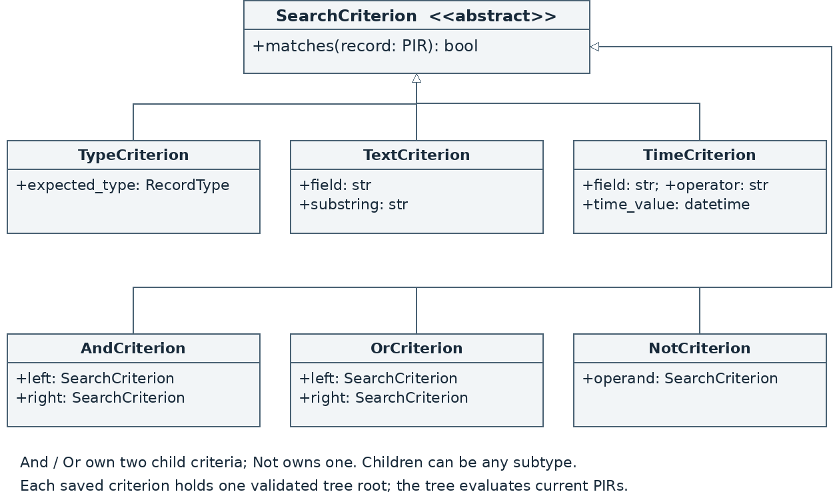
Figure 4. Six concrete classes implement SearchCriterion. Hollow triangles indicate inheritance. Composite operands are specified in the class fields and the relationship table in Section 2 1.
The Composite pattern gives both single comparisons and Boolean combinations the same matches(record) interface. TypeCriterion, TextCriterion and TimeCriterion are leaves. AndCriterion, OrCriterion and NotCriterion compose children, so nested parentheses and mixed logical operators require no special collection-manager cases.
This adopts the team design’s explicit criterion types. It replaces v1.0 FieldCriterion and BinaryCriterion with constructors whose arguments express each operation directly. The external symbolic syntax and evaluation results remain unchanged. Internal class names such as AndCriterion do not introduce text operators into the command language.
The parser validates every node before evaluation, even when later short-circuit evaluation would skip a branch. A missing record field makes an atomic condition false; an unknown field in the expression is an error. Negation applies to the Boolean result. For example, !(deadline < T) can match a Contact, while type = TASK && !(deadline < T) cannot.
SavedCriterion contains an identifier, original expression and validated root. CriteriaRegistry generates C1, C2, ... only after parsing succeeds. Definitions retain the tree rather than cached results, and therefore continue to work on the current collection after edits or a successful load.

5 1 Search class and service contracts
SearchCriterion.matches(record: PIR) -> bool
Abstract method implemented by all six concrete classes. Returns a Boolean for a valid PIR; raises no expected exception after construction. The abstract class has no data fields and is not instantiated directly.
TypeCriterion(expected_type: RecordType) -> TypeCriterion
Read-only expected_type field. Match record.type exactly. Constructor raises ExpressionError for an invalid type; matches raises none.
TextCriterion(field: str, substring: str) -> TextCriterion
Read-only field and substring fields. Constructor requires a recognized text field and a non-empty literal substring; it preserves whitespace and underscores. Raises ExpressionError. matches returns false for a missing field and otherwise performs case-sensitive consecutive substring matching; no wildcards or regular expressions.
TimeCriterion(field: str, operator: str,
time_value: datetime) -> TimeCriterion
Read-only field, operator and time_value. Constructor checks deadline/start/alarm, < or > or =, and a valid naive datetime at minute precision; raises ExpressionError. matches returns false for a missing field and otherwise compares the whole date and time.
AndCriterion(left: SearchCriterion,
right: SearchCriterion) -> AndCriterion
OrCriterion(left: SearchCriterion,
right: SearchCriterion) -> OrCriterion
NotCriterion(operand: SearchCriterion) -> NotCriterion
All child fields are read-only. Constructors require valid criterion objects and raise ExpressionError for invalid children. And and Or short-circuit Boolean evaluation; Not negates its child. matches raises none. The parser builds only acyclic trees.
PIMService.search(expression: str) -> tuple[PIR, ...]
PIMService.search_saved(criterion_id: str) -> tuple[PIR, ...]
search calls _parser.parse before evaluating all current records. search_saved obtains an existing root from the registry. Both return numerical ID order without mutation. Raises ExpressionError; search_saved may raise UnknownCriterionError.
PIMService.define_criterion(expression: str) -> SavedCriterion
PIMService.list_criteria() -> tuple[SavedCriterion, ...]
Delegate to the registry. Definition raises ExpressionError; listing raises none. Return definitions in numeric criterion-ID order. Neither operation changes dirty state.

6 Expression parser and reusable criteria

6 1 Public interfaces
ExpressionParser() -> ExpressionParser
ExpressionParser.parse(expression: str) -> SearchCriterion
Stateless public parser with private per-call token/index state. Constructor raises none. parse raises ExpressionError for syntax errors, unknown fields/types, invalid literals, unsupported escapes or trailing tokens. It returns a fully validated immutable abstract syntax tree (AST), never a partially accepted expression.
SavedCriterion(id: str, expression: str,
root: SearchCriterion) -> SavedCriterion
Frozen data carrier created by the registry after successful parsing. Fields are public and read-only. Constructor receives a generated identifier, exact expression text and validated root; no expected exception under these internal preconditions. It defines no additional public methods.
CriteriaRegistry(parser: ExpressionParser) -> CriteriaRegistry
define(expression: str) -> SavedCriterion
get(criterion_id: str) -> SavedCriterion
all() -> tuple[SavedCriterion, ...]
Constructor retains _parser: ExpressionParser, sets _items: dict[str, SavedCriterion] = {} and _next_id: int = 1; raises none. define parses before assigning Cn and incrementing the counter; raises ExpressionError without consuming an ID. get raises UnknownCriterionError. all returns numeric criterion-ID order and raises none. No edit, delete or persistence interface is supplied.

6 2 Grammar and meaning
expression := or_expr
or_expr := and_expr { "||" and_expr }
and_expr := unary { "&&" unary }
unary := "!" unary | "(" expression ")" | comparison
comparison := "type" "=" TYPE
| TEXT_FIELD "~" STRING
| TIME_FIELD ("<" | ">" | "=") STRING
TEXT_FIELD is text, description, name, address or mobile. TIME_FIELD is deadline, start or alarm. TYPE is PLAIN_TEXT, TASK, EVENT or CONTACT. The lexer recognizes && and || as complete tokens and does not interpret operator characters inside quoted literals. Field names and type values are case-sensitive. AND, OR, NOT and CONTAINS are not accepted operators.
STRING is double-quoted. Only escaped double quote (\") and escaped backslash (\\) are accepted; unsupported escapes, unclosed quotes and line breaks are errors. Search text must be non-empty but is not trimmed: spaces and underscores remain valid literal substrings. Time strings use parse_time. The parser requires end of input after the expression.
Precedence is comparison, then !, then &&, then ||. Private recursive-descent helpers follow the grammar. Each text/time leaf checks field existence before comparing. For example, a Contact satisfies !(deadline < "2026-11-20 20:00"); add type = TASK when only Tasks are wanted. The implementation never calls eval or executes user expressions as Python.
Evaluation of m AST nodes over n records is O(nm), followed by O(k log k) sorting for k matches. A saved criterion caches the tree, not result records, so edits and loads affect the next search immediately.

7 Terminal commands and coordination
Commands are entered at the application prompt, not interpreted by the operating-system shell. Command keywords are lowercase; type names and fields use the exact spellings below. Commands use text words, while search operators use symbols exclusively. Values and paths are double-quoted using the same quote and backslash rules as search literals.
Command format | Operation
create TYPE field="value" ... | Require every field exactly once; reject missing, repeated or extra fields.
update ID field="value" | Change exactly one business field.
show ID / show all | Display full record details in ID order.
delete ID | Show the selected record and request confirmation.
define EXPRESSION / criteria | Create a reusable criterion / list ID and expression.
search EXPRESSION / search @C1 | Evaluate a direct expression / a defined criterion.
save "path.pim" / load "path.pim" | Save to a path / explicitly replace the collection from a file.
exit | Apply the unsaved-changes guard and end the loop if allowed.

create TASK description="report" deadline="2026-11-20 20:00"
define type = TASK && description ~ "report"
search @C1
update 1 deadline="2026-11-19 18:00"
save "records.pim"
CommandParser extracts the command verb and arguments without destroying quoted content. It forwards the raw expression tail for define/search to the model parser. It accepts a positive decimal ID and rejects malformed input, repeated assignments and extra tokens. Whitespace outside quoted values separates tokens. Windows backslashes must be escaped inside quotes; forward-slash paths may also be used.

7 1 Command and parser contracts
Command(verb: str, arguments: dict[str, object]) -> Command
CommandParser() -> CommandParser
CommandParser.parse(line: str) -> Command
Command is a frozen carrier with verb: str and arguments: Mapping[str, object], defensively copied with nested field maps also made read-only; it has no public behavioural methods. Argument values are RecordType, int, str, Path or Mapping[str, str], as appropriate to the command. Constructors raise none under internal preconditions. parse returns one Command or raises CommandError; parser has no retained state.

7 2 Confirmation rules
PIMView accepts y or n for duplicate creation, deletion and overwrite. An invalid response produces ERROR and repeats that confirmation without mutation. The unsaved-change prompt accepts s (save and continue), d (discard and continue), or c (cancel). Choosing s requests a save path; a failed save or refused overwrite returns to the main prompt and stops the pending load/exit. No :cancel field-entry convention is used.

8 Controller and view contracts
PIMController(service: PIMService, parser: CommandParser,
view: PIMView) -> PIMController
Retains private _service, _parser, _view and _running: bool = True. Constructor raises none. The controller owns the interactive lifecycle and ensures the confirmation policy is applied before mutation.
PIMController.run() -> None
Read/parse commands and call execute. Catch CommandError/PIMError, render ERROR and continue. Catch recoverable Ctrl-C only at input boundaries and cancel pending input without losing changes. Permanent EOF exits without retrying: dirty warns on stderr and raises SystemExit(1), clean may raise SystemExit(0). Section 14 defines the user-approved clarification, normal exit/commit safeguards and private view helper. Normal signatures remain unchanged.
PIMController.execute(command: Command) -> bool
Dispatch a well-formed command, render its result and return true to continue or false after an approved exit. May raise CommandError or PIMError to run. On DuplicateRecordError, display matching IDs and retry create with allow_duplicate=True only after y. On delete, get/display the record before requesting confirmation. On OverwriteRequiredError, confirm before retrying save with overwrite=True.
Private controller helpers coordinate save, confirmation and the unsaved-change guard; they are not additional public interfaces. The controller does not alter records, dirty state or ID counters directly. Each input command completes before another begins, so confirmation and mutation operate on one serial session state.
PIMView() -> PIMView
read_line(prompt: str = "pim> ") -> str
Stateless view. Constructor raises none. read_line uses standard input and returns a single line without the terminal newline; may raise EOFError or KeyboardInterrupt to run.
confirm(message: str) -> bool
choose_unsaved() -> str
read_path() -> Path
confirm returns true for y and false for n. choose_unsaved returns s, d or c. read_path uses the shared command-literal decoder to parse one quoted path; invalid syntax produces ERROR and is requested again. These methods may raise EOFError or KeyboardInterrupt to run; they never mutate model state.
show_records(records: tuple[PIR, ...]) -> None
show_criteria(items: tuple[SavedCriterion, ...]) -> None
message(text: str) -> None
error(reason: str) -> None
Ordinary output uses stdout; a private helper writes exceptional EOF diagnostics to stderr (Section 14). Records include ID, type and every business field, with dates formatted YYYY-MM-DD HH:MM and numeric ID order. Empty search output says Zero matches; display-all says Collection is empty, selected by the controller via message. Empty criteria says No criteria defined. error prefixes ERROR exactly once. No expected domain exception; terminal device failures are outside the normal application error contract.

8 1 Exception hierarchy
PIMError(Exception) is the model base exception with a reason: str. ValidationError, NotFoundError, ExpressionError, UnknownCriterionError and PersistenceError derive from it. OverwriteRequiredError derives from PersistenceError. DuplicateRecordError derives from PIMError and adds matching_ids: tuple[int, ...]. Each constructor accepts reason: str; DuplicateRecordError also accepts matching_ids. Constructors return the named exception and raise none for valid arguments. CommandError(Exception) belongs to cli and accepts reason: str. No custom public methods are needed beyond inherited exception behaviour.

9 File format and persistence design

9 1 Service and store contracts
PIMService.save(path: Path, overwrite: bool = False) -> None
PIMService.load(path: Path) -> None
save serializes a sorted snapshot and clears dirty only after successful writing. Raises PersistenceError or OverwriteRequiredError. load obtains a fully validated tuple, then replaces records, sets high_water = max(old high_water, loaded IDs, 0), and clears dirty. Raises PersistenceError. Criteria survive either operation. The controller resolves unsaved changes before calling load.
PIMFileStorage() -> PIMFileStorage
read(path: Path) -> tuple[PIR, ...]
write(path: Path, records: tuple[PIR, ...],
overwrite: bool = False) -> None
Stateless file adapter. Constructor raises none. read validates the extension, decodes and validates the entire file, and returns a sorted tuple. write validates the path and serializes the supplied valid snapshot; if a destination exists and overwrite is false, it raises OverwriteRequiredError. Both methods wrap expected OSError, encoding, JSON and validation errors as PersistenceError with an actionable reason.

9 2 Versioned data format
{
"format": "PIM",
"version": 1,
"records": [
{"id": 2, "type": "PLAIN_TEXT", "text": "Meeting notes"},
{"id": 7, "type": "TASK", "description": "project report",
"deadline": "2026-11-20 20:00"}
]
}
The .pim file is UTF-8 JSON without a byte-order mark. The root has exactly format, version and records; format is PIM, version is the integer 1 and records is an array. Each record has id and type plus exactly the fields in Section 3. Times are canonical strings; use explicit zero-padded numeric formatting, including years below 1000. Mobile is a string. Keys have fixed serialization order and records are written in ascending numeric ID order. Unicode is written directly with ensure_ascii=False. The empty collection uses records: [].
Criteria, dirty state and the session ID high-water counter are not saved. The counter is reconstructed from loaded IDs while retaining any higher value already reached in this session. Therefore loading can restore a deleted saved ID, while new creation never reuses an ID previously allocated or loaded in the current session.

9 3 Validation and commit boundary
read requires the lowercase .pim suffix and a readable file. Reject malformed JSON, duplicate JSON object keys, unknown format/version, unknown keys, incorrect primitive types, missing fields, invalid dates, invalid mobile values, Boolean IDs, non-positive IDs and repeated record IDs. Reuse build_record and verify that serialized input already equals its canonical normalized values; reject non-canonical files rather than silently changing stored values. Equal business content under different IDs is valid.
write first encodes the complete snapshot, then writes a temporary file in the destination directory, flushes and closes it, and replaces the target with os.replace only after successful completion. On failure, remove the temporary file where possible and leave the in-memory collection and dirty flag unchanged. Report success only after replacement succeeds. Concurrent external writes and recovery from power loss are outside this version’s guarantees.

10 Example search and update sequence
Precondition: Tasks 2 and 7 have descriptions containing "COMP3211" and deadlines before "2026-11-22 00:00". Task 2 currently has deadline "2026-11-20 20:00". The user searches for these tasks, reviews both results, then updates Task 2.
search type = TASK && description ~ "COMP3211"
&& deadline < "2026-11-22 00:00"
update 2 deadline="2026-11-25 23:59"
The search above is wrapped for readability; the user enters it on one line. The sequence shows the successful path. CommandParser calls within the controller and record construction within the service are explained below.
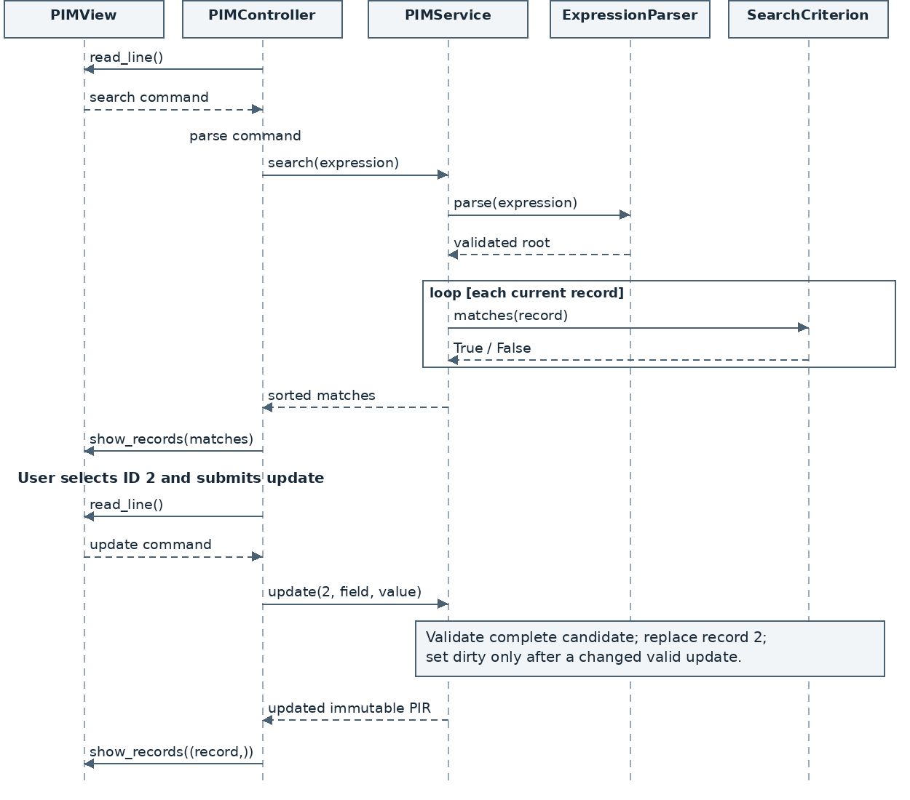
Figure 5. Search then update. Solid arrows are calls; dashed arrows are returns. The controller pulls input from PIMView and sends all model results back to the view.

10 1 Sequence explanation and alternatives
1. PIMController.run asks PIMView.read_line for a command. CommandParser.parse identifies search and preserves the expression tail. execute invokes PIMService.search. The service asks ExpressionParser to build a validated SearchCriterion tree: And(And(Type(TASK), Text(description, "COMP3211")), Time(deadline, <, T)).
2. The service calls matches(record) for each current PIR. The tree reads immutable fields, returns true or false, and the service sorts matching records by ID. The controller calls PIMView.show_records to display Tasks 2 and 7 with all their fields. A zero-match result produces an explicit message instead.
3. The user enters update 2 deadline="2026-11-25 23:59". After command parsing, the controller invokes PIMService.update(2, "deadline", "2026-11-25 23:59"). The service retrieves Task 2, combines its unchanged description with the new deadline and validates a complete replacement record.
4. A valid changed replacement is committed under the same ID, and dirty becomes true. The controller displays the returned record. Task 7 remains unchanged. Task 2 will no longer match the original deadline filter. Repeating a saved criterion also reflects this change because results are not cached.
Alternative | Required behaviour
Malformed search / unknown field | ExpressionError before evaluation; render ERROR and return to the prompt. No result set or record change.
No matching records | Display Zero matches. The user can submit a different search; do not imply that a search result exists to update.
Missing record ID | NotFoundError; retain the collection, ID counter and dirty state.
Invalid new value | ValidationError before committing a replacement. An Event start/alarm change revalidates alarm <= start.
No-change update | Return the existing normalized record; do not introduce unsaved changes.
Multiple chosen records | Submit a separate update command for each ID. Search does not implicitly update all matches.

The sequence adopts the team design’s type/text/time search scenario and explicit component calls. It uses update consistently, keeps expression parsing inside model, and replaces public record setters with one validated service operation. The Model has no display method and never calls the View.

11 State transitions and failure handling
The dirty flag describes record changes since startup or the last successful save/load. Defining criteria and searching do not affect it. ID allocation changes only on a committed creation or successful load containing a higher ID. These rules are enforced in the model so that terminal behaviour and automated calls share the same guarantees.
Event | Collection and identifier effect | Dirty effect
Start | Empty; high-water = 0. | False
Successful create | Insert new ID = high-water + 1; advance counter. | True
Changed edit / delete | Replace or remove one record; retain counter. | True
No-op edit / read / define | No record change; retain counter. | Unchanged
Invalid / declined operation | No record change; retain counter. | Unchanged
Successful save | Records and counter unchanged. | False
Failed save / declined overwrite | Records and counter unchanged; stop pending action. | Unchanged
Successful load | Replace all records; max(old counter, loaded IDs). | False
Failed load | Keep original records and counter. | Unchanged since any prior save

11 1 Guarding load and exit
When dirty is false, load proceeds directly to full file validation, and exit ends the loop. When dirty is true, the controller first asks s/d/c. Cancel stops the action immediately. Discard allows the action to proceed but does not clear memory or dirty state before a successful load. Save requests a path and completes the save flow before continuing. Any error or declined overwrite stops the pending action.
Example: dirty records A + discard + invalid file B leaves A present and dirty. Dirty records A + successful save + invalid file B leaves A present and clean. Dirty records A + failed save never attempts to load B or exit. The user can then retry save or separately choose discard.

11 2 Representative error messages
ERROR Unknown command. Expected create, update, search, ...
ERROR Invalid deadline. Expected YYYY-MM-DD HH:MM.
ERROR Event alarm must be earlier than or equal to start.
ERROR Record 99 does not exist.
ERROR Unknown criterion C9. Use criteria to list definitions.
ERROR Cannot save file: destination directory is not writable.
ERROR Invalid .pim file: duplicate record ID 7.
Expected errors are translated at the boundary where their meaning is known: parser errors identify syntax, model errors identify fields or records, and file errors identify the operation and path issue. The controller catches these errors and returns to the prompt. Unexpected programming defects are not silently reported as successful operations.

12 Traceability and verification considerations
Source requirements | Design allocation | Verification focus
US1; FR1–FR3 | PIMService; PIR inheritance | Empty startup, mixed types, persistent unique IDs and counter boundaries.
US2–US5; FR4–FR8, FR32 | Record constructors; validators; create | Required fields, normalized duplicates, confirm/refuse, past times, alarm <= start.
US6; FR9–FR10 | update; immutable records | One-field change, whole-record validation, immutable ID/type, no-op edit.
US7; FR11–FR18, FR30–FR31 | SearchCriterion tree; parser; registry; search | Operator precedence, missing fields, Unicode substrings, invalid expressions, criteria survive load.
US8–US9; FR19–FR21 | get/all_records/delete; view/controller | Full fields, ascending ID order, empty output and deletion confirmation.
US10; FR22–FR23, FR26, FR33 | PIMFileStorage.write; service.save | Unicode/leading-zero round trip, empty save, overwrite refusal and write failures.
US11; FR24–FR26 | PIMFileStorage.read; service.load | Whole-file validation, no merge, duplicate IDs, preserved current data on failure.
FR27–FR29 | CommandParser; controller.run; view | Commands and arguments, invalid command recovery, explicit exit.
FR34–FR36 | Service dirty flag; controller guard | All s/d/c branches, failed save blocks continuation, failed load after save/discard.
NFR1–NFR2 | Errors and boundary handling | ERROR prefix, correction guidance and state preservation.
NFR3–NFR5 | model package; standard-library MVC | Model calls without terminal I/O; Windows operation offline; import inspection.

12 1 Testable boundaries
Model tests can instantiate PIMService directly with a store test double and a real CriteriaRegistry. File tests use temporary directories and failure injection at the write/read boundary. Expression tests evaluate fixed records against parsed trees. These seams allow tests to check state, return values and exception types without terminal interaction or a network connection.
Important boundaries include whitespace-only search literals, underscore-only invalid record text, malformed calendar dates, year 0001, optional + and leading zeroes in mobile values, equal alarm/start times, missing fields under negation, deleted high IDs followed by loads, and duplicate contents under different saved IDs. All public mutating operations need assertions that rejected input leaves records, counter and dirty state unchanged.
This document specifies the design; it does not claim completed implementation, passing tests or achieved coverage. The project’s separate model unit tests and line-coverage report will provide that evidence. The user and developer manuals must use the command formats and module boundaries defined here. The project AI-use declaration must also reflect the assistance actually used.

13 Source comparison and resolved decisions
The three inputs serve different purposes. [R2] SRS v1.4 (handoff clarification of the selected v1.3 Word source) is the updated SRS, not a third design proposal. Its requirements take precedence over implementation choices in either design. [R3] is the team design; [R4] is Design v1.0. Sections 2–12 define one unified design, rather than alternative implementations.
Input | Strength retained | Application in this revision
[R2] Updated SRS | Precise record, expression, identity and failure rules; alarm assumption already incorporated. | FR1–FR36 and NFR1–NFR5 govern all operations, including duplicate creation and save/load guards.
[R3] Team design | Clear MVC rationale, six specialized search classes, inheritance/composition diagrams and a search/update sequence. | Adopt explicit criterion classes, redraw readable class/dependency diagrams, and use the COMP3211 scenario.
[R4] Design v1.0 | Typed interfaces, grammar, immutable records, JSON schema and defined state transitions. | Retain validated service operations, session criteria, persistence commit rules and requirement traceability.

13 1 Choices that must not coexist
Issue and source | Classification | Unified decision
Public record setters [R3] vs immutable values [R4] | Design choice with a state-tracking risk, not an automatic SRS violation. | PIMService.update is the only edit entry. Validate a full candidate before replacing; update dirty centrally.
PIR.display and View output [R3] | Responsibility overlap; returning formatted text is not itself terminal I/O. | PIR exposes business_fields; PIMView alone formats terminal output.
Controller expression parser [R3] vs model parser [R4] | Both placements can work; use one owner. | CommandParser handles command syntax; model.ExpressionParser validates and constructs criteria.
Controller and PIM both depend on storage [R3] | Two potential save/load paths; coordination ambiguity. | Controller invokes service.save/load only. PIMFileStorage is a private service dependency.
edit ID field value [R3] vs update ID field="value" [R4] | Command/interface mismatch between designs. | Use update ID field="value" in commands, diagrams and manuals. No edit alias is specified.

13 2 Gaps and consistency corrections
Finding | Resolution and rationale
Generic criteria [R4] vs six named subclasses [R3] | Adopt Type/Text/Time/And/Or/NotCriterion. All implement SearchCriterion.matches. This is internal structure; external operators remain ~, =, <, >, !, && and ||.
Duplicate confirmation is not exposed in create_pir [R3] | Add allow_duplicate plus DuplicateRecordError. A declined/failed create consumes no ID. Apply duplicate-content confirmation only to creation, as FR32 requires.
Saved expression listing is underspecified [R3] | SavedCriterion retains ID, expression text and root. Registry provides all(); service exposes list_criteria. Definitions survive loads, are immutable and are excluded from .pim.
Save/load guard contracts are underspecified [R3] | Specify overwrite confirmation, s/d/c choices, failed-save cancellation and complete validation before replacement. A failed load retains the old collection with the correct dirty state.
next_id [R3] vs high_water [R4] | Equivalent representations if next_id = high_water + 1. Choose high_water; never lower it on delete or load. Restored IDs are preserved, including a previously deleted saved ID.
ValueError / KeyError / IOError [R3] vs named errors [R4] | Use the PIMError hierarchy and a separate CommandError. Wrap expected I/O errors; controller renders ERROR with corrective detail. This is a design convention, not a new user requirement.
PIR.matches plus SearchCriterion.matches [R3] | Keep matching on SearchCriterion only. Records expose immutable typed data; avoid redundant delegation and a reverse dependency.
Several public argument types and constructors omitted [R3] | Specify constructors, parameter names/types, returns and expected exceptions in Sections 3–9. Private helpers do not form extra public APIs.
Sequence and document clarity [R3/R4] | Replace the broad MVC activity flow with a typed component sequence. Show sorted results, update one selected ID, and explain zero-match and validation failures. Use one canonical architecture figure.
Alarm scope [R2/R4] | No conflict after the SRS update: store/manage/search alarm times without automatic notifications. The assumption remains subject to instructor confirmation.

No unresolved design conflict remains among the selected interfaces and behaviours. The outstanding scope qualification is instructor confirmation of alarm notifications. These decisions establish design consistency; they are not claims that implementation, tests or line coverage have been completed.
Handoff revision 1.2 (20 October 2026) synchronizes only the user-approved permanent-EOF/input-boundary clarification and the selected SRS reference. Approved MVC, public interfaces, field/schema rules and provisional alarm scope remain. Iterative Composite evaluation is a private implementation detail preserving the designed semantics; it adds no command or feature.

14 Handoff input lifecycle clarification
This section records the explicit user decision made after the approved v1.1 design. It synchronizes the final handoff with the SRS v1.4 clarification, without changing the approved MVC architecture, public ordinary return types, command grammar, record fields or file schema. It is not presented as behaviour originally specified in v1.1. Instructor confirmation of the stored-alarm scope remains outstanding.

14 1 Normal exit and recoverable interruption
Normal exit and dirty load retain save/discard/cancel. Save permits continuation only after a genuine successful save; failure or refused overwrite stops the pending action. Discard before load does not erase the original collection before complete file validation. A failed load retains the original dirty state except that an independently completed preliminary save leaves it clean.
Catch recoverable KeyboardInterrupt only at input, confirmation and save-path boundaries. Cancel pending uncommitted input without silently discarding changes or granting consent, then return to usable input. Do not broadly catch and continue across record replacement, ID allocation, dirty updates or persistence commits. A save already completed remains completed; forced termination cannot preserve unsaved memory.

14 2 Permanent stdin closure
If stdin is permanently closed and confirmation is impossible, stop on that input failure without repeated prompting or a pending mutation. If unsaved changes exist, a private PIMView helper writes a clear English stderr warning that the session is terminating with unsaved changes. PIMController.run raises SystemExit(1), which main.py allows to determine the process status. Clean EOF may raise SystemExit(0), without claiming EOF saved anything.
Do not automatically save, overwrite any file, report a successful save or clear dirty on this path. Do not call a pending load/delete/confirmed-create retry. This is exceptional termination with unsaved changes, not user-confirmed discard. All ordinary view messages/errors remain on stdout with ERROR exactly once; the exceptional diagnostic is the explicit stderr qualification.

14 3 Verification obligations
Assert bounded input reads, stderr content, dirty nonzero status, clean status, unchanged files and no implicit confirmation or pending mutation at every input boundary. Exercise actual subprocess EOF as well as controller input doubles. Preserve truthful results after a completed save, including a later failed load or EOF. Local evidence does not complete the real Windows/offline acceptance run.

