

| Business Auction Database  **Auction Model** |
| --- |
|  |

**Contents**

1 Business Description 3

1.1 Business background 3

1.2 Problems. Current Situation 3

1.3 The benefits of implementing a database. Project Vision 3

2 Model description 3

2.1 Definitions & Acronyms 3

2.2 Logical Scheme 3

2.3 Objects 3

# 

# Business Description

## Business background

The organization in question operates as an auction house with a specific focus on the trade of antiques and artwork. It serves as an intermediary between lawful sellers (those seeking to auction their possessions) and potential buyers interested in acquiring these unique items. The company receives assortments of items from sellers and determines the most advantageous auctions for each item's presentation. Each item is assigned a lot number, akin to a product code for identification purposes. The company maintains records of auction-related information, such as auction dates, locations, times, and specific attributes related to the items, such as their age. Additionally, details about each sold item are meticulously documented, including the associated auction, lot number, seller, starting price, and a brief item description. Importantly, the system accommodates individuals or entities that can assume dual roles as both sellers and buyers.

## Problems. Current Situation

Presently, the company operates using manual and disparate procedures to manage its auction processes. Information is stored in various unconnected documents and spreadsheets, leading to challenges in efficiently monitoring items, sellers, buyers, and auction particulars. This manual approach introduces data inconsistencies, errors, and redundancies. Consequently, the organization grapples with difficulties in accurately recording transactions, tracking historical data, and making informed business judgments. Moreover, the absence of a centralized database hinders the ability to recognize market trends and optimize auction strategies.

## Benefits of implementing a database. Project Vision

The envisaged project, the implementation of an integrated database system, promises several notable advantages for the auction house:

# Model description

## Definitions & Acronyms

Seller: An entity that offers items for auction within the system.

Buyer: An entity interested in acquiring items through the auction process.

Item: A unique piece up for auction, characterized by its lot number, starting price, and description.

Auction: An event organized by the company to facilitate the sale of items, recorded with details like date, place, and time.

AuctionItem: The actual sale of an item at an auction, capturing the actual sale price.

SellerItem: A relationship entity representing the connection between sellers and the items they provide for auction.

BuyerItem: A relationship entity representing the connection between buyers and the items they have purchased.

Category: A classification label for items based on common attributes.

ItemCategory: A relationship entity establishing the many-to-many relationship between items and categories.

AuctionItemSpecifics: An entity for recording specific details related to an auction item.

## Logical Scheme

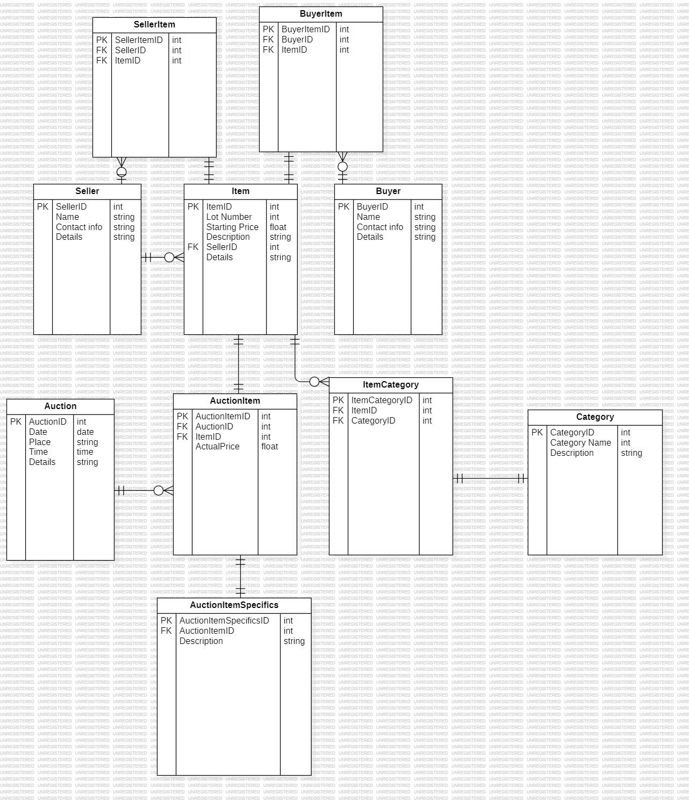

## Objects

Table Description

<description>

| Table Name | Field name | Field Description | Data Type |
| --- | --- | --- | --- |
| Seller | SellerID | PK | Integer |
| Name |  | Text |
| Contact info |  | Text |
| Details |  | Text |
| Item | ItemID | PK | Integer |
| Lot Number |  | Text |
| Starting Price |  | Decimal |
| Description |  | Text |
|  | SellerID |  | Int |
|  | Details |  | Text |
| Auction | AuctionID | PK | Integer |
|  | Date |  | Date/Time |
|  | Place |  | Text |
|  | Time |  | Time |
|  | Details |  | Text |
| AuctionItem | AuctionItemID | PK | Integer |
|  | AuctionID | FK | Integer |
|  | ItemID | FK | Integer |
|  | Actual Price |  | Decimal |
| SellerItem | SellerItemID | PK | Integer |
|  | SellerID | FK | Integer |
|  | ItemID | FK | Integer |
| BuyerItem | BuyerItemID | PK | Integer |
|  | BuyerID | FK | Integer |
|  | ItemID | FK | Integer |
| Category | CategoryID | PK | Integer |
|  | Category Name |  | Text |
|  | Description |  | Text |
| ItemCategory | ItemCategoryID | PK | Integer |
|  | ItemID | FK | Integer |
|  | CategoryID | FK | Integer |
| AuctionItemSpecifics | AuctionItemSpecificsID | PK | Integer |
|  | AuctionItemID | FK | Integer |
|  | Description |  | Text |