CFPB Data Profile — TriageIQ v1
Generated: 2026-08-29 · seed 42

Funnel
{ "narratives": 3843057, "date_window": 1639068, "min_words": 1569044, "redaction": 1444945, "template_clusters": 1105370, "product_cap": 178765, "final_sample": 40000 }

Gate verdict (Cell 3b)
- dup rate: 19.8% | sentence CV: 0.94 | TTR: 0.065
- top opener: "in accordance with the fair" (3.7%) — redaction convention, override noted
- placeholders: 1

TODO (fill by hand from cell outputs)
- Bias notes (Cell 2): ...
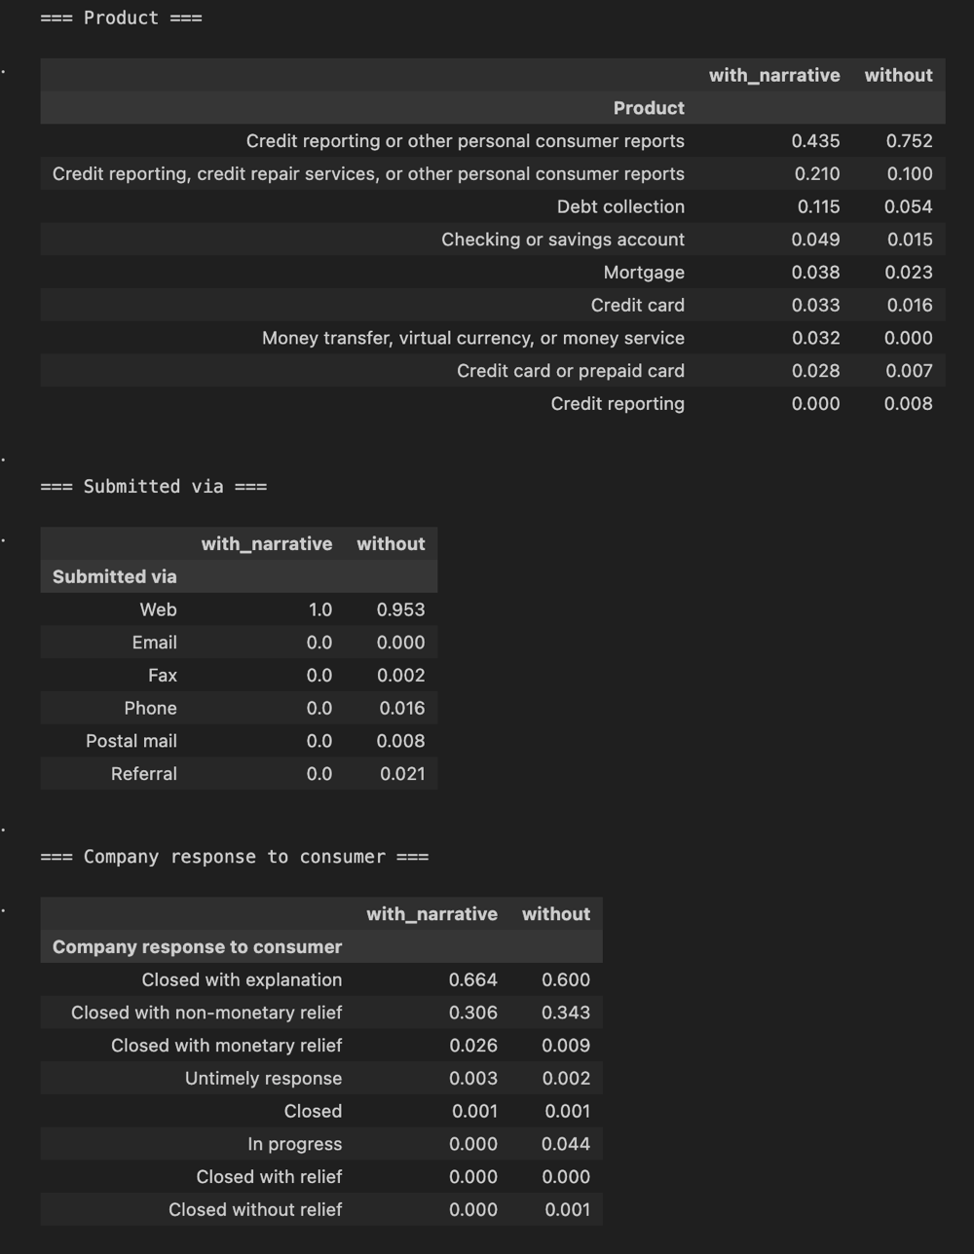

- Duplicate anatomy + dedup decision for Layer 1 CTE (Cell 4): ...
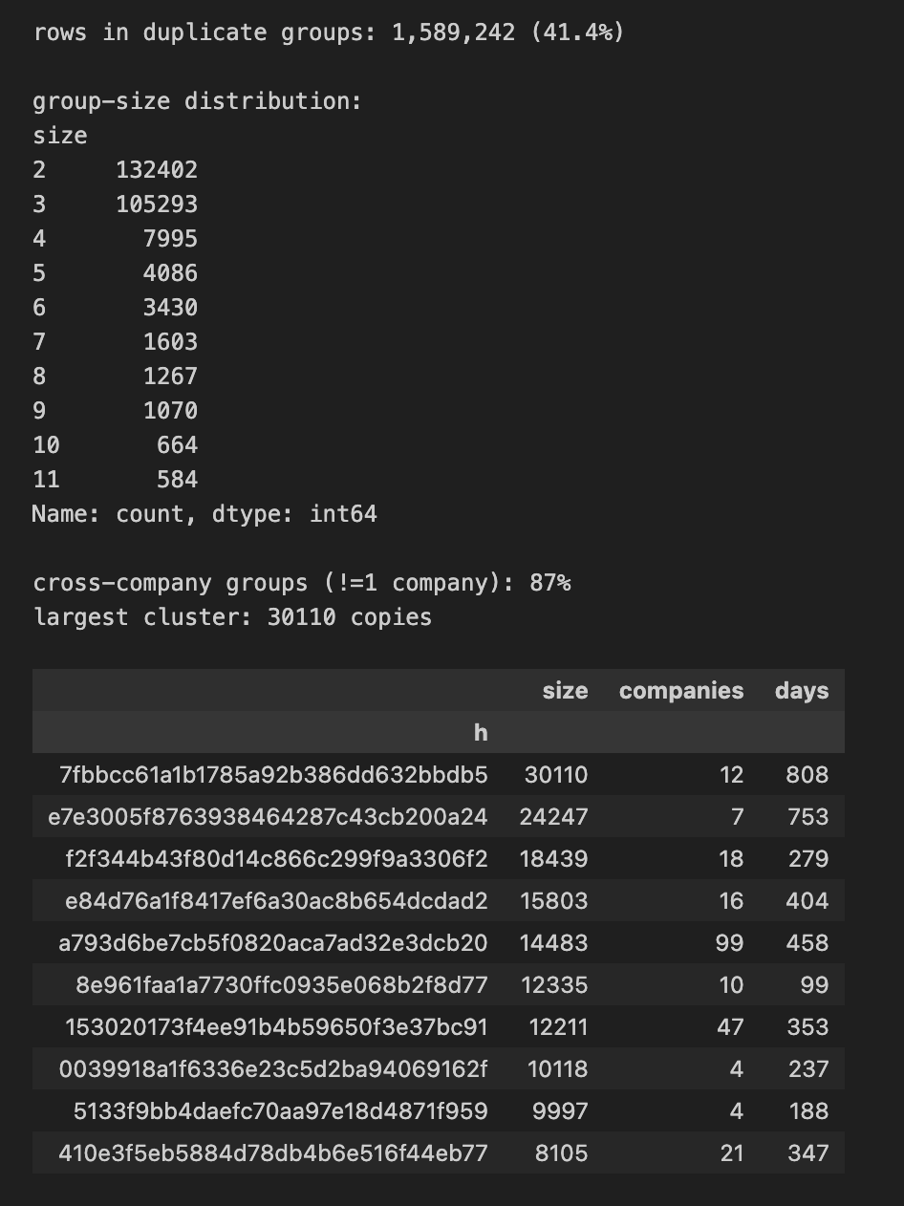

- Redaction handling decision (Cell 5): ...
narratives with ≥1 redaction: 69%
redaction density p50/p90/p99: 0.03 / 0.19 / 0.64
redaction soup (density > 0.30): 5.6%
--- worst offender ---
Thefollowingaccountsthatarelistedonmycreditreportarefraudulent.Ihavetriedtocorrectthisissuemultipletimeswithnosuccesswiththecreditbureau.XXXXXXXXXXXXXXXXXXXXXXXX,$XXXX,openedonXX/XX/XXXX.XXXXXXXX,$XXXX,openedonXX/XX/XXXX.XXXXXXXX,$XXXX,openedonXX/XX/XXXX.XXXX,$XXXX,openedonXX/XX/XXXX.XXXXXXXX$XXXX,openedonXX/XX/XXXXChapterXXXXBankruptcyDischarged,filingdateXX/XX/XXXX,referencenumberXXXX,U.S.Bankru
- Field mapping table for tickets DDL (Cell 6): ...
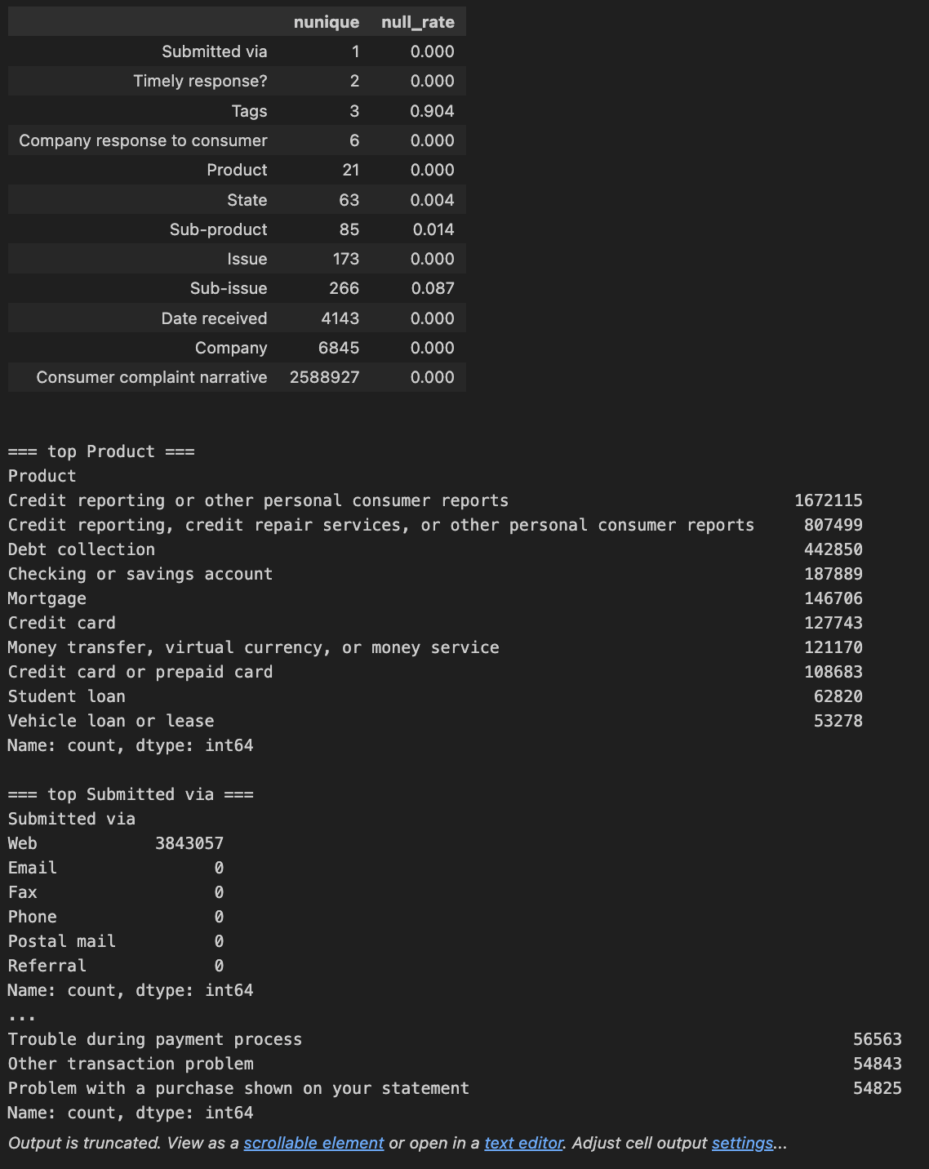

- Temporal story + why this date window (Cell 7): ...

