SMART FRAUD DETECTION PIPELINE
Using PySpark, Spark SQL, Databricks & Delta Lake
Project Report
Submitted by: Manjit Bajaj
StudentId: CT_CSI_DE_1160
B.Tech Computer Engineering
Sanjivani College of Engineering, Kopargaon

1. Executive Summary
The Smart Fraud Detection Pipeline is an end-to-end data engineering and analytics solution for processing financial transaction data and identifying transactions associated with accounts present in a fraud watchlist. It is implemented on Databricks using PySpark, Spark SQL, Unity Catalog and Delta Lake, following the Medallion Architecture with Bronze, Silver and Gold layers.
The pipeline separates raw ingestion, data quality and enrichment, fraud detection, validation and business analytics into distinct stages. Curated Gold datasets are consumed by Power BI for KPI monitoring, fraud trends, fraud-type analysis, high-risk account analysis and transaction-level investigation.

2. Problem Statement
Financial institutions process large volumes of transactions across accounts, merchants and locations. Manual inspection is inefficient and makes consistent identification of suspicious activity difficult. The project therefore builds a scalable pipeline that ingests transaction-related data, cleans and integrates datasets, applies fraud-detection rules, and produces reliable analytical outputs.

3. Objectives
- Build a scalable pipeline for account, transaction and fraud-watchlist data.
- Ingest raw CSV files into Databricks while preserving the original data.
- Clean, validate and standardize data in the Silver layer.
- Join transaction and account datasets to create enriched transaction records.
- Apply fraud-detection logic using the fraud watchlist.
- Generate Gold-layer datasets for KPIs, trends, account-level and fraud-type analysis.
- Validate processed data and analytical metrics before reporting.
- Create an interactive Power BI dashboard for business-level fraud insights.

4. Technology Stack and Why It Was Used
Table 4.1 Technology Stack used
Technology | Role | Why Used
Python | Pipeline scripting | Provides the programming environment for PySpark notebooks and reusable processing logic.
PySpark | Distributed processing | Scales DataFrame transformations, filtering, joins and aggregations across Spark resources.
Spark SQL | SQL analytics | Makes joins, aggregations, validation queries and business rules easy to express.
Databricks | Data engineering platform | Provides integrated Spark execution, notebooks, Unity Catalog, SQL Warehouses and workflows.
Unity Catalog | Governance and organization | Organizes catalogs, schemas, tables and volumes with centralized governance.
Delta Lake | Storage layer | Provides reliable Delta tables and supports consistent data processing across pipeline layers.
Medallion Architecture | Pipeline design | Separates raw, cleaned/enriched and business-ready data for traceability and maintainability.
Power BI | Visualization | Converts curated Gold datasets into interactive KPIs, trends and investigation views.

5. System Architecture
The system follows a Medallion Architecture. Source CSV files are ingested into Databricks and stored as Delta tables in Bronze. Silver performs data cleaning, standardization and enrichment. Gold applies fraud-detection logic and produces business-ready datasets. Validation and Power BI consume these curated outputs.
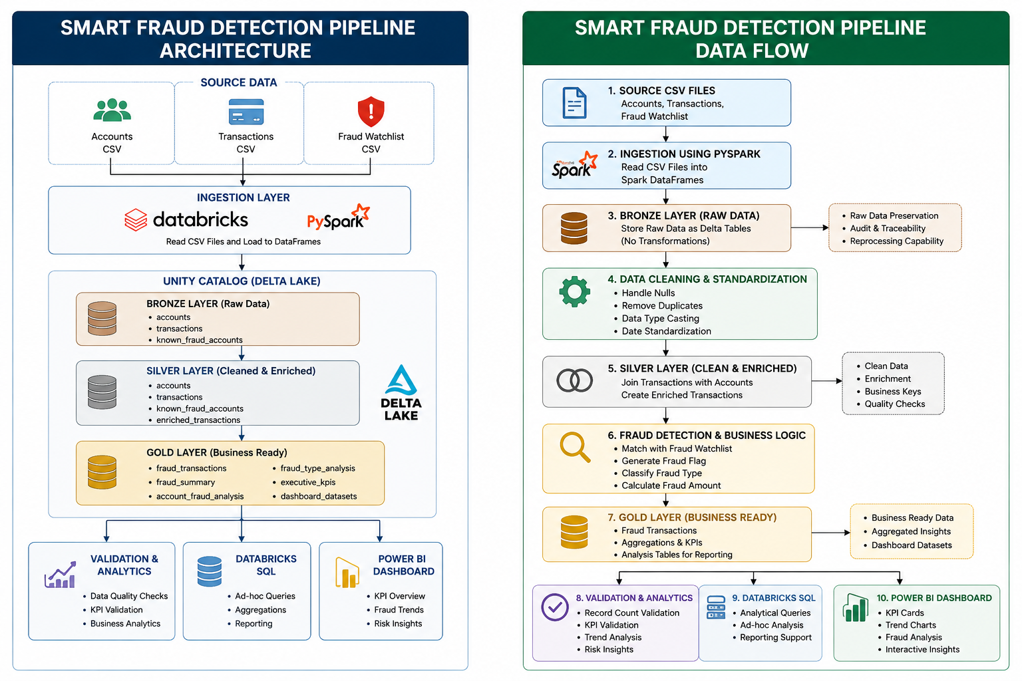
Figure 5.1. Smart Fraud Detection Pipeline Architecture and Data Flow

5.1 Architecture Components
Component | Purpose
Source Layer | Accounts, transactions and fraud-watchlist CSV files.
Bronze Layer | Raw Delta tables retained for traceability and reprocessing.
Silver Layer | Cleaned, standardized and enriched datasets.
Gold Layer | Fraud-classified transactions, KPIs and analytical datasets.
Databricks SQL | Querying, validation and analytical investigation.
Power BI | Interactive reporting and business visualization.

6. End-to-End Workflow
Step 1 - Source Preparation
Accounts, transactions and fraud-watchlist CSV files were uploaded to a Unity Catalog Volume and kept separate from processed tables.
Step 2 - Bronze Ingestion
PySpark reads source CSV files into Spark DataFrames and writes Delta tables. This preserves a reliable raw representation for traceability and reprocessing.
Step 3 - Data Cleaning
The Silver process checks schema, handles missing values according to field requirements, handles duplicates where appropriate, standardizes dates and casts numeric/string fields to suitable types.
Step 4 - Data Enrichment
Transactions are joined with account information using account_id to add customer and account context.
Step 5 - Fraud Detection
Enriched transactions are matched with the fraud watchlist. Matching records are classified as fraudulent and relevant fraud attributes are retained.
Step 6 - Gold Analytics
Business-ready datasets are created for fraud transactions, summaries, account analysis, fraud-type analysis and dashboard reporting.
Step 7 - Validation
Record counts, classifications and analytical totals are checked before reporting to reduce the risk of incorrect results.
Step 8 - Power BI
Gold datasets are connected to Power BI to create KPI cards, fraud trends, fraud-type analysis, international/domestic comparison, high-risk account analysis and transaction details.

7. Why Medallion Architecture Was Used
Layer | Reason
Bronze | Preserves source data and supports traceability and reprocessing.
Silver | Creates a trusted data foundation by separating data-quality work from business rules.
Gold | Provides business-ready datasets so reporting tools do not repeatedly perform complex engineering transformations.

8. Data Quality and Validation
- Schema and data types are checked before transformed datasets are written.
- Missing-value conditions are reviewed during silver processing.
- Duplicates are handled according to dataset uniqueness requirements.
- Date and numeric fields are standardized before analytical use.
- Join outputs are inspected to ensure account and transaction relationships are valid.
- Gold-layer fraud counts and reporting metrics are validated before Power BI consumption.
- Dashboard measures are based on defined business metrics rather than misleading aggregations.

9. Power BI Dashboard and Insights
The Power BI dashboard serves as the presentation layer of the pipeline. Curated Gold datasets are used so that data engineering logic remains in Databricks while Power BI focuses on analysis and visualization.
- Executive KPIs: total transactions, fraud transactions, fraud rate and fraud amount.
- Fraud transactions over time to identify changes and spikes.
- Fraud by type to identify dominant fraud categories.
- International versus domestic fraud comparison.
- Daily fraud-rate trend for monitoring fraud intensity.
- Top accounts by fraudulent financial exposure.
- Transaction-level details for investigation.
Metric definitions must be validated before final reporting. Fraud rate should be calculated as fraud transactions divided by total transactions, while account fraud exposure should use the sum of fraudulent transaction amounts.

10. Benefits
Benefit | Project Contribution
Scalability | PySpark distributes processing and is suitable for larger transaction volumes.
Reliability | Delta Lake provides reliable structured storage.
Traceability | Bronze preserves the ingested representation for audit and reprocessing.
Data Quality | Silver standardizes and enriches data before business logic.
Maintainability | Layer separation makes transformations easier to understand and modify.
Actionable Analytics | Gold datasets expose business-oriented fraud metrics.
Interactive Monitoring | Power BI allows filtering and exploration from KPIs to transactions.
Extensibility | Architecture can be extended with streaming, ML scoring and automated alerts.

11. Implementation Considerations
- Unity Catalog compatibility was considered during file ingestion; Unity Catalog-supported metadata fields can be used where legacy file-name functions are unsupported.
- Schema and type inconsistencies were resolved before downstream transformations to avoid runtime casting failures.
- Cleaning was performed before saving silver datasets so downstream fraud logic operates on standardized data.
- Power BI measures were reviewed independently from ETL logic so visual aggregations represent the intended business definition.

12. Future Enhancements
- Implement Spark Structured Streaming for near-real-time transaction processing.
- Introduce machine-learning-based fraud scoring alongside watchlist rules.
- Add anomaly detection for unusual amount, location, merchant and transaction-frequency patterns.
- Implement automated alerts for high-risk transactions and accounts.
- Introduce incremental processing for new or changed records.
- Add automated data-quality checks and pipeline failure alerts.
- Strengthen role-based access and governance for sensitive financial data.

13. Conclusion
The Smart Fraud Detection Pipeline demonstrates an end-to-end modern data engineering workflow for transforming raw financial datasets into structured fraud intelligence. PySpark and Spark SQL provide distributed processing, Databricks and Unity Catalog provide the engineering and governance environment, Delta Lake provides reliable storage, and Power BI provides interactive business analytics.
The separation of Bronze, Silver and Gold responsibilities improve traceability, data quality and maintainability. The resulting architecture provides a strong foundation for future enhancements such as streaming ingestion, machine-learning risk scoring, automated alerting and enterprise-scale monitoring.

14. Project Deliverables
- Databricks notebooks for Bronze, Silver, Gold and validation/analytics processing.
- Unity Catalog schemas, volumes and Delta tables.
- Databricks workflow for sequential pipeline execution.
- SQL queries for transformation and validation.
- Power BI fraud analytics dashboard.
- Architecture and data-flow diagrams.
- Implementation screenshots and project documentation.

