

Dr. D. Y. Patil Pratishthan's College of Engineering Salokhenagar, Kolhapur

2023-2024

DEPARTMENT OF COMPUTER SCIENCE & ENGINEERING

(DATA SCIENCE)



PROJECT REPORT ON

“ONLINE STUDENT FEEDBACK SYSTEM”

Submitted by:

|  |  |
| --- | --- |
| Name | Roll No. |
| Mr. Swarup A Patil | 51 |
| Miss. Disha S Shinde | 70 |
| Miss. Revati S Patil | 48 |
| Miss. Darshana K Phalke | 54 |

## Under the Guidance of

Prof. S. S. Laykar



Dr. D. Y. Patil Pratishthan's College of Engineering Salokhenagar, Kolhapur

2023-2024

DEPARTMENT OF COMPUTER SCIENCE & ENGINEERING (DATA SCIENCE)





Certified that the Project topic entitled “ONLINE STUDENT FEEDBACK SYSTEM” a bonafide work carried out by Swarup Patil, Disha Shinde, Revati Patil, Darshana Phalke in partial fulfilment for the award of Degree of Bachelor of Technology in 8th Semester of the SHIVAJI UNIVERSITY, KOLHAPUR during the year 2023-2024. It is certified that all corrections/ suggestions indicated for Internal Assessment have been incorporated in the report deposited in the Department Library. The Project report has been approved as it satisfies the Academic requirement in respect of Project work prescribed for BACHELOR OF TECHNOLOGY DEGREE.

|  |  |  |
| --- | --- | --- |
| Prof. S. S. Laykar | Dr. S. D. Bhopale | Dr. Suresh D. Mane |
| (Guide) | (H.O.D) | (Principal) |

EXAMINERS SIGNATURE WITH DATE

1.

2.

# DECLARATION

We, the undersigned, students of B.Tech. Computer Science and Engineering (Data Science) declare that the project work report entitled **“ONLINE STUDENT FEEDBACK SYSTEM”** written and submitted under the guidance of Prof. **S. S. Laykar**. The empirical findings in this report are based on the data collected by us. The matter assimilated in this report is not reproduction from any readymade report.

Place: Salokhenagar, Kolhapur

Date:

Yours Sincerely, Sign

Mr. Swarup A Patil Miss. Disha S Shinde Miss. Revati S Patil

Miss. Darshana K. Phalke

# ACKNOWLEDGEMENT

*The sense of contentment and relation that accompanies the successful completion of the project* ***“ONLINE STUDENT FEEDBACK SYSTEM”*** *would be incomplete without mentioning the names of those people who helped us in accomplishing the project. Those*

*people whose Constant guidance and encouragement resulted in its realization.*

*We take this opportunity to thank our Campus Director* ***Dr. A. B. Mane*** *for providing a constant support and resources that helped us in completing the task.*

*We take this opportunity to thank our Principal* ***Dr. S. D. Mane*** *for providing a healthy environment in the college that helped us in concentrating on the task.*

*We express a deep sense of gratitude to our* ***H.O.D Prof. S.D. Bhopale*** *for providing the inspiration required for taking the Project to its completion.*

*We convey our heart full thanks to our guide* ***Prof. S. S. Laykar*** *for the guidance and inspiration they had given during the course of completion of our project. We also thank all the staff member, teaching and non-teaching for helping us to accomplish this project.*

# CONTENTS

## INTRODUCTION Page No.

* 1. Introduction 1
  2. Need of project 3
  3. Methodologies 4

1. LITERATURE SURVEY
   1. Literature Survey 5
2. PROPOSED SYSTEM
   1. Proposed System 6
3. EXISTING SYSTEM
   1. Existing Systems 13
4. SYSTEM ANALYSIS
   1. Problem Statement 9
   2. System Requirements 9
      1. Software Requirements 9
      2. Hardware Requirements 9
5. SYSTEM DESIGN
   1. Use Case Diagram 10
   2. State Diagram 11
   3. Activity Diagram 12
   4. System Design 13
   5. Sequence Diagram 14
6. SYSTEM IMPLEMENTATION
   1. System Implementation 15
   2. Snapshots 16
7. SYSTEM TESTING
   1. System testing 26
      1. Test Results 26
8. APPLICATIONS
   1. Applications 30
9. CONCLUSION
   1. Conclusion 31
10. FUTURE WORK
    1. Future work 32
11. REFERENCES
    1. References 33

**Fig. No. Description Page no.**

* 1. Proposed Diagram 6
  2. Use Case Diagram 10
  3. State Diagram 11
  4. Activity Diagram 12
  5. System Design 13
  6. Sequence Diagram 14
  7. System Implementation 15

**“**ONLINE STUDENT FEEDBACK SYSTEM” is used to get the feedback from the students. It generates the reports for the faculty on the basis of feedback given by the students. The total report is visible to the admin. It contains the modules like student and admin. Admin is the responsible for creating a class and assigning the corresponding faculty to the class. Admin can add, remove students, faculties, class, academic year, questions. The system is web based that can be accessed throughout by institution or a specified department. Online student feedback system will be helpful to maintain and facilitate easy access to information. In existing system all work is done manually and has paper work.

Within short time we can get the performance of the faculty from the student point of view. There are 8 questions to evaluate the status of faculty and each question contains 5 options like Strongly agree, agree, uncertain, disagree, strongly disagree. System generates report for faculty based on student feedback. Report contains Percentages of each question as per the category. It generates bar graph of percentage vs categories. Finally generates either appreciation or improvement letter for respective subject and faculty.



**CHAPTER 1 INTRODUCTION**

## Introduction

A Student Feedback System is an automatic feedback generation system that provides the proper feedback to the teachers as per the categories like strongly agree, agree, uncertain, disagree, strongly disagree. In the existing system students can give feedback about the lecturers by doing manually. By this process student can give feedback in online system without wasting his time in writing. After giving feedback by every student data are collected by the faculty and calculated the overall grade for each subject and each lecturer.

The main aim of this system is to develop online feedback which covers all the details of students

i.e. Academic year, department, semester, subjects, students, faculties, admin. But there are two main modules of this system like students and admin. The proposed system reduces the time, the paperwork, manual labour as well as communication cost. The modules are as follows: -

## Admin Module:

* Admin can add any no students based on student details like school ID, name, class, email and password is assigned by admin to each student.
* Admin can add faculty based on faculty details like school ID, name, email and password is assigned by admin to each faculty. Later at the time of feedback collecting each teacher assigned with one or multiple subjects.
* Per department admin can add Classes like FY, SY, TY and B. Tech in classes module. (for e.g. CSE(DS) – B. Tech)
* Admin can add subjects. With subject code, subject name and little bit description about subject.
* Adding Questionaries is important task done by admin. While adding Questionaries we can add it by year and semester. (for e.g. year 2023-24, semester 8)
* Admin can add or remove Student, Faculty, Classes, Subjects, Academic Year, Questionnaire, generate report based on evaluation of feedback given by students.
* Admin have an access to generate appreciation or improvement letter for faculty member based on student feedback given to particular faculty.

## Student Module:

* On student dashboard student can check feedback status like started, closed.
* When feedback is live student can login to the system and give feedback to respective faculties.

## Database:

* It will be used to maintain the data required for student feedback system.

## Need of Project

* + - Student feedback is an important key to overcome the many problems related to the college education process.
    - Student feedback is necessary to improve the lecturers’ teaching, infrastructure, library and other facilities. If the proper evaluation has taken, then the student beneficial programs can be run.
    - To obtain this the feedback plays a vital role. In the past time, the feedback was taken manually, in that the time was more consumed as well as the analysis of feedback was not accurate.
    - The system is web based that can be accessed throughout by institution or a specified department.
    - Online student feedback system will be helpful to maintain and facilitate easy access to information.

## Methodologies

The online student feedback system consists of two modules student, admin.

Firstly, the admin has to login with his email and password and then he can add the subjects, classes, academic year, questionnaire, feedback criteria, faculties, students, admin level users and generate report in the feedback system. Then the student will be able to login with email id and password which is assigned by admin later students have the right to change the password after login to the student module, in the student module, where the dashboard page of the student is created. After this, the student will now able to give the feedback to both the faculty. The student has to give feedback for different faculty. Because the feedback is stored for one faculty at a time then he/she has to select other faculty. The faculty will be selected as per semester.

1. Student: It will be used by the student to give the feedback by using his login credentials.
2. Admin: This module provides the functionalities like add, delete, modify the content of the faculty and updating the format of report generations.

The last module is the Admin. Admin has the right to add the faculty, remove the faculty and student. Admin has also managed the student, faculty. Admin also has seen the feedback. Admin has a count of the total number of the student who gives the feedback. Also, admin has the right to check the Average feedback of each faculty. In admin, the last is report generation for faculty members using average feedback of each faculty.



**CHAPTER 2 LITERATURE SURVEY**

Online Student Feedback System

## Literature Survey

The researchers all over the world are also working in this area. Also, many researchers are working on mobile technology and embedded system for college management related system to

make the campus smart. Now-a-days, education is playing very significant role in the society. This system provides an overview of existing studies and trends in this field, highlighting key findings and identifying gaps for further research. Maintaining the records manually leads to error prone and required more man power and it consumes more time for processing the records. The system

provides guidance to the admin to keep track of each student, faculty, year, classes, semester and questionaries. The admin to have the access to the database of system. In an educational related system is crucial thing. So in order to reduce the efforts of staff we are introducing our system.

1. ISSN No: -2456-2165 [1] Implementation of an Online Student Feedback System aims to streamline feedback collection, enhance analysis efficiency, and improve overall college quality across faculties and facilities. –
2. ISSN: 2456-8880 [2] The Student Feedback System collects student input, generates faculty reports, and allows staff access with unique credentials. Administrators oversee class creation and faculty assignments. Results are visible to higher authorities and include 15 questions assessing faculty performance with five response options.
3. e-ISSN:2582-5208 [3] The web-based Online Feedback System facilitates digital feedback collection, review, and analysis for colleges. It features three modules: admin, faculty, and students, serving to enhance institutional quality through genuine feedback.
4. ISSN: 2278-0181 [4] This study develops a web-based feedback system for assessing academic staff in higher education institutions, following the waterfall model. It utilizes

HTML for the frontend, NoSQL for the database, and PHP for data processing. This system aims to enhance academic staff performance, especially in developing countries like Nigeria, where such systems are lacking.

1. ISSN: -2321-9653 [5] From This paper we understood how to manage Database records and maintain tables.



**CHAPTER 3 PROPOSED SYSTEM**

## Proposed System

* 1. **Proposed Diagram:**

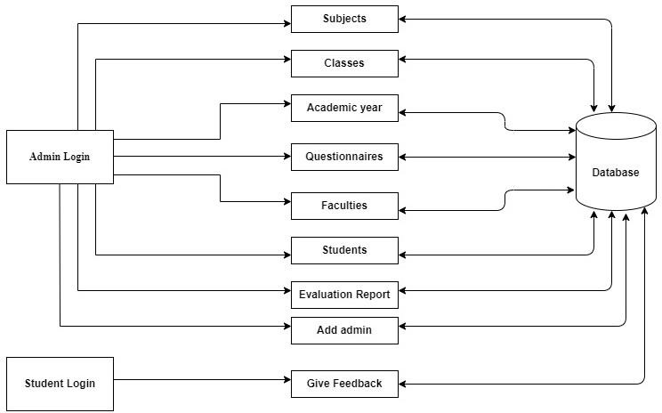

**Fig. 3.1 Proposed Diagram for web Portal**

* 1. **Modules:**

The modules are as follows: -

## Admin:

The administrator holds the highest authority and is empowered to:

* + - Manage faculty,
    - Manage students,
    - Manage classes, academic years, subjects, and questions,
    - Initiate or conclude feedback processes for specific years, classes, and semesters,
    - Review feedback provided by students,
    - Dynamically update contact details,
    - Update passwords,
    - Manage reports.

Additionally, the administrator can generate evaluation reports for faculty based on student feedback.

These reports include graphs to facilitate understanding of the distribution of positive and negative feedback received by each faculty member and their respective subjects.

## Student:

* + - View profile: This feature allows students to access and review their profile information.
    - Manage profile: With this feature, students can modify and edit their profile details as needed.
    - Update password: Students can utilize this feature to change and reset their passwords for enhanced security.
    - Choose feedback: This feature enables students to select feedback which is available at feedback page.
    - Give feedback: Students can provide feedback for each question, ensuring a thorough evaluation process.



**CHAPTER 4 EXISTING SYSTEM**

Online Student Feedback System

## Existing System:

In the existing manual system of student feedback system in educational institutions, if the students need to give feedback, they are supposed to submit a feedback application to the HOD

concerned. After receiving consent from the HOD concerned, the HOD needs to submit the feedback application to the principal. If the HOD or the Principal is not available, then the students cannot get consent for their feedback application and this whole record use to maintain on paper and files so

there might be chances of missing. Drawbacks of existing system-

* + - Inaccuracy
    - Time consuming
    - Difficulty to maintain records.

So, from above, this new system is developed to overcome all the drawbacks and limitations.

The problem statement is to develop an efficient and user-friendly Student Feedback System that leverages technology to gather, process, and act upon student feedback can be accessible over the internet. The data tier employs MySQL for database management, handling data storage, retrieval, and various database operations. The presentation tier utilizes HTML, CSS, and JavaScript for GUI development.



**CHAPTER 5 SYSTEM ANALYSIS**

Online Student Feedback System

## System Analysis

## Problem Statement

In educational institutions, collecting and analysing student feedback is a crucial process to ensure the quality of an education and maintain a positive learning environment. Traditionally, this feedback has been collected through paper surveys, which are time-consuming, less efficient, and often result in a delayed response to students' concerns. The problem statement is to develop an efficient and user-friendly Student Feedback System that leverages technology to gather, process, and act upon student feedback.

## System Requirements:

## Software Requirements:

Sublime text editor

PHP (code ignitor framework) HTML, CSS, JavaScript, BootStrap XAMPP

MySQL

## Hardware Requirements:

Minimum 1GB RAM

Minimum 10GB Hard disk

1 gigahertz (GHz) or faster 32-bit (x86) or 64-bit (x64) processor



**CHAPTER 6 SYSTEM DESIGN**

## System Design

## Use Case Diagram:

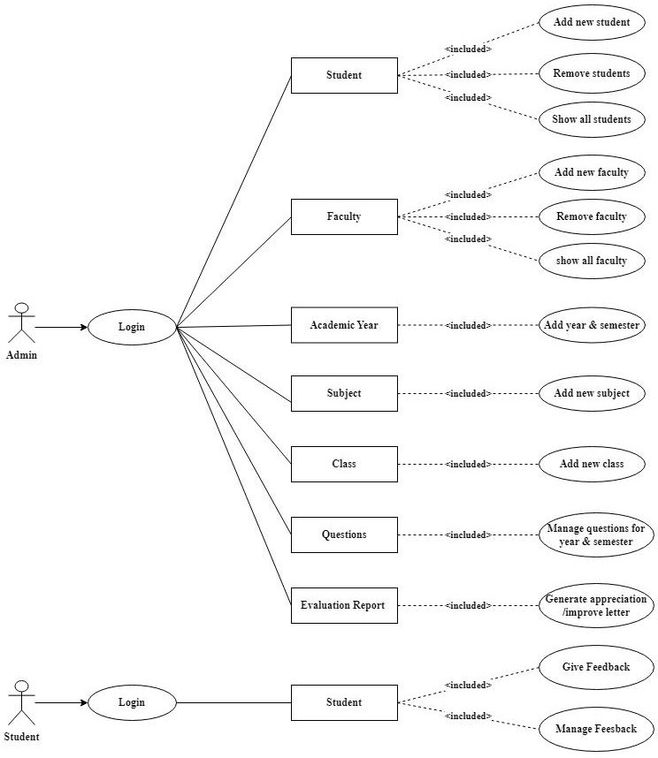

**Fig. 6.1 Use Case Diagram**

In above fig. 6.1, the admin can login into the system and can access through data. Admin can access the student’s data, faculty data, feedback data and questions management. Students can access feedback and fill and manage it.

## State Diagram

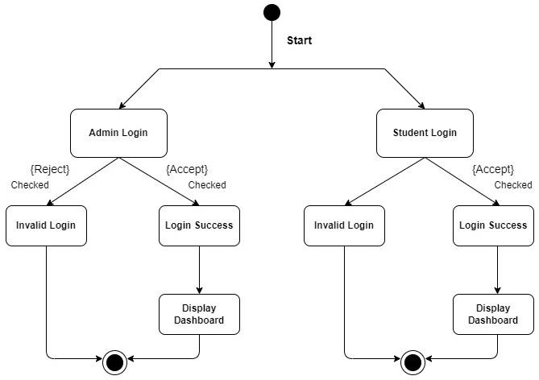

**Fig 6.2 State Diagram**

In above fig. 6.2, Admin and students can login successfully and go to the display dashboard and can logout after access. If the login is invalid then admin and students are rejected to get access.

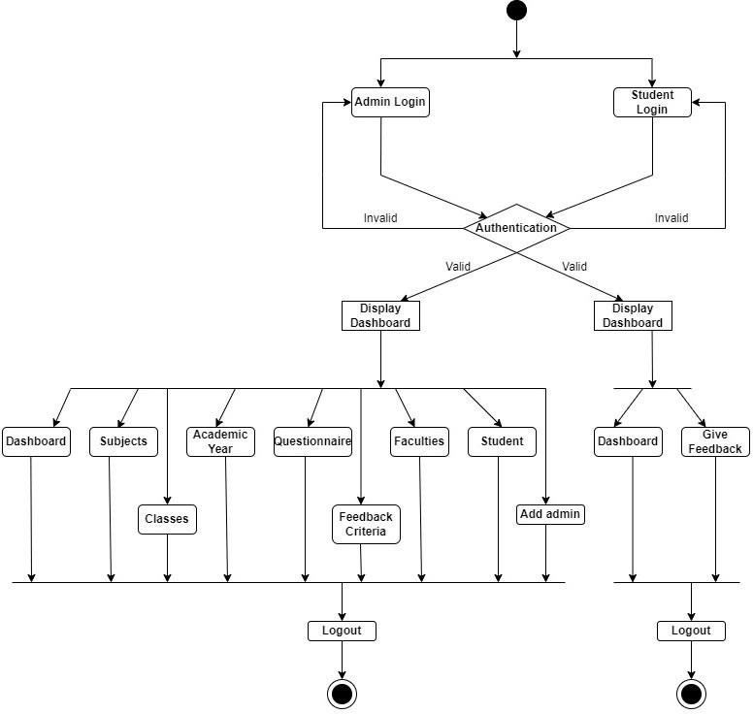

## Activity Diagram

**Fig. 6.3 Activity Diagram**

## System Design

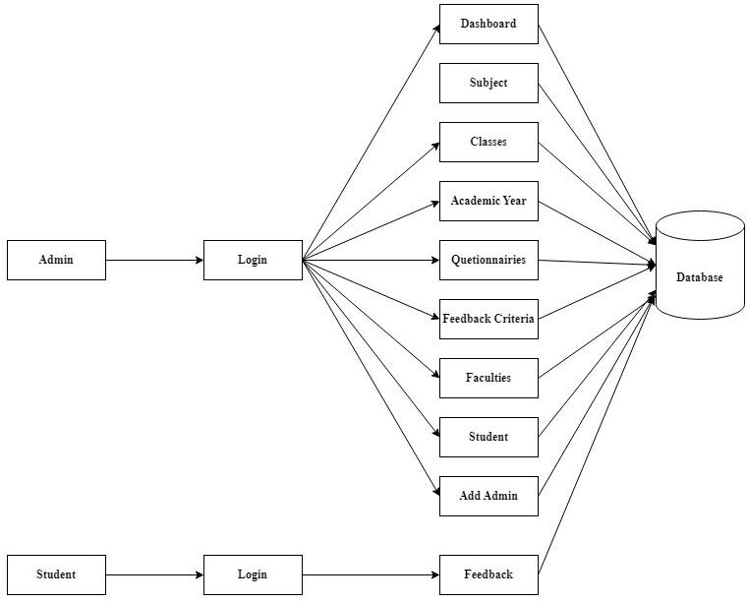

**Fig. 6.4 System Design**

## 6.5 Sequence Diagram

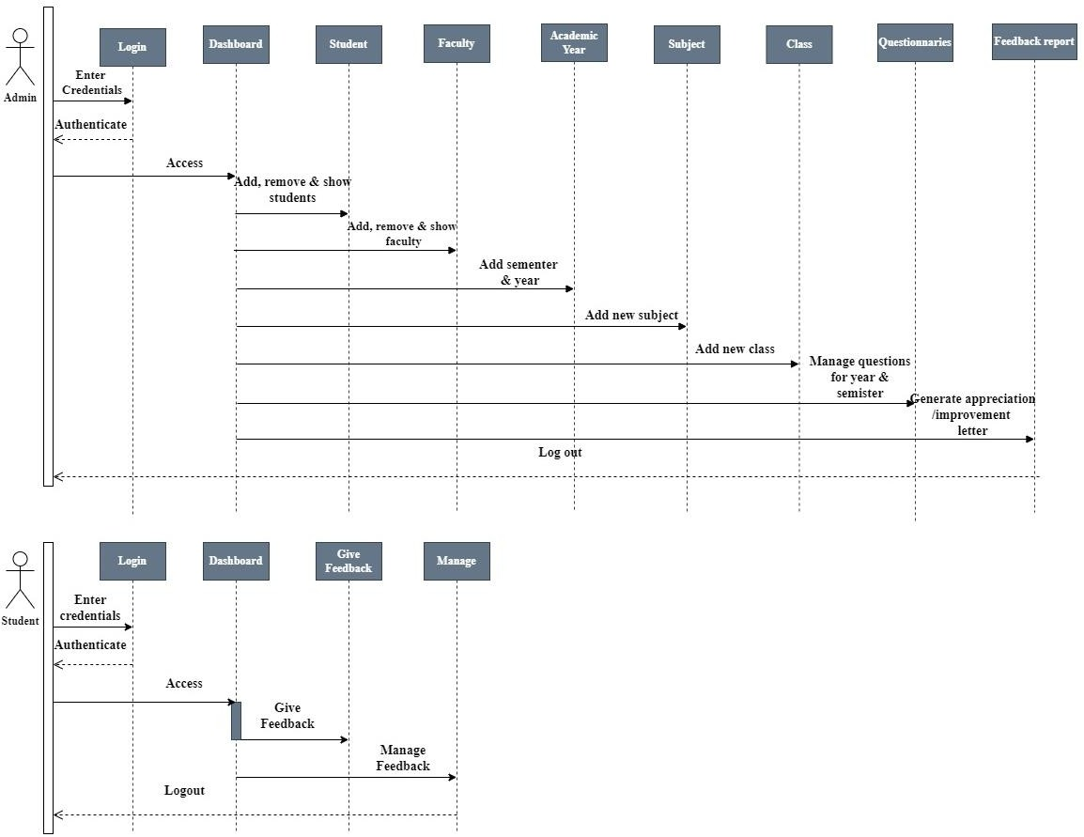

**Fig. 6.5 Sequence Diagram**



**CHAPTER 7 SYSTEM IMPLEMENTATION**

## System Implementation

## System Implementation:

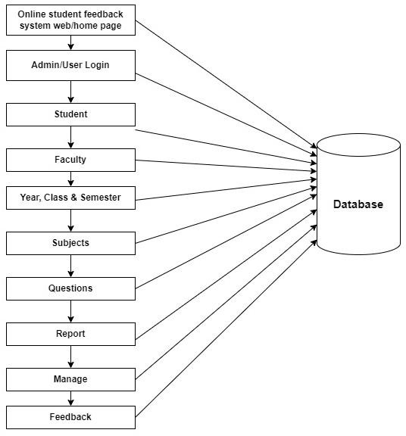

**Fig. 7.1 System Implementation**

## Snapshots

* + 1. **Admin Login Home Page:**

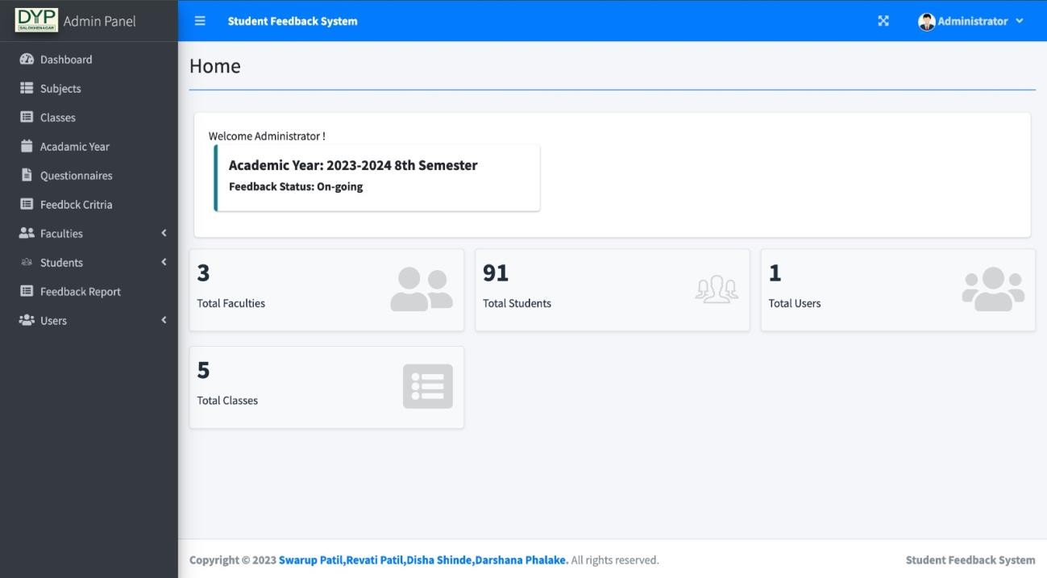

**Subjects:**

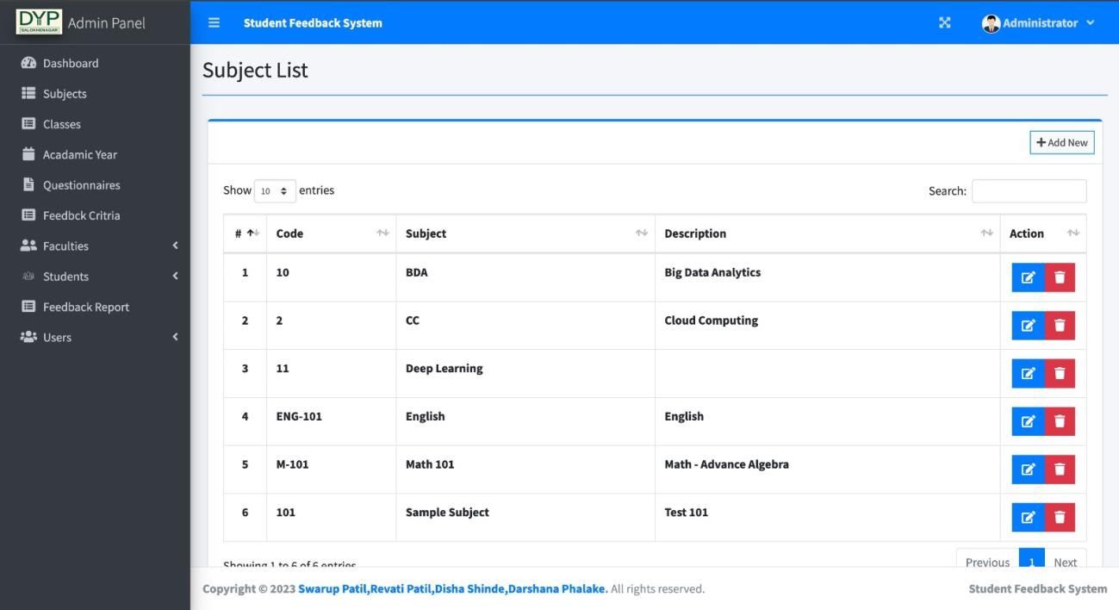

**Classes:**

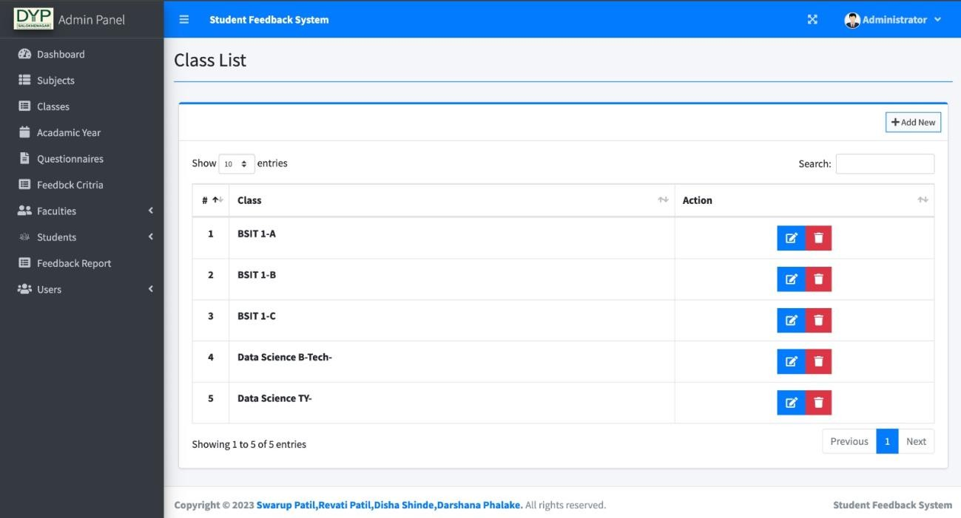

**Academic Year:**

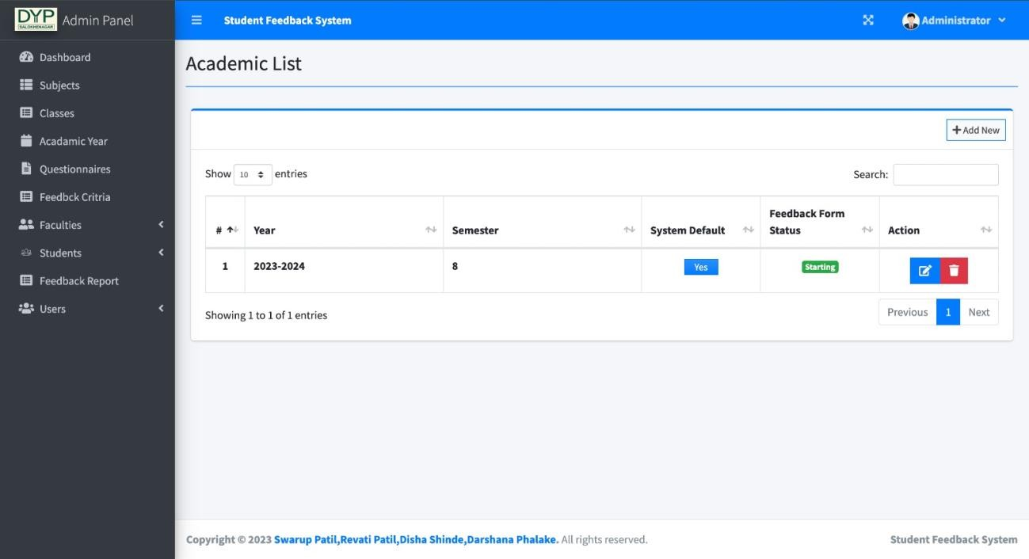

**Questionnaire:**

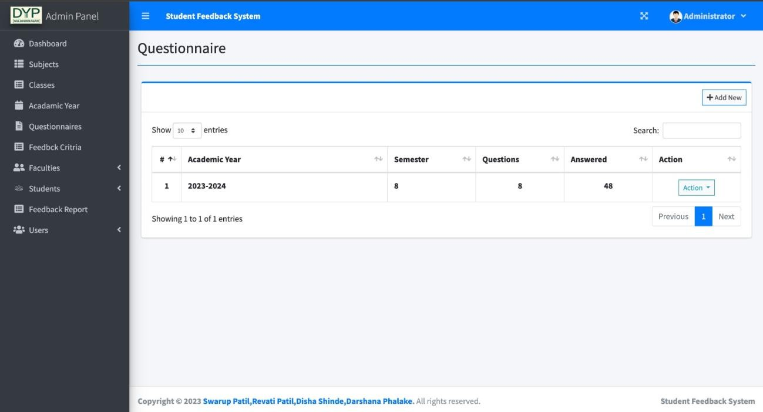

**Feedback criteria list:**

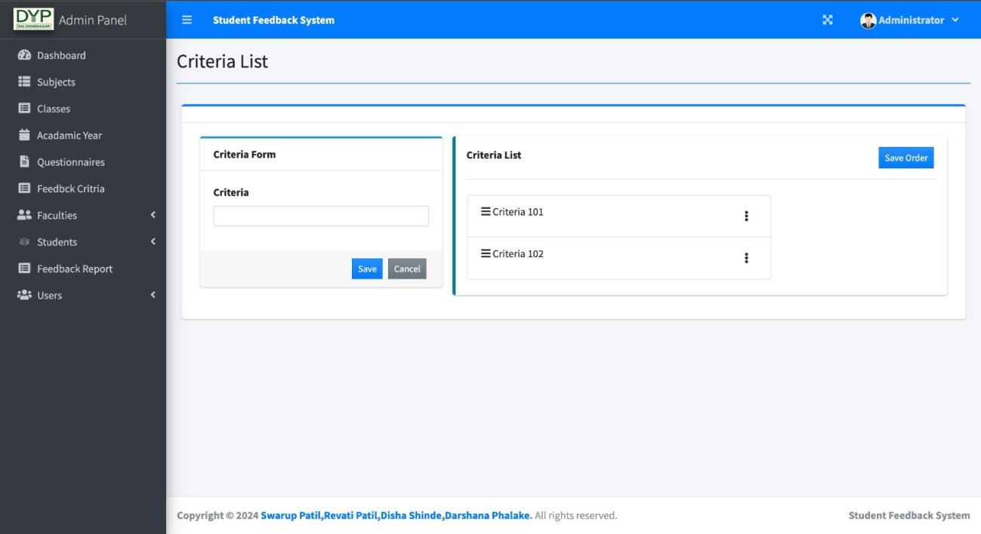

**Faculties:**

* + - 1. **Add new faculty:**

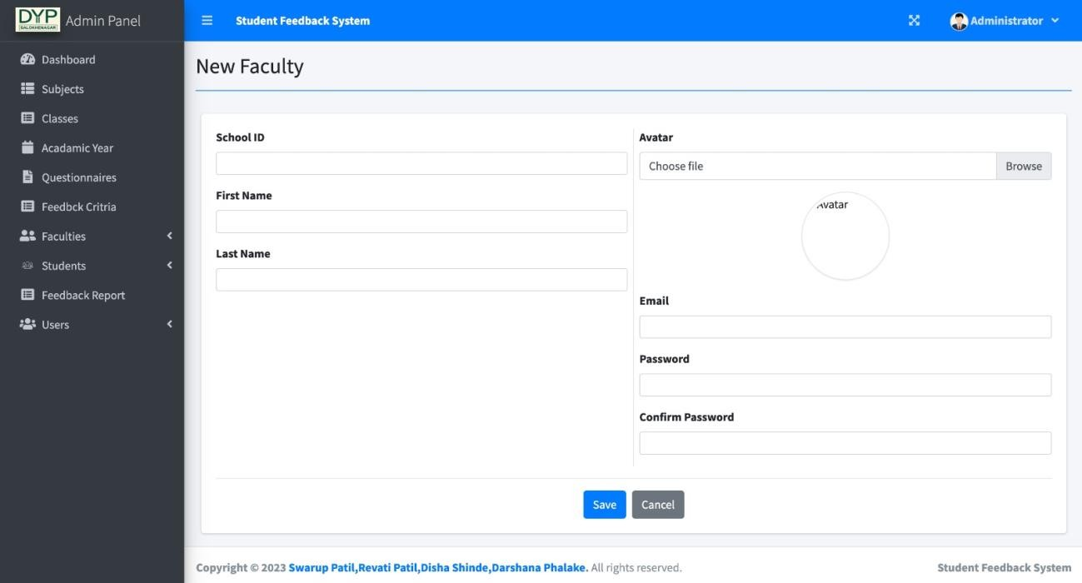

* + - 1. **Faculty List:**

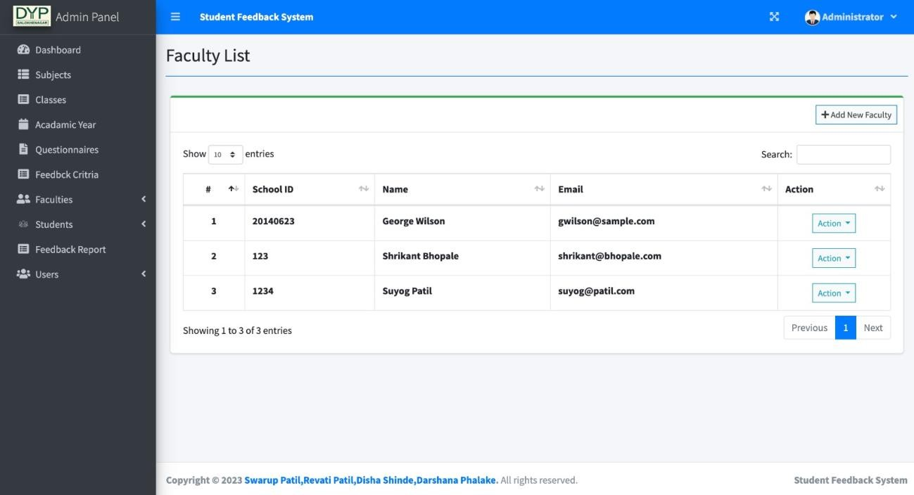

**Students:**

1. **Add new student:**

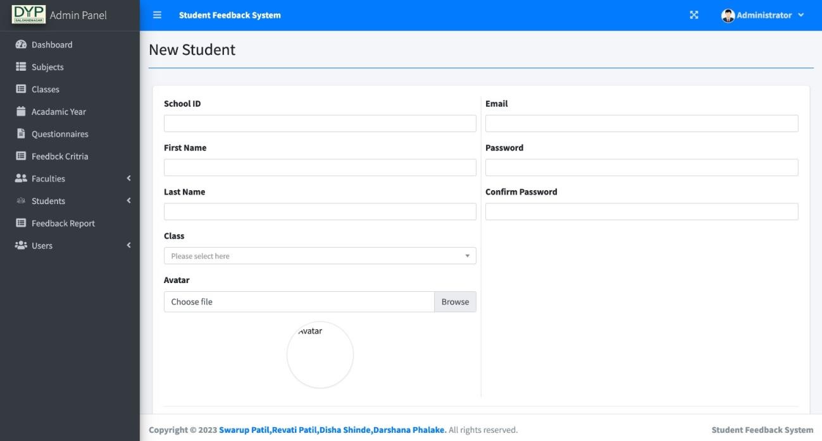

1. **Student List:**

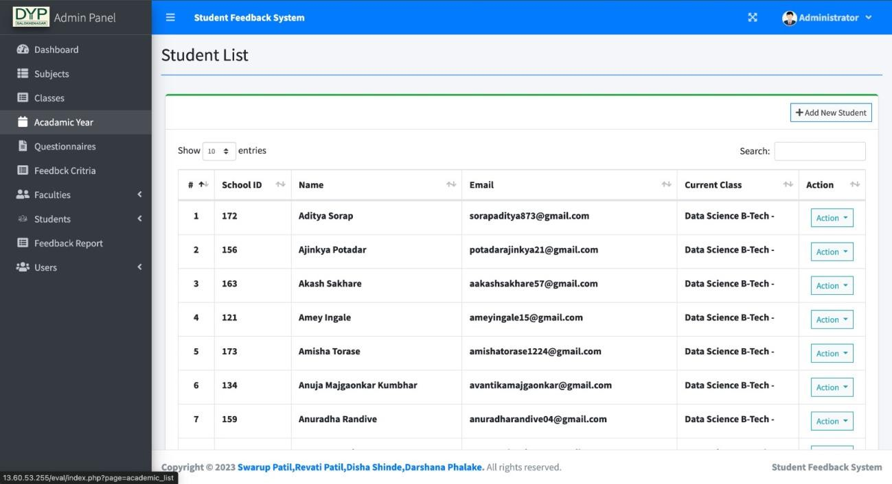

**Add admin/user:**

1. **Add new admin user:**

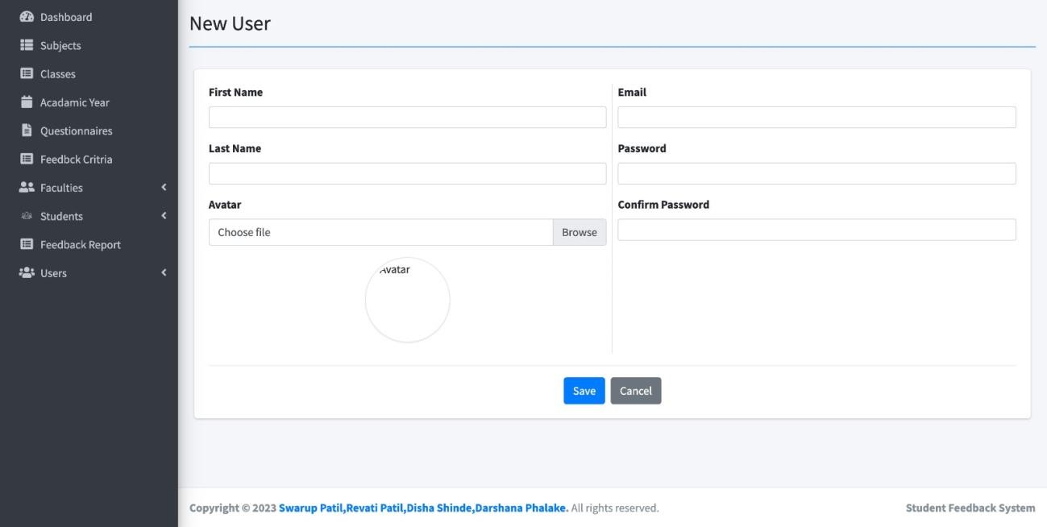

1. **User list**

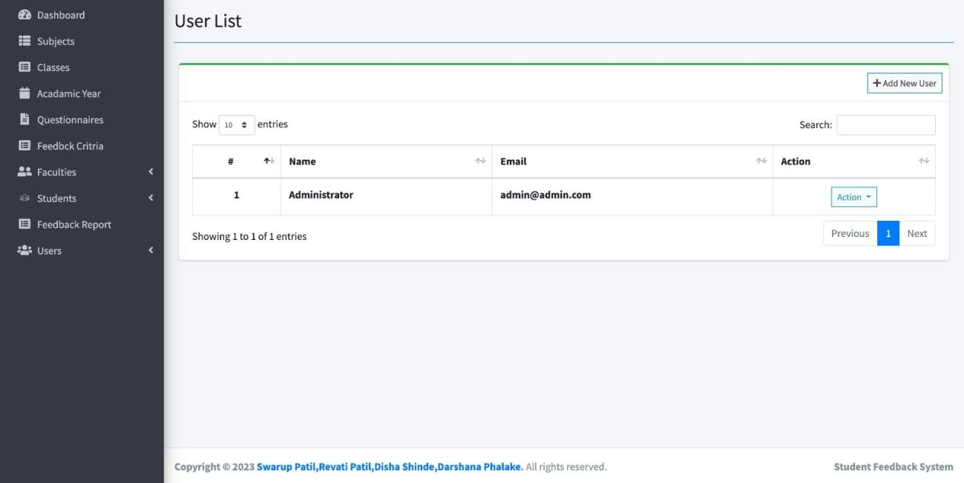

* + 1. **Student Login Home page:**

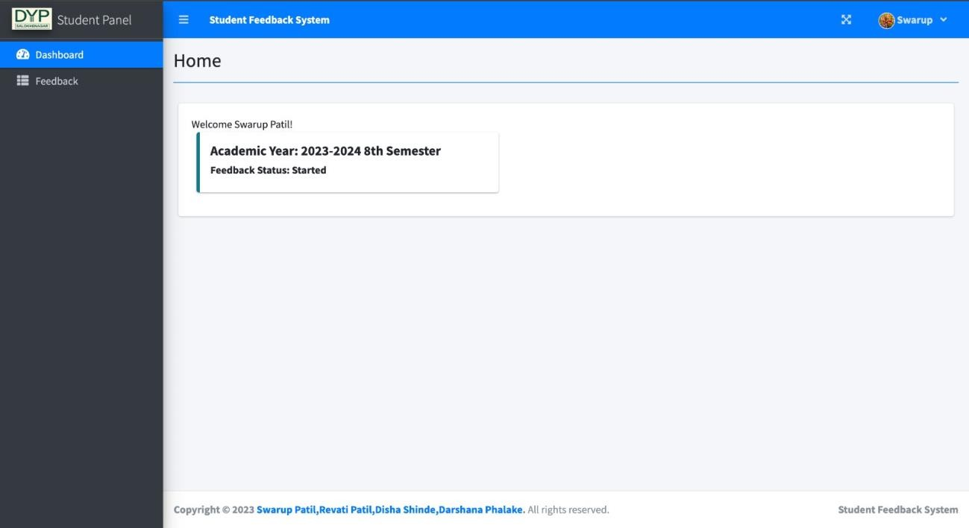

**Manage feedback**

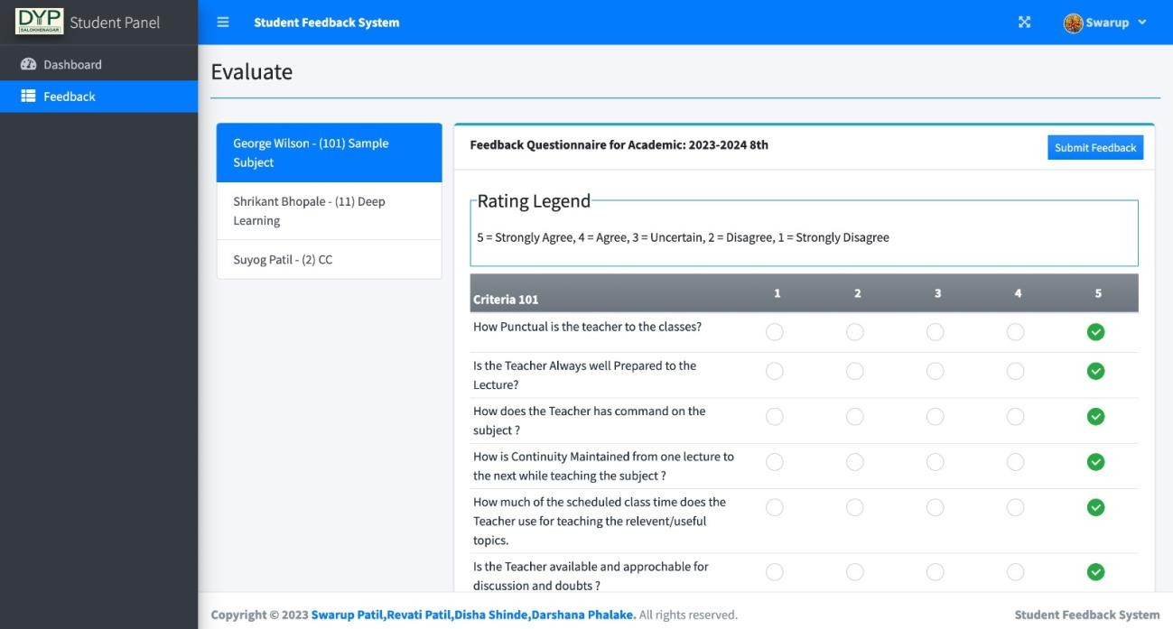

**Report generated after Feedback Analysis:**

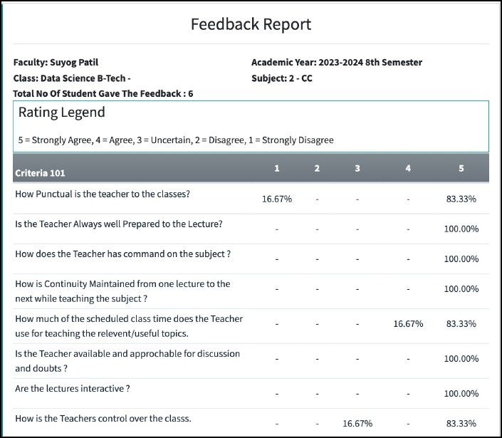

**Bar chart:**

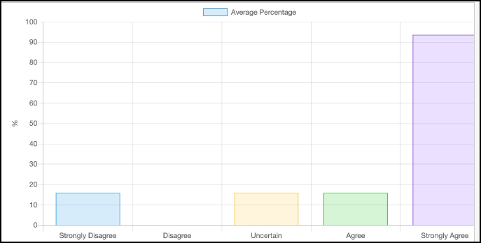

**Appreciation Letter:**

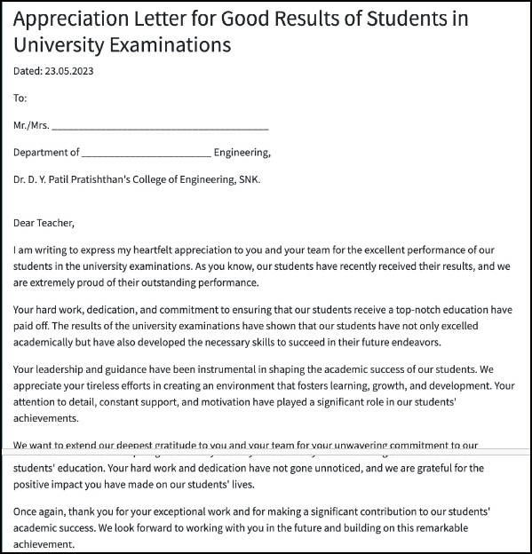

Appreciation letter generated after student’s feedback for the performance of the teacher.



**CHAPTER 8 SYSTEM TESTING**

## System Testing

## System Testing:

System Testing is a level of software testing where complete and integrated software is tested. The purpose of this test is to evaluate the system’s compliance with the specified requirements. The process of testing an integrated system to verify that it meets specified requirements.

* 1. **Test Results:**
     1. **Test Cases for Admin Panel:**

|  |  |  |  |  |  |
| --- | --- | --- | --- | --- | --- |
| **Test Case ID** | **Test Case Objective** | **Test Data** | **Expected Result** | **Actual Result** | **Status** |
| TC 01 | Check the validity of Username and Password | Username and Password | It will Accept usernames with special symbols, minimum length 1 character. Passwords should include a combination of alphabets, numbers, and special characters. Upon clicking, the main page displays. | Accept usernames with special symbols,  minimum length 1 character.  Passwords should include a  combination of alphabets,  numbers, and special characters. Upon clicking, the main page displays. | Pass |
| TC 02 | Add new Subject | Subjects Related data like subject  code, name and  description | I will accept Subject names and codes, minimum length 01 character. Three options for subject details:   1. Add: Add subject entry. 2. Delete: Remove subject entry. 3. Update: Modify subject details. Save changes with   "Save" option. | Subject names and codes accepted, minimum length 01 character. Three options:  Add: Add subject entry.  Delete: Remove subject entry. Update: Modify subject details. | Pass |

|  |  |  |  |  |  |
| --- | --- | --- | --- | --- | --- |
| TC_03 | Add new Classes | Classes Related data like  curriculum,  year level and section. | It will accept Class name, curriculum, year level, and section accepted with minimum length 01 character. Three options for class details:   1. Add: Save class entry. 2. Delete: Remove class entry. 3. Update: Modify class details. Save changes with   "Save" option. | Class names and codes accepted, minimum length 01 character. Three options:  Add: Add Class entry.  Delete: Remove Class entry.  Update: Modify Class details. | Pass |
| TC 04 | Add new  Academic Year | Academic Year data year,  semester, feedback form status | It will accept Academic year name and semester min. length 01 character, and feedback form status (started, pending, closed) accept. Three options for academic year details:   1. Add: Save entry. 2. Delete: Remove entry. 3. Update: Modify details. Save changes. | Name of the Academic Year, semester is accepted as with at least the character length 01, The three options are made available on the availability of the Academic  Year, semester entry is made. | Pass |
| TC 05 | Add Questionnaire | Questionnaire – set of proper  questions according to criteria. | It will accept Name of criteria and a question as with at least the character length 01, The three options are made available on the availability of the subject details:   1. click add button the question entry is saved 2. click delete button the question entry is deleted. 3. click edit button the question changes are updated. | Question is accepted as with at least the character length 01, The three options are made available on the availability of the question entry is made. | Pass |

|  |  |  |  |  |  |
| --- | --- | --- | --- | --- | --- |
| TC 06 | Add new faculties | Faculty’s data school-ID, first-name, last-name, email-id,  password | School-ID, first-name, last-name, email-id, password will accepts as with at least the character length 01, The two options are made available on the availability of the faculty details:   1. Click add button the faculty entry is saved ii.On the click list button,   the faculty list is displayed. | School-ID, first- name, last-name, email-id, password is accepted as with at least the character length 01, The three options are made available on the availability of the faculty entry is made. | Pass |
| TC_07 | Add new Students | Students’ data school-ID, first-name, last-name, class, email- id, password | School-ID, first-name, last-name, class, email- id, password will accepts as with at least the  character length 01, The two options are made available on the  availability of the student details:   1. Click add button the student entry is saved 2. Click list button, the student list is displayed. | School-ID, first- name, last-name, class, email-id,  password is accepted as with at least the character  length 01, The three options are made available on the availability of the student the  entry is made. | Pass |
| TC_08 | Generate Report/ Evaluation report | Select the faculty name and the  subject for  which you would like to generate a report | You will head to evaluation report page and can generate evaluation report by selecting faculty name and subject it will display either improvement letter or appreciation letter. | Report generated by selecting the faculty's name and subject. It will display either an improvement letter or an appreciation letter. | Pass |

* + 1. **Test Cases for Student Panel:**

|  |  |  |  |  |  |
| --- | --- | --- | --- | --- | --- |
| **Test Case ID** | **Test Case Objective** | **Test Data** | **Expected Result** | **Actual Result** | **Status** |
| TC_01 | Check the validity of  Username and Password | Username and Password | Accept usernames with special symbols, minimum length 1 character. Passwords should include a  combination of alphabets, numbers, and special  characters. Upon clicking, the main page displays. | Accept usernames with special symbols, minimum length 1 character. Passwords should include a  combination of alphabets, numbers, and special characters. Upon clicking, the main page displays. | Pass |
| TC_02 | Fill and submit feedback | **-** | You will head to feedback page and where you can see how many feedbacks are available for subjects and give feedback for each subject and submit feedback  successfully. | You will head to feedback page and can give feedbacks for subjects (Strongly agree, Agree, Uncertain, Disagree, strongly disagree) and give feedback for each  subject and submit feedback  successfully. | Pass |
| TC-03 | Manage account | New Password | You will head to Manage account  page and where you can change  password by feeling all details related to you (student). | Password accepted with the  combination of special characters and the alphabets  and the numbers on the click the  update, password updated  successfully. | Pass |



**CHAPTER 9 APPLICATIONS**

Online Student Feedback System

## Applications

## Applications:

* Manual work reduces considerably.
* Reduces Paper Work, Improve Work Efficiency and Save Time.
* Operations of Academic department get in-synced.
* Generates reports for all faculties.
* Data stays secure.
* Affordable Customization.
* Modern Web Technologies
* 24x7 available online.



**CHAPTER 10 COCLUSION**

Online Student Feedback System

## Conclusion:

In this research, we have presented a novel approach to enhance the capabilities of “Online Student Feedback System” system simplifies all the facilities of the organization. “Online Student Feedback System” is an emerging and challenging concept for the technology to bring it in reality. The design of the system has created a scheme for implementation of online feedback. This system described the study of the concept that can be helpful in building the online feedback with less efforts and time. The result of this system is the design of online student feedback system that includes smart education development, Student feedback is an important key to overcome the many problems related to the college education process. Student feedback is necessary to improve the lecturers’ teaching. The implementation of the feedback showed that the online feedback will play a key role to enhance the teaching process and improve the others aspects also. This system also takes the view of the student, which will help for increase the improvement in the education. By carrying the result of each aspect, the improvement can be done in a well-planned way.

This research represents a significant advancement in the field of website development for college, contributing to the ongoing efforts in making system technologies more accessible,

equitable, and up-to-date. The presented methodology and the resulting fine-tuned model serve as a valuable resource for researchers, developers, paving the way for a more inclusive and prospective future.



**CHAPTER 11 FUTURE WORK**

Online Student Feedback System

## Future Work

* + - In future our system plans on including a email integration feature whereby every student will be periodically notified regarding his/her feedback status.
    - It is also planned to add feedback facility to infrastructure, library and other facilities in institute.
    - In future, there can be a provision to import new student names through the portal.
    - It is also planned to implement the app on various other mobile platforms like android and IOS.

For the truthfulness of the feedback some truth detector device can be used. Take the questions as per student suggestions. Increase the web designing for the ease to use for the student.



**CHAPTER 12 REFERENCES**

Online Student Feedback System

## References

1. ISSN No: -2456-2165 - “Online Student Feedback System” 1Kunal A. Rahangdale, 2Sweta Raut (Assistant Professor), 3Vrushabh Suresh Giri, 4Pankaj D. Patel, 5Vinit Sudhir Meshram, 6Param R. Jangam. Department of Computer Science, Nagpur Institute of Technology, Nagpur, India.
2. ISSN: 2456-8880 “Student Feedback System” G. BHANUKIRAN1, K. N. V. SREE VATHSA2, K. VENKATA RAVI3, B. LAKSHMI PRAVEENA4, A. KALAVATHI5 1, 2,3,4,5 Dept. of Information

Technology, VVIT College, Nambur (V), Guntur Dt., AP, India.

1. e-ISSN:2582-5208, “ONLINE STUDENT FEEDBACK SYSTEM” Sanjay Boga*1, *1Student,

Department Of Computer Science & Engineering, Malla Reddy Institute Of Technology, Hyderabad, Telangana, India.

1. ISSN: 2278-0181 - Development of A “Web-based Feedback System for Academic Staff Assessment” Muhtahir O. Oloyede1*; Ismaeel A. Sikiru1; Maryam A. Brimmo1; Naeem A. Balogun1; Sirajuddin A. Sanni1 1Department of Information and Communication Science University of Ilorin, Ilorin, Kwara State, Nigeria.
2. ISSN: -2321-9653 - Student Feedback System Authors: Mayur Kamble, Neeraj Tambe, Omkar Pawaskar, Abhishek Nachanekar, Prof. M. G. Gore.
3. Web-based Feedback System for Staff Assessment: Ismaeel A. Sikiru, Surajudeen A. Sanni, IJERT, ISSN:2278-0181, volume 9, Issue 6, June 2020.