EASi Cabs Database Design v1.1

The EASi cabs module consists of three types of users listed below :

- User – A user is a company employee using the cab service
- Driver – A Driver is a company verified driver
- Admin – An admin is the administrator who can see all the user's and the driver's activities and can provide any permissions required

All the details and the activities related to the above user types, need to be maintained in the database.

- User :

A User is a company employee who has opted to use the cab service for pick up/drop. An employee using the cab service has the following details :

1.1. Employee / User Details :

1.1.1. EmployeeName :
It represents the name of the employee.

1.1.2. EmployeeID :
It represents the employee ID.

1.1.3. EmployeeAddress :
It represents the current address of the employee.

1.1.4. OfficeLocation :
It represents the office location of the employee. It will be selected by the employee while registration, form the list of the available locations.

1.1.5. DepartmentID :
It represents the ID of the department, the employee is working in. Using this ID, the detail of the department can be fetched from the departments table.

1.1.6. ContactNumber :
It represents the valid contact number of the employee

1.1.7. EmergencyContactNumber :
It represents the emergency contact number of the employee which can be connected in case of any emergency

1.1.8. ShiftType :
It represents the shift type of the employee, he / she is working in. It will be selected by the user from the list of available shift types while registration. It can be Morning, Noon or Night shift. The Shift types are pre-defined.

1.1.9. ServiceID :
It represents the ID representing the service the employee is using. Using this ID the details of the service (e.g. cab/ driver/ ride) details can be fetched through chaining, from the 1.2UserServiceDetails.

1.2. User Service Details :

1.2.1 ServiceID :
It represents the unique id representing a service. This ID will be generated automatically whenever a service is created.

1.2.2. ServiceType :
It represents the type of the service the employee is using. It can be of three types e.g. Pickup, Drop or Pickup & Drop. The service types are be pre-defined.

1.2.3. PickUpTime :
It represents the Pick up time of the employee from his / her home location.

1.2.4. DropTime :
It represents the Pick up time of the employee from the office location.

1.2.5. CabID :
It represents the unique ID of the cab assigned to the employee for service. Using this ID, the details of the cab can be fetched from the 1.3CabDetails.

1.3. Cab Details :

1.3.1. CabID :
It represents the unique ID assigned to a cab whenever a cab is added into the database.

1.3.2. CabNumber :
It represents the vehicle Number of the cab against the respective cab ID.

1.3.3. CabType :
It represents the type of the cab on the basis of the seats capacity of the vehicle. It will be selected from the list of pre-defined options while the cab entry is being added to the database. It can be a 4 Seater, 7 Seater, 10 seater etc. The Cab Types are pre-defined.

1.3.4. DriverID :
It represents a employee ID of the driver. (Assuming that a driver is also an employee of the company and is assigned an employee ID, department, manager etc. as any other employee) Using this ID the further details of the driver can be fetched from the 1.1Employee

1.3. UserActivity Details :

1.3.1. ActivityID :
It represents the unique ID assigned to an activity performed by an employee. e.g. Whenever an employee checks in / check out for a ride.

1.3.2. EmployeeID :
It represents the unique ID of the employee performing the activity.

1.3.3. ServiceType :
It represents the type of the service for which the activity is performed. It can contain two values i.e PickUp / Drop. e.g CheckIn / CheckOut performed during the PickUp/Drop.

1.3.4. ActionType :
It represents the type of the action performed by the employee. It can have two values e.g. CheckIn / CheckOut.

1.3.4. ActionTime :
It represents the time when the action is performed.

1.3.4. ActionDate :
It represents the date when the action is performed.

2. Driver :

A Driver is a registered cab driver providing the cab service to the Employees. A cab driver has the following details:

2.1. Driver Details :

2.1.1. DriverID :
It represents the employee ID of the driver. (Assuming that a driver is also an employee of the company and is assigned an employee ID, department, manager etc. as any other employee). Same as 1.1.2EmployeeID

2.1.2. DriverName :
It represents the name of the driver. Same as 1.1.1EmployeeName

2.1.3. OfficeLocation :
It represents the office location assigned to the driver. It will be selected from the list of available options while adding a driver entry into the database. Office Locations are pre-defined. Same as 1.1.4OfficeLocation

2.1.4. ContactNumber :
It represents the contact number of the driver. Same as 1.1.6ContactNumber

2.1.5. EmergencyContactNumber :
It represents the emergency contact number of the driver which can be connected in case of any emergency. Same as 1.1.7EmergencyContactNumber

2.1.6. Morning Shift :
It represents the shift type of the employee, he / she is working in. It will be yes if the user is working in the morning shift.

2.1.6. Noon Shift :
It represents the shift type of the employee, he / she is working in. It will be yes if the user is working in the noon shift.

2.1.6. Evening Shift :
It represents the shift type of the employee, he / she is working in. It will be yes if the user is working in the evening shift.

2.1.6. Night Shift :
It represents the shift type of the employee, he / she is working in. It will be yes if the user is working in the night shift.

3. Admin :

An admin is the administrator who can see all the user's and the driver's activities and can provide any permissions required. An admin has the same details as an employee because an admin is a company employee. But, an admin has the permission to read and edit any data.

Database Tables :

On the basis of the above defined users and the user types, the database design will be as follows :

- Users Table :
  - user_id (Int, Primary key)
  - user_password (varchar)
  - user_type (User, Driver or Admin) (varchar)
  - emp_id (varchar, Foreign Key references Employees(emp_id))

- Employees Table :
  - emp_name (varchar)
  - emp_id (varchar, Primary Key)
  - emp_email
  - emp_address (varchar)
  - emp_officeLocation (varchar)
  - emp_contact (int)
  - emp_emergencyContact (int)
  - emp_shift (varchar)
  - dep_id (varchar, Foreign Key references Departments(dep_id))
  - service_id (varchar, Foreign Key references ServiceDetails(service_id))

- Departments Table :
  - dep_id (int, Primary Key)
  - dep_name (varchar)
  - dep_manager (varchar)
  - dep_manager_emailID (varchar)

- ServiceDetails Table :
  - service_id (int, Primary Key)
  - service_type (Pickup / Drop / Pickup & Drop) (varchar)
  - pickup_time (time)
  - drop_time (time)

  - cab_id (int, Foreign Key references CabDetails(cab_id)

- UserActivityDetails Table :
  - activity_id
  - service_type
  - action_type
  - action_time
  - action_date
  - emp_id

- CabDetails Table :
  - cab_id (int, Primary Key)
  - cab_type (varchar)
  - cab_number (int)
  - driver_id (varchar, Foreign Key references Employees(emp_id) – values are of emp_id

Database ER-Diagram :

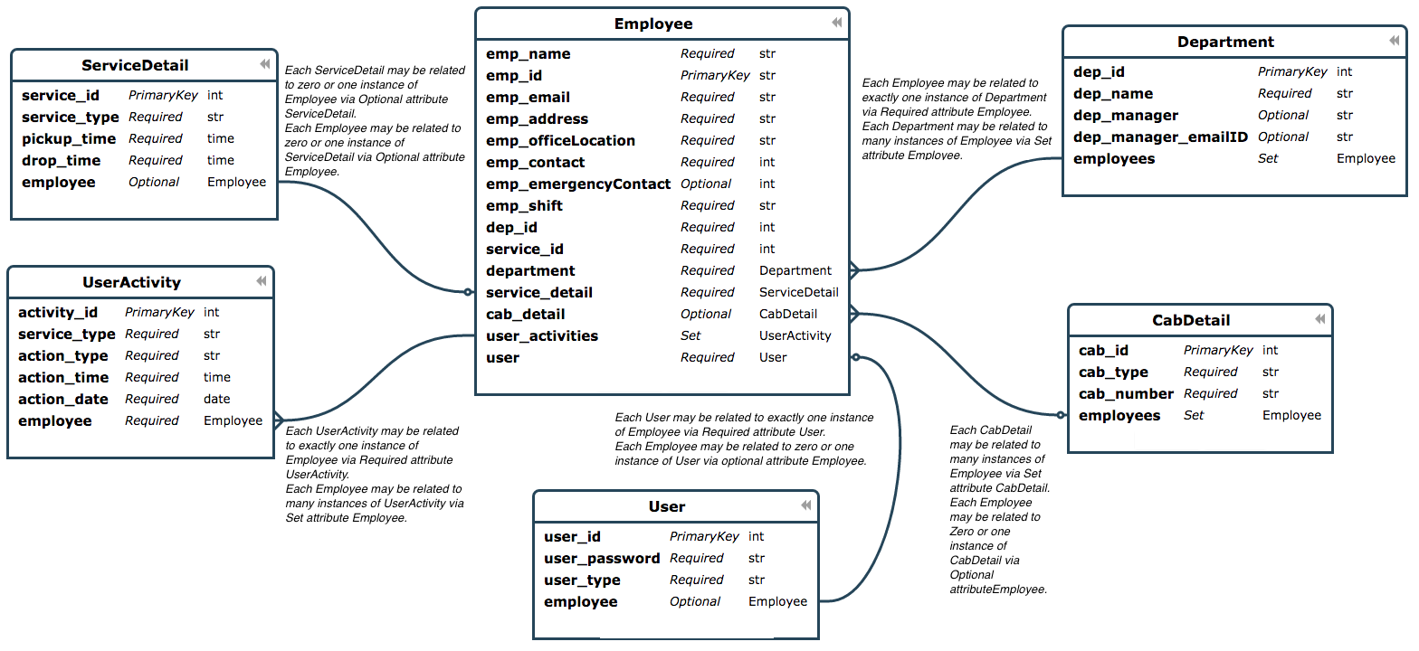Illustration 1: ER-Diagram of the EASi Cabs Database model. Ref : https://editor.ponyorm.com/

