**7-segment Display:**

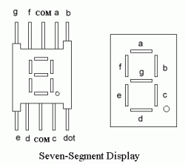

An LED or Light Emitting Diode is a solid state optical PN-junction diode which emits light energy in the form of “photons” when it is forward biased by a voltage allowing current to flow across its junction, and in Electronics we call this process electroluminescence.

The displays common pin is generally used to identify which type of 7-segment display it is. As each LED has two connecting pins, one called the “Anode” and the other called the “Cathode”, there are therefore two types of LED 7-segment display called: **Common Cathode** (CC) and **Common Anode** (CA).

The difference between the two displays, as their name suggests, is that the common cathode has all the cathodes of the 7-segments connected directly together and the common anode has all the anodes of the 7-segments connected together and is illuminated as follows.

1. The Common Cathode (CC) – In the common cathode display, all the cathode connections of the LED segments are joined together to logic “0” or ground. The individual segments are illuminated by application of a “HIGH”, or logic “1” signal via a current limiting resistor to forward bias the individual Anode terminals (a-g).

### Common Cathode 7-segment Display:

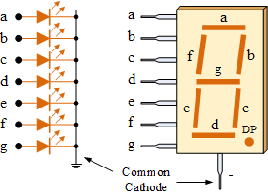

1. The Common Anode (CA) – In the common anode display, all the anode connections of the LED segments are joined together to logic “1”. The individual segments are illuminated by applying a ground, logic “0” or “LOW” signal via a suitable current limiting resistor to the Cathode of the particular segment (a-g).

### Common Anode 7-segment Display:

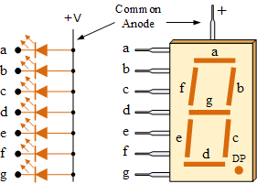

In general, common anode displays are more popular as many logic circuits can sink more current than they can source. Also note that a common cathode display is not a direct replacement in a circuit for a common anode display and vice versa, as it is the same as connecting the LEDs in reverse and hence light emission will not take place.

Depending upon the decimal digit to be displayed, the particular set of LEDs is forward biased. For instance, to display the numerical digit 0, we will need to light up six of the LED segments corresponding to a, b, c, d, e and f. Then the various digits from 0through 9 can be displayed using a 7-segment display as shown.

### 7-Segment Display Segments for all Numbers:

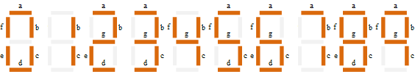

Then for a 7-segment display, we can produce a truth table giving the individual segments that need to be illuminated in order to produce the required decimal digit from 0 through 9 as shown below.

# 0 - 99 Counter Using IC 4026:

**CD4026** is a **Johnson counter IC** commonly used in digital display. It has a 5 stage Johnson decade counter with a decoder which converts the Johnson code to a 7 segment decoded output. To put it simply, it will convert the input into numeric display and can be seen on 7 segment display or with LED. It can be used for displaying analogue value such as temperature with [pic microcontroller](http://www.engineersgarage.com/articles/pic-microcontroller-tutorial) or for counting objects. There are various other applications like in 7 segments decimal display circuit, in clocks, timer etc.

**Advantages of 4026 counter:**

It contains counters and 7 segment decoded in one package, It can be easily interfaced with 7 segment types, Ideal for low power display, Operated at wide range of temperature from 5V to 20V and the biggest advantage of the 4026B counter IC is that it can drive a 7-segment display without needing a decoder driver IC

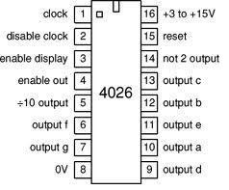

### [Interfacing 4026 with 7 segment display](http://www.engineersgarage.com/electronic-circuits/Interfacing-4026-with-7-segment-display):

**1.** Pin 1 or clock pin- It receives clock signals, and at every positive clock and  counter advances one by one. You can provide clock with the switch, 555 timer or with the help of logic gates. In short high pulse on this input increments the counter.

**2.** Pin 2 or disable clock (clk inhibit) pin- 4026 counter advances one by one by receiving positive pulse at this time for this clock inhibit pin should be grounded. If it is connected to supply than counter advancement will be inhibited means there will be no meaning of clock pulse.

**3.** Pin 3 or enable display (En in) pin- It enable the 7 segment display to display the numeric value. It should be kept high for enabling the display. Mean output goes high when only when display enable is high.

**4.** Pin 4 or enable out- It Enables the carry out pin. In our circuit we have left this pin unconnected.

**5.** Pin 5 or divide by 10 outputs- It is used to complete one cycle for every 10 clock input cycle and it also used to cascade more IC's.

**6.** Pin 6, pin7 and Pin9 to pin 13 - These are 7 decoded output from a to g used to illuminates the corresponding segment of 7 segment display to display the digit from 0 to 9.

**7.** Pin 14 or not 2 output (UNGATED "C" SEGMENT) signals- They are not gated by the Display clock and therefore are available continuously. This feature is a requirement in implementation of certain divider function such a as divide by 60 and divide by 12.

**8.** Pin 15 or Reset pin- It is used to reset the counter. When it receives high it clears the counter and counting again starts from zero. One important thing reset pin should again made low to start the counter once again.

**9.** Pin 8 or ground pin and Pin 16 known or Vdd it should be connected to power supply.

It uses a 4026 combined counter and display driver IC which is designed to drive 7 segment displays. When you press the switch S1 counter starts from zero and it advances one each time whenever pin 1 receives a positive pulse. When you press the switch for first time numeric 1 will display. Then you again press the switch numeric 2 will display, giving you second output. In similar manner 3 and 4 will display. When count reaches to 9 after that it again starts it counting from zero. For resetting the counter to zero at any point press switch S2. For this pin 15 must be taken high and then taken low again.

# How to Build a 555 Timer Monostable Circuit:

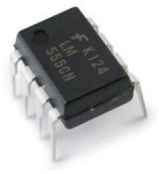

**555 IC**

In this circuit, we will show how to build a 555 timer monostable circuit. When a 555 timer is in monostable mode, when the 555 timer is triggered, a single high pulse is released, turning on the output for a certain period of time. Once this HIGH period of the pulse has passed, the output turns off and stays off- unless the pushbutton is pressed again.The reason this is called the monostable state is because there is only one stable output state unless there is a trigger. The one stable state is OFF. The signal feeding the output is normally LOW. The only time it is HIGH is when we press the pushbutton, triggering a single pulse.  
The signal that is triggered will resemble that which is shown below.   
  
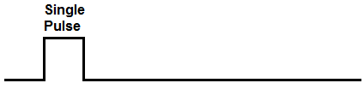 

So you can see based on this signal, there is a single pulse. This is when we press down on the pushbutton. This sends a trigger signal to the 555 timer. This trigger signal creates that single pulse. After the period of time of the pulse has elapsed, the signal goes back to a LOW state, which is the only stable state it has. It will stay at this LOW state, until the pushbutton is pressed again and another single pulse is created before going LOW again.

This circuit lends itself well to conditions where the output needs to be on only for brief periods of time and be user-operated, as this circuit lends itself well to pushbuttons.This circuit is actually great for demonstration purposes because a user can press the button, see the operation of the circuit, with the circuit automatically turning to the OFF state on its own.

In this circuit, we will use an LED as our output device. So when the circuit is triggered, the LED will turn on for a few seconds and then turns off.We will show also how you can vary the duration of the pulse, so that the output device which you are turning on can be on for different periods of time.

**Components:**

* 555 Timer Chip
* 2 10kKΩ resistors
* 220μF capacitor
* 47kΩ resistor
* LED

**Description:**

* The 555 timer can be obtained very cheaply from pretty much any electronic retailer.
* The 555 timer is an 8-pin chip.
* If you want to know all the pin out of the 555 timer, what each pin is and what each pin does, see 555 Timer Pin out.
* In this circuit, we will connect the 555 timer to be in monostable mode.
* In this mode, the 555 timer will produce a single pulse when triggered.

The connections are shown below:

### 555 Timer Monostable Circuit:

The monostable circuit that we will build using a 555 timer is shown below.

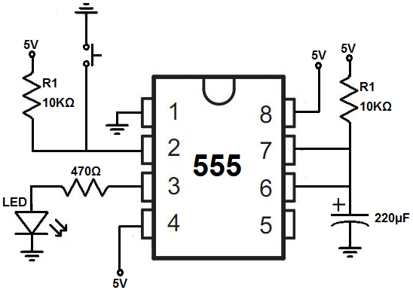   
  
**The breadboard schematic of the above circuit is shown below:**  
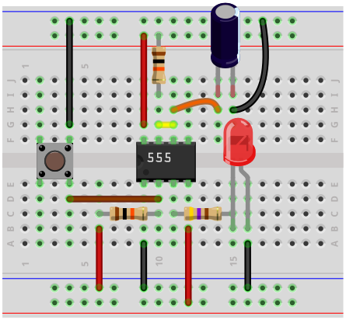

The circuit operates on 9VDC of power. So the power line is 9V.Pin 8, which is the power supply pin, VCC, gets connected to +9VDC. Pin 1, which is power ground, gets connected to ground. This establishes sufficient power to the chip for this circuit. This 555 timer is in monostable mode. Monostable mode produces a single pulse of adjustable duration during a pushbutton press. Pin 2, the trigger pin, is one of the focal pins of this chip. This is how the 555 timer gets triggered to create that single pulse. Once a trigger is sent to this pin, the 555 timer output temporarily gets taken out of its stable state, which is the LOW state, and goes temporarily to its unstable state, which is the HIGH state. This creates the single pulse that you see on the output.

In order for pin to work, we first connect a 10KΩ resistor to 5V. Then in parallel to this resistor, we connect a pushbutton. One end of the pushbutton button connects to the pin 2 terminal and the other end of the pushbutton connects to ground. Pin 2 of the 555 timer is an active low trigger. This means that this pin is only activated when the voltage being fed into is LOW, or less than 1/3 of the supply voltage. Since we are supplying the 555 timer with 9VDC, once the voltage at this pin gets to 3V or lower, these pins activates. When the 555 timer is triggered via pin 2, the output at pin 3 goes HIGH. So during operation, while the pushbutton is un pressed, pin 2 is connected to +5V via the resistor. So the pin 2 reads a HIGH value. So it's connected HIGH. In this HIGH state, the pin is not triggered, because again the pin is active LOW.

Now when we press down on the pushbutton, now pin 2 has direct contact with ground. The voltage drops dramatically well below 1/3 of the power supply voltage. Thus, a trigger is activated. This lets the output pin, pin 3, go HIGH. And this is the principle behind a 555 timer monostable circuit.

Once the trigger pin is activated, a brief HIGH pulse is created at pin 3. This, again, is a single pulse that is not repeated unless another trigger is created- by pushing down again on the pushbutton. Pin 3 is the output pin. To this pin, we attach the output that we want to be turned on. In the case of this circuit, we connect an LED along with a current-limiting resistor, as to not burn out the LED. Pin 4 is the reset pin. Being that we aren't using it for this circuit, we simply connect to +5V. The reset pin is active LOW, which means it turns on when the voltage fed to it is LOW. Thus, in order to inactivate it, we simply permanently connect it to the positive voltage. Pin 5, the control voltage, is not needed for this circuit and is not unused. Pin 6 and pin 7 control the time interval of the duration of the pulse monostable pulse created.

The resistor and capacitor values used create an RC network. The value, τ= RC, forms the time constant for how long the pulse will last. Thus, if you use a greater resistor and capacitor value, this will increase the time constant of the signal, thus making the duration of the pulse longer or greater. If you want the pulse to be shorter, which makes the output on for a shorter period of time, you want to use smaller values for the resistor and capacitor. So this is by adjusting the resistor and capacitor values, we can adjust how long the output is on for when the 555 timer is triggered and this is a basic monostable circuit built with a 555 timer chip.

# Digital Pulse Counter - Two Digit - Using Seven Segment LED, IC 4026 and Timer 555:

There are two 7 segment displays and IC 4026 used here to count up to 99. The 5th pin of 4026 gives out a pulse when it moves from 9 to 0. The pulse from the one's place fed to the ten's place 4026 to move to the next digit as one's place digit moves to 0 from 9. Note the connection from pin 5 of second IC to pin 1 of first IC.

