GROWTHWORKS SYSTEMS
Homepage AI Visibility Differentiator
Buyer-journey shift copy specification for Section 07 of the revised homepage
Prepared for | GrowthWorks Systems - Website Enhancement Project
Section | 07 - AI Visibility Differentiator
Narrative beat | How GWS Works - applied example
Task copy ceiling | Approximately 50 visible words maximum
Architecture allowance | 75 words maximum; tighter task ceiling governs this deliverable
Primary route | Learn About AI Visibility
Status | PROPOSED FOR CLAYTON’S REVIEW

Governing principle
Explain the buying shift, not the technology behind it.
Section 07 is a concise applied example of the connected-system story. Its job is to show why AI Visibility matters commercially: buyers can now receive recommendations before they ever visit a website. The homepage introduces that shift and routes depth to the canonical AI Visibility page.

1. Recommended Homepage Copy
One concise explanation paired with the Buyer Journey visual
The way buyers find businesses is changing.
Buyers increasingly ask AI tools which companies to consider, not just search engines which websites to visit. If AI systems cannot clearly understand your business, you may never enter the shortlist.
Learn About AI Visibility

Visible copy remains below the approximately 50-word task ceiling, so no additional explanatory paragraph is recommended.
Why this direction works
• It starts with a recognizable change in buyer behavior rather than AEO, GEO, or technical terminology.
• It frames the commercial consequence as lost consideration: if AI cannot clearly understand the business, the company may not enter the shortlist.
• It gives the existing visual room to explain the old-versus-new journey instead of duplicating the diagram in prose.
• It ends with the approved education route, Learn About AI Visibility, so deeper explanation stays on the canonical page.

2. Visual Pairing and Narrative Role
The existing Buyer Journey asset should remain the single visual paired with this copy. The homepage copy should not introduce a second diagram or recreate the visual in text.
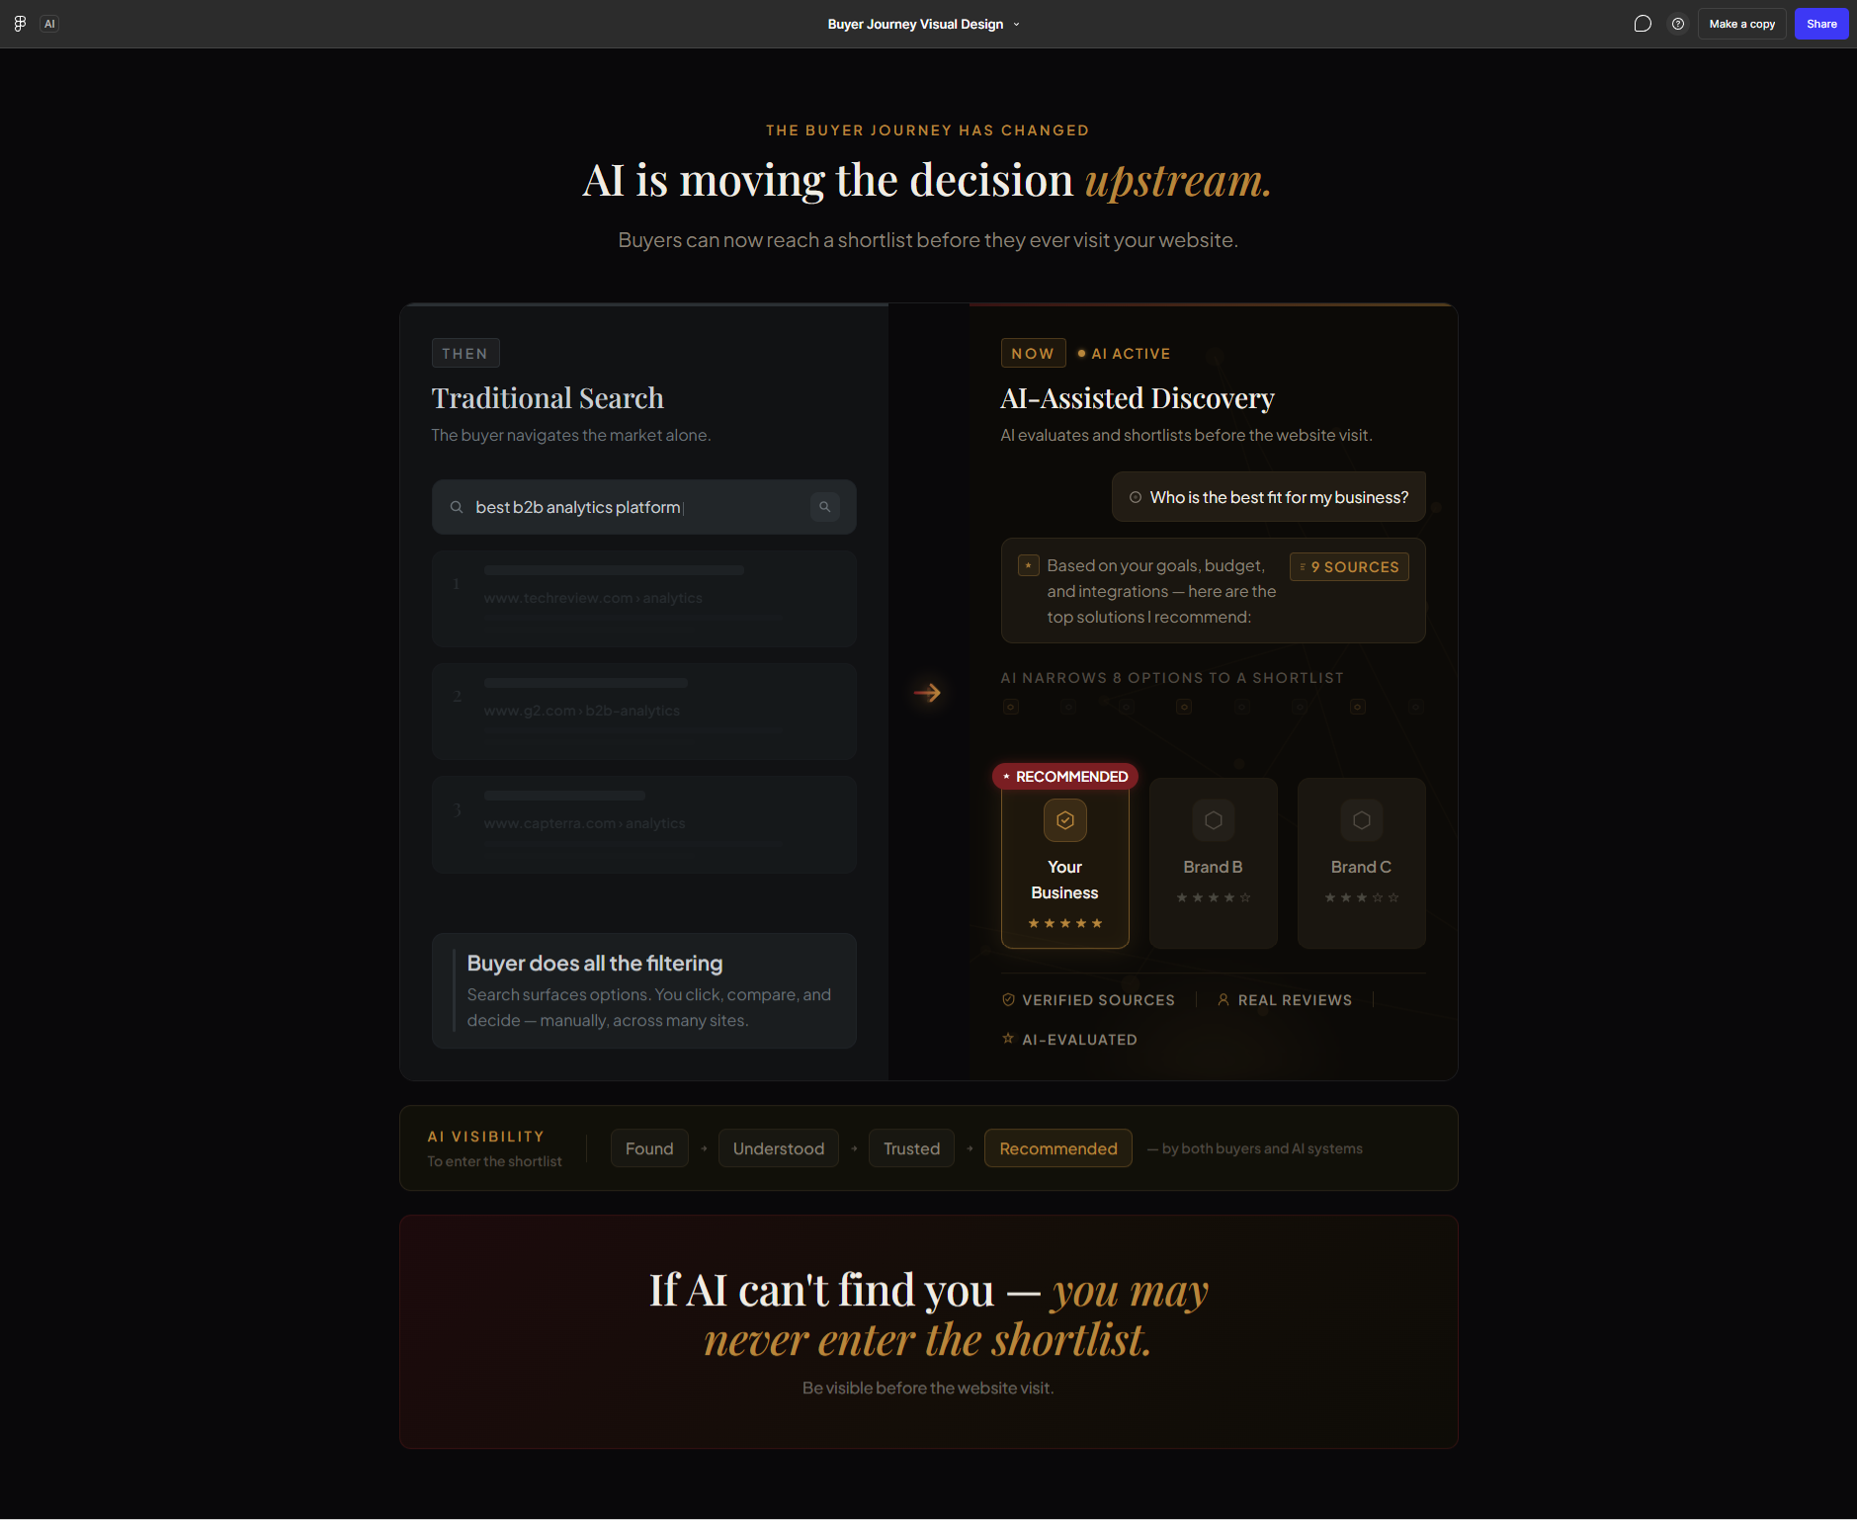
Existing Buyer Journey visual: Traditional Search versus AI-Assisted Discovery.
Layer | What it should communicate | What it should not do
Copy | Buyer behavior is shifting from search-result browsing toward AI-assisted recommendations, and visibility now affects whether a business enters consideration. | Explain AEO/GEO, schema, entities, optimization tactics, platform mechanics, or technical implementation.
Visual | Show the contrast between Traditional Search and AI-Assisted Discovery, with the shortlist forming earlier in the journey. | Repeat the paragraph as labels or become a technical systems diagram.
Route | Invite deeper learning through Learn About AI Visibility. | Create a second CTA or teach the canonical AI Visibility page on Home.

Narrative handoff
Section 06: The parts work better as one connected system. > Section 07: Buyer discovery itself is changing, making visibility inside AI-assisted recommendations commercially important. > Section 08: Here are the core capability modules GWS applies inside that connected system.
3. Manus Implementation Guardrails
Keep the homepage treatment focused on one buyer-behavior shift and one explanatory visual.
• Use the Buyer Journey visual as the single explanatory asset for this section. Do not add a second AI diagram.
• Keep the copy adjacent to, above, or immediately below the visual so the words and visual are interpreted as one message.
• Do not add AEO, GEO, schema, entities, platform lists, optimization tactics, or technical proof points to the homepage treatment.
• Use one education route only: Learn About AI Visibility. Do not introduce a competing conversion CTA inside this section.
• On mobile, place the concise copy before the visual and preserve the Traditional Search to AI-Assisted Discovery reading order.
Handoff to Section 08
Section 07 should leave the visitor with one clear conclusion: being considered now depends on visibility in both traditional search and AI-assisted discovery. Section 08 can then show the core GWS capability modules that support the broader connected system.

