GROWTHWORKS SYSTEMS
Homepage Hero
Headline and Supporting Copy
Outcome-led copy specification for the opening screen

Prepared for | GrowthWorks Systems - Website Enhancement Project
Section | 01 - Outcome-Led Hero
Narrative beat | Desired Outcome
Copy ceiling | 45 visible words including CTA
Status | Governing hero structure and CTA are established. Headline and supporting copy in this document are proposed for stakeholder review, not previously approved final copy.

Governing principle
Lead with the customer outcome. Explain the category later.

1. Proposed Hero Copy for Review
This is the leading copy recommendation for stakeholder review. It is not yet approved final copy. It follows the governing hero brief while sharpening the commercial message around existing opportunity, revenue leakage, and the economic value of repairing the gaps that suppress growth - without introducing frameworks, technical mechanisms, or category language.
PROPOSED FOR REVIEW
Turn more of your existing opportunity into revenue.
GrowthWorks Systems helps founder-led service businesses identify and repair the gaps that prevent demand, leads, and customers from producing their full value.
Book a Revenue Diagnostic

Why this proposal fits the governing brief
Requirement | Status | How the copy handles it
Outcome focused | PASS | Starts with the commercial result: turning more existing opportunity into revenue.
What GWS does | PASS | Explains the role of GWS as identifying and repairing gaps that suppress the value of demand, leads, and customers - without prescribing tools.
Who it serves | PASS | Explicitly identifies founder-led service businesses.
Why it matters | PASS | Frames the problem in economic terms: valuable opportunity already exists, but gaps prevent the business from capturing its full value.
No jargon/framework | PASS | No Revenue Infrastructure, domains, methodology, technical mechanisms, or tool language.
Opening-screen clarity | PASS | One headline, one supporting sentence, one primary CTA.
Word budget | PASS | Approximately 35 visible words including CTA, below the 45-word ceiling.
Economic relevance | PASS | Makes the financial logic implicit: improve the return from demand, leads, and customer relationships the business already has.
Diagnostic congruence | PASS | Creates a natural reason to investigate where value is being lost, making Book a Revenue Diagnostic the logical next step.

2. Opening-Screen Visual Direction
The visual below is an illustrative centered hero composition, not the final UI. It reflects the intended centered opening-screen direction and shows how the proposed copy can remain dominant without competing with founder credentials, framework education, or dense explanatory content.
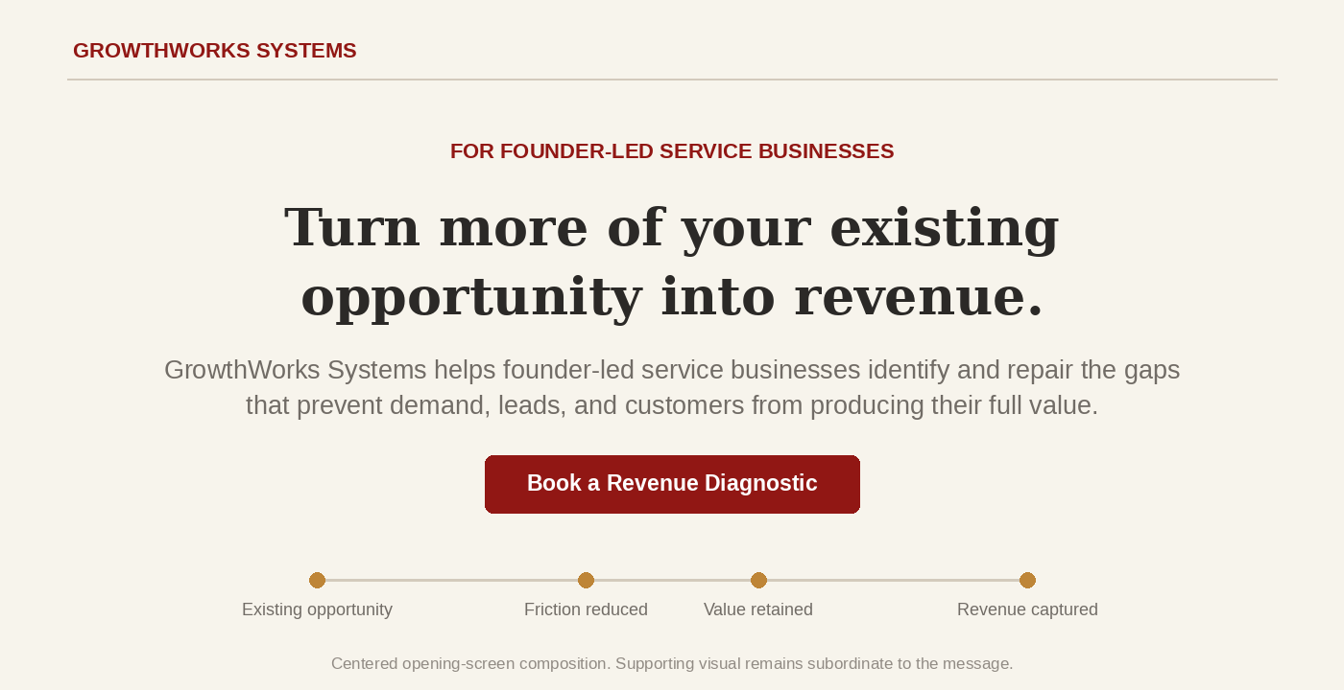
Illustrative centered hero mockup: proposed outcome-led copy with a restrained opportunity-to-revenue motif.
Visual element | Implementation intent
Headline dominance | Headline remains the strongest first-look element. Supporting copy and CTA are clearly subordinate.
Outcome motif | Use a simple, non-framework visual suggesting opportunity moving through a business with friction or gaps reduced so more value reaches revenue. Avoid duplicating the four customer outcomes in the hero visual; those are introduced later in the homepage story.
Whitespace | Keep the first screen open and calm. Do not fill unused space with proof points, framework labels, or additional cards.
CTA | Use one dominant primary action: Book a Revenue Diagnostic.
Mobile | Keep the hero content centered. Preserve headline readability and CTA prominence, then place any supporting visual beneath the message rather than beside it.

3. Additional Copy Options for Review
These alternatives remain within the same governance boundary and are presented for stakeholder review. None should be treated as approved final copy until explicitly selected.

Option 2 - Existing opportunity
Capture more revenue from the opportunities you already have.
GrowthWorks Systems helps founder-led service businesses reduce the gaps that cause valuable opportunities to be missed, delayed, lost, or overlooked.
CTA: Book a Revenue Diagnostic

Option 3 - Revenue leakage
Stop letting good opportunities become lost revenue.
GrowthWorks Systems helps founder-led service businesses strengthen how customers find, engage, buy, and return - so more existing opportunity becomes measurable growth.
CTA: Book a Revenue Diagnostic

Option 4 - Demand value
Get more growth from the demand you've already earned.
GrowthWorks Systems helps founder-led service businesses turn visibility, leads, customers, and existing relationships into more consistent revenue.
CTA: Book a Revenue Diagnostic

4. Copy and Implementation Guardrails
- Keep the hero inside the Desired Outcome beat. The opening screen should answer “What becomes better?” while implying that valuable opportunity may already be going uncaptured; detailed problem diagnosis belongs later in the page.
- Do not introduce Revenue Infrastructure, the nine-domain framework, the Diagnose / Design / Implement / Optimize process, or specific technologies in the hero.
- Do not place founder biography or long credential proof in the first-look area. The credibility bridge and founder section handle those jobs later.
- Use one primary CTA only: Book a Revenue Diagnostic.
- Keep the total visible hero copy at or below 45 words. An unused budget is not a reason to add copy.
- If a visual can carry meaning, simplify the copy rather than duplicating the explanation. Prefer a restrained opportunity-to-revenue motif over a labeled feature or framework diagram.
- Keep the hero centered across desktop and mobile. Supporting visuals may reflow beneath the core message, but should not shift the headline, supporting copy, and CTA into a competing side-by-side composition.
PROPOSED DIRECTION - PENDING APPROVAL
Turn more of your existing opportunity into revenue.
Use as the leading recommendation for stakeholder review. It is the strongest current fit because it is outcome-led, economically grounded, solution-agnostic, and naturally supports the Revenue Diagnostic CTA. Final headline and support copy remain pending explicit approval.

