GROWTHWORKS SYSTEMS
Mobile View Ruling & Responsive Behavior Specification
Revenue Infrastructure component and homepage middle-section guidance
Prepared for: GrowthWorks Systems - Website Enhancement Project
Status: PROPOSED FOR CLAYTON'S REVIEW
Scope | Mobile homepage composition, density, reading order, terminology, and interaction behavior, with governing rules for the Revenue Infrastructure visual and Sections 5-8. This document is the final mobile interaction ruling for the homepage Revenue Infrastructure component.
Core mobile principle | Preserve meaning, not desktop density.
Typography | Documentation: Calibri. Website implementation: DM Serif Display + DM Sans.
Primary breakpoint | Use the mobile/narrow-layout treatment below 1024px, subject to component-fit testing.
Canonical story | Problem -> Connected System -> Outcome.

1. Governing Mobile Principles
• Mobile changes the presentation, not the story.
• The Revenue Infrastructure visual must remain the same approved system adapted for a narrower viewport. No new framework, taxonomy, branded terminology, or service categories may be introduced.
• The mobile experience must be understandable with zero interaction. Taps may reveal diagnostic depth in Disconnected Tools and Business Outcomes, but the Revenue Infrastructure centerpiece itself remains fully understandable and static without interaction.
• Sections 5-8 should be intentionally reduced in density. Do not stack every desktop detail vertically simply because space is available.
• One primary focal point should dominate each section at a time. Secondary copy, labels, visual annotations, and explanatory detail should be removed or deferred before core meaning is reduced.
PRODUCTION COPY | Text intended to appear on the live website exactly or substantially as written.
IMPLEMENTATION NOTE | Breakpoint, layout, interaction, density, and Manus guidance. Never render these annotations as website copy.

Interaction Annotation Standard
[STATIC] | Informational only.
[TAP] | Navigation or primary/secondary action.
[EXPAND] | Progressive-disclosure content.

2. Revenue Infrastructure Mobile Story
Desktop story: Disconnected Tools -> Connected Revenue Infrastructure -> Business Outcomes
Mobile ruling: Recompose the same relationship into a guided vertical narrative rather than shrinking the desktop three-column layout.
01 WHERE REVENUE LEAKS
Disconnected Tools
Website | Search & AI Visibility | CRM | Lead Response | Automation | Analytics
[EXPAND] Single-open progressive disclosure. Expanded copy follows: capability exists -> connection is missing -> revenue consequence results.
02 ONE CONNECTED SYSTEM
Revenue Infrastructure
Digital Presence | Lead Response | Sales Operations | Revenue Intelligence
[STATIC] Centerpiece in the homepage ruling. Preserve Diagnose -> Design -> Implement -> Optimize as a compact methodology anchor. Detailed capability-level interaction is not retained on the homepage mobile component. All four capabilities remain simultaneously visible as static connected-system elements. They should not expand independently, behave as separate cards, or function as separate navigation items. This also makes the task requirement for a selected/open Revenue Infrastructure capability state intentionally N/A.

03 WHAT IMPROVES
Business Outcomes
Be Found | Capture & Respond | Convert Consistently | Improve & Scale
[EXPAND] Compact disclosure is allowed. Outcomes remain customer-facing lenses, not solution modules.
Fragmented -> Connected
Connected -> Improved

Visual transition treatment
Stages remain in normal vertical document flow. Use a restrained schematic connector such as a thin vertical line with a small directional marker or arrow between stages. No horizontal scrolling is permitted. No animated path is required. Any motion may only reinforce progression and comprehension must never depend on animation. The Revenue Infrastructure center must visually read as the resolution point between fragmentation and improvement.

Disconnected Tools Expanded-Copy Rule
Keep the labels exactly as approved. Expanded copy should not explain the feature itself. Each item should diagnose the commercial consequence of disconnection using the same structure:
• Capability exists.
• The connection to the revenue path is missing or weak.
• A specific revenue consequence results.

Terminology Lock
Search & AI Visibility | Use this customer-facing label. Do not use AEO / Search or Agentic Search in this component.
Revenue Infrastructure | Keep as the connected-system concept, not a product or funnel.
Diagnose -> Design -> Implement -> Optimize | Keep unchanged as methodology anchor.
Business Outcomes | Be Found; Capture & Respond; Convert Consistently; Improve & Scale.

3. Mobile Middle-Section Ruling: Sections 5-8
Purpose: Reduce vertical density through the most concept-heavy portion of the homepage while ensuring each section introduces a distinct new idea.
# | Section | Narrative job | Mobile ruling | Interaction
05 | How GWS Works | Simple process | Preserve Diagnose -> Design -> Implement -> Optimize. Compress spacing and presentation; do not add extra interactions or explanatory layers. | [STATIC] Process sequence. [TAP] Explore the Framework route only if retained by the governing homepage copy.
06 | Connected Revenue Infrastructure | Connected-system value | Simplify the mobile treatment so the value of integration is understood within a few seconds. Reduce visible detail approximately 30-50%. This is a design-density guideline, not a literal element or word-count requirement: remove secondary annotations, repeated explanatory copy, nonessential labels, and desktop-only visual detail before reducing canonical terminology or the core relationship. Capability-level interaction is not retained on the homepage mobile component. | [STATIC] Core system and relationship. All four Revenue Infrastructure capabilities remain simultaneously visible. No capability selection, accordion, individual expansion, separate navigation, or selected/open state is used.
07 | AI Visibility | Changing discovery environment | Lead with the shift from traditional search toward AI-assisted discovery and recommendations. GWS should appear as the partner that helps businesses remain findable and recommendable, not as a software-product showcase. | [STATIC] Buyer-journey explanation and core visual. [TAP] Learn About AI Visibility.
08 | Where GWS Applies the System | Application areas / revenue performance | Differentiate clearly from Section 6. This section answers where GWS applies the system to strengthen revenue performance, not how Revenue Infrastructure is architected. Avoid a service-catalog treatment. Do not reuse the center-node, connected-line, or system-diagram composition from Section 6; use a simpler application-area treatment such as concise rows or cards under one shared heading and route. | [STATIC] Four application areas as one coordinated set. [TAP] Explore Solutions. Avoid per-card CTAs.

Density Reduction Rule

Mobile content priority order: 1) section purpose, 2) canonical terminology, 3) primary production copy, 4) essential visual relationship, 5) primary route/action, 6) secondary explanation, 7) decorative or supplementary detail. When space is constrained, remove from the bottom of this hierarchy upward.
• Remove repeated context before shortening the primary message.
• Remove secondary labels and explanatory captions before reducing canonical terminology.
• Prefer one strong visual relationship over several miniature explanations.
• If desktop content is useful but not necessary for first-pass comprehension, defer it to progressive disclosure or the supporting page.
• Do not create extra mobile carousels or horizontal scrolling to preserve desktop density.

4. Required Mobile Component States
These are the final governing mobile component states for the homepage Revenue Infrastructure experience. The center capability group is intentionally static; only Disconnected Tools and Business Outcomes use progressive disclosure.
A. COMPLETE COLLAPSED / DEFAULT VIEW
• [STATIC] Where Revenue Leaks label
• [EXPAND] Six collapsed Disconnected Tools rows
• [STATIC] Revenue Infrastructure centerpiece + four capability labels
• [STATIC] Diagnose -> Design -> Implement -> Optimize
• [EXPAND] Four collapsed Business Outcome rows
Current mobile wireframe reference - complete Revenue Infrastructure mobile treatment
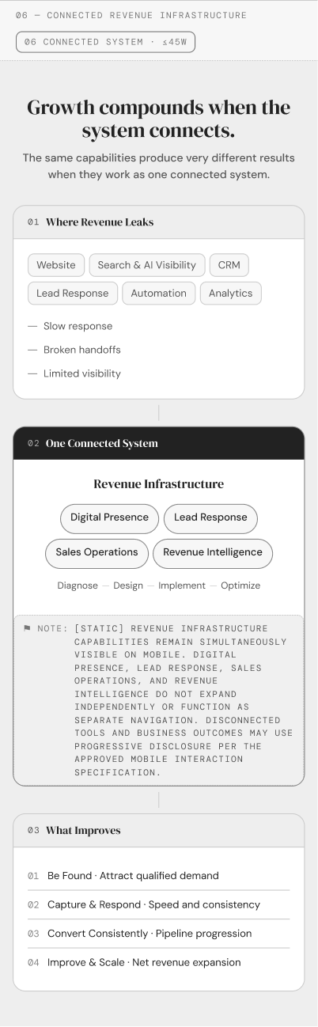
B. DISCONNECTED TOOLS ITEM OPEN
• [EXPAND] One item open only
• Concise diagnostic copy only
• Opening a second item closes the first
• No hover or horizontal scrolling
Current mobile wireframe crop - Disconnected Tools region. Open-state behavior is governed by the specification above.
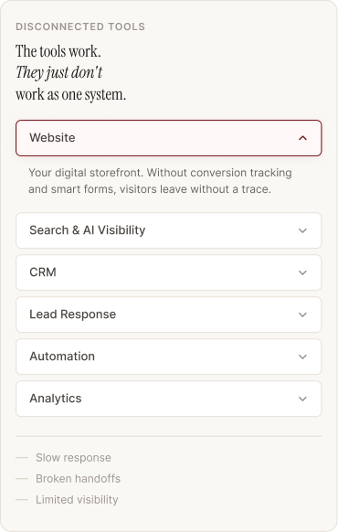
C. REVENUE INFRASTRUCTURE CENTERPIECE STATE
• [STATIC] All four capability labels remain simultaneously visible
• Capability-level interaction is not retained on the homepage mobile component
• The four capabilities do not expand independently, behave as separate selectable cards, or function as separate navigation items
• Selected/open Revenue Infrastructure capability state: N/A by design
• Preserve Diagnose -> Design -> Implement -> Optimize as the compact methodology anchor
Current mobile wireframe crop - static Revenue Infrastructure centerpiece
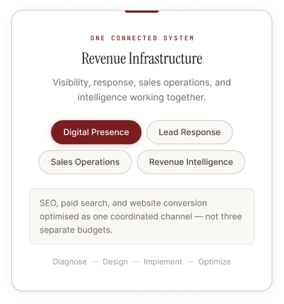
D. BUSINESS OUTCOME OPEN
• [EXPAND] One outcome open at a time
• Outcome label remains visible
• Expanded text explains the customer improvement, not a service/tool
• Opening another outcome closes the current one

Current mobile wireframe crop - Business Outcomes region. Open-state behavior is governed by the specification above.
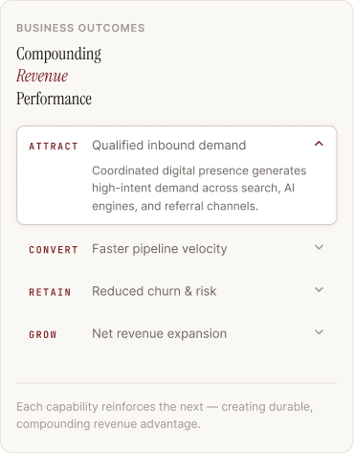

Tap / Open / Close Behavior
• Tap-to-expand only; no hover dependency.
• Keep one item open per accordion group. Tapping another closes the previous item.
• Do not auto-close panels on scroll; state changes follow explicit user action.
• Primary comprehension must not depend on interaction.
• The Revenue Infrastructure centerpiece must not introduce a third interaction pattern. It communicates connection and resolution through static visibility of all four capabilities.

5. Responsive Breakpoint and Manus Implementation Guidance
Viewport / fit condition | Treatment | Rule
>= 1024px and desktop composition remains readable | Approved three-stage desktop diagram | Preserve left / center / right spatial comparison.
< 1024px or desktop relationships lose clarity | Guided vertical mobile/narrow-tablet layout | Problem -> Connected System -> Outcome.
Any width where typography, tap targets, or relationships degrade | Switch to simplified layout based on component fit | Do not preserve a desktop composition merely to satisfy a numeric breakpoint.

Implementation Requirements
• Use semantic document order matching the visible reading order: Problem -> Connected System -> Outcome.
• Accordion triggers must be real buttons with accessible names and programmatically exposed expanded/collapsed state.
• Collapsed content must not break the heading hierarchy. Canonical labels remain present in the page structure.
• Use readable mobile typography from the approved website system: DM Serif Display for headings and DM Sans for body/UI. Documentation remains Calibri only.
• Maintain minimum 48px interactive height for tappable controls.
• Maintain the approved light editorial / schematic visual language. Do not convert the mobile version into a SaaS dashboard, dense process map, or generic FAQ component.
• Use restrained motion only when it clarifies open/close state or stage progression. No decorative animation.
• No horizontal scrolling for primary comprehension.
• Section 6 uses the final interaction ruling in this document: Disconnected Tools and Business Outcomes may expand one item at a time; the Revenue Infrastructure centerpiece and all four capability labels remain static and simultaneously visible.

Confirmation of Locked Desktop Architecture
Desktop terminology, architecture, taxonomy, and section order remain unchanged other than already approved content revisions. Mobile is a responsive adaptation only.

6. Acceptance Criteria
☐ A mobile visitor can understand fragmented capability -> connected Revenue Infrastructure -> business outcome without seeing the desktop version.
☐ The canonical outcomes are Be Found, Capture & Respond, Convert Consistently, and Improve & Scale.
☐ Search & AI Visibility is used consistently; AEO / Search and Agentic Search are not used in this component.
☐ No new service categories, methodologies, or branded terminology are introduced.
☐ The mobile design does not depend on hover behavior or horizontal scrolling.
☐ The default/collapsed state communicates the basic proposition without requiring a tap.
☐ Progressive disclosure is used for secondary explanatory copy rather than presenting all details simultaneously.
☐ Revenue Infrastructure remains the visual and conceptual centerpiece.
☐ Section 8 reads as where GWS applies the system to strengthen revenue performance, not as a second Revenue Infrastructure explanation or a service catalog, and it does not reuse Section 6's system-diagram composition.
☐ Sections 5-8 are selectively simplified so the mobile page does not become disproportionately long through its most concept-heavy portion, using the documented mobile content-priority hierarchy.
☐ Interactive/tappable elements are explicitly annotated in wireframes and implementation specs.
☐ Production copy is clearly separated from implementation notes.
☐ The mobile visual remains recognizably related to the approved desktop diagram and uses the same light editorial / schematic design language.
☐ The specification is sufficient for Manus implementation without requiring a new UX decision round. Section 6 interaction behavior is fully resolved in this document.

Implementation Handoff Summary
Mobile preserves the narrative while reducing the information required to understand it.
For Sections 5-8: simple process -> connected-system value -> changing discovery environment -> where GWS applies the system. Preserve approved terminology and section order. For Section 6, use progressive disclosure only for Disconnected Tools and Business Outcomes; keep the Revenue Infrastructure centerpiece static with all four capabilities visible at once.

