Task 1

Title: Non-responsive web site

1/ Navigate to <http://www.007museum.com/>

2/ Type of user: End-user

3/ Device/Browser: PC Windows 10 / Chrome(Version 97.0.4692.99 (64-bit))

4/ Observe the responsive design

5/ Screenshot or video:

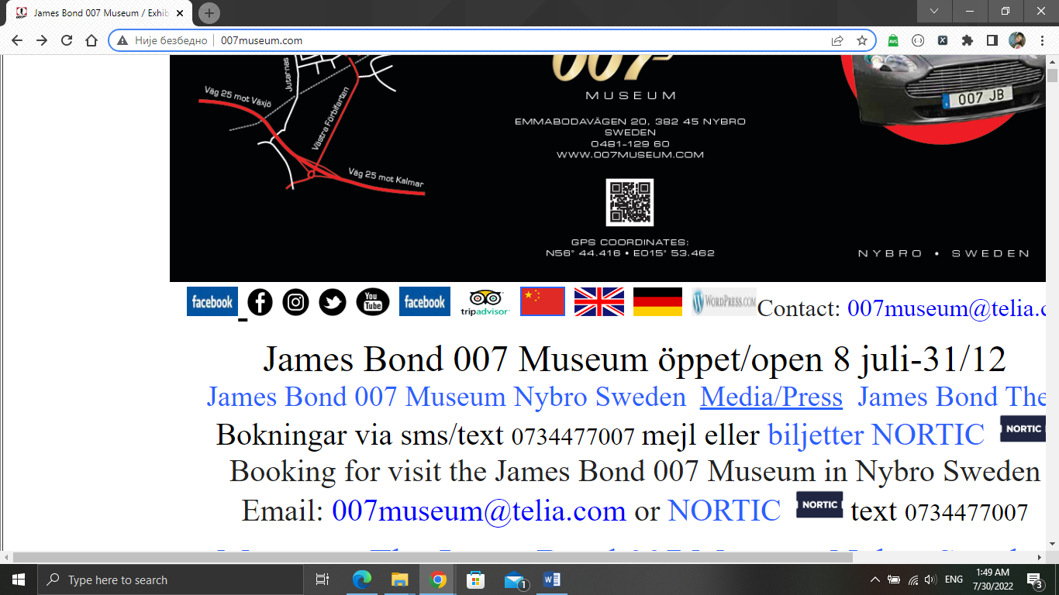

Title: Slow loading web site

1/ Navigate to <http://www.007museum.com/>

2/ Type of user: End-user

3/ Device/Browser: PC Windows 10 / Chrome(Version 97.0.4692.99 (64-bit))

4/ Observe the load on the site

5/ Screenshot or video:

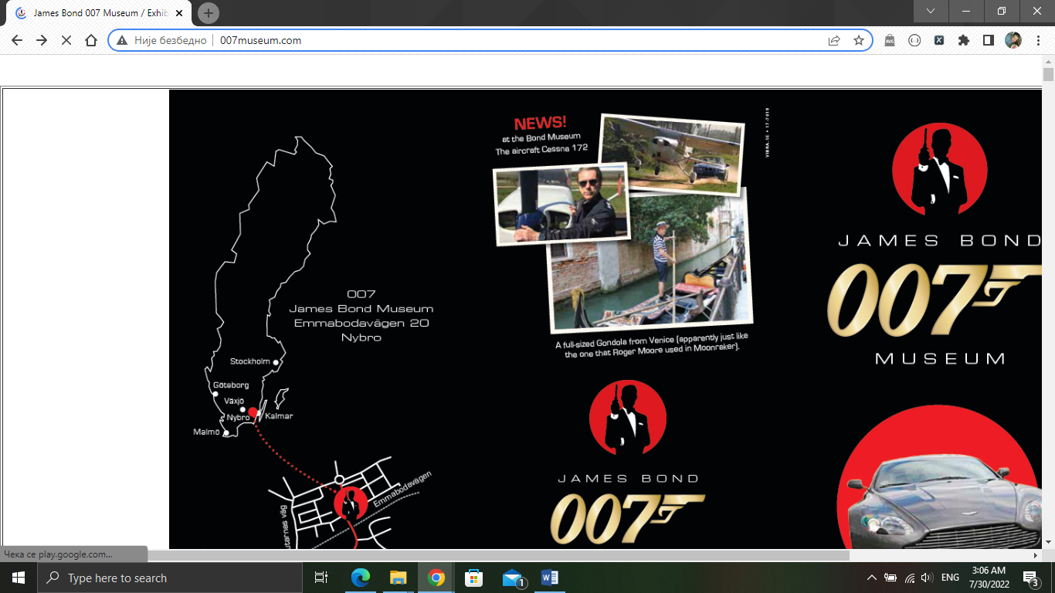

Title: Large single-page site

1/ Navigate to <http://www.007museum.com/>

2/ Type of user: End-user

3/ Device/Browser: PC Windows 10 / Chrome(Version 97.0.4692.99 (64-bit))

4/ Observe at the page size

5/ Screenshot or video:

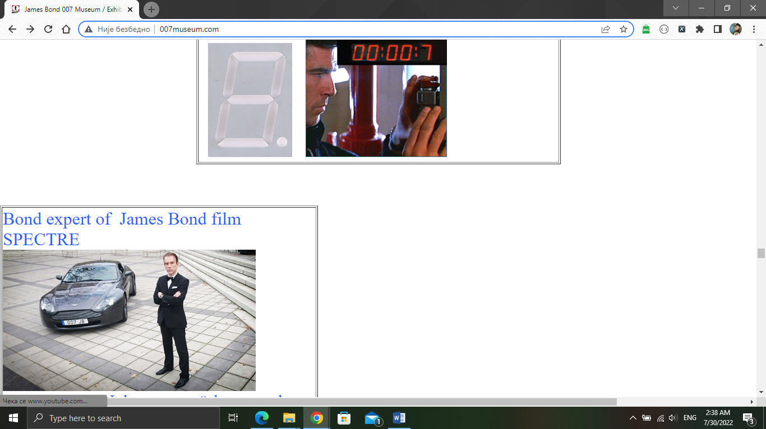

Title: Lots of links on the site

1/ Navigate to <http://www.007museum.com/>

2/ Type of user: End-user

3/ Device/Browser: PC Windows 10 / Chrome(Version 97.0.4692.99 (64-bit))

4/ Observe the number of links on the site

5/ Screenshot or video:

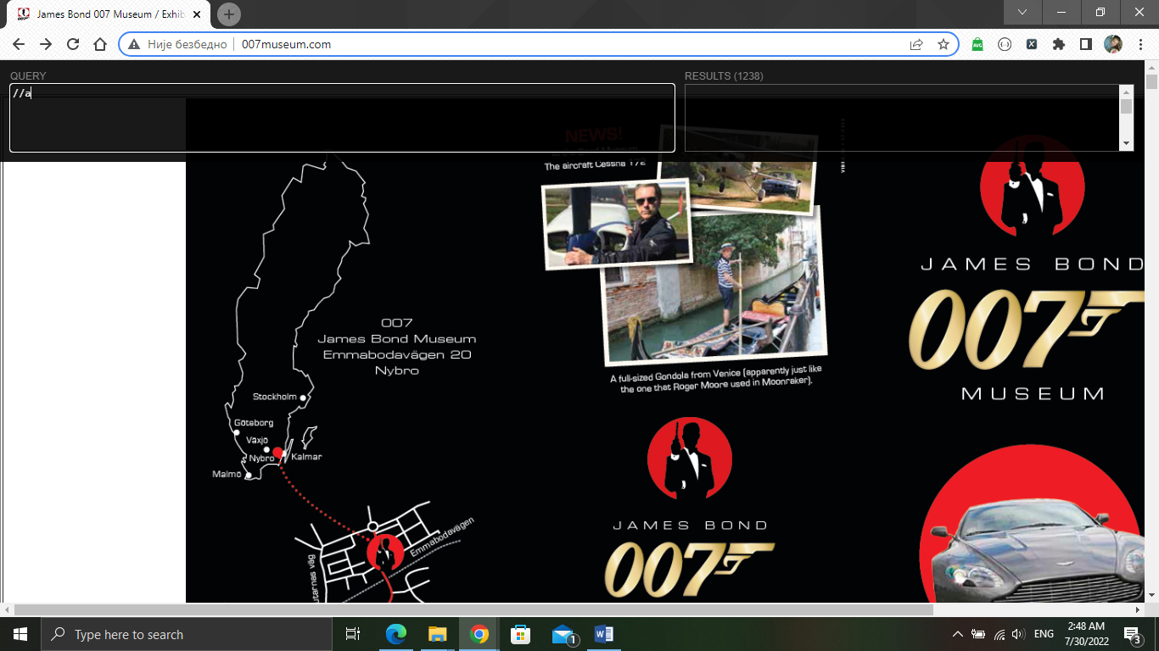

Title: Lots of errors on the site

1/ Navigate to <http://www.007museum.com/>

2/ Type of user: End-user

3/ Device/Browser: PC Windows 10 / Chrome(Version 97.0.4692.99 (64-bit))

4/ Observe how many errors there are on the site

5/ Screenshot or video:

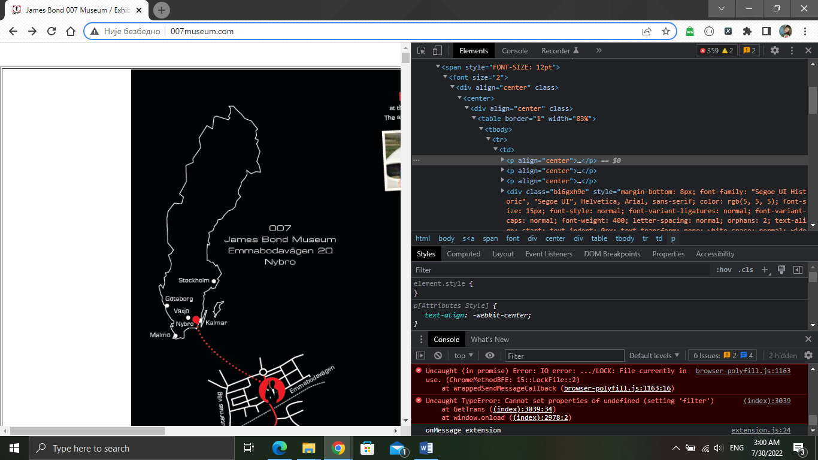

Title: Web site without buttons

1/ Navigate to <http://www.007museum.com/>

2/ Type of user: End-user

3/ Device/Browser: PC Windows 10 / Chrome(Version 97.0.4692.99 (64-bit))

4/ There is not a single button on the site

5/ Screenshot or video:

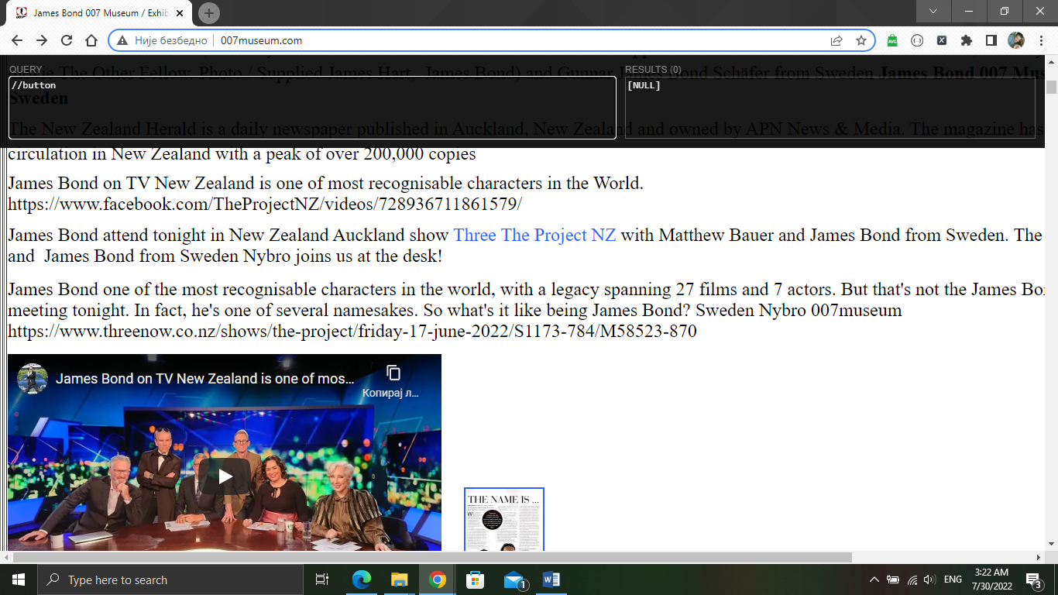

Title: Unfriendly design

1/ Navigate to <http://www.007museum.com/>

2/ Type of user: End-user

3/ Device/Browser: PC Windows 10 / Chrome(Version 97.0.4692.99 (64-bit))

4/ Observe design on the site

5/ Screenshot or video:

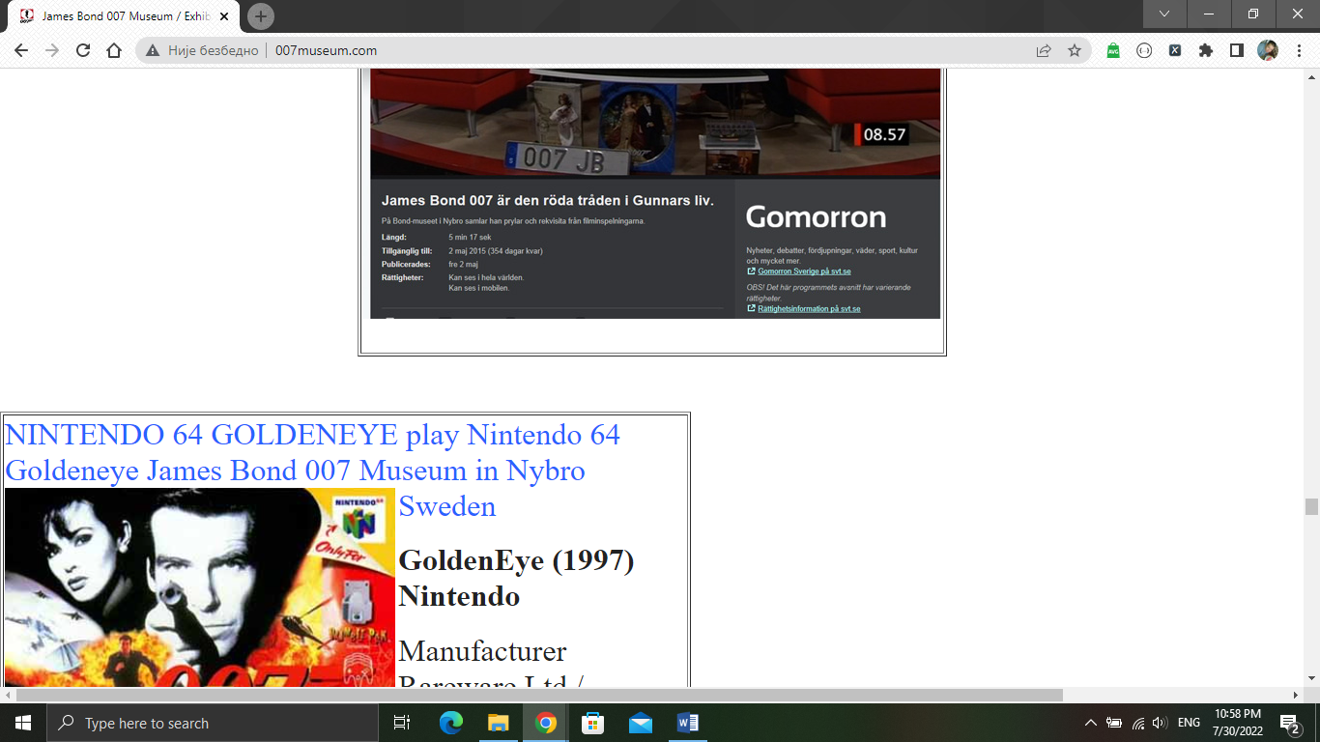

Title: Navigation bar missing

1/ Navigate to <http://www.007museum.com/>

2/ Type of user: End-user

3/ Device/Browser: PC Windows 10 / Chrome(Version 97.0.4692.99 (64-bit))

4/ Web site don’t have navigation bar

5/ Screenshot or video:

