Economical Diagnosis of Cognitive Impairment Using the AIBL Dataset
A Machine Learning Approach with kNN Imputation, ROSE Balancing, and RFE Feature Selection

Emmanuel Bajimi
Department of Computing, Engineering & Intelligent Systems
Ulster University, Derry/Londonderry, Northern Ireland, UK
Bajimi-e@ulster.ac.uk

Abstract—This paper presents a machine learning pipeline for the economical binary classification of Alzheimer's disease and mild cognitive impairment (Non-HC) versus healthy controls (HC) using the Australian Imaging Biomarkers and Lifestyle (AIBL) baseline dataset. Four classifiers—Random Forest, k-Nearest Neighbours (kNN), Gradient Boosting (GBM), and Naive Bayes—are evaluated after applying kNN imputation for missing data, IQR-based outlier capping, and ROSE class balancing. Recursive Feature Elimination (RFE) objectively identifies the minimum feature subset required for near-peak diagnostic performance, supporting a cost-effective clinical screening pathway. Naive Bayes achieved the highest AUC of 98.41 percent. Config A (4 cognitive features) matched the full-model AUC at 98.43 percent, confirming that expensive blood and genomic tests are unnecessary for first-line screening.
Keywords— AIBL; Alzheimer's disease; machine learning; feature selection; RFE; class imbalance; economical diagnosis.

Introduction
Dementia affects over 55 million people globally, with Alzheimer’s disease accounting for 60–70% of cases [1]. Early, affordable screening is critical, as timely identification opens a window for interventions that delay cognitive decline. The Australian Imaging Biomarkers and Lifestyle (AIBL) study provides a multimodal baseline dataset of 862 participants classified as Healthy Control (HC), Mild Cognitive Impairment (MCI), or Alzheimer’s disease [2].
Prior studies using the AIBL dataset have frequently benchmarked classifiers across all available features or relied on manually curated, domain-knowledge-driven feature subsets. While informative, such approaches do not provide an objective, data-driven answer to the question of how few features are genuinely required for clinically adequate predictive performance [3, 4]. This study addresses that gap directly.
The three-class problem is re-framed as binary (HC vs Non-HC, combining MCI and AD) to reflect the practical first-line screening decision clinicians face: is this patient cognitively healthy or not? The key methodological contribution is the application of Recursive Feature Elimination (RFE) to objectively determine the minimum feature set necessary for near-peak diagnostic performance, providing an evidence-based foundation for a tiered, economical clinical pathway.

Materials and methods

Dataset
Only baseline visits (VISCODE = ‘bl’) are retained, yielding 628 participants: 447 HC and 181 Non-HC. Features span four cost tiers: demographic (age, gender), medical history (10 binary comorbidities), ApoE genotype (2 alleles), blood laboratory values (12 biomarkers), and cognitive assessments (CDR, MMSE, LMIR, LMDR) — 29 predictors in total.

Pre-processing
Missing values encoded as −4 were replaced with NA. kNN imputation (k=5) was applied to all numeric features [5], preserving local data structure by filling each missing entry from the five most similar participants—preferable to global mean substitution when missingness is not completely at random. Gender was imputed by mode. Blood biomarkers were outlier-capped using the IQR fence rule, retaining all 628 participants. The dataset was split into 75/25 stratified. The 71:29 training imbalance was corrected using ROSE, which synthesises balanced samples via a smoothed bootstrap procedure [6, 7].

Exploratory Data Analysis
A pairwise cognitive score plot revealed strong negative correlations between CDR and MMSE and logical memory scores. A correlation matrix confirmed pronounced multicollinearity among hematological markers, motivating feature selection. A medical history heatmap showed modest between-class differences in cardiovascular comorbidities.

PCA
Principal Component Analysis was applied to the complete 29-feature set after standardization (zero mean, unit variance). The resulting scree plot indicated that the first three principal components collectively explain approximately 40% of total variance, with a pronounced elbow after the first component, signaling that a small number of latent dimensions captures most discriminative signal.
The PC1–PC2 biplot (Fig. 1) reveals partial class separation between HC and Non-HC clusters, with cognitive score loadings dominating PC1 and hematological markers loading heterogeneously on PC2. A notable column of points near PC1 ≈ 5 in the supplementary biplot (Fig. A4) is attributable to a single categorical feature contributing a dominant, constant component weight.
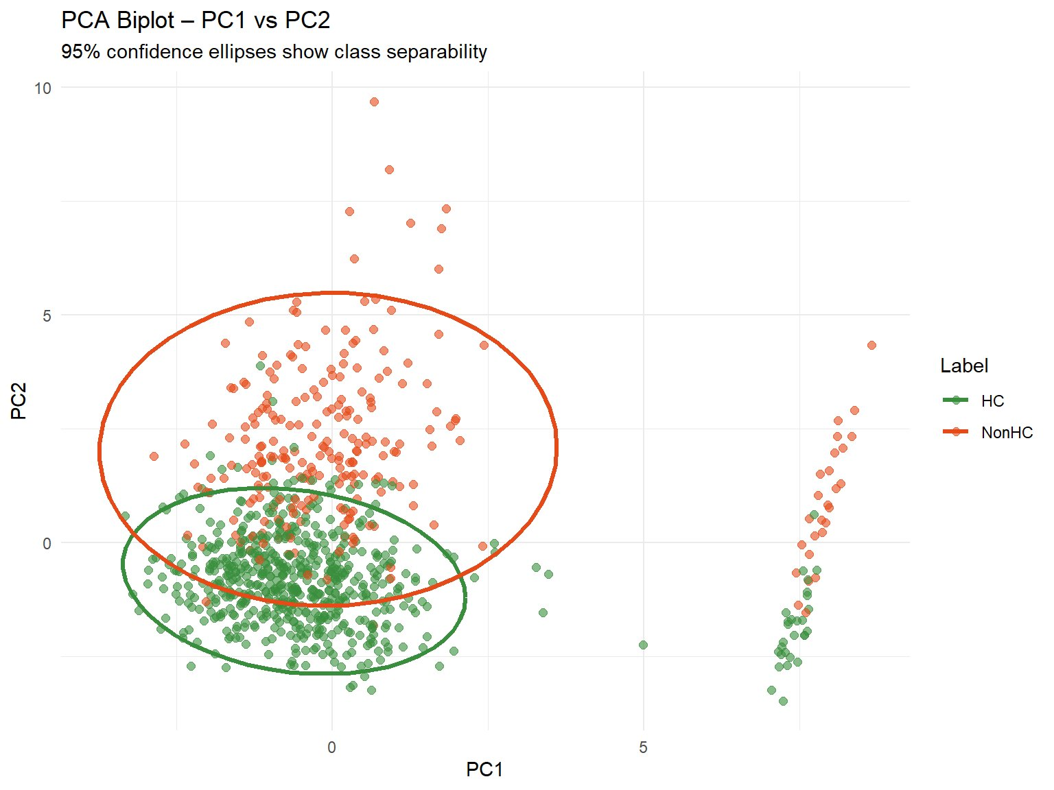
Fig. 1. PCA biplot (PC1 vs PC2). Ellipses show 95% confidence regions for HC (green) and NonHC (orange).

Classifiers
Four classifiers were trained on the ROSE-balanced training set under a rigorous 10-fold cross-validation framework repeated three times, with AUC as the optimization metric. Random Forest (RF) was configured with 300 trees and tuned mtry (number of features sampled at each split). The kNN classifier was evaluated across seven candidate values of k ∈ {3, 5, 7, 9, 11, 15, 21}. Gradient Boosting (GBM) used a focused grid comprising three values of nrounds, two tree depths, and two shrinkage rates. Naive Bayes was implemented via the klaR package with Laplace smoothing tuned over the cross-validation grid. All classifiers applied centring and scaling pre-processing within each CV fold to prevent data leakage from the held-out validation partitions.

RFE
Recursive Feature Elimination with Random Forest as the base learner was executed under the same repeated 10-fold CV framework. RFE evaluates candidate subset sizes {2, 4, 6, 8, 10, 15, 20}, iteratively removing the least important variable at each step and recording cross-validated accuracy for each subset size [8]. The optimal subset is identified at the point where accuracy of plateaus, beyond which retaining additional features yields no meaningful benefit. This data-driven selection procedure is the central methodological contribution of this work, providing an objective and reproducible answer to the economical diagnosis question that is free from subjective domain pre-selection.

RESULTS

Full-Feature Model Comparison
Table I presents test-set performance for all four classifiers evaluated on the held-out 25% partition. Three of the four models achieved AUC exceeding 98%, demonstrating strong overall discrimination. Naive Bayes led at 98.41%, closely followed by GBM at 98.39% and RF at 98.37%, with differences of less than 0.05 percentage points separating the top three models. The kNN classifier lagged considerably at 93.80% AUC, with particularly poor sensitivity at 58.06%, indicating that it correctly identified fewer than six in ten NonHC cases. This deficiency is attributable to the locally imbalanced feature space: without dimensionality reduction, the distance metric used by kNN is diluted by irrelevant features, degrading nearest-neighbour quality despite ROSE balancing.
TABLE I. Test Set Performance (%)
Model | AUC | Sens. | Spec. | F1
Random Forest | 98.37 | 95.16 | 94.74 | 91.47
kNN | 93.80 | 58.06 | 96.71 | 69.90
GBM | 98.39 | 93.55 | 96.05 | 92.06
Naive Bayes | 98.41 | 93.55 | 93.42 | 89.23
Shaded row = best AUC. Sens. = Sensitivity, Spec. = Specificity.

ROC Curves
RF, GBM, and Naive Bayes cluster near the top-left corner of ROC space (Fig. 2). kNN diverges substantially, confirming lower sensitivity across all thresholds.

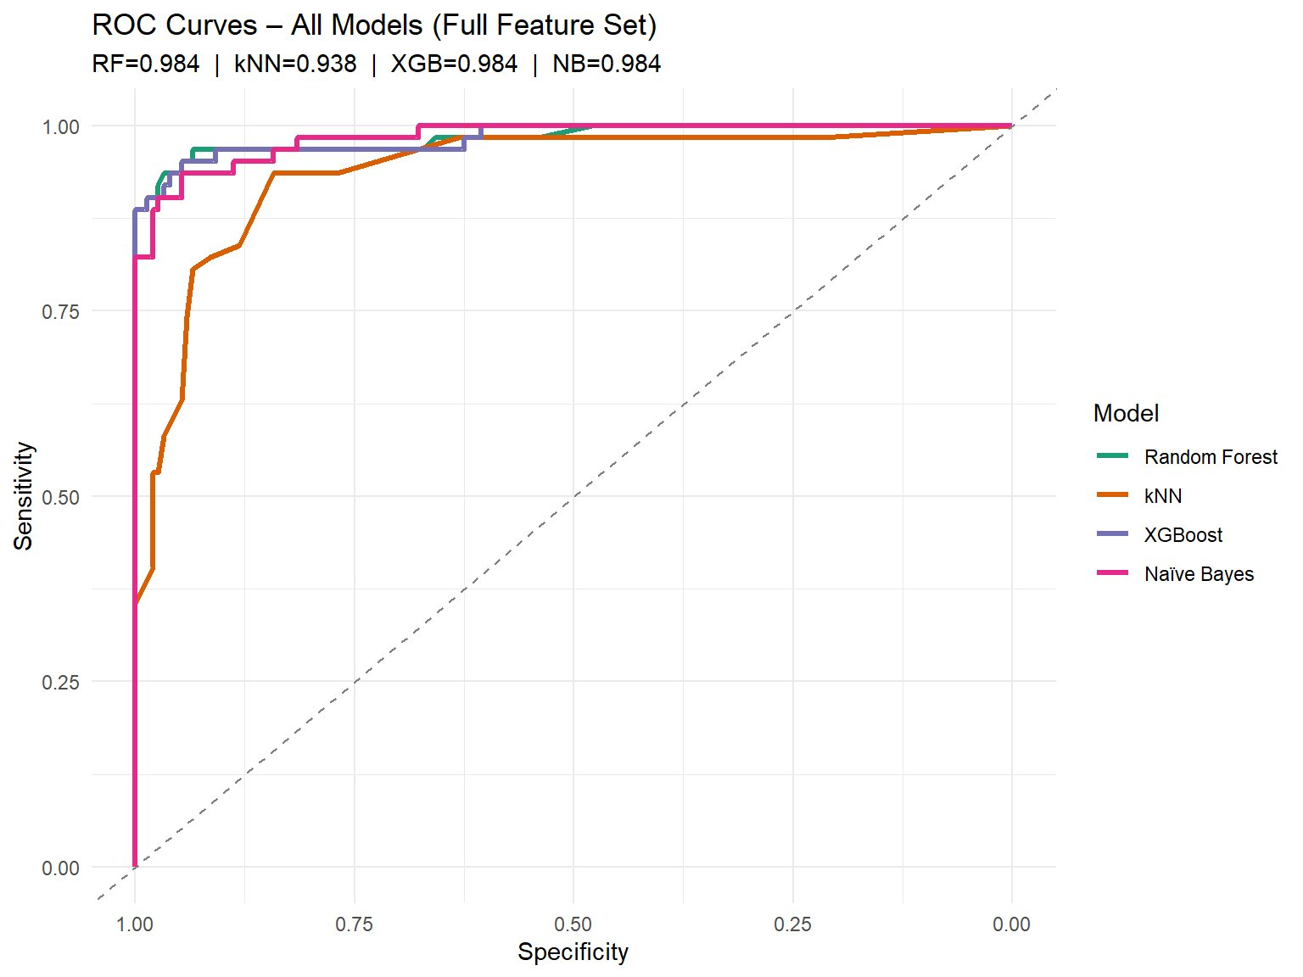
Fig. 2. ROC curves for all four classifiers. kNN (orange) shows markedly lower sensitivity.

Feature Importance
Figure 3 displays the RF-derived variable importance scores, normalized so that the most important feature receives a score of 100. CDR dominates RF importance at 100, followed by MMSE, LMDR, and LMIR. All blood biomarkers and ApoE alleles rank near zero, confirming negligible discriminative contribution beyond cognitive scores.

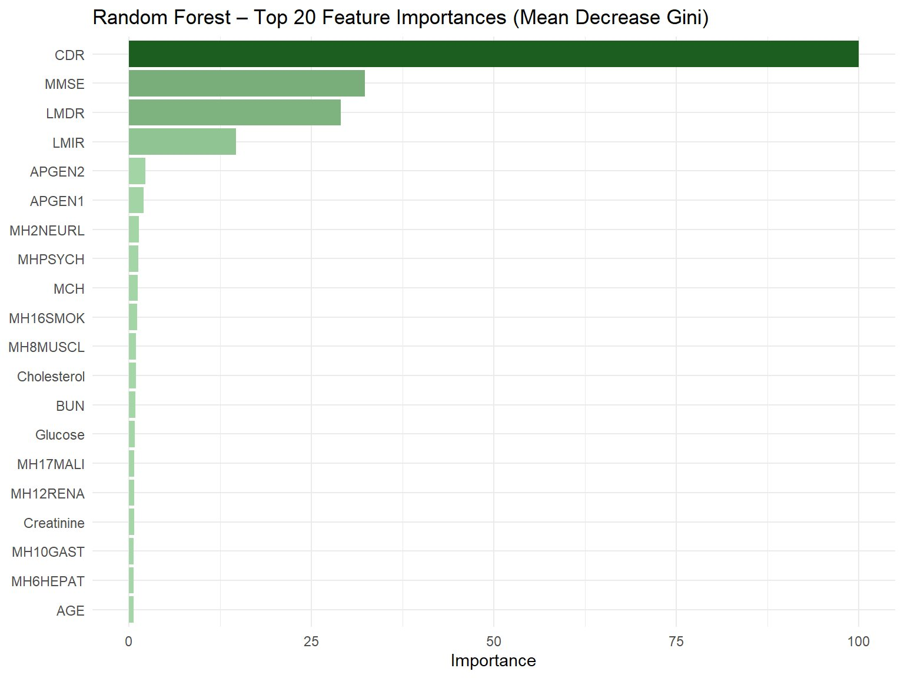
Fig. 3. RF feature importances. Cognitive scores dominate; ApoE alleles rank lowest.

Confusion Matrix
Naive Bayes correctly identified 58 of 62 NonHC cases (sensitivity 93.55%) and 142 of 152 HC participants (specificity 93.42%), with 10 false positives and 4 false negatives (Fig. 4). This error profile is acceptable for screening, as false positives are resolved by subsequent specialist assessment.
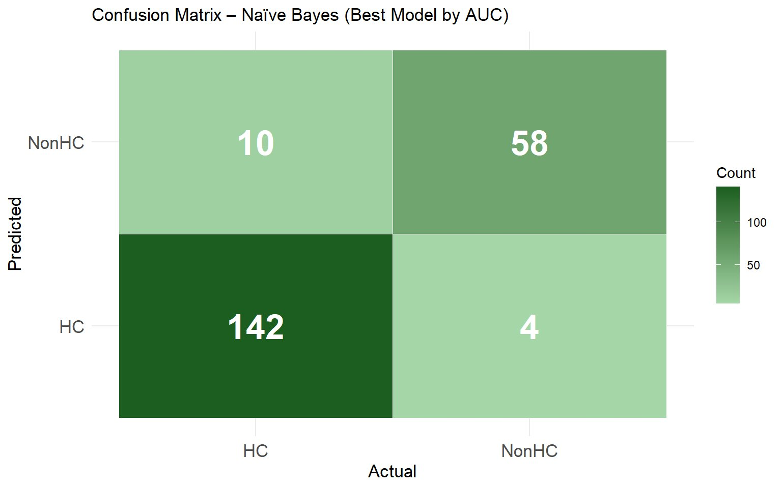
Fig. 4. Confusion matrix – Naive Bayes. TP=58, TN=142, FP=10, FN=4.

RFE Economical Configurations
The RFE curve (Fig. 5) shows accuracy of plateauing at four features. Table II confirms that Config A (4 cognitive features) achieves 98.43% AUC, exceeding the full 29-feature model at 98.37%. Adding features beyond the cognitive core yields no benefit.
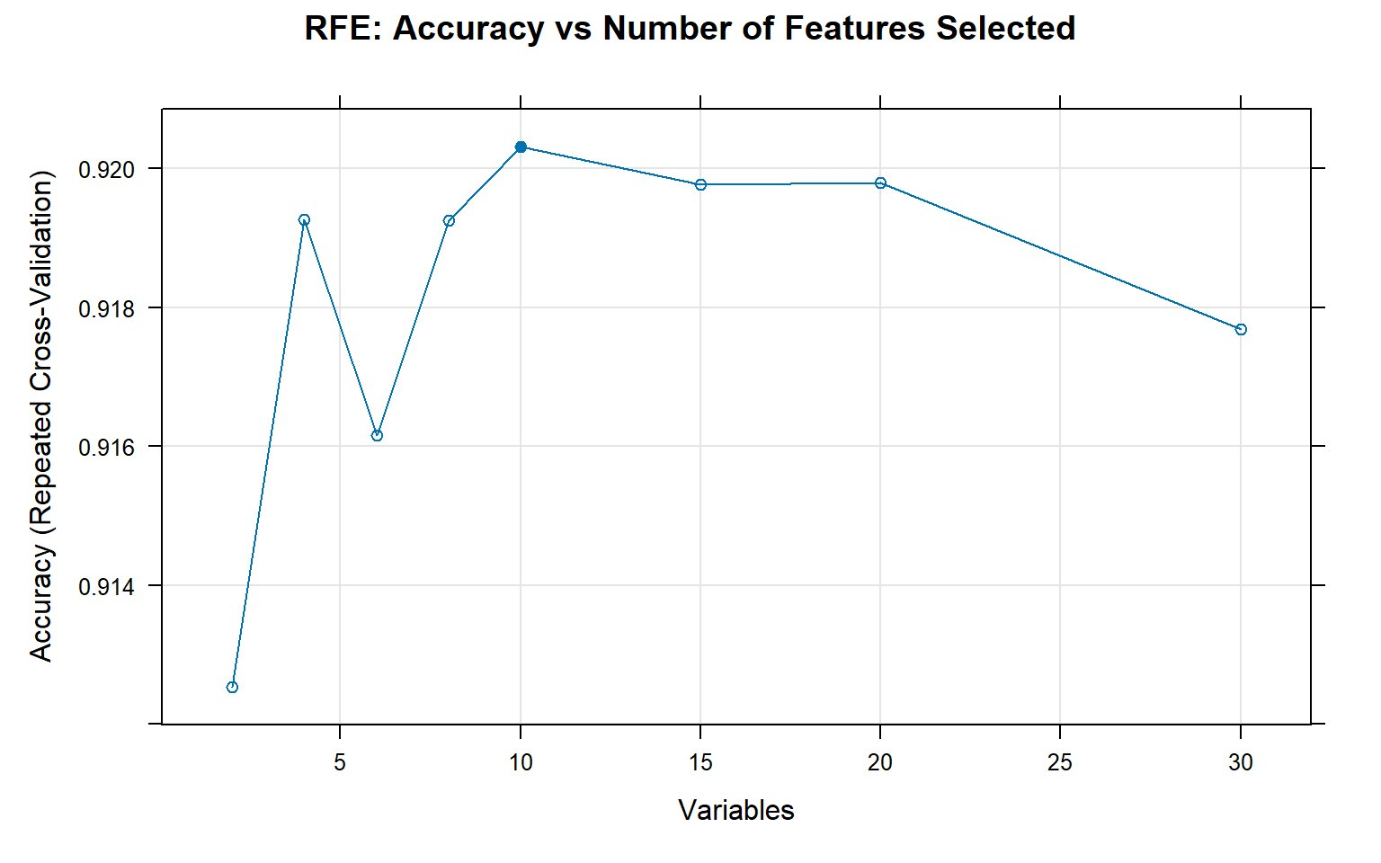
Fig. 5. RFE curve: accuracy peaks at 10 features.

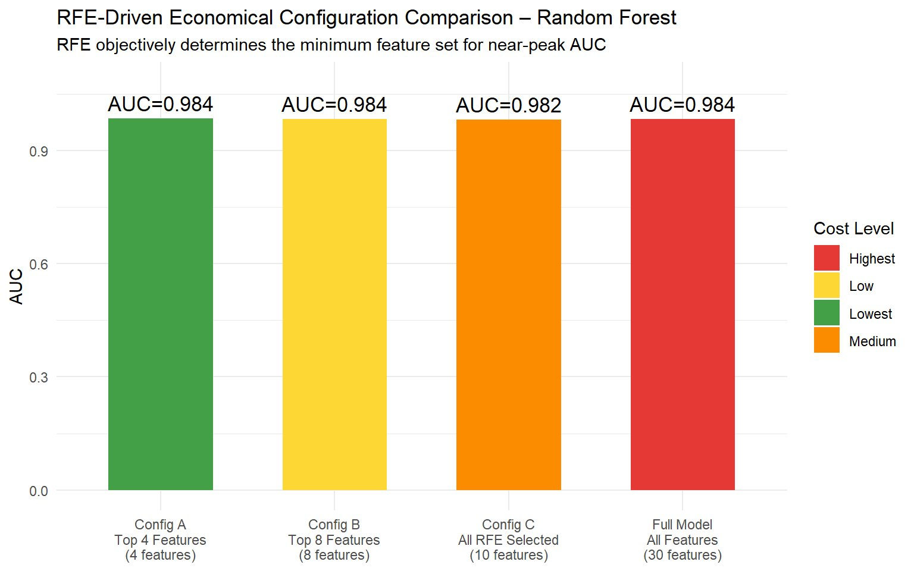
Fig. 6. Economical config comparison. Config A (4 features, lowest cost) matches full-model AUC.

TABLE II. Economical Configuration AUC
Config | Feats | Key Features | AUC
A (Lowest) | 4 | Cognitive only | 98.43
B (Low) | 8 | Top 8 RFE | 98.43
C (Medium) | 10 | All RFE-sel. | 98.23
Full | 29 | All features | 98.37
Config A shaded — lowest cost, highest AUC

Discussion
The central finding of this study is that Config A, which uses only four cognitive features, achieves an AUC of 98.43%, compared to 98.37% for the full 29-feature model. Although this result may seem counter-intuitive, it is explained by the curse of dimensionality. As the number of features increases, the feature space expands, and the distance between training observations grows, making it harder for classifiers to generalize new cases. Blood biomarkers and genomic features do not provide enough complementary information to offset this effect, leading to a slight decrease in generalization despite the larger dataset. These results support the clinical recommendation that first-line cognitive screening should use only MMSE, CDR, LMIR, and LMDR, which can be administered by a trained nurse or GP without laboratory infrastructure.
The use of kNN imputation is methodologically important and requires specific justification. In the AIBL dataset, missing data are not distributed uniformly; participants with more advanced cognitive decline often have incomplete blood records due to reduced compliance or protocol differences. In this context, the assumption of missing-completely-at-random, which underlies mean or median substitution, does not hold. kNN imputation addresses this by filling each missing value using the five most similar observed participants, leveraging local correlations to produce diagnostically plausible values [5, 9]. This approach preserves between-class distinctions and reduces the risk of imputation bias affecting classifier training.
ROSE balancing addressed the 71:29 HC-to-NonHC imbalance in the training data by generating synthetic minority-class samples using a smoothed bootstrap method. Unlike SMOTE, which creates synthetic observations only along line segments between real minority samples [10], ROSE uses a kernel-based approximation of the feature distribution. This produces more diverse synthetic cases and reduces the risk of overfitting minority cluster boundaries [6, 7]. The improvement in NonHC sensitivity across the top three models, all exceeding 93%, confirms that ROSE effectively recalibrated classifier decision boundaries toward the clinically important minority class.
The minimal predictive value of blood biomarkers, including hematological and metabolic markers, as well as ApoE genotyping (APGEN1, APGEN2), aligns with current clinical understanding. While ApoE-ε4 carriership is a known genetic risk factor for late-onset Alzheimer’s disease, its positive predictive value at the individual level is low: many carriers do not develop AD, and many AD patients are non-carriers [11]. At baseline, its ability to distinguish cases in the general population is modest. Therefore, ApoE genotyping should be reserved for specialist genetic counselling after cognitive screening, rather than used as a routine first-line test. A tiered clinical pathway, cognitive assessment first, targeted blood tests for borderline cases, and specialist referral with genomic profiling only for confirmed risk cases, is both evidence-based and resource-efficient.
This study is not without limitations. The analysis is cross-sectional, utilizing only baseline visits, and therefore cannot model the trajectory of cognitive decline over time. Longitudinal modelling would allow the detection of subtle early-stage changes before threshold classification criteria are met, potentially improving sensitivity for pre-clinical MCI. Additionally, the Naive Bayes classifier assumes conditional independence between features, an assumption violated by the high inter-correlations among cognitive scores; probability calibration using isotonic regression or Platt scaling would be advisable before deploying predicted probabilities as clinical decision thresholds. External validation on an independent cohort, such as ADNI or the UK Biobank, would further assess the generalizability of the four-feature configuration.

Conclusion
This paper demonstrated a complete and reproducible machine learning pipeline for economical HC versus Non-HC diagnostic classification using the AIBL baseline dataset. Among four evaluated classifiers, Random Forest, kNN, Gradient Boosting, and Naive Bayes, Naive Bayes achieved the highest test-set AUC of 98.41%, with RF and GBM within 0.05 percentage points. All three high-performing models exceeded 93% of sensitivity, demonstrating effective NonHC recall under ROSE-balanced training conditions.
RFE with a Random Forest base learner objectively identified that only four cognitive features, CDR, MMSE, LMIR, and LMDR, are necessary for near-peak diagnostic performance. Config A (4 cognitive features) achieved 98.43% AUC, marginally exceeding the full 29-feature model, providing compelling evidence that blood biomarkers and ApoE genotyping add no first-line screening value. The recommended clinical pathway arising from these findings is a three-tier structure: cognitive screening with the four identified instruments as the universal entry point; targeted blood investigations only for cases with borderline cognitive scores; and ApoE genotyping reserved exclusively for specialist referral. This design maximises diagnostic yield while minimising the cost and invasiveness imposed on the majority of screened individuals.

Acknowledgment
The AIBL data was provided by the AIBL Study Group. The author thanks the COM736 teaching team for module guidance.

References
[1] World Health Organization, "Dementia," WHO Fact Sheet, Sept. 2023.
[2] S. M. Laws et al., "The AIBL study of aging," Int. Psychogeriatr., vol. 22, no. 4, pp. 672–687, 2010.
[3] C. Chu et al., "Developing a machine learning stack model to forecast the progression of mild cognitive impairment to Alzheimer’s dementia using the AIBL study dataset," Alzheimer’s Dement., vol. 21, no. S1, 2025, doi: 10.1002/alz.084645.
[4] V. Youssofzadeh, B. McGuinness, L. P. Maguire, and K. Wong-Lin, "Multi-kernel learning with Dartel improves combined MRI-PET classification of Alzheimer’s disease in AIBL data," Front. Hum. Neurosci., vol. 11, p. 380, 2017.
[5] A. Gelman and J. Hill, Data Analysis Using Regression and Multilevel Models. Cambridge: CUP, 2007.
[6] G. Menardi and N. Torelli, "Training and assessing classification rules with imbalanced data," Data Min. Knowl. Discov., vol. 28, no. 1, pp. 92–122, 2014.
[7] N. Lunardon, G. Menardi, and N. Torelli, "ROSE: A package for binary imbalanced learning," R J., vol. 6, no. 1, pp. 82–92, 2014.
[8] I. Guyon et al., "Gene selection for cancer classification using SVM," Mach. Learn., vol. 46, pp. 389–422, 2002.
[9] S. van Buuren, Flexible Imputation of Missing Data, 2nd ed. Boca Raton, FL: CRC Press, 2018. [Online]. Available: https://stefvanbuuren.name/fimd/
[10] N. V. Chawla, K. W. Bowyer, L. O. Hall, and W. P. Kegelmeyer, "SMOTE: Synthetic minority over-sampling technique," J. Artif. Intell. Res., vol. 16, pp. 321–357, 2002.
[11] D. M. Rentz et al., "Cognition, reserve, and amyloid deposition in normal aging," Ann. Neurol., vol. 67, pp. 353–364, 2010.

Appendix: Additional Figures
The following figures support the main body analysis and are provided as supplementary material.
Fig. A1. RF feature importances — full ranking (top 20).
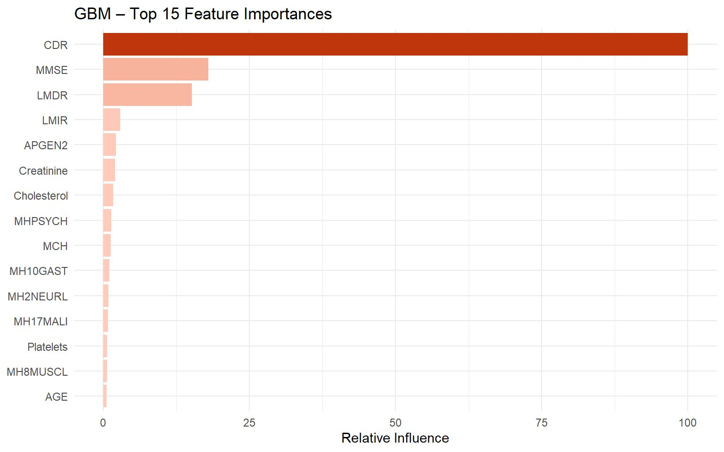
Fig. A2. GBM feature importances — relative influence (top 15). CDR dominates both models.
Fig. A3. RFE learning curve — accuracy vs number of features retained.
Fig. A4. PCA biplot — note the column of points at PC1 ≈ 5 likely from a single categorical feature dominating that component.

