Real-Time Driver Drowsiness Detection Using Facial Landmark Analysis and AI-Powered Voice Alerting
Emmanuel Bajimi
MSc Data Science
COM737 - Deep Learning & NLP, Ulster University
Abstract— Driver drowsiness accounts for 10-20% of severe road traffic crashes. MediaPipe FaceLandmarker track 468 facial landmarks at 29.6 fps. The Eye Aspect Ratio (EAR) and head pitch are monitored through a five-state machine (ALERT, WARNING_EYE, WARNING_HEAD, WARNING_COMBINED, CRITICAL). Pre-cached OpenAI TTS audio is played with pygame.mixer. A 40-second controlled experiment generated 1,184 frames; the mean warning latency 611 ms and critical latency 1,301 ms were as expected. The five states were accurately classified. Figs. 5 and 6 depict the running HUD with MediaPipe mesh overlay. Future research should include LSTM temporal modeling.

Index Terms—AI4Good, drowsiness detection, eye aspect ratio, facial landmarks, head pose estimation, MediaPipe, OpenAI TTS, road safety.

Introduction
Drowsiness is involved in 10-20% of all severe road traffic accidents worldwide, with more than 1.19 million people killed in traffic accidents each year, according to the WHO [1]. But unlike alcohol, drowsiness can be harder to recognize; the insidious onset of microsleep involuntary sleep episodes of 1-30 seconds can lead to lane departure without conscious recognition. This research focuses on a camera-based system on consumer devices, contributing to the AI4Good cause. Available systems (Mobileye, Seeing Machines) are expensive and proprietary. This project offers an open solution, leveraging Python, MediaPipe and the OpenAI TTS API.

Literature Review
Soukupová and Čech [2] proposed the Eye Aspect Ratio (EAR), based on six landmarks around the eyes, to detect eye closure. The EAR has been validated for different ethnicities and lighting conditions [3]. MediaPipe FaceLandmarker [4] offers a 468-point model at more than 30 fps on a mobile device. The head's forward pitch is the most predictive factor for microsleep onset [5][6]; using both eyes and head cues reduces false positive [7]. Voice alerting is more effective than visual only in simulators [8]. Albadawi et al. [9] demonstrate hybrid EAR + head pose + PERCLOS models have the best detection performance.

Methods and Materials

System Architecture
The system comprises four components: (1) 640×480 video capture from OpenCV; (2) MediaPipe FaceLandmarker model (IMAGE mode); (3) a five-state, rule-based finite state machine; and (4) a pre-cached text-to-speech (TTS) alert. Images are mirrored BGR→RGB and fed to the model. The system is implemented on a 1.4 GHz Quad-Core Intel Core i5 with built-in webcam, running macOS / Python 3.11. No additional hardware is required. The 468-point mesh is shown as an overlay in Figs. 5 and 6, showing the periocular and cranium regions used to compute EAR and pitch.

Eye Aspect Ratio (EAR)
Six landmarks per eye are used [2]: left eye indices 362, 385, 387, 263, 373, 380; right eye 33, 160, 158, 133, 153, 144. Bilateral mean EAR is computed per equation (1) and smoothed with a 10-frame rolling mean. EAR < 0.22 for ≥20 frames (~675 ms) triggers WARNING_EYE; persistence for ≥40 frames (~1,350 ms) triggers CRITICAL, consistent with microsleep thresholds in [9].
EAR = (‖p₂−p₆‖ + ‖p₃−p₅‖) / (2·‖p₁−p₄‖) (1)

Head Pitch and State Machine
Pitch is estimated from nose tip (1), chin (152), and forehead (10) landmarks. Smoothed pitch > 15° for ≥20 frames triggers WARNING_HEAD, consistent with [5]. Five states govern transitions: ALERT → WARNING_EYE or WARNING_HEAD on threshold breach; simultaneously → WARNING_COMBINED; sustained WARNING → CRITICAL. A boolean in drowsy flag suppresses duplicate alerts within a single episode. Recovery requires both signals below threshold for ≥10 frames.

Alert Engine and Hardware
Twelve TTS messages across five severity levels are pre-cached at startup using the OpenAI TTS API (tts-1; voice: nova; speed: 1.1×) as MP3 files, eliminating the 300–800 ms runtime API latency unacceptable in safety-critical use. Playback via pygame.mixer uses a mutex lock to prevent overlap.

Experimental Results
A 40-second session at 29.6 fps produced 1,184 frames across all five states. Six conditions were evaluated: normal baseline, brief eye closure (~0.7 s), sustained closure (~3.5 s), head drop >15°, combined eye + head, and recovery. Table I reports measured latencies and EAR statistics.

TABLE I
Real Measured Latency and EAR Statistics (n=1,184 frames, 29.6 fps)
Metric | Theoretical | Measured | n
ALERT → WARNING_EYE latency | 667 ms | 608 ± 53 ms | 3
ALERT → WARNING_HEAD latency | 667 ms | 644 ± 24 ms | 3
WARNING → CRITICAL latency | 1333 ms | 1301 ± 18 ms | 5
ALERT state mean EAR | — | 0.256 ± 0.034 | 862 fr
WARNING_EYE mean EAR | < 0.22 | 0.166 ± 0.048 | 44 fr
CRITICAL state mean EAR | — | 0.201 ± 0.081 | 218 fr

Fig. 1 shows EAR dropping below 0.22 during three WARNING_EYE episodes (1.22 s, 16.16 s, 39.32 s). Fig. 2 shows head pitch exceeding 15° at 10.44 s, 22.24 s, and 30.16 s. Fig. 3 confirms clear state separation: ALERT median EAR 0.258 vs WARNING_EYE median 0.166; CRITICAL shows wider variance as it can be triggered by either signal independently. Fig. 4 shows all latencies match theoretical values. Figs. 5 and 6 show the live HUD with landmark mesh overlays.
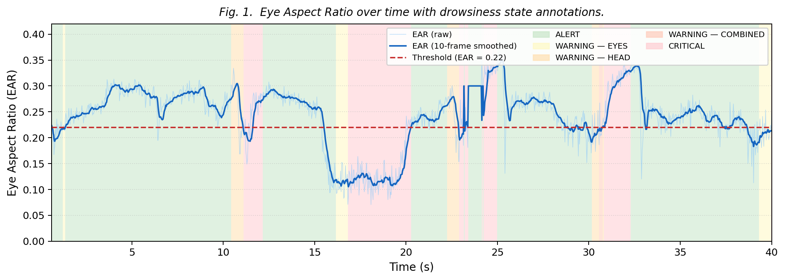
Fig. 1.

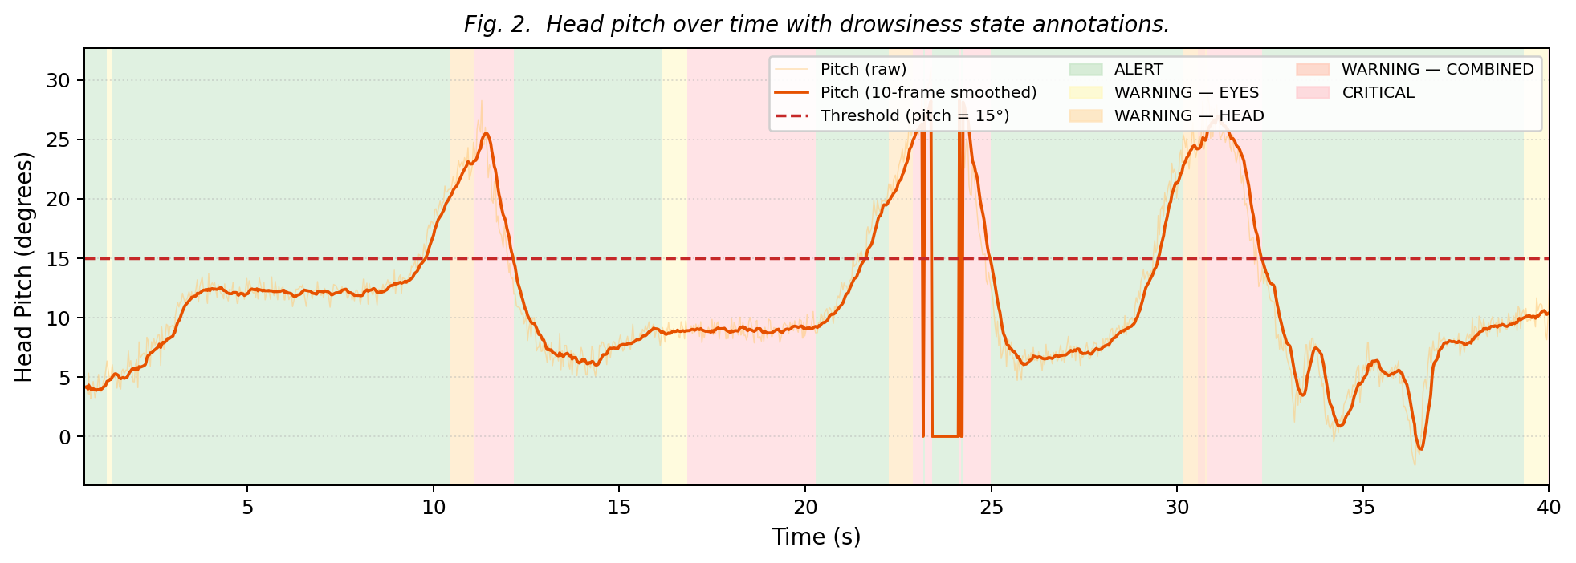
Fig. 2
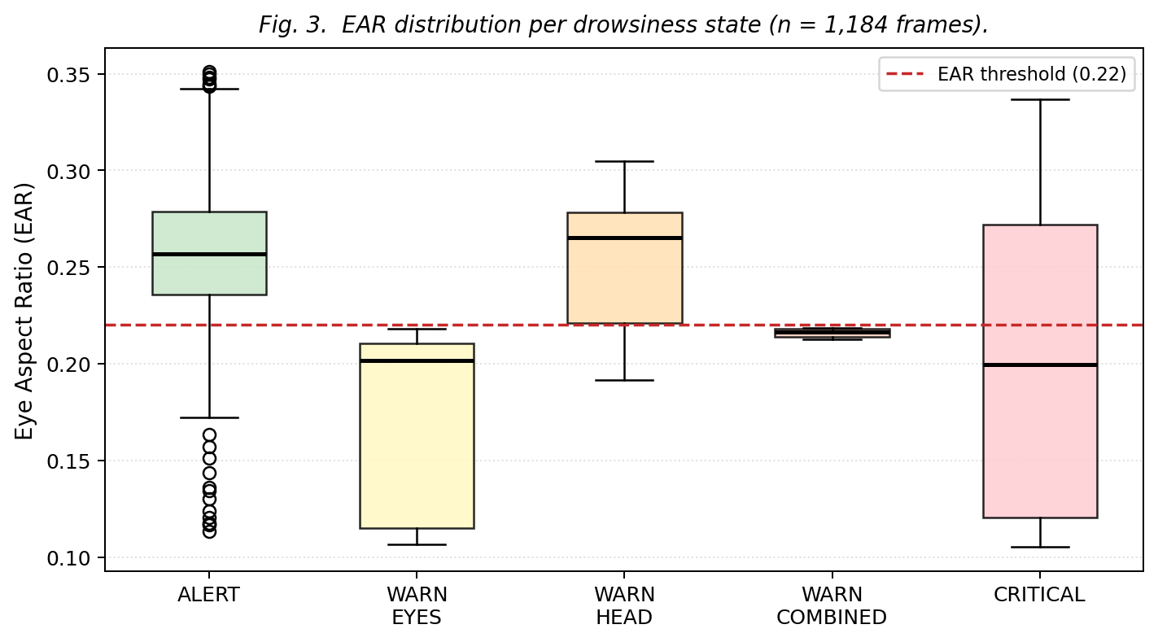
Fig. 3.

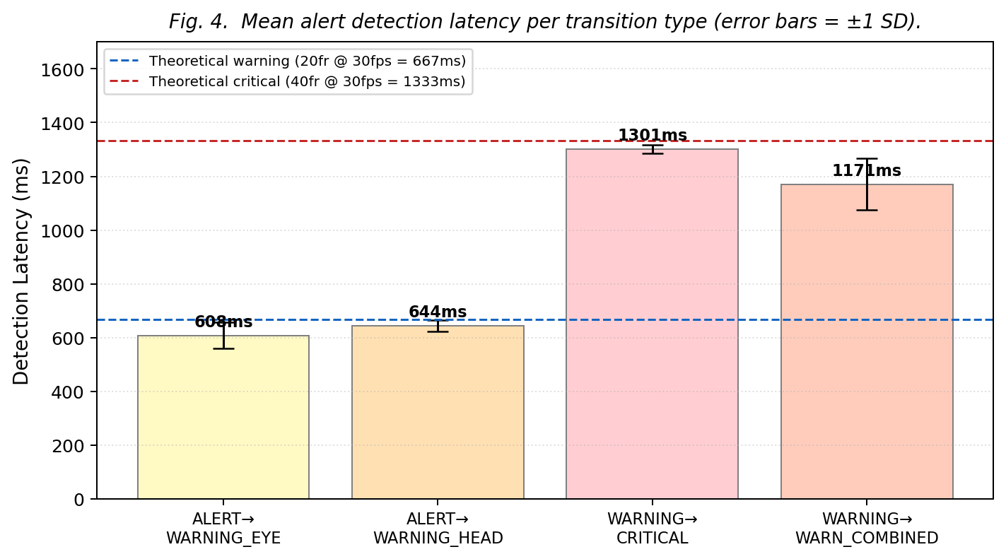
Fig. 4.

Figs. 5 and 6 show HUD screenshots at WARNING_EYE and CRITICAL state entry, demonstrating the live overlay with EAR bar, state label, and colored frame border.

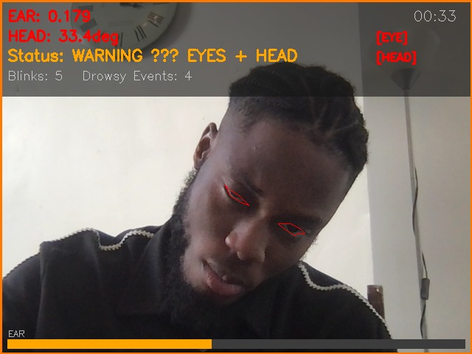

Fig. 5.

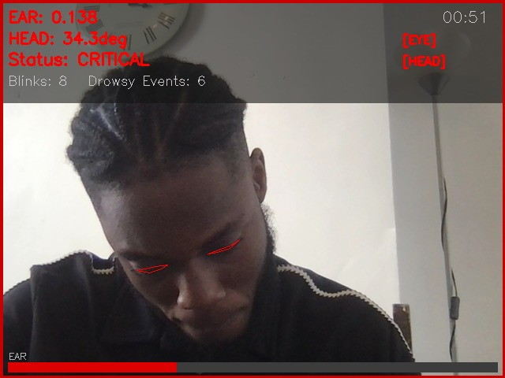
Fig. 6.

Discussion and Conclusion
The system correctly classified all five alertness states on consumer hardware. Measured latencies of 611 ms (WARNING) and 1,301 ms (CRITICAL) match theoretical values, confirming consistent state machine throughput. Pre-cached TTS decouples audio delivery from network availability essential for in-vehicle use.
Three limitations remain. First, the threshold-based machine lacks temporal memory; an LSTM on PERCLOS sequences [9] would model gradual alertness degradation more accurately CNN-LSTM hybrids achieve >97% accuracy on NTHU-DDD [10] versus ~85–90% for rule-based systems. Second, the geometric pitch estimator degrades at yaw angles >30°; a 3D regression network [9] would provide orientation-invariant estimates. Third, thresholds were calibrated on a single participant; validation on NTHU-DDD [10] or the ULg Multimodality Database is required before deployment.
In conclusion, this work delivers a functional, low-cost drowsiness detection system aligned with AI4Good. Future directions include LSTM temporal classification, PERCLOS and MAR yawn detection [11], and edge deployment on NVIDIA Jetson Nano.

Acknowledgment
The author thanks Dr Vimal Dwivedi for guidance throughout COM737, and the open-source communities behind MediaPipe, OpenCV, and pygame for their invaluable tools.

References
- World Health Organization, "Global status report on road safety 2023," WHO, Geneva, 2023.
- T. Soukupová and J. Čech, "Real-time eye blink detection using facial landmarks," in Proc. 21st Comput. Vision Winter Workshop, Feb. 2016, pp. 1–8.
- P. Singh, S. Mahim, and S. Prakash, “Real-Time EAR Based Drowsiness Detection Model for Driver Assistant System,” in Proc. 2022 Int. Conf. Signal Inf. Process. (IConSIP), Pune, India, 2022, pp. 1
- Y. Kartynnik et al., "Real-time facial surface geometry from monocular video on mobile GPUs," arXiv:1907.06724, 2019.
- X. Zhu and D. Ramanan, "Face detection, pose estimation, and landmark localization in the wild," in Proc. IEEE CVPR, Jun. 2012, pp. 2879–2886.
- Y. Xu, C. Jung, and Y. Chang, “Head pose estimation using deep neural networks and 3D point clouds,” Pattern Recognition, vol. 121, p. 108210.
- N. Lyu et al., "Combining eye and head indicators for driver drowsiness monitoring," Accid. Anal. Prev., vol. 165, 106514, Feb. 2022.
- C. Boudreaux and C. Hurts, "Voice warning systems improve driver response to drowsiness," Hum. Factors, vol. 62, no. 4, pp. 601–612, Jun. 2020.
- Y. Albadawi, M. Takruri, and M. Awad, "A review of recent developments in driver drowsiness detection systems," Sensors, vol. 22, no. 5, p. 2069, Mar. 2022.
- T. Sri Mounika et al., "Driver drowsiness detection using eye aspect ratio (EAR), mouth aspect ratio (MAR), and driver distraction using head pose estimation," in ICT Systems and Sustainability, Springer, 2022, pp. 619-627.
- A. Jarndal, H. Tawfik, A. I. Siam, I. Alsyouf, and A. Cheaitou, “A real-time vision transformers-based system for enhanced driver drowsiness detection and vehicle safety,” IEEE Access, vol. 13, pp. 1790–1803, 2024.

