Applying Data Science Principles to Classify Plant Species
Emmanuel Bajimi
MSc Data Science (B00997887), Ulster University Magee Campus, Northern Ireland
Bajimi-e@ulster.ac.uk

Abstract—This paper discusses how data science and machine learning can be applied to classify plant species automatically using a leaf dataset available in the UCI Machine Learning Repository. The dataset contains 14 morphological and texture-based features like eccentricity, aspect ratio, solidity, and entropy. Five algorithms, namely k-Nearest Neighbors (kNN), Support Vector Machine (SVM), Decision Tree, Random Forest, and Naïve Bayes, were implemented using Python and WEKA. Data was preprocessed by Z-score standardization and Min-Max normalization. Performance metrics are calculated using 10-fold cross-validation and hold-out splits. Random Forest yielded the best performance with an accuracy of 86.97%, along with the highest stability, for its ensemble nature and nonlinear relations modeling capability. The results assure that machine learning will help in plant identification, and morphological descriptors bear strong predictive power; hence, they can be used in scalable taxonomy and intelligent agricultural systems.
Keywords— Plant species classification, Multi-Class classification, leaf morphology, supervised learning, Random Forest, K-Nearest Neighbors, Support Vector Machine, Decision Tree, Naïve Bayes.

INTRODUCTION
Plant species classification plays an important role in biodiversity conservation, agriculture, forestry, and ecological monitoring. By accurately identifying plant specimens, one can perform ecosystem health assessments, control invasive species, optimize crops, and conduct massive environmental surveys. Traditionally, botanists focus on manual observation of leaf morphology, such as venation, shape, and texture. Even though this may be reliable taxonomically, it is very slow, subjective, and unsuitable for real-time or large-scale applications.
Machine learning provides an automated alternative by learning discriminative patterns from quantitative leaf features. Leaves are ideal subjects for classification, as they are abundant, easily collected, and display species-specific morphological fingerprints. Harnessing these properties empowers scalable taxonomy and intelligent agricultural systems. In this work, we utilize the dataset of 14 numerical attributes that represent geometric and texture characteristics, such as eccentricity, aspect ratio, solidity, entropy, skewness, and kurtosis, features previously identified as effective.
Unlike previous works, which have been limited to a single-platform implementation, this paper compares five algorithms: k-Nearest Neighbors, Support Vector Machine, Decision Tree, Random Forest, and Naïve Bayes, using Python's Scikit-Learn and the WEKA environment. Python allows flexible modeling pipelines and advanced kernels, while WEKA provides standardized evaluation and interpretable models. Cross-platform evaluation underlines differences in algorithmic implementations, hyperparameters, and preprocessing methods.
Aims and Objectives
The primary goal of this work is to determine which machine learning model demonstrates the highest generalization capability for leaf-based species prediction. This study examines the impact of software default settings on model performance. Specifically, this study aims to:
- Perform exploratory data analysis and assess data quality.
- Preprocess the data using Python.
- Train classification models using Python and WEKA.
- Evaluate and compare kNN, SVM, Decision Tree, Random Forest, and Naïve Bayes.
- Identify the most effective model and provide justification based on accuracy, stability, and ROC analysis.

DATASET DESCRIPTION
The dataset utilized in this study, leaf_labelled_V1.csv, was obtained from the UCI Machine Learning Repository [9]. It contains 340 samples belonging to 30 plant species. The number of samples per species varies, with most species containing 10–15 samples; however, a few species have slightly fewer or more samples. The dataset comprises 14 numerical features that describe leaf geometry and texture, as well as a class label (See Appendix F).
Feature Engineering & Attributes: The dataset characterizes leaf specimens using fourteen quantitative attributes that capture distinct biological properties. These features can be broadly categorized into two:
- Morphological Descriptors: Eccentricity, Aspect Ratio, Elongation, Solidity, Stochastic Convexity, and Isoperimetric Factor describe the physical geometry and boundary complexity of the leaf. These metrics are essential for distinguishing between broad, round leaves and those with narrow or lobed structures.
- Texture & Statistical Metrics: These quantify grayscale intensity patterns and surface texture: Intensity, Contrast, Smoothness, Third Moment, Uniformity, Entropy
Target Variable and Data Integrity: The target variable, Species, is categorical; it represents the species identity for each sample. A preliminary quality assessment revealed that the dataset is highly structured, and there are no missing values. 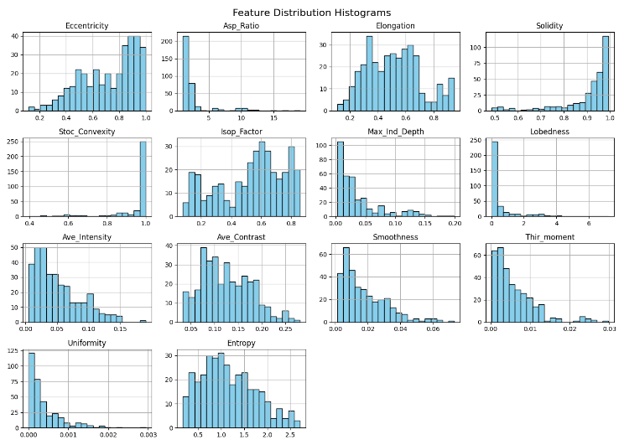
Fig. 1 Feature Distribution Histograms

DATA QUALITY REPORT
A full data quality assessment was done to ensure that the leaf dataset is suitable for machine learning classification.

A. Class Distribution
An analysis of the target variable (Class (Species)) shows that:
- The dataset contains multiple plant species (e.g., SP_1, SP_2, SP_3, etc.).
- The number of samples per species varies notably.
- While the dataset covers 30 distinct species, the density of observations varies significantly, ranging from a minimum of 8 samples (e.g., SP_4, SP_6) to a maximum of 16 samples (e.g., SP_11).
This indicates a class imbalance (see Appendix A), a challenge commonly reported in plant disease and species classification datasets [1], [6]. Class imbalance can bias models toward the majority species, making accuracy misleading. Metrics like F1-score are vital; kNN and Decision Trees struggle, while ensemble methods such as Random Forest handle imbalance better.

B. Correlation Analysis
A correlation analysis was conducted to understand relationships among the 14 numerical features (See Appendix B). The heatmap revealed moderate correlations among geometric features such as eccentricity, elongation, and aspect ratio, and clustering among texture features including entropy, skewness, and kurtosis.

METHODOLOGY
This section describes the rigorous experimental protocol employed to ensure reproducibility and fair comparison, following widely accepted practices in plant classification and machine-learning research [3], [5], [7], [9].
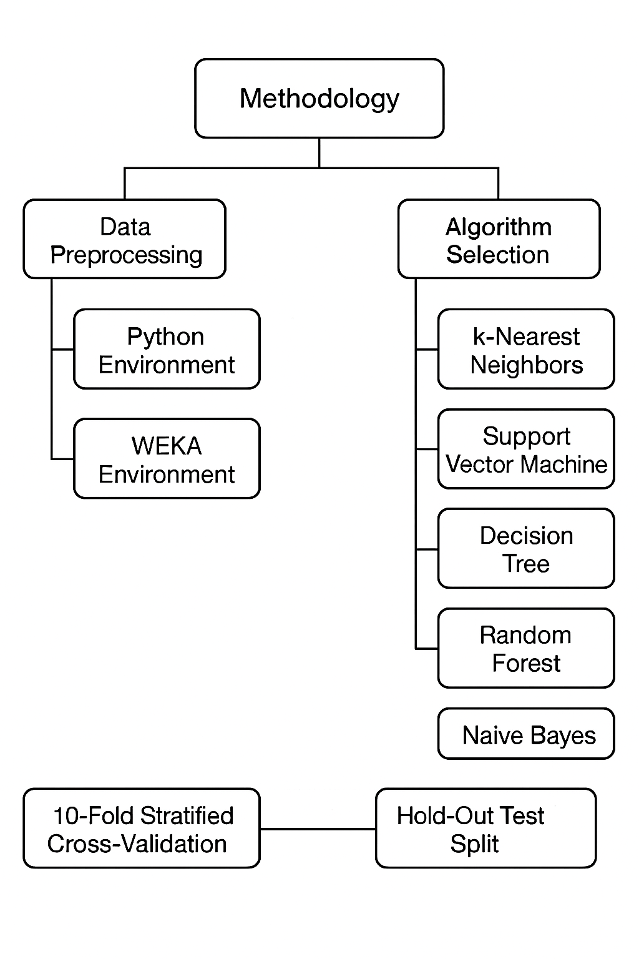
Fig. 2: Flow Diagram of Methodology

Data Preprocessing: The Scaler Divergence
In Python, class imbalance was addressed using SMOTE (see Appendix C), which synthesizes new minority-class instances. Feature variables were standardized using Z-score normalization (StandardScaler), yielding zero-mean, unit-variance scaling known to improve the performance of algorithms such as SVM and kNN. In WEKA, however, SMOTE was not feasible due to the presence of 30 species classes, several of which contain too few instances to satisfy SMOTE’s requirement for sufficient same c lass nearest neighbors. This limitation results in unstable or invalid synthetic samples in highly multi-class settings. Consequently, the Resample filter (see Appendix D) was employed to balance the dataset through random oversampling. Feature normalization was then performed using the Min-Max Normalize filter, which scales values to the range [0,1], although this method may be more sensitive to outliers and less suitable for SVM compared to Z-score scaling.

B. Algorithm Selection & Configuration
- k-Nearest Neighbors (kNN)
- Support Vector Machine (SVM)
- Decision Tree (J48/CART)
- Random Forest (RF)
- Naïve Bayes
C. Validation Strategy: Model performance was evaluated using 10-fold stratified cross-validation, which preserves class distribution across folds, and a generalization test with an 80/20 hold-out split. These strategies were followed in both Python and WEKA to ensure an unbiased and comprehensive assessment. Only a combination of cross-validation with hold-out evaluation will provide substantial evidence regarding model stability and predictive accuracy across different environments.

MODELLING
Five algorithms were implemented to compare classification performance.
    - k-Nearest Neighbors (kNN): A non-parametric, instance-based algorithm that classifies samples based on the majority label among nearest neighbors [9].
Configuration: k = 5 (IBk in WEKA) and k = 5 in the Python implementation.
    - Support Vector Machine (SVM): A margin-based classifier that identifies the optimal separating hyperplane between classes. By maximizing the margin, SVMs tend to generalize well, especially in high-dimensional spaces [3], [9]. Kernel functions (e.g., RBF) can be used to capture non-linear boundaries.
    - Decision Tree (J48/CART): A hierarchical, rule-based model that recursively splits the dataset based on feature thresholds. Each internal node represents a decision rule (e.g., If Solidity > 0.9 → Species X), while leaves correspond to class labels [7].
    - Random Forest (RF): An ensemble learning method that constructs multiple decision trees using bootstrapped samples and random feature subsets. Predictions are aggregated (majority vote), reducing variance and mitigating overfitting [4], [10].
Configuration: 100 trees in WEKA; 200 trees in the Python implementation.
    - Naïve Bayes: A probabilistic classifier grounded in Bayes’ theorem, assuming conditional independence among features. Despite its simplicity, it performs well on high-dimensional datasets and provides fast classification.

RESULTS
A. Python Results (Scikit-Learn)
TABLE I: PYTHON PERFORMANCE SUMMARY
Model | Test Accuracy | CV Mean (10-Fold)
Random Forest | 88.54% | 86.25%
Naïve Bayes | 78.12% | 82.29%
SVM (Linear) | 82.23% | 85.21%
kNN (k=5) | 79.17% | 80.42%
Decision Tree | 79.17% | 77.29%
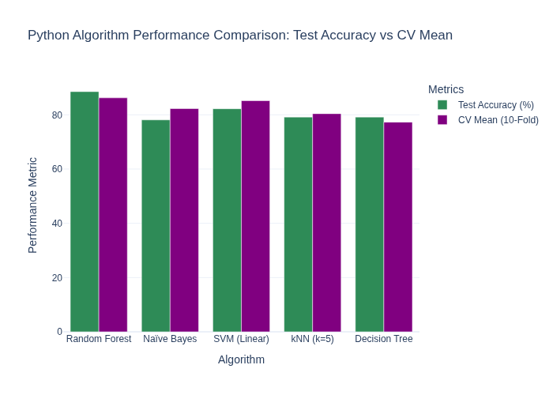
Fig. 3: Python Algorithm Performance Comparison: Test Accuracy vs CV Mean

B. WEKA Results
TABLE II: WEKA PERFORMANCE SUMMARY
Algorithm | Test Accuracy (20% Split) | CV Mean (10-Fold) | ROC Area
Random Forest | 86.36% | 86.97% | 0.994
Naïve Bayes | 75.76% | 77.58% | 0.986
kNN (IBk, k=5) | 72.73% | 71.21% | 0.961
Decision Tree (J48) | 83.33% | 78.48% | 0.913
SVM (SMO) | 40.9% | 63% | 0.965

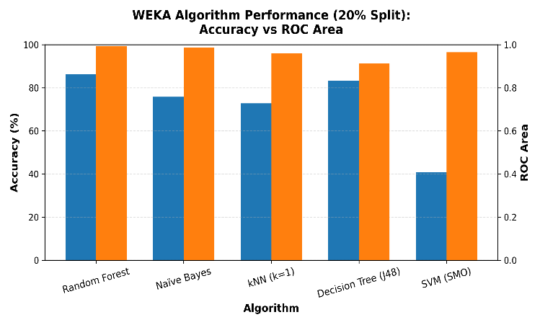
Fig. 4: WEKA Algorithm Performance (20% split): Accuracy vs ROC Area

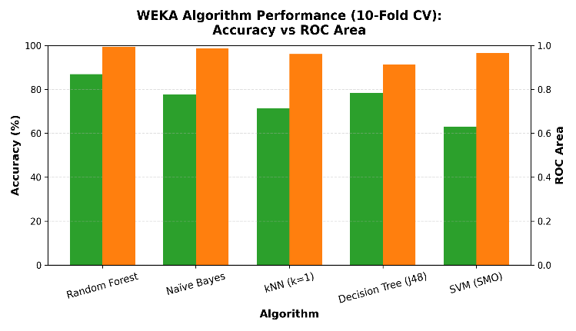
Fig. 5: WEKA Algorithm Performance (10-fold CV): Accuracy vs ROC Area

C. Detailed Error Analysis (WEKA)
The confusion matrix for the SMO (SVM) model in WEKA reveals a catastrophic failure mode. The model achieved only 40.9% accuracy on the test split. The SVM confusion matrix revealed frequent misclassification among species with similar geometric traits, suggesting insufficient feature separability for margin-based models. In contrast, Random Forest demonstrated strong stability, achieving 100% recall for species like SP_5, SP_8, and SP_15. This highlights the advantage of tree-based ensembles in handling nonlinear, heterogeneous feature spaces.

DISCUSSION

The Dominance of Ensemble Learning
The results unequivocally demonstrate that Random Forest is the superior classifier for this domain. It achieved the highest Cross-Validation score in both tools (86.97% in WEKA, 86.25% in Python).
- Why? Single Decision Trees (like J48) performed moderately well in WEKA (83.33%) but lower in Python (79.17%), showing some susceptibility to overfitting. Random Forest mitigates this by aggregating predictions from multiple trees, reducing variance and handling noise in texture features more effectively than any single tree model

B. The "Scaler Hypothesis": Explaining the SVM Anomaly
The most striking finding of this study is the massive performance gap in Linear SVMs:
- Python (Linear SVC): 82.23% Accuracy (High Performance).
- WEKA (SMO): 40.9% Accuracy.
Python applied Z-score scaling, centering data for optimal margin detection, whereas WEKA used Min-Max normalization, which compresses feature ranges and amplifies outlier effects. For leaf datasets with morphological variability, Z-score standardization is critical for margin-based models. kNN also benefited from Z-score scaling, preserving distance relationships better than Min-Max normalization.

C. Feature Importance
The feature importance analysis derived from the Python Random Forest model highlights Solidity as the most discriminative feature.
- Biological Significance: Solidity measures the "lobedness" of a leaf. A maple leaf (deeply lobed) has low solidity, while an orange leaf (entire/smooth) has high solidity. This single geometric property is seemingly the strongest predictor of species identity in this dataset (See Appendix E).

D. The Probabilistic Power of Naïve Bayes
Despite being a simple model, Naïve Bayes performed exceptionally well, achieving the highest ROC Area (0.986) in WEKA. This suggests that the feature distributions for each species roughly follow a Gaussian (Normal) distribution. While it may not always predict the top class correctly (75.76% accuracy in WEKA), a high ROC value suggests that the classifier assigns higher probabilities to the correct class on average, even if its final classification accuracy is lower.

CONCLUSION
This study presented a comprehensive data science approach to automating plant species identification. By rigorously benchmarking five algorithms across two platforms, we derived the following conclusions:
- Optimal Model: Random Forest demonstrated the best overall performance, in agreement with prior studies advocating ensemble methods for botanical datasets [4], [10]. The study also revealed that preprocessing choices significantly affect SVM performance, with Z-score scaling outperforming Min-Max normalization.
- Critical Insight on Tools: Software defaults matter. The failure of WEKA's SVM highlights that "out-of-the-box" settings (specifically Min-Max normalization) can be detrimental to linear models. Researchers using WEKA should manually apply Standardization filters.
- Feature Efficacy: Morphological features, specifically Solidity and Aspect Ratio, are powerful predictors that can distinguish species without the need for complex deep learning on raw pixels.
- Future work includes applying advanced hyperparameter optimization, expanding feature engineering, exploring deep learning on raw leaf imagery, and evaluating the system on larger and more diverse datasets.

REFERENCES
- R. N. Nandi, A. H. Palash, N. Siddique, and M. G. Zilani, "Device-friendly guava fruit and leaf disease detection using deep learning," arXiv, 2022.
- A. Khan, U. Nawaz, A. Ulhaq, and R. W. Robinson, "Real-time plant health assessment via implementing cloud-based scalable transfer learning on AWS DeepLens," arXiv, 2020.
- S. M. Hassan, A. K. Maji, M. Jasiński, Z. Leonowicz, and E. Jasińska, "Identification of plant-leaf diseases using CNN and transfer-learning approach," Electronics, vol. 10, no. 12, Art. no. 1388, 2021, doi:10.3390/electronics10121388.
- G. Goyal, V. T. Raghavan, and R. Singh, "EnConv: Enhanced CNN for leaf disease classification," Journal of Plant Diseases and Protection, 2024.
- R. Chen, Y. Liang, and M. Yang, "Identification of plant leaf diseases by deep learning based on channel attention and pruning," Frontiers in Plant Science, vol. 13, 2022, doi:10.3389/fpls.. 2022.1023515.
- Z. Y. Younes and E. M. T. A. Alsaadi, "A review on plant leaf disease classification using deep learning," Iraqi Journal of Science, vol. 65, no. 11, pp. 6738–6752, 2024, doi:10.24996/ijs.2024.65.11.43.
- Khan, A., "Review on Convolutional Neural Network (CNN) Applied to Plant Leaf Disease Classification," Agriculture, vol. 11, 2021, Art. no. 80707, doi:10.3390/agriculture11080707.
- S. Too, L. Yujian, S. Njuki, and L. Yingchun, “A comparative study of fine-tuning deep learning models for plant disease identification,” Computers and Electronics in Agriculture, vol. 161, pp. 272–279, 2019, doi: 10.1016/j.compag.2018.03.032.
- A. K. Singh, S. P. Singh, and A. K. Misra, “Plant leaf disease detection and classification using machine learning models,” International Journal of Engineering Research & Technology (IJERT), vol. 9, no. 07, pp. 402–408, 2020.
- "Plant leaf disease detection and classification using convolutional neural networks: a review," Artificial Intelligence Review, vol. 58, 2025, article no. 322.
- D. P. Kingma and M. Welling, "Auto-encoding variational Bayes," 2013, arXiv:1312.6114. [Online]. Available: https://arxiv.org/abs/1312.6114
Appendix A

Class Distribution of Unbalanced Leaf Species

Appendix B

Correlation Heatmap of Leaf Features

Appendix C

Class Distribution of Balanced Leaf Species after using SMOTE analysis in Python Preprocessing

Appendix D

Class Distribution of Balanced Leaf Species after using Resample filter in WEKA Preprocessing

Appendix E

Feature importance ranking derived from the Random Forest classifier, identifying Solidity, Aspect Ratio, and Elongation as the most discriminative morphological attributes

Appendix F

Appendix G

Random Forest Model using 10-Folds Cross Validation

Random Forest Model using 20% Test data Split Ratio

Naïve Bayes Model using 10-Folds Cross Validation

Naïve Bayes Model using 20% Test data Split Ratio
K-Nearest Neighbors Model using 10-Folds Cross Validation

K-Nearest Neighbors Model using 20% Test data Split Ratio

Decision Tree Model using 10-Folds Cross Validation

Decision Tree Model using 20% Test data Split Ratio
SMO (SVM) Model using 10-Folds Cross Validation

SMO (SVM) Model using 20% Test data Split Ratio

