ASTREABLUE ENTERPRISE ITSM

Nontechnical System Documentation
Architecture, Workflows, Roles, Controls and Operational Reference

Document version | Documentation Baseline 1.0
Publication date | 28 July 2026
Primary audience | Management, project panel, operations, users and process owners
Classification | Internal project documentation

This edition is intentionally monochrome for reliable office printing. Editable diagrams.net source files are supplied with this document.

Document Control
Field | Controlled value
Purpose | Describe the implemented AstreaBlue system, responsibilities, workflows and controls.
Source basis | Current repository routes, services, database migrations, frontend views and native-agent source.
Secrets | No passwords, API keys, device credentials or production secret values are included.
Editable assets | DOCX files and diagrams.net (.drawio) source diagrams.

Contents
01 Document Control
02 Executive / Architecture Summary
03 Executive Summary
04 System Scope
05 Roles and Responsibilities
06 Service Desk and Ticketing
07 Asset and Configuration Management
08 Replacement Management
09 Endpoint Monitoring and Consent
10 Employee Lifecycle
11 SLA, Risk and Reporting Rules
12 Known Boundaries and Operational Cautions
13 Diagram Portfolio
14 Implementation Status and Roadmap
15 Glossary
Note: page numbers are intentionally omitted from this editable contents list so it remains correct after revisions.

Executive Summary
AstreaBlue is a centralized enterprise IT service-management platform. It combines employee and external ticket intake, hardware and software asset records, configuration management, replacement processing, SLA tracking, endpoint monitoring, reporting, and employee lifecycle coordination.
The platform is role-aware. SuperAdmin has enterprise scope; Admin normally operates within a branch; Technician handles eligible same-branch or assigned service work; HR coordinates employee lifecycle cases and their linked internal records; Employee works with personal tickets, consent, assigned assets, and replacement requests.

System Scope
In scope: authentication and invitations, role-based access, branches and users, Service Desk ticketing, external ticket gateway, knowledge base, ticket calendar, SLA dashboards, hardware assets, software licenses, discovery and reconciliation, asset finance, configuration items and dependencies, replacement management, analytics, endpoint telemetry, consent and policy, screenshots, USB/DLP, and employee onboarding/offboarding.
External business systems are not directly administered by AstreaBlue. They may submit tickets through the controlled API. Offboarding records internal AstreaBlue actions; it does not automatically disable unrelated HRIS, payroll, email, VPN, or cloud accounts.

Roles and Responsibilities
SuperAdmin: system-wide configuration, users, roles, branches, integrations, endpoint administration, sensitive monitoring controls, and enterprise records.
Admin: branch-scoped operational management, approvals, assets, tickets, lifecycle tasks, and reports where authorized.
Technician: assigned and eligible same-branch ticket work. Sensitive privacy/role-change tickets, external enterprise tickets, and onboarding-generated tickets are excluded from the technician queue.
HR: creates and manages onboarding/offboarding cases and can access only the lifecycle-related ticket records allowed by the backend scope rules.
Employee: sees and updates personal records allowed by the workflow, including own tickets, consent, assigned assets, and replacement requests.

Service Desk and Ticketing
Tickets may originate from employees, authorized lifecycle workflows, or registered external systems. Internal tickets follow branch and requester/assignment rules. External integration tickets are enterprise records visible only to SuperAdmin.
A ticket records its priority, category, branch, requester, assignee, timestamps, comments, attachments, history, and SLA targets. Status changes are audited. Resolution duration is calculated from the work-start time to resolution/closure when those timestamps exist.

Asset and Configuration Management
Hardware Asset Management maintains ownership, location, assignment, lifecycle status, history, images, and financial data. Software License Management tracks purchased seats, assignment, expiry and renewal history.
Asset Discovery imports or scans device facts and reconciles them with registered assets. A matched discovery already points to an asset; unmanaged data may be linked to an existing asset or used to create a new record.
Configuration Items model applications, databases, servers and related services. Dependencies explain how a change can propagate. The change-impact view derives affected items and recommendations from the stored dependency graph and CI attributes.

Replacement Management
Replacement Management replaces the retired Change & Release module in the active user workflow. It supports assessment, repair, approval, reservation, issue and completion paths.
When repair completes, the asset is returned to a valid state based on assignment and its recorded pre-repair state. When a replacement is issued, assignment and history are retained for auditability.

Endpoint Monitoring and Consent
A monitored laptop uses a unique device credential obtained through a short-lived, single-use enrollment code. The native Windows service sends heartbeat, inventory and policy traffic. An interactive companion handles user-session activity and screenshots.
Privacy-sensitive collectors run only when the approved effective policy enables them. Screenshot objects are encrypted before private R2 storage. USB/DLP collection records device and transfer metadata; file contents are not collected.

Employee Lifecycle
Onboarding may begin before an AstreaBlue user account exists. HR creates the lifecycle case; the system creates a linked internal ticket; an authorized administrator creates the invitation; the employee activates the account, completes profile and consent; assets and endpoint monitoring are then linked and verified.
Offboarding deactivates AstreaBlue access, recovers assets, records license and internal data-handover evidence, classifies returned assets, creates internal notifications, verifies required tasks, and closes the linked ticket. Required tasks prevent premature completion.

SLA, Risk and Reporting Rules
SLA policies are selected first by priority and category, then by priority fallback. Current code calculates targets as elapsed minutes from ticket creation; business-hour calendars are not yet applied. First response and resolution are separate targets, so two SLA history rows for one ticket can be legitimate.
USB/DLP scoring is server-authoritative: a high-risk extension adds 55, a sensitive filename adds 35, and a transfer at or above the configured threshold adds 25. Medium begins at 25, High at 50 and Critical at 70.
Reports and exports are controlled by the active role and filters. Generated documents should be treated as snapshots; source-of-truth records remain in PostgreSQL.

Known Boundaries and Operational Cautions
Email delivery depends on correctly configured production provider credentials. The application must never embed those secret values in manuals or client-side code.
The native-agent rollout is not complete until second-laptop restart, repair, DLP and uninstall tests are recorded. Legacy global-token support must remain until all active laptops use unique device credentials.
The platform records internal lifecycle evidence but does not directly operate external mailboxes or third-party business systems.

Diagram Portfolio
The following diagrams are rendered from the supplied diagrams.net source files. Open any .drawio file in diagrams.net or draw.io Desktop to edit shapes and connectors.

Diagram 1. System Context and Trust Boundaries
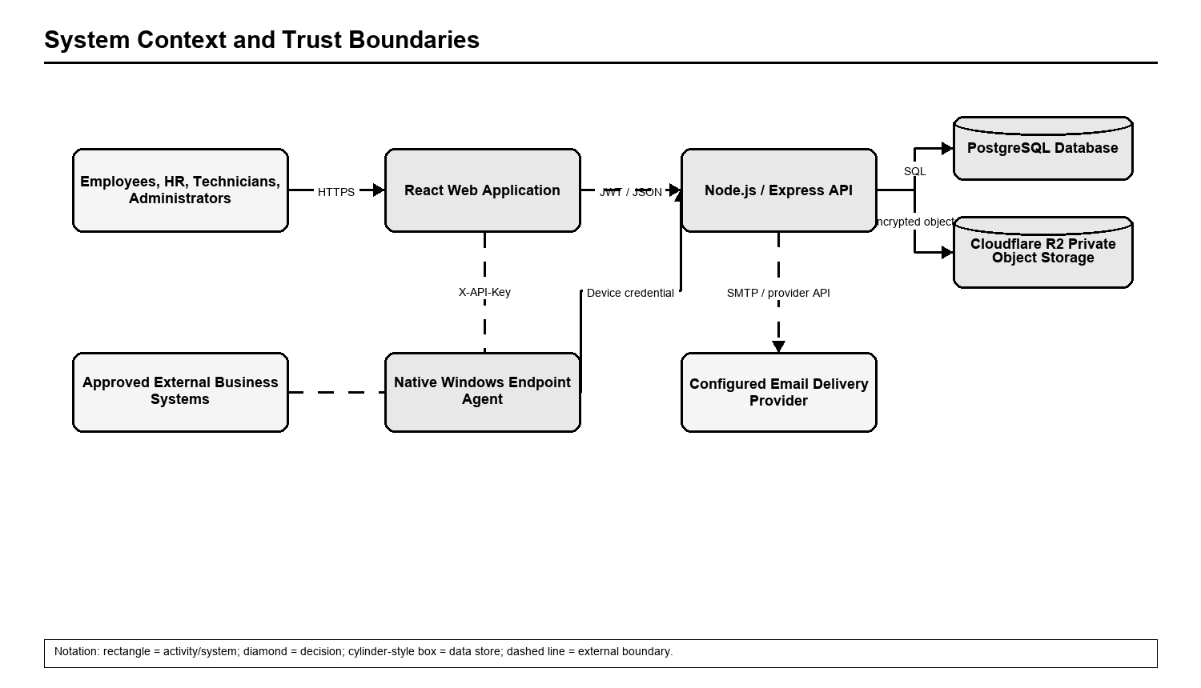
Editable source: diagrams/system-context.drawio. Flow follows the currently implemented route/service rules.

Diagram 2. Role-Based Access and Operational Scope
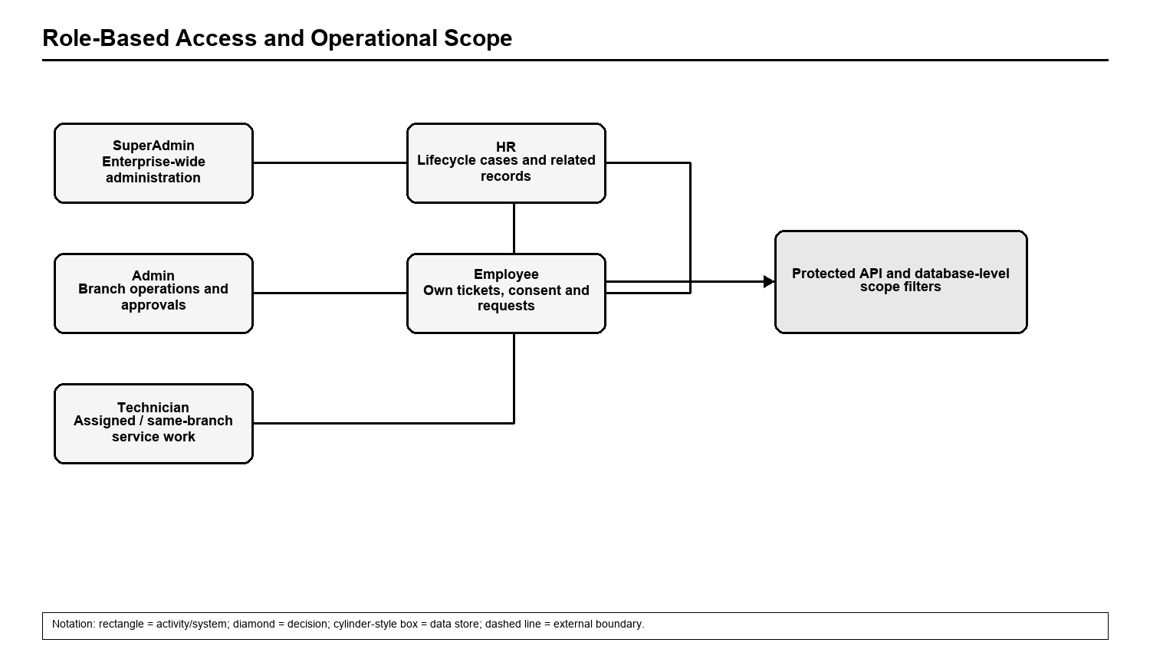
Editable source: diagrams/role-access.drawio. Flow follows the currently implemented route/service rules.

Diagram 3. Employee Onboarding Workflow
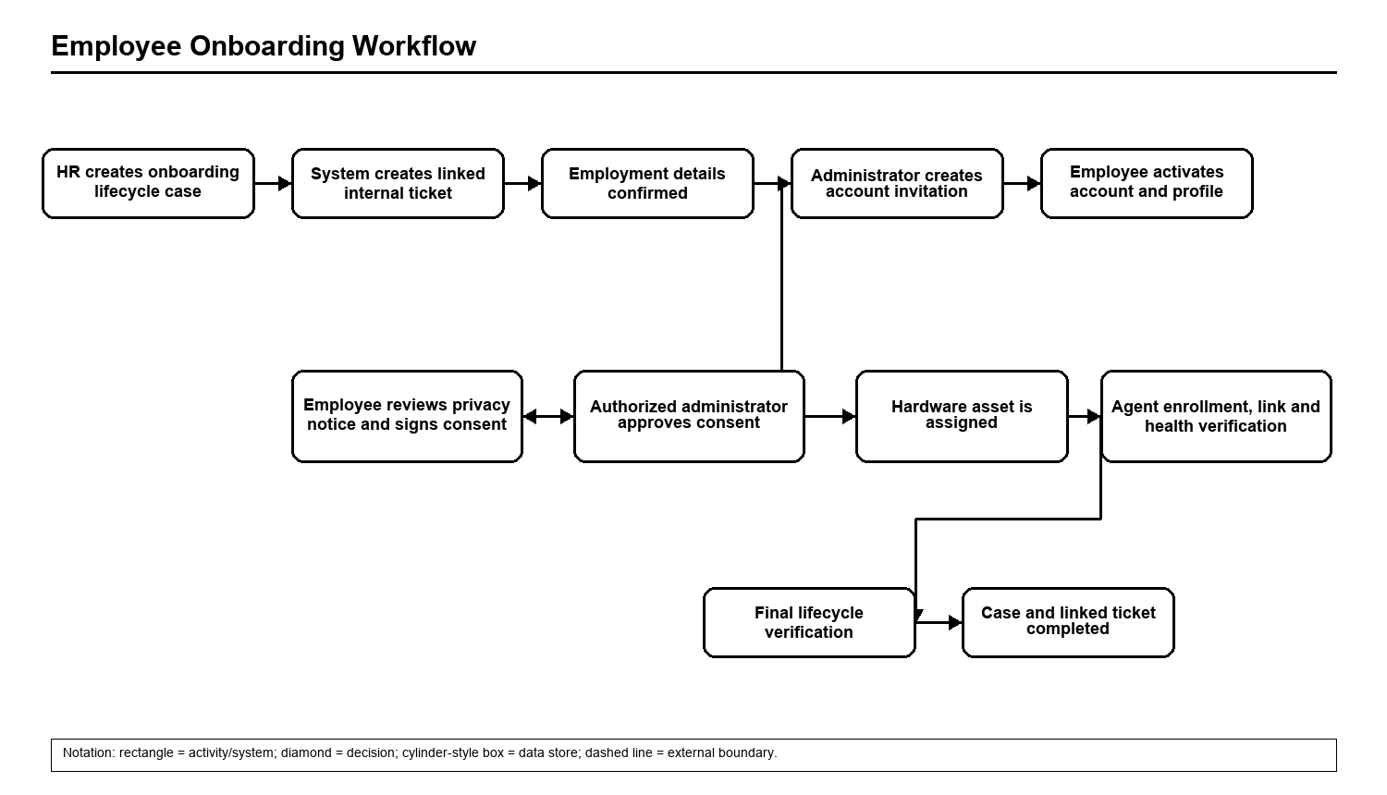
Editable source: diagrams/onboarding.drawio. Flow follows the currently implemented route/service rules.

Diagram 4. Employee Offboarding Workflow
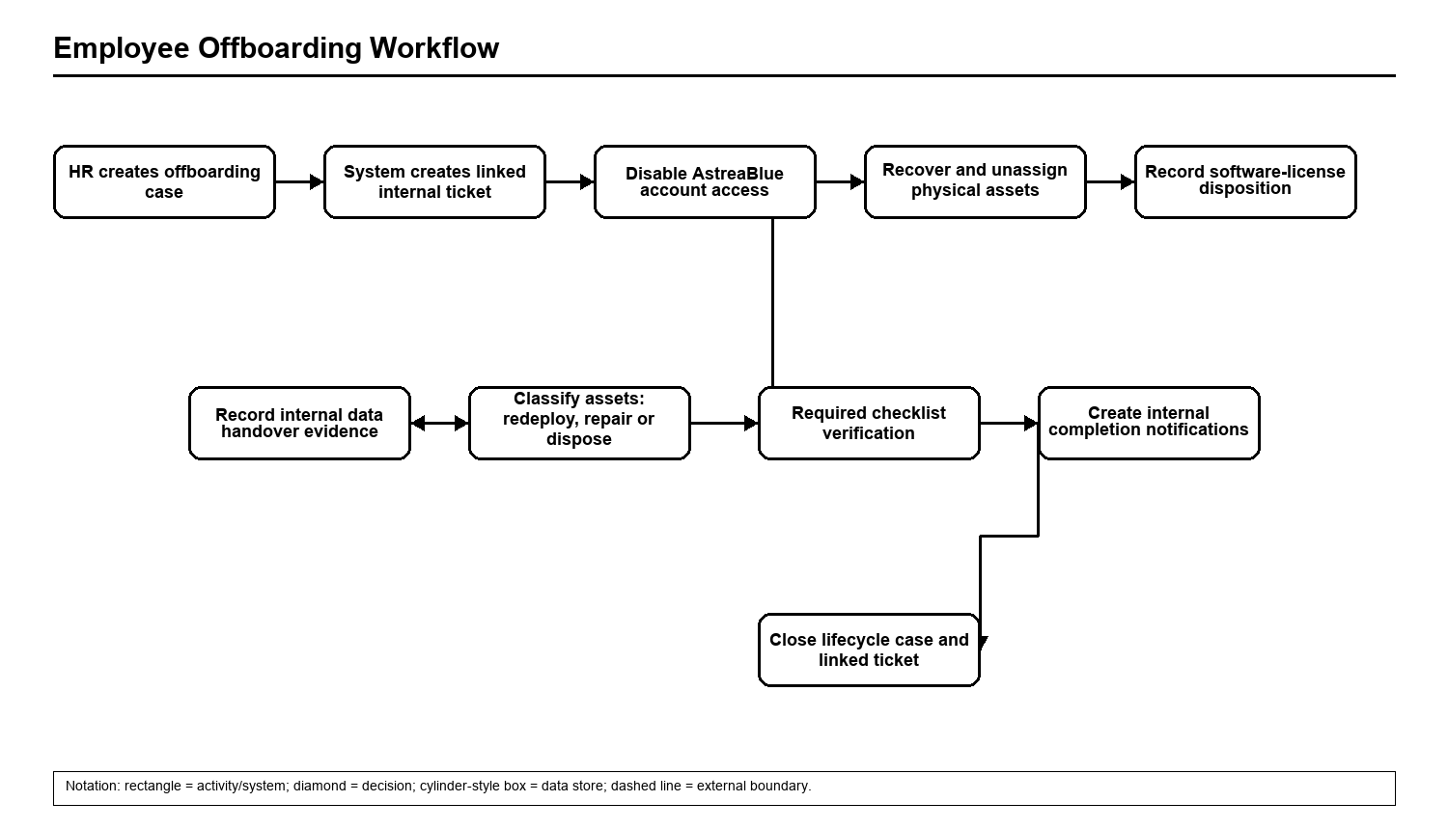
Editable source: diagrams/offboarding.drawio. Flow follows the currently implemented route/service rules.

Diagram 5. Internal and External Ticket Processing
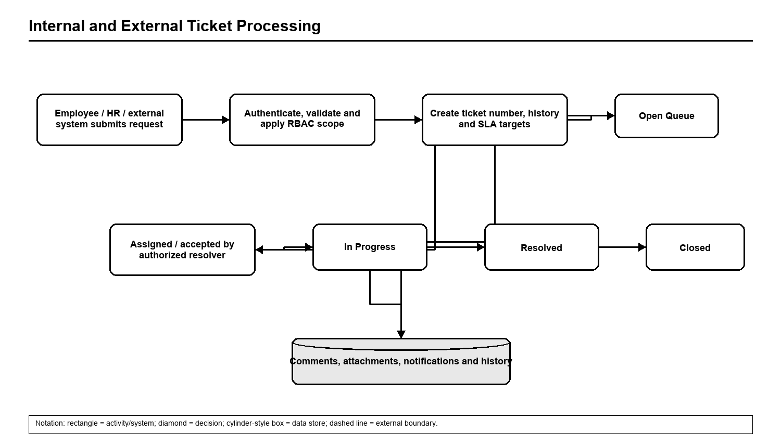
Editable source: diagrams/ticket-lifecycle.drawio. Flow follows the currently implemented route/service rules.

Diagram 6. Hardware Asset Replacement and Repair Workflow
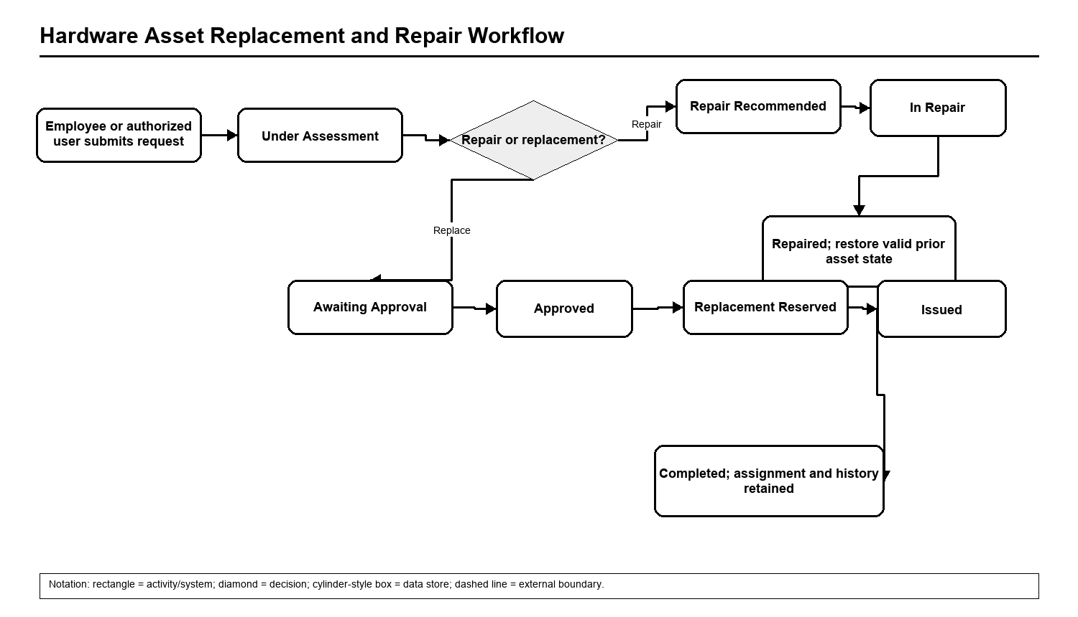
Editable source: diagrams/asset-replacement.drawio. Flow follows the currently implemented route/service rules.

Diagram 7. Consent-Aware Endpoint Monitoring
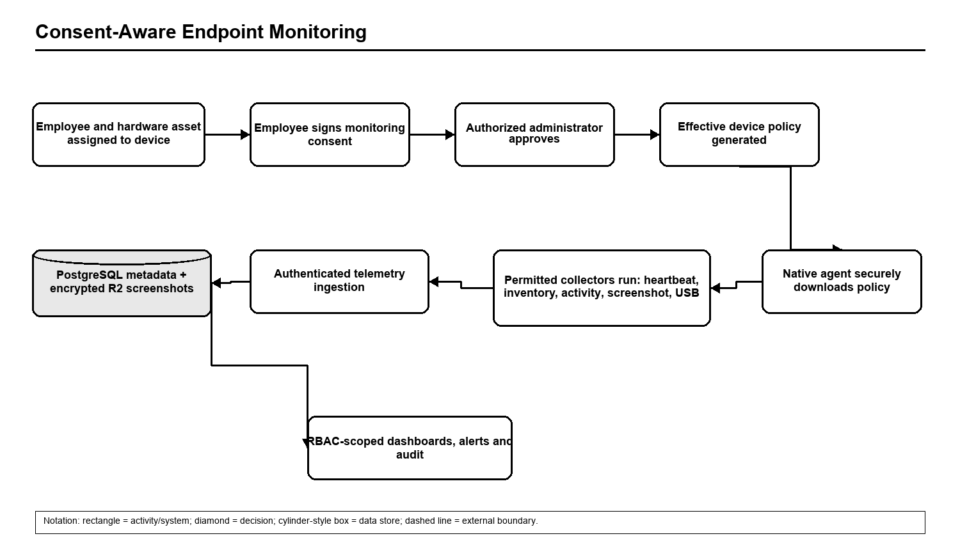
Editable source: diagrams/consent-monitoring.drawio. Flow follows the currently implemented route/service rules.

Diagram 8. Centralized External Ticket Gateway
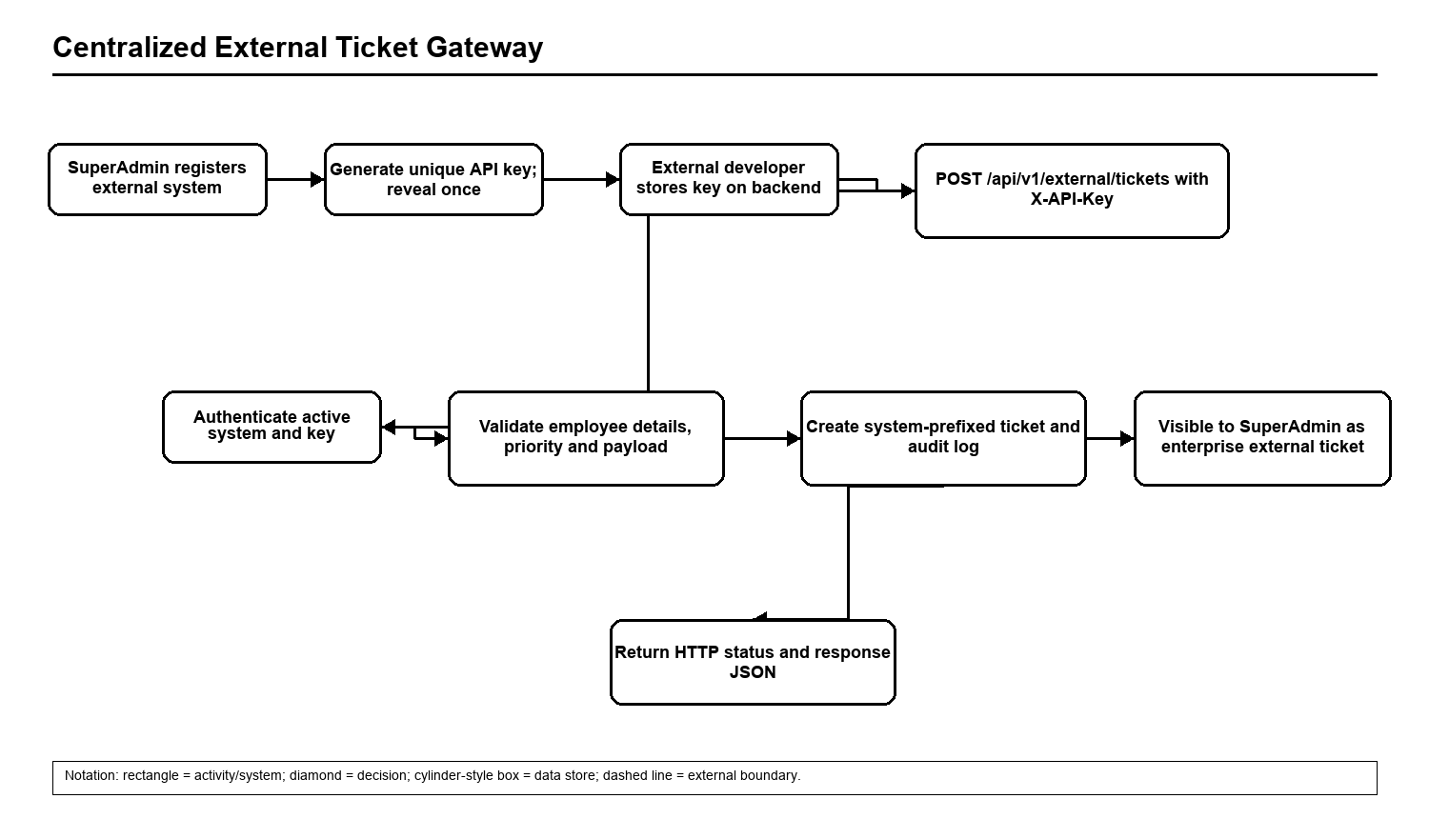
Editable source: diagrams/external-gateway.drawio. Flow follows the currently implemented route/service rules.

Implementation Status and Roadmap
Area | Status | Evidence / next action
Foundation | Implemented | Authentication, RBAC, branches/users, assets, endpoint, consent, policy and diagnostics.
External gateway | Implemented / validate consumers | Registration, API keys, external tickets, audit logs and SuperAdmin scope.
Native agent | Pilot | Unique credentials, service, inventory, activity, screenshot and USB/DLP implemented; physical pilot coverage remains.
Installer | In progress | ZIP install/repair/diagnostics/uninstall exist; trusted signing and MSI remain.
Updates | In progress | Framework exists; production manifest, signed channels and rollback validation remain.
SLA calendar | Technical debt | Current targets use elapsed minutes; business-hour calendars are not yet applied.

Glossary
Term | Meaning
API | Application Programming Interface.
CI | Configuration Item.
DLP | Data Loss Prevention.
DPAPI | Windows Data Protection API.
JWT | JSON Web Token used for interactive-user sessions.
R2 | Cloudflare private object storage used for encrypted screenshot objects.
RBAC | Role-Based Access Control.
SLA | Service Level Agreement target for response and resolution.
Telemetry | Operational measurements sent by a managed endpoint.

