**Section 3**

Question : 01

Code

*// Bajrang 363*

*// September 6, 2022*

*// Assignment 2 Question 3*

function **d**=depth(**t**)

**d** = 0.5 * 9.81 * **t**^2

endfunction

clf()

t = [1:0.25:10];

for i = 1:length(t)

d(i) = depth(t(i))

end

disp([d, t'])

plot(t', d)

title("Depth of well with respect to time taken by a stone dropped into the well.")

xlabel('time t (seconds) ->', 'fontsize', 2)

ylabel('depth d (meters) ->', 'fontsize', 2)

xs2png(0, 'e2q3.png')

Output on Console

--> exec('C:\Users\system13\Desktop\B_363\e213.sce', -1)

4.905 1.

7.6640625 1.25

11.03625 1.5

15.021562 1.75

19.62 2.

24.831563 2.25

30.65625 2.5

37.094062 2.75

44.145 3.

51.809063 3.25

60.08625 3.5

68.976562 3.75

78.48 4.

88.596563 4.25

99.32625 4.5

110.66906 4.75

122.625 5.

135.19406 5.25

148.37625 5.5

162.17156 5.75

176.58 6.

191.60156 6.25

207.23625 6.5

223.48406 6.75

240.345 7.

257.81906 7.25

275.90625 7.5

294.60656 7.75

313.92 8.

333.84656 8.25

354.38625 8.5

375.53906 8.75

397.305 9.

419.68406 9.25

442.67625 9.5

466.28156 9.75

490.5 10.

Graph

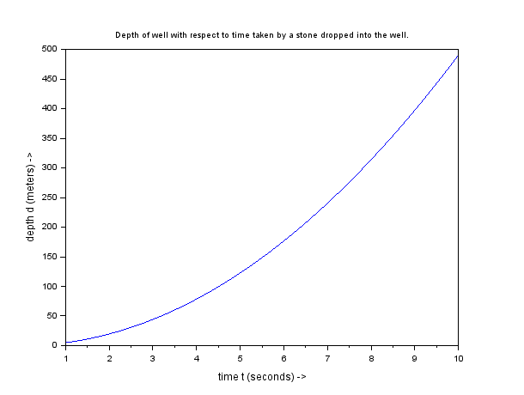

Question 02:

Code

*// Bajrang 363*

*// September 6, 2022*

*// Horizontal Range of projectile with respect to theta*

function **R**=horizontal_range(**theta**)

u = 750;

**R** = (u^2*(sind(2\***theta**))/9.81)

endfunction

theta = [5:5:85]

for i = 1:length(theta)

r(i) = horizontal_range(theta(i))

end

clf()

disp('Theta (degrees) and R (meters) ')

A = [theta',r];

disp(A)

plot(theta', r)

title("Range of projectile with angle theta")

xlabel("Angle theta (degrees) -> ", 'fontsize', 2)

ylabel("Range of projectile (meters) -> ", 'fontsize', 2)

xs2png(0, 'e2q4.png')

Result :

Theta and R

5. 9956.8909

10. 19611.247

15. 28669.725

20. 36857.088

25. 43924.567

30. 49657.42

35. 53881.458

40. 56468.334

45. 57339.45

50. 56468.334

55. 53881.458

60. 49657.42

65. 43924.567

70. 36857.088

75. 28669.725

80. 19611.247

85. 9956.8909

Graph

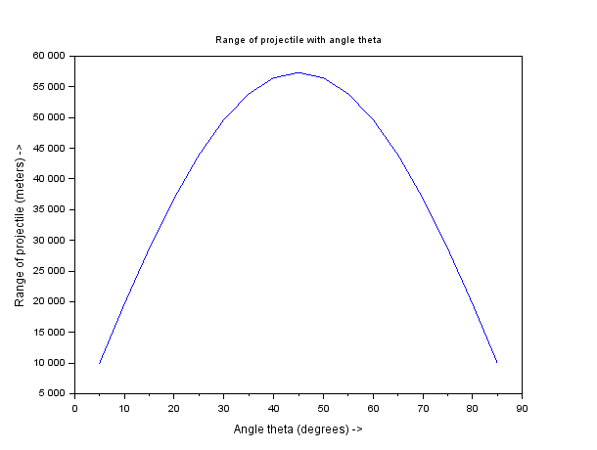

Question 3:

Code

*// Bajrang 363*

*// September 6, 2022*

*// Vandermonde Matrix*

function **vand**=vandermonde_my(**x**)

v = ones(length(**x**),1)

for i = 1:length(**x**)-1

for j = 1:length(**x**)

r(j) = **x**(j)^i

end

c = [v, r]

v = c

end

**vand** = c

endfunction

x = [2,-3, 5, -2]

vand = vandermonde_my(x)

disp(vand)

Output

1. 2. 4. 8.

1. -3. 9. -27.

1. 5. 25. 125.

1. -2. 4. -8.