Final Concept for VR with Glasses

Disclaimer: Please treat this idea as if AR glasses were used instead of VR glasses. We would like to do an AR Project, which VR glasses are not exactly meant for.

# Problem to be solved (Goal)

Recognize images (faces of employees, objects relevant to job) and display metadata concerning the recognized person/object (e.g. Name, job title, function, instructions on how to use, ...). Allow reporting of persons (for inappropriate behaviour) and objects (when broken). The data is maintained in a database that already exists. A mapping between the recognition of the person/object and the respective entry in the database needs to be established.

# State of the Art

Collection of links: <https://github.com/mnrmja007/awesome-virtual-reality> (curated list of VR-resources)

ApertusVR: <https://github.com/MTASZTAKI/ApertusVR> (Free virtual and augmented reality engine)

NewtonVR: <https://github.com/TomorrowTodayLabs/NewtonVR> (VR with physics -> pickup/hold/throw items, no clipping of objects through each other, etc.)

EscapeMuseum VR: <https://github.com/ErickSimoes/EscapeMuseumVR> (explore museum in VR, answer questions about picture to be able to leave)

Calcflow: <https://github.com/matryx/calcflow> (Mathematical Modeling in VR)

Research on Virtual Rehab: <https://github.com/ViRehab/VirtualRealityResearchDocs> (Various research papers on using Virtual Reality for rehabilitation (e.g. Physiotherapy))

State of VR and AR: <https://www.qbittech.com/index.php/vr-blog/item/136-the-state-of-vr-and-ar> (opinion about the current state of VR and AR (from 2020))

AI learns tracking people: <https://www.youtube.com/watch?v=dd1kN_myNDs> (2 minute paper about AI learning to track people)

CES 2020: <https://venturebeat.com/2020/01/09/ces-2020-proved-vr-and-ar-are-thriving-and-moving-into-automobiles/> (article about the developments of VR as seen at the CES this year)

Unity AR-foundation: <https://github.com/Unity-Technologies/arfoundation-samples> (examples for using AR foundation)

Unity VR best practice: <https://learn.unity.com/tutorial/vr-best-practice> (tutorial on best practices when developing for VR with Unity)

Unity AR-foundation essentials: <https://github.com/dilmerv/UnityARFoundationEssentials> (examples for FaceTracking, BodyTracking, etc. using Unity)

Object Recognition in AR: <https://virtualrealitypop.com/object-recognition-in-augmented-reality-8f7f17127a7a> (frameworks for object recognition evaluated)

Object/Facial Recognition in Augmented and Virtual Reality: <https://ntrs.nasa.gov/archive/nasa/casi.ntrs.nasa.gov/20170011671.pdf> (investigation into software, hardware and potential use)

# 

# Target Group

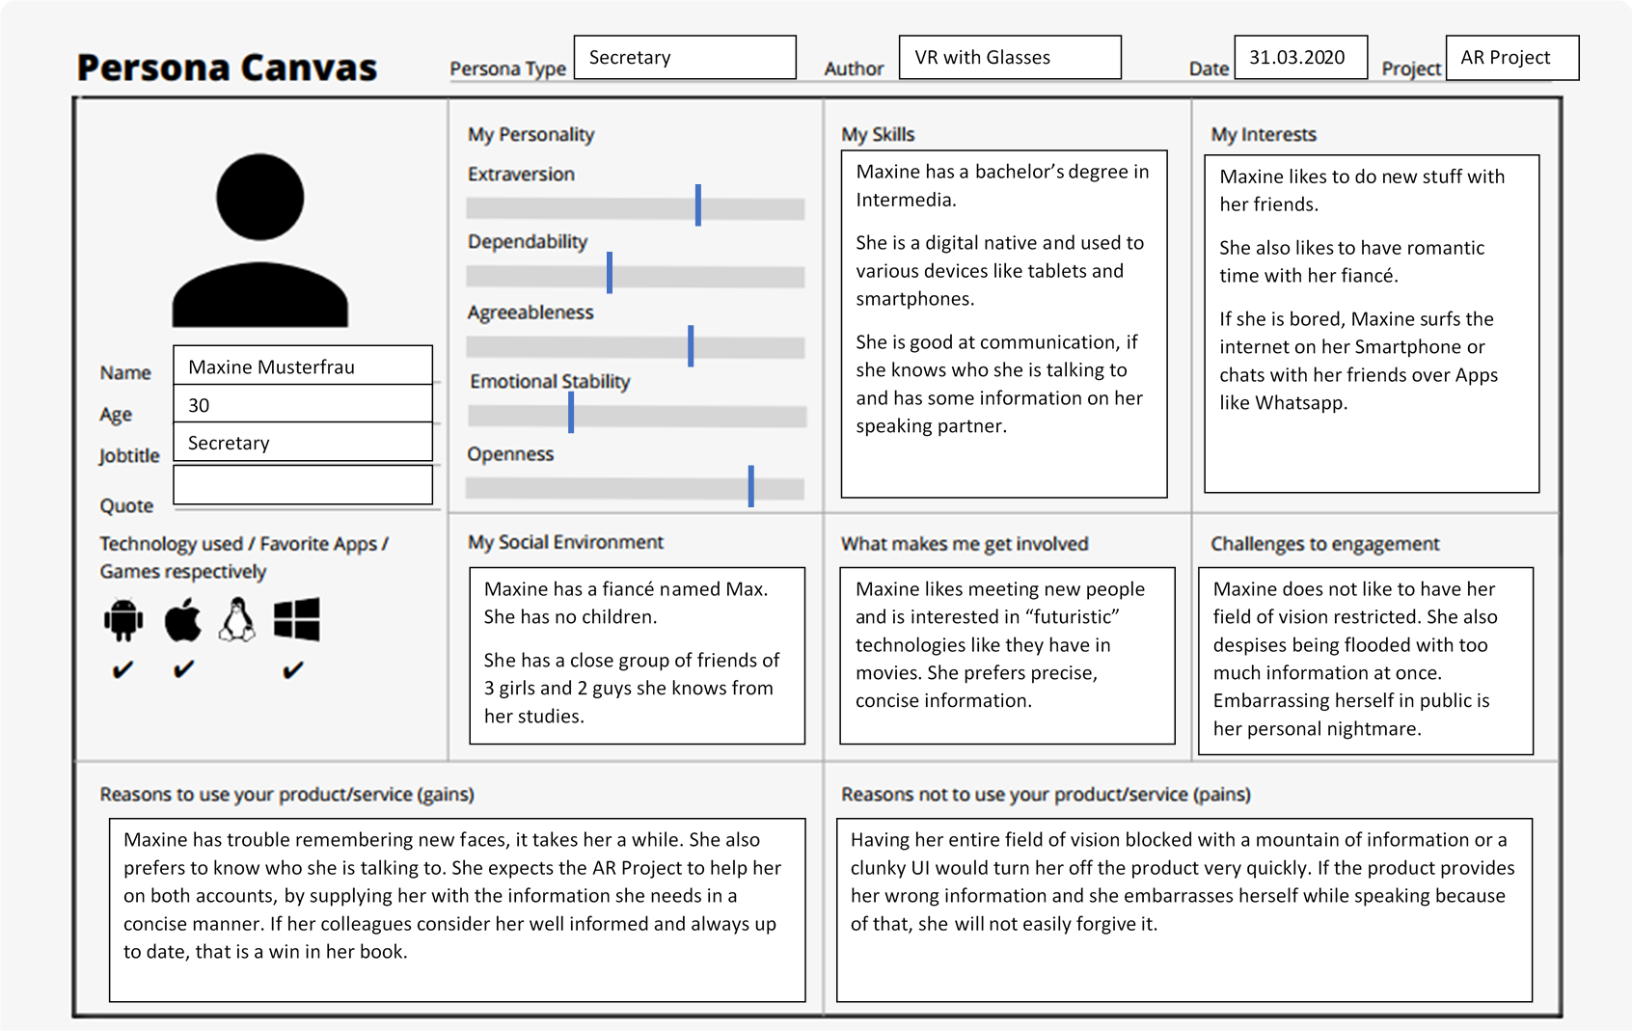

# 

# 

# User Scenarios

## **Scenario 1**

## **Task: Complement loyal people**

## **Persona: Jack Hammer**

## **User Group: CEO**

Date: March 2020

### **Background**

AR Project is a system for Virtual/Augmented Reality hardware that recognizes images and displays relevant information about the recognized person/object to the user. It benefits all employees. User Groups include: employees in offices, people working in warehouses, etc.

### **Scenario**

Jack has decided to take a walk through his company to personally complement all employees that have been working for them for more than 5 years.

Jack puts on his VR/AR system and loads the AR project.

Once it is loaded, he simply starts his walk through the company.

Each time the image recognition recognizes an employee, information regarding this employee is retrieved from the database and displayed next to the person’s head.

Should another employee be recognized while the information is still being displayed, the new display will be displayed next to the new person’s head as well.

Jack sees the field “Since”, a date field that shows how long an employee has been working for the company.

If this “Since” date is 5 or more years in the past, he congratulates the employee.

After congratulating/not congratulating the employee, Jack closes the information window for that person with gesture controls OR simply continues his walk while the system closes the window automatically (after a certain time/when the image disappears from the field of view).

After finishing his walk, Jack closes the AR project and takes off the hardware.

## **Scenario 2**

## **Task: Greet new employees with name**

## **Persona: Maxine Mustermann**

## **User Group: Secretary**

Date: March 2020

### **Background**

AR Project is a system for Virtual/Augmented Reality hardware that recognizes images and displays relevant information about the recognized person/object to the user. It benefits all employees. User Groups include: employees in offices, people working in warehouses, etc.

### **Scenario**

Maxine is doing her job as the secretary of a company. She is the only one secretary in the administration right now and has been sick for two weeks. Since then, some new employees have been hired.

Maxine puts on her VR/AR hardware and starts the AR project when she starts her shift.

An employee Maxine has never met before, but who is already in the company database needs something from her.

The image recognition recognizes the employee and retrieves his data from the database, displaying next to his head.

Maxine can read his first and last name from this display.

Maxine greets the employee with his full name.

Maxine realizes that the employee’s display is still missing some key information.

She asks the employee about the missing information.

The employee thanks her for the reminder, having not gotten around to supply the information to the company yet.

He gives her the information he can give right away and promises to bring the rest on the next opportunity.

Maxine enters the new information into the system.

The employee finishes what he came to do and leaves.

The display next to his head disappears when he leaves the view/after some time.

Maxine continues with her work day.

## **Scenario 3**

## **Task: Print for first time with printer**

## **Persona: Samuel Abebe**

## **User Group: Intern**

Date: March 2020

### **Background**

AR Project is a system for Virtual/Augmented Reality hardware that recognizes images and displays relevant information about the recognized person/object to the user. It benefits all employees. User Groups include: employees in offices, people working in warehouses, etc.

### **Scenario**

Samuel is a new intern for the company that has never handled the type of printer used in the office before. While he understands English, there are still some phrases he has trouble with. The chief of his department has asked him to print out a report, but forget to instruct him on how to operate the printer. Samuel would rather not ask the other employees how to do something as trivial as printing.

Samuel puts on his VR/AR system and starts the AR project.

He heads for the printer and looks at it.

The AR project recognizes the printer and retrieves the information associated with it from the database, displaying it next to the printer.

Samuel selects the instructions from the displayed menu.

The system displays the instructions that were supplied to the database for the printer object.

Samuel follows the displayed instructions and succeeds in printing the report for the department chief.

Samuel closes the instructions OR the whole information window.

Samuel retrieves the report and leaves the printer room.

The system stops displaying the information, if Samuel has not closed the window already himself.

Samuel delivers the report and continues with his day.

**Alternative Path:**

Samuel realizes the printer is broken. He clicks the “Report” button in the information window.

Samuel is asked to type in a comment, which he does. He confirms the report.

The system takes a screenshot and saves it in the database with date, time, reporting person, reported object and the comment.

Samuel leaves the room and the system closes the information window OR Samuel closes the window himself and leaves the room.

Samuel informs the department chief of the broken printer. The department chief forgets to tell the IT-department to take a look at the printer.

When checking the database for reported objects in the morning like everyday, the IT-department sees the broken printer and fixes it.

## **Scenario 4**

## **Task: Report illicit activity**

## **Persona: Maxine Musterfrau**

## **User Group: Intern**

Date: March 2020

### **Background**

AR Project is a system for Virtual/Augmented Reality hardware that recognizes images and displays relevant information about the recognized person/object to the user. It benefits all employees. User Groups include: employees in offices, people working in warehouses, etc.

### **Scenario**

Maxine is wearing her VR/AR equipment and starts the AR project.

During her work, she has to print out some things and heads for the printer room.

There, the system recognizes Jack Hammer and displays his information window.

Maxine realizes Jack is in the middle of a drug deal.

Maxine presses the report button in the window that is displayed next to Jack.

She quickly hits the confirm button in the comment window to skip it.

The system takes a screenshot of the scene and saves the report with date, time, reporting person, reported person, the empty comment and the screenshot in the database.

Maxine gets out of dodge and alerts the authorities, providing the saved data as evidence.

# User Interface Scribbles

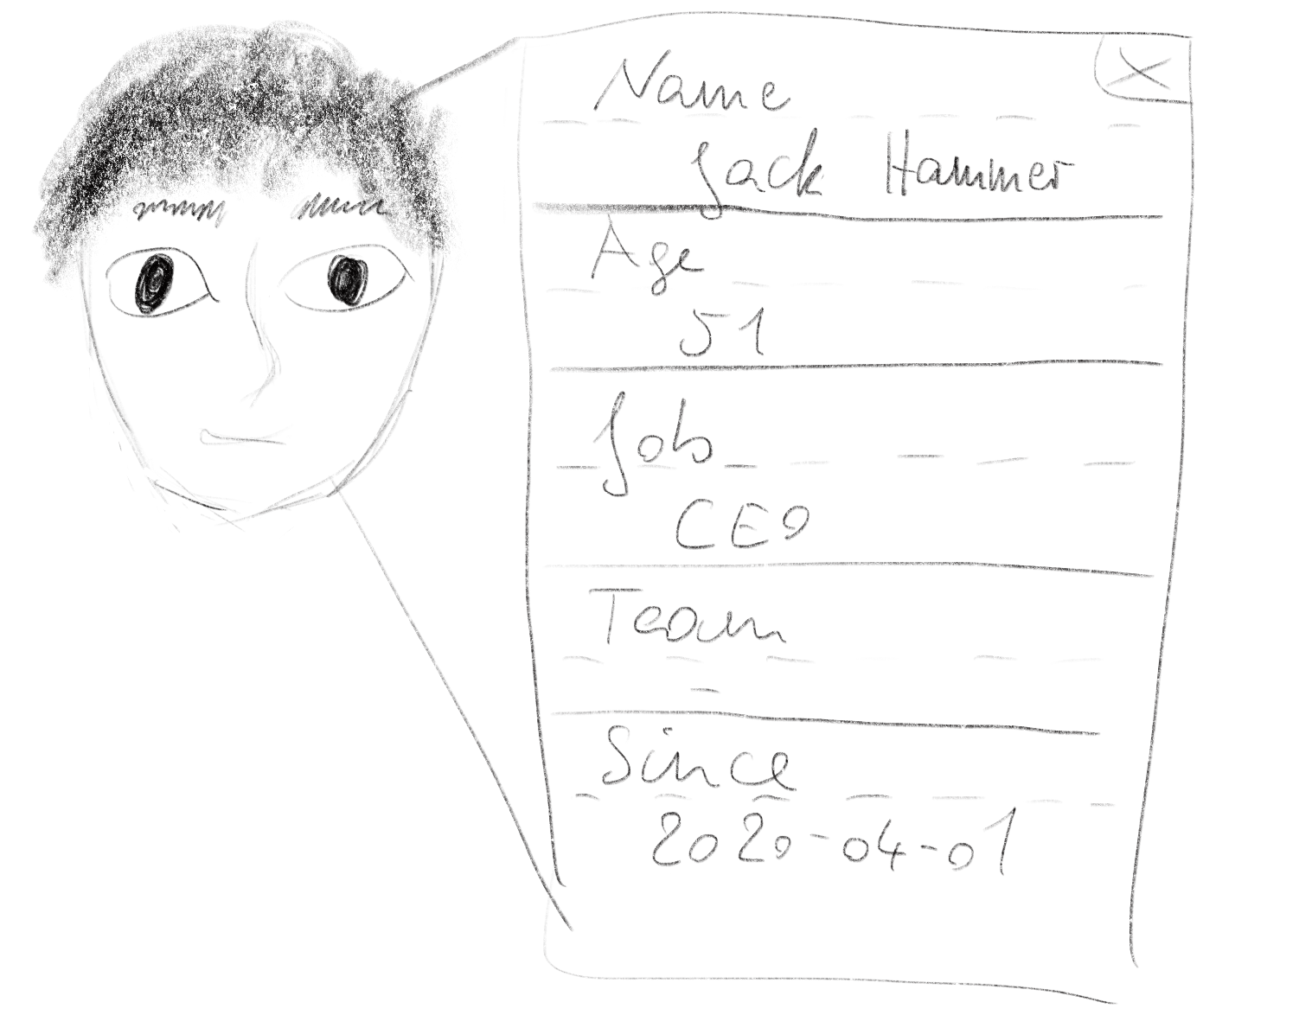

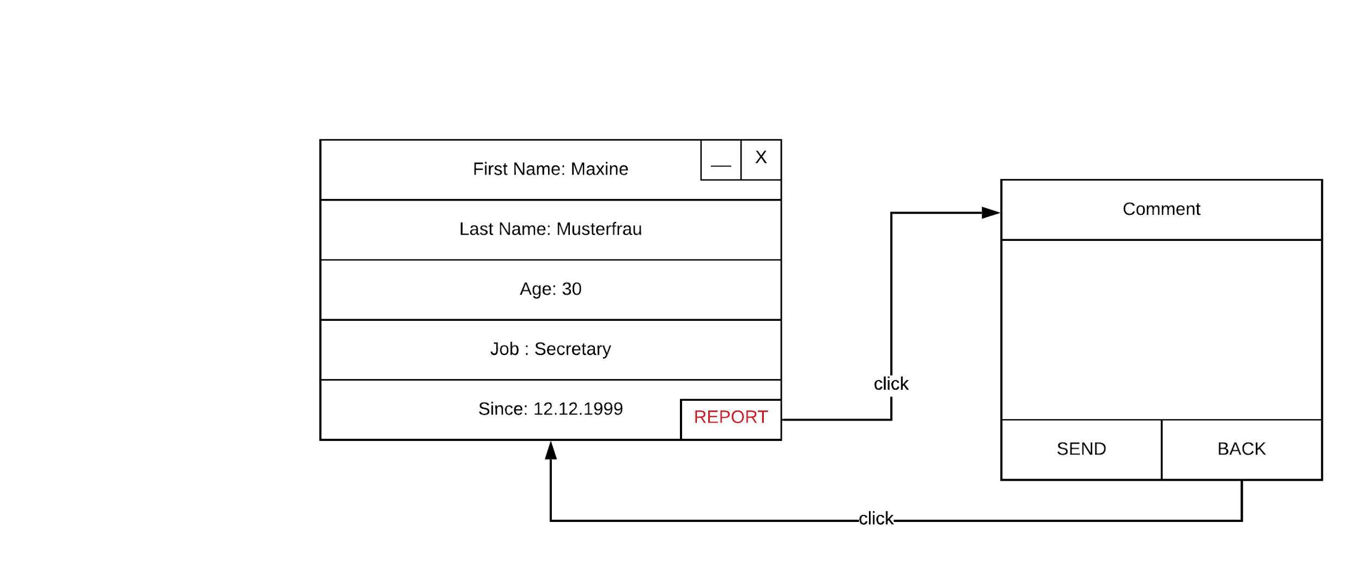

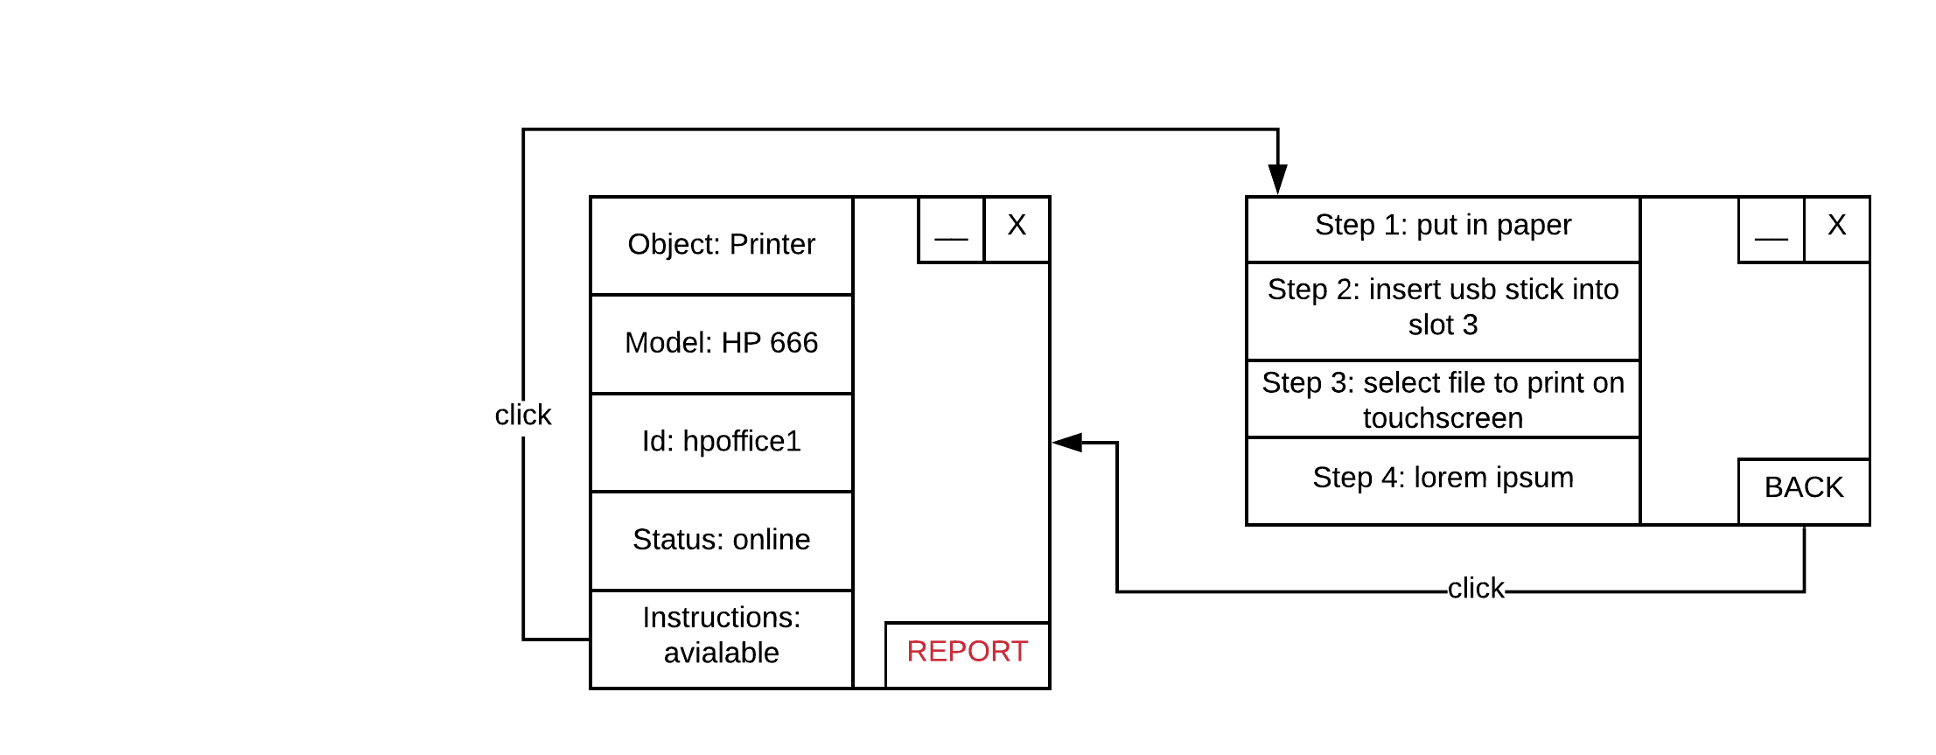

# User Interaction Concept

**Screen**

Since the project is for VR glasses, those serve as the screen. For the intermediate solution (while no VR glasses are available), the screen of the smartphone will serve as the screen.

**UI**

A way to access settings (button in corner of view? special “gesture” (e.g. wipe diagonally)?). No other UI needed.

**Settings**

Can customize what general information is displayed for a person/object. Select which fields out of possible fields available via database (company-specific!).

**Information Display**

Next to the recognized image (e.g. person’s face). Is displayed in a window (see Interface scribble). Has a minimize button and a close button in the upper right corner. Also, a report button (causes report to higher-up (also saved in database)).

**Controls**

Controlled with the controllers delivered with VR glasses (the touchscreen of the smartphone for intermediate solution). Simply tap on settings button/close button. Windows can also be closed by “throwing” them off the screen (quickly wipe over the window). Same for minimizing them (maybe double tap on it/wiping downwards).

**Audio**

No audio is planned at this time.