Jack has studied Business at Harvard.

He has been working at the same company since graduation and has been its CEO for many years.

He is easily able to take in large amounts of information and is second to none when it comes to talking at someone without letting them get a word in.

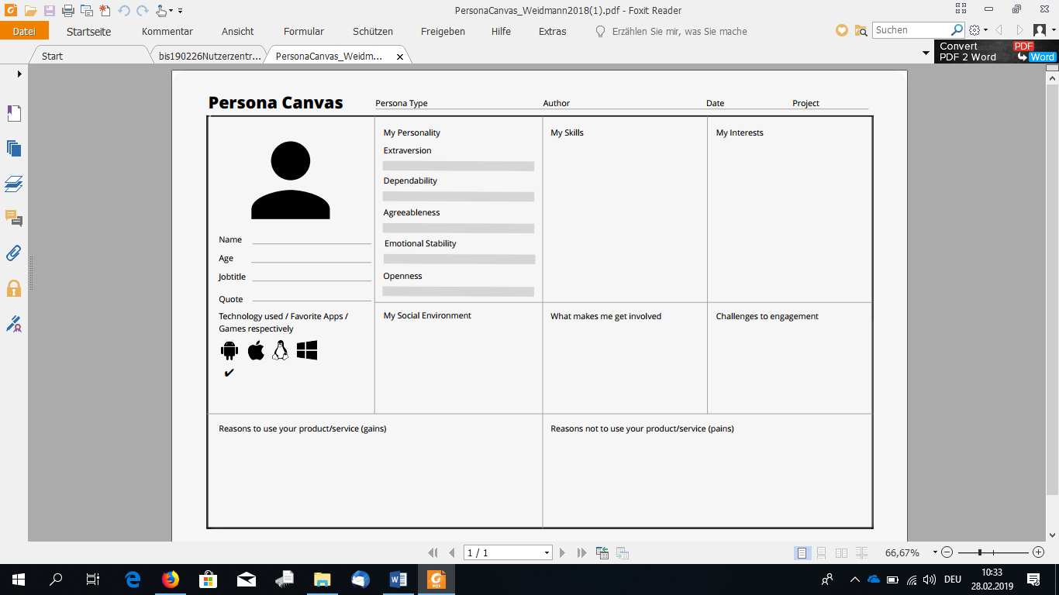

Jack likes to be in charge of things.

When talking, Jack is not that interested in what his partner has to say, he just wants to talk himself.

In the rare cases where Jack has free time, he smokes a cigar and plays some Candy Crush on his iPhone.

Jack wants all the information he can get, so he can decide what’s important. He likes controlling things directly with gestures (like the touchscreen of his iPhone).

Jack does not have the patience to look for information in nested menus. His experience with technology is limited to his iPhone, and he has no desire to learn complex new controls.

Jack has been married and divorced twice.

He regularly goes drinking with his old Harvard-buddies.

Jack would love to impress his employees with the information the AR Project gives him. He would also like to be able to complement people who have been in the company for a long time without having to learn their names or faces. If the AR project could help him remember which people he has to ignore for slighting him in an easily recognizable manner, that would mean a lot to him.

If information is pre-filtered for him, with no way of turning this off, Jack will stop using the AR project right away. He has neither the patience nor the interest necessary for learning complex control schemes, so that is a no go. Jack is American, and his applications speak English, or they can get out. If the UI confuses him, he would rather stop using it than learning the layout.

Jack Hammer

51

CEO

CEO

VR with Glasses

31.03.2020

AR Project



Jack has studied Business at Harvard.

He has been working at the same company since graduation and has been its CEO for many years.

He is easily able to take in large amounts of information and is second to none when it comes to talking at someone without letting them get a word in.



