Jack has studied Business at Harvard.

He has been working at the same company since graduation and has been its CEO for many years.

He is easily able to take in large amounts of information and is second to none when it comes to talking at someone without letting them get a word in.

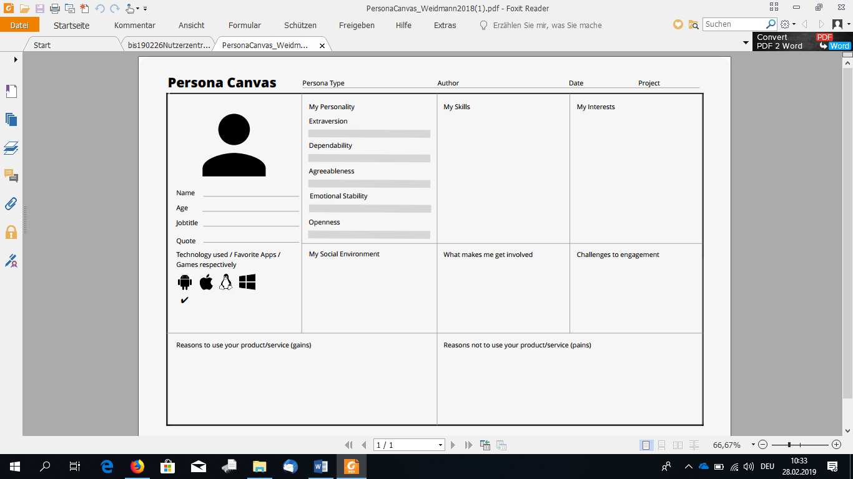

Samuel has come to Austria to experience new things, especially regarding technology.

He calls home every evening, to report how his day went to his family.

In his free time, he likes to play basketball with his newfound group or with strangers.

Samuel likes to have clear instructions and an idea what he must do. He is intrigued by VR/AR technology and looks forward to working with it.

Samuel does not like to ask other people for instructions on everyday tasks (like printing a paper). He also does not like cluttered interfaces.

Samuel has a younger brother and sister and many uncles, aunts and nephews.

He has found a group of people he regularly plays basketball with.

Samuel hopes that the AR project will provide him with instructions on the basic office tasks that use hardware he has not used before, so he does not have to bother his new coworkers. He further wishes for instructions that are easily understandable to him. Support in remembering all the new people he meets at the new company would also be greatly appreciated.

Unclear instructions, or instructions that are just walls of text or speech are a nightmare to Samuel. Since everything is new to him, he does not want to be overwhelmed by too much information or a cluttered interface. Constantly asking his coworkers how simple things work would be very embarrassing to him and learning something only to find out the provided information was wrong would upset him greatly.

Samuel Abebe

18

Intern

Intern

VR with Glasses

31.03.2020

AR Project



Samuel is currently studying at Addis Ababa University in Ethiopia. He has gotten an internship in an Austrian company.

He is highly adaptable and understands English very well.

Samuel is very independent and will focus his full attention on the task at hand.



