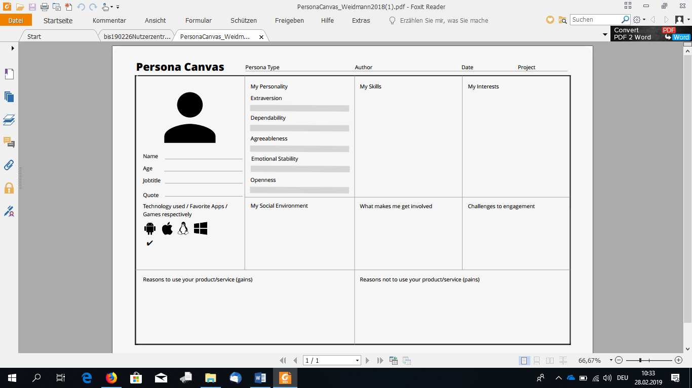

Maxine likes to do new stuff with her friends.

She also likes to have romantic time with her fiancé.

If she is bored, Maxine surfs the internet on her Smartphone or chats with her friends over Apps like Whatsapp.

Maxine likes meeting new people and is interested in “futuristic” technologies like they have in movies. She prefers precise, concise information.

Maxine does not like to have her field of vision restricted. She also despises being flooded with too much information at once. Embarrassing herself in public is her personal nightmare.

Maxine has a fiancé named Max. She has no children.

She has a close group of friends of 3 girls and 2 guys she knows from her studies.

Maxine has trouble remembering new faces, it takes her a while. She also prefers to know who she is talking to. She expects the AR Project to help her on both accounts, by supplying her with the information she needs in a concise manner. If her colleagues consider her well informed and always up to date, that is a win in her book.

Having her entire field of vision blocked with a mountain of information or a clunky UI would turn her off the product very quickly. If the product provides her wrong information and she embarrasses herself while speaking because of that, she will not easily forgive it.



Maxine Musterfrau

30

Secretary

Secretary

VR with Glasses

31.03.2020

AR Project



Maxine has a bachelor’s degree in Intermedia.

She is a digital native and used to various devices like tablets and smartphones.

She is good at communication, if she knows who she is talking to and has some information on her speaking partner.