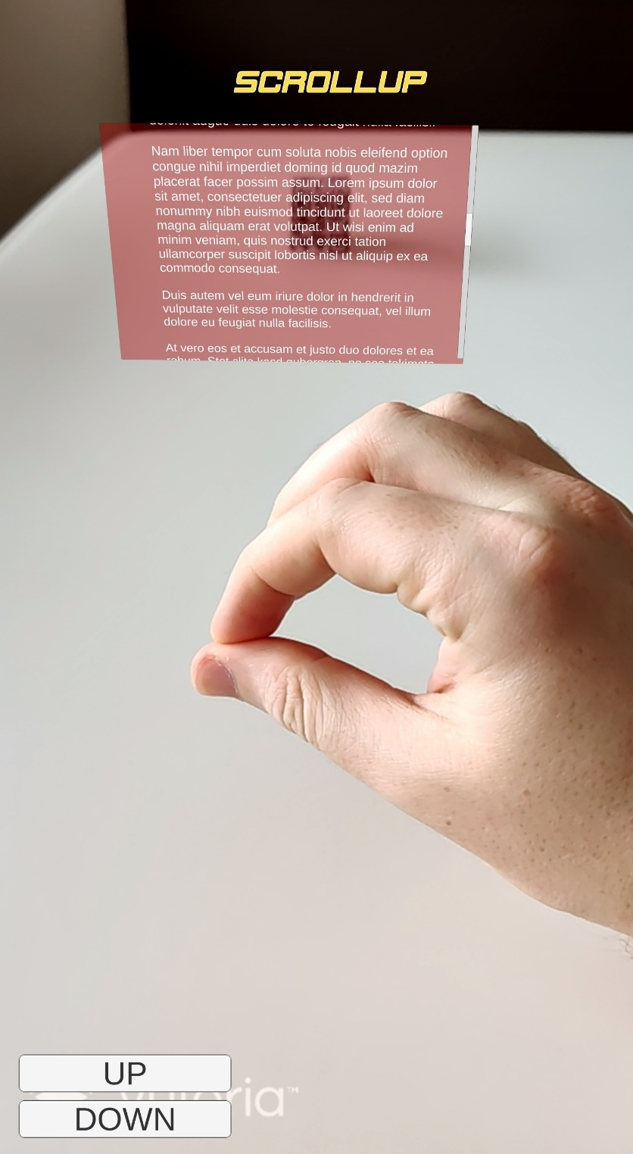

on screen scroll commands

Gesture to identify

InfoScreen of recognised object

Recognised object

Indicator which gesture was recognised