

**综合实践项目中期检查报告**

**Mid-term Report of Practical Project**

课题名称Topic：

Machine Vision-based Intelligent Recognition of Building Air Conditioning Interface

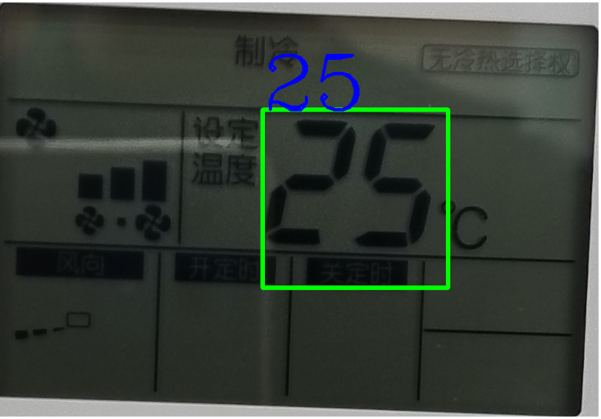

Figure 1: Illustration of our project’s first result

教师姓名Supervisor：**Helin Gong**

学生姓名Student：**Babic Marko**学号Student ID：**J12426099007**

专业名称Major：**Computer Science - Information Engineer**

学院(系)：**巴黎卓越工程师学院SPEIT**

|  |  |  |  |
| --- | --- | --- | --- |
| **综合实践项目课题的基本内容与要求：**  **Main research content and requirements of your project:**  Main research content  The purpose of this project is to establish a model capable of reading the digits from an air-conditioner (AC) interface, from our own pictures.  In fact, we took two hundreds of pictures with a smartphone of AC’s interfaces in the SJTU campus. Our goal is to be able to read as many as possible even if they have visual problems. Indeed, some images can be taken with different angle, with different brightness or with reflections.  Requirements and tools used  Here are the 3 requirements we did:   * **Take 205 pictures of AC:** many different AC on the SJTU campus where we could take pictures with different angles, zoom, brightness, reflections. During free time on the campus, after a course, while visiting different schools of SJTU. Some pictures do not have digit. * **Establish a model that can read 1 picture:** we had to establish our tools, install packages, test different python libraries, learn to adapt the image before the reading, manage technical issues… * **Establish a model that can read at least 5 pictures:** the solution was to separate the pre-process of the image in 2 part. One part is dedicated to crop only the screen of the AC. The other part is to focus only on the way we make the image more blurred. Cropping helps to reduce the time of reading the image. Blurring helps to read only the digits and not the other information on the screen.   Concerning the tools, the programming language we decided to use is **Python** for his accessibility and for the reason that is a programming language easier to pick up even if other programming languages are better in term of performance. We used **Pycharm** (developed by JetBrains) as our python Integrated Development Environment(IDE) with a python version 3.12. Moreover, we needed different libraries in order to achieve our project at this point:   * **cv2**: An open-source computer vision library that provides a wide range of image and video processing functions. * **Numpy**: A fundamental package for scientific computing with Python, providing support for arrays, matrices, and mathematical functions. * **Matplotlib**: A plotting library used for creating static, animated, and interactive visualizations in Python. * **Easyocr**: A simple, easy-to-use OCR (Optical Character Recognition) library that can recognize text from images with high accuracy   Next steps till January   * **Establishing a testing program:** Test the accuracy and the efficiency of each model on all images. Return the images that failed to be read, the accuracy and the execution time. * **Upgrading cropping:** Improve the number of pictures that are correctly cropped so as to read more image and to run the testing with a lower time of execution. * **Upgrading image processing:** By using filter and mask against reflections, angles, brightness and other visual imperfections. Therefore, it will improve the accuracy of our model | | | |
| **综合实践项目进度安排Researching plan：** | | | |
| No. | 各阶段内容 Progress | 时间安排Period | 备注Notes |
| 1 - 4 |  |  |  |
| 5 | Find a supervisor and start of the project | 10th – 12th October | Short amount of time |
| 6 | Taking 200 hundreds of photos in SJTU | 13th – 19th October | Long task |
| 7 | Testing different python libraries | 20th – 27th October | Many technical issues related to installations |
| 8 | Establishing a first model capable to recognize 1 picture | 28th October– 4th November | Find strategies on the image processing so as to isolate the digits |
| 9 | Testing and upgrading the first model | 4th– 14th November | Separate the different functions of the code and upgrade each one |
| 10 | New version capable of reading at least 7 pictures. Finishing the midterm report. | 15th– 21th November | A code more organized |
| 11 | Starting the final report | 22th– 27th November | Organize the ideas and the collected resources quoted or used. Fill it with the work done at this moment. |
| 12 | Establishing a testing program | 28th November– 2nd December | Get an idea of the accuracy of our model. Test the second model. |
| 13 | Upgrading cropping | 4th– 12th December | Find the common problems in cropping to improve the accuracy and execution time. |
| 14 | Upgrading the rest of the image processing | 13th– 22th December | Solve the problems found on pictures unread even after a good cropping. |
| 15 | Getting the best model as possible | 23th– 27th December | Increase the accuracy and the execution time. |
| 16 | Finishing the final report and clear the code | 28th December – Final report submit date | Make the code easier to read and the report more precise. |
| 学生签名Student signature：  日期Date(YYYY-MM-DD)：2024.11.18 | | | |
| **指导教师意见Comments from supervisor：**  The project is currently progressing smoothly and meets the schedule requirements. It is recommended to continue the research work as planned.  指导教师签名Supervisor signature：  日期Date(YYYY-MM-DD)：2024.11.18 | | | |

|  |
| --- |
| **学院（系）意见Comments from institute：**  院长（系主任）签名Dean signature：  日期Date(YYYY-MM-DD)： |