**Name:**

**Email:**

**Module:**

Documentation

I created a program that translates Setswana language and French into English Language if the words are input in the text-fields.

1. **Use Of Concepts**
2. **Abstraction**

I used abstraction, where I created two abstract classes with methods that contain array-lists of the words to be translated from English.

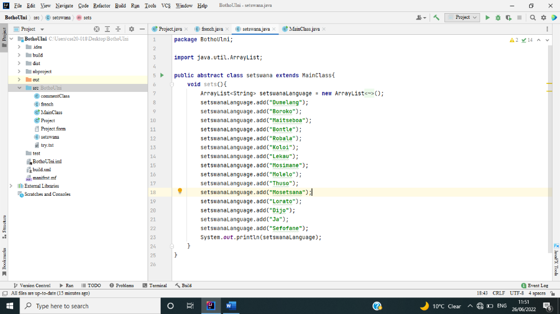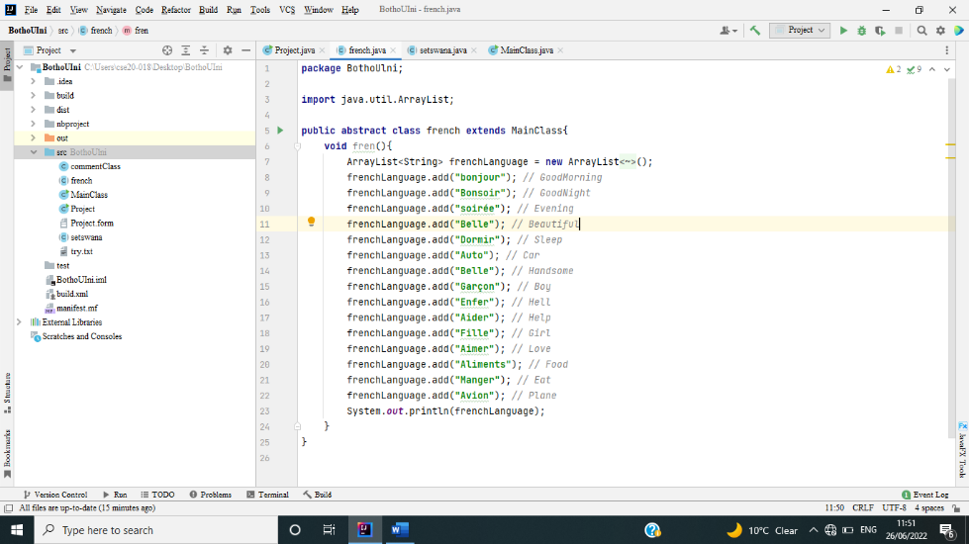

1. **Encapsulation**

I also used encapsulation to hide data in my classes like in the below picture from line 17 to 30.

1. **Inheritance**

I extended my classes to the interface class like shown below.

This is the French class extending to the Main Class.

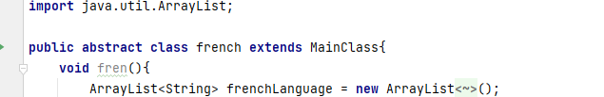

This is the Setswana class extending to the Main Class.

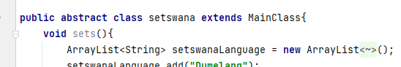

This is the Project class extending to the JFrame to make the interface.

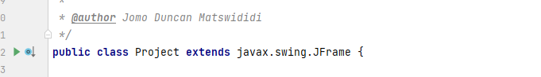

This is the MainClass class extending to the Project class.

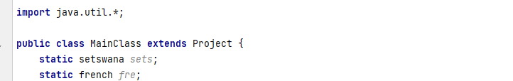

1. **Inputs, Outputs and Searching**

The main class has the inputs, outputs and the searching of words in array-list algorithm, like shown in the picture below. On line 27, a word was input and by the console the results were shown as below.

1. **SOLUTION MEETING ALL REQUIREMENTS (use of conditionals, iteration, comparison operation, reading input, showing output etc)**
2. **Conditionals**

I used the **IF** and **ELSE** to switch the words being searched on the text-field in the GUI like shown below in the code snippet.

1. **Iteration**

I used iteration to show the first word in the array-list like shown below in the snippet below.

1. **Comparison Operation**

I used the (==) to be used in the search text-field so that if a word is searched it may show the word that is there, hence why I used the IF and ELSE conditionals. Find attached a code snippet below.

1. **Reading Input And Showing Output**

I searched a word that is there in the array-list, then it translated the words as I had set them in the coding scripts, I entered word “Hello” then I searched, and it translated the words like had shown in the array-list. See code snippet below.

1. **PROGRAM RUNNING WITHOUT ERRORS**

I built the program and showed no errors, also ran it and it ran successfully. Find snippets below.

1. The code running

1. The code after being built, it did not show any errors.

1. **USE OF EXCEPTION DURING EXECUTION**

I used the try catch exception to manage error handling in the code. Find attached snippets below.

This is the try catch exception.

I also used the else method as a way of error handling, so that if a word that is not there is searched then it can show an error.

This is the else condition that I had used.

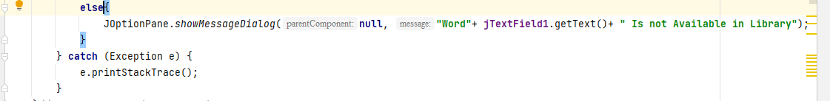

**CITATIONS**

(w3schools, n.d.)

(CodeAcademy, n.d.)