**Names: Monei Bakang Mothuti**

**Email:** [**bakangmonei@swiftiq.co.bw**](mailto:bakangmonei@swiftiq.co.bw)

**Contact: +267 72711192 || +267 73065111 || +267 74066905**

Table of Contents

Introduction 3

Technology Stack 3

The Architecture 4

Dummy Database 4

How to Run the Scripts 4

EMPLOYEE 6

SUPERVISOR 8

# **Introduction**

As an IT software programmer at Tanganyika Technologies, I have been tasked with a critical responsibility: designing and implementing a comprehensive solution for managing employee leave records. Leveraging my expertise in Linux Shell Scripting, I embarked on a mission to develop a robust "**Employee Leave Management**" application tailored to our company's unique requirements.

With the goal of empowering both employees and supervisors, I methodically designed a system that allows for easy access to vital capabilities. Employees may easily log onto the system, update their personal information such as names and birth dates, and request for leave by defining the duration and cause for their absence.

Furthermore, supervisors have the tools they need to efficiently review and handle leave requests. They can easily approve or reject leave applications, ensuring prompt decisions and effective leave management processes. Supervisors can also print leave records, which simplifies paperwork and record-keeping operations.

Through hard work and dedication, I created a simple leave management solution that improves organizational efficiency and employee happiness. This initiative demonstrates my commitment to using technology to solve real-world business problems and produce positive results for Tanganyika Technologies.

# **Technology Stack**

I did the assignment on my MacBook, with Visual Studio Code (VSCode) as my primary programming environment. With its simple UI and robust functionality, I found VSCode to be a fantastic tool for creating and testing shell scripts.

Throughout the project, I used VSCode's built-in terminal to run commands and shell scripts right from the editor. This expedited my development workflow and allowed me to quickly iterate on the code while keeping everything organized in one workspace.

Furthermore, VSCode's extensive ecosystem of extensions was useful in increasing my productivity. I installed Shell Scripting and Git integration extensions, which enabled syntax highlighting, code completion, and version control, thereby increasing my development experience.

Overall, the combination of my MacBook and VSCode provided me with a smooth and efficient working environment, allowing me to complete the project and produce a strong employee leave management system suited to the company's requirements.

# **The Architecture**

I created my system and made each functionality to have a file script, with having the **main_dashboard.sh** as the main file.

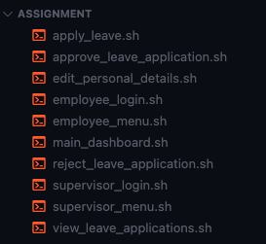

# **Dummy Database**

For testing, this script uses a fake database to replicate employee leave information.

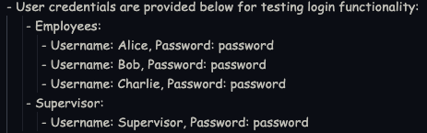

# **How to Run the Scripts**

To run all the scripts simultaneously, run the main dashboard script **(main_dashboard.sh).** Here's how you can accomplish it:

Ensure that all scripts have execution rights. If not, you can grant them using the **chmod** command;



After you've provided execution rights, you may launch the main dashboard script (main_dashboard.sh). Navigate to the directory containing your scripts in the terminal and execute them:



Then the main_dashboard.sh will be shown;

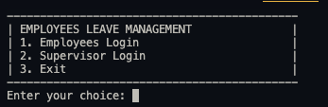

# **EMPLOYEE**

Employee Login

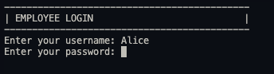

Successful Login

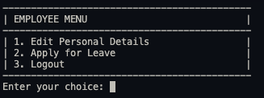

Unsuccessful Login

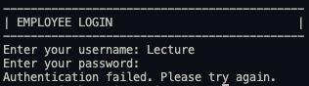

Editing Personal Details

Apply For Leave

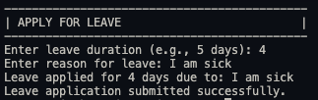

# **SUPERVISOR**

Supervisor Login

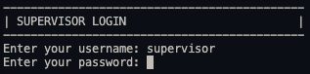

Successful Login

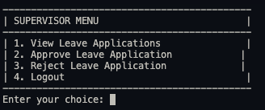

Unsuccessful Login

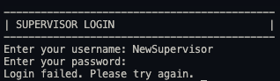

View Leave Applications

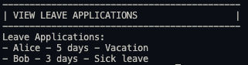

Approve Leave Applications

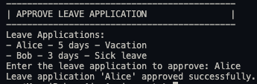

Reject Leave Application

