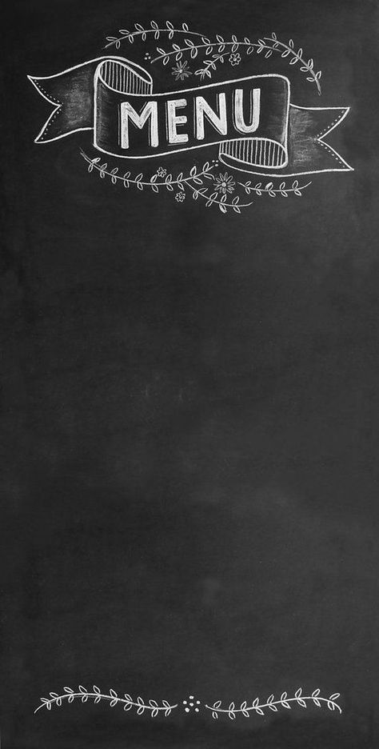

**ESPRESSO M L Frappuccino M L**

**Premium Espresso 0.158 $ Java Chip 1.59 $ 1.75 $**

**Premium Dopio 0.32 $ Caramel 2.14 $ 2.46 $**

**Lungo 0.8 $ Caramel Lotus 2.8 $ 3 $**

**Chemex 1.12 $ Protein Shake 3.1 $**

**Affogato 1.43 $ Mocha 1.59 $ 1.75 $**

**French Press 1.12 $ 1.27 $ Choco Chip 2.5 $ 2.7 $**

**Americano 1.12 $ 1.43 $**

**Cappuccino 1.27 $ 1.43 $ ICED COFFEE M L**

**Latte 1.27 $ 1.43 $ Iced Americano 1.12 $ 1.27 $**

**Flat White 1.27 $ 1.43 $ Iced Latte 1.43 $ 1.59 $**

**Iced Spanish 1.59 $ 1.75 $**

**Iced Mocha 1.59 $ 1.75 $**

**Iced Caramel 1.59 $ 1.75 $**

**BLACK SERIES M L**

**Caramel Macchiato 2.06 $ 2.86 $ Pastry**

**Hot Chocolate** **1.43 $** **1.59 $** **Lotus Cheese Cake** **65000**

**Spanish Latte 1.32 $ 1.35 $ Strawberry Cheese Cake 50000**

**Mocha 1.43 $ 1.59 $ Scones 0.95 $**

**Great Coffee Served Everyday**

**Welcome to Baker St.**