# Relation DB Diagram

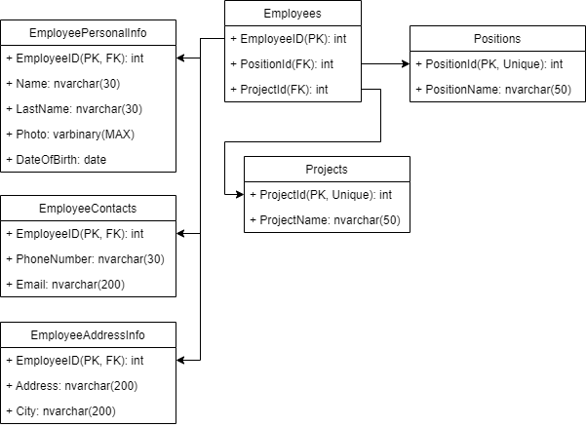

Figure 1Relational DB Diagram of AddAgency company (does not include ModificationsLog table)

# Self-evaluation

The basement for the project was selected the model designed by one group member in CW1. The DB schema was simplified but covers all requirements of the CW2. The main table is presented by “Employees” it receives data from all other tables. “Projects” and “Positions” tables are also separate from main table and are used in web application for CRUD operations. One employee is assigned to some project and has some position, and all other information about him or her are stored in separate tables which are joined in the business logic.

For our team, the problems we encountered during the development were mostly connected to SQL issues. For instance, implementing Filtering and Sorting behavior were the most difficult part. Another issue which unfortunately was not solved by our team is trigger for logging changes in Employee table. As the data of this table are separated by multiple tables it was not possible for us to implement UPDATE behavior properly and it writes the same data to both Inserted and Deleted columns (as XML of course).

Details pages for all business entities (Employees, Positions and Projects) were not implemented because all information is presented on main Index page of the entity.

Triggers for business logic only show error on DB layer. So, if user wants to add ProjectName or PositionName to table Projects and Positions respectively, they have to make sure that length of those values are at least 3 characters. This functionality is applied only for create method.

Triggers for logging data manipulation in all 3 tables are also presented.

# Black Box Testing

|  |  |  |  |
| --- | --- | --- | --- |
| Test description | Expected results | Actual results | Comments |
| Filtration testing | No data | No data | Trying to filter for item which is not in table returns no data |
| Creating new Employee | Validation error | Validation error | Trying to add employee with no data in any input field (All fields are required) |
| Create and Update Employee (wrong date of birth) | Validation error (before submission) | App crash | Trying to add the minimal date of birth to employee leads in error because SQL does not support minimal value of .net DateTime (SQL Datetime overflow) |
| Create and Update Employee (short or wrong number) | Validation error | Validation error | Trying to add number without “+” or adding short number (less than 12 chars) leads to validation error |
| Create and Update Positions | Validation error | Validation error | Trying to create or edit data with empty inputs leads to validation error |
| Import invalid JSON (invalid column names) | Validation error | App crash | Trying to import invalid JSON results in app crash |
| Import invalid CSV  (Invalid column names) | Validation error | App crash | Trying to import invalid CSV results in app crash |
| Import invalid XML  (Invalid column names) | Validation error | App crash | Trying to import invalid XML results in app crash |
| Export empty filter | Error message that searches and filter is empty | No page error | Trying to export empty filtered data leads to no page available error |
|  |  |  |  |