MindMesh Connecting minds, Creating knowledge

Final Year Project Report Session 2022-2026

A project submitted in partial fulfillment of the
BS in Computer Science
University of the Punjab



Department of Computer Science
University of the Punjab, Lahore

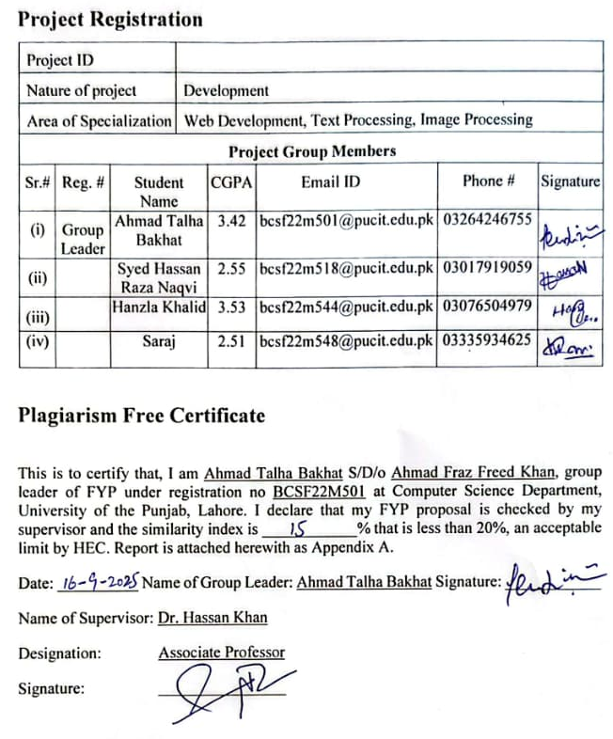

ABSTRACT

In recent few years, the boom in digital platforms has changed how people around the globe share knowledge and collaborate with each other. However, students/teachers/researchers usually lack a platform that is academic-oriented and dedicated to peer-to-peer knowledge exchange which results in intellectual isolation and lack of familiarity with ongoing trends in academia. Our project MindMesh, focuses on bridging this gap and connecting the verified university/college students/teachers/researchers based on their subdomains/fields.

This platform will let students/teachers/researchers post questions, share thoughts, and involve in threaded discussions over diverse academic topics. Features will include endorse/refute mechanism, defined SOPs to keep this platform relevant, AI-assisted moderation to flag the irrelevant content, categorization based on sub-domains, direct messaging, and user profile with contribution score. A following system will allow the user to the follow other peers and based on interests; recommendation engine will suggest related posts for broader engagement.

MindMesh - a forum style website to connect intellect, will be developed using web stack, with React.js for frontend, Node.js and Express.js for backend, and PostgreSQL as the primary database. To implement content regularization, under defined SOPs, we will be using the content-filtering APIs of Large Language Models such as (Mistral or Gemini). The solution aims to develop a fully secure and purely academic-oriented community that fosters mutual collaboration, problem-solving, and making the intellectual resources available among students/teachers/researchers.

The outcome is a functional Minimum Viable Product, with the ability to register students/teachers/researchers, create posts, involve in discussions and endorse content. MindMesh provides a platform to foster collaborative learning, bridges the intellectual gaps, and promotes the academic excellence in higher education.

Table of Contents
Contents
ABSTRACT 3
Table of Contents 4
Chapter 1: INTRODUCTION 7
1.1. Project Summary 8
1.2. Purpose 8
1.3. Scope 9
1.4. Report Outline 9
Chapter 2: LITERATURE REVIEW 10
1.1. Reddit 11
1.1.1. Limitations 11
1.2. LinkedIn 11
1.2.1. Limitations 11
1.3. Solution 11
Chapter 3: PROJECT MANAGEMENT 12
3.1. Project Planning and scheduling 12
3.1.1. Project Development Approach 12
3.1.2. Advantages of Agile Model 12
3.2. Project Plan 14
3.3. Gantt Chart 15
Chapter 4: System Requirement Specification 16
4.1. User Characteristics 16
4.2. Hardware and Software Requirements 17
Chapter 5: SYSTEM ANALYSIS 18
5.1. Feasibility Study 18
5.1.1. Technical Feasibility 18
5.1.2. Economical Feasibility 18
5.1.3. Operational Feasibility 19
5.1 Functions of System 20
5.3. Non-Functional requirements 23
5.4. Use case Diagrams and Tables 24
5.4.1. Use Tables 24
5.4.2. Use Case Diagrams 37
5.5. Data Modeling 39
5.5.1. E-R Diagram 39
5.5.2. Activity Diagram 40
5.5.3. Sequence Diagram 42
5.6. Functional and Behavioral Modeling 46
5.6.1. Data Flow Diagram 46
5.7. Database Schema Design 48
Categories Table 48
Posts Table 48
replies Table 49
follows Table 49
messages Table 50
5.8. CANVAS 51
5.8.1. AEIOU SUMMARY 51
5.8.2. EMPATHY SUMMARY 52
5.8.3. IDEATION CANVAS 52
5.8.4. PRODUCT DEVELOPMENT CANVAS 53
5.8.5. BUISSNESS MODEL CANVAS 54
Chapter 6: Implementation 55
6.1. Testing 55
6.2. Test Cases 56
Chapter 7: CONCLUSION AND FUTURE WORK 58
7.1. Conclusion 58
7.2. Future Work 58

Chapter 1: INTRODUCTION

Currently, there is no such platform where student/teachers/researches can connect and share their thoughts for mutual learning. Mostly students have to rely on social groups (e.g WhatsApp, Facebook) but they lack the specific structure, categorization, and moderation needed for such platform. So, students face challenges while finding reliable information and connecting with the peers for mutual learning.

Such online forums are viewed positively by 93% of the students as they enhance the critical thinking and let students reflect their ideas. Moreover, such a space can help shy students flexibly participate online.

Q&A communities have a huge user base, 2024 Stack Overflow survey revealed that around 65,437 respondents actively involved in discussions from 185 countries.
The proposed system, MindMesh, mitigates these fundamental challenges by creating secure platform where students/teachers/researchers can register, create posts, involve in discussions and endorse content. The project’s objective includes:

- Building a forum system with categorization based on sub-domains for structured discussions.
- Allowing students, teachers, and researcher to create and share posts for knowledge exchange.
- Use AI-driven moderation to keep content relevant and aligned with our SOPs.
- Implementing the following and direct messaging systems.
- Introducing use profile score and reputation system based on his contributions to community.

By focusing on the academic community, the platform ensures that students engage in productive discussions that support learning, project collaboration, and knowledge-sharing across diverse domains.

Project Summary
The aim of project is to provide the platform for the collaboration of student/teachers/researchers. Through this project we would be facilitating educators by allowing them to make account with an institute email, uploading useful stuff on forum, direct messaging for sharing knowledge and discussing ideas.

Purpose
Our purpose of developing this project is to provide a forum-based platform where educators can collaborate with each other in a respectful manner.
    - You must have intuitional email to sign up.
    - You have access to only domain specific knowledge.

So, our purpose is to overcome this limitation with following features.

    - Easy to access knowledge.
    - Flag irrelevant content.
    - Domain specific knowledge.
    - Only Intuitional certified can get access to platform.

Scope

The project scope includes:
- Core Forum Features: Student registration, post creation, threaded replies, endorsing.
- Profiles & Reputation: Reputation points based on contributions.
- AI Moderation: Flagging of irrelevant content.
- Communication Tools: Direct messaging and notifications.
- Domain-based Categorization: Ensuring relevant, academic discussions.

Report Outline
Chapter 1 is the general introduction to the project. This gives the summary of project and its purpose & the scope of this project.

Chapter 2 captures the literature review of the existing system its working & its advantages and disadvantages.

Chapter 3 captures the Planning and Scheduling details of the project which is first step towards making project. This chapter includes models is being followed by us to develop a project, Project evaluation and review technique, the work plan of the project.

Chapter 4 introduces the use of the system and hardware and software required to implement the system that is the system requirement & specification.

Chapter 5 covers the system analysis made by the developer of the system. This chapter includes feasibility study made by the developer of the system. The chapter also covers the design analysis made by developer of the system which includes details of the use cases, ER Diagram, Dataflow diagram, sequence, and activity diagram which shows the functional and behavioral aspect of the systems.

Chapter 6 describes the database schema design and data dictionary which shows the relations used in system as well as their relationship to each other.

Chapter 7 deals with the implementation details of the system. This chapter includes the static pages for designing the system.

References it includes the references which we have referred for working on this project.

Chapter 2: LITERATURE REVIEW

Existing platforms like Stack Overflow and Reddit (550 million users monthly, 70 million actively involved in discussions) provide space for threaded discussions but they are neither domain-specific nor exclusive for academia. These platforms do not have any mechanism to remove the irrelevant posts.
LinkedIn and Facebook allow users to make posts but they don’t restrict the users to remain relevant to their domains. User can post anything ranging from their personal life to their hobbies. Moreover, LinkedIn is a professional space; to connect the professionals around the globe and doesn’t specify content and Facebook (students spend 4.84 hours weekly on Facebook) is much more of a social media platform, now being used for entertainment.
The lack of domain-specific moderation on these platforms often leads to cluttered discussions, where academic or professional topics get buried under unrelated or low-quality content. For instance, Reddit’s broad subreddits may host academic discussions, but they frequently get sidetracked by memes, off-topic comments, or unverified information. This makes it challenging for researchers, students, or professors to engage in focused, high-quality exchanges without significant noise.
A dedicated academic platform could address these issues by implementing strict content moderation and domain-specific guidelines. Features like peer-reviewed posts, verified user credentials, and topic-based channels could ensure relevance and quality. Unlike LinkedIn’s broad professional networking or Facebook’s social focus, such a platform would prioritize scholarly collaboration, fostering an environment where academic discussions thrive without the distraction of irrelevant content.
Current platforms also struggle with accessibility for niche academic fields. For example, specialized topics in theoretical physics or computational biology often lack dedicated spaces on platforms like Reddit or Stack Overflow, forcing researchers to sift through generalized forums or create makeshift groups. This fragmentation hinders collaboration and knowledge-sharing, as users must navigate disparate sources to find relevant discussions.
Moreover, the absence of robust verification mechanisms on these platforms allows misinformation to spread easily. On Reddit, for instance, anyone can post without credentials, leading to discussions that may lack credibility. An academia-focused platform could implement user authentication, such as institutional affiliations or publication records, to ensure discussions are grounded in expertise, enhancing trust and reliability.
Finally, existing platforms often prioritize engagement metrics over content quality, rewarding viral or sensational posts rather than substantive academic contributions. This gamification can discourage in-depth discussions, as users may feel pressured to post attention-grabbing content rather than nuanced arguments. A tailored academic platform could shift this focus by rewarding contributions based on peer feedback, citations, or relevance, creating a more productive environment for scholarly discourse.

Reddit

Limitations

- Not domain-specific
- Does not flag the irrelevant posts
- Lacks robust moderation for academic content
- Susceptible to misinformation due to unverified users
- Discussions often diluted by off-topic or low-quality posts

LinkedIn

Limitations

- Does not flag irrelevant posts
- No location features
- Broad professional focus, not tailored for academia
- Limited tools for structured, threaded discussions
- Content often skewed toward self-promotion or networking

Solution

- Domain-specific channels: Dedicated spaces for niche fields like theoretical physics or computational biology to ensure focused discussions.
- Content moderation and flagging: Automated and peer-based systems to flag and remove irrelevant or low-quality posts, maintaining discussion quality.
- User verification: Requiring institutional affiliations or publication records to enhance credibility and reduce misinformation.
- Location-based features: Enabling users to connect with local and international academic communities or events, addressing LinkedIn’s lack of location functionality.
- Quality-driven engagement: Rewarding contributions based on peer reviews, citations, or relevance rather than viral metrics, fostering substantive discussions.

Chapter 3: PROJECT MANAGEMENT

Project Planning and scheduling

Project Development Approach

Our project is developed using specific software development lifecycle. Software development approach is best suited for the project depends on the requirement and other factors. A process model is a development strategy that is used to achieve a goal that satisfies the requirements abiding by the constraints.

Agile Model

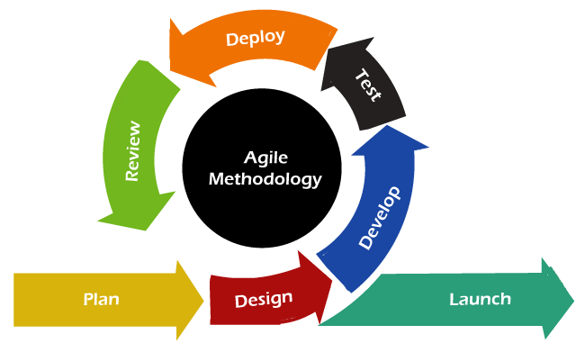

Advantages of Agile Model
- This model is simple and easy to understand and use.
- It is easy to manage due to its iterative nature – each sprint has specific deliverables and a review process.
- In this model, work is broken into sprints, allowing flexibility with overlapping tasks as needed.
- Agile model works well for projects like an academic platform where requirements may evolve based on user feedback.

Analysis
Analysis is used to understand the needs of users. Means what they want or what they are expecting from the system.
Requirement Gathering
Data is gathering form the users in five ways. Interviewing the users, taking surveys, Questionnaire, Observation and documents analysis.
Requirement Specification
The customer requirements identified during the requirement gathering and analysis are organized into a dynamic product backlog with user stories, updated regularly to reflect new insights for the academic platform.
Design
The goal of the design phase is to transform the prioritized user stories into a modular structure suitable for implementation, with the software architecture evolving iteratively based on sprint outcomes.
Code
To convert the design into source code is the goal of the coding phase, conducted in sprints to deliver working increments. Each module (e.g., user authentication) is implemented following team-defined coding standards, including naming conventions and commenting practices, ensuring high-quality code for the academic platform.
Testing
Testing is integrated into each sprint, conducted iteratively with unit tests and user acceptance testing based on a flexible test plan, ensuring the platform’s features like flagging irrelevant posts are reliable.
Maintenance
Maintenance of the academic platform requires ongoing effort post-launch, with iterative updates based on user feedback, estimated at a 40:60 ratio compared to development, to sustain its relevance and functionality.

Project Plan

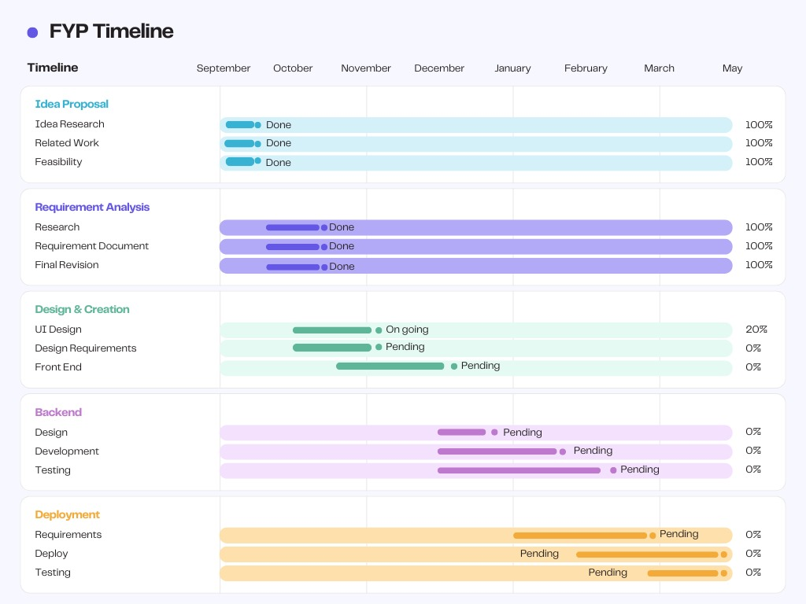

Gantt Chart

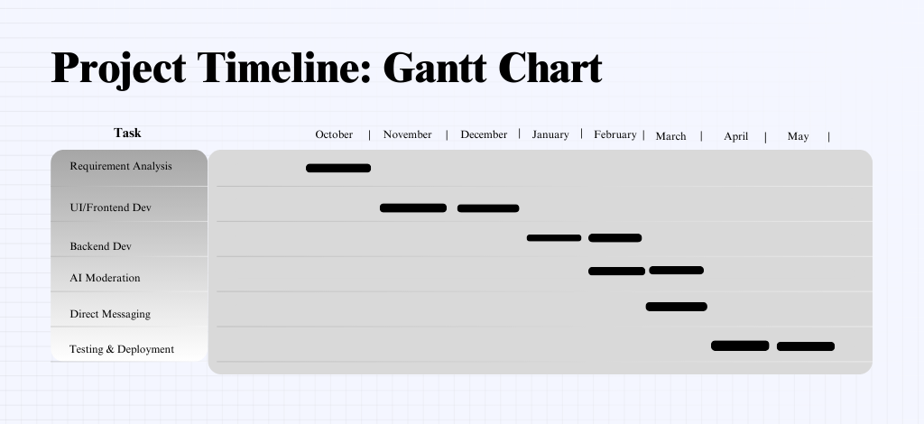

Chapter 4: System Requirement Specification

User Characteristics
The users of the system include:

- Admin

He / She can verify posts which are flag by AI.
He / She can remove user.
He / She can remove a post.
He / She can verify users.
He / She can send warning notification to the user.
He / She can generate analysis report.
- User
He / She can view profiles of other users.
He / She can follow user to other users.
He / She can edit his/her profile.
He / She can create a post.
He / She can comment on a post.
He / She can endorse/refute someone post.

Hardware and Software Requirements

Hardware:

    - Processor: Intel Core i3 and above
    - RAM: 2GB or more
    - Hard disk 250 GB and more

Software:

    - Operating System:
      - Microsoft Windows 7 and above
      - Smart Phone

- Front End:
  - HTML
  - CSS
  - REACT
  - REACT TAILWINDCSS

- Back End:
  - JAVASCRIPT
  - NODE
  - JQUERY
  - EXPRESS
  - PSQL

Others:

- Web Browser: Internet Explorer, Google Chrome, Mozilla Firefox.

Documentation:

- Microsoft Word 2016 and above
- Microsoft Excel 2016 and above
- Canva

Chapter 5: SYSTEM ANALYSIS

Feasibility Study
A feasibility study is conducted to evaluate the practicality of addressing the identified challenge of intellectual isolation in academia through the MindMesh platform. Following the "Look Before You Leap" approach to project management, this study assesses the viability of developing MindMesh as a new system to foster peer-to-peer academic collaboration among verified students, teachers, and researchers.

Technical Feasibility

Technical feasibility evaluates whether the available technology, including software, hardware, and human resources, can support the development and operation of MindMesh. The platform leverages a robust tech stack: React.js with Tailwind CSS for a responsive frontend, Node.js and Express.js for the backend, and PostgreSQL as the primary database. These technologies are well-suited for building a forum-style website with features like user registration, post creation, threaded discussions, and direct messaging. The system integrates content-filtering APIs from Large Language Models (e.g., Mistral or Gemini) for AI-assisted moderation to flag irrelevant content, ensuring alignment with defined Standard Operating Procedures (SOPs).
MindMesh is designed to handle large-scale data, including user profiles, posts, replies, and domain-based categorizations, with PostgreSQL’s relational database capabilities ensuring efficient data management. The platform supports scalability, allowing the addition of features like a recommendation engine and reputation system based on user contributions. Hardware requirements are minimal, requiring a processor like Intel Core i3 or above, 2GB RAM, and 250GB storage, which are readily available. The system is accessible on web browsers (e.g., Chrome, Firefox) and mobile devices, ensuring broad compatibility. Given the availability of these technologies and the development team’s expertise, MindMesh is technically feasible.

Economical Feasibility

Economic feasibility assesses whether the benefits of MindMesh outweigh its development and maintenance costs, ensuring cost-effectiveness. MindMesh addresses critical pain points in academia, such as intellectual isolation and lack of domain-specific knowledge exchange, by providing a secure platform for verified users to collaborate. Key benefits include faster access to reliable, domain-specific content through categorized posts, reduced errors via digital records, and enhanced collaboration through features like threaded discussions and direct messaging. The institutional email verification process streamlines user onboarding compared to manual methods, saving time and administrative effort.
Development costs are optimized by using open-source technologies like React.js, Node.js, and PostgreSQL, with primary expenses tied to software development, server hosting, and API licensing for AI moderation. Maintenance is estimated at a 40:60 ratio compared to development, covering iterative updates based on user feedback. These costs are justified by the platform’s value in fostering academic excellence, reducing reliance on cluttered social media, and enabling structured knowledge-sharing. Thus, MindMesh is economically viable, as its benefits significantly outweigh the development and operational costs.

Operational Feasibility

Operational feasibility examines whether MindMesh will be accepted and effectively utilized by its target users—verified students, teachers, and researchers—after deployment. The platform is designed to be intuitive, with a user-friendly interface similar to familiar social media platforms but tailored for academic use. Features like post creation, threaded replies, endorse/refute mechanisms, and AI-driven moderation align with the academic community’s need for structured, high-quality discussions. The requirement for institutional email verification ensures a secure and credible environment, addressing user concerns about misinformation and irrelevant content.
The academic community has expressed support for MindMesh as a dedicated platform, recognizing its potential to bridge intellectual gaps and replace less structured social media groups (e.g., WhatsApp, Facebook). The installation process is seamless, as MindMesh operates as a web-based application with responsive design, requiring no complex setup. Administrators can manage content and verify users efficiently, while users benefit from features like profile scores and recommendation engines. This alignment with user needs and ease of adoption confirms that MindMesh is operationally feasible, poised for successful integration into academic workflows.

Functions of System
The function of the system consists of the Use case Diagram which represents how the customer, Service Provider & admin interact with the system.

FR01: User Registration & Verification

Requirement Number | Functional Requirement
FR01-1 | The system shall allow new users to register using a university-affiliated email.
FR01-2 | The system shall send a verification link to the user's email to confirm their identity.

FR02: Login

Requirement Number | Functional Requirement
FR02-1 | The system shall allow registered and verified users to log in with their email and password.
FR02-2 | The system shall provide a secure session for the logged-in user.

FR03: Post Management

Requirement Number | Functional Requirement
FR03-1 | Logged-in user shall be able to create posts (questions, thoughts, solutions or research papers) categorized by sub-domains.
FR03-2 | The user will be able to browse posts categorized by sub-domains/fields.
FR03-3 | The user shall be able to reply to posts in threaded format.

FR04: Content Interaction

Requirement Number | Functional Requirement
FR04-1 | A logged-in user shall be able to endorse a post.
FR04-2 | A logged-in user shall be able to refute a post.
FR04-3 | Endorsements and refutations shall affect the content's visibility and the author's reputation score.

FR05: Search

Req. No. | Description
FR05-01 | The application should allow users to search for posts, discussions, or other users based on keywords, sub-domains, or usernames.
FR05-02 | The users should be able to search profiles based on fields of expertise, contribution scores, or followed users.

FR06: User Interaction

Req. No. | Description
FR06-01 | A logged-in user shall be able to follow another user.
FR06-02 | A logged-in user shall be able to send a direct message to another user.
FR06-03 | The user shall be able to view other users' profiles. When the user clicks on a specific profile, they shall see contribution scores, activity statistics, followed users, and sub-domains.

FR07: AI Moderation

Req. No. | Description
FR07-01 | The system shall automatically scan new posts and replies for content that violates SOPs.
FR07-02 | The system shall flag violating content and place it in a queue for administrator review.

FR08: Profile Management

Req. No. | Description
FR08-01 | A logged-in user shall have a profile displaying their posts, replies, and reputation score.

FR09: Administrator Functions

Req. No. | Description
FR09-01 | An administrator shall be able to view and act upon flagged content (approve/delete).
FR09-2 | An administrator shall be able to manage user accounts (verify, suspend, delete).
FR09-3 | An administrator shall be able to create, edit, and delete content categories.

Non-Functional requirements

Requirement Number | Non-functional Requirements
NFR01 | Response time for loading posts, profiles, or searches should not exceed 2 seconds.
NFR02 | Users should not be able to login with mismatched credentials; multi-factor authentication should be supported for security.
NFR03 | Duplicate registrations with the same university email must be prevented.
NFR04 | User data (profiles, messages, contributions) must remain protected with encryption and compliance to data privacy standards (e.g., GDPR-like for academic data).
NFR05 | The system should handle up to 1,000 concurrent users without performance degradation.
NFR06 | The platform should be accessible on web and mobile devices with responsive design.
NFR07 | AI moderation should achieve at least 90% accuracy in flagging irrelevant content.
NFR08 | The system should maintain 99.9% uptime for real-time features like notifications and messaging.

Use case Diagrams and Tables

A set of use cases, actors, and their relationships are shown in use case diagrams. They represent a system's use case perspective. A use case illustrates a certain system capability. The links between the functionality and their internal/external controllers are therefore described using use case diagrams. Actors are the name given to these controllers.

Use Tables

Login and Signup

Use case ID: 001
Use case name: LOGIN & SIGN UP
Priority High
Actor: User
Use Case Summary
Pre-condition
The users must open the application and provide university-affiliated credentials.

Normal Course of Events | Alternate Path
The use case starts when the user opens the application. The users must be able to login by providing correct email and password, or signup with verification. | If credentials are invalid, prompt for retry or password reset.
Post Conditions
The user will be able to access the platform's features.
Use Case Cross References
Includes | Name, Username, Email, Password, Sub-domains/Fields
Excludes

Search Posts/Users

Use case ID: 002
Use case name: SEARCH POSTS/USERS

Priority High

Actor: User
Use Case Summary
Pre-condition
The user has logged into the platform.

Normal Course of Events | Alternate Path
The use case starts when the user clicks on the search bar in the dashboard. The user must enter keywords or filters to view results, including posts or profiles. | If no results, suggest related recommendations.
Post Conditions
The user can browse search results and navigate to posts/profiles.

Use Case Cross References
Includes | Keywords, Sub-domains, Usernames, Contribution Scores
Excludes

View Recommendations

Use case ID: 003

Use case name: VIEW RECOMMENDATIONS
Priority High
Actor: User
Use Case Summary
Pre-condition
The user must have followed other users or specified sub-domains.
Normal Course of Events | Alternate Path
This use case starts when the user accesses the dashboard or recommendations feed. The user shall see suggested posts and users based on algorithms.

Post Conditions
The user can engage with recommended content.

Use Case Cross References
Includes | Followed Users, Sub-domains, Post Relevance
Excludes

Direct Messaging

Use case ID: 004
Use case name: DIRECT MESSAGING
Priority High
Actor: User
Use Case Summary
Pre-condition
The user must select another user's profile and click on message.
Normal Course of Events | Alternate Path
The user clicks on the message button in the profile. The user must be able to send/receive messages in real-time. | If offline, queue messages for delivery.
Post Conditions
The users can continue conversations via notifications.
Use Case Cross References
Includes | Username, Message Timestamp, Notifications
Excludes

Create Posts

Use case ID: 005
Use case name: CREATE POSTS
Priority High
Actor: User
Use Case Summary
Pre-condition
The user is logged in and selects a sub-domain.

Normal Course of Events | Alternate Path
This use case starts when the user clicks on the create post option. The user shall categorize and submit the post (question/thought). | AI moderates for relevance before posting.
Post Conditions
The post is visible in threaded discussions.

Use Case Cross References
Includes | Title, Content, Sub-domain, Tags
Excludes

Reply To Posts

Use case ID: 006
Use case name: REPLY TO POSTS
Priority High
Actor: User
Use Case Summary
Pre-condition
The user views an existing post.

Normal Course of Events | Alternate Path
This use case starts when the user clicks on reply in a post. The user shall submit a reply.
Post Conditions
The reply appears in the thread.

Use Case Cross References
Includes | Reply Content, Parent Post ID
Excludes

Endorse / Refute

Use case ID: 007

Use case name: ENDORSE / REFUTE
Priority High
Actor: User
Use Case Summary
Pre-condition
The user views a post or reply.

Normal Course of Events | Alternate Path
This use case starts when the user clicks endorse/refute. The action updates visibility and scores.
Post Conditions
Contribution scores are updated.
Use Case Cross References

Includes | Endorsement Type, Content ID
Excludes

View Profile

Use case ID: 008
Use case name: VIEW PROFILE
Priority High
Actor: User
Use Case Summary
Pre-condition
The user searches or clicks on a username.

Normal Course of Events | Alternate Path
This use case starts when the user selects a profile. The user shall see scores, activities, and follows.

Post Conditions
The user can follow or message from the profile.

Use Case Cross References
Includes | Contribution Score, Sub-domains, Activity Stats
Excludes

Manage Moderation

Use case ID: 009
Use case name: MANAGE MODERATION

Priority High
Actor: Admin
Use Case Summary

Pre-condition
Admin is logged in.
Normal Course of Events | Alternate Path
This use case starts when admin accesses the moderation dashboard. Admin reviews and approves/removes flagged items.
Post Conditions
Content is updated accordingly.

Use Case Cross References
Includes | Flagged Content, AI Reports
Excludes

Verify users

Use case ID: 010
Use case name: VERIFY USERS
Priority High
Actor: Admin
Use Case Summary
Pre-condition
Admin views pending verifications.

Normal Course of Events | Alternate Path
This use case starts when admin checks pending users. Admin approves based on credentials. | Reject if invalid.

Post Conditions
Verified users gain access.

Use Case Cross References
Includes | Email, University Proof
Excludes

View Reports

Use case ID: 011
Use case name: VIEW REPORTS

Priority High
Actor: Admin
Use Case Summary
Pre-condition
Admin is logged in.

Normal Course of Events | Alternate Path
This use case starts when admin selects reports. Admin views usage stats and feedback.

Post Conditions
Admin can take actions based on insights.

Use Case Cross References
Includes | Usage Stats, New Registrations, Flagged Items
Excludes

Follow Users

Use case ID: 012
Use case name: FOLLOW USERS

Priority High
Actor: User
Use Case Summary
Pre-condition
User views a profile.
Normal Course of Events | Alternate Path
This use case starts when user clicks follow. The follow is added, enabling updates.

Post Conditions
Recommendations are updated.

Use Case Cross References
Includes | User ID, Follow Status

View Notifications

Use case ID: 013

Use case name: VIEW NOTIFICATIONS
Priority High
Actor: User
Use Case Summary
Pre-condition
User is logged in.

Normal Course of Events | Alternate Path
This use case starts when user accesses notifications. User views alerts for messages, replies, endorsements.

Post Conditions
User can navigate to related content.

Use Case Cross References
Includes | Notification Type, Timestamp

Use Case Diagrams

User
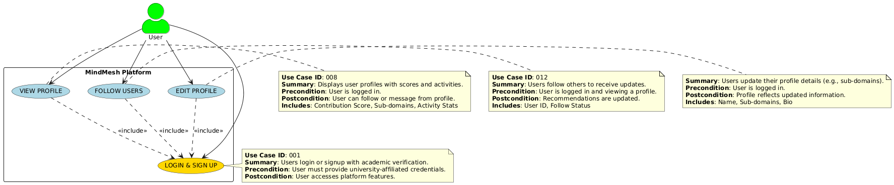

User Interaction

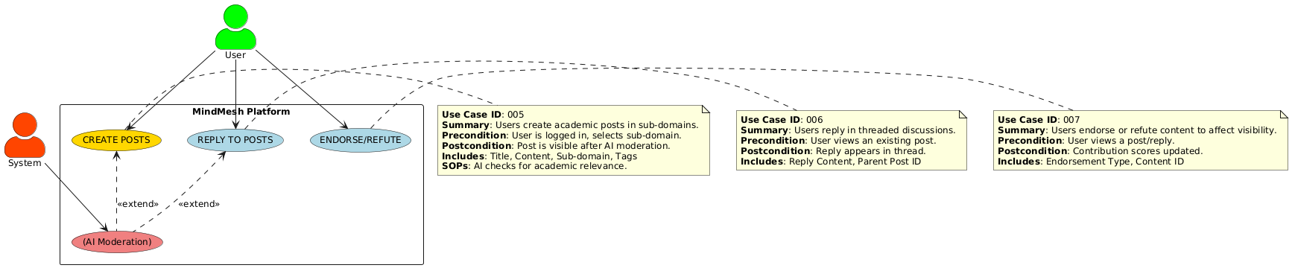

Posts

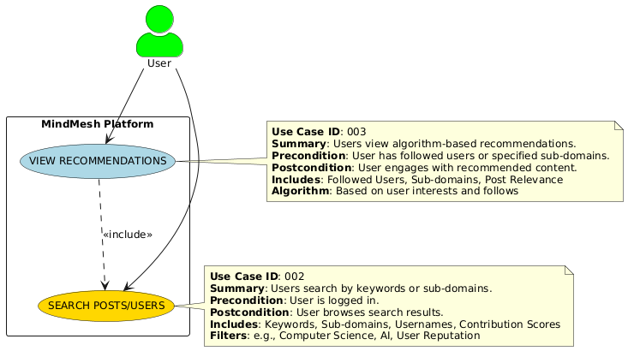

Messaging and Notify

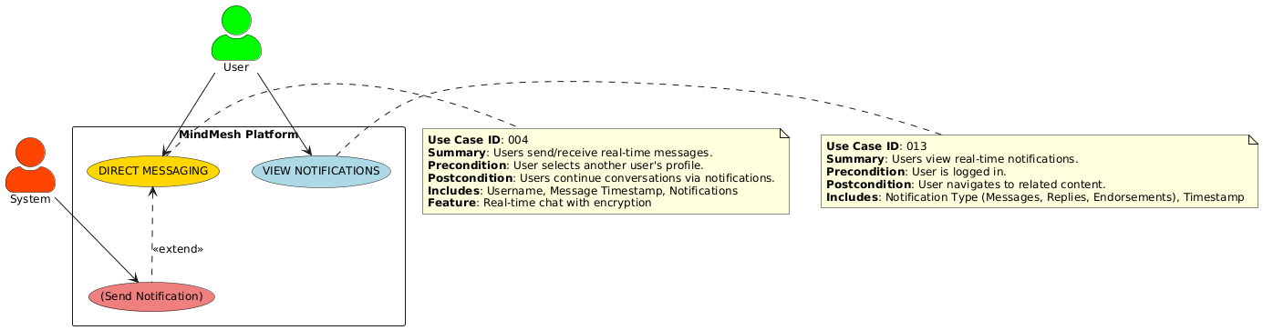

Admin

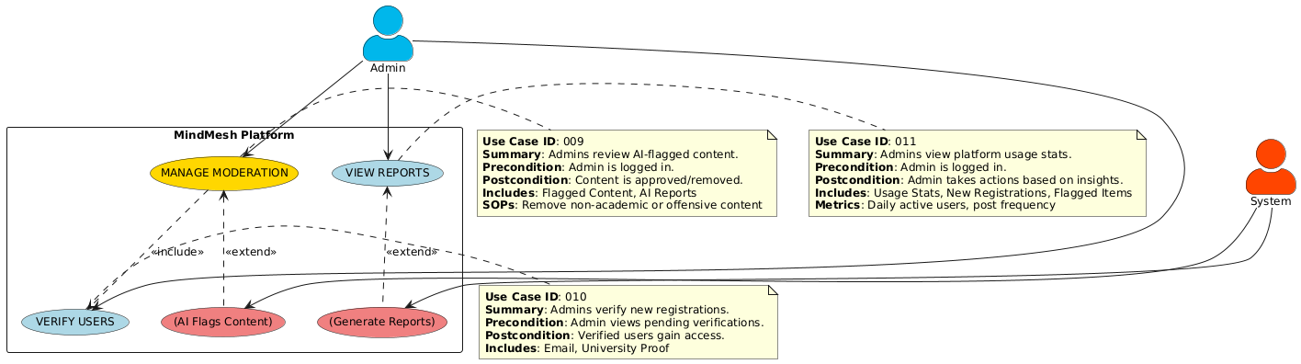

Data Modeling
It consists of:

- E-R Diagram
- Activity Diagram
- Sequence Diagram

E-R Diagram

The relationship between individuals, things, locations, concepts, or events inside an information system is depicted graphically in an entity-relationship diagram (ERD). A relation database may be built on top of a (ERD), a data modelling approach that can be used to create business processes.
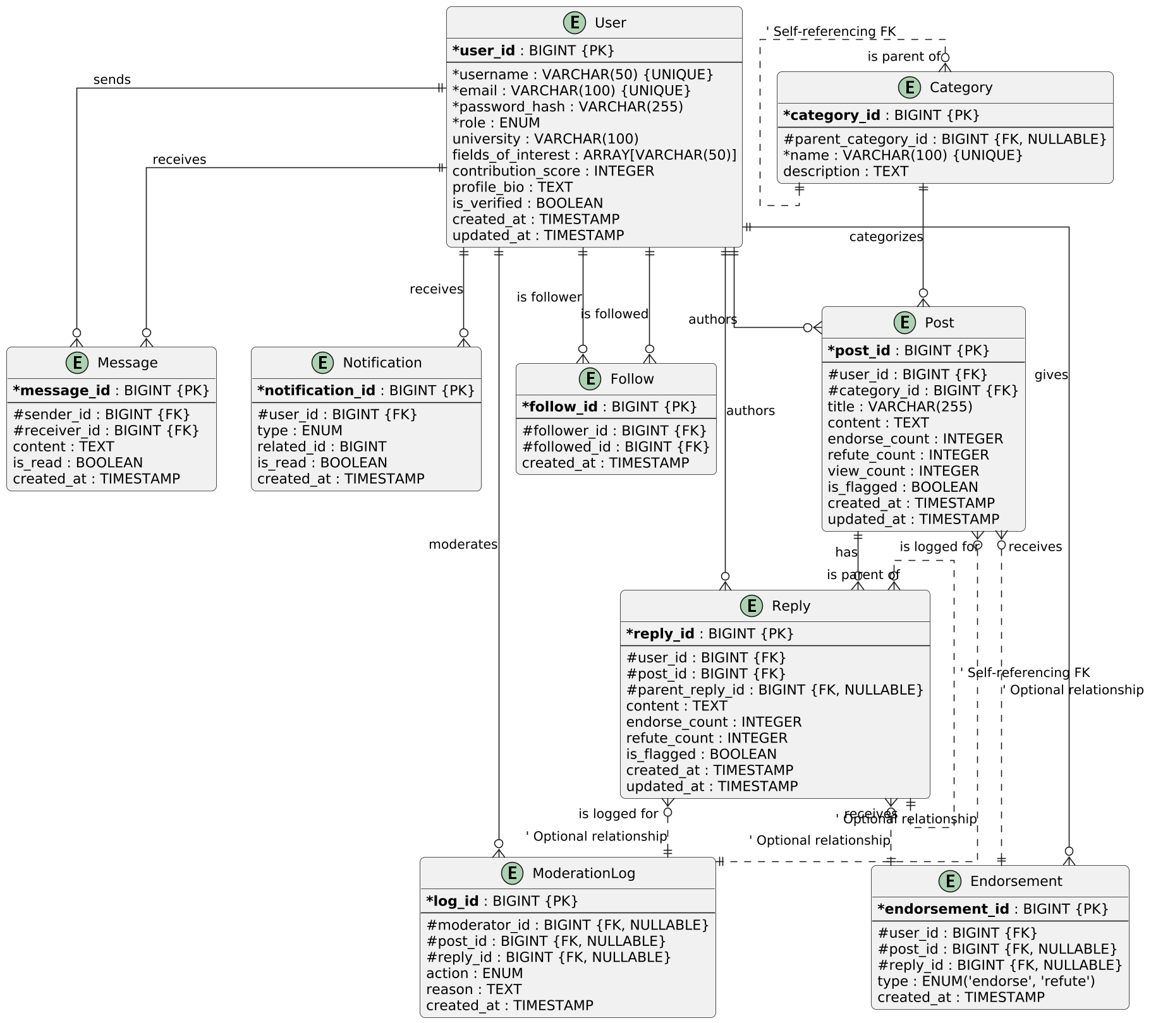

Activity Diagram

Login & Registration

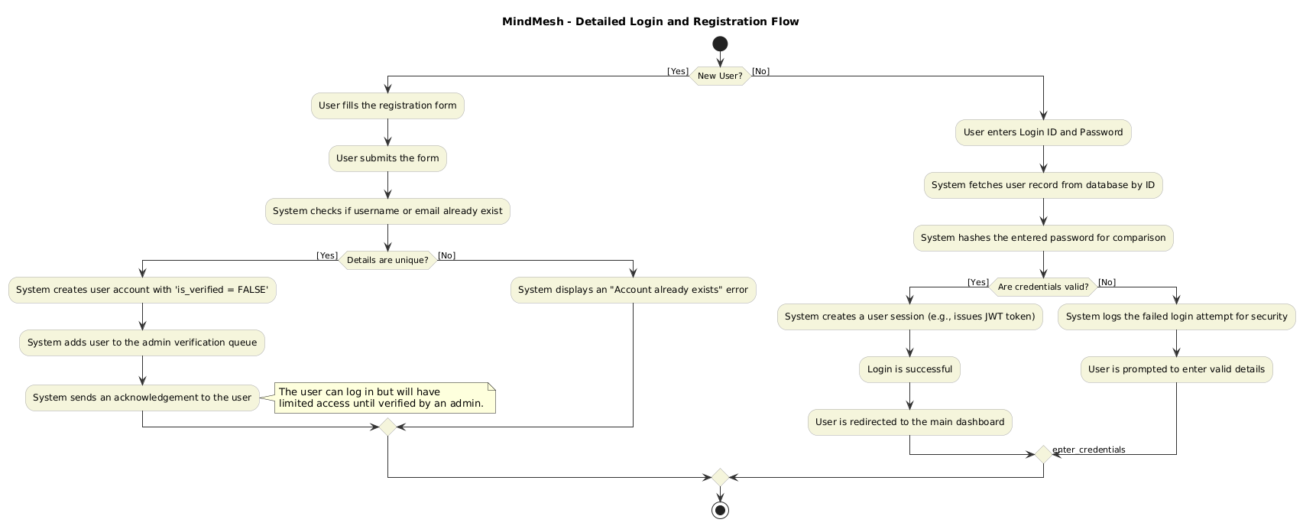

AI Moderation
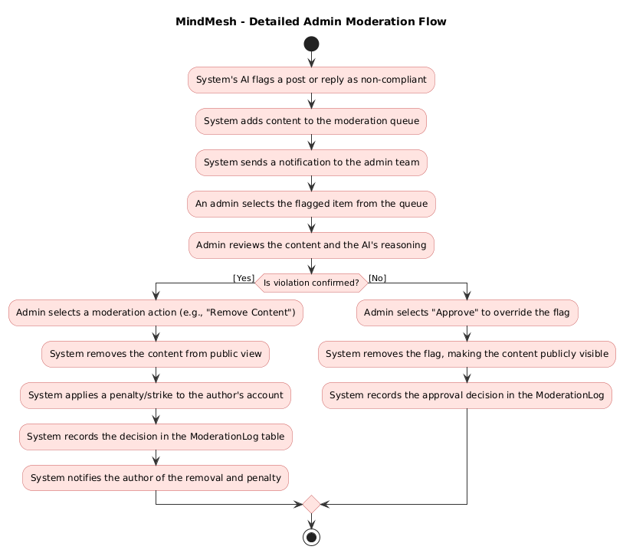

Content Interaction
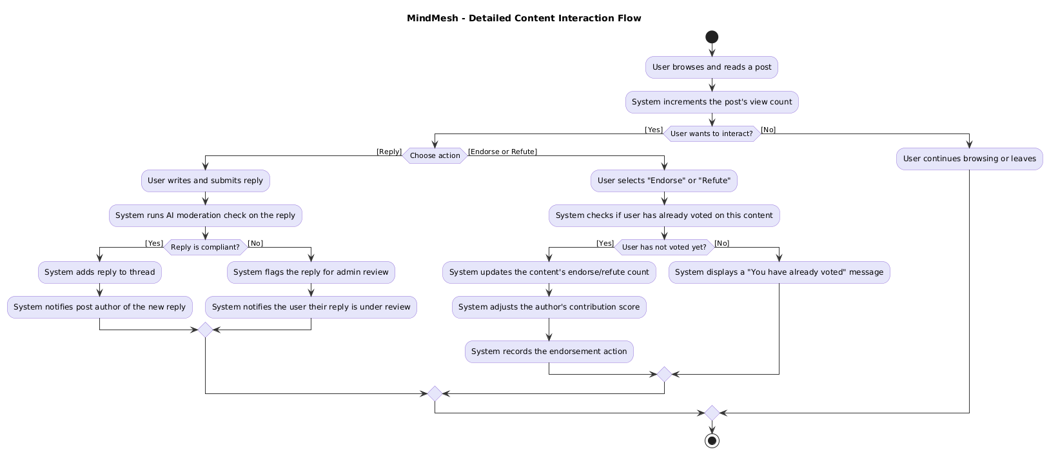

Post Creation
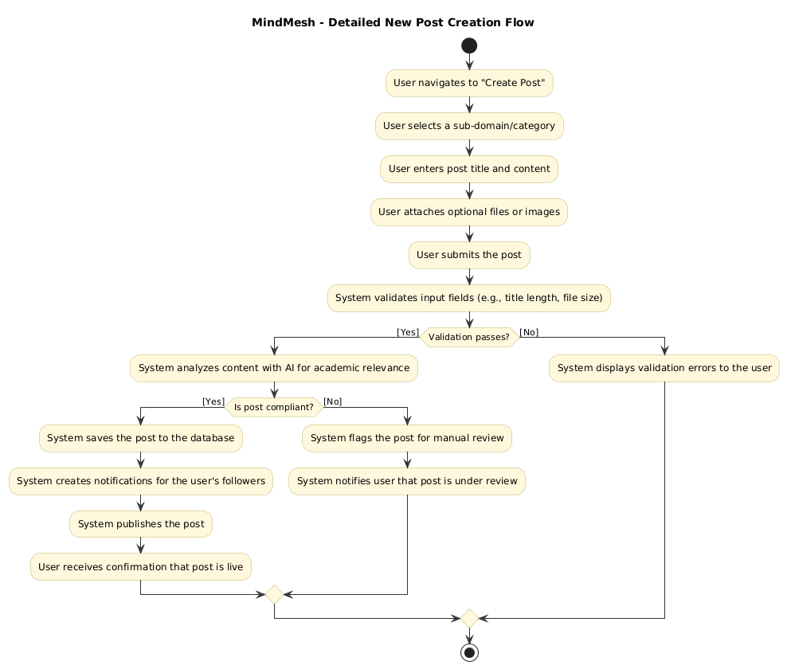

Sequence Diagram

User Login and Post Creation
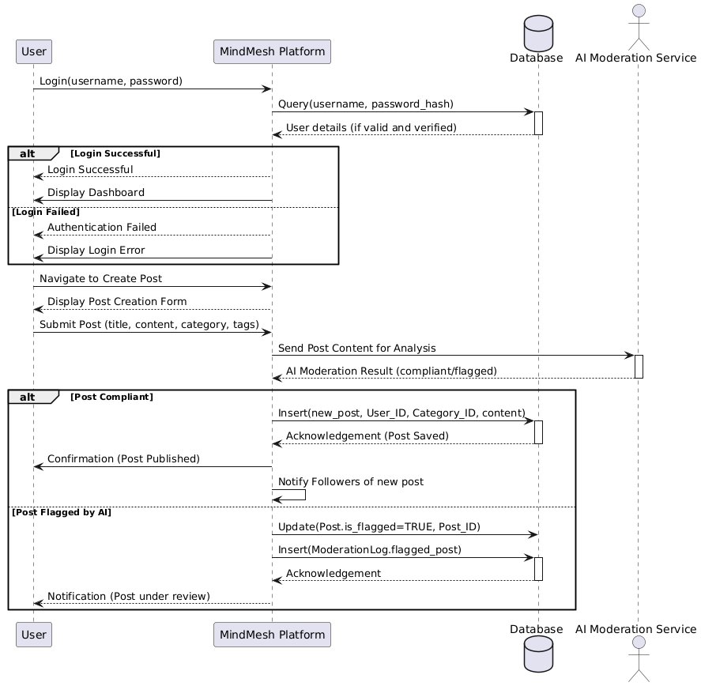

User Interaction
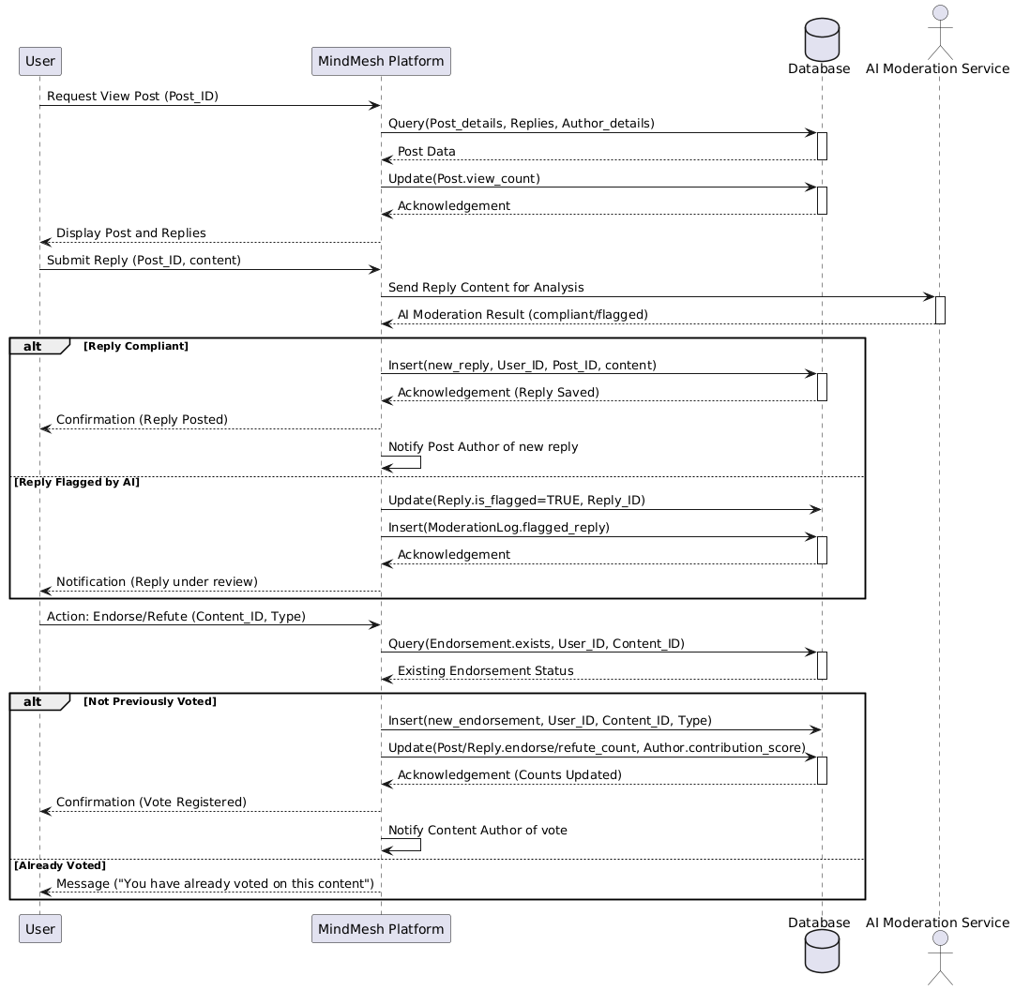

Admin
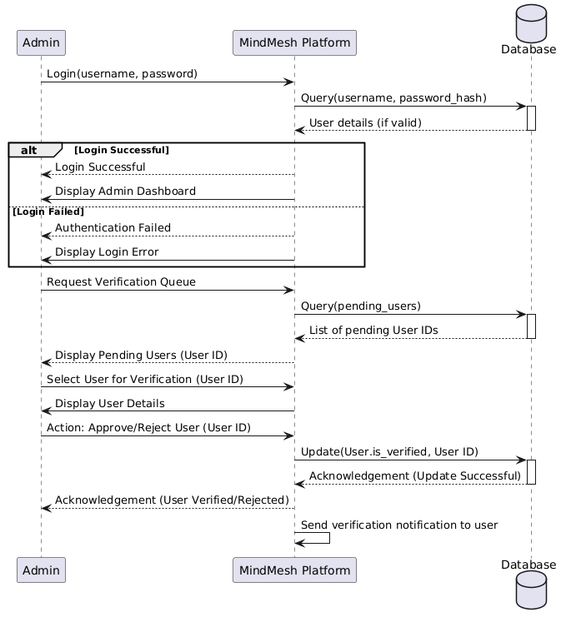

Admin AI Moderation
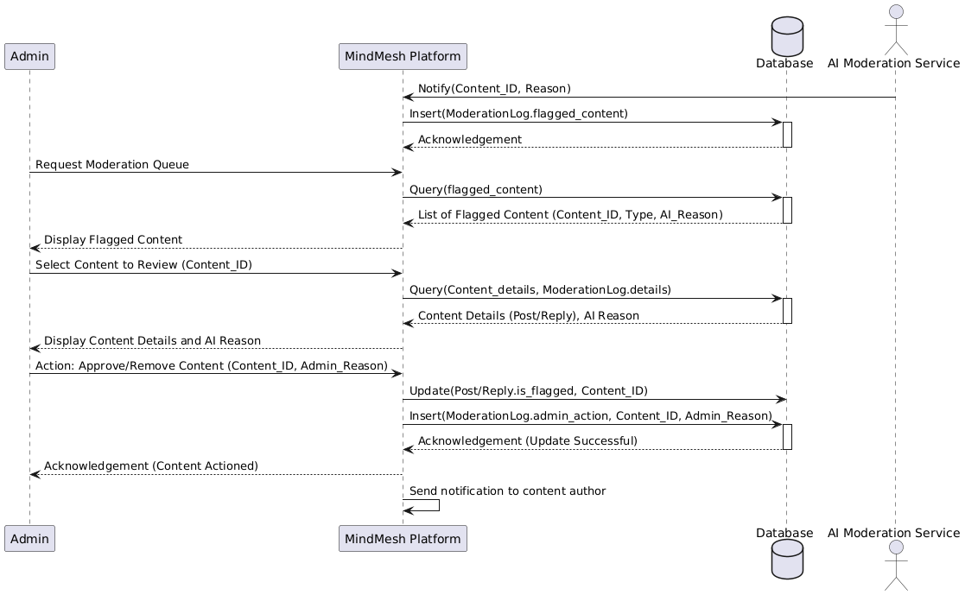

Functional and Behavioral Modeling
It provides a brief explanation of the system's behavior and operations.

Data Flow Diagram

A data flow diagram is a visual depiction of how data "flows" through an information system, simulating some features of its operation.

A DFD outlines the types of data that will be entered into the system and exported from it, as well as where the data will be kept. It does not display information on process time or whether processes will run sequentially or concurrently.

DFD DIAGRAM LEVEL 0

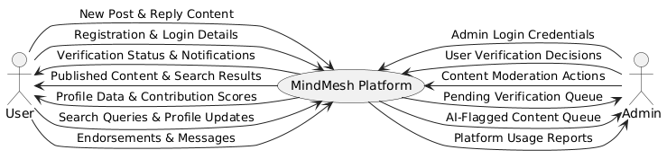

DFD DIAGRAM LEVEL 0

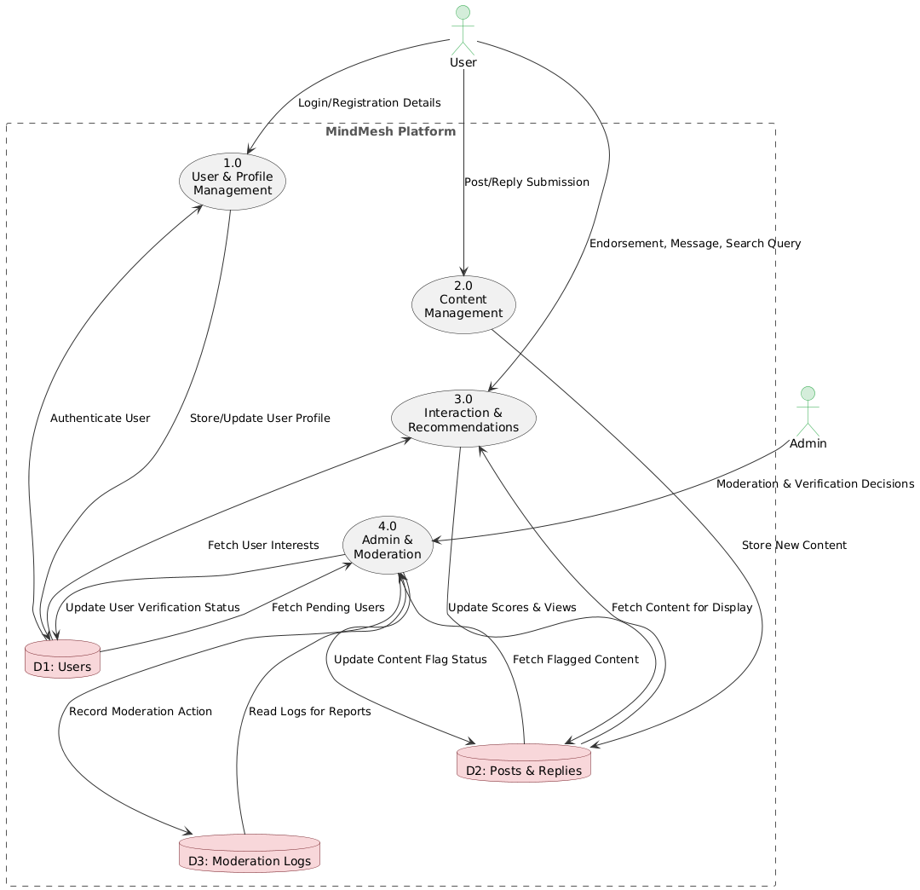

Database Schema Design

Users Table
- user_id (PK): Primary that uniquely identifies the users.
user_id (PK) | username | email | role | is_verified | contribution_score
1 | ali_khan | ali@uni.edu | student | TRUE | 85
2 | dr_sara | sara@uni.edu | teacher | TRUE | 250
3 | hassan_r | hassan@uni.edu | researcher | TRUE | 175

Categories Table
- category_id (PK): Primary Key for categories.
- parent_category_id (FK): Foreign Key that joins to same table, purpose is to create sub-categories.
category_id (PK) | name | parent_category_id (FK)
101 | Computer Science | NULL
102 | Artificial Intelligence | 101
103 | Physics | NULL

Posts Table
- post_id (PK): Primary Key for Posts.
- user_id (FK): Foreign Key for users.user_id which tells us who created the post.
- category_id (FK): Foreign Key for categories.category_id which tells us about the category of post.
post_id (PK) | user_id (FK) | category_id (FK) | title | endorse_count
1001 | 1 | 102 | Question about Neural Networks | 15
1002 | 2 | 102 | New Paper on Reinforcement Learning | 42

replies Table
- reply_id (PK):Primary Key for replies.
- user_id (FK): References users.user_id and tell who wrote the reply.
- post_id (FK): References posts.post_id to link the reply to its main post.
- parent_reply_id (FK): References another reply_id in this same table to create threaded discussions.

reply_id (PK) | user_id (FK) | post_id (FK) | parent_reply_id (FK) | content
5001 | 3 | 1001 | NULL | A good place to start is the original...
5002 | 2 | 1001 | NULL | Great question, Ali. Also, consider...
5003 | 1 | 1001 | 5001 | Thank you, Hassan! That's very helpful.

follows Table
- This table has a Composite Primary Key. It is the combination of following two keys of our table:
- follower_id (PK, FK): References users.user_id.
- followed_id (PK, FK): References users.user_id.
follower_id (PK, FK) | followed_id (PK, FK)
1 | 2

messages Table
- message_id (PK): The Primary Key for each message.
- sender_id (FK): References users.user_id and show who sent the message.
- receiver_id (FK): References users.user_id and show who received the message.
message_id (PK) | sender_id (FK) | receiver_id (FK) | content | is_read
9001 | 1 | 2 | Hello Dr. Sara, I had a question about your post. | TRUE
9002 | 2 | 1 | Of course, Ali. I'm happy to help. What is it? | TRUE
9003 | 1 | 2 | It was about the activation function you mentioned... | FALSE

CANVAS

AEIOU SUMMARY
- Environment:
A secure, highly focused academic community that exists as a dedicated forum-style website. It aims to fill a gap left by general social platforms that lack specific structure, categorization, and moderation for academic content.
- Interaction:
Verified university/college students, teachers, and researchers connect based on shared subdomains/fields. They engage in peer-to-peer knowledge exchange through posting questions, sharing thoughts, and involving in threaded discussions. Users can directly endorse or refute content.
- Objects:
Key objects include the Post (which can be questions, thoughts, solutions, or research papers) , Replies in a threaded format , and the User Profile which displays a contribution score. Content is explicitly managed using categorization based on academic sub-domains.
- Activities:
Activities center on collaborative learning and structured communication: Registration requires a university-affiliated email. AI-assisted moderation runs to check posts/replies for relevance and flag non-compliant content against defined SOPs. A recommendation engine suggests related posts and peers based on interests and following activities.
- Users:
The intended users are the academic community—specifically, students, teachers, and researchers. Access is strictly limited to those Intuitional certified. The Admin user has privileges to manage user accounts, verify new users, and act upon flagged content (approve/delete).

EMPATHY SUMMARY
- Input through AEIOU framework (The Current Problem):
Currently, there is no one platform where all students, teachers, and researchers can connect for mutual learning. They often rely on social groups (like WhatsApp or Facebook), which lack the necessary specific structure, categorization, and moderation. General platforms do not restrict users to domain-specific knowledge, leading to clutter and noise.
- Scouted Challenges (User Pain Points):
  - Intellectual Isolation and a lack of familiarity with ongoing academic trends.
  - Difficulty finding reliable information and connecting with relevant peers for mutual learning.
  - Discussions are often diluted by off-topic comments, memes, or low-quality content due to a lack of robust moderation.
  - Misinformation can spread easily because existing platforms lack verification mechanisms.

IDEATION CANVAS

- People:
The platform is built to connect and serve users who prioritize scholarly collaboration: verified academic peers (students, teachers, researchers).
- Activities:
Key activities include creating posts (questions/thoughts) in defined sub-domains, engaging in discussions, and using the endorse/refute mechanism to curate content quality. AI will constantly analyze submissions for relevance.
- Situation/Context/Location:
The platform's context is to operate as a secure space where all discourse is highly academic-oriented and confined to domain-specific knowledge.
- Props/Possible Solution:
The project will be a web application utilizing the MERN/PERN stack components: React.js for the frontend, Node.js and Express.js for the backend, and PostgreSQL as the database. The platform wil

PRODUCT DEVELOPMENT CANVAS

- Purpose:
The aim is to mitigate the challenges of social media groups by creating a secure platform where students, teachers, and researchers can register, create posts, and endorse content.
- Product Experience:
The user experience will be characterized by ease of access to domain-specific knowledge and a focus on productive, relevant discussions. It is designed as an MVP with core interaction features.
- Components:
Core functions include user registration/login with institutional verification, a system for post management and threaded replies, and the functionality for endorsing/refuting content.
- People:
The platform ensures that users engage in productive discussions that support learning and knowledge-sharing across diverse domains by focusing purely on the academic community.
- Product Function:
To act as an exclusive academic space that ensures all content is kept relevant and aligned with platform SOPs through robust moderation.
- Product Features:
Key features are: AI Moderation, Domain-based Categorization, Direct Messaging, a Following system, and a User Profile Score/Reputation system.
- Customer Revalidation:
The platform requires ongoing effort post-launch for iterative updates based on user feedback to maintain its relevance and functionality.

BUISSNESS MODEL CANVAS

- Customer Segments:
Verified academic users who can only sign up with an institutional email. This targets the niche audience of higher education students, teachers, and researchers.
- Value Propositions:
Access to a secure platform for peer-to-peer collaboration, AI-driven moderation to ensure content quality, and access to knowledge segmented by sub-domains.
- Channels:
The primary channel is the forum-style website. It should be accessible on web and mobile devices with responsive design.
- Customer Relationship:
Maintained through the profile score and reputation system, the direct messaging feature for one-to-one communication, and real-time notifications.
- Revenue Streams:
No revenue streams are explicitly defined in the provided document.
- Key Activities:
Building the core forum system with categorization, implementing the AI-driven moderation logic, and developing the profile/reputation system.
- Key Resources:
Human (software developers/team members), Technical (React.js, Node.js, Express.js, PostgreSQL), and Intellectual/API access (Large Language Models for content filtering).
- Key Partnerships:
Strategic partnerships with LLM providers (Mistral or Gemini) for content-filtering APIs. Implied partnership with academic institutions for user verification.
- Cost Structure:
The most important costs will be tied to Software Development and Maintenance (estimated at a 40:60 ratio compared to development). Other costs include servers and licensing fees for AI services.

Chapter 6: Implementation

Testing
Software testing is a critical component of software quality assurance, representing the final review of the specification, design, and code generation. Testing was integrated into the project to ensure proper functionality, validation, and navigation, aiming to uncover errors and prevent erroneous working conditions or user dissatisfaction.

Types of Testing Performed
The system was tested using several methods to uncover errors:

Validation Testing:

Ensures the user must log in with unique credentials and complete all mandatory fields; a warning message is issued if a user fails to do so.

Functional Testing:

The entire system was divided into sub-modules, and the adding/updating of user information in the database was tested.

Navigational Testing:

Ensured all pages were properly accessible with their respective links.

Input Checking:

Tested the validation process to ensure proper input format (e.g., numeric data for numeric fields, checking for null values).

Condition Testing:

Exercised the logical conditions in the program modules, examining and testing all relational statements, and using extreme case values.

Loop Testing:

Examined each loop separately, testing its end-point values and terminating conditions.

Output Testing:

Checked the friendliness and accuracy of the output, ensuring it presents all relevant information and reports missing data.

Acceptance Testing:
The system was run with live data by actual users.

Test Cases
Test Case ID | Test Case Scenario | Pre-Conditions | Test Steps | Expected Post Conditions
TC-M01 | Institutional Verification | User registers with a university-affiliated email, and the registration is pending admin review. | 1. Admin logs into the moderation dashboard.  2. Admin views the pending verification queue.  3. Admin selects the new user and approves the credentials. | The user's account is marked as verified, and the user gains full access to the platform's features.
TC-M02 | Create Academic Post | User is logged in and has selected a sub-domain (e.g., "Computer Science") | 1. User navigates to the "Create Post" option  2. User enters a title and content relevant to the selected sub-domain.  3. User submits the post. | The system runs AI moderation for relevance. If compliant, the post is saved, published, and visible in the threaded discussions.
TC-M03 | AI Moderation & Flagging | User is logged in. Content in the post violates defined SOPs (e.g., non-academic or offensive content) | 1. User attempts to create and submit the non-compliant post.  2. System analyzes the content with the AI Moderation service. | The system flags the content and places it in a queue for administrator review. The user is notified that the post is under review.
TC-M04 | Endorse a Post/Reply | User is logged in and views a post¹⁵. The user has not previously voted on this content. | 1. User clicks the “Endorse” button on the post.  2. System checks if a vote already exists. | The endorsement is recorded, the content's visibility is updated, and the author's contribution score/reputation is adjusted (increased).
TC-M05 | Direct Message a Peer | User A is logged in and views User B's profile. | 1. User A clicks on the "Message" button on User B's profile.  2. User A types and sends a message in the chat interface. | User B receives the message in real-time and a corresponding notification. Users can continue the conversation.
TC-M06 | Search by Sub-domain/Score | User is logged in. Many posts and users exist. | 1. User accesses the search bar.  2. User searches for posts using a specific sub-domain (e.g., “Web Development”).  3. User searches for users based on a high contribution score. | The system returns a list of posts and a list of user profiles filtered by the requested criteria (sub-domains/contribution scores/fields).
TC-M07 | Admin Content Management | Admin is logged in and there is content in the AI-flagged queue. | 1. Admin accesses the Moderation Dashboard.  2. Admin reviews the flagged content details and the AI's reason.  3. Admin chooses the "Remove Content" action. | The content is removed from public view, the removal is recorded in the Moderation Log, and a notification is sent to the content author.

Chapter 7: CONCLUSION AND FUTURE WORK

Conclusion

The MindMesh project successfully achieved its goal of developing a functional Minimum Viable Product (MVP) for an academic-oriented forum. By focusing on verified university/college students, teachers, and researchers, the platform successfully bridges the critical gap left by general social media, which often leads to intellectual isolation and a diffusion of academic focus.
The core success of MindMesh lies in its structured approach to knowledge exchange:
- Security & Credibility:
Mandatory institutional verification ensures that all participants are verified peers, enhancing the credibility of discussions.
- Content Quality:
The implementation of AI-assisted moderation (using LLM content-filtering APIs) and the endorse/refute mechanism provides necessary tools to flag irrelevant content and promote high-quality academic contributions.
- Structured Collaboration:
By organizing discourse through categorization based on sub-domains and facilitating threaded discussions, MindMesh fosters focused, mutual collaboration and problem-solving, thereby promoting academic excellence within higher education.
MindMesh provides a dedicated, moderated, and efficient space for the academic community to connect intellect, share resources, and stay abreast of ongoing trends in their respective fields.

Future Work

To evolve MindMesh from its MVP status into a robust, comprehensive academic resource, the following areas should be prioritized for future development:

- Enhanced Reputation System Integration:

Further refine the impact of the endorse/refute system, perhaps integrating external metrics like citation counts or publication records (where feasible) to create a deeper, more nuanced contribution score.

- Advanced Recommendation Engine:

Expand the logic of the recommendation engine to suggest personalized learning pathways or potential research collaborators based on semantic analysis of a user's post history and followed sub-domains.

- Real-Time Collaborative Tools:

Introduce features beyond basic direct messaging, such as real-time document sharing or collaborative whiteboards, to support joint project work directly within the platform.

- Community Governance:

Implement a formal, peer-driven flagging and review system that complements the AI moderation, allowing established, high-reputation users to assist in maintaining content quality and SOP compliance.

