

Application Programming in Java

Library Management System

Project Team 7

Team members:
U1910271 Bakhoriddin Fayzullaev (Section 006)
U1910282 Viktor Ogay (Section 006)
U1910289 Fayyozbek Fozilov (Section 006)
U1910262 Azimbek Ismatullaev (Section 006)
U1910294 Bekhzod Akhmadjonov (Section 006)
U1910237 Makhinura Teberikova (Section 005)

Link to github:
https://github.com/iuthub/group-project-team-7

Submission date – 10/01/2021
Description of Implemented Functionality
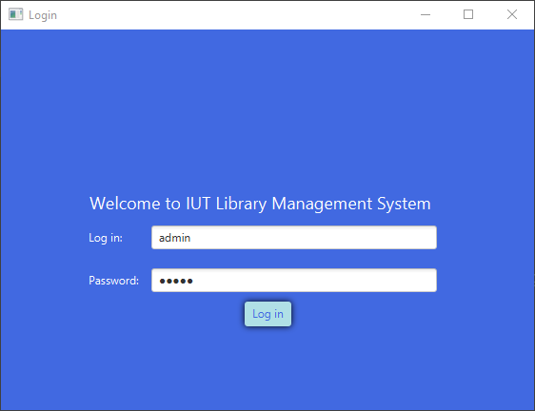
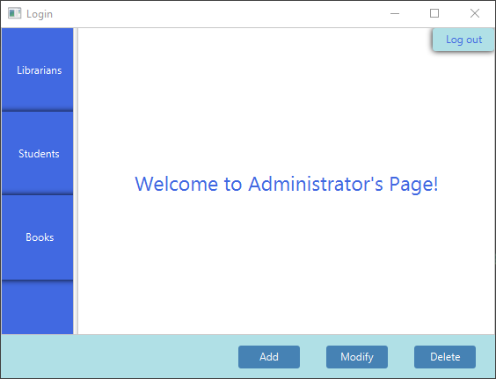

Librarians list:
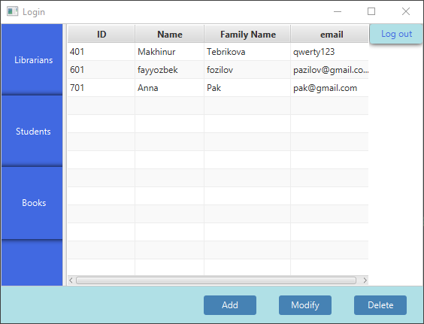
Students list:
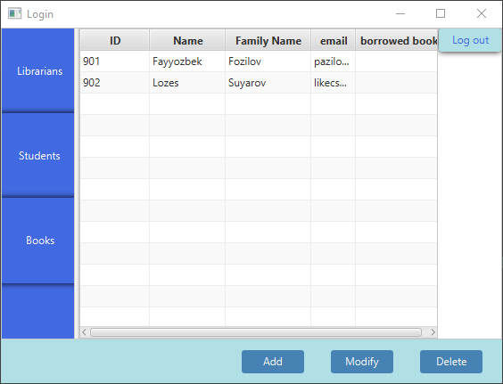

Books list:
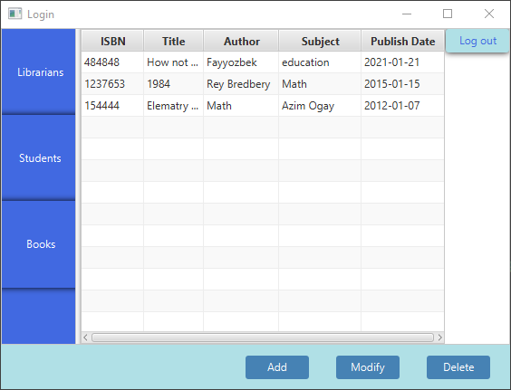
Add/Modify page:
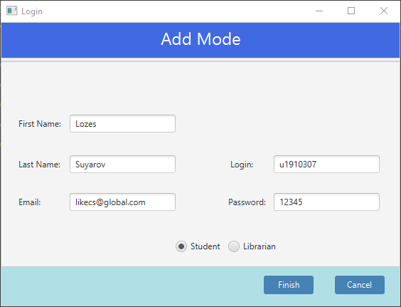

Borrowed books list:
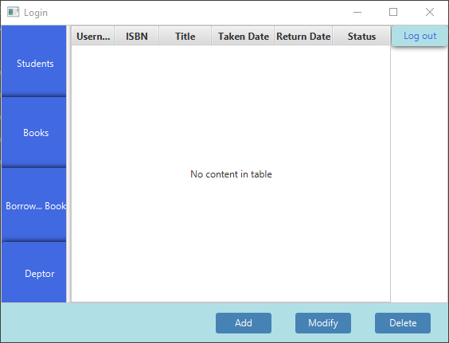
Deptors list:
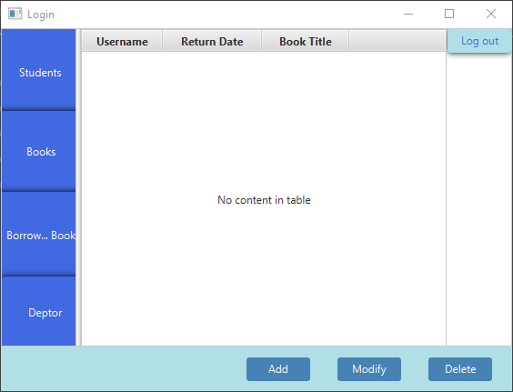

Cabinet of student:
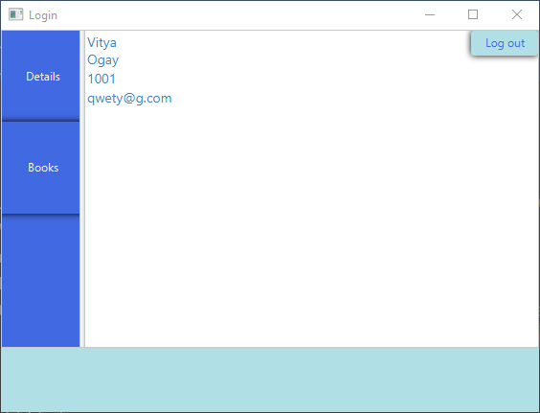
List of books which student can borrow:
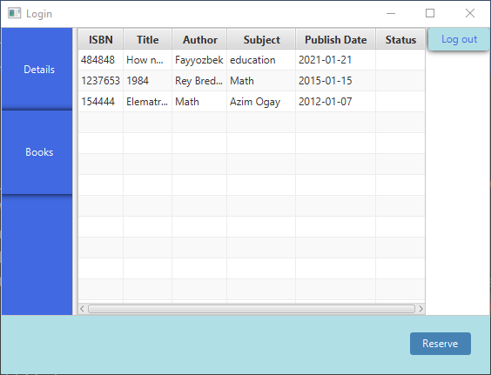

Add/Modify book details:
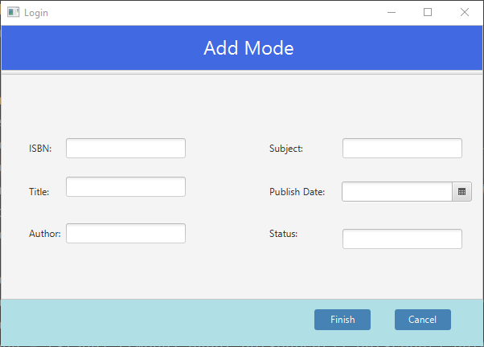

Main Class, used for running application:
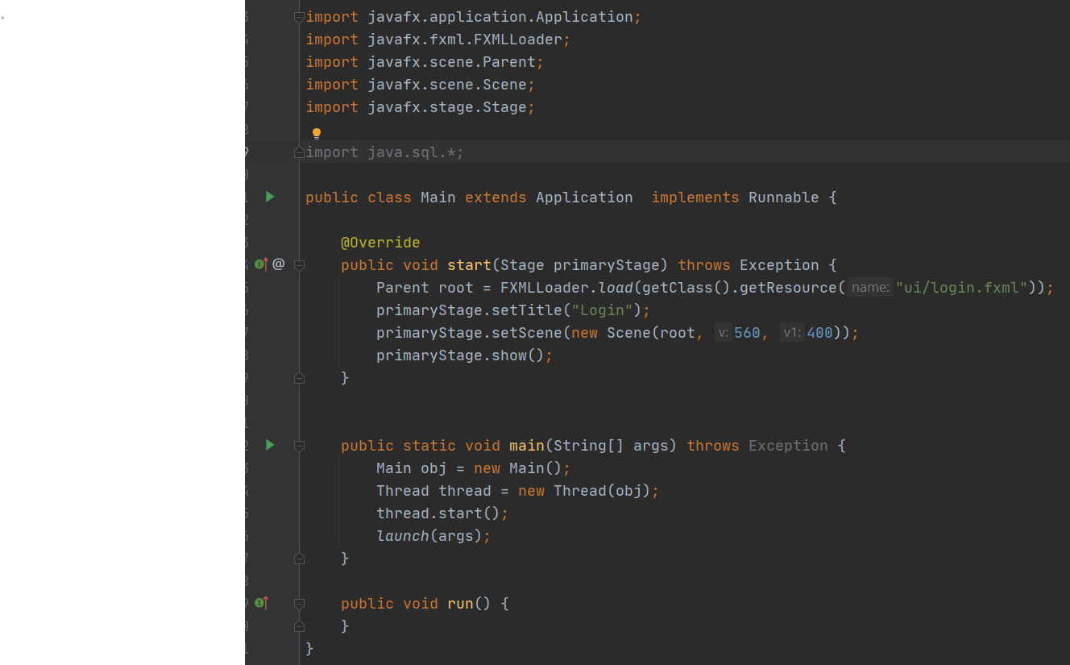
Librarian class, used for getting and setting data and transferring it to the main methods:
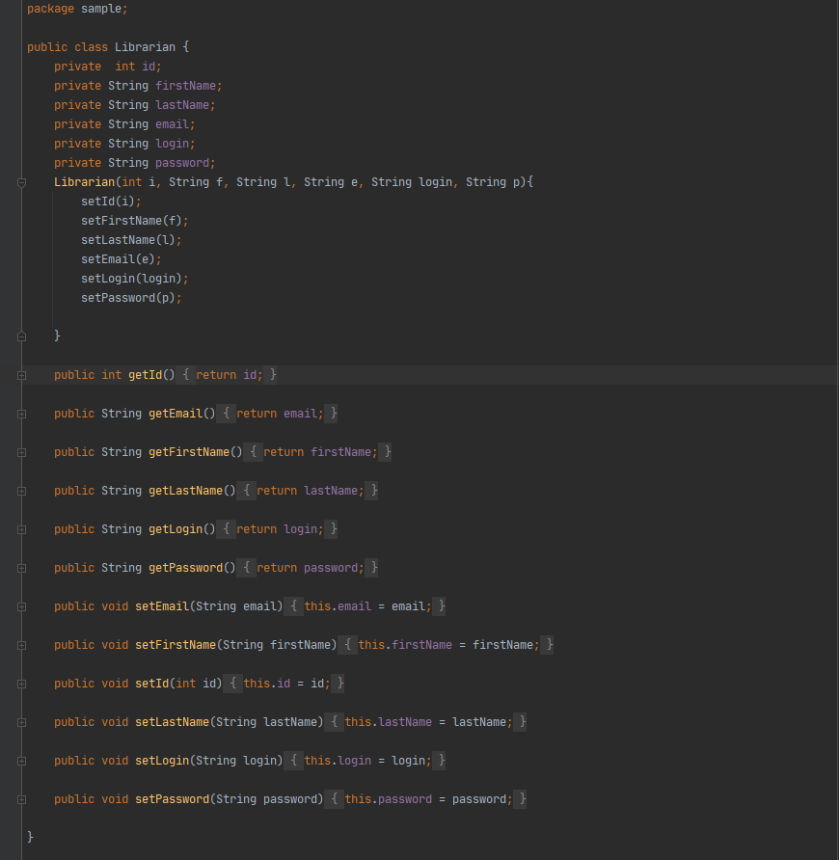

Class Students, used to set and get data and to transfer it database: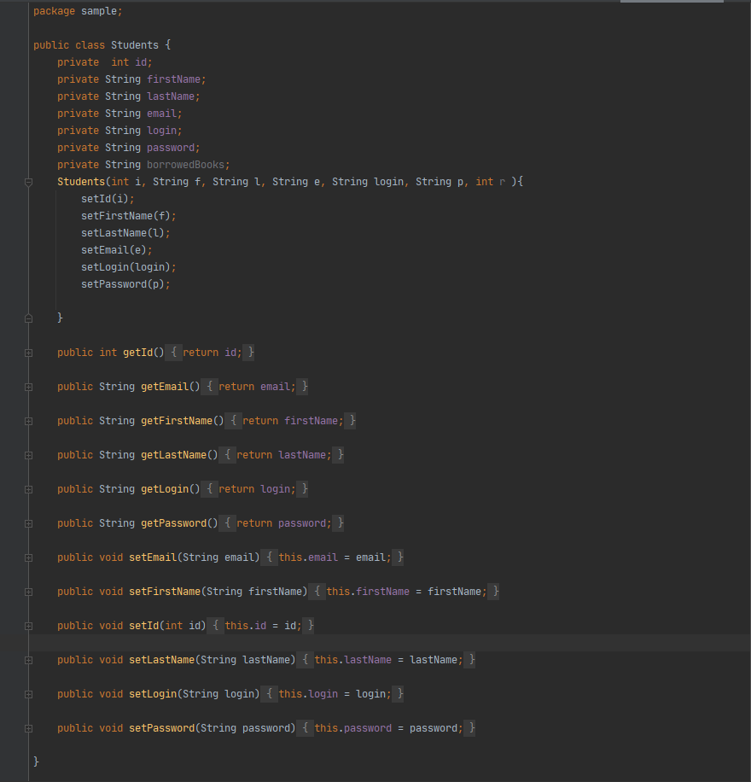

Class Books used to set/get data and to transfer it database:
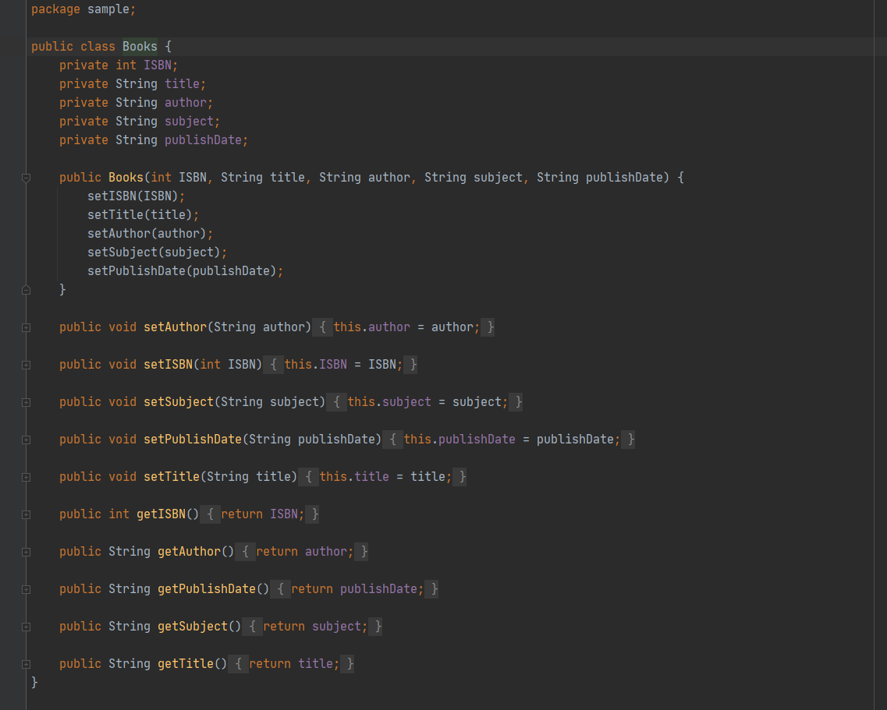

Function back in Edit.java:
Used for back button inside of the add/modify window, if you’re admin it will return to the window of the admin, or if you were librarian before you’ve entered add/modify window it will return librarian window

Initialize method in Edit.java:
Used for insering data from database into tables in windows librarian/students/books

onEdit method in Edit.java:
Used for catching data in database and modifying it

onRdSlctStudnt/onRdSlctLbr method in Edit.java:
Used for Radio Buttons in add/modify button for choosing role of the user

Cancel method in Edit.java:
Does the same as function back, but for button named cancel

onLogin method in Controller.java:
Used for logging in, takes all users from database, checks for details, whether entered username and password are correct, also tells the program role of the user, whether it’s admin, librarian or student

onLogout method in Controller.java:
Used for logging out from your personal area

onLibrarians method in Controller.java:
Used for parsing librarians list and showing it in admin panel

onStudents method in Controller.java:
Used for showing all students and their details in admin panel

onBooks mehtod in Controller.java:
Used for showing all books and their details in admin panel

onModify method in Controller.java:
Used for editing details of students/librarians/books

onDelete method in Controller.java:
Used for deleting users/books from database and list

onLStudents method in Controller.java:
One of the methods in librarians panel for listing students from database and adding it to the table

onLBooks method in Controller.java:
One of the methods in librarians panel for listing books from database and adding it to the table

onBorrowedBooks method in Controller.java:
Used for listing books which are borrowed in librarian cabinet

onDeptor method in Controller.java:
One of methods in librarian cabined, used for listing details of books which are borrowed

onSDetails function in Controller.java:
Function is used to list students personal details

onSBooks method in Controller.java:
Used for listing books which are available in students personal cabinet

onAdd method in Controller.java:
Method is used to insert new data to database

openPage function in Controller.java:
Function is used to switch between windows

During the work on this project we’ve faced with a lot of problems, they were concerned about databases, work experience with git version control and of course with bugs which were appearing in the places in which we’ve not expected them to be. Overall our team members – Viktor, Makhinura and Bekhzod have worked on ui and functionality, while Fazzyobek, Bakhoriddin and Azimbek have worked on databases and connection of databases with program itself.

Accounts
Admin panel:
Login – admin
Pass – admin

Librarian panel:
Login – qwerty123
Pass – 12345

Students panel:
Login – qwerty1234
Pass – 12345

UML Diagram

