**Section 1: Mobile Devices**

**Hardware**

Laptop_Memory:

* All of the programs that are executing in your operating system are executing in memory. And if we ever need to increase the amount of memory in our laptop, then we’ll probably **want to use SO-DIMM– or the small outline dual in-line memory module**. This form factor is very common for laptops and other mobile devices and often there is a window or an opening at the bottom of the laptop that allows you to easily add and remove these memory modules.

Laptop_Storage:

* Our laptops also needs some type of storage space so that we can retrieve or save files to that system. Older laptops might have storage in the form of **a magnetic disk**. This is the hard drives that we traditionally think about. These are **spinning**, **physical drives**. But they’re in a form factor that’s around 2 and 1/2 inches. This 2 and 1/2 inch form factor works well for these portable platforms, especially when you consider that desktop platforms have the **larger 3 and 1/2 inch size hard drives**.
* **SSDs**, instead of spinning hard drives. As the name implies, **a solid state drive is solid state**. There are no moving parts inside of an SSD. This makes it very easy to perform an upgrade because you can unplug a hard drive and connect an SSD to the same interface using exactly the same form factor. One significant **advantage of the SSD is the greatly increased speed for reading and writing data to this device**. And by simply upgrading from a hard drive to an SSD, you can **greatly improve the performance** of almost any device.
* This is **an M.2 interface on an SSD drive**. And you can see the size of this SSD is much smaller than the larger and more traditional SATA-connected SSD. This means we can fit a lot more storage in a much smaller space. And we don’t have the cables that you would normally find on a traditional SATA-connected SSD.

**wireless functionality using 802.11 or Bluetooth:**

* you may find that wireless functionality using 802.11 or Bluetooth connections are built into the system board or motherboard of that laptop. Older laptops may include **Mini PCI** or **Mini PCI Express interfaces** so that you can add additional wireless connectivity. For example, you could plug in one of these cards and you might have 802.11 access that will provide you with local area network coverage on wireless networks.

**NFC– or near-field communication:**

* NFC is Near Field Communication and it’s a way to send small amounts of data between devices that are located very close to each other. If you’ve ever gone into a store and used a payment system or you needed to transfer information between two mobile devices, then you’re probably using NFC to facilitate that conversation. You can also use NFC as an access device, or something like an identification card that you could hold up to a sensor and use it to unlock an electronic door
* This allows us to transfer data or perform authentication to the device without physically touching the device. If you’re in a store, and you paid during checkout with your phone or your watch, then you were using NFC.
* But you could also use your phone or your watch to authenticate to the laptop. This is great if you’re in a hospital or a warehouse where you might be using this laptop only occasionally, and you need it to quickly authenticate each time you walk up to the laptop. By using your phone or your watch, you’re able to provide that authentication without having to touch anything else on the system, input any extra passwords, and quickly gain access to the operating system.

**LCD display:**

* This is a liquid crystal display where there are a series of liquid crystals associated with color filters, and there is a backlight or light source behind all of that shines through to give us the image that’s on our screen. From a laptop perspective, the advantages of an LCD display is that they are lightweight and use very little power, and they’re relatively inexpensive to make, keeping the cost of the laptop down.
* **disadvantages with LCD displays**. One is that this light source in the back has to shine through to provide the color, which means getting a true black can be quite difficult on an LCD display. We might also have different kinds of backlights on our displays. The light source may be fluorescent, it may be LED, or may be some other type of light. If this backlight was to fail, you could see that it’s part of the display itself, making it relatively difficult to be able to repair or replace.
* There are **three** different technologies of liquid crystal displays that you need to be aware of. One is the **TN LCD, this is the Twisted Nematic LCD**, which gives us very good response times. If you’re a gamer or you’re using some application that **has fast moving graphics**, this may be the display type for you. Unfortunately, these displays often have very bad viewing angles, which means once you get off to the side of the display, you’ll notice there’s an inversion of the color. If you want the best possible view of a TN LCD, you need to be looking directly at the display.
* best possible color representation on an LCD display, you’ll want to use **an IPS LCD**. The IPS stands for **In Plane Switching**. This gives you very **good color representation**, which is great for using graphics or doing some type of desktop publishing. But these are slightly **more expensive than a TN.** So that extra color representation comes at a bit of a cost.
* If you like something that’s in **the middle between TN and IPS**, you may want a **vertical alignment LCD or a VA display**. This has good color representation, but you’ll find the response times are a bit slower than a twisted nomadic LCD.

**an OLED display:**

* The OLED stands **for Organic Light Emitting Diode**. And it **doesn’t have a backlight**. Instead, this organic material **emits light** when you **provide it with a current**. Because **there’s no backlight and no liquid crystals**, these are **very thin displays**. And there’s no glass that you would need on the front of the display to protect it.
* The real key is that organic material that’s able to create its own light when you provide it with power. And that’s what allows these displays to be very light and very thin. You’ll find them on tablets, phones, and smart devices, not only because they provide such great color representation, but because they’re so light and so easy to carry.

### **1.3 – Mobile Device Configuration**

**USB or Universal Serial Bus:**

* USB is designed for high speed communication and it’s often used to connect our mobile device with our computer or with a power source. You’re probably already familiar with the larger type A plug that we often see on computers. The device itself may have a different type of USB connection. 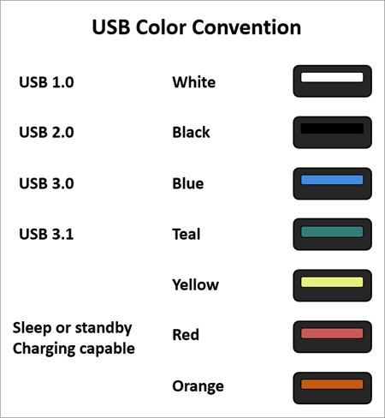

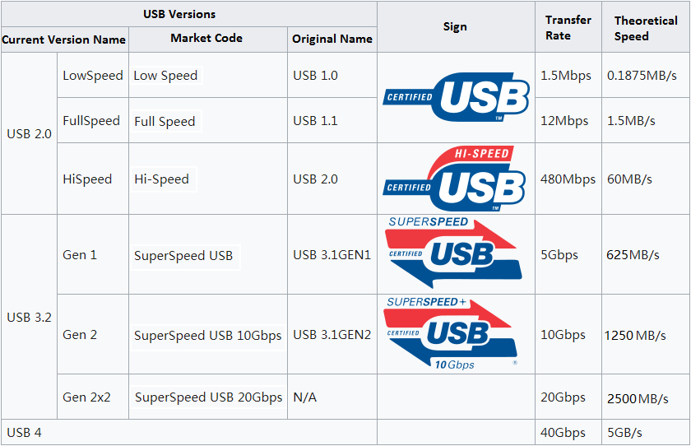

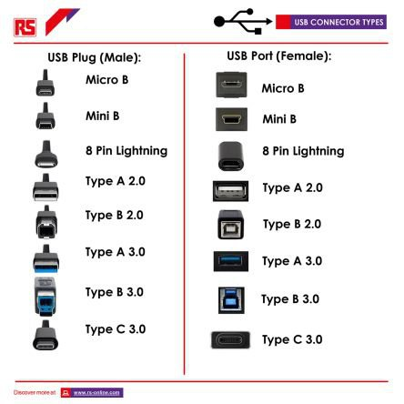

 **Serial interface:**

**DB-9 interface:**

* This is a nine pin connection. These serial cables commonly transported RS232 signals. And this is a standard of communication that’s been around for a very long time. You can probably still find devices in your infrastructure that use DB-9 connections with RS232 to be able to connect and view consoles on switches, routers, and other devices.
* These days we see a lot more USB and a lot less DB-9 in our environments. But if you still have an older switch or router around, then you’ll probably need a serial cable with a DB-9 connector at the end so that you’re able to configure that device. 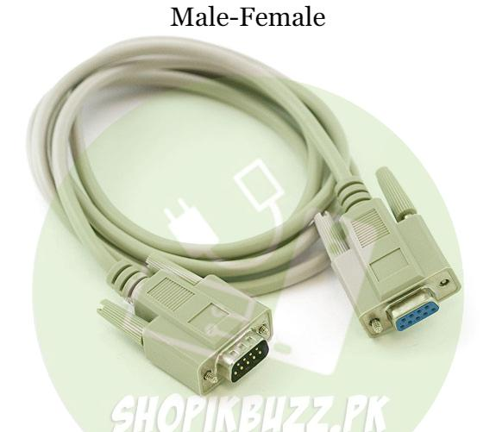

### **Other Connectors:**

### **Cellular standards**

* Many of the things we do in our normal workday involve using our mobile phones. These are our cell phones. And we call them cell phones because they are using a cellular network. We call it cellular because we are separating up the geography of an area into sections or cells. And we put antennas at the edges of those cells so that we’re able to maintain connectivity wherever we might happen to travel.
* The G in 2G, 3G, 4G or 5G stands for “Generation”. The very first generation of a commercial cellular network, 1G, was developed since the late 1970s and introduced 1987 by Telstra, an Australian operator. On a frequency of 30 kHz and a bandwidth of 2 kilobit per second (kbps) it was a technology that came with very poor battery life, low voice quality and not much security. It did not survive long.

### **2G - The first digital standard**

* 2G has been established in 1991 and is the first digital standard. It delivered more reliable and secure communication. The 2G standard implemented the CDMA and GSM con-cepts:
* And they consisted of two global standards. One of these standards was GSM or the Global System for Mobile Communications. And the other one is CDMA or Code Division Multiple Access. Both of these standards were very good for voice communication, but they had very limited support for sending data over these wireless networks. They were originally circuit switched networks and really had to be upgraded to allow some type of data connectivity.
* 2G networks introduced many of the fundamental mobile services we still use today. One of them: The Short-Message-Service SMS. SMS was doing machine-to-machine (M2M) communication long before the term "internet of things" made its rounds. With “General Packet Radio Service” (GPRS) and “Enhanced Data Rates for GSM Evolution” (EDGE) the 2G Standard was updated twice to 2.5G and 2.75G enhancing its maximum speed to 171 kbps and 384 kbps.  
    
  2G connectivity is up to now a reliable standard for connecting low-bandwidth devices with the Internet of Things. However, the days of 2G are counted. Since newer standards have emerged, Telstra was one of the first operators abandoning 2G in December 2016. In Europe the 2G phase out will start by the end of 2020.
* **GSM (Global System for Mobile Communications):**
* It is a standard to describe the protocols for second-generation digital cellular networks. Developed in the early 1990s in Europe it became a global standard by the mid-2010s.
* GSM was a big part of that very early cellular network. GSM being the Global System for Mobile Communications. GSM was about 90% of the worldwide market. It was a standard in the European Union and allowed you to have coverage wherever you happen to travel in the world. In the United States, common GSM networks were the AT&T network and T-Mobile network. This GSM network allowed you to have all of your phone configurations on a subscriber identity module or a SIM card. And you can move that card from phone to phone, and your phone number would follow you depending on where that SIM card happened to be.
* This GSM standard used multiplexing to be able to have many people communicating at the same time over the same frequencies. Every user got a little slice of time and could send the information while other people were also conversing on that same network. This allowed people to perform voice communication, data communication, and combine all of that across many people in one single geographic area.
* **CDMA (Codedivision multiple access)** enables several transmitters to send information simultaneously. Basically, it allows several users to share a band of frequencies.
* And as the name implies, you can have multiple people communicating over this network. But as they were sending information, they were sending it with a particular code. Each call used a different code to be able to communicate, which meant that the handset that you were using could filter out codes that weren’t important to your conversation and focused only on the code specific between you and who you’re talking to. In the United States, CDMA was commonly used by Verizon and Sprint. They controlled exactly what handsets you were able to use on those networks. And unfortunately, CDMA wasn’t popular in other parts of the world or with other providers

### **3G - Introducing mobile multimedia capabilities**

* 3G was introduced in 2003. At its core network it used a new architecture called “**Universal Mobile Telecommunications System” (UMTS**). Its main advancement to its predecessor 2G was a significantly **higher bandwidth**. **This made 3G the first mobile “multi-media standard”.** For the first time, **video streams could be transmitted** via mobile cellular networks. In 2006 3G was updated **to 3.5G by introducing the High-Speed Downlink Packet Access (HSDPA)** communication protocol further increasing the data bandwidth of 3G up to 42 Mbps.
* third generation or 3G technologies that we introduced in 1998. This allowed us to have much more capabilities for the data that we were sending from our mobile devices. And we had additional speed so we could send more of that data much faster over these same networks. Usually we got about several megabits per second of speed over the best possible 3G connectivity.
* With these enhanced speeds, we were able to introduce new capabilities for our mobile handsets, such as GPS, mobile television, streaming video and streaming audio, or video on demand. It became very clear that the separation between GSM and CDMA was creating a number of challenges for users that wanted to move between different providers or use different networks that might be available in their area. To be able to converge these together, we introduced LTE. This is 4G technology in the cellular world. And LTE stands for Long Term Evolution.

### **4G - High speed and ubiquitous computing:**

* Another update introduced the “**Long Term Evolution” (LTE**) standard that increased the capacity and speed of mobile communications once more. Even though LTE has been marketed as “4G” or “4G LTE” it does not meet the technical criteria of “real” 4G wireless service. **Technically LTE is a “3.9G”.**
* The fourth Generation 4G was introduced in 2012. Its main purpose is to deliver high speed communication with enhanced security to enable high definition mobile TV, video conferencing and pervasive computing respectively ubiquitous computing with bandwidths up to 150 Mbps. While 4G sets the standards and general conditions, LTE delivers the technological fundament to fulfil these standards. But only the enhanced LTE+ or LTE Advanced is meeting the 4G requirements.
* This was a converged standard, so companies that used to be GSM or CDMA can now use one standard LTE to be able to send data over a wireless network. It’s based on GSM and what we call EDGE or the Enhanced Data Rates for GSM Evolution. You combine all those together to create this newer LTE standard. And it increased the throughput up to 150 megabits per second on the best possible mobile connection. In some areas you may find an upgraded version of LTE called LTE Advanced or LTE-A, where it effectively doubled the throughput on these LTE networks up to 300 megabits per second.

### **5G - The future standard:**

* In 2020, we introduced a newer generation of mobile communication called our 5G or fifth generation cellular networking. And we will eventually have 5G networks that can perform at around 10 gigabits per second.
* we should eventually get to 10 gigabit per second throughput from one single mobile device. As these networks are rolling out, you may find that you have speeds between 100 and 900 megabits per second, which is still much faster than the older LTE networks.

**3.2 Memory**

# 3.2.1 Memory Hierarchy:

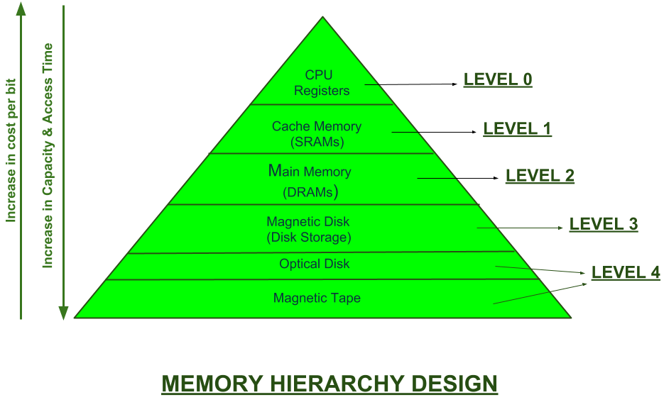

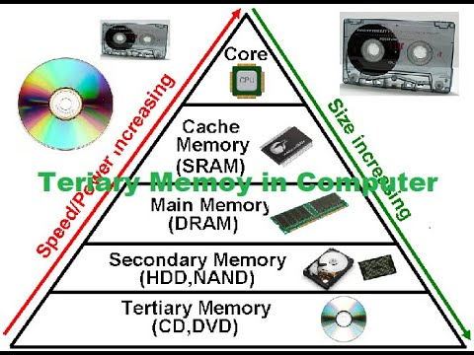

1. **External Memory or Secondary Memory –** Comprising of Magnetic Disk, Optical Disk, Magnetic Tape i.e. peripheral storage devices which are accessible by the processor via I/O Module.
2. **Internal Memory or Primary Memory –** Comprising of Main Memory, Cache Memory & CPU registers. This is directly accessible by the processor.

## Registers

* Usually, the register is a static RAM or SRAM in the processor of the computer which is used for holding the data word which is typically 64 or 128 bits. The program counter [register is the most important](https://www.elprocus.com/know-about-types-of-registers-in-8051-microcontroller/) as well as found in all the processors. Most of the processors use a status word register as well as an accumulator. A status word register is used for decision making, and the accumulator is used to store the data like mathematical operation. Usually, computers like [**complex instruction set computers**](https://www.elprocus.com/difference-between-risc-and-cisc-architecture/) have so many registers for accepting main memory, and [**RISC- reduced instruction set**](https://www.elprocus.com/what-is-risc-and-cisc-architecture-and-their-workings/) computers have more registers.
* A CPU [register](https://www.techtarget.com/whatis/definition/register) is a small section of memory in a CPU that can store small amounts of the data required to perform various operations. It loads the resulting data to the main memory and contains the address of the memory location.
* Registers are present inside the CPU and therefore have the quickest access time. Since they are the fastest memory type, they are the most expensive. They are also the smallest in size, typically measured in [kilobytes](https://www.techtarget.com/searchstorage/definition/kilobyte).
* A CPU register is implemented using digital logic circuits called [flip-flops](https://www.techtarget.com/whatis/definition/flip-flops-bistable-gates). It is an implementation of static RAM ([SRAM](https://www.techtarget.com/whatis/definition/SRAM-static-random-access-memory)) within the processor. Most processors include a program counter register, a status word register for decision-making and an [accumulator](https://www.techtarget.com/whatis/definition/accumulator) to store data and mathematical operations.

## ****Cache memory:****

* It is required to store segments of programs or chunks of data that are frequently accessed by the processor. When the CPU needs to access program code or data, it first checks the cache memory. If it finds the data, it reads it quickly. If it doesn't, it looks into the main memory to find the required data.
* Cache memory is usually smaller in size than a CPU register, typically measured in megabytes ([MB](https://www.techtarget.com/searchstorage/definition/megabyte)). It is implemented using SRAM. Usually, the cache is inside the processor. However, it may also be implemented as a separate integrated circuit ([IC](https://www.techtarget.com/whatis/definition/integrated-circuit-IC)).
* Cache memory can also be found in the processor, however rarely it may be another [**IC (integrated circuit)**](https://www.elprocus.com/how-integrated-circuits-work-physically/) which is separated into levels. The cache holds the chunk of data which are frequently used from main memory. When the processor has a single core then it will have two (or) more cache levels rarely. Present multi-core processors will be having three, 2-levels for each one core, and one level is shared.

## ****Main Memory (Primary):****

## The main memory in the computer is nothing but, the memory unit in the CPU that communicates directly. It is the main storage unit of the computer. This memory is fast as well as large memory used for storing the data throughout the operations of the computer. This memory is made up of RAM as well as ROM.

## That is RAM, is volatile memory

## ****Secondary Storage****:

## Secondary storage, such as hard disk drives (HDD) and solid-state drives (SSD), is a non-volatile memory unit that has a larger storage capacity than main memory. It is used to store data and instructions that are not currently in use by the CPU. Secondary storage has the slowest access time and is typically the least expensive type of memory in the memory hierarchy.

## Tertiary storage:

## Tertiary storage devices like magnetic tape are present at level 4. They are used to store removable files and are the cheapest and largest in size (1-20 TB).

* Tertiary storage devices are usually [magnetic tapes](https://www.techtarget.com/searchdatabackup/definition/magnetic-tape) or optical disks. These devices are typically used to store duplicate or archive copies of data. Also known as auxiliary storage, tertiary memory devices are usually used to store programs and data for the long term or when not required for immediate use.
* Tertiary devices are suitable for data archiving and backup. They are the cheapest and slowest memory type; they typically have capacities of 1 TB to 20 TB. 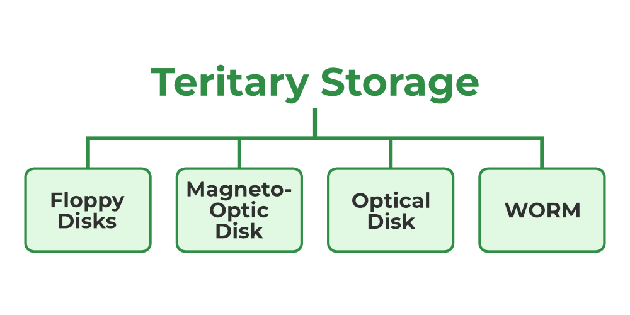

## DIMM:

## This is a dual in-line memory module because the connectors that are on one side of the memory module are different than the connectors that are on the other side of the memory module.

## these DIMMs is information is transferred in and out of the DIMM in 64-bit data widths. So we’re able to transfer these blocks of information to the CPU or the storage devices that are on our system.

## SO-DIMM:

## The SO stands for small outline dual in-line memory module, and it’s about half the width of a normal dual in-line memory module. These are very common on laptops and other mobile devices, where space is at a premium because these modules are so much smaller than the full sized DIMMs.

## DDR:

## Our modern systems use double data rate memory or DDR. This double data rate can transfer twice in a single clock cycle, which means we can effectively transfer twice as much than a single data rate.

## We’ve also updated our memory modules. Version 3 of this memory type is double data rate three or DDR3. These were an improvement over the older DDR2 memory and allowed you to increase the data rates to be twice as fast as those older DDR2 systems.

## That have a maximum amount of RAM of 16 gigabytes per module. And remember, there’s no backwards compatibility with these memory modules, so this notch at the bottom ensures that this will only be installed on a system that can support DDR3.

## On newer systems, you may find DDR4, which increases the speed over DDR3, but perhaps even more importantly, increases the maximum amount of storage on a single module to 64 gigabytes. Again, this is not backwards compatible with previous versions, so if you want to use DDR4 memory, you’ll need a motherboard that can support this memory type. And you may find some systems that can support faster memory in the form of DDR5.

## Hard disk drive (HDD):

## A hard drive consists of spinning magnetic platters. And even when your system is powered off, it still retains the data that you’ve stored on that hard drive.

## non-volatile” because the information continues to be on that drive even when there’s no power to the system. That means that we could power on our system and access any bit of data that may be on this hard drive. We don’t have to forward or rewind information like you might with a tape drive. And that’s why we refer to access on a hard drive as “random access.”

## Inside the drive itself are a lot of moving parts. You’ve got platters that are constantly spinning. You’ve got actuator arms that are moving back and forth to find the data that’s on this drive. And all of these mechanical components create limitations on how quickly we can retrieve and store data on this storage device.

* Another concern is that any time there’s moving parts, these moving parts will eventually break. And so we know that a hard drive will eventually fail. The question is exactly when that failure might occur.
* Here’s the view inside of a hard drive. All of the data is stored on these platters that are spinning at very high rates of speed. That platter is rotating around a spindle that’s in the middle of the platters. And an actuator on the hard drive controls an arm that moves back and forth over these platters to be able to store or retrieve data.
* There’s a small head at the end of the arm that is used to very precisely locate, retrieve, and write data to the spinning platters. These platters can spin at different speeds. And the faster they spin, the faster you’ll be able to retrieve the data.

## flash memory:

## This is an EEPROM, which is an electrically erasable programmable read-only memory. This is also a non-volatile form of storage, so you can remove the flash drive from your system. There’s no power going to the flash drive, yet it’s able to retain all of the data we’ve stored in that flash memory.

## common examples of flash memory. Your USB flash drive that you’re probably familiar with is up here in the upper left. And if you have a camera or some other mobile device, you may also be using an SD type of flash memory. If you have a mobile phone or a very small device, it might use a very small version of the SD called a microSD. And for older systems, you may find some legacy flash drives, such as the compact flash or the xD picture card.

## An optical drive:

* This is a storage type that uses a laser to either read small pits or different colors that are on this individual optical disk. This is a very common type of storage to use for archival media, especially if it’s a media type that you would not want to change once it’s been written.
* There are many different formats of optical drives. But some of the most popular are CD-ROMs, DVD-ROMs, or Blu-ray. And you’ll find optical drives as an option available for internal laptop or desktop use. And there are also external drives that can connect via USB to those systems as well.

## What is RAID:

## RAID is an acronym for "Redundant Array of Inexpensive Disks".

* it means storing information across an array of relatively low cost hard disk drives (HDDs). It is generally considered to be "Technology that combines numbers of such inexpensive HDDs into a single HDD."
* RAID is the use of multiple disks to manage HDD data using a range of different techniques. These are typically divided into 6 levels ; RAID 0, RAID 1, RAID 2, RAID 3, RAID 4, RAID 5. They all differ in terms of data deployment and the type of redundancy offered.

## It has also become popular to mix and match the various RAID level technologies to provide more specific cost reductions and performance enhancements.

* Both software RAID and hardware RAID are available for installation.  
  Software RAID can be implemented through features that combine multiple disk devices connected directly to a host computer (typically via a SCSI interface) and regard them as a single logical memory device. This feature introduced with the operating systems Windows NT/2000 is commonly used.
* With Hardware RAID, a control component, independent of the host CPU implements RAID. The two most popular methods of Hardware RAID are via PCI bus connection to the host computer using a card, or integrated with the disk drive and connected to the host computer via fibre channel or SCSI.  
  Hardware RAID is by far the most common method in full-fledged server systems, as it places no additional processing burdens on the server.

## Cloud Model:

## Type of cloud model:

### Public Cloud

* Cloud most often means a public cloud. Most well-known and popular cloud services are public clouds. A public cloud basically offers services to any number of customers (the general public) and is accessible from the public information (subject to security restrictions - see cloud security.
* Public clouds are offered by a plethora of [**cloud service providers**](https://www.ssh.com/academy/cloud/cloud-service-providers).

### Private Cloud

* A private cloud uses the infrastructure to provide services only to a single customer. A private cloud is close related to [**virtualization**](https://www.ssh.com/cloud/virtualization/) but provides many of the benefits of public clouds, such as elastic scaling and resource sharing.
* Many large enterprises run sizable private clouds using various technologies.

### Virtual Private Cloud

* A virtual private cloud (VPC) is an isolated set of servers within a public cloud. Typically, the VPC would have a VPN connection to the enterprise network, and might logically seem to be part of the internal enterprise network.

### Community Cloud

* A community cloud extends the private cloud to incorporate multiple customers within a defined community (e.g., within an industry, such as health care or a cloud service serving diverse agencies and departments of the same government). This model is often preferred when the data is regulated and sensitive, and a degree of trust is required between the customers to accept the risks of cloud computing.

### Hybrid Cloud

* A hybrid cloud has characteristics of both a public cloud and a private cloud. For example, some resources could be offered to the public, while some are reserved for internal use.

### IaaS (Infrastructure-as-a-Service)

* In IaaS, the cloud service provides computing infrastructure, such as [**virtual machines**](https://www.ssh.com/cloud/virtualization/virtual-machine), storage, containers, and [**serverless computing**](https://www.ssh.com/cloud/providers/amazon-aws/lambda/).
* Infrastructure as a Service, sometimes abbreviated as IaaS, contains the basic building blocks for cloud IT and typically provide access to networking features, computers (virtual or on dedicated hardware), and data storage space. Infrastructure as a Service provides you with the highest level of flexibility and management control over your IT resources and is most similar to existing IT resources that many IT departments and developers are familiar with today.
* Infrastructure as a service offers a standardized way of acquiring computing capabilities on demand and over the web. Such resources include storage facilities, networks, processing power, and virtual private servers. These are charged under a “pay as you go” model where you are billed by factors such as how much storage you use or the amount of processing power you consume over a certain timespan. In this service model, customers do not need to manage infrastructure, it is up to the provider to guarantee the contracted amount of resources and availability. IaaS services offered today, include Google Cloud Platform and Amazon EC2.

### PaaS (Platform-as-a-Service)

* In PaaS, the cloud service provides a computing platform, typically tied to a particular set of programming languages, tools, and applications. Generic operating system access (command line) is typically not permitted and the same virtual machines may be shared by multiple users. Typical examples include [**Google App Engine**](https://www.ssh.com/cloud/providers/google/app-engine) and many web hosting services.
* Platforms as a service remove the need for organizations to manage the underlying infrastructure (usually hardware and operating systems) and allow you to focus on the deployment and management of your applications. This helps you be more efficient as you don’t need to worry about resource procurement, capacity planning, software maintenance, patching, or any of the other undifferentiated heavy lifting involved in running your application.

### SaaS (Software-as-a-Service)

* In SaaS, an application running in the cloud is offered as a service. The cloud service provider handles all infrastructure and upgrades and provides the application software. The customer basically just gets to use the software. The software may run in a customer-specific virtual machine, multiple software instances may run in the same virtual machine, or the same application server instance could even serve multiple customers.
* Software offered as a service is generally offered on a subscription basis - for example, the customer pays a monthly fee per user to use the software. However, not all software offered on a subscription basis is SaaS - these days it is increasingly common to offer even software run on customer premises as a typically annual subscription, as it provides lower initial costs for customers and higher and smoother run-rate income for vendors and their investors.
* Software as a Service provides you with a completed product that is run and managed by the service provider. In most cases, people referring to Software as a Service are referring to end-user applications. With a SaaS offering you do not have to think about how the service is maintained or how the underlying infrastructure is managed; you only need to think about how you will use that particular piece of software. A common example of a SaaS application is web-based email where you can send and receive email without having to manage feature additions to the email product or maintaining the servers and operating systems that the email program is running on.

# Troubleshooting

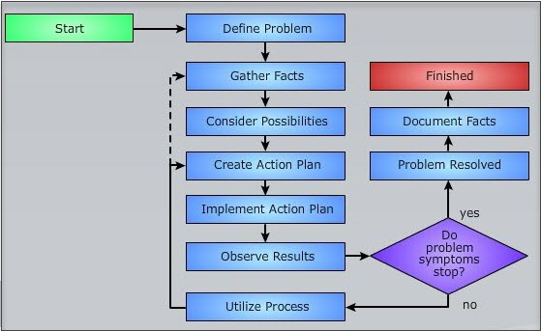

## Identify the problem:

## The first step in this troubleshooting process is to collect as much information as possible about the problem.

## We need to get details about what people may be seeing. It may be useful to get screenshots of the error occurring or a list of area messages that are provided to the user.

## Sometimes these problems are associated with a single symptom.

## They can sometimes tell you more over the telephone about the issue than you would have ever received in an email.

## It might also be good to look at your records to see if anything may have changed in the environment from the time that this was working until the time that this problem was reported. There may have been patches or changes to the application. And all of these problems may have occurred after those patches were put in place.

## It may seem that there is a lot to take in during this information gathering process. And in some cases, there certainly is. But if you break all of this down into smaller pieces and approach each symptom as its own individual problem, you’ll have a better method of stepping through each one of these issues and resolving all of the problems.

## take backups of everything that you have.

## It might also be good to look at documentation from the change control board to see what may have changed in the environment that the users may not know about. A single change to a router or a firewall could have a dramatic effect on how an application might perform. the application or the operating system itself may have a set of log files that might give you a little bit more insight into the problems that are occurring for this user.

## Establish a theory:

## it’s time to start theorizing on what the root cause might be of this issue. We should start looking at the most obvious causes.

## We might want to make a list of what all the possible causes might be. We might put the more obvious causes at the top of the list, and then put the more unusual root causes lower in that list. This will give us a starting point when we want to test our theories to see which one of these may be the root cause of the issue.

## Test the theory:

## We can now test our theory to see if we found a problem or not. If we look at the top of our list, it may say, check the power cord.

## Create the plan of action:

## So now, how do we implement that troubleshooting step in the actual production environment? To be able to do that, we’ll need a plan that not only incorporates the change that we want to make, but also allows us to revert back if we run into any problems.

## We might want to look at documentation from the operating system vendor or the application vendor to see what their suggestions might be for implementing this particular fix. And once we have information from them, we can create our own plan for implementing that fix in our production environment. Of course, we’ll not only need that plan A that steps through the primary fix, but we might also need alternate plans if we happen to run into problems during the implementation.

## Of course, there should always be a rollback as well. So if you go through these plans and in the middle of the implementation, something completely unexpected happens, you can roll everything back to the original configuration.

## Implement the plane:

* And we take all of our plans that we’ve created and we implement that change on our environment. Usually th
* at change control window gives us a certain amount of time that we can be down. And we want to be sure to have everything completed in that change control window.
* If it’s a very small window, we may have limited time. So we may need to pull in additional resources to help perform multiple functions simultaneously.

## Verify full system functionality:

## Once the fix has been implemented, we still don’t know if it’s actually fixed the problem. And the only way to tell is by performing some tests. Usually there are a set of tests that you’ve defined prior to making this change that would allow you to test the environment, confirm that it’s still working, and confirm that the original problem was resolved. This might also be a good opportunity to implement some preventative measures so that this particular problem does not occur in the future.

## Document Finding:

## after all of this is over, we have to be sure that we document everything that we did, not only because we need some way to confirm the changes we made, but later on if we run into this problem again, we’ll have some documentation that will tell us how we resolved it last time.

## This documentation might list the symptoms the users were having, it might list out all of the changes we made to resolve those issues, and explain what the results were after implementing those changes. Most environments will have help desk software or knowledge-based software that’s perfect for adding this documentation so that everyone will have access to this data.

# Troubleshooting the hardware:

* **This power-on self-test or POST** is designed to make sure that all of the main components of your system are available. So it will check to make sure that the CPU is active, that video is working properly, that your keyboard is operating, and that there’s memory installed in the system.
* If you start your computer and you get a **blank screen** with nothing else on the display, then you’ll want to listen to hear what those beeps are telling you. And those beep codes may tell you that you **have a bad video adapter**, maybe the **memory is not installed** in your system or it’s not working properly, **or there’s no CPU or the** CPU inside of the system has some type of fault. This could also be associated with **a bad BIOS configuration**. So you want to listen to those beep codes to know exactly which direction you should go to help troubleshoot this particular problem.
* while you’re booting your system is that **the date and time is either incorrect** or has been reset. The way that it’s able to maintain this date and time, even when you’ve unplugged your system, is through **the use of a battery that’s installed on your motherboard**. And if that **battery has gone bad or all of the voltage has been depleted**, then the system will not have any idea what the date and time might be.
* It might also be the case that you’ve **left a USB drive plugged** in and the USB drive attempts to boot prior to the primary storage drive. In that case, you would simply need to remove the USB drive, restart your computer, and it will begin to boot from the normal boot drive. This is **a Windows stop error or what we commonly call a blue screen of death**. And it’s telling us that something fatal has occurred. And you’ll need to restart your system to get things back up and running.
* **This blue screen gives you information on why this particular error** may have occurred. But you’ll have to restart your system to get your operating system running again. If this blue screen goes by very quickly and your system restarts, you can still go to the Windows Event. Viewer to see all of the information associated with this Windows stop error.
* **a screen that stays black**. There’s nothing on the screen, no writing, no messages, and no feedback as to where the problem may be occurring. When we first see a problem like this, one of the first things you should **check is all of the cabling**. Do we have a power cable plugged into the back of the monitor? And is it properly connected to the video output of your computer? This is probably the majority of issues that you will have with the black monitor. Because either one of those **cables being disconnected** will cause the screen to be completely black.
* **check the input option on the front of the monitor**.  You might connect to this **monitor over an HDMI connection, a DVI connection. a DisplayPort connection**. There might be a **VGA interface. And any one of those can provide video signal for the monitor**. But if you’ve not told the monitor which one of those interfaces is in use, the monitor will simply stay black.