**Robust model evaluation** is a crucial aspect of machine learning and data science. It involves assessing the performance and generalization capabilities of a model under various conditions to ensure its reliability and suitability for real-world deployment. The goal is to obtain a comprehensive understanding of how well the model performs across different scenarios and data distributions. Here are some essential practices for robust model evaluation:

1. Cross-validation: Use cross-validation techniques like k-fold or stratified cross-validation to assess the model's performance on multiple subsets of the data. This helps in reducing the risk of overfitting and provides a more robust estimate of the model's performance.
2. Train-test split: Divide the dataset into training and testing sets, ensuring that the data in the test set is representative of the data the model will encounter in the real world. It is important to avoid data leakage and maintain independence between the two sets.
3. Out-of-distribution evaluation: Test the model on data that is different from the training distribution. This is particularly important to check the model's performance on unexpected inputs that might not be present in the training data.
4. Adversarial testing: Assess the model's robustness against adversarial examples, which are intentionally perturbed inputs designed to fool the model. This helps in understanding the model's vulnerability to potential attacks.
5. Performance metrics: Choose appropriate evaluation metrics that align with the problem's objectives. For example, accuracy, precision, recall, F1-score, area under the receiver operating characteristic curve (AUC-ROC), etc.
6. Confidence intervals: Report the uncertainty in the evaluation metrics by calculating confidence intervals. This provides a more nuanced understanding of the model's performance variability.
7. Hyperparameter tuning: Perform robust hyperparameter optimization to ensure the model's stability and generalization across different parameter settings.
8. Data preprocessing and cleaning: Pay close attention to data preprocessing steps, as they can significantly impact the model's performance. Proper data cleaning and normalization are essential for robust model evaluation.
9. Bias and fairness assessment: Evaluate the model for potential biases and fairness concerns to ensure equitable performance across different demographic groups.
10. Ensemble methods: Utilize ensemble methods such as bagging or boosting to combine multiple models' predictions and improve robustness.
11. Time stability: For time-series data, assess the model's performance over different time periods to ensure its consistency over time.
12. Model comparison: Compare the performance of different models on the same evaluation metrics to select the most robust and suitable model.

By following these practices, you can gain a deeper understanding of your model's strengths and weaknesses, making informed decisions about its deployment and potential improvements. Remember that robust evaluation is an ongoing process that requires continuous monitoring and adaptation as the model and data change over time.

**An instance-based estimator**, also known as an instance-based learning algorithm or lazy learning algorithm, is a type of machine learning method that makes predictions based on the similarity between new instances and the instances in the training dataset. Unlike traditional model-based algorithms, instance-based estimators do not explicitly learn a global model from the training data. Instead, they memorize or store the entire training dataset and use it for prediction when new data points need to be classified or regressed.

The two main types of instance-based estimators are:

1. K-Nearest Neighbors (KNN): KNN is one of the most popular instance-based learning algorithms. Given a new data point, KNN searches for the "k" closest data points (neighbors) in the training dataset based on a distance metric (e.g., Euclidean distance or Manhattan distance). The class or value of the new instance is then determined by majority voting (for classification) or averaging (for regression) the labels or values of its k-nearest neighbors.
2. Locally Weighted Regression (LWR): LWR is an instance-based regression algorithm. For each new data point, LWR assigns different weights to the training data points based on their distance from the new instance. The weights are used to compute a weighted average of the target values of the neighboring training data points, and this average becomes the prediction for the new instance.

Instance-based estimators have several advantages and limitations:

Advantages:

* They can handle complex decision boundaries and non-linear relationships in the data.
* No explicit training phase is required, making the training process very fast.
* They can adapt to changes in the data distribution without retraining the model.

Limitations:

* They can be computationally expensive during prediction, especially when dealing with large datasets.
* The storage of the entire training dataset can be memory-intensive for large datasets.
* Instance-based methods may suffer from the curse of dimensionality when the feature space becomes very high-dimensional.

Due to their simplicity and effectiveness in certain situations, instance-based estimators are widely used for classification and regression tasks, especially when the size of the training dataset is not prohibitively large. However, they may not always be the best choice for extremely large datasets or when computational efficiency is a primary concern.

**Model validation** is a critical step in the machine learning workflow that involves assessing the performance and generalization ability of a trained model. The main goal of model validation is to ensure that the model performs well on unseen data and can make accurate predictions on new instances. The validation process helps to identify potential issues such as overfitting or underfitting, and it allows you to make informed decisions about the model's suitability for deployment.

The model validation process typically involves the following steps:

1. **Train-Test Split**: The original dataset is divided into two subsets: a training set and a testing (or validation) set. The training set is used to train the model, while the testing set is used to evaluate its performance.
2. **Model Training**: The model is trained on the training set using an appropriate algorithm and optimization process. The objective is to find the model parameters that best fit the training data.
3. **Model Evaluation**: Once the model is trained, it is evaluated on the testing set. The evaluation metrics used depend on the nature of the problem (e.g., accuracy, precision, recall, F1-score for classification; mean squared error, mean absolute error for regression, etc.).
4. **Performance Analysis**: Analyze the model's performance on the testing set. If the model exhibits good performance and generalization on unseen data, it can be considered a successful model. Otherwise, further investigation is needed to understand the model's weaknesses and potential areas of improvement.
5. **Hyper parameter Tuning**: In some cases, model performance can be enhanced by tuning hyper parameters (parameters that are not learned during training but are set before the training process). Techniques like cross-validation or grid search can be used to find the best combination of hyper parameters.
6. **Validation Strategies**: Depending on the dataset size and characteristics, different validation strategies can be used, such as k-fold cross-validation, stratified sampling, or time-based splitting for time series data.
7. **Out-of-Sample Testing**: For an extra level of validation, the model should be tested on entirely unseen data not used during training or tuning. This could be a separate dataset collected for this purpose or data from future time periods for time-series data.
8. **Final Model Selection**: After model validation and hyper parameter tuning, select the best-performing model for deployment based on the evaluation results.

Remember that the validation process is an iterative one, and you may need to repeat steps 3 to 7 several times to achieve the desired model performance. Additionally, be cautious about overfitting to the validation set during hyperparameter tuning, as this can lead to unrealistic expectations of the model's performance on truly unseen data.

**Hyperparameter tuning,** also known as hyperparameter optimization, is the process of finding the best combination of hyperparameters for a machine learning model to achieve optimal performance. Hyperparameters are parameters that are set before the model training process begins and are not learned from the data like model parameters. These hyperparameters significantly influence the model's behavior and can impact its performance and generalization ability.

Examples of hyperparameters include learning rate, regularization strength, the number of hidden layers in a neural network, the number of trees in a random forest, the number of neighbors in K-nearest neighbors (KNN), etc.

The goal of hyperparameter tuning is to find the hyperparameter values that maximize the model's performance on unseen data, usually measured using a chosen evaluation metric (e.g., accuracy, F1-score, mean squared error, etc.).

There are several approaches to hyperparameter tuning:

1. **Grid Search**: In grid search, you define a set of possible values for each hyperparameter, and the algorithm exhaustively tries all combinations of hyperparameters to find the best one based on the validation performance.
2. **Random Search**: Random search randomly samples hyperparameters from predefined ranges. This approach is more efficient than grid search when the search space is large.
3. **Bayesian Optimization**: Bayesian optimization is a probabilistic model-based optimization technique. It models the unknown function (validation performance) and updates its belief with each evaluation of hyperparameters to efficiently find the optimal set.
4. **Genetic Algorithms**: Genetic algorithms are inspired by the process of natural selection. They maintain a population of candidate hyperparameter sets and evolve them over generations based on their fitness (validation performance).
5. **Sequential Model-Based Optimization (SMBO)**: SMBO uses a surrogate model to approximate the validation performance function. It selects new hyperparameter to evaluate based on the surrogate model's predictions and updates the model with new data.
6. **Gradient-based Optimization**: In some cases, hyperparameters can be optimized using gradient-based optimization methods, similar to how model parameters are optimized during training. This approach requires hyperparameters to be differentiable.

It's essential to perform hyperparameter tuning using a separate validation set or using cross-validation to avoid overfitting to the test set. This means that the model's performance during hyperparameter tuning should be based on data that the model has not seen during training.

Hyperparameter tuning is an essential part of the machine learning pipeline to achieve the best model performance and generalization on unseen data. Automated tools and libraries, such as GridSearchCV and RandomizedSearchCV in scikit-learn, can be used to facilitate the hyperparameter tuning process and efficiently explore the hyperparameter space.

**"LeaveOneOut" (LOO):** Itis a cross-validation technique commonly used for model evaluation, particularly when dealing with small datasets. It is an extension of the k-fold cross-validation, where the number of folds is equal to the number of samples in the dataset.

In "LeaveOneOut" cross-validation:

1. For each data point in the dataset, the model is trained on all the other data points except that specific data point.
2. The model's performance is then evaluated on the single data point that was left out during training.
3. This process is repeated for all data points in the dataset, and the evaluation results are collected.

The benefits of LeaveOneOut cross-validation are that it maximizes the use of data for training, and each data point gets an opportunity to be in the test set. As a result, it can give a less biased estimate of the model's performance compared to other cross-validation techniques. However, it also has some drawbacks:

1. Computationally Expensive: "LeaveOneOut" can be computationally expensive, especially for large datasets, as it requires training and evaluating the model for each data point separately.
2. Variance in Results: Since each iteration uses a slightly different subset of the data for training, the evaluation results can have higher variance compared to other cross-validation methods.
3. Potential Overfitting: In some cases, "LeaveOneOut" may lead to overfitting, as the model is trained on almost the entire dataset in each iteration, and it might not generalize well to unseen data.

As a result of these drawbacks, "LeaveOneOut" is often used when the dataset is small or when you want to get the most accurate estimate of the model's performance. For larger datasets, k-fold cross-validation or other techniques like stratified sampling may be preferred due to their lower computational cost and reduced variance in the results.

Top of Form

**The bias-variance trade-off**: It is a fundamental concept in machine learning that addresses the trade-off between two types of errors a model can make: bias and variance. It is crucial to strike the right balance between these two errors to build a model that performs well on both training data and unseen data.

1. **Bias**: Bias refers to the error introduced by approximating a real-world problem with a simplified model. It occurs when a model is unable to capture the underlying patterns in the data, resulting in significant underfitting. A model with high bias typically has poor performance on both the training data and unseen data.
2. **Variance**: Variance refers to the error caused by the model's sensitivity to fluctuations in the training data. It occurs when a model is too complex or overfits the training data. An overfitted model performs well on the training data but poorly on unseen data due to its inability to generalize.

**Understanding the bias-variance trade-off:**

* A model with high bias and low variance is likely to underfit the data. It will have poor performance on both the training data and unseen data.
* A model with low bias and high variance is likely to overfit the data. It will have excellent performance on the training data but perform poorly on unseen data.
* The goal is to find a model with an optimal balance between bias and variance, where the model can generalize well to unseen data while still capturing the important patterns in the training data.

Managing the bias-variance trade-off:

* **Model Complexity**: As a general rule, increasing model complexity (e.g., adding more layers to a neural network) reduces bias but increases variance. Decreasing model complexity reduces variance but may increase bias. It is essential to find the right level of complexity that balances the trade-off.
* **Regularization**: Regularization techniques like L1 or L2 regularization can help reduce variance by adding a penalty to overly complex models.
* **Ensemble Methods**: Ensemble methods like bagging (e.g., Random Forest) and boosting (e.g., Gradient Boosting Machines) combine multiple models to reduce variance and improve generalization.
* **Cross-Validation**: Properly using cross-validation techniques helps in estimating both bias and variance and helps in selecting a model that generalizes well to unseen data.

In summary, the bias-variance trade-off is a critical concept to understand when developing machine learning models. By managing the trade-off effectively, you can build models that perform well on both the training data and unseen data, leading to more robust and reliable predictions.

The R-squared (𝑅²) score

* The R-squared (𝑅²) score, also known as the coefficient of determination, is a statistical measure that represents the proportion of the variance in the dependent variable (target) that is predictable from the independent variables (features) in a regression model. It quantifies how well the regression model fits the observed data.
* The 𝑅² score ranges from 0 to 1:
* 𝑅² = 0 indicates that the model explains none of the variance in the target variable, and the model's predictions are no better than the mean of the target variable.
* 𝑅² = 1 indicates that the model perfectly fits the data, and all variance in the target variable is explained by the model. This is rare and often implies overfitting.
* 0 < 𝑅² < 1 indicates the proportion of variance in the target variable that is explained by the model. A higher 𝑅² score indicates that the model is better at explaining the variance in the target variable.
* For high-bias models, the performance of the model on the validation set is similar to the performance on the training set.
* For high-variance models, the performance of the model on the validation set is far worse than the performance on the training set.
* Mathematically, the 𝑅² score is calculated as:
* 𝑅² = 1 - (Sum of Squared Residuals / Total Sum of Squares)
* Where:
* 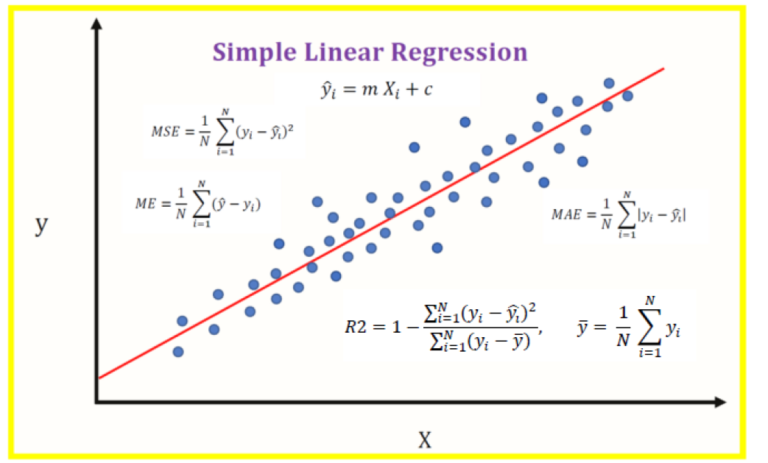
* Sum of Squared Residuals (SSR) is the sum of the squared differences between the predicted values and the actual values of the target variable.
* Total Sum of Squares (SST) is the sum of the squared differences between the actual values of the target variable and the mean of the target variable.
* In general, a higher 𝑅² score is desirable, indicating a better fit of the regression model to the data. However, it is essential to interpret the 𝑅² score in the context of the specific problem and consider other evaluation metrics and visualizations to gain a comprehensive understanding of the model's performance.
* **MSE (Mean Square Error)**: Uses Euclidean distance to calculate the error. MSE gives the magnitude of the error only.
* **MAE (Mean Absolute Error)**: Uses Manhattan distance to calculate the error. MAE (like MSE) gives the magnitude of the error only.
* **ME (Mean Error)**: keeps track of the sign of error, is model over-predicting or under-predicting?
* **R2 Score**

Where *R2 Score*is between 0 and 1, the closer to 1, the better the regression fit.

**A validation curve**

* A validation curve, also known as a performance curve or hyperparameter curve, is a graphical representation of how the performance metric of a machine learning model changes with different values of a hyperparameter. It is a useful tool for hyperparameter tuning and model selection.
* The validation curve is typically plotted by varying one specific hyperparameter while keeping all other hyperparameters constant. The model's performance is then evaluated using a chosen evaluation metric (e.g., accuracy, F1-score, mean squared error) on both the training set and the validation set for each hyperparameter value. The resulting curve shows how the model's performance changes as the hyperparameter value changes.

The validation curve helps in understanding:

* **Overfitting and Underfitting**: By observing how the training and validation performance change with different hyperparameter values, you can identify whether the model is underfitting (both training and validation performance are low) or overfitting (training performance is high, but validation performance is low).
* **Optimal Hyperparameter Value**: The curve allows you to identify the hyperparameter value that leads to the best generalization performance on unseen data. The optimal value is usually the one that results in the highest validation performance.
* **Sensitivity of the Model to the Hyperparameter**: The curve provides insights into how sensitive the model's performance is to changes in the hyperparameter value. A steep slope on the curve indicates high sensitivity, while a flatter slope indicates low sensitivity.
* A learning curve is a graphical representation of how a machine learning model's performance (e.g., accuracy, error, or any other evaluation metric) changes as the size of the training dataset increases. It is a valuable tool for understanding how a model's performance improves or plateaus with more training data.

**The learning curve**

* The learning curve is typically plotted by varying the size of the training dataset and evaluating the model's performance on both the training set and the validation set (or a separate test set) for each training dataset size. The resulting curve shows how the model's performance changes as it is exposed to more training data.

**Grid Search** uses a different combination of all the specified hyperparameters and their values and calculates the performance for each combination and selects the best value for the hyperparameters. This makes the processing time-consuming and expensive based on the number of hyperparameters involved. Top of Form