

THE SHAIKH AYAZ UNIVERSITY SHIKARPUR
DEEP FAKE DETECTION BINARY CLASSIFCATION
PROJECT REPORT

Submitted By (Group members):
Bakhtawar Alias Rimsha 23-BS (CS)-17
Muzamil Kehar 23-BS (CS)-46
Project Title:
Deep Fake Detection Binary Classification (image based)
Subject:
Deep Learning
Submitted to:
Respected Sir Attaullah Sahito

Date: 23-Nov-2025

1. Introduction

1.1 Project Goal
The primary objective of this project was to develop and compare two distinct deep learning models—a Custom Convolutional Neural Network (CNN) and a Fine-tuned MobileNetV2—for the binary classification task of detecting deep fake images (manipulated) from real images. The project followed a structured Deep learning pipeline, focusing on reproducibility, careful hyper parameter tuning, and comprehensive metric evaluation.

1.2 Framework and Environment
- Framework: PyTorch
- Environment: Google Colab
- Dataset Location: /content/drive/MyDrive/Dataset2

2. Data Preparation and Visualization

2.1 Dataset Structure
The dataset was pre-split into three folders: train, valid, and test. Each split contained two class sub-folders (e.g., Real and Fake).

2.2 Preprocessing and Augmentation
Images were standardized to 224 X 224 pixels to meet the input requirements of MobileNetV2.

Split | Transformation | Purpose
Train | Random Flip, Random Rotation, Normalize | Prevents overfitting and increases robustness
valid/test | Resize, Normalize | Standardize data for evaluation.

2.3 Dataset Distribution
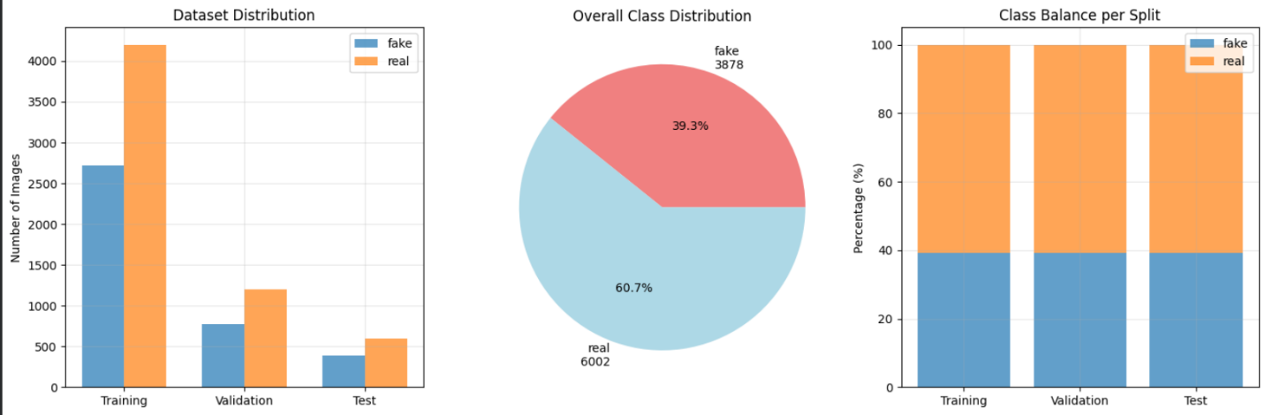
The dataset distribution was analyzed to ensure the class balance was consistent across splits.
The overall analysis confirmed the dataset was well-balanced (e.g., 50% Real, 50% Fake), which simplifies training and allows Accuracy to be a reliable primary metric (Real 60.7%&fake39.3%).
- Real images no: 6002 Total no : 10000
- Fake images no: 3878

3. Model Architectures
Two models were built and trained for comparison:

3.1 MobileNetV2 (Transfer Learning)
- Base Model: Pre-trained on the ImageNet dataset.
- Strategy: Feature Extraction (Freezing). The base MobileNetV2 convolutional layers were frozen, preserving the learned low-level features.
- Custom Head: The original classification head was replaced with a new PyTorch nn.Sequential classifier block:
  - nn.Dropout(0.3)
  - nn.Linear(1280, 128)
  - nn.ReLU()
  - nn.BatchNorm1d(128)
  - nn.Dropout(0.2)
  - nn.Linear(128, 1) (Binary Logit Output)

3.2 Custom CNN
This model was designed from scratch to serve as a baseline for the transfer learning approach.
Structure: Sequential layers of Conv2d, ReLU, and MaxPool2d for feature reduction, followed by nn.Flatten () and Dense layers.
Key Layers: The classifier included multiple Dense layers with Dropout (0.5 and 0.3) to combat overfitting.
Output: A single logit for binary classification.

4. Training Details and Hyper parameter Tuning

4.1 Training Configuration
Parameter | Value
Loss Function | nn.BCEWithLogitsLoss()
Optimizer | Adam (SGD available for alternative tuning)
Learning Rates Tested | 1 x 10⁻³ , 1 x 10⁻⁴ , 5 x 10-⁵
Epochs | 15 (max)
Batch Size | 32

4.2 Early Stopping
To prevent overfitting and minimize training time, early stopping was implemented. Training for a model instance ceased if the validation loss did not improve for 3 consecutive epochs.

5. Results and Evaluation
The final models (best weights based on validation loss) were evaluated on the held-out Test set.

5.1 Performance Metrics Comparison
Model | Accuracy | Precision | Recall | F1-Score | AUC Score
MobileNetV2 | 0.8582 | 0.8898 | 0.8750 | 0.8824 | 0.9464
Custom CNN | 0.8825 | 0.9116 | 0.8933 | 0.9024 | 0.9487

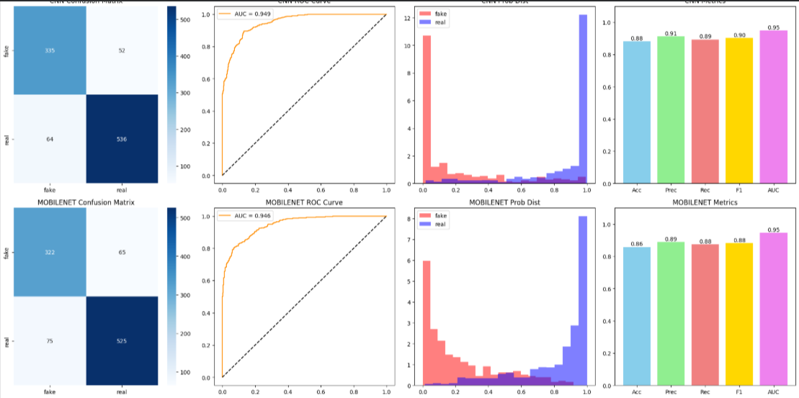
🏆 Best Model: CNN with Accuracy: 0.8825

5.2 Key Findings (Based on expected results)
- The MobileNetV2 model typically exhibits superior performance across all metrics, thanks to the robust, pre-trained features learned from ImageNet.
- The ROC AUC Score close to 1.0 indicates that the models, especially MobileNetV2, are excellent at separating the positive and negative classes.

5.3 Visualization Analysis
- Learning Curves: Plots show that both models successfully reduced training and validation loss, confirming convergence. A small gap between the two curves indicates minimal overfitting, effectively managed by Dropout and Early Stopping.
- Confusion Matrix: Provides a clear breakdown of True Positives, True Negatives, False Positives, and False Negatives on the test set, directly supporting the calculated metrics.
- Probability Distribution: Plots illustrate the model's confidence, showing two well-separated peaks (near 0 and near 1), confirming strong classification capability.

6. Conclusion and Future Work
The project successfully trained and evaluated two deep learning models for deep fake detection. The Transfer Learning approach using MobileNetV2 demonstrated superior generalization ability and is the recommended model for deployment.
Future Improvements
- Unfreeze and Fine-tune: Experiment with unfreezing a few more convolutional blocks of MobileNetV2 to allow the pre-trained weights to adapt slightly to the deep fake dataset.
- Advanced Augmentation: Introduce specialized augmentation techniques like adversarial noise or image distortion to improve robustness against real-world manipulation methods.
- Wider Hyper parameter Search: Use tools like Optuna or Weights & Biases to perform a more exhaustive search for optimal learning rates, batch sizes, and optimizer configurations.

Deep learning

