NAME: Bakhtawar Munir
CLASS: BSCS-E
CMS-ID: 588984

CS-117: Introduction to ICT

Lab 04 - Technical Document Preparation with LaTeX
Student Copy

Duration | 3 Hours | Primary environments | Overleaf + Local LaTeX
Source material | Lab 03 survey/report | Final product | 2-3 page LaTeX report + PDF

What You Will Learn
In Lab 03, you prepared a technical report using productivity tools. In this lab, you will create a technical report differently: you will write LaTeX source that describes the structure of the document, then compile it into a PDF.
Workflow: Source -> Compile -> Inspect -> Modify -> Structure -> Reference -> Cite -> Produce.

Final Product
Your group will convert and extend its Lab 03 work into a 2-3 page LaTeX technical report containing:
  - title and author/group information
  - sections and subsection(s)
  - paragraph text and at least one list
  - one table
  - one figure
  - captions and meaningful labels
  - cross-references to the table and figure
  - one equation and equation reference
  - 4-5 legitimate references
  - in-text citations
  - automatically generated bibliography
  - final PDF compiled in Overleaf and locally

Suggested Project Structure
Lab04_GroupXX/
|-- report.tex
|-- references.bib
|-- images/
| `-- survey_chart.png
`-- report.pdf

Starter File
\documentclass{article}

\usepackage{graphicx}
\usepackage{amsmath}

\begin{document}

% Your content goes here.

\end{document}
You will build the rest of the report during the lab rather than receiving a complete finished template.

Session Plan

Time | Activity
0:00-0:15 | Introduction to LaTeX and compilation
0:15-0:35 | Task 1 - First document
0:35-0:55 | Task 2 - Sections, text and lists
0:55-1:20 | Task 3 - Tables and figures
1:20-1:30 | Break
1:30-1:50 | Task 4 - Cross-references and equation
1:50-2:15 | Task 5 - Citations and bibliography
2:15-2:35 | Task 6 - Local LaTeX compilation
2:35-2:50 | Task 7 - Troubleshooting and comparison
2:50-3:00 | Individual exit task / viva

Task 1 - Create and Compile Your First Document
Open Overleaf, create a project and use the starter file.

Add title information
\title{Your Report Title}
\author{Group XX}
\date{\today}
Inside the document body add:
\maketitle
Compile the document and observe the editable .tex source and generated PDF. Key idea: the .tex file is your source. The PDF is compiled output.
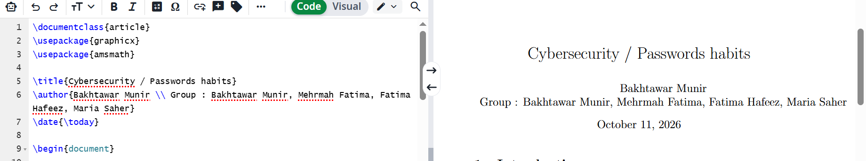

Task 2 - Structure the Report
Reuse the content from your Lab 03 report. Create sections such as:
\section{Introduction}
\section{Methodology}
\section{Results}
\subsection{Survey Response Summary}
\section{Conclusion}

Basic formatting
\textbf{important text}
\textit{emphasized text}

Create a list
\begin{itemize}
\item First item
\item Second item
\item Third item
\end{itemize}
\begin{enumerate}
\item First step
\item Second step

\item Third step
\end{enumerate}
Be prepared to create a subsection, add a list item, compile and explain the difference between .tex and PDF during a live checkpoint.
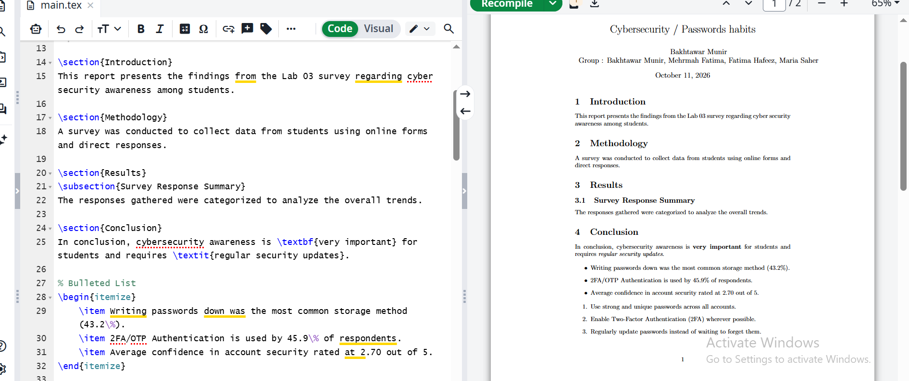

Task 3 - Add a Table
Create a table containing real results from your Lab 03 survey. Example structure:
\begin{table}[h]
\centering
\caption{Summary of Survey Responses}
\label{tab:survey-summary}
\begin{tabular}{l r}
\hline
Response & Count \\
\hline
Option A & 6 \\ Option B & 5 \\ Option C & 2 \\
\hline
\end{tabular}
\end{table}
Replace the example values with your real data. Use a meaningful label such as tab:survey-summary.
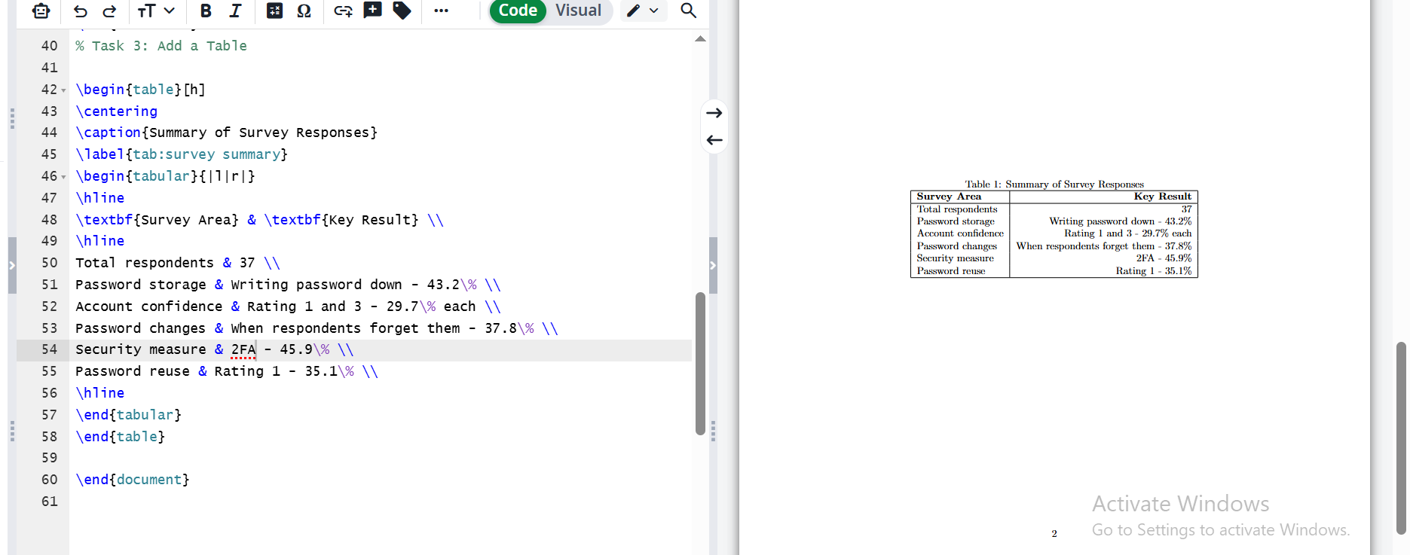

Task 4 - Add Your Lab 03 Chart as a Figure
Export your Lab 03 chart as an image and place it in the images folder. Example:
\begin{figure}[h]
\centering
\includegraphics[width=0.75\textwidth]{images/survey_chart.png}
\caption{Student Preferences for Digital Productivity Tools}
\label{fig:survey-chart}
\end{figure}
Change the caption and filename to match your actual chart. If the image file is renamed, the LaTeX path must also be updated.
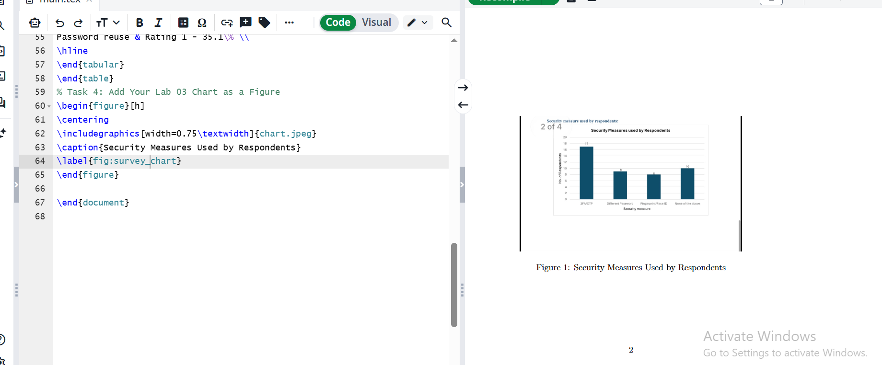

Task 5 - Cross-Reference the Table and Figure
Do not manually type “Figure 1” or “Table 1” for assessed references. Use:
Figure~\ref{fig:survey-chart}
Table~\ref{tab:survey-summary}
Write at least one meaningful sentence referencing each object. Example:
As shown in Figure~\ref{fig:survey-chart}, the most common response was ...
Why? If another figure or table is inserted earlier, LaTeX can automatically update the numbering.
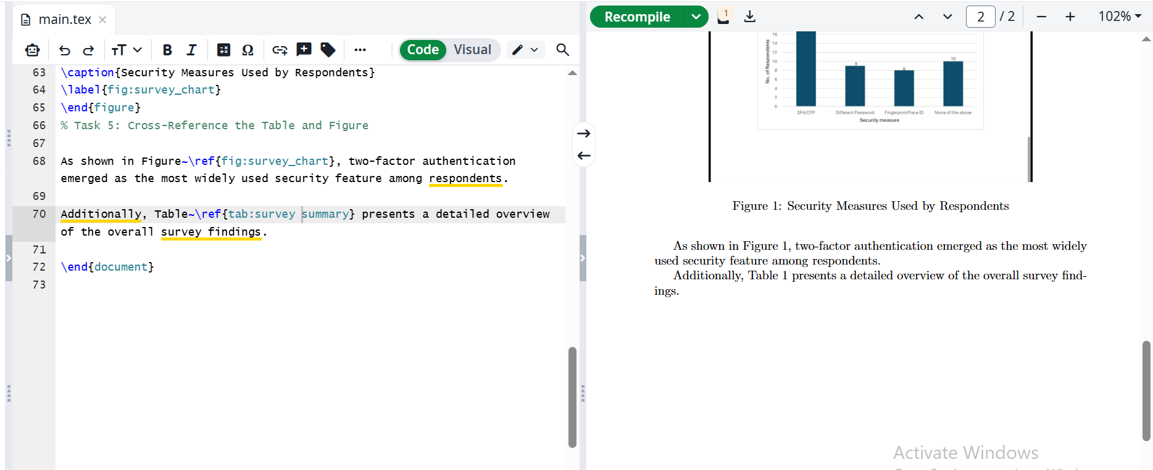

Task 6 - Add an Equation
Include a meaningful percentage equation connected to your survey:
\begin{equation} P =
\frac{\text{Number of selected responses}}
{\text{Total valid responses}}
\times 100

\label{eq:percentage}
\end{equation}
Reference it later:
Percentages were calculated using Equation~\eqref{eq:percentage}.
If a reference displays ??, first check whether the label exists and matches exactly, then compile again.
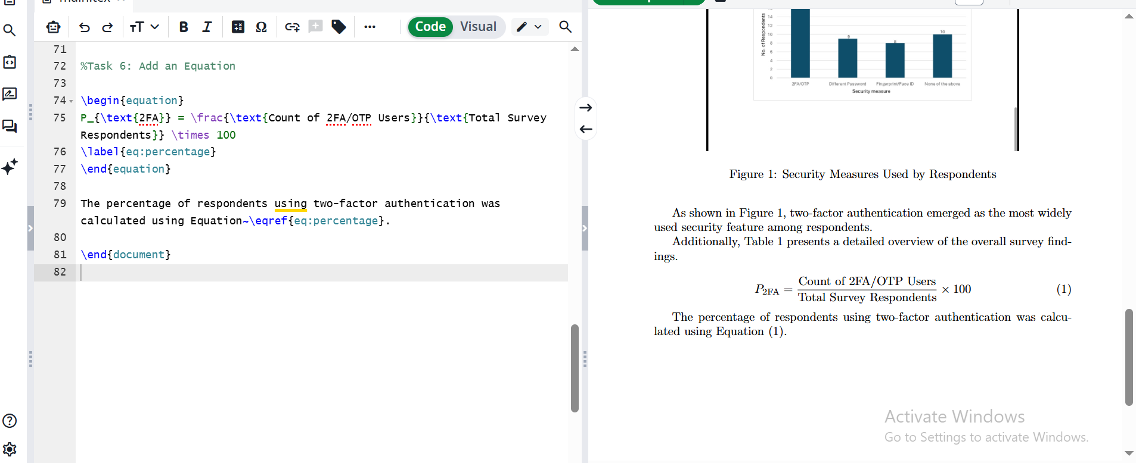

Task 7 - Create the Bibliography File
Create references.bib. Your group must include 4-5 real, traceable references relevant to the report topic. Do not invent sources.
@article{examplekey, author = {Author Name}, title = {Article Title}, journal = {Journal Name}, year = {2025}
}
This is only an example of the structure. Replace it with real source information. The citation key in this example is examplekey.
Use the key in the report:
\cite{examplekey}
Near the end of report.tex:
\bibliographystyle{plain}
\bibliography{references}
Your final report should contain 4-5 bibliography entries and appropriate in-text citations.
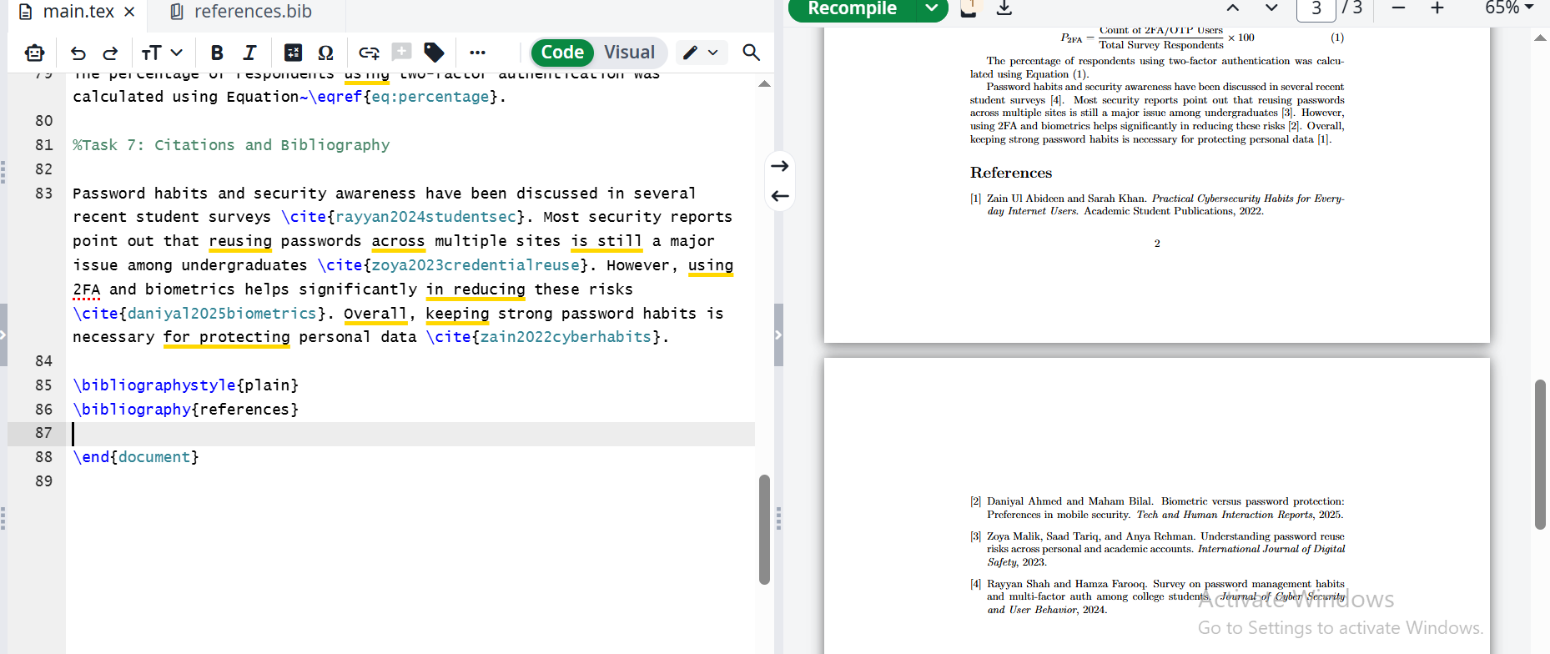

Task 8 - Download and Compile Locally
- Download/export the complete Overleaf project.
- Open/extract the project locally.
- Verify report.tex, references.bib and image assets are present.
- Open report.tex in the local LaTeX editor.
- Compile the project.
- Make one small change locally.
- Compile again and verify the change.
Record the local editor, compiler/distribution environment, change made and compilation result on your evidence sheet.
Where supported, a bibliography build may conceptually involve:
pdflatex report.tex bibtex report pdflatex report.tex
pdflatex report.tex
You do not need to memorize these commands today; understand why several processing stages may be required.

Task 9 - Troubleshooting
Use this process: Read -> Locate -> Interpret -> Correct -> Recompile.

Problem | Example | What to inspect
Missing brace | \textbf{Important result | Opening/closing braces
Misspelled command | \secton{Results} | Command spelling

Problem | Example | What to inspect
Missing image | Code requests images/chart.png but actual filename differs | Filename and relative path
Undefined reference | \ref{fig:results} has no matching label | Label spelling/existence and recompilation
Undefined citation | \cite{smith2025} key absent from .bib | Citation key and bibliography processing

Compare Lab 03 and Lab 04

Concept | Microsoft Word | LaTeX
Heading | Heading Style | \section{}
Figure | Insert Picture | figure environment
Caption | Insert Caption | \caption{}
Cross-reference | Cross-reference tool | \label{} + \ref{}
Equation | Equation editor | equation environment
Citation | Citation manager | \cite{} + .bib
References | Bibliography tool | BibTeX
Main editable file | .docx | .tex
Final output | .docx / PDF | compiled PDF
Do not assume one tool is always better. Tool choice depends on the document, task, collaboration requirements and amount of structured technical content.

Individual Exit Task
You will receive one short task and must explain what you changed. Possible tasks:
  - create a section and subsection
  - add/fix a figure caption, label and reference
  - add/fix a table label and prose reference
  - insert or repair a numbered equation and reference
  - insert a citation from an existing .bib entry
  - correct a deliberately broken LaTeX snippet

Individual Evidence Sheet
Complete evidence progressively during the lab. Record your first successful compilation, one section/subsection, figure/table/equation labels and references, one citation key, local compilation result, troubleshooting record.

Required Submission
Lab04_
|-- Evidence sheet
|-- references.bib
|-- images
|`-- report.pdf
Include every additional asset needed for your document to compile. The final PDF should not contain unresolved ?? references or missing citations.

Assessment - 10 Marks

Component | Marks
Document structure and compilation | 1.5
Sections, formatting and lists | 1.0
Table and figure construction | 1.5
Cross-referencing of figure, table and equation | 1.5
Equation typesetting | 0.5
4-5 references, citations and bibliography | 1.5
Successful Overleaf + local workflow | 0.5
Individual evidence, troubleshooting, exit task and viva | 2.0
Total | 10.0

Common Problems
PDF does not update: Check whether you compiled and whether an error stopped compilation.
Image does not appear: Check filename, extension, folder, relative path and capitalization.
Reference shows ??: Check that the label exists, spelling matches, and compile again.
Citation is missing: Check the citation key, .bib filename, bibliography commands and bibliography processing.
A command produces an error: Check the backslash, spelling, braces and environment structure.

Final Concept
Do not leave the lab thinking only “I learned some LaTeX commands.” The larger idea is that a LaTeX document is structured source content compiled into a professionally typeset document, and that figures, tables, equations, citations and references can be managed structurally instead of manually.

Analytic Evaluation Rubric - 10 Marks
Use the descriptor that best matches the demonstrated performance and award marks within the stated criterion weight. Half marks may be used where appropriate. A polished group artifact does not replace individual live competence; live demonstration/viva marks must reflect the individual student's performance.

Criterion | Weight | Excellent | Good | Satisfactory | Needs Improvement
Document structure & compilation | 1.5 | Creates a valid LaTeX document with correct preamble/body, title metadata and successful compilation; clearly explains .tex source vs generated PDF. | Document compiles and structure is mostly correct with minor syntax/organization issues. | Basic document compiles with assistance; structure understanding is partial. | Document does not reliably compile or student cannot identify/explain core LaTeX structure.
Sections, formatting & lists | 1.0 | Uses sections/subsections, paragraphs, emphasis and list environments correctly and consistently to structure Lab 03 content. | Required structures are present with minor syntax/organization issues. | Basic structure is present but inconsistent or created with substantial prompting. | Major required structures are missing or syntactically incorrect.
Table & figure construction | 1.5 | Creates a correct table and figure using appropriate environments, real Lab 03 data/chart, meaningful captions/labels and correct image path. | Table/figure are functional with minor formatting, caption, label, or path issues. | Both are present but one requires assistance or contains notable structural problems. | Table/figure are missing, fail to compile, or are not understood.
Cross-referencing | 1.5 | Correctly labels and cross-references figure, table and equation using meaningful labels and explains automatic numbering/recompilation. | Most references work correctly; minor label/reference issues remain. | Some cross-references work but student needs prompting or uses inconsistent/manual numbering. | References are missing/broken or student relies mainly on manually typed numbers.
Equation typesetting | 0.5 | Includes a meaningful numbered equation and references it correctly in the report. | Equation is correct with a minor formatting/reference issue. | Equation is present but needs assistance or is weakly integrated. | Equation is missing, incorrect, or cannot be compiled/explained.
References, citations & bibliography | 1.5 | Uses a separate .bib file with 4-5 legitimate references, correct citation keys/in-text citations and a successfully generated bibliography. | Bibliography workflow works with minor metadata/citation issues. | References are present but citation/BibTeX workflow requires substantial assistance or has unresolved issues. | References are invented/missing, .bib workflow fails, or citations cannot be explained.
Overleaf + local workflow | 0.5 | Successfully transfers project, locates all dependencies, compiles locally, makes a local edit and explains that Overleaf is an environment rather than LaTeX itself. | Local workflow succeeds with only a minor issue or limited explanation. | Local compilation succeeds only with assistance or project transfer is incomplete. | Cannot transfer/compile locally or misunderstands the relationship between Overleaf and LaTeX.
Individual evidence, troubleshooting, exit task & viva | 2.0 | Evidence is complete; student independently edits source, diagnoses a syntax/path/reference/citation issue, recompiles, and explains relevant code in own words. | Demonstrates individual competence with minor prompting and mostly correct explanations. | Completes basic task with significant prompting; troubleshooting/explanation is limited. | Cannot independently modify/troubleshoot the source or explain submitted LaTeX work.

CS-117 | Lab 04 | Analytic Evaluation Rubric | Page 7

