CS-117: Introduction to ICT

Lab 03 - Exploring Operating Systems, Hardware, Drivers, Files, Backup and Troubleshooting
NAME : Bakhtawar Munir
CLASS : BSCS (E)
CMS-ID : 588984
STUDENT COPY

Duration | 3 Hours | Primary Platform | Windows 10/11
Second OS | Ubuntu VM | Platform Balance | ~70% Windows / 30% Ubuntu
Assessment | Individual evidence + live checks | Submission | Hybrid evidence + group synthesis

Welcome
In Lab 01 you learned how to navigate files and folders, use basic PowerShell commands and observe running processes. Today we go one step deeper: instead of only asking "How do I use this computer?" we will ask "How does the operating system see and manage the computer?"
You will work with both Windows and Ubuntu Linux. You are not expected to know Linux before this lab.

Learning Outcomes
  - Identify computer hardware using operating-system tools.
  - Inspect device status and driver information in Windows.
  - Identify Windows version/build information.
  - Identify selected installed software and versions.
  - Navigate Ubuntu using its GUI and terminal.
  - Retrieve CPU, memory, storage and OS information in Ubuntu.
  - Compare Windows and Ubuntu tools.
  - Identify common file types and sizes.
  - Compress and extract files.
  - Create local and cloud backups.
  - Restore a deleted test file from Google Drive.
  - Diagnose basic computer problems using evidence.

How You Will Work
Learning cycle
Predict -> Perform -> Observe -> Explain. Complete your evidence sheet during the lab, not afterward. You may be asked to reproduce or explain any task live.

Important Safety Rules
You will inspect devices and drivers. You must not:
- uninstall, install, update or roll back drivers;
- disable devices;
- change BIOS settings or disk partitions;
- install operating-system updates;
- delete unfamiliar system files.

Before the Lab
- Confirm access to your official university Google account and Google Drive.
- Confirm you can launch and sign in to the preconfigured Ubuntu VM.
- Review Lab 01 ideas: files, folders, paths, processes, pwd, dir and cd.

Session Plan

Time | Activity
0:00-0:10 | Introduction, readiness check and evidence-sheet briefing
0:10-0:30 | Task 1 - Windows system, OS and software inspection
0:30-0:50 | Task 2 - Devices, drivers and status
0:50-1:05 | Task 3 - Windows troubleshooting case cards
1:05-1:15 | Break
1:15-1:30 | Task 4 - Ubuntu VM GUI orientation
1:30-1:55 | Task 5 - Ubuntu terminal and Windows/Linux comparison
1:55-2:15 | Task 6 - File types and compression
2:15-2:35 | Task 7 - Local + Google Drive backup and restore
2:35-2:50 | Task 8 - Integrated student-laptop scenario
2:50-3:00 | Individual exit task, viva spot checks and submission

Task 1 - Windows System and Software Inspection
Time: 20 minutes | Mode: Individual

Part A - Windows Information
Open Settings -> System -> About and record:

Item | Your Machine
Windows edition | Windows 10 Enterprise
Version | 22H2
OS build | 19045.6456
System type | 64-bit operating system , x64-based processor
Device name | DESKTOP-FGFRGM4
Now open PowerShell and run:
Systeminfo
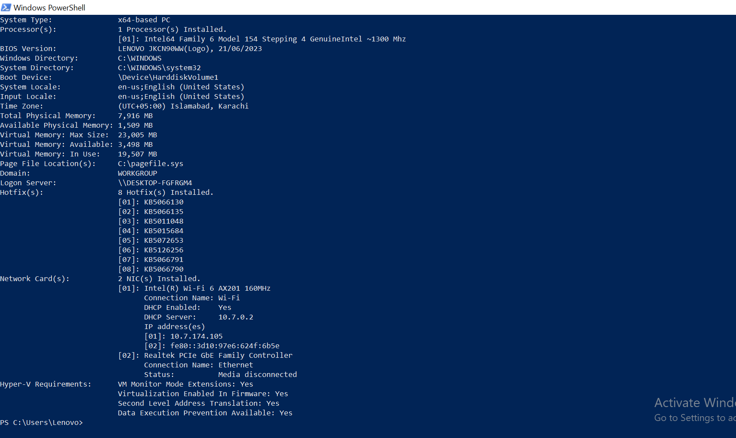
Write one piece of information that appeared in both places: DESKTOP-FGFRGM4

Part B - Windows Update Status
Open Settings -> Windows Update. Record the current status and whether updates are pending.
Updates are pending ( version of Windows has reached end of support and feature update to Windows 11 version 25H2 is available).
Do not install updates.
Why might the exact Windows version/build matter when solving a technical problem? Write 1-2 sentences.
Exact version and build numbers help determine software compatibility and identify missing security patches needed to fix specific system bugs.

Part C - Software Inventory
Open Settings -> Apps -> Installed Apps. Choose three applications.

Application | Version | Publisher | System or Application Software
3D Viewer | 7.2105.4012.0 | Microsoft Corporation | Application Software
Calculator | 10.2103.8.0 | Microsoft Corporation | Application Software
Camera | 2021.105.10.0 | Microsoft Corporation | Application Software
Be prepared to explain why you classified each one.

Task 2 - Devices and Drivers
Time: 20 minutes | Mode: Individual
A driver is software that helps the operating system communicate with a hardware device.
Mental model
Hardware -> Driver -> Operating System

Step 1 - Open Device Manager
Find a display adapter, network adapter and audio device.

Before Looking at Driver Information
Predict: Do you expect every device to use a Microsoft driver? My prediction: No because hardware manufacturers such as Intel often provide their own specialized drivers for better performance and feature support.

Step 2 - Inspect Each Device
Right-click the device -> Properties. Check General -> Device status and Driver -> Provider / Version.

Device | Status | Driver Provider | Driver Version
Display | This device is working properly | Intel Corporation | 32.0.101.6314
Network | This device is working properly | Intel | 22.200.0.6
Audio | This device is working properly | Microsoft | 10.0.19041.1
In your own words, what is the difference between the hardware device and the driver?
Hardware is a physical device component, whereas a driver is software that translates operating system commands into instructions the hardware can understand.

Task 3 - Windows Troubleshooting Cases
Time: 15 minutes | Mode: Individual first, then group discussion
Important
Work individually first. Do not immediately copy the group answer. For each case record: evidence, possible problem, what you would inspect next, what you would avoid changing, and a safe recommendation.

Case A - Device Warning
Evidence: Yellow exclamation mark icon next to a device in Device Manager.
Possible problems: Missing, outdated, or corrupted device driver.
What I would inspect next: Device Properties, Device Status error code, and Driver tab details.
What you would avoid changing : What I would avoid changing: I would avoid uninstalling or disabling the device before identifying the exact problem.
Safe recommendation: Update the driver via Device Manager or download the official driver from the manufacturer's website.

Case B - Low Free Disk Space
A laptop has almost no free space remaining. Explain what you would inspect, what kinds of files you might safely manage, and what you would avoid deleting.
What I would inspect: Storage settings, Disk Management, and large files in Downloads/Temp folders.
Safely manage: Temporary files, browser cache, system junk via Storage Disk Cleanup, and unneeded downloaded files.
Avoid deleting: Windows system files , essential program files , and critical user documents.

Case C - Corrupted ZIP File
A downloaded ZIP file gives an error when extracted. Write at least three safe troubleshooting steps.
- Re-download the ZIP file using a stable internet connection.
- Use a different extraction tool like 7-Zip or WinRAR instead of default Windows Extractor.
- Verify file integrity (check file size or MD5/SHA-256 hash checksum).

Group Discussion
After your individual answers, compare them with your group. Record one idea your group added that you did not originally consider: Using System Restore to roll back the PC to a previous working state.

Task 4 - Ubuntu GUI Orientation
Time: 15 minutes | Mode: Individual
Launch the preconfigured Ubuntu Virtual Machine. Do not open the terminal immediately. First locate: desktop, application launcher, Files, Settings and system/About information.
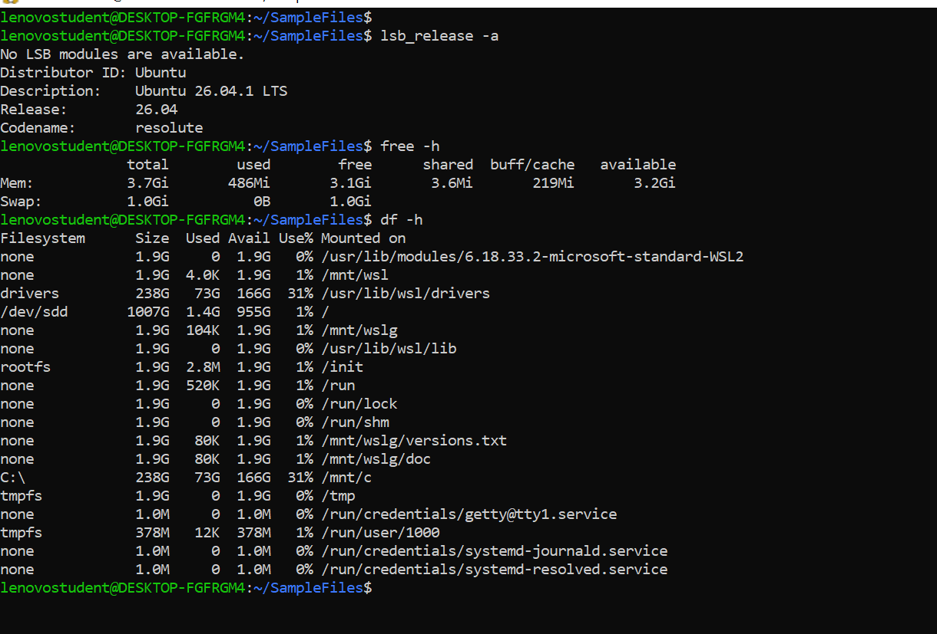
Item | Ubuntu VM
Ubuntu version | Ubuntu 26.04.1 LTS
Memory shown | 3.7 GiB
Storage shown | 1007 GB
The Ubuntu VM may report less memory or different storage than Windows. Why might this happen? Write your best explanation; deep virtualization knowledge is not expected yet.
A Virtual Machine only reports the specific portion of RAM and disk storage allocated to it by the host system rather than the full hardware capacity of the physical computer.

Task 5 - Ubuntu Terminal and Windows/Linux Comparison
Time: 25 minutes | Mode: Individual

Part A - Current Location
Before running pwd, predict what it will show.
Prediction: I expect pwd to show the current working directory, such as /home/lenovostudent.
Then run:
Pwd
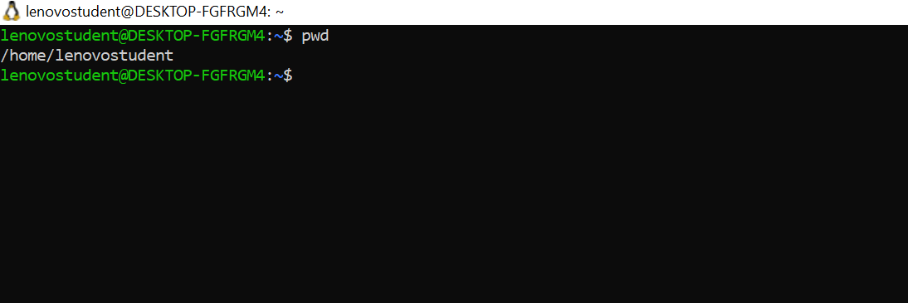

Part B - List Files
ls
Compare it with the Windows command dir.

Part C - Create a Folder
mkdir Lab02_Test ls
Confirm that the folder exists.
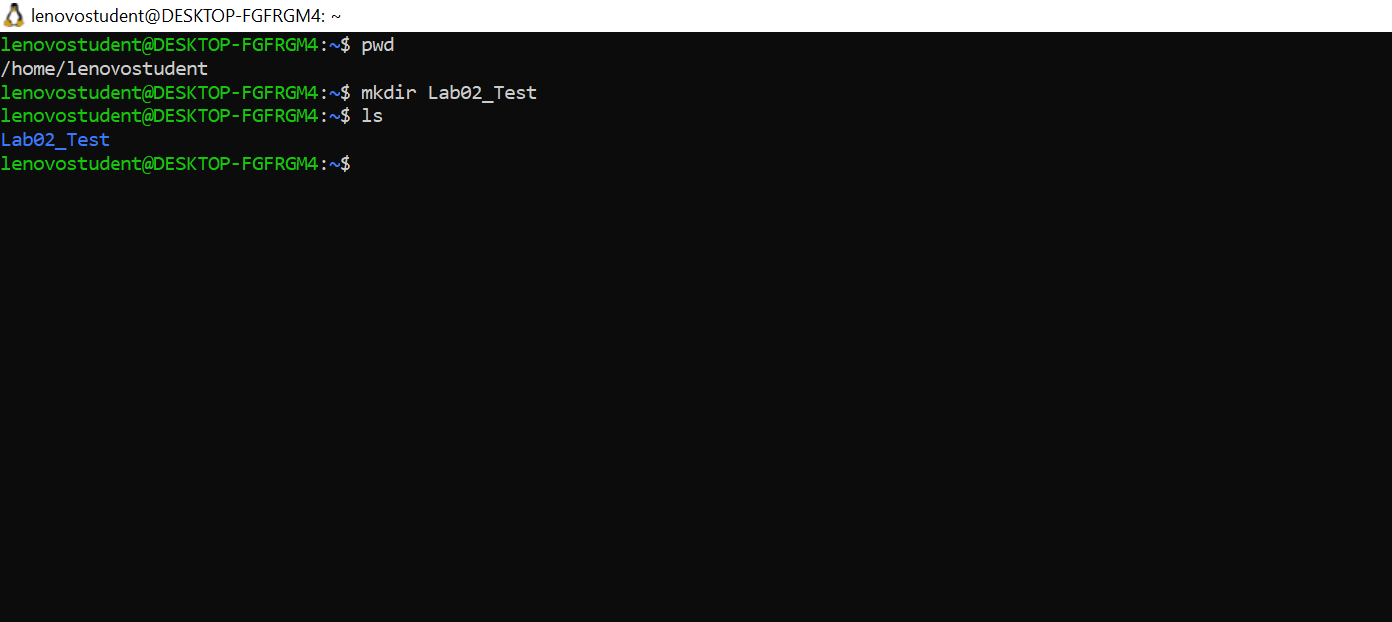

Hardware Discovery in Ubuntu
Run each command and locate the requested information:
lscpu
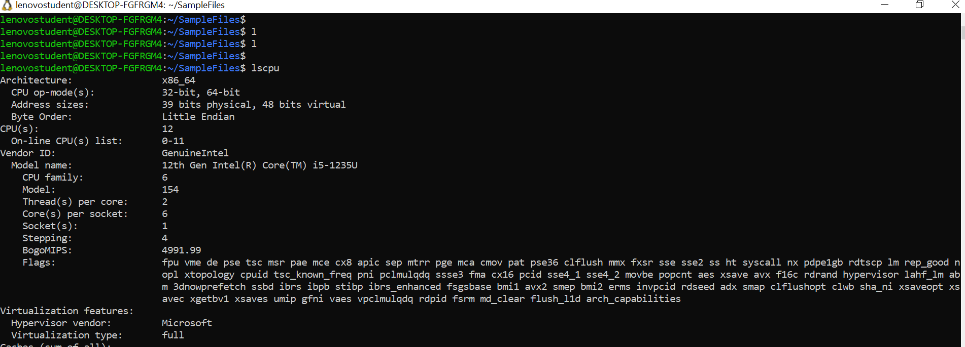
free -h
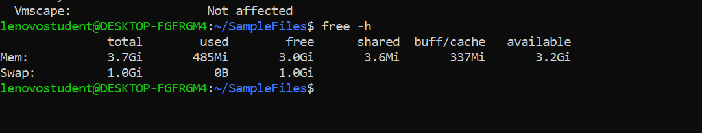
Lsblk
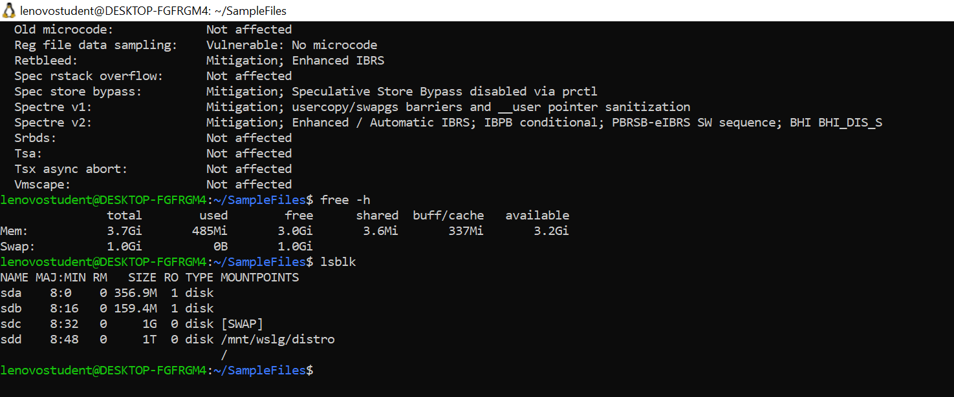
Lspci
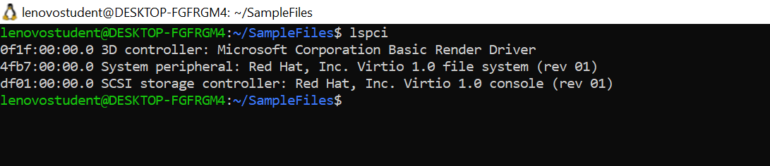
uname -a
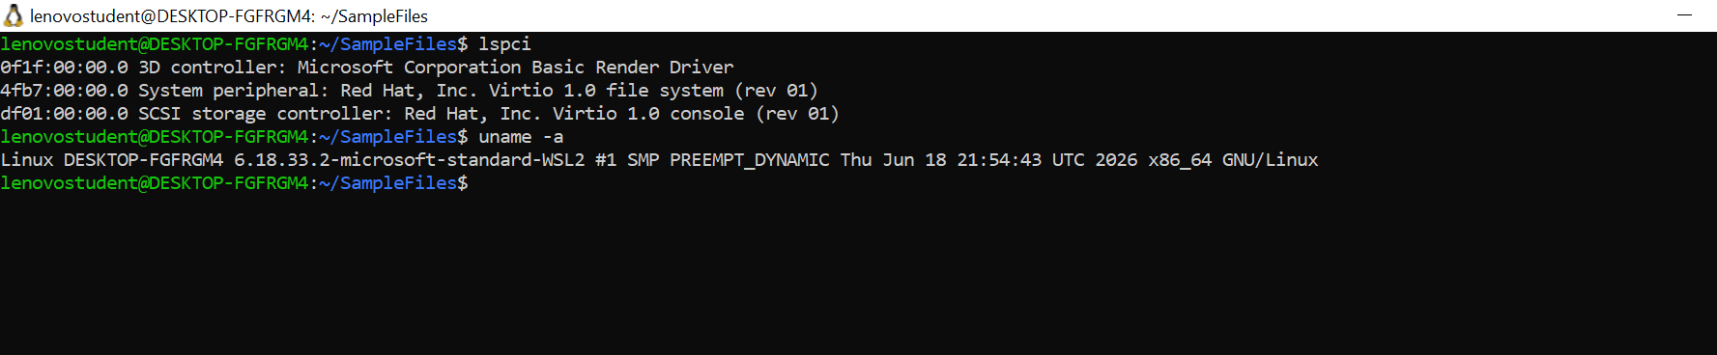
cat /etc/os-release
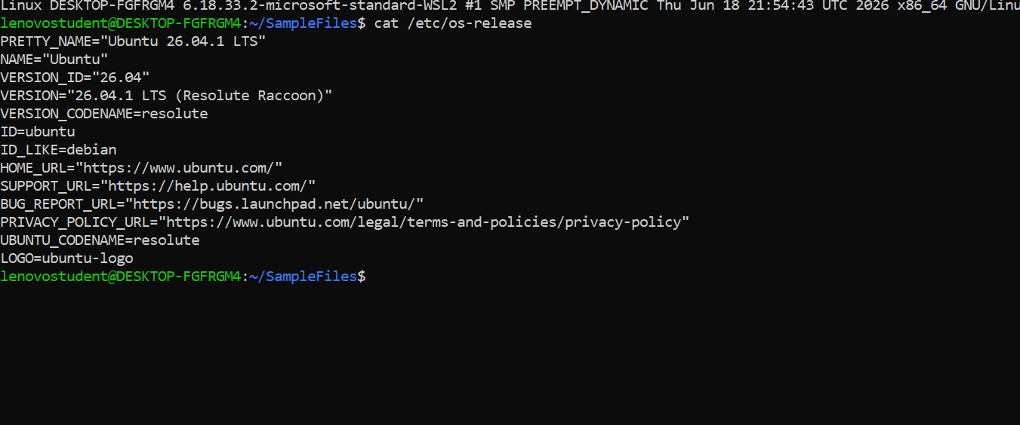
- lscpu - CPU/architecture information
- free -h - memory
- lsblk - disks/virtual disks
- lspci - device/controllers
- uname -a - kernel/system information
- cat /etc/os-release - Ubuntu release information

Windows-Ubuntu Comparison Matrix

Concept | Windows / PowerShell | Ubuntu
Current location | pwd / Get-Location | pwd
List files | dir / Get-ChildItem | ls
Create directory | mkdir | mkdir
Home location | User profile folder | /home/<user>
File-system root | Drive based, e.g. C:\ | /
CPU information | Windows tools / PowerShell | lscpu
Memory information | Task Manager / PowerShell | free -h
Storage information | Windows tools / PowerShell | lsblk
OS/kernel information | systeminfo | uname -a / /etc/os-release
Processes | Get-Process | ps

File-System Comparison
A Windows user folder may look like C:\Users\Student. An Ubuntu home directory may look like /home/student. Linux begins its hierarchy at /. What concept is similar between a Windows user folder and an Ubuntu home directory?
Answer: Both represent a user's personal directory/workspace where user-specific files, settings, and documents are stored independently from system files.

Optional Challenge
Compare host Windows CPU/RAM/storage with Ubuntu VM values. Why may the values differ?
Reason: The values differ because Ubuntu WSL/VM operates in a virtualized environment where only a subset of the host system hardware resources (CPU, RAM, and Storage) is dynamically allocated to it, while Windows Host retains full access to the complete physical hardware.

Resource | Windows Host | Ubuntu VM
CPU | Intel / AMD Multi-Core CPU (Logical Processors) | Allocated Virtual Cores (e.g., 2 to 4 Cores)
RAM | Total Physical RAM (e.g., 8 GB / 16 GB) | Assigned Virtual Memory (e.g. 2 GB / 4 GB )
Storage | Total C : Drive Disk Space (e.g., 256 GB / 512 GB) | Virtual Disk Size (e.g. 8 GB to 20 GB)

Task 6 - File Types and Compression
Time: 20 minutes | Mode: Individual
You will receive a standard set of files and must add one file of your own.

Part A - Investigate the Files

File | Extension | Size | What It Contains | Suitable Use
Document | .docx | 25 KB | Formatted text and layout | Reports , official letters
Image | .jpg | 1.5 MB | Compressed Pixel photo | Photographs , web graphics
Audio | .mp3 | 3.2 MB | Compressed audio data | Music tracks , voice notes
Plain Text | .txt | 2 KB | Raw unformatted text | Code snippets , quick notes
Presentation | .pptx | 50 KB | Slides with text and images | Presentations

File | Extension | Size | What It Contains | Suitable Use
Archive | .zip | 4.5 MB | Compressed bundle of files | Sharing multiple files via email
Custom File | .pdf | 1.2 MB | Formatted document with embedded graphics | Sharing read only files and assignments
Executable | .exe | 15 MB | Compiled application binary code | Running and installing software programs
Prediction: Which file type do you expect to compress the most? Plain Text(.txt) Why?
Because plain text is raw , unformatted and repetitive, and it is not already compressed, so ZIP can reduce it a lot.

Part B - ZIP Compression
- Create a test folder containing the sample files.
- Record its total size.
- Compress it into a .zip archive.
- Record the archive size.
- Extract the ZIP.
- Confirm the extracted files open correctly.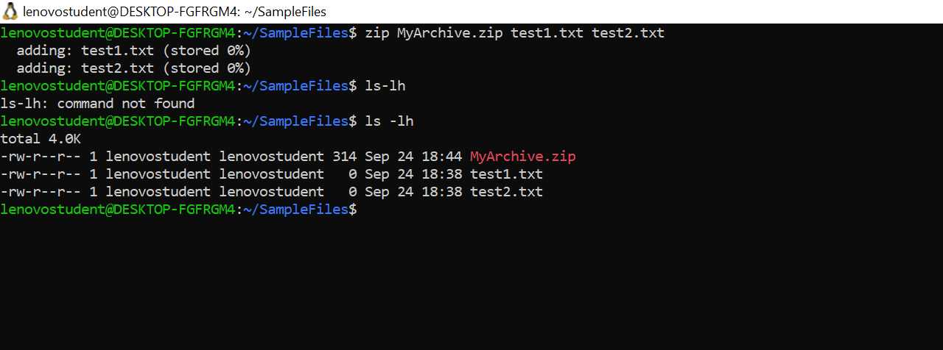

Measurement | Size
Original | 0 B
ZIP archive | 314 B
Did every file shrink equally? Why might JPG, MP3 or ZIP compress less than plain text?
Answer : No. In my test, the two .txt files were empty (0 B), so the ZIP archive (314 B) was actually larger because ZIP adds header and directory information. Compression only helps when a file has real, repetitive data. Plain text with real content compresses well, because it is raw and repetitive. JPG and MP3 are already compressed, and DOCX and ZIP files are too, so they shrink very little.
Reason: Plain text files contain uncompressed raw data with high repetition, allowing ZIP algorithms to reduce their size significantly. In contrast, media files like JPG and MP3 (as well as already archived ZIP files) are already compressed using specialized algorithms. Applying ZIP compression to them yields little to no size reduction because there is almost no redundant data left to compress.

Task 7 - Local and Cloud Backup
Time: 20 minutes | Mode: Individual
Key principle
A backup is useful only if you can restore from it.
- Create a folder containing 2-3 test files. Do not use important personal files.
- Copy the folder to a separate local backup location and verify the files open.
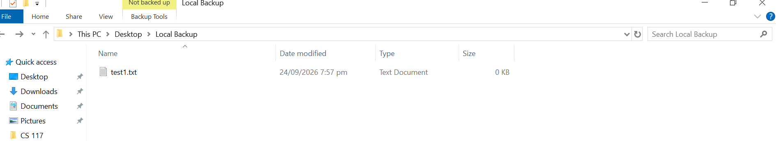
- Using your official university Google account, upload the same backup to Google Drive and verify completion.
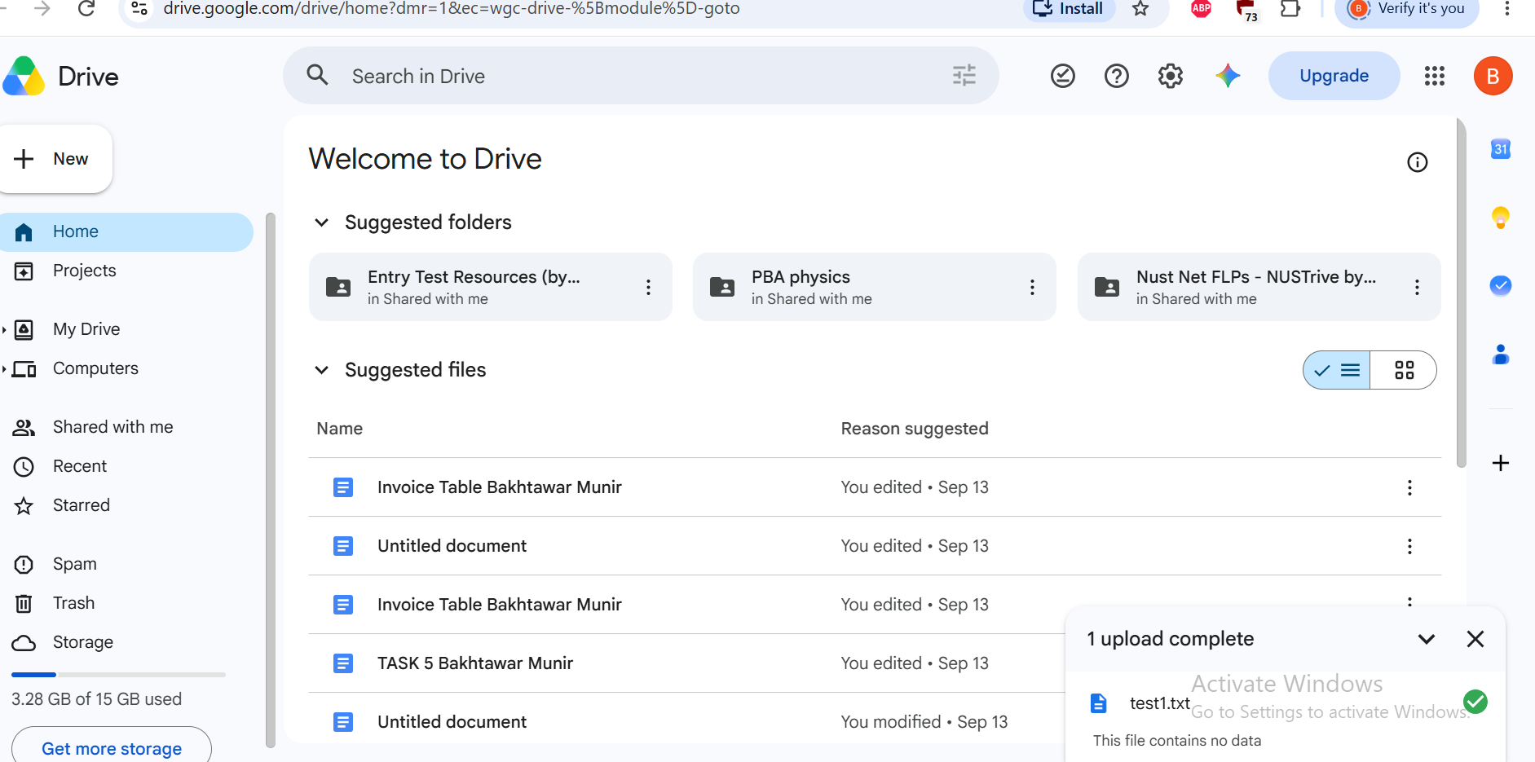
- Delete only the designated local test file. Do not delete either backup copy.
- Restore the deleted file by downloading it from Google Drive.
- Open the restored file to verify recovery.
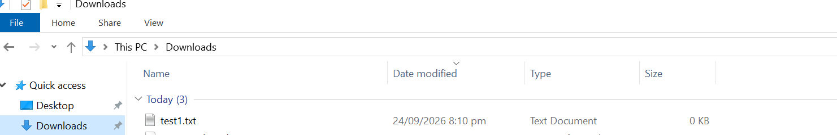

Check | Result
Local backup created | Yes
Drive upload completed | Yes

Check | Result
Test file deleted locally | Verified
File restored from Drive | Yes
Restored file opened successfully | Verified
Question 1: If the Internet is unavailable, which backup is easier to access?
Answer: Local Backup. Because it is stored directly on a local disk or external storage drive, it does not require an active internet connection to access or restore files.
Question 2: If your laptop is lost or damaged, which backup is more useful?
Answer: Cloud Backup (Google Drive). Because it is stored securely on remote cloud servers, allowing you to easily recover all your files from any other computer or device if your physical laptop is lost, stolen, or damaged.

Task 8 - Integrated Student-Laptop Scenario
Time: 15 minutes | Mode: Individual first, then group synthesis
Standardized case
A student laptop has very little free disk space. Device Manager shows a warning on the Wi-Fi adapter. The laptop has not been backed up recently. It contains documents, images, audio files and ZIP archives. Windows also reports pending updates.
Write a safe sequence of actions. Your answer must include:
- What information you would inspect first.
Answer : Check total available disk space using File Explorer (This PC) and review Device Manager to inspect the Wi-Fi adapter error status. Also check the last backup date and whether Windows Update shows pending updates.
- What data you would protect before making changes.
Answer : Backup all critical user data including personal documents, images, audio files, and important archives to an external drive or cloud storage before troubleshooting.
- What you would investigate about the Wi-Fi device.
Answer : Check the error code in Device Manager properties, verify if the driver is disabled or outdated, and test if physical hardware is functioning properly.
- How you would manage storage safely.
Answer : Run Disk Cleanup to clear temporary files, uninstall unused applications, and move large media files to external/cloud storage .Delete or move files only after the backup is verified. After freeing space, install the pending Windows updates and restart.
- Where compression might help.
Answer : Compress plain text files, logs and folders of uncompressed files into ZIP. JPG, MP3, DOCX and existing ZIP files are already compressed, so they will not shrink much.
- What you would not delete or modify.
Answer : Never delete critical system files, system drivers, Windows system directories, or unknown program files required for the OS to boot.
- When professional/administrator support may be appropriate.
Answer : Seek administrator or IT support if system driver reinstalls fail, hardware defects are detected, or system errors persist after basic cleanup.

Group Synthesis
After your individual answer, compare with your group and agree on one recommended sequence. Discuss why the order matters; do not simply adopt the strongest student's answer.
Order matters because backup must come first, otherwise cleanup or updates can cause data loss.

Personal-Device Reflection

Prompt | Your Response
Operating system you normally use | Windows 10
Approximate free storage (if known) | 50 GB
Do you currently maintain a backup? | Yes
Where is it stored? | Google Drive and External USB Drive
One practical backup strategy from this lab | Following the 3-2-1 backup rule by keeping a local backup on an external drive and a cloud backup on Google Drive
You are not required to bring a personal laptop. If you do not know a value, write "I do not currently know."

Digital Evidence
Submit the digital items specified by your instructor, including required screenshots, selected command output, backup/restore evidence and the group troubleshooting synthesis. Do not submit screenshots you cannot explain.

Assessment - 10 Marks

Component | Marks
Windows system/device/driver inspection | 2.0
Windows-Ubuntu comparison and Ubuntu practical | 2.0
Troubleshooting reasoning | 1.5
File types and compression | 1.0
Backup and successful restore | 1.5
Integrated scenario | 1.0
Individual exit task / viva | 1.0
TOTAL | 10.0

Troubleshooting Tips

Ubuntu VM Does Not Start
Do not reinstall anything. Inform the instructor/lab engineer.

A Linux Command Says "Command Not Found"
Check spelling, spaces and capitalization. Linux commands are case-sensitive.

Device Manager Shows Many Devices
Use the category requested by the task. Do not change anything.

You Cannot Find Driver Information
Open Device -> Properties -> Driver. If the option is unavailable, ask before changing settings.

ZIP Extraction Fails
Check whether the file downloaded fully, its size, whether it is really a ZIP and whether another source copy works.

Google Drive Upload Does Not Complete
Check Internet connection, correct official account and upload status. Selecting Upload does not prove that the backup has completed.

Before You Leave
- Can you discover what hardware Windows or Ubuntu sees?

- Can you locate where Windows reports device status and driver information?
- Can you explain how Windows and Ubuntu use different tools for similar concepts?
- Can you explain why different file types compress differently?
- Can you restore a file, not just upload it?
- Did you collect evidence before trying to fix a problem?
Troubleshooting habit
Inspect first. Protect your data. Change only what you understand. Verify the result.

Analytic Evaluation Rubric - 10 Marks
CS-117 | Lab 02 | Student Copy

Use the descriptor that best matches the demonstrated performance and award marks within the stated criterion weight. Half marks may be used where appropriate. A polished group artifact does not replace individual live competence; live demonstration/viva marks must reflect the individual student's performance.
Criterion | Weight | Excellent | Good | Satisfactory | Needs Improvement
Windows system, device & driver inspection | 2.0 | Accurately identifies Windows/OS status, software, devices and driver information; evidence is complete and student explains what the status means. | Most inspection tasks and evidence are correct; only minor omissions or interpretation errors. | Basic inspection is completed, but evidence or interpretation is incomplete and some prompting is needed. | Major inspection tasks/evidence are missing or incorrect; student cannot explain device/driver status.
Windows-Ubuntu comparison & Ubuntu practical | 2.0 | Performs required Ubuntu commands confidently, interprets outputs correctly, and makes accurate Windows-Linux comparisons including file-system concepts. | Performs most commands and comparisons correctly with minor mistakes or limited explanation. | Completes basic commands with assistance; comparison is superficial or partly inaccurate. | Cannot reliably perform/interpret required commands or distinguish key Windows-Linux concepts.
Troubleshooting reasoning | 1.5 | Diagnoses case evidence logically, separates symptom/cause/action, proposes safe next steps, and clearly justifies reasoning. | Diagnosis is mostly correct with reasonable evidence; minor reasoning gaps remain. | Identifies likely issue with prompting but reasoning is weak, incomplete, or partly based on guessing. | Diagnosis is unsupported/incorrect, relies on guessing, or proposes unsafe/unrelated actions.
File types & compression | 1.0 | Correctly identifies file types/sizes, creates/extracts ZIP and demonstrates .tar.gz exposure while explaining compression vs extraction. | Completes required compression tasks with minor errors or weak explanation. | Completes basic ZIP work with assistance; file-type/compression understanding is partial. | Cannot complete required compression/extraction tasks or explain the concepts.
Backup & successful restore | 1.5 | Creates local/cloud backup correctly, deletes only the test local copy, restores from Google Drive, verifies recovered content, and explains backup vs sync/storage. | Backup and restore succeed with minor evidence or explanation gaps. | Completes backup/restore with substantial prompting or incomplete verification. | Backup/restore is incomplete, unverified, or performed unsafely.
Integrated scenario | 1.0 | Connects hardware, OS, drivers, storage, files and backup concepts into a coherent diagnosis/recommendation with appropriate evidence. | Scenario response is mostly correct and connected, with minor omissions. | Addresses some scenario elements but connections/reasoning are limited. | Response is fragmented, largely incorrect, or unsupported.
Individual exit task / viva | 1.0 | Performs assigned task independently and accurately; explains commands/actions and results in own words. | Performs task with only minor prompting and explains most of it correctly. | Completes part of the task with significant prompting; explanation shows only basic understanding. | Cannot independently demonstrate the required skill or explain submitted work.

CS-117: Introduction to ICT | Page 11

