**Marketplace Technical Foundation – Shoes**

Define Technical Requirements:

1. **Frontend Requirements**

* **User-friendly interface:**

Design an intuitive and attractive interface for browsing shoe products.

Include easy navigation for users to find shoes by categories.

* **Responsive Design:**

Ensure the website is fully responsive, providing an optimal viewing experience across mobile, tablet, and desktop devices.

* **Essential pages:**

**Homepage:**

Display featured shoe products, seasonal trends, featured products, bestselling products, gear up and a search bar for easy navigation.

**Product Listing:**

Include filters for shoe categories, price range, size, color and popularity.

**Product Details Page:**

Provide detailed information about each shoe product, including images, descriptions prices, sizes, colors, and customer reviews.

**Cart Page:**

Allow users to view and edit their selected products before proceeding to checkout.

**Checkout Page:**

Collect user details, shipping information, and payment options securely.

1. **Sanity CMS as Backend:**

Use **Sanity** for:

* **Managing product data:** Name, price, size, tags, category, stock, image
* **Storing order details:** orderId, cutomerId, productDetails, status, Timestamp.
* **Storing Customer Data:** Customer ID, Name, Contact Info, Address, Order history.
* **Managing Shipments:** Shipment Id, Order Id, Delivery Date, Status.
* **Managing Payments:** Payment Id, Order Id, Amount, method, status.

1. **Third-Party APIs:**

* **Shipment Tracking:**

Use **ShipEngine** API for shipment tracking.

* **Payment Gateway:**

Use **Stripe** and **PayPal** for secure payment processing.

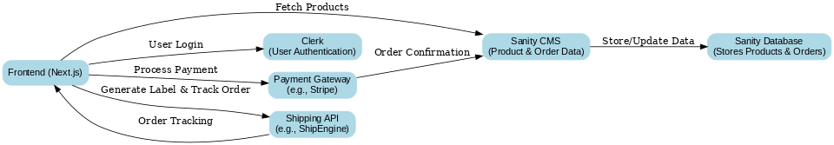**System Architecture**

**Workflow:**

1. **User Authentication:**
   * User logs in via Clerk **→** Clerk authenticates the user **→** Access granted to the frontend.
2. **Product Browsing:**
   * User browses products **→** Next.js fetches product data from Sanity CMS **→** Displays the product list.
3. **Cart Management:**

User adds products to the cart **→** Frontend sends cart data /api/cart

Cart details are saved in Sanity.

1. **Order Placement:**

* User places an order **→** Order details are sent to Sanity CMS **→** Sanity stores the order.
* Stripe processes payment securely **→** Confirmation is sent to the user.

1. **Shipping:**
   * Order data is sent to ShipEngine **→** Shipping label generated **→** Tracking details are stored in Sanity and shared with the user.