**LAPORAN UAS** **FRAMEWORK PROGRAMMINNG**

**PENGUJIAN MENGGUNAKAN**

**WHITEBOX TESTING DAN BLACK BOX TESTING**



Laporan Ini Disusun Untuk Memenuhi UAS

Mata Kuliah Frame Work Programming

Pada Program Studi D IV Teknik Informatika

**Disusun Oleh :**

**Nama : Bakhtiar Shofawi**

**Kelas : 6B**

**NIM : 16090130**

**D-IV TEKNIK INFORMATIKA**

**POLITEKNIK HARAPAN BERSAMA TEGAL**

**2019**

Pengujian ini dilakukan pada Aplikasi Rumah. Aplikasi Rumah adalah aplikasi berbasis website yang berisi tentang sebuah informasi penjualan rumah pada kota Tegal.

1. **White Box Testing**

Berikut ini adalah dokumen-dokumen pengujian mengunakan white box testing:

1. *Flowchart Diagram*

Pada Aplikasi ini terdapat dua *flowchart diagram* yaitu :

1. *Flowchart Diagram Admin*

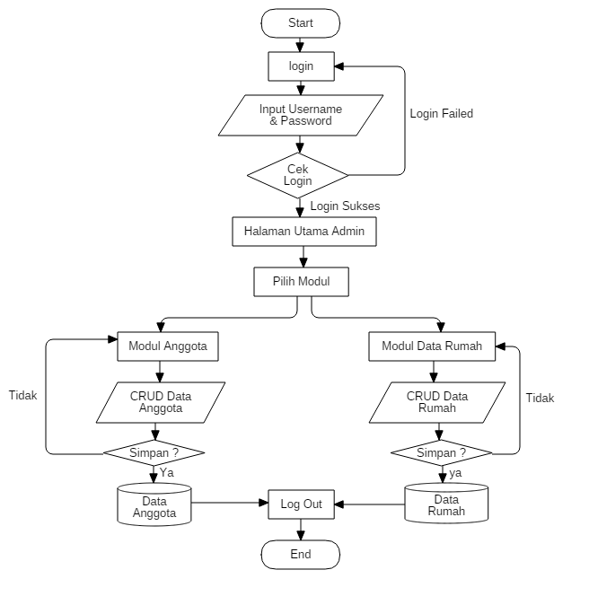

1. *Flowchart* *Diagram* *User*

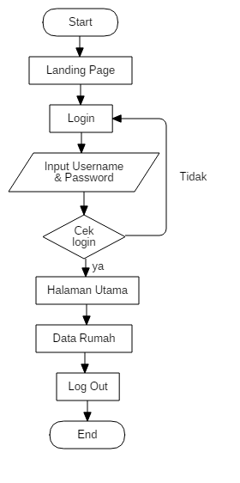

1. *Control* *Flow* *Graph*
2. *Control* *Flow* *Graph Admin*

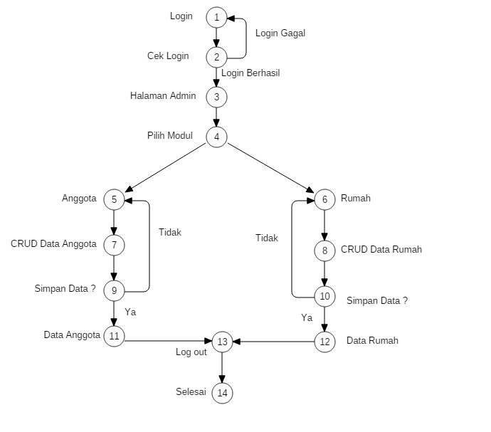

1. *Control* *Flow* *Graph User*

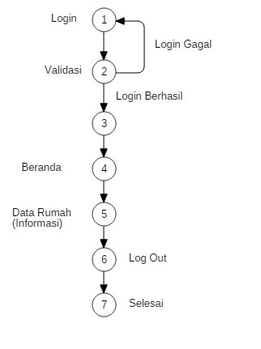

1. Basich Path

Flow Garph merupakan grafik yang digunakan untuk menggambarkan aliran kontrol dari sebuah program. Berbeda dengan flowchart, grafik pada flow garph tidak menggambarkan secara detail proses yang terjadi pada setiap blok notasi.

V(G) = E – N + 2

V(G) : Cyclomatic Complexity

E : total jumlah edge

N : total jumlah node

Hasil Basich Path

1. Hasil Admin

Jawab = V(G) = E – N + 2

= 17 – 14 + 2

= 3 + 2

= 5

1. Hasil User

Jawab = V(G) = E – N + 2

= 7 – 7 + 2

= 0 + 2

= 2

1. Basic Alur Path

Berdasarkan gambar flowchart diagram, maka alur-alur independet yang di dapat :

1. Basic Path Admin

Path 1 : 1-2-1-2-3-4-5-7-9-11-13-14

Path 2 : 1-2-3-4-5-7-9-11-13-14

Path 3 : 1-2-1-2-3-4-6-8-10-12-13-14

Path 4 : 1-2-3-4-6-8-10-12-13-14

Path 5 : 1-2-1-2-3-4-5-7-9-5-7-9-11-13-14

Path 6 : 1-2-3-4-5-7-9-5-7-9-11-13-14

Path 7 : 1-2-1-2-3-4-6-8-10-6-8-10-12-13-14

Path 8 : 1-2-3-4-6-8-10-6-8-10-12-13-14

1. Basic Path User

Path 1 : 1-2-1-2-3-4-5-6-7

Path 2 : 1-2-3-4-5-6-7

1. **Black Box Testing**

Kita akan menguji sistem menggunakan black box testing dengan teknik boundary value analysis (BVA) dan menggunakan tabel kebenaran.

1. **Boundary Value Analysis (BVA).**
2. Tabel Login

|  |  |  |  |  |
| --- | --- | --- | --- | --- |
| **Nama Kolom** | **Invalid** | **Valid** | **Invalid** | **Valid** |
| Username | 0 Character | 1 Character | 11 Character | 10 Character |
| Password | 0 Character | 1 Character | 21 Character | 20 Character |

1. Tabel Rumah

|  |  |  |  |  |
| --- | --- | --- | --- | --- |
| **Nama Kolom** | **Invalid** | **Valid** | **Invalid** | **Valid** |
| Id_Rumah | 0 | 1 | 21 | 20 |
| Nama | 0 Character | 1 Character | 51 Character | 50 Character |
| Kategori | 0 Character | 1 Character | 11 Character | 10 Character |
| Tanggal | 0 | 8 | 9 | 8 |
| Keterangan | 0 Character | 1 Character | 256 Character | 255 Character |
| Gambar | 0 Character | 1 Character | 256 Chracter | 256 Character |

1. Tabel Pertanyaan

|  |  |  |  |  |
| --- | --- | --- | --- | --- |
| **Nama Kolom** | **Invalid** | **Valid** | **Invalid** | **Valid** |
| Id_Anggota | 0 | 1 | 21 | 20 |
| Id_Rumah | 0 Character | 1 Character | 21 Character | 20 Character |
| Nama | 0 Character | 1 Character | 21 Chracter | 20 Character |
| Email | 0 Character | 1 Character | 21 Character | 20 Character |
| Tanggal | 0 | 8 | 9 | 8 |
| Pesan | 0 Character | 1 Character | 256 Character | 255 Character |

1. Tabel view

|  |  |  |  |  |
| --- | --- | --- | --- | --- |
| **Nama Kolom** | **Invalid** | **Valid** | **Invalid** | **Valid** |
| Id_view | 0 | 1 | 21 | 20 |
| Nama | 0 Character | 1 Character | 51 Character | 50 Character |
| Keterangan | 0 Character | 1 Character | 11 Character | 10 Character |
| Gambar | 0 Character | 1 Character | 256 Character | 256 Character |

1. **Tabel Kebenaran**
2. *Form* *login*

|  |  |  |
| --- | --- | --- |
| **username** | **Password** | **Action** |
| Blank | Blank | No |
| Blank | True | No |
| Blank | False | No |
| False | True | No |
| False | False | No |
| False | True | No |
| True | False | No |
| True | Blank | No |
| True | True | Success |

User akan berhasil login apabila username dan password bernilai (true).

1. Form Tambah Rumah

|  |  |  |  |  |
| --- | --- | --- | --- | --- |
| **Nama** | **Keterangan** | **Kategori** | **Foto** | **Action** |
| Blank | Blank | Blank | Blank | No |
| Blank | False | False | False | No |
| Blank | True | True | True | No |
| True | True | True | True | Success |
| True | False | False | False | No |
| True | Blank | Blank | Blank | No |
| False | True | True | True | No |
| False | False | False | False | No |
| False | Blank | Blank | Blank | No |
| Blank | Blank | Blank | True | No |
| Blank | Blank | Blank | False | No |

Tambah berita akan berhasil apabila kolom Nama, Keterangan, kategori dan foto bernilai (true) selain itu akan gagal.

1. Form Tambah Pertanyaan

|  |  |  |  |
| --- | --- | --- | --- |
| **Nama** | **Email** | **Pesan** | **Action** |
| Blank | Blank | Blank | No |
| Blank | False | False | No |
| Blank | True | True | No |
| Blank | True | False | No |
| Blank | False | True | No |
| False | Blank | Blank | No |
| False | Blank | False | No |
| False | Blank | True | No |
| False | False | False | No |
| False | True | False | No |
| False | False | False | No |
| False | True | True | No |
| True | Blank | Blank | No |
| True | Blank | False | No |
| True | Blank | True | No |
| True | False | False | No |
| True | False | True | No |
| True | False | Blank | No |
| True | True | True | Success |

Form tambah pertanyaan akan berhasil jika kolom nama, email dan pesan bernilai benar (true) selain itu gagal.