Brownian Motion and its Applications in Stochastic Processes

# 1. Introduction

Brownian motion, also known as a Wiener process, is a fundamental concept in probability theory and stochastic processes. It describes the random motion of particles suspended in a fluid resulting from collisions with fast-moving molecules in the fluid. This physical phenomenon has been mathematically formalized and serves as a cornerstone in the study of stochastic processes, particularly in finance, physics, and biology.

# 2. Theoretical Background

Brownian motion is characterized by the following properties:  
- It starts at zero: B(0) = 0.  
- It has independent increments.  
- The increments are normally distributed: B(t) - B(s) ~ N(0, t-s).  
- It has continuous paths.  
  
Mathematically, Brownian motion is denoted as B(t), where t ≥ 0, and is used to model various real-life random processes.

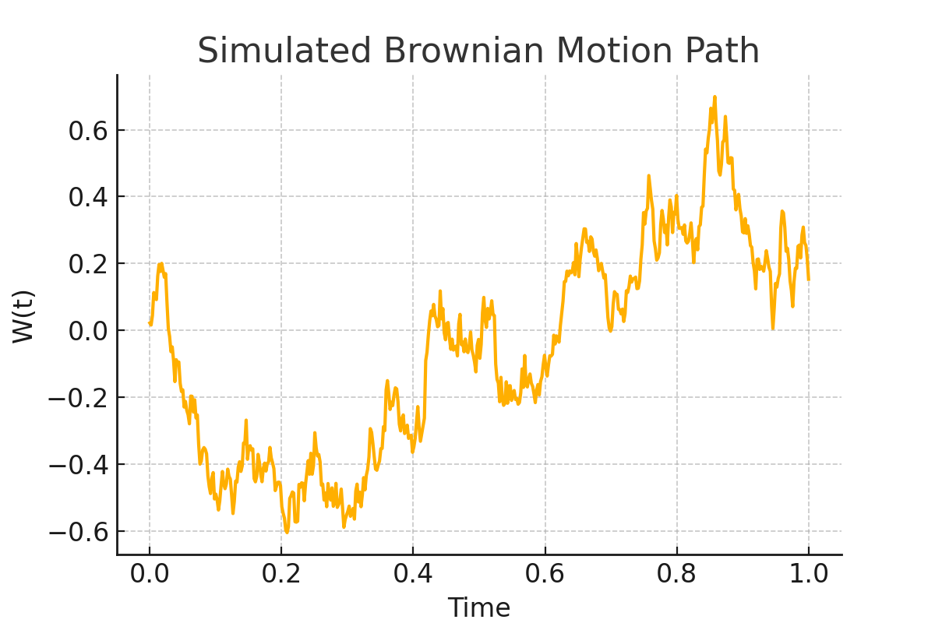

Figure 1: Simulated Brownian Motion Path

# 3. Applications in Stochastic Processes

Brownian motion is a fundamental building block in the modeling of various stochastic processes. Some key applications include:

- Financial Mathematics: Modeling stock prices using the Geometric Brownian Motion (GBM) in the Black-Scholes model.  
- Physics: Describing diffusion processes.  
- Biology: Modeling population genetics and neural activity.

# 4. Real-World Scenario: Stock Price Modeling

In finance, the price of a stock is often modeled using Geometric Brownian Motion (GBM), given by the stochastic differential equation:  
 dS(t) = μS(t)dt + σS(t)dB(t),  
where:  
- S(t) is the stock price at time t,  
- μ is the drift rate,  
- σ is the volatility,  
- B(t) is standard Brownian motion.  
  
This model is widely used due to its analytical tractability and ability to capture the randomness of financial markets.

# 5. Advantages and Disadvantages

|  |  |
| --- | --- |
| Advantages | Disadvantages |
| - Simple and mathematically tractable - Captures essential features of random motion - Widely applicable in various fields | - Assumes continuous paths which may not hold in reality - Assumes constant drift and volatility - Cannot capture sudden jumps or extreme events |

# 6. Conclusion

Brownian motion plays a crucial role in the modeling of stochastic systems, particularly in finance and physics. Despite its limitations, it remains a foundational concept due to its simplicity and wide applicability. Future models often extend Brownian motion to include more complex phenomena like jumps or stochastic volatility.