| Drag & Drop Playground | | |
| --- | --- | --- |
| Test 1 | Completed on **Jun 21, 2025 9:00 PM** | Prepared by [**Bakhtiar Aleem**](mailto:bakhtiar.aleem93@gmail.com) |

# Project Summary

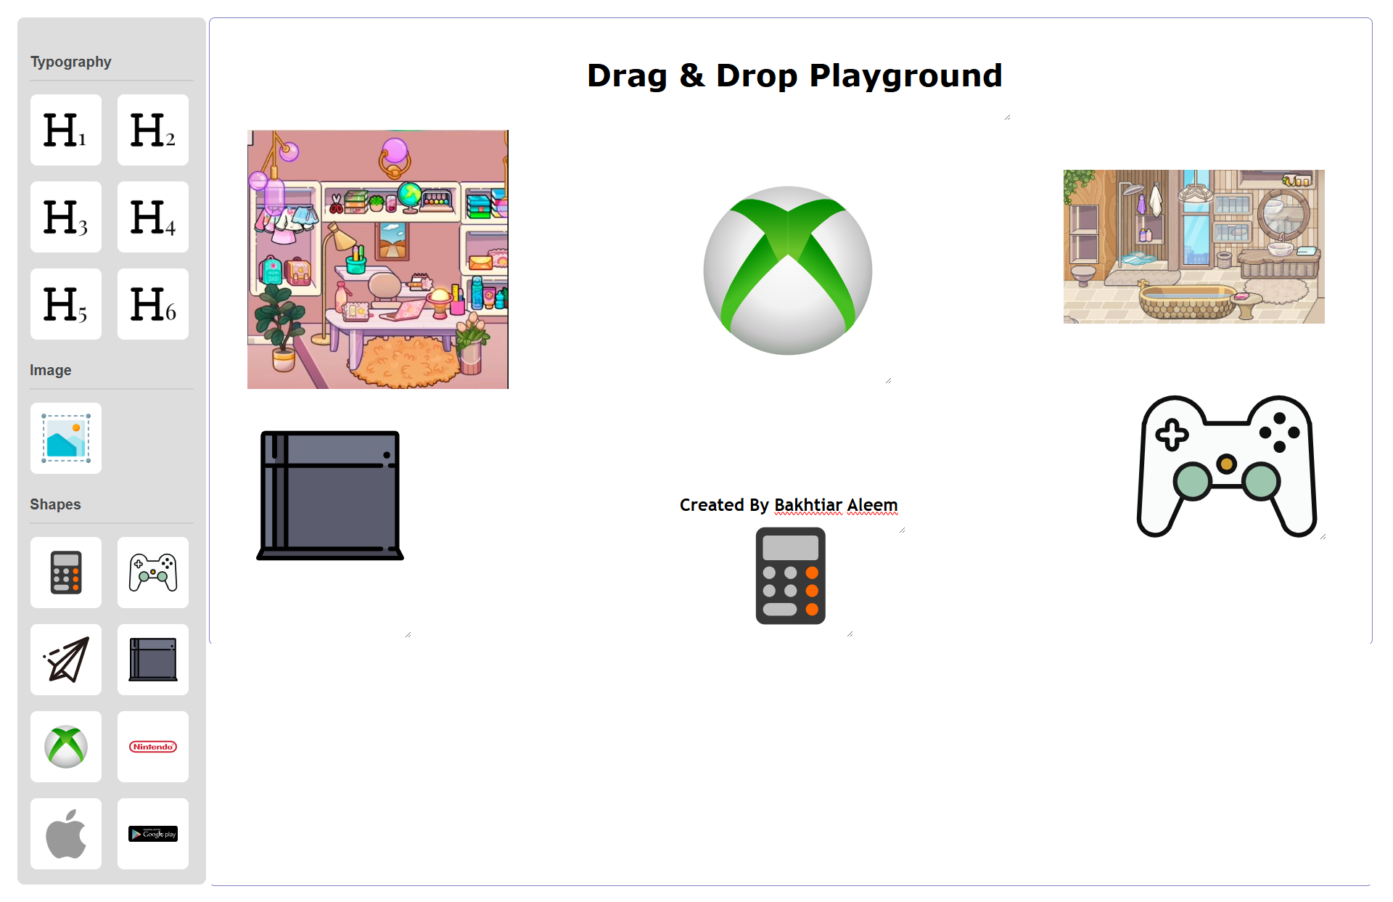

## Key Features

Core Features used in this Project

| * Html/Css * Vanilla JS * Svg Icons |
| --- |

# Project Usage/Installation

You can use/install the project by simply putting it through a web development environment like Xampp, Wamp or Laragon.  
  
**GitHub Repo**

<https://github.com/BakhtiarAleem/drag-and-drop-playground-vanillajs>

**Live Demo**

<https://drag-and-drop-playground-vanillajs.vercel.app/>

# Section Usage

**TypoGraphy Section**  
  
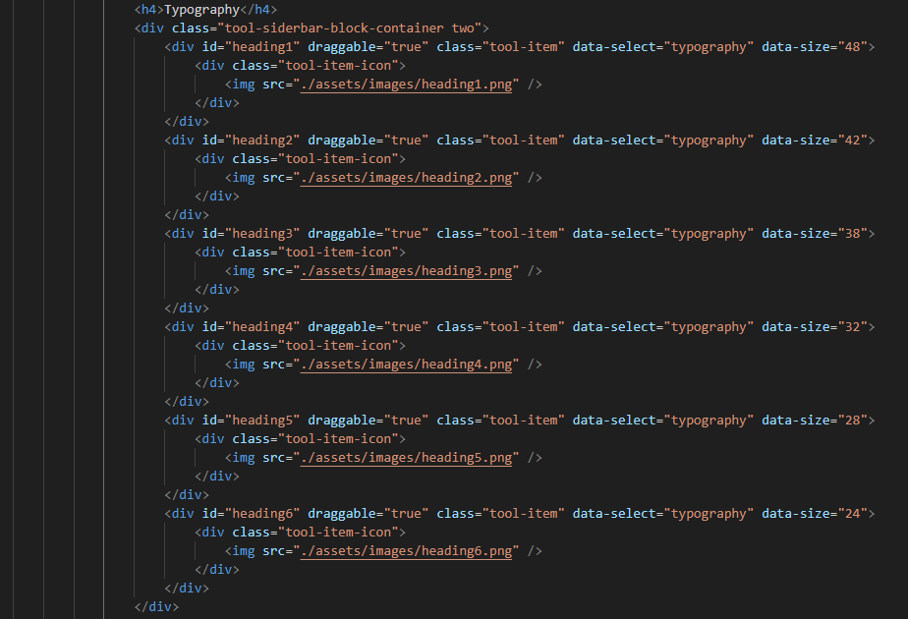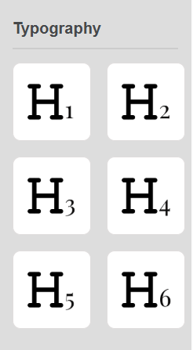

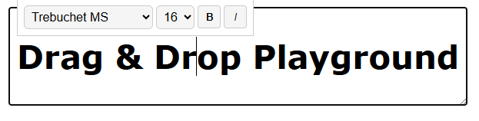

Typography Section are use so user can write the heading/text and can drag and drop easily.  
  
**Functions Used**

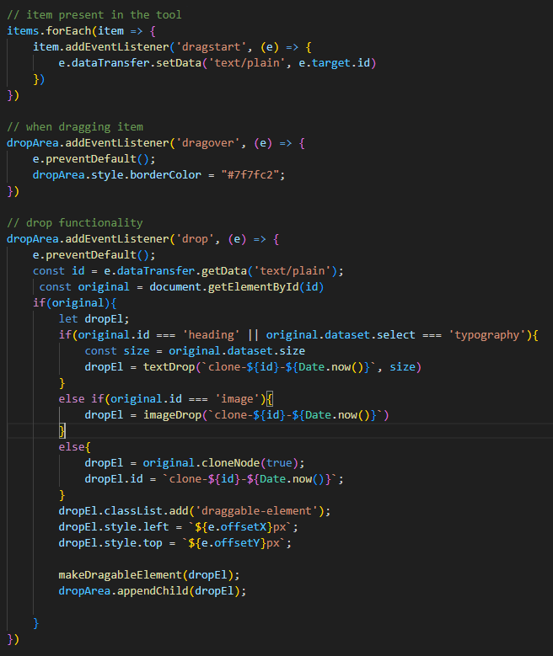

These event listeners are use to initialize item is selected and drag to the playground & check weather if its a text or any other thing.  
  
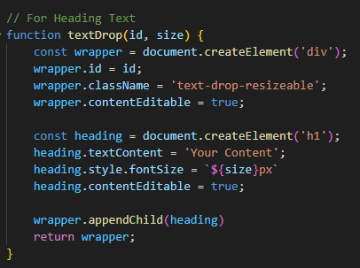

This function is used to create the text element.

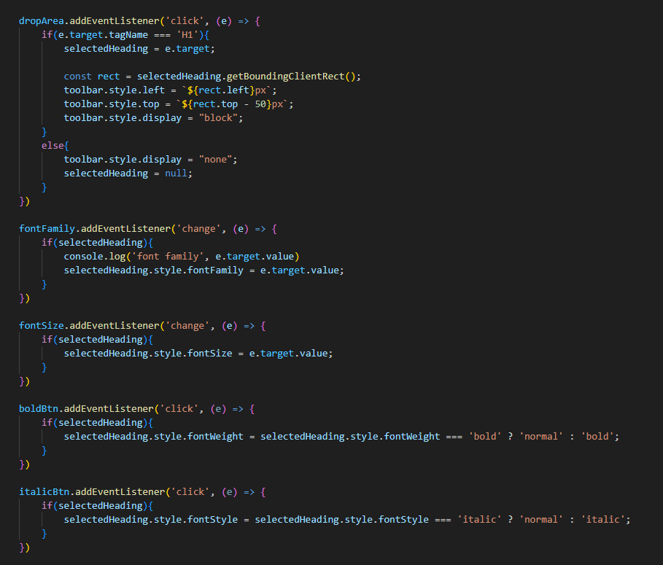

These Event listeners are used for tooltip to change the value of the selected text

**Image Section**

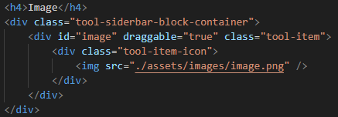

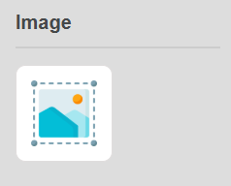

****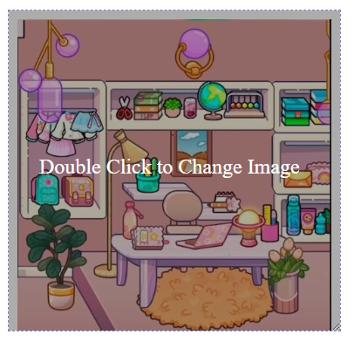

Image Sections are used to Drag and Drop Images section and upload you images bu Double Clicking the Section you dropped on playground.

**Functions Used**

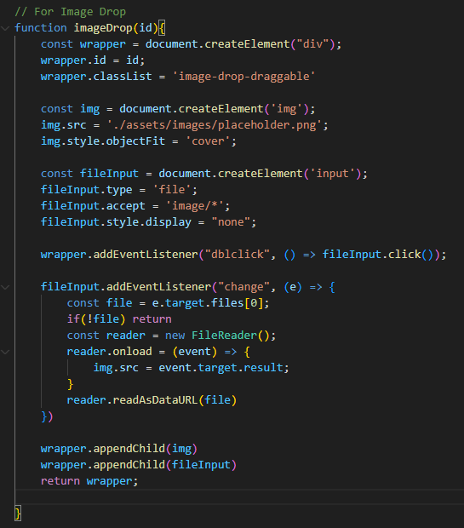

This function is used to initialized the image when it is drop along side add event of double clicking the section to upload an image.

**Shapes Section**

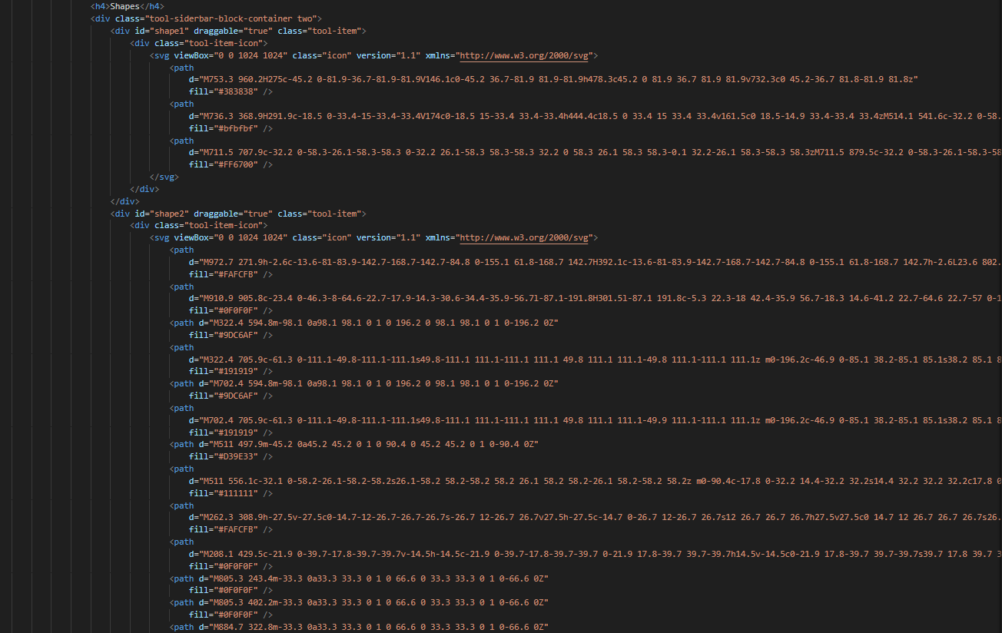

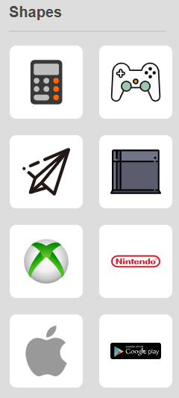



Shape Sections are used to Drag and Drop Predefine Svg icons on the playground.  
  
**Functions Used**

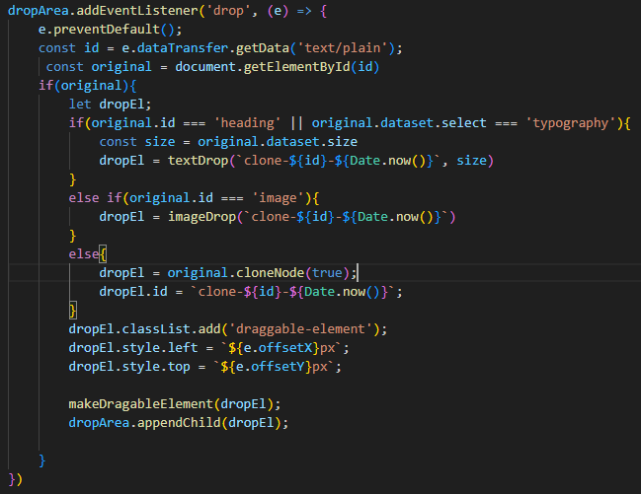

Used this common function to create a copy of shape while dragging and drop on playground.

## Conclusions

This Project is purely a Javascript project with no framework or Library used .

| * I could use jQueryUI and it will solve most the problem but I will be dependent on the library. * I could use Bootstrap, SCSS or Tailwind for this but due to project scope we need to keep it simple and light weighted. |
| --- |