HTMX-based CRUD Chat Rooms

#### By [Bakhtiar Aleem](mailto:bakhtiar.aleem93@gmail.com) Date

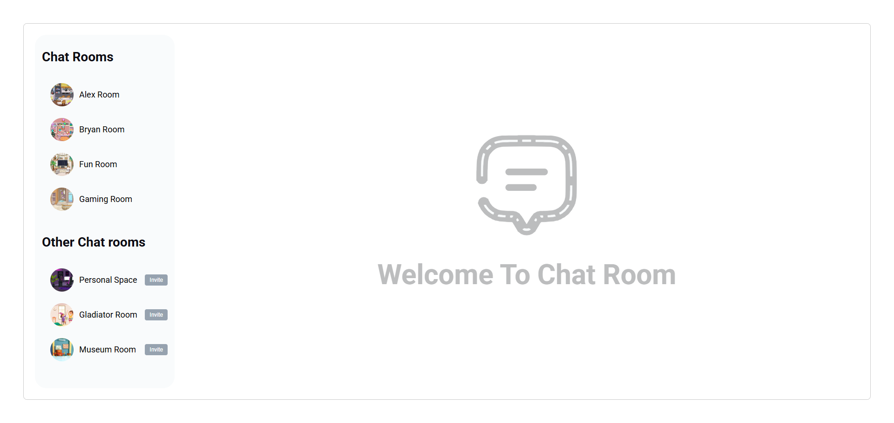

### Project Usage/Installation

You can only use the project by simply putting it through a web development environment like Xampp, Wamp or Laragon. Otherwise it will give Cors error when calling htmx function ajax.

### Github Repo

<https://github.com/BakhtiarAleem/htmx>

### Live Demo

<https://htmx-cdq0pb9x0-bakhtiaraleems-projects.vercel.app/>

# Project Images

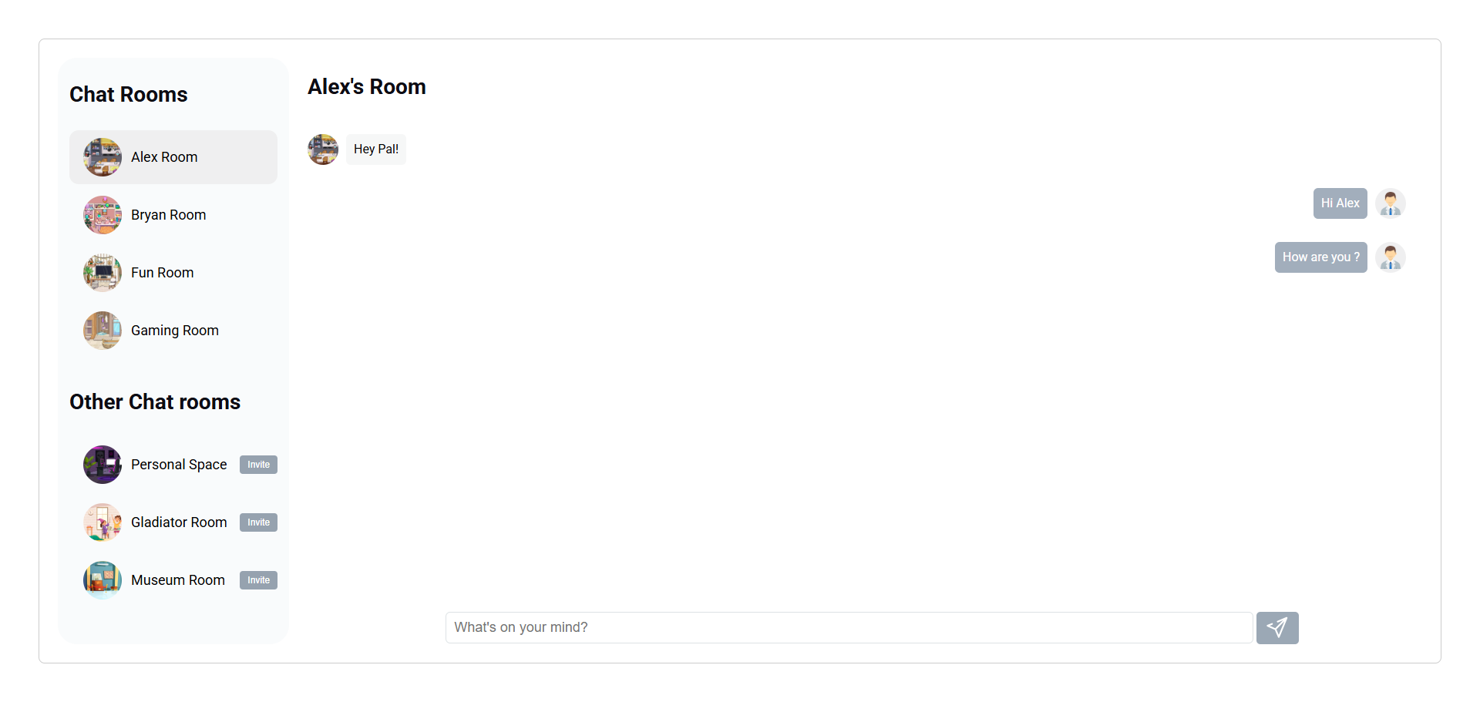

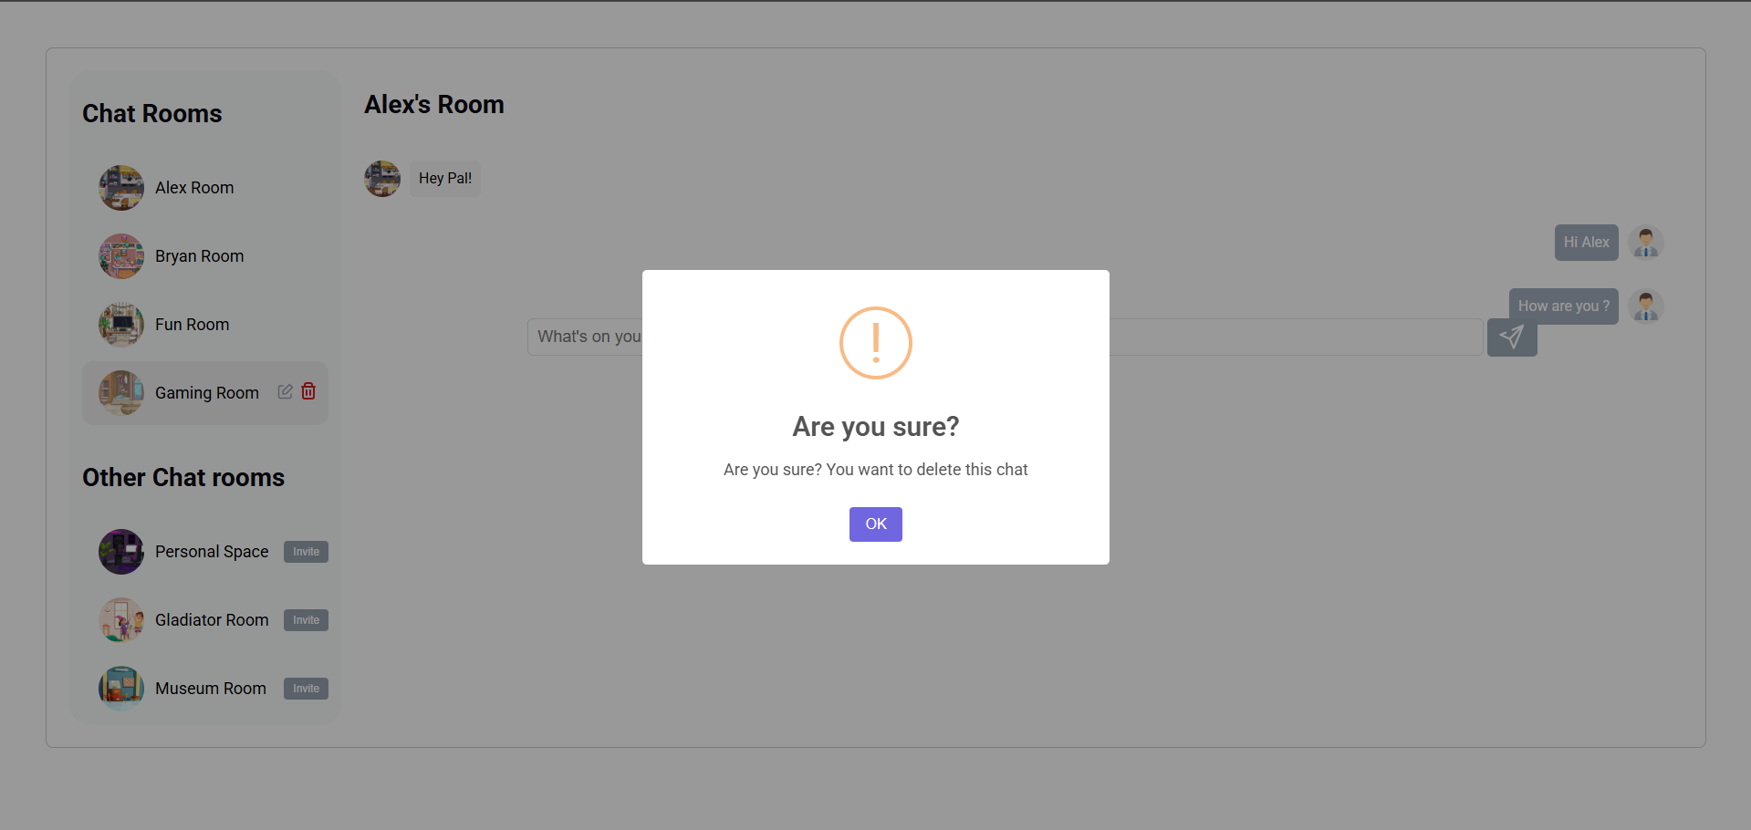

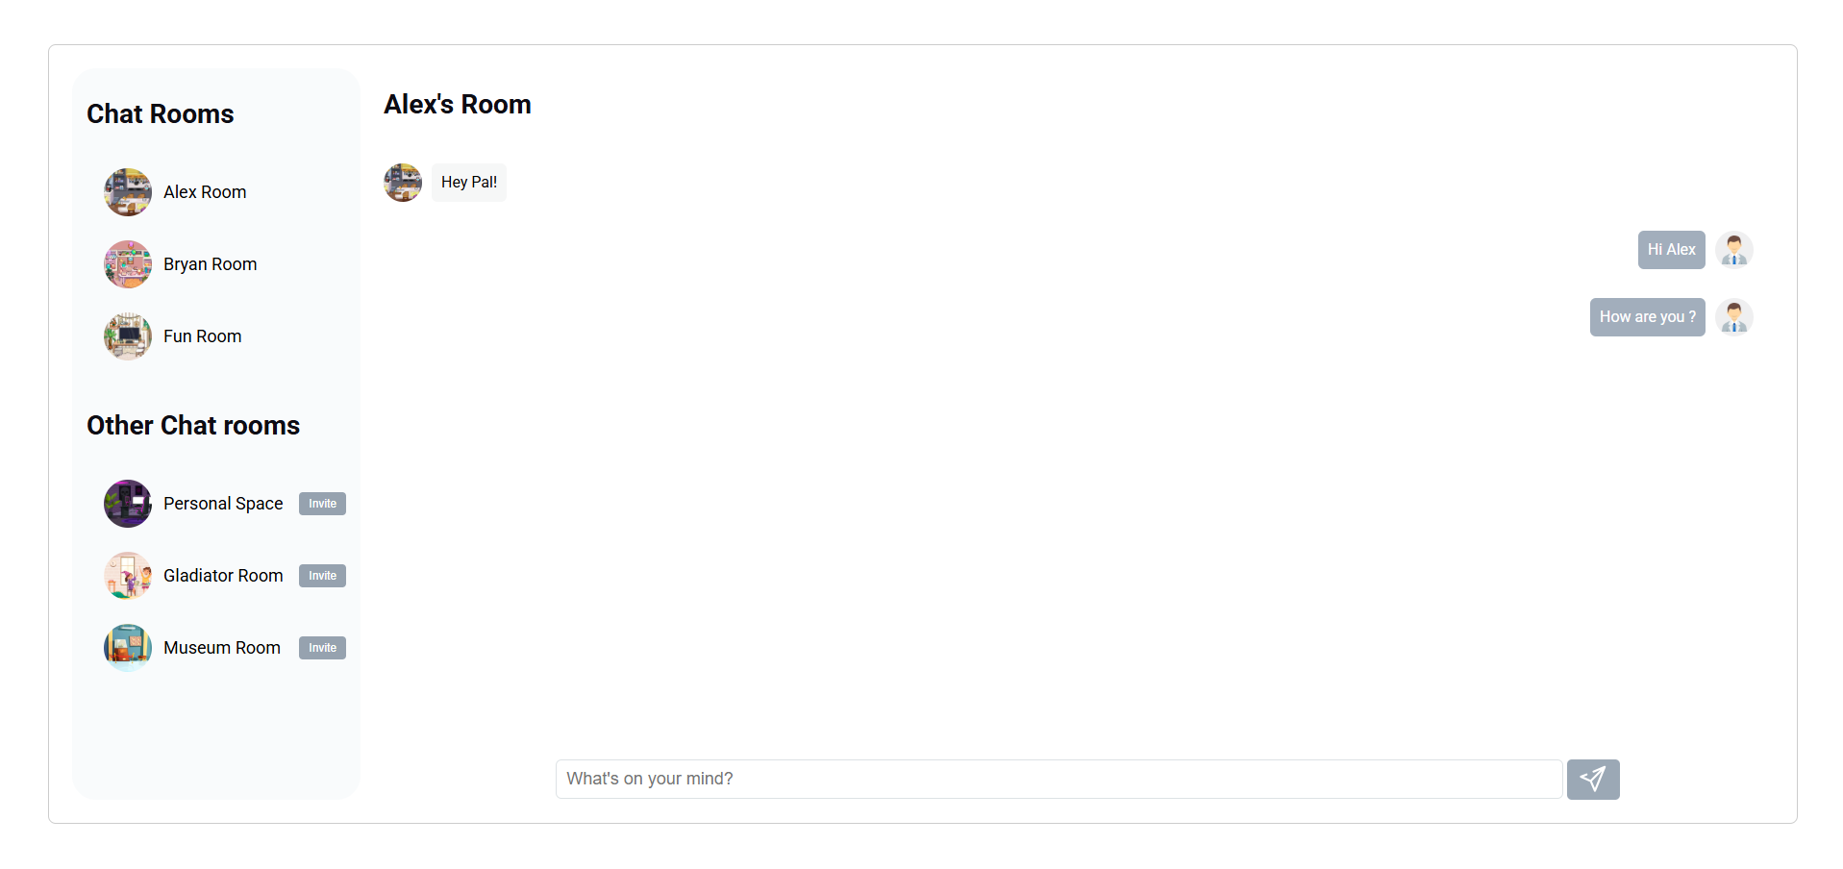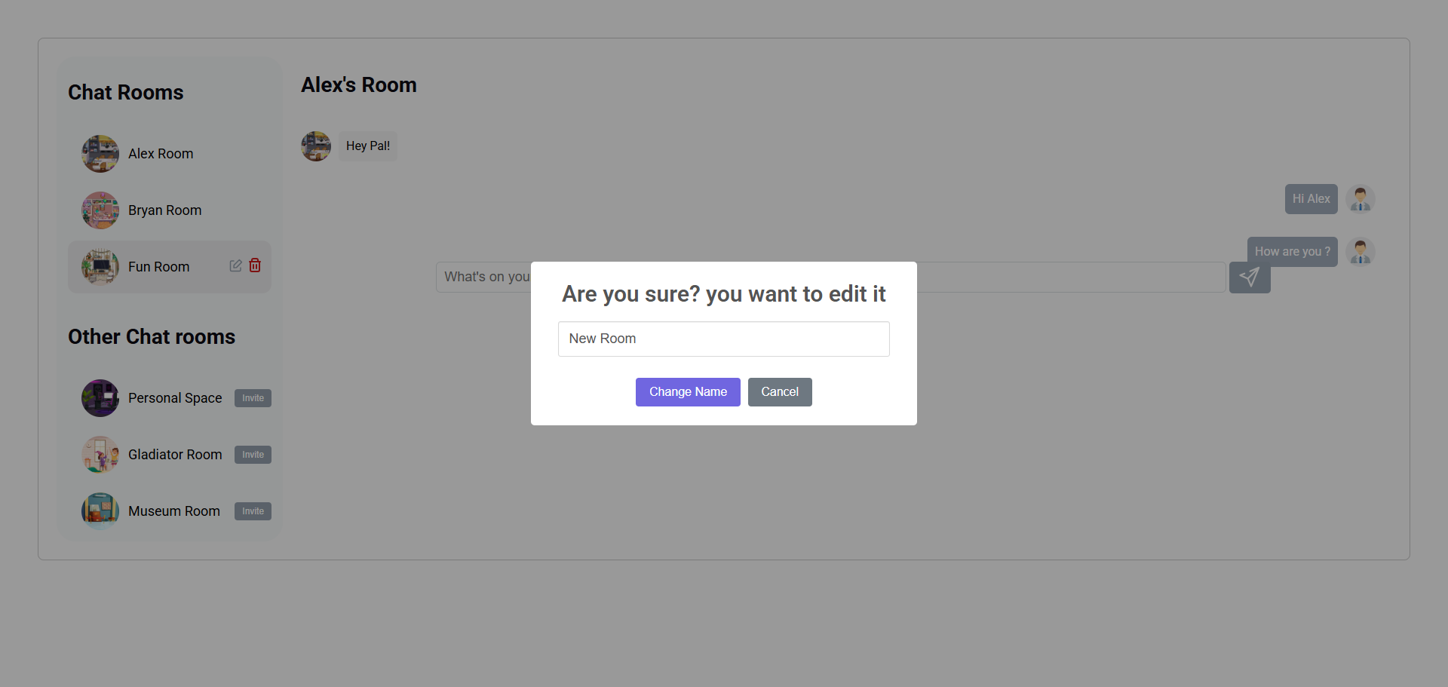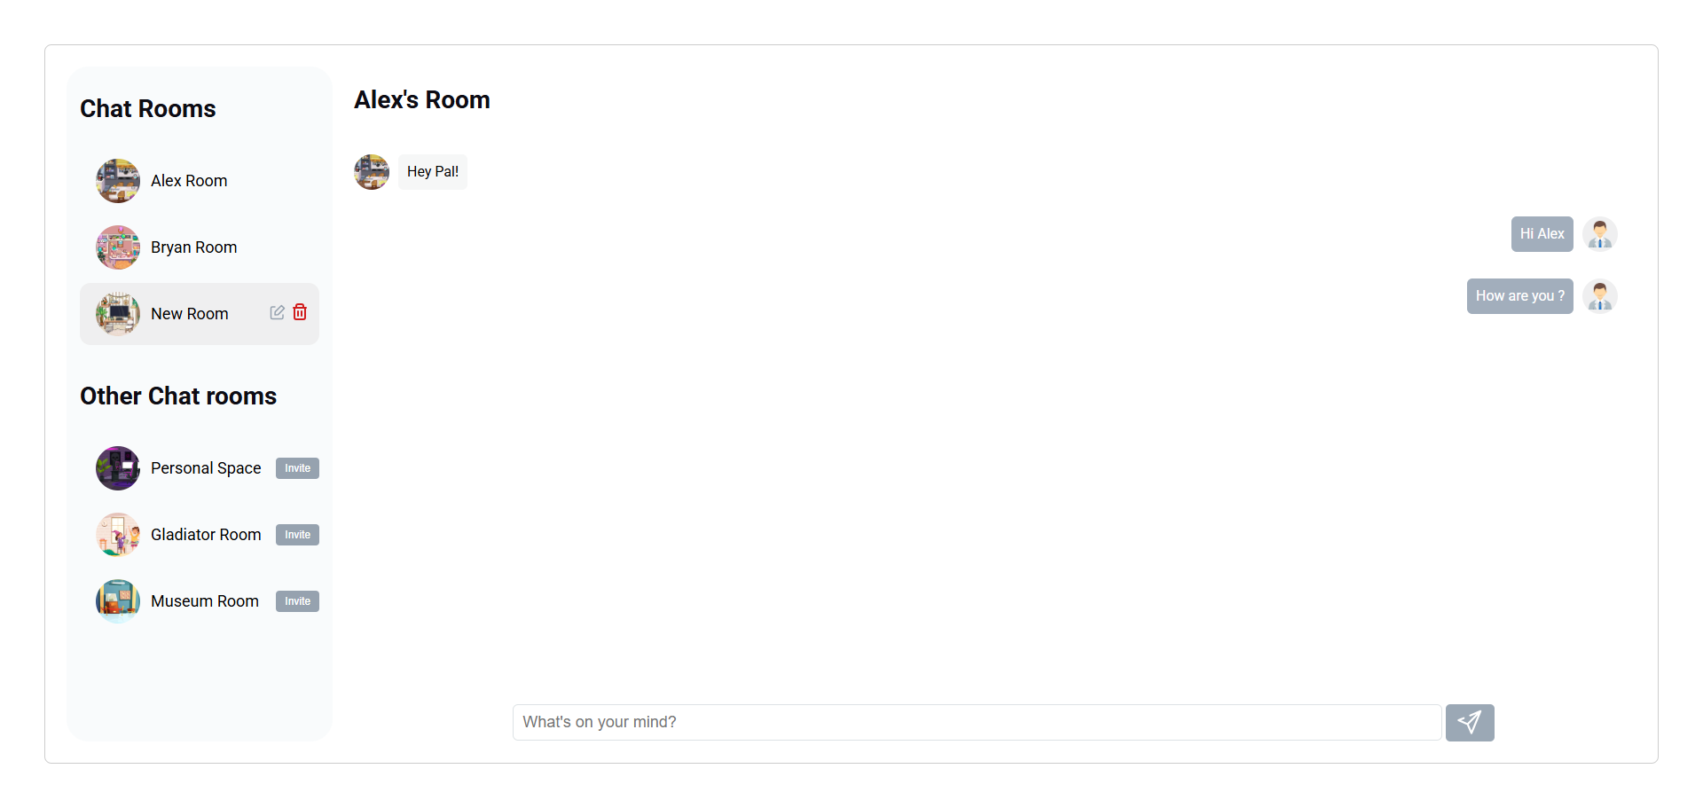

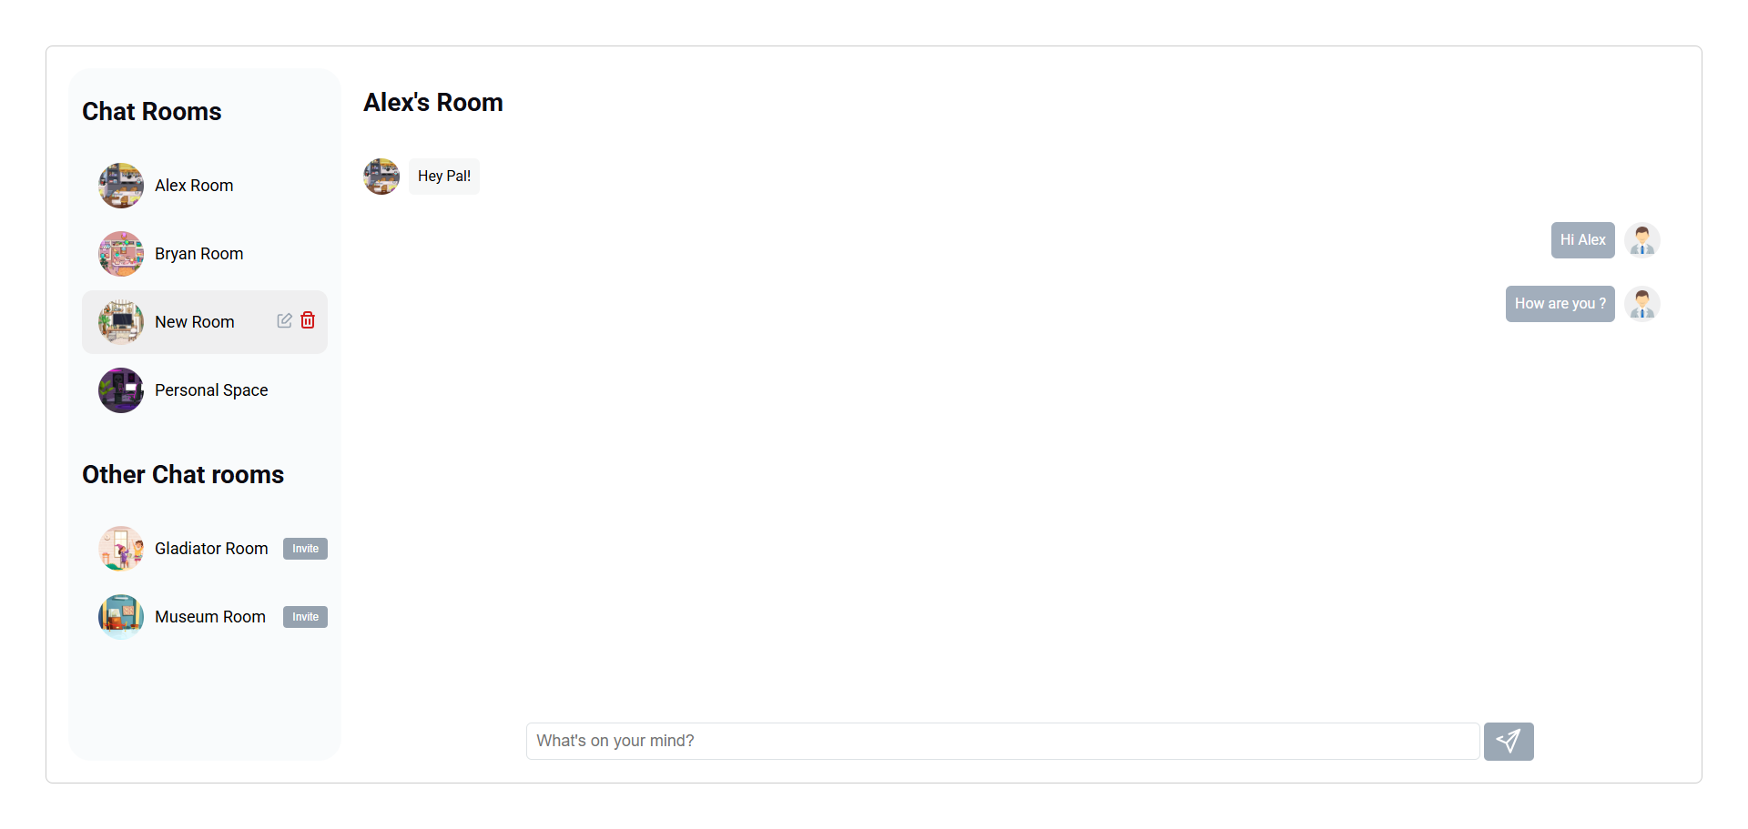

# 

### For any inquiries, please contact:

[Bakhtiar Aleem](mailto:bakhtiar.aleem93@gmail.com)