Launching new windows instance in AWS:

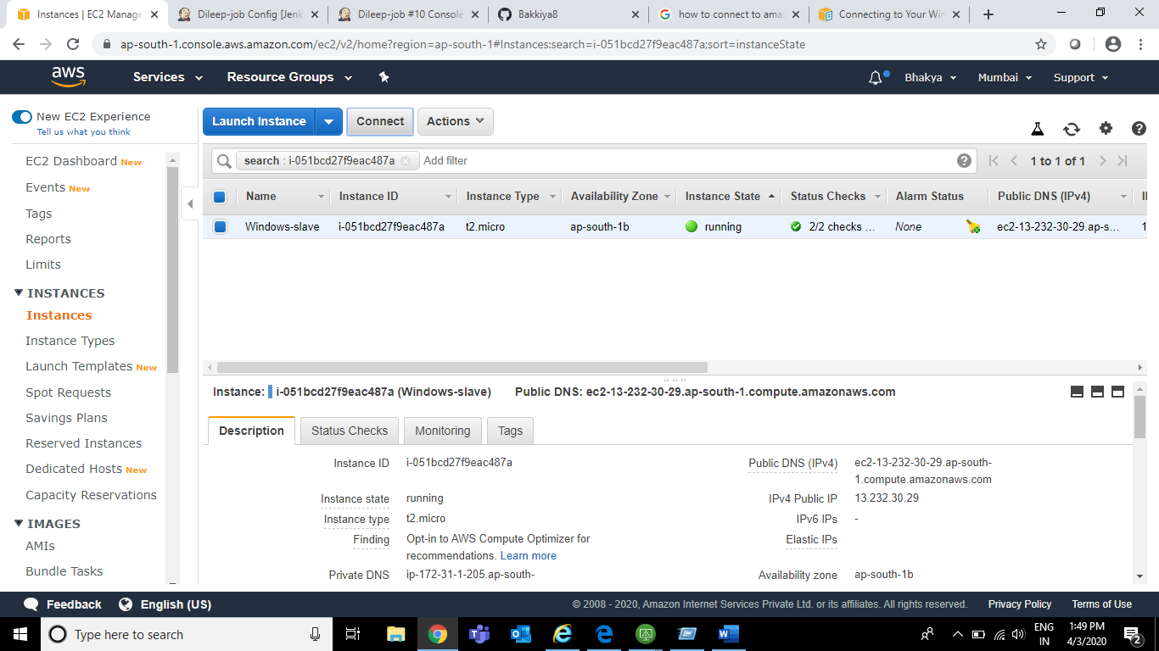

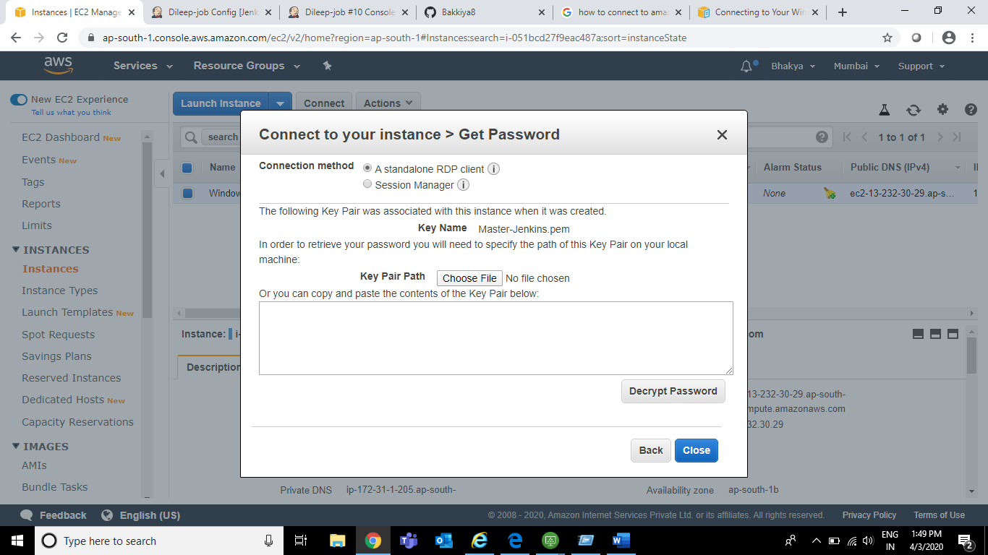

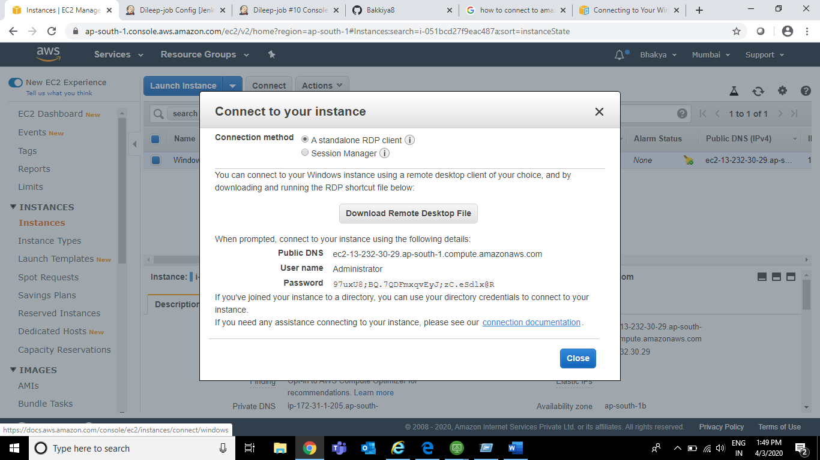

Connect the windows instance via RDP and create new folder JENKINS in C drive in order to make this as Home directory while creating new node in Manage nodes.

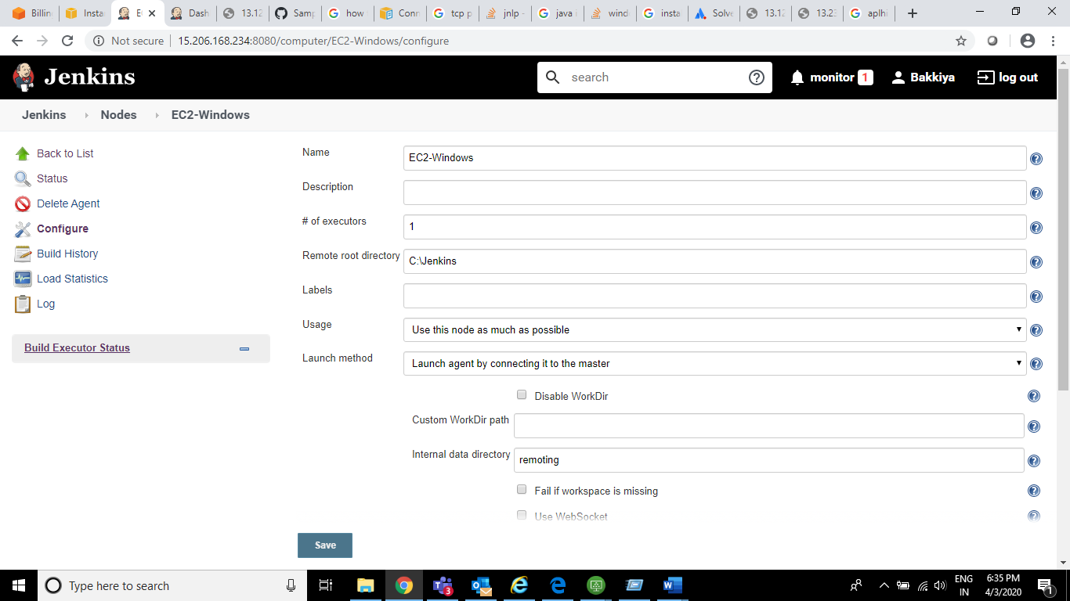

Go to Configure Global security and make sure the Agents in TCP port for inbound agents is in **RANDOM**

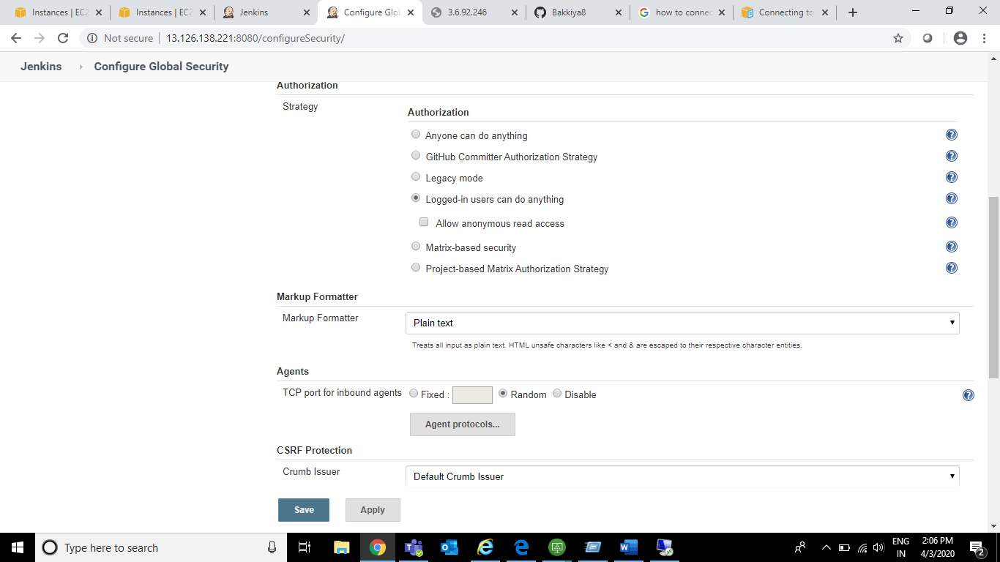

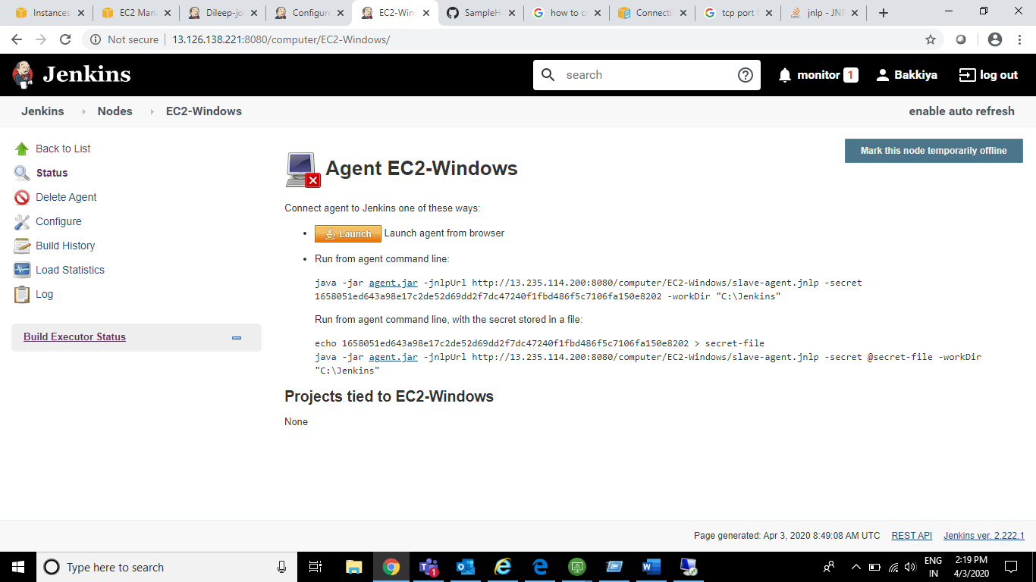

Paste the jenkins url (<http://XXXXX:8080/computer/EC2-Windows/>)in Windows machine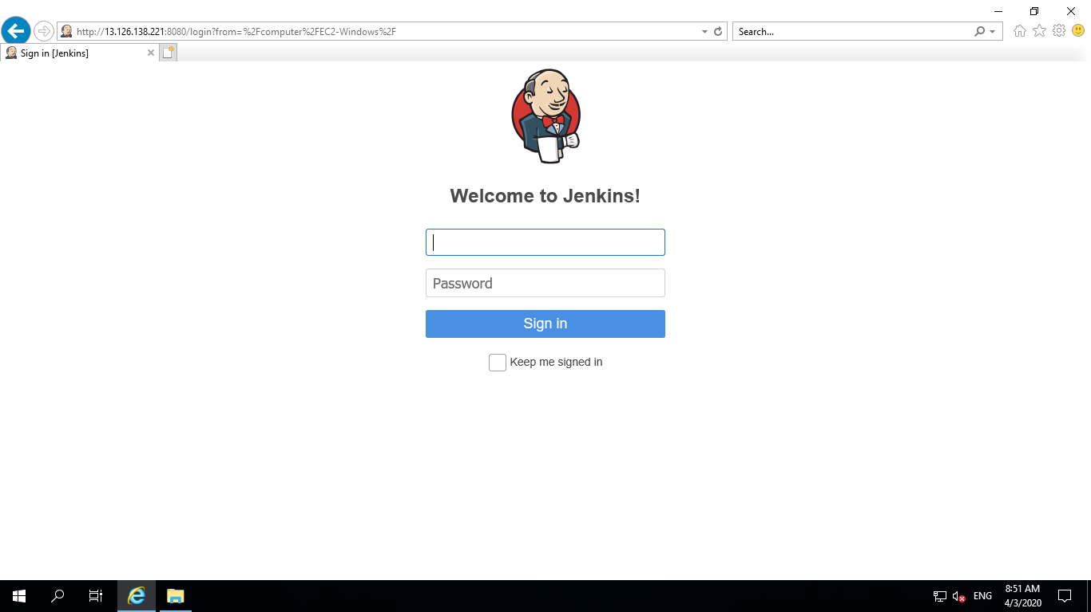

Download the agent.jar in Jenkins folder which we created and copy the below in cmd of windows machine.

Note: Jenkins url IP and IP which is in agent.jar should be same (ip get varies once instance restarted and we need to change the agent.jar commands accordingly otherwise slave agent couldn’t establish the connection)

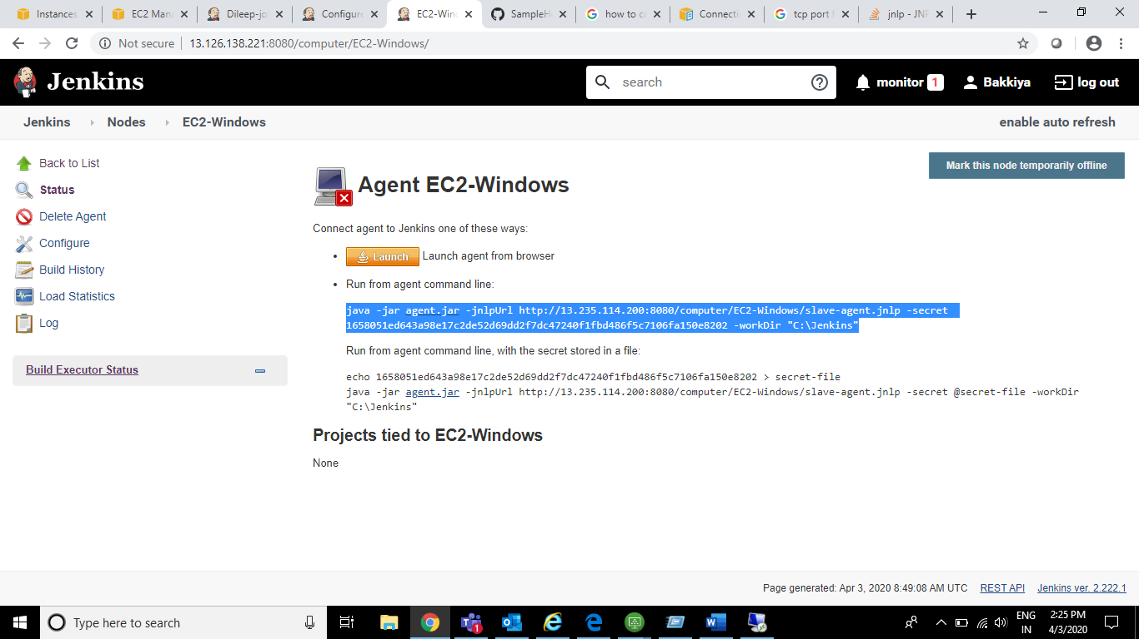

As java is not there, we are facing the below error and need to configure the Java path in Environment variables (System as well as user variables)

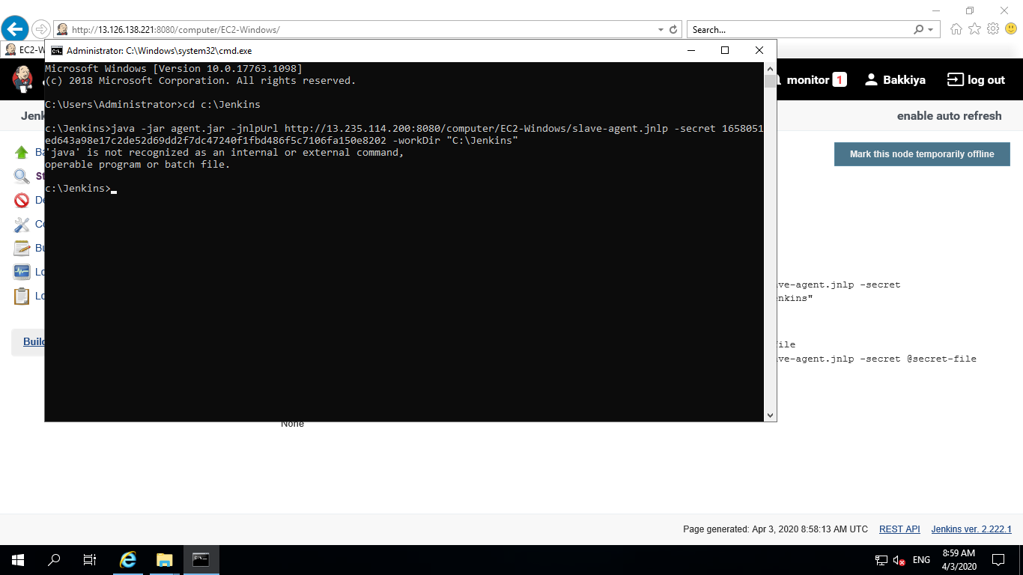

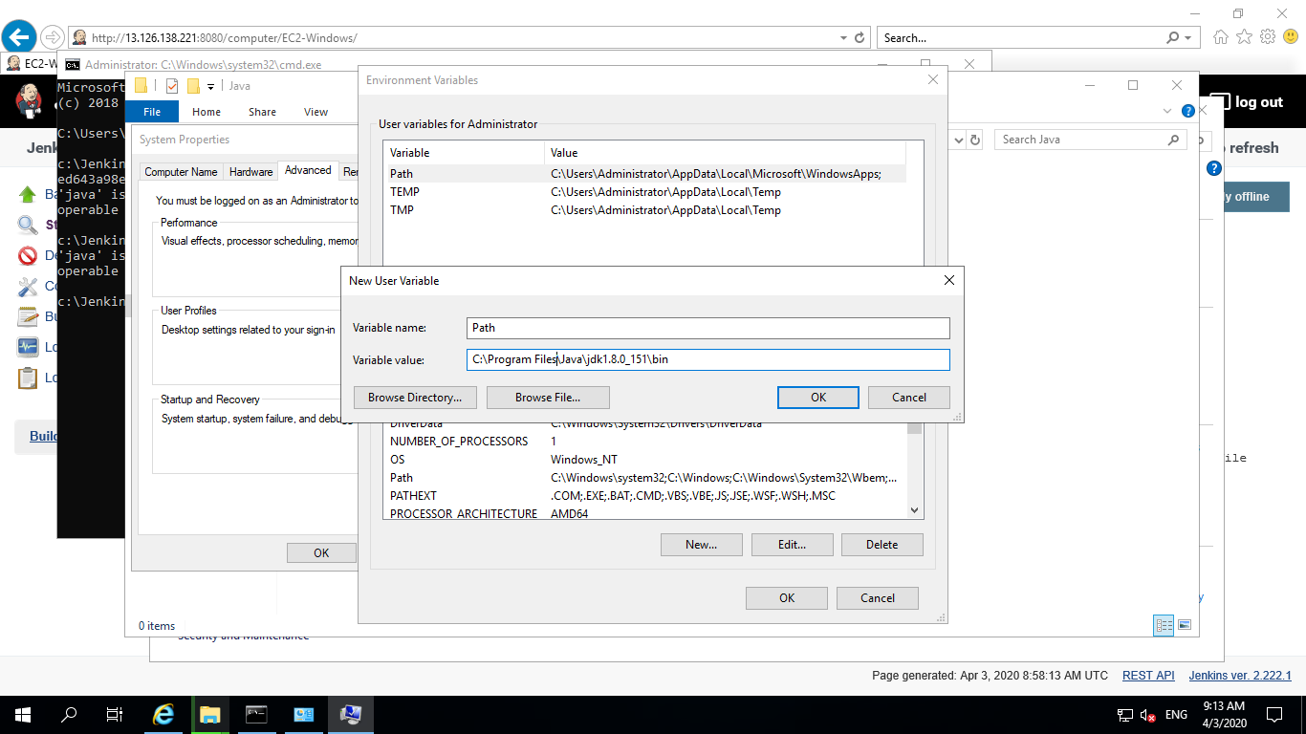

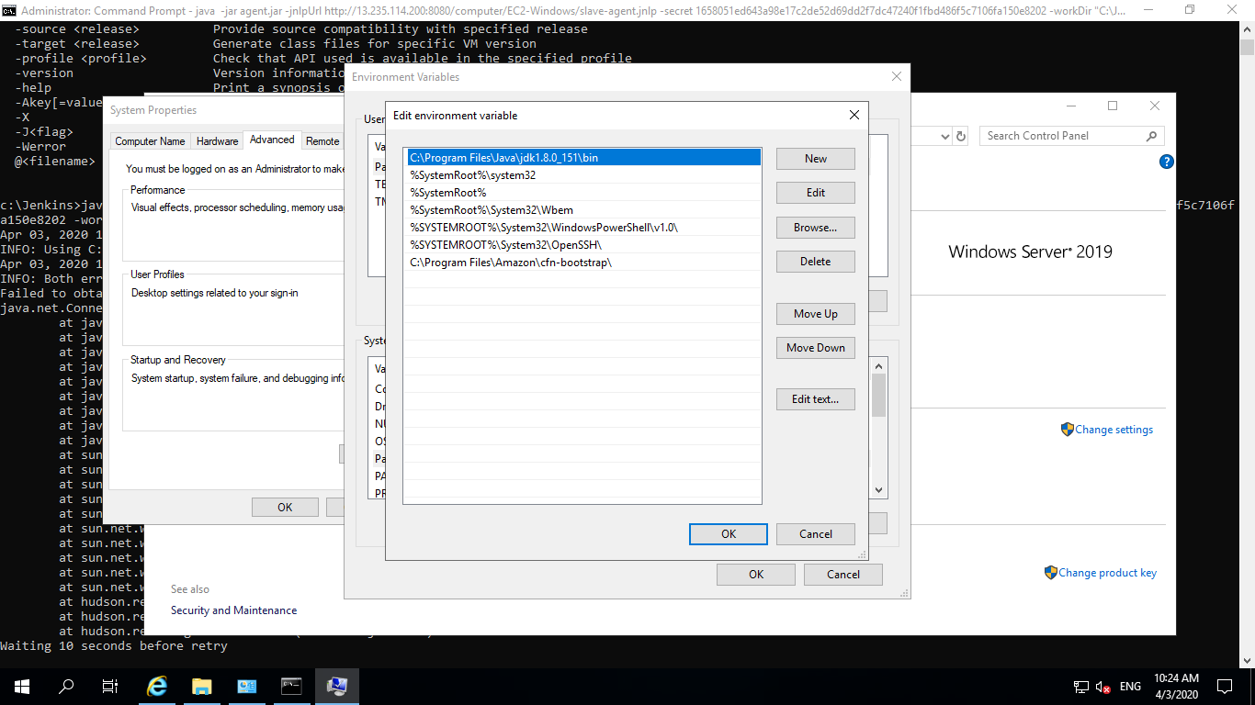

Agent got connected

