The National University of Lesotho
Department of Mathematics and Computer Science
Faculty of Science and technology

CS4433: Software Engineering
Phase 3: System Design
Bakoena Thamae 202321319
BSc Information Systems

Table of Contents
1. Introduction 3
1.1 Design objectives 3
1.2 Design assumptions 4
2. Architectural Design 4
2.1 Selected architectural style: layered architecture 4
2.2 Components and responsibilities 5
2.3 Alternative considered and rejected 5
2.4 Key architecture rules 5
3. Detailed Class Design 6
3.1 Core class specifications 7
3.2 Important relationships and multiplicities 7
4. Design Patterns and SOLID 7
4.1 Strategy pattern — late-penalty policy 7
4.2 Repository / DAO pattern — persistence 8
4.3 SOLID application 8
4.4 Security and integrity decisions 8
5. Behavioural Models 8
5.1 Submission state machine 8
5.2 End-to-end activity with swimlanes 9
5.3 Sequence diagram — Submit assignment 10
5.4 Sequence diagram — Moderate and release marks 11
6. Database Design 12
6.1 ERD and normalisation 12
6.2 Data dictionary 12
6.3 SQL schema (MySQL) 12
6.4 Database constraints and implementation notes 14
6.5 Mapping from classes to tables 15
7. Requirements-to-Design Traceability 15
8. Design Decisions and Limitations 15
References 17

Introduction
This document presents Phase 3—System Design for the Moderated Learning Management System (LMS). It translates the requirements agreed in Phase 2 into an implementable architecture, class structure, behavioural models and relational database design. The system supports Administrator, Lecturer, Head of Department (HoD) and Student roles; runs as a C++17 console or simple desktop application; stores data locally in MySQL; and must work without internet access.
The design follows a layered architecture and uses UML models to describe static structure and dynamic behaviour. The design is intended to be detailed enough to guide implementation and testing, while keeping the system feasible for a single-school, seven-week project. UML is used as a standard modelling language for communicating system structure and behaviour (Object Management Group, 2017).

Design objectives
• Enforce role-based access and keep student marks hidden until HoD moderation and release.
• Support assignment creation, individual extensions, submission versions, late penalties, marking and written feedback.
• Record every mark change with actor, timestamp, old mark, new mark and reason.
• Persist data locally and safely through MySQL repositories using parameterised SQL and transactions.
• Keep business rules testable and independent of the user interface and database implementation.

Architectural Design

Selected architectural style: layered architecture
A layered architecture separates the user interface, application services, domain rules and data access. This is suitable because the LMS has a clear set of business rules and must operate offline on older school computers. It also allows the database or interface to change without rewriting the late-penalty, moderation and access-control rules. Layering supports separation of concerns and makes components easier to test (Sommerville, 2021).
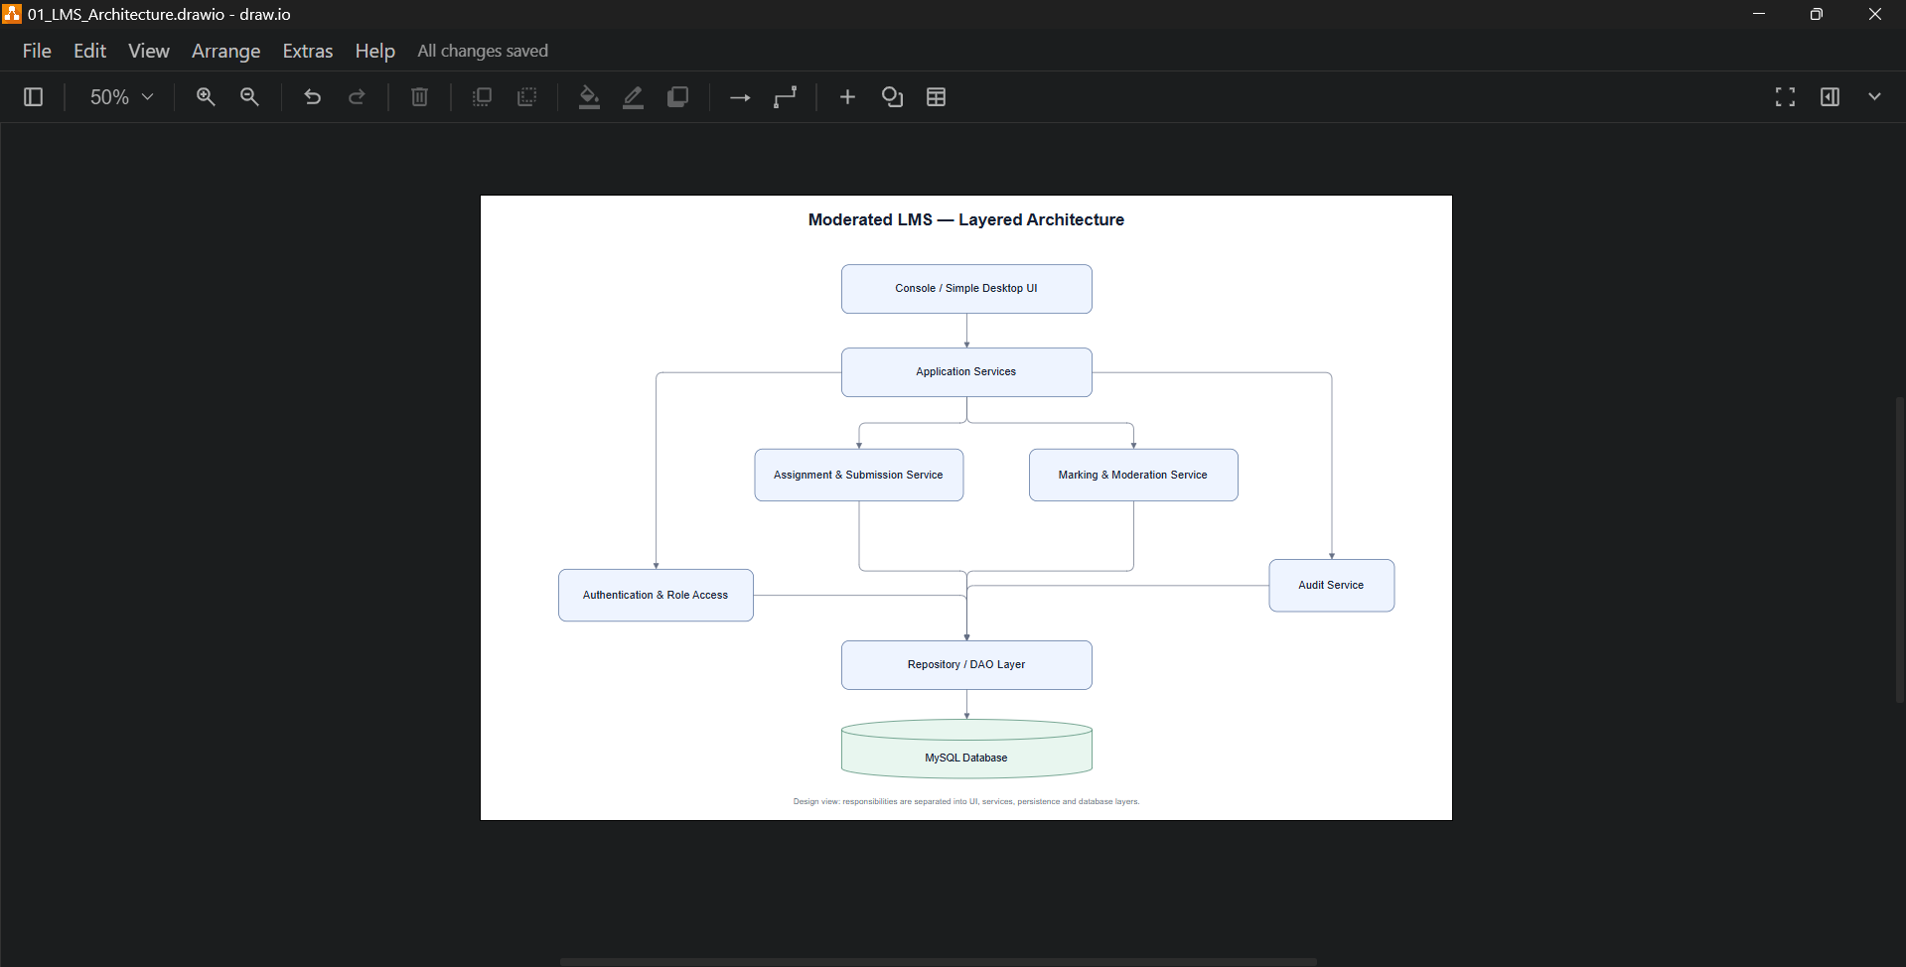
Figure 1. Layered architecture of the Moderated LMS, captured in draw.io.

Alternative considered and rejected
Model–View–Controller (MVC) was considered. MVC can be appropriate for applications with multiple views and complex user-interface interaction, but this project is restricted to a console or simple desktop interface and a short schedule. A layered design provides the needed separation with less presentation-framework overhead. A monolithic design with SQL embedded in menu handlers was also rejected because it would mix concerns, make testing difficult and increase the risk of bypassing access checks or audit logging.

Key architecture rules
• UI calls application services; it does not call MySQL directly.
• Application services obtain the authenticated user context and enforce permissions before reading or changing protected records.
• Repositories accept domain data and return results; they do not decide who is authorised.
• Mark updates and their audit entries are written in the same database transaction.
• Submission versions are retained; a new resubmission creates a new row rather than overwriting the earlier attempt.
• Passwords are stored only as salted hashes produced by a recognised library.

Detailed Class Design
The class model uses an abstract User superclass and four specialised roles. Shared identity and authentication fields belong in User, while role-specific operations remain in application services and role classes. Domain entities capture school concepts; interfaces isolate policies and persistence mechanisms. Visibility uses UML conventions: + public, − private and # protected.
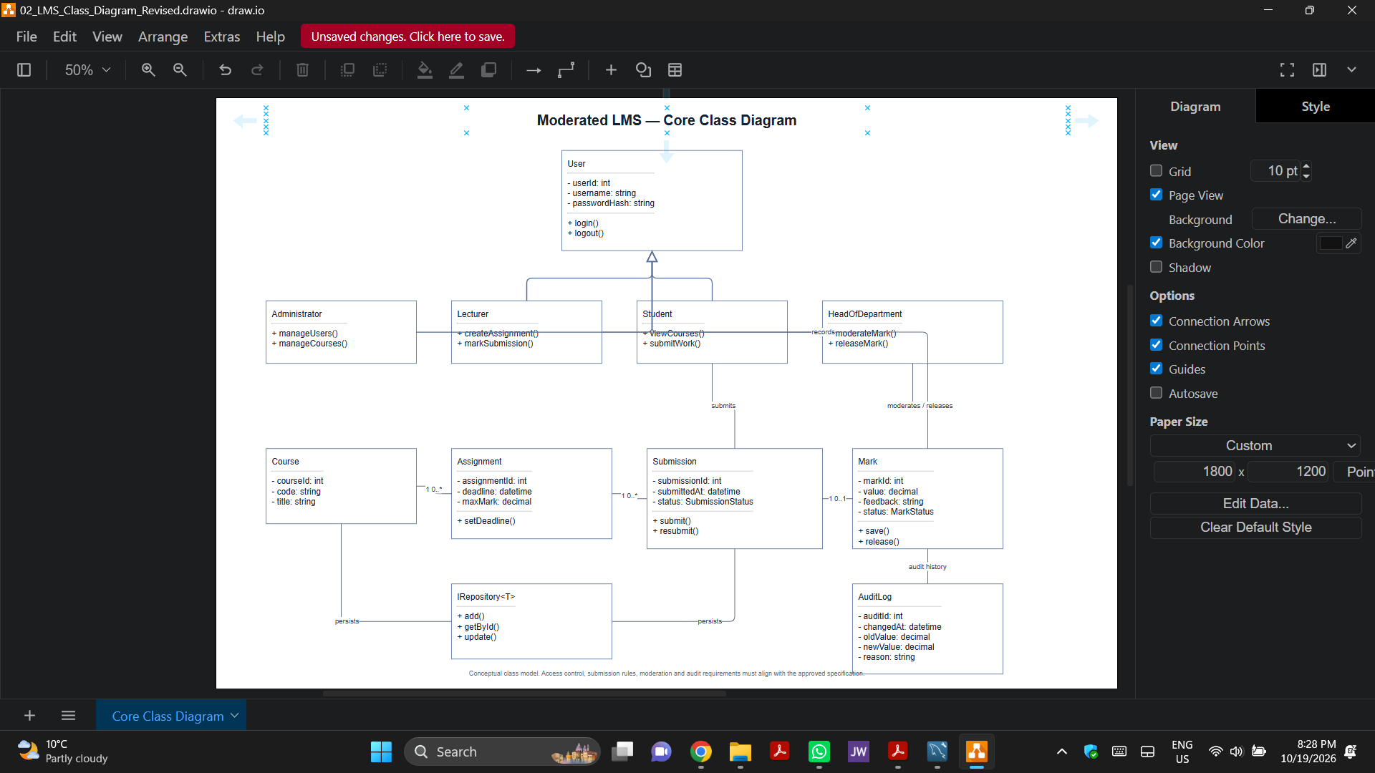
Figure 2. Core class diagram, captured in draw.io.

Important relationships and multiplicities
• One Department has zero or many Courses; each Course belongs to exactly one Department.
• One Course has zero or many Assignments; each Assignment belongs to one Course and is created by an assigned Lecturer.
• Students and Courses have a many-to-many relationship resolved by Enrolment records.
• One Assignment can have many Submission attempts; each attempt belongs to one Student and one Assignment. A unique constraint on (assignment_id, student_id, version_no) prevents duplicate version numbers.
• A Submission has zero or one MarkRecord; a MarkRecord can have many AuditEntry records.
• User-role inheritance expresses shared identity and role-specific specialisation. The role stored in the user record must be validated against the application’s role model.

Design Patterns and SOLID

Strategy pattern — late-penalty policy
The IPenaltyStrategy interface defines the calculation contract, while StandardLatePenalty implements the school’s current rule. SubmissionService or MarkingService receives a strategy rather than hard-coding the formula in UI handlers. This isolates a changeable policy and makes boundary testing straightforward. For the agreed rule, lateDays = 0 yields no penalty; days 1–3 subtract 10% of the assignment maximum per late day; more than 3 days yields zero or is rejected according to the confirmed acceptance rule. An approved extension changes the effective deadline before lateness is calculated.

Repository / DAO pattern — persistence
Repository interfaces such as SubmissionRepository and MarkRepository isolate SQL from domain logic. MySQL implementations use prepared/parameterised statements, enforce foreign keys, and commit related writes atomically. This supports unit tests with fake repositories and protects the application from SQL being scattered throughout menus or business services.

SOLID application

Security and integrity decisions
Access control is enforced in application services for every operation, not merely by hiding menu options. Students may query only their own records; lecturers may act only on assigned courses; HoDs may moderate and release results only for their department; administrators manage system-wide records. Mark changes and audit entries are written within one transaction. If either write fails, the transaction rolls back so an unaudited mark change cannot be committed. Password verification uses a recognised password-hashing library with a unique salt per password; the exact library must be selected and documented during implementation.

Behavioural Models

Submission state machine
The state machine models the lifecycle required by the assignment. State changes are performed by authorised operations and persisted. The design distinguishes a submission that is late from one that has been marked, moderated and released. Resubmission creates a new version and must not erase the historical attempt. The exact treatment of a submission more than three days late must be confirmed: the requirements currently allow a zero outcome under the policy while the SRS also says the system accepts submissions within the permitted late window.
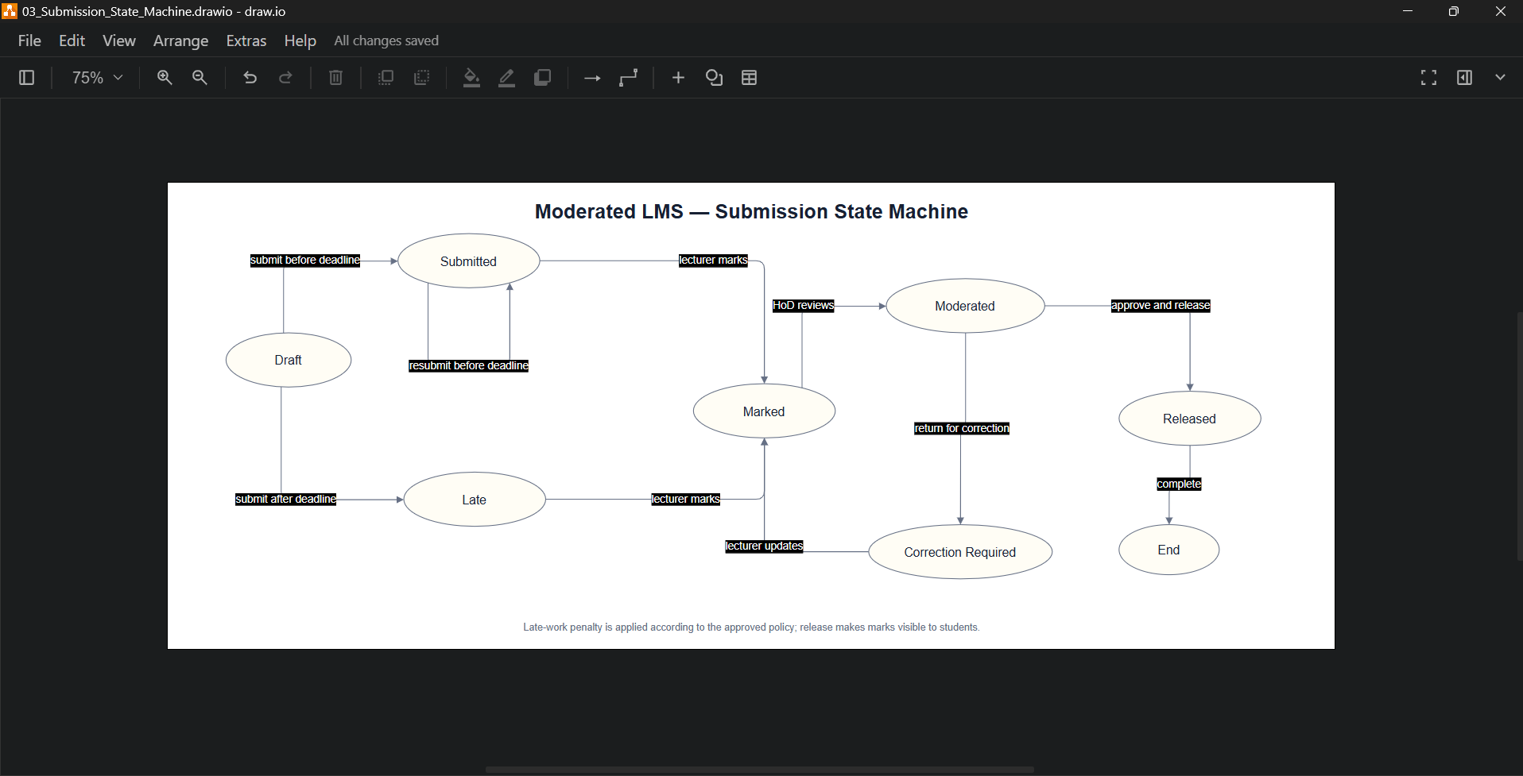
Figure 3. Submission state machine, captured in draw.io.

End-to-end activity with swimlanes
The activity diagram follows work from student submission through system validation, lecturer marking, HoD moderation and final release. It highlights that the system calculates the applicable late policy and keeps marks hidden until the HoD completes release.
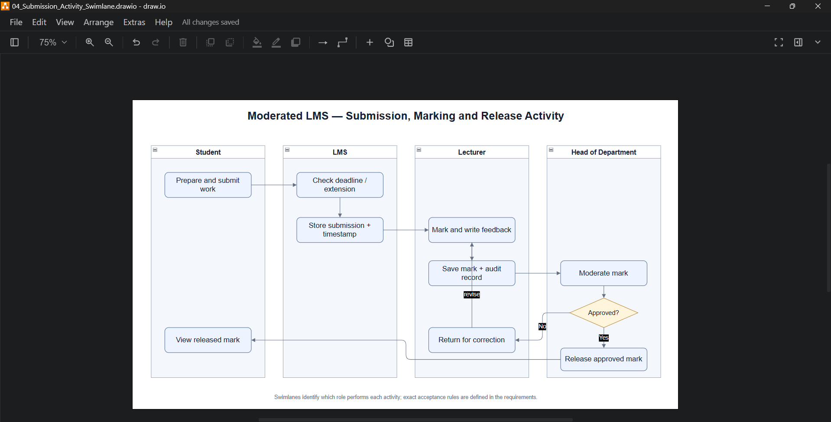
Figure 4. Submission, marking and release activity diagram, captured in draw.io.

Sequence diagram
The submission sequence checks the student identity and enrolment, obtains the effective deadline, determines whether the attempt is on time or late, and stores a new version. The submission repository uses a transaction to persist metadata and status. Invalid files, unauthorised course access, duplicate version numbers or submissions outside the permitted window are rejected with a clear message. Previous attempts remain in history.
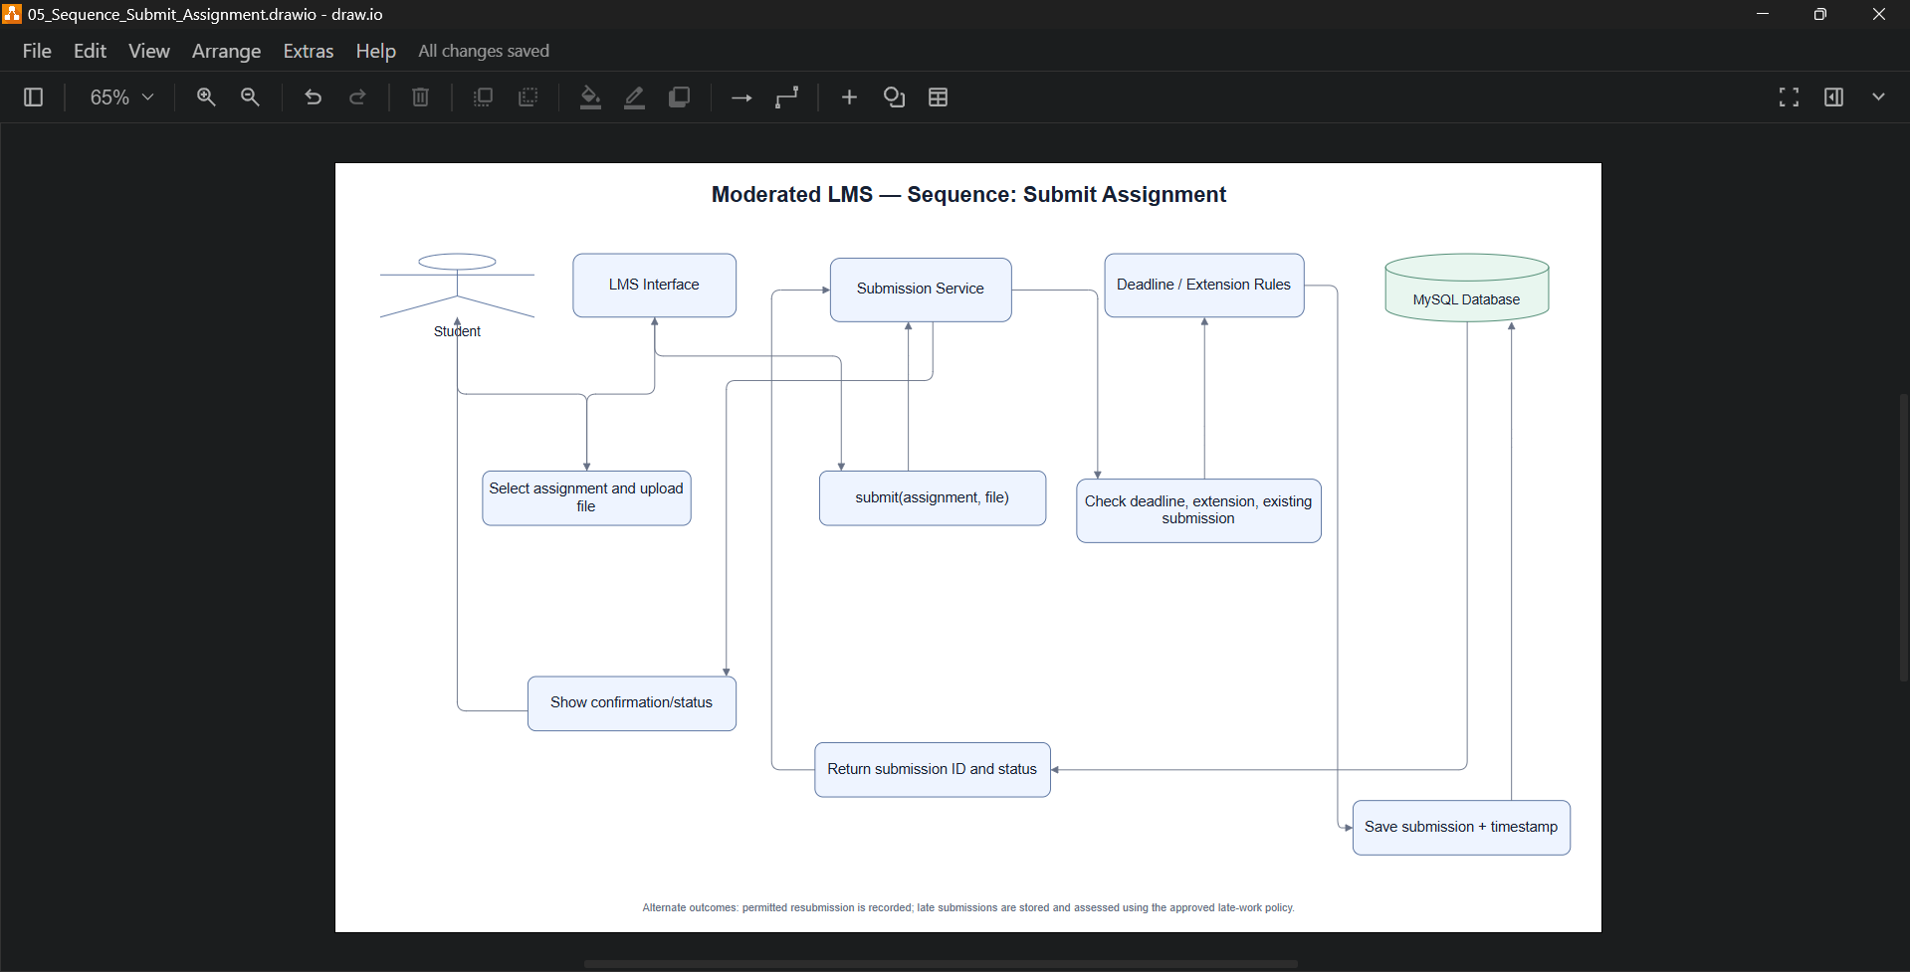
Figure 5. Assignment submission sequence diagram, captured in draw.io.

Sequence diagram — Moderate and release marks
The HoD opens the moderation queue and reviews departmental marks. A decision to amend a mark triggers an audit record containing the actor, time, old value, new value and reason. The mark, moderation status and audit entry are committed together. Release is a separate explicit action; only approved and released results become visible to the corresponding student.
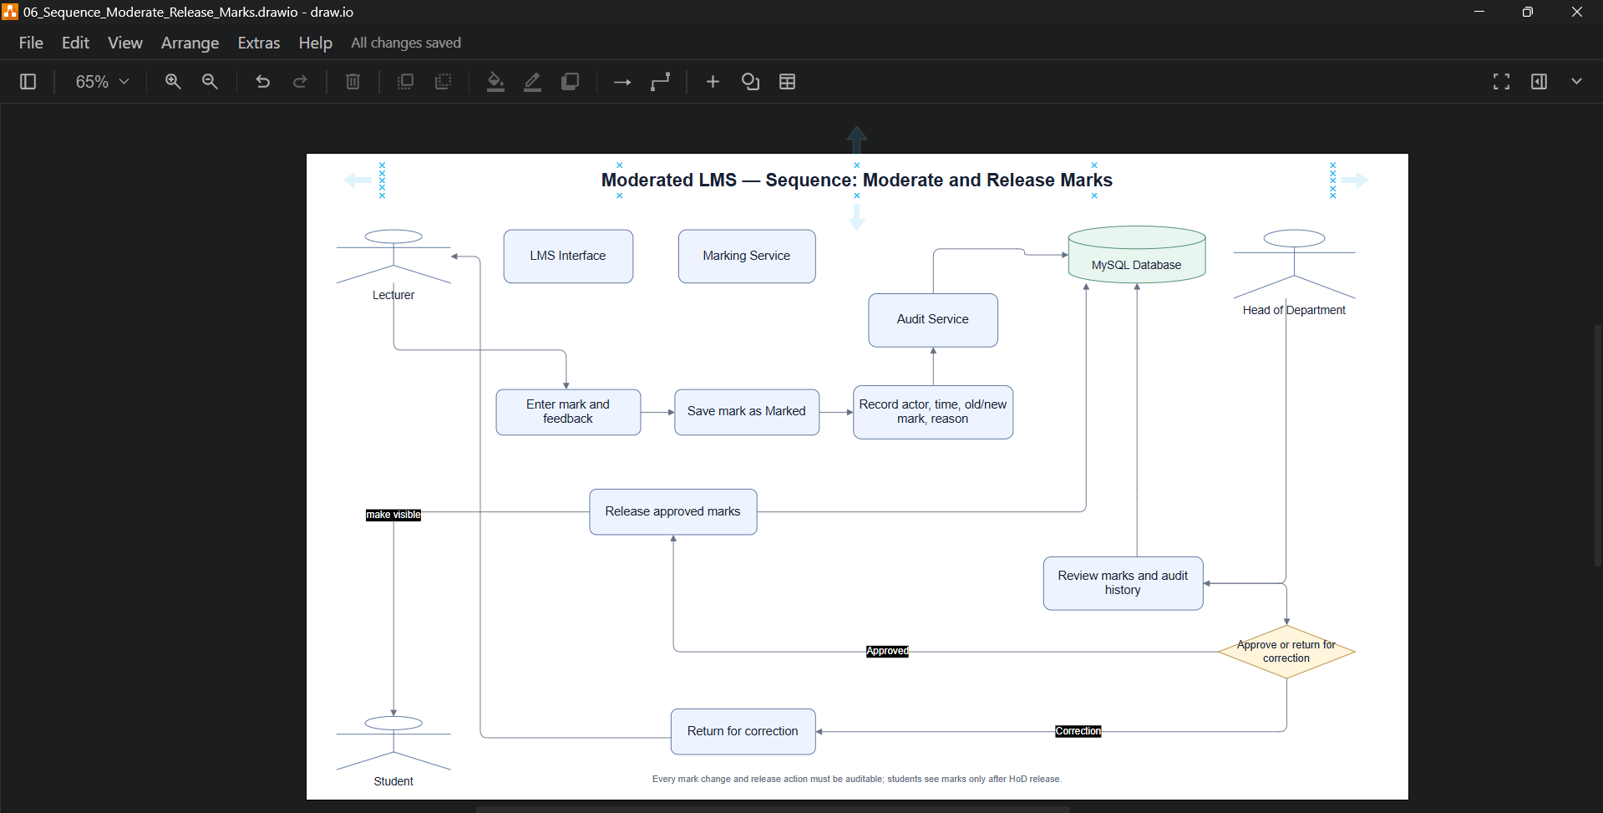
Figure 6. Mark moderation and release sequence diagram, captured in draw.io.

Database Design

ERD and normalisation
The relational schema is designed to Third Normal Form (3NF). Each table represents one entity or relationship; repeating groups are separated into related tables; non-key attributes depend on the key, the whole key and nothing but the key. Enrolments resolve the many-to-many relationship between students and courses. Submission versions are separate rows. Mark changes are recorded in a separate audit table rather than overwriting history.
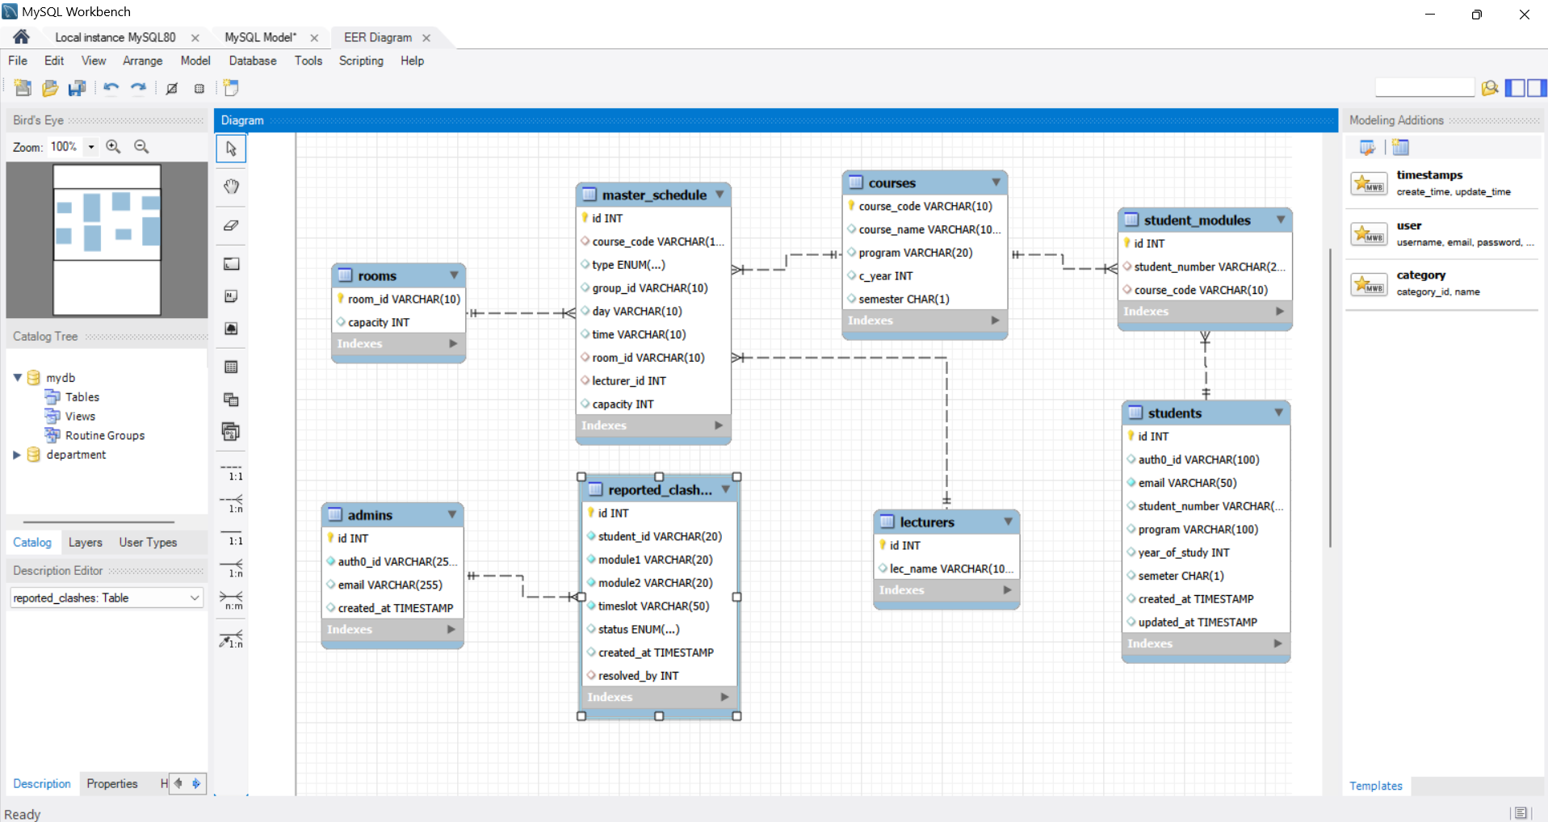
Figure 7. Moderated LMS entity-relationship diagram, captured in MySQL Workbench.

SQL schema (MySQL)
-- CS4433 Phase 3: Moderated LMS database schema
CREATE DATABASE IF NOT EXISTS moderated_lms
CHARACTER SET utf8mb4 COLLATE utf8mb4_0900_ai_ci;
USE moderated_lms;
CREATE TABLE department (
department_id INT AUTO_INCREMENT PRIMARY KEY,
name VARCHAR(100) NOT NULL UNIQUE
) ENGINE=InnoDB;
CREATE TABLE user_account (
user_id INT AUTO_INCREMENT PRIMARY KEY,
department_id INT NULL,
username VARCHAR(80) NOT NULL UNIQUE,
password_hash VARCHAR(255) NOT NULL,
full_name VARCHAR(160) NOT NULL,
email VARCHAR(160) NULL UNIQUE,
role ENUM('ADMINISTRATOR','LECTURER','HOD','STUDENT') NOT NULL,
is_active BOOLEAN NOT NULL DEFAULT TRUE,
created_at DATETIME NOT NULL DEFAULT CURRENT_TIMESTAMP,
CONSTRAINT fk_user_department FOREIGN KEY (department_id)
REFERENCES department(department_id) ON UPDATE CASCADE ON DELETE SET NULL
) ENGINE=InnoDB;
CREATE TABLE course (
course_id INT AUTO_INCREMENT PRIMARY KEY,
department_id INT NOT NULL,
course_code VARCHAR(30) NOT NULL UNIQUE,
title VARCHAR(160) NOT NULL,
description TEXT NULL,
is_active BOOLEAN NOT NULL DEFAULT TRUE,
CONSTRAINT fk_course_department FOREIGN KEY (department_id)
REFERENCES department(department_id) ON UPDATE CASCADE ON DELETE RESTRICT
) ENGINE=InnoDB;
CREATE TABLE lecturer_course (
lecturer_id INT NOT NULL,
course_id INT NOT NULL,
assigned_at DATETIME NOT NULL DEFAULT CURRENT_TIMESTAMP,
PRIMARY KEY (lecturer_id, course_id),
CONSTRAINT fk_lc_lecturer FOREIGN KEY (lecturer_id)
REFERENCES user_account(user_id) ON UPDATE CASCADE ON DELETE RESTRICT,
CONSTRAINT fk_lc_course FOREIGN KEY (course_id)
REFERENCES course(course_id) ON UPDATE CASCADE ON DELETE RESTRICT
) ENGINE=InnoDB;
CREATE TABLE enrolment (
enrolment_id INT AUTO_INCREMENT PRIMARY KEY,
student_id INT NOT NULL,
course_id INT NOT NULL,
enrolled_at DATETIME NOT NULL DEFAULT CURRENT_TIMESTAMP,
UNIQUE KEY uq_student_course (student_id, course_id),
CONSTRAINT fk_enrolment_student FOREIGN KEY (student_id)
REFERENCES user_account(user_id) ON UPDATE CASCADE ON DELETE RESTRICT,
CONSTRAINT fk_enrolment_course FOREIGN KEY (course_id)
REFERENCES course(course_id) ON UPDATE CASCADE ON DELETE RESTRICT
) ENGINE=InnoDB;
CREATE TABLE assignment (
assignment_id INT AUTO_INCREMENT PRIMARY KEY,
course_id INT NOT NULL,
lecturer_id INT NOT NULL,
title VARCHAR(180) NOT NULL,
instructions TEXT NULL,
deadline DATETIME NOT NULL,
max_mark DECIMAL(7,2) NOT NULL,
created_at DATETIME NOT NULL DEFAULT CURRENT_TIMESTAMP,
CONSTRAINT chk_assignment_max_mark CHECK (max_mark > 0),
CONSTRAINT fk_assignment_course FOREIGN KEY (course_id)
REFERENCES course(course_id) ON UPDATE CASCADE ON DELETE RESTRICT,
CONSTRAINT fk_assignment_lecturer FOREIGN KEY (lecturer_id)
REFERENCES user_account(user_id) ON UPDATE CASCADE ON DELETE RESTRICT
) ENGINE=InnoDB;
CREATE TABLE extension_grant (
extension_id INT AUTO_INCREMENT PRIMARY KEY,
assignment_id INT NOT NULL,
student_id INT NOT NULL,
granted_by INT NOT NULL,
revised_deadline DATETIME NOT NULL,
reason VARCHAR(500) NOT NULL,
granted_at DATETIME NOT NULL DEFAULT CURRENT_TIMESTAMP,
UNIQUE KEY uq_extension_assignment_student (assignment_id, student_id),
CONSTRAINT fk_extension_assignment FOREIGN KEY (assignment_id)
REFERENCES assignment(assignment_id) ON UPDATE CASCADE ON DELETE CASCADE,
CONSTRAINT fk_extension_student FOREIGN KEY (student_id)
REFERENCES user_account(user_id) ON UPDATE CASCADE ON DELETE RESTRICT,
CONSTRAINT fk_extension_granted_by FOREIGN KEY (granted_by)
REFERENCES user_account(user_id) ON UPDATE CASCADE ON DELETE RESTRICT
) ENGINE=InnoDB;
CREATE TABLE submission (
submission_id INT AUTO_INCREMENT PRIMARY KEY,
assignment_id INT NOT NULL,
student_id INT NOT NULL,
submitted_at DATETIME NOT NULL DEFAULT CURRENT_TIMESTAMP,
file_name VARCHAR(255) NOT NULL,
file_location VARCHAR(500) NOT NULL,
status ENUM('SUBMITTED','LATE','MARKED','MODERATED','RELEASED') NOT NULL DEFAULT 'SUBMITTED',
version_no INT NOT NULL DEFAULT 1,
CONSTRAINT chk_submission_version CHECK (version_no >= 1),
KEY ix_submission_assignment_student (assignment_id, student_id),
CONSTRAINT fk_submission_assignment FOREIGN KEY (assignment_id)
REFERENCES assignment(assignment_id) ON UPDATE CASCADE ON DELETE RESTRICT,
CONSTRAINT fk_submission_student FOREIGN KEY (student_id)
REFERENCES user_account(user_id) ON UPDATE CASCADE ON DELETE RESTRICT
) ENGINE=InnoDB;
CREATE TABLE mark_record (
mark_id INT AUTO_INCREMENT PRIMARY KEY,
submission_id INT NOT NULL UNIQUE,
lecturer_id INT NOT NULL,
mark_value DECIMAL(7,2) NOT NULL,
feedback TEXT NOT NULL,
moderation_status ENUM('PENDING','RETURNED','APPROVED','RELEASED') NOT NULL DEFAULT 'PENDING',
marked_at DATETIME NOT NULL DEFAULT CURRENT_TIMESTAMP,
moderated_by INT NULL,
moderated_at DATETIME NULL,
released_by INT NULL,
released_at DATETIME NULL,
CONSTRAINT chk_mark_value CHECK (mark_value >= 0),
CONSTRAINT fk_mark_submission FOREIGN KEY (submission_id)
REFERENCES submission(submission_id) ON UPDATE CASCADE ON DELETE RESTRICT,
CONSTRAINT fk_mark_lecturer FOREIGN KEY (lecturer_id)
REFERENCES user_account(user_id) ON UPDATE CASCADE ON DELETE RESTRICT,
CONSTRAINT fk_mark_moderator FOREIGN KEY (moderated_by)
REFERENCES user_account(user_id) ON UPDATE CASCADE ON DELETE RESTRICT,
CONSTRAINT fk_mark_releaser FOREIGN KEY (released_by)
REFERENCES user_account(user_id) ON UPDATE CASCADE ON DELETE RESTRICT
) ENGINE=InnoDB;
CREATE TABLE audit_log (
audit_id BIGINT AUTO_INCREMENT PRIMARY KEY,
mark_id INT NULL,
actor_id INT NOT NULL,
action_type VARCHAR(40) NOT NULL,
changed_at DATETIME NOT NULL DEFAULT CURRENT_TIMESTAMP,
old_value DECIMAL(7,2) NULL,
new_value DECIMAL(7,2) NULL,
reason VARCHAR(500) NULL,
details JSON NULL,
CONSTRAINT fk_audit_mark FOREIGN KEY (mark_id)
REFERENCES mark_record(mark_id) ON UPDATE CASCADE ON DELETE SET NULL,
CONSTRAINT fk_audit_actor FOREIGN KEY (actor_id)
REFERENCES user_account(user_id) ON UPDATE CASCADE ON DELETE RESTRICT
) ENGINE=InnoDB;
CREATE INDEX ix_assignment_course_deadline ON assignment(course_id, deadline);
CREATE INDEX ix_submission_student_status ON submission(student_id, status);
CREATE INDEX ix_mark_moderation_status ON mark_record(moderation_status);

Database constraints and implementation notes
• Use MySQL foreign-key enforcement on every connection (PRAGMA foreign_keys = ON).
• The service layer must validate that user IDs have the expected role and that course/department assignments match the authenticated actor; basic SQL foreign keys alone cannot enforce these role rules.
• Add triggers or restrict direct database access so ordinary application operations cannot update or delete mark_audit records.
• Validate raw_mark and adjusted_mark against the related assignment maximum in application logic or a suitable trigger, because a simple CHECK constraint cannot reference another table.
• Use transactions for marking/moderation operations, and parameterised statements for all values.
• Store timestamps in one consistent ISO-8601 format; define whether late days are calendar or working days before implementation.
• The submission file path should be generated by the application, validated to remain inside the controlled submission directory, and not accepted as an arbitrary filesystem path from user input.

Design Decisions and Limitations
The design provides a clear route to implementation, but some decisions require confirmation before Gate 2 approval. The school should confirm calendar days versus working days for late penalties, how to treat submissions beyond the three-day window (reject versus accept with zero), supported submission file types and maximum file size, and whether a moderated mark can be changed after release. The assignment also requires all mark changes to be auditable; the implementation should record the reason for each change and avoid deleting historical entries.
The SQL schema is a baseline design. Additional database constraints, triggers, indexes and error-handling will be refined during implementation and testing. Role-specific validation (for example, confirming that a lecturer is assigned to a course) must be performed by application services and cannot be guaranteed by the basic foreign keys alone.

References
International Organization for Standardization and International Electrotechnical Commission (ISO/IEC/IEEE) (2018) ISO/IEC/IEEE 29148:2018 Systems and software engineering — Life cycle processes — Requirements engineering. Geneva: ISO. Available at: https://www.iso.org/standard/72089.html (Accessed: 19 October 2026).
Object Management Group (2017) OMG Unified Modeling Language (OMG UML), Version 2.5.1. Available at: https://www.omg.org/spec/UML/2.5.1 (Accessed: 19 October 2026).
Sommerville, I. (2016) Software Engineering. 10th edn. Boston: Pearson.
Tool evidence: Figures 1–6 are screenshots showing the diagrams open in draw.io. The supplied MySQL Workbench screenshot confirms use of Workbench, but it displays a different schema (including rooms, master_schedule and student_modules), not the Moderated LMS tables. It is therefore included below only as application evidence and must not be treated as the LMS ERD.
ERD completion note: The Moderated LMS ERD must be generated in MySQL Workbench from the supplied 07_MySQL_ERD_Schema.sql file and exported for insertion as Figure 7 before final submission.

