THE NATIONAL UNIVERSITY OF LESOTHO
Department of Mathematics and Computer Science
Faculty of Science and Technology

CS4433: SOFTWARE ENGINEERING

PHASE 2: REQUIREMENTS ENGINEERING
Moderated Learning Management System (LMS)

Bakoena Thamae | 202321319
BSc Information Systems

Contents
- 1. Introduction
- 2. Stakeholder Analysis
- 3. Conflict and Ambiguity Resolution
- 4. Software Requirements Specification
- 5. Use Case Model
- 6. Fully Dressed Use Case Specifications
- References

1. Introduction
This document presents Phase 2—Requirements Engineering for the Moderated Learning Management System (LMS) proposed for a secondary school. It follows the CS4433 individual assignment and builds on the Phase 1 project management plan (National University of Lesotho, 2026). The specification is structured around identifiable, verifiable requirements and traceability, consistent with recognised requirements-engineering guidance (ISO/IEC/IEEE, 2018).
The four actors are Administrator, Lecturer, Head of Department (HoD) and Student. The system is a C++17 console or simple desktop application using SQLite on a school computer or local network, and must operate offline. Online payment, video conferencing, automated grading, plagiarism detection and web/mobile interfaces are outside the agreed scope (National University of Lesotho, 2026).
This phase identifies stakeholders, resolves conflicting statements, specifies functional and non-functional requirements using MoSCoW priorities, and defines use cases with fully dressed specifications.

2. Stakeholder Analysis
Stakeholder | Interests / needs | Influence | Requirements implications
Principal | Simple system; students must not see marks before HoD checks them. | High | Prioritise usability and HoD approval before release.
Administrator | Manage accounts, departments, courses, lecturer assignment and enrolment. | High | Provide system-wide user and academic-structure management.
Lecturer | Create assignments, deadlines/max marks, grant extensions, mark work and provide feedback. | High | Support assignment, extension, marking and feedback workflows.
Head of Department (HoD) | Review/moderate departmental marks, apply late policy and release approved results. | High | Provide moderation queue, late rules and release control.
Students | View enrolled courses, submit/resubmit, receive written feedback and have late work handled consistently. | Medium–High | Support submission versions, feedback and controlled result visibility.
IT Officer | Offline operation, protected passwords, old computers and acceptable response with 800 students stored. | High | Use local storage, secure hashes, role access and measurable performance.
Project supervisor | Complete and consistent requirements evidence for Gate 1. | High | Provide unique IDs, priorities, verification criteria and documented decisions.

3. Conflict and Ambiguity Resolution
ID | Conflict / ambiguity | Resolution adopted | Reason
C1 | Lecturer wants immediate marks; Principal requires HoD checking first. | Marks remain unreleased after lecturer marking. Students see them only after HoD moderation and explicit release. | Preserves school approval control.
C2 | Students want late work accepted; HoD states 10% per late day up to 3 days, then zero. | Accept late work up to three calendar days after the effective deadline; deduct 10% of the assignment maximum per late day; beyond three days receives zero under the rule. | Makes the rule testable. Confirm calendar vs working days with stakeholders.
C3 | Extensions are allowed, but process/effect is unclear. | Only the Lecturer assigned to the course may record an individual extension, revised deadline and reason. The revised deadline becomes the effective deadline for that Student. | Defines authority and makes the change auditable.
C4 | Resubmission is allowed before deadline, but number of attempts is unspecified. | Allow multiple resubmissions before the effective deadline; latest version is active and earlier versions remain in history. | Supports corrections while preserving evidence.
C5 | ‘Respond quickly’ is vague. | Propose that 95% of common read operations complete within 2 seconds with 800 student records stored on target hardware. | Provides a measurable acceptance criterion.
C6 | Audit detail is not fully stated. | Each mark change records actor, timestamp, old mark, new mark and reason; normal user functions cannot edit/delete audit records. | Supports accountability.
C7 | Access to courses/results is unclear. | Students see only their enrolments/results; Lecturers access assigned courses; HoDs access their department; Administrators manage system-wide records. | Applies least privilege.

4. Software Requirements Specification

4.1 Purpose, scope and priorities
Requirements are uniquely identified and verifiable. This follows the principle that requirements should be clear, traceable and capable of verification (ISO/IEC/IEEE, 2018). MoSCoW means Must (essential), Should (important but not essential to the minimum viable release), and Could (desirable if time permits). Verification may use inspection, demonstration or testing, as appropriate (Sommerville, 2016).

4.2 Functional requirements
ID | Function | Requirement statement | Priority | Verification / acceptance
FR-01 | Authentication | The system shall allow each registered user to log in using a unique username and password. | Must | Valid credentials succeed; invalid credentials are rejected.
FR-02 | Role-based access | The system shall restrict each user to operations allowed for Administrator, Lecturer, HoD or Student. | Must | All defined role-permission tests deny unauthorised operations.
FR-03 | User administration | Administrator shall create, view, update, deactivate and assign roles to accounts. | Must | Verify each operation; deactivated users cannot log in.
FR-04 | Academic structure | Administrator shall create/update departments and courses and associate each course with a department. | Must | Create/update sample records and inspect them.
FR-05 | Assignment/enrolment | Administrator shall assign Lecturers to courses and enrol Students in courses. | Must | Membership records reflect the changes.
FR-06 | View courses | Students shall see only enrolled courses and their assignments. | Must | Displayed list matches enrolment records.
FR-07 | Create assignment | Assigned Lecturer shall create an assignment with title, description, deadline and maximum mark greater than zero. | Must | Valid assignment saves; invalid required fields/maximum mark are rejected.
FR-08 | Grant extension | Assigned Lecturer shall record an individual extension, revised deadline and reason. | Must | Only the selected Student's effective deadline changes.
FR-09 | Submit assignment | Student shall submit work before or within the permitted late window, subject to the effective deadline and late rule. | Must | Test on-time, late and beyond-window cases.
FR-10 | Resubmit assignment | Student shall replace the active submission before the effective deadline; earlier versions shall be retained. | Must | Latest version active; prior versions remain retrievable.
FR-11 | Late penalty | System shall deduct 10% of assignment maximum per late day for up to three days; after three days the mark is zero. | Must | Test 0, 1, 2, 3 and more-than-3-day boundaries.
FR-12 | Mark/feedback | Assigned Lecturer shall enter a mark within range and written feedback. | Must | Reject mark below 0 or above maximum; feedback is saved.
FR-13 | Moderate marks | HoD shall review departmental marks and record a moderation decision before release. | Must | Unmoderated marks cannot be released.
FR-14 | Release marks | HoD shall release approved marks; only then can the relevant Student view them. | Must | Unreleased marks hidden; released marks visible to correct Student.
FR-15 | Audit mark changes | System shall log user, date/time, old mark, new mark and reason for every mark change. | Must | Change a mark and inspect all audit fields.
FR-16 | View results | Students shall view only their own released marks and feedback. | Must | Cross-account and pre-release visibility tests pass.
FR-17 | Submission states | System should track Submitted, Late, Marked, Moderated and Released states. | Should | Exercise workflow and inspect valid state transitions.
FR-18 | Work queues | System should list submissions awaiting marking/moderation for the relevant Lecturer/HoD. | Should | Pending items appear only for authorised staff.

4.3 Non-functional requirements
ID | Attribute | Measurable requirement | Priority | Verification
NFR-01 | Performance | 95% of common login, course-list and assignment-list operations shall finish within 2 seconds with 800 student records on target hardware. | Must | Timed test with representative database.
NFR-02 | Offline operation | Login, course viewing, assignment creation, submission, marking, moderation and result viewing shall work without internet access. | Must | Disconnect internet and complete workflow.
NFR-03 | Password protection | System shall not store plain-text passwords; it shall store salted hashes using a recognised password-hashing library. | Must | Inspect database and hashing implementation.
NFR-04 | Access control | 100% of defined unauthorised role-permission test cases shall be denied before data is read or changed. | Must | Run role-permission test matrix.
NFR-05 | Data integrity | Marks shall be constrained to 0..maximum; required fields and foreign-key relationships shall be validated; failed transactions shall not leave partial records. | Must | Invalid-input and transaction-failure tests.
NFR-06 | Auditability | Every mark change shall create an audit record with actor, timestamp, old/new mark and reason; ordinary users cannot edit/delete records through the app. | Must | Audit and unauthorised-change tests.
NFR-07 | Usability | A first-time user following the role guide shall complete login and one primary role task within 5 minutes without developer help. | Should | Observe at least one representative user per role.
NFR-08 | Compatibility | Application shall build as C++17 from a clean checkout and run on the designated school computer without a browser. | Must | Clean build and target-machine smoke test.
NFR-09 | Recoverability | A valid local database backup shall be restorable within 15 minutes on the target computer using the documented procedure. | Should | Timed restore test.

4.4 Business rules and assumptions
- BR-01: Students access only their own enrolments, submissions, marks and feedback.
- BR-02: Lecturers manage assignments, extensions and marking only for assigned courses.
- BR-03: HoDs moderate/release marks for courses in their department.
- BR-04: Marks remain hidden until HoD moderation and release.
- BR-05: Late penalty is 10% of assignment maximum per late day for up to three days; later work receives zero. Calendar days are assumed pending stakeholder confirmation.
- BR-06: Approved individual extension replaces the original deadline for that Student.
- BR-07: Latest submission before the effective deadline is active; previous attempts remain in history.
- BR-08: Online payment, video conferencing, automated grading, plagiarism detection and web/mobile interfaces are out of scope.

4.5 Traceability overview
Stakeholder need | Related requirements
Simple for non-technical teachers | NFR-07, NFR-08
No student marks before HoD approval | FR-13, FR-14, FR-16, BR-04
Lecturer assignments/extensions/marking | FR-07, FR-08, FR-12
Late work and resubmission | FR-09, FR-10, FR-11, BR-05–BR-07
Offline and old computer constraints | NFR-01, NFR-02, NFR-08
Password protection and audit trail | NFR-03, NFR-04, NFR-06, FR-15
Manage users and courses | FR-03, FR-04, FR-05

5. Use Case Model
The diagram covers all four required actors and the main LMS functions. It uses standard UML use-case notation: actors represent external roles, ellipses represent system functions, and the system boundary separates the LMS from its environment (Object Management Group, 2017). The use cases are derived from the assignment case study (National University of Lesotho, 2026). The separate .drawio file is editable in diagrams.net/draw.io.

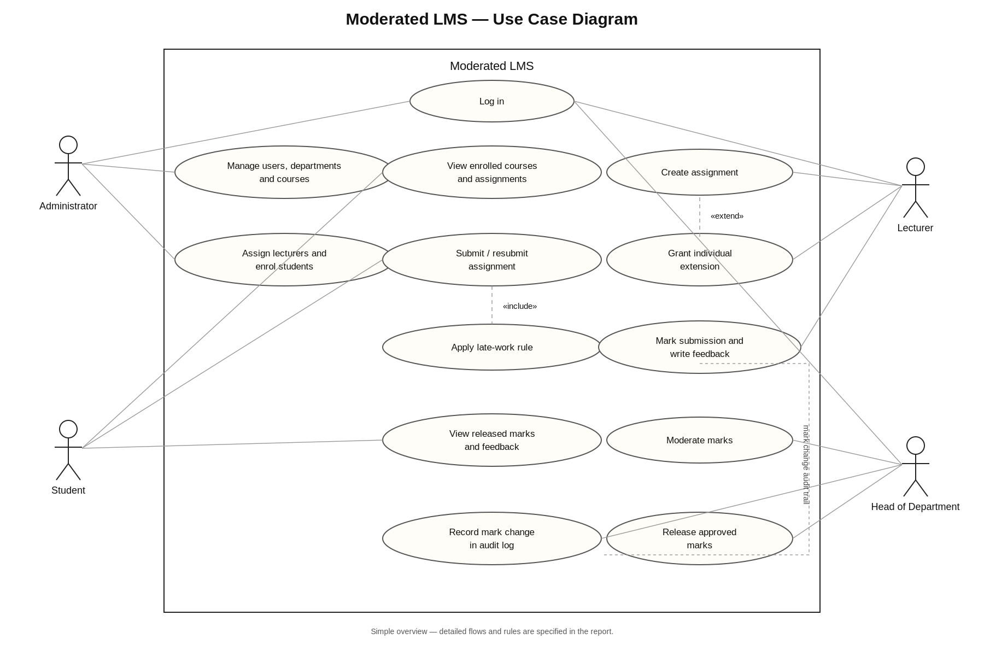
Figure 1. Moderated LMS use case diagram. Editable source: CS4433_Phase_2_Use_Case_Diagram.drawio.

References
International Organization for Standardization and International Electrotechnical Commission (ISO/IEC/IEEE) (2018) ISO/IEC/IEEE 29148:2018 Systems and software engineering — Life cycle processes — Requirements engineering. Geneva: ISO. Available at: https://www.iso.org/standard/72089.html (Accessed: 11 October 2026).
National University of Lesotho, Department of Mathematics and Computer Science (2026) CS4433 – Software Engineering – Individual Assignment: Moderated Learning Management System. Maseru: National University of Lesotho.
Object Management Group (2017) OMG Unified Modeling Language (OMG UML), Version 2.5.1. Available at: https://www.omg.org/spec/UML/2.5.1 (Accessed: 11 October 2026).
Sommerville, I. (2016) Software Engineering. 10th edn. Boston: Pearson.

