The National University of Lesotho
Department of Mathematics and Computer Science
Faculty of Science and technology

CS4433: Software Engineering
Phase 1: Project Planning and Management
Bakoena Thamae 202321319
BSc Information Systems

Contents
1. Introduction 3
2. Feasibility Study 4
2.1 Technical Feasibility 4
2.2 Operational Feasibility 5
2.3 Economic Feasibility 5
2.4 Legal Feasibility 5
2.5 Schedule Feasibility 6
2.6 Economic Planning Assumptions 6
2.7 Feasibility Recommendation 7
3. Work Breakdown Structure and Project Schedule 7
3.1 Detailed WBS 8
3.2 Seven-Week Schedule 10
3.3 Dependencies 12
3.4 Milestones and Phase Gates 12
3.5 Critical Path 13
4. Risk Management 13
References 16

1. Introduction
This Phase 1 project management plan presents the planning basis for the Moderated Learning Management System (LMS) proposed for a secondary school. The project will be developed over seven weeks using the Waterfall Model with V-Model verification and validation.
The proposed LMS will manage courses, assignments and assessment for four user roles: Administrator, Lecturer, Head of Department (HoD) and Student. The system is specified as a C++17 application using SQLite for persistent storage and operating on a single school computer or local network. It must work offline, protect passwords, enforce role-based access, maintain assessment records and provide acceptable response time for the expected user population. This phase therefore evaluates feasibility, decomposes the work into a WBS and schedule, and identifies the major project risks.
The Administrator manages users, departments, courses and enrolments; the Lecturer creates assignments, grants individual extensions, marks submissions and provides feedback; the HoD reviews and moderates marks and releases approved marks; and the Student views courses and assignments, submits and resubmits work before the deadline, and views released marks and feedback.
The system must operate offline because the school has unreliable internet access. It must protect passwords and provide acceptable response time with up to 800 students stored in the system. The project follows the Waterfall Model.

2. Feasibility Study
A feasibility study determines whether the proposed system is worthwhile and whether it can be engineered using available technology, resources and constraints. We are going to assess the technical, operational, economic, legal and schedule feasibility before proceeding.

2.1 Technical Feasibility
The project is technically feasible because the prescribed technology stack is appropriate for a local application. C++17 provides object-oriented language features required for the design, SQLite provides local persistent storage, CMake can manage the build process, Git provides version control, and GoogleTest or Catch2 can support automated testing. The offline requirement also makes a local database suitable. The main technical concerns are secure password handling, database integration, performance with approximately 800 students, input validation and reliable audit logging. These concerns can be controlled through layered design, parameterised database access, testing and security controls.

2.2 Operational Feasibility
The system is operationally feasible because its functions correspond directly to school assessment activities. Role-based access separates administrative, lecturer, HoD and student responsibilities. The Principal's concern that teachers are not IT experts means that simplicity and ease of use should be treated as important operational requirements. User documentation and basic training will be required. The offline design also fits the stated operating environment.

2.3 Economic Feasibility
The project is economically feasible because the assignment specifies technologies that can be used without purchasing a commercial database or development environment. SQLite is suitable for local persistent storage, while Git and common testing/static-analysis tools can be used at low or no software-licence cost. Existing school computers are assumed to be available. The main costs are therefore development time, electricity, training, documentation and contingency rather than major software procurement.

2.4 Legal Feasibility
The system is legally feasible provided that personal and academic information is protected and access is restricted to authorised users. Passwords must not be stored as plain text. Assessment records require integrity and accountability, and the system must maintain an audit trail for mark changes. The final system should be reviewed against applicable data-protection and privacy requirements in Lesotho and the school's information-management policies. This document does not claim that a particular legal compliance assessment has already been completed.

2.5 Schedule Feasibility
The project is schedule-feasible within the prescribed seven weeks if the team follows the planned dependencies and phase gates. Planning occurs in Week 1, requirements span Weeks 1–2, design spans Weeks 2–3, implementation occurs in Weeks 4–5, verification and validation in Weeks 5–6, deployment in Week 6, and maintenance/completion in Week 7. Configuration management and quality assurance are treated as ongoing activities. The largest schedule threats are requirements delays, technical integration problems and insufficient time for defect correction.

2.6 Economic Planning Assumptions
Cost item | Planning assumption | Estimated cash cost (M)
Development tools | Open-source/free tools where possible | 0
Database | SQLite | 0
Version control | Git/GitHub tooling | 0
Testing/static analysis | GoogleTest/Catch2 and cppcheck/clang-tidy | 0
Development resources | Electricity/data allowance | 500
Training/documentation | User training and printed documentation | 300
Contingency | Unallocated planning reserve | 200
Total | Preliminary planning estimate | 1,000

The amounts above are planning assumptions rather than quotations or confirmed procurement costs. They are included to demonstrate economic feasibility; actual costs should be replaced with verified figures if the school requires a financial budget.

2.7 Feasibility Recommendation
Recommendation: PROCEED. The proposed LMS is feasible under the constraints in the case study. The recommendation is conditional on maintaining the seven-week schedule, controlling scope, implementing appropriate security, testing performance for the expected data volume, and providing sufficient usability support for non-technical staff.

3. Work Breakdown Structure and Project Schedule
The Work Breakdown Structure decomposes the project into manageable deliverables and activities. It provides the basis for assigning responsibilities, estimating work and constructing the schedule.
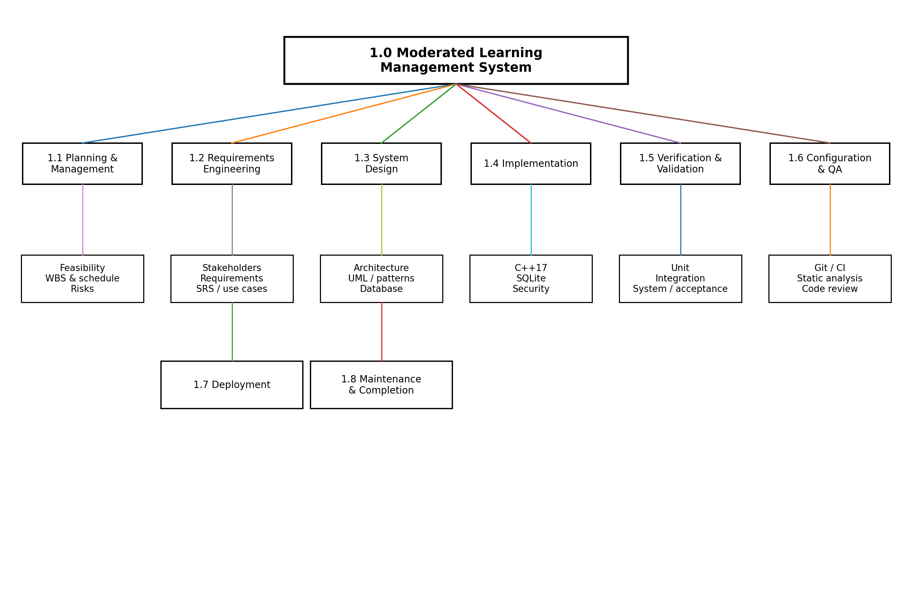
Figure 1: Work Breakdown Structure for the Moderated LMS project.

3.1 Detailed WBS
WBS ID | Work package | Main tasks
1.1 | Project Planning and Management | Feasibility study; project scope; WBS; schedule; risk register
1.2 | Requirements Engineering | Stakeholder analysis; requirements collection; conflict resolution; SRS; use case model
1.3 | System Design | Architecture; UML design; design patterns; database design; design document
1.4 | Implementation | C++17; authentication; role management; courses; assignments; submissions; marking; moderation; SQLite
1.5 | Verification and Validation | Test plan; unit; integration; system; acceptance testing; defect correction
1.6 | Configuration Management and QA | Git; branching; CI; code review; static analysis
1.7 | Deployment | Packaging; installation guide; user manuals; release v1.0
1.8 | Maintenance and Completion | CR1 analysis; v1.1 changes; regression testing; final report; viva
The WBS deliberately includes configuration management and quality assurance as a work package that runs throughout the project rather than treating quality as a single activity at the end.

3.2 Seven-Week Schedule
The assignment prescribes a seven-week schedule. The schedule below uses a simple Microsoft Excel-style Gantt chart layout to show task timing, duration, milestones and the critical delivery chain.
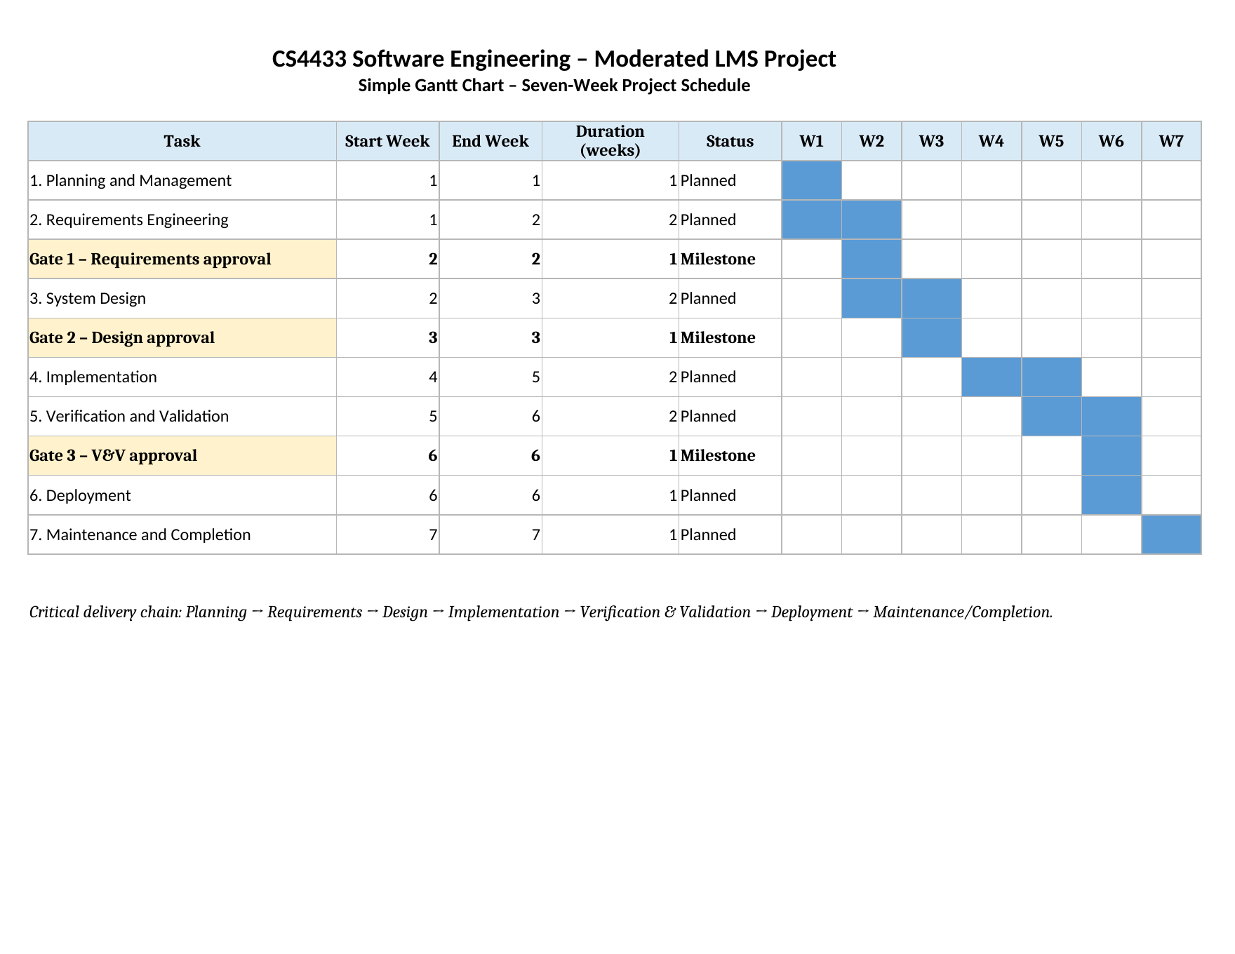
Figure 2: Simple Excel-style seven-week Gantt chart with phase gates and the critical delivery chain.
Activity | Week(s) | Deliverable / work | Dependency
Planning and management | 1 | Feasibility, WBS, schedule, risk register | Project initiation
Requirements engineering | 1–2 | Stakeholder analysis, conflict resolution, SRS, use case model | Planning
System design | 2–3 | Architecture, UML, patterns, database design | Requirements
Implementation | 4–5 | C++ development, SQLite, CI, code reviews | Approved design / Gate 2
Verification & validation | 5–6 | Unit, integration, system, acceptance testing | Working implementation
Configuration management & QA | 1–6 | Git, CI, static analysis, code review | Starts with project
Deployment | 6 | Packaging, installation guide, user manuals, v1.0 | Successful testing
Maintenance & completion | 7 | CR1, impact analysis, v1.1, regression, final report, viva | v1.0 deployment

3.3 Dependencies
- Requirements engineering depends on the initial project planning because the scope and feasibility must be understood before detailed requirements work begins.
- System design depends on the requirements artefacts produced during Phase 2.
- Implementation cannot begin until the design has passed Gate 2, as required by the assignment.
- Verification and validation depend on a working implementation and the requirements/design artefacts that define expected behaviour.
- Deployment depends on successful testing and completion of the release documentation.
- Maintenance follows the initial release and uses the prescribed CR1 change request.

3.4 Milestones and Phase Gates
ID | Milestone | Target | Expected evidence
M1 | Planning completed | End of Week 1 | Project management plan
M2 | Gate 1 – Requirements ready | End of Week 2 | Stakeholder analysis, SRS and use case model
M3 | Gate 2 – Design approved | End of Week 3 | Software design document
M4 | Implementation completed | End of Week 5 | Working C++ application
M5 | Gate 3 – Testing completed | End of Week 6 | Test results and defect log
M6 | Release v1.0 | End of Week 6 | Deployment package and manuals
M7 | Project completion | End of Week 7 | v1.1, final report and viva

3.5 Critical Path
The critical path is the sequence of dependent activities that determines the minimum project completion time. For planning purposes, the principal dependency chain is:
Planning → Requirements → Design → Implementation → Testing → Deployment → Maintenance/Completion
Because these activities form the main delivery chain, a delay in a critical activity can delay the overall seven-week completion date. Configuration management and quality assurance run in parallel and support the chain. The critical path should be recalculated if actual task durations change.

4. Risk Management
Risk management is included as a formal Phase 1 deliverable. The assignment requires at least six risks covering technical, project and people concerns, with likelihood, impact, exposure, mitigation and an owner, and requires the register to be updated at each phase gate. (Sommerville, 2021)
ID | Risk | Category | L | I | Exposure | Mitigation | Owner
R1 | Limited C++17/SQLite knowledge | Technical | 3 | 4 | 12 | Use small prototypes; consult documentation; peer review difficult components. | Developer
R2 | Database integration defects | Technical | 3 | 4 | 12 | Design schema early; test database access separately; use a data-access layer. | Developer
R3 | Performance problems with 800 students | Technical | 3 | 5 | 15 | Optimise queries; use indexes where justified; conduct performance testing. | Developer
R4 | Seven-week schedule slippage | Project | 4 | 5 | 20 | Track weekly progress; prioritise Must-have work; resolve blockers quickly. | Project Manager
R5 | Uncontrolled scope change | Project | 3 | 4 | 12 | Freeze approved scope; evaluate change requests for impact before acceptance. | Project Manager
R6 | Unauthorised access or loss of assessment data | Technical | 3 | 5 | 15 | Role-based access; salted password hashes; backups; audit logging; security testing. | Developer / Security
R7 | User resistance or limited IT skills | People | 3 | 3 | 9 | Simple interface; training; user manual; early user feedback. | Project Manager
R8 | Stakeholder misunderstanding/conflict | People | 3 | 4 | 12 | Structured elicitation; documented decisions; review and sign-off at Gate 1. | Requirements Analyst

References
- Sommerville, I. (2021) Software Engineering, 10th edition. Harlow: Pearson.

