## REQUIREMENTS DOCUMENTATION (WORK IN PROGRESS)

**High-Level Use Case**

1. ***Perform Search***

*Sub Use Cases:

1.1 Enter Search Query

* **Use Case Name -** Enter Search Query
* **Participating Actors -** User, Database
* **Entry Condition(s) -** 
  + User wants to make a search
  + User clicks on search bar
* **Normal Flow of Events**

1. User enters their search query
2. System processes query keywords
3. System narrows down search results related to query
4. Search results are displayed to user

* **Exit Condition(s)**
  + User clicks off of search bar
* **Exceptions (Alternate Flow of Events)**

1. User clicks on search bar
2. User clicks off search bar

* **Special Requirements**
  + None

1.2 Validate Query

* **Use Case Name -** Validate Query
* **Participating Actors -** User, Database
* **Entry Condition(s) -** 
  + A search query has been entered and submitted by user
* **Normal Flow of Events**

1. Keywords are evaluated by system
2. Relevant pages indexed in database are brought up

* **Exit Condition(s)**
  + Query is validated and results are found
* **Exceptions (Alternate Flow of Events)**

1. Keywords are evaluated by system
2. There is a typo in keywords
3. System suggests replacement for typo in query
4. User selects updated query
5. Relevant pages indexed in database are brought up

* **Special Requirements**
  + Display loading icon or message

1.3 Display Search Results

* **Use Case Name -** Display search results
* **Participating Actors -** User, Database
* **Entry Condition(s) -** 
  + Indexed pages related to search query are found
* **Normal Flow of Events**

1. Indexed pages relevant to query are found
2. Summaries of relevant information on top pages are formed
3. Summaries of information are displayed to user

* **Exit Condition(s)**
  + Information is displayed to user
* **Exceptions (Alternate Flow of Events)**

1. No indexed pages relevant to query are found
2. Error message is displayed tp user

* **Special Requirements**
  + Results are displayed in a timely manner

1.4 Handle No Results Found

* **Use Case Name -** Handle no results found
* **Participating Actors -** User, Database
* **Entry Condition(s) -** 
  + No indexed pages related to search query are found
* **Normal Flow of Events**

1. No indexed pages relevant to query are found
2. Display error message to user
3. (Optional): display possible relevant and/or popular results

* **Exit Condition(s)**
  + Error message is displayed to user
* **Exceptions (Alternate Flow of Events)**
* **Special Requirements**

*Reusable Use Cases:

*Validate Query

*Display Error Message

2. ***Refine Search Results***

*Sub Use Cases:

2.1 Apply Filter

* **Use Case Name -** Apply filter
* **Participating Actors -** User, Database
* **Entry Conditions -** 
  + User filters search to narrow results
* **Normal Flow of Events -**

1. User enters into search query what they’d like to search
2. System will display the search results
3. System will allow the option for the user to filter search results

* **Exit Conditions -**

1. Exits once the system has displayed search results

* **Exceptions -**

1. User decides to search again
2. No search results are found
   1. Gives error message

2.2 Sort Results

* **Use Case Name -** Sort Results
* **Participating Actors -** Database
* **Entry Conditions -** 
  + System displays the results of the search query to the user
* **Normal Flow of Events -**

1) User enters query into search

2) System displays search results to user

* **Exit Conditions -**
  + Search results are displayed
  + No search results are found
    - Gives error message
* **Exceptions -**
  + User decides to search once again
  + User decides to check out other relevant information

*Reusable Use Cases:

*Display Search Result

*Gives error message

*Display other relevant information

3. View Search Result Details

*Sub Use Cases:

3.1 Select Search Result

* **Use Case Name -** Select Search Result
* **Participating Actors -** User, Database
* **Entry Conditions -** 
  + User wants to make a search
  + User enters their search into the search bar
  + System displays information regarding the search
* **Normal Flow of Events -**

1. User wants to make a search
2. User enters their search into the search bar
3. System displays information regarding the search
4. System then gives the user relevant topics that correlate to the search

* **Exit Conditions -**
  + The system has displayed the search results
* **Exceptions -**
  + If the user decides to search another topic
  + If the user decides to click on the relevant topics that the system has provided

3.2 Display Detailed Information

* **Use Case Name -** Display Detailed Information
* **Participating Actors -** Database
* **Entry Conditions -** 
  + User enters search into search bar
  + System displays search results to the user
  + System orders information from most relevant to least
* **Normal Flow of Events -**

1. User enters search into search bar
2. System displays search results to the user
3. System orders information from most relevant to least
4. System displays other topics that can provide more information to the user about the topic

* **Exit Conditions -**
  + The system displays the results of the search query to the user
  + No search results are found
    - Gives error message
* **Exceptions -**
  + No search results found
    - Gives error message to user
  + User continues searching
* **Special Requirements -**

*Reusable Use Cases:

*Log User Interaction (for improving search relevance)

*Display Other Relevant Information

*Display error message

3.3 Save and Retrieve Saved Searches

● Use Case Name - Save Search Query

● Participating Actors: User, Database

● Entry Conditions:

○ Users want to save their search for future reference.

● Normal Flow of Events:

○ User saves a search query.

○ System confirms the search has been saved.

● Exit Conditions:

○ Users can access saved searches at a later time.

● Exceptions:

○ Issues with saving due to system error or connectivity issues.

● Special Requirements:

○ Provide a user friendly interface for managing saved searches.

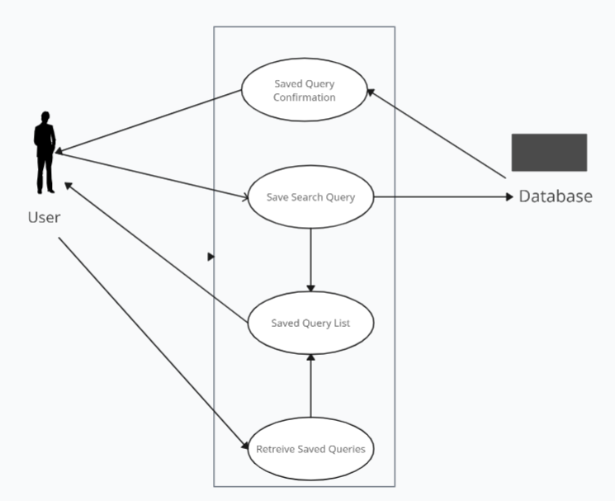

3.4 Reattempt Search for Updated Results

● Use Case Name: Reattempt Search for Updated Results

* Participating Actors: User, Database
* Entry Conditions:
  + User has previously executed a search and wants to re-execute it for a potentially better response/answer.
* Normal Flow of Events:
  + User selects a previously executed search query to reattempt it.
  + System processes the search query as a new request.
  + System displays the search results updated since the last search was made.
* Exit Conditions:
  + User views the updated search results.
* Exceptions:
  + No new or better results since the last search then the system informs the user that there is no update to the former answer.
* Special Requirements:

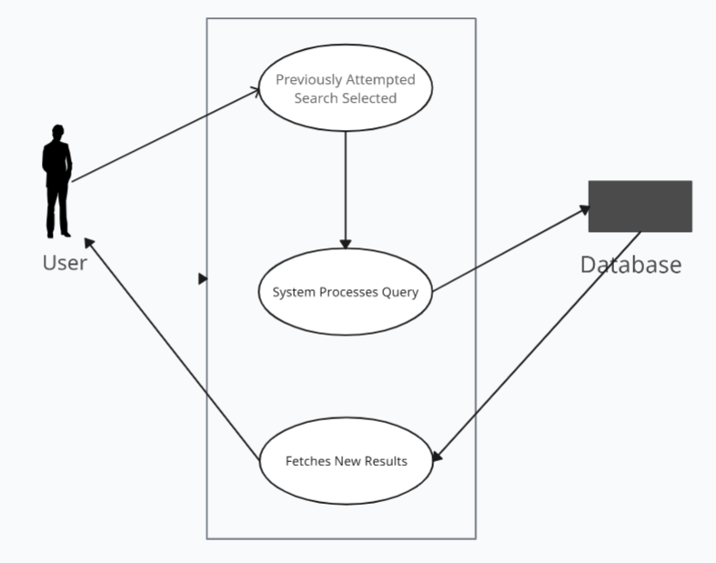

4. User Feedback Submission

*Sub Use Cases:

4.1 Submit Feedback on Results

4.2 Rate Search Tool Usability

*Reusable Use Cases:

*Validate User Authentication

*Display Confirmation Message

**Network of Models for Reusable Use Cases**

1. Validate Query

Ensures the search query meets the system's requirements for processing.

2. Display Search Results

Shows the user the results of their search in a structured format.

3. Display Error Message

Informs the user of any errors that occur during their interaction with the system.

4. Display Confirmation Message

Confirms to the user that an action has been successfully completed.

5. Validate User Authentication

Checks if the user is logged in for actions that require authentication.

6. Display Other Relevant Information

Show user relevant information about search query

7. Autocorrect wrong words for user

Show search results for words spelt slightly wrong

8. Display Past Search Results

Shows the user a drop down menu of past search queries