

Faculté des sciences et techniques de Tanger
^{Département Informatique}

^{Developpement web}

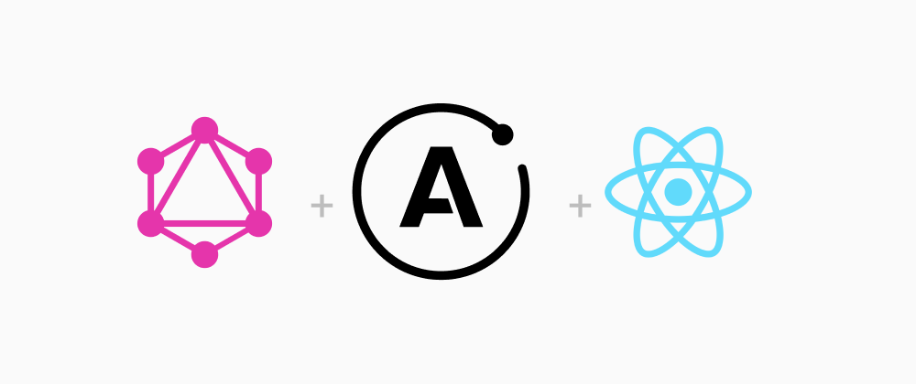
Projet: Un clone du site Fiverr en utilisant la technologie de PWA.

^{Réalisé par: Asskali Bakr}
^{Amal Maroua}
^{LSI-1}
Objectif : Mise en place d ‘une application web en mode web progressive application, l’application
doit être un clone de Fiverr , Freelancer.

Les outils utilisé:
- Pour le frontend: REACT typescript, Vite developpement server, Apollo-client/Graphql, PWA, ChakraUI, Codux, Google registration, Cookies, Lazy loading.
- Pour le Backend: Apollo-server/Graphql, Mongodb, nodeJS, JWTToken, Mongoose.

Project installation:
1.Clone the github repository using:
git clone https://github.com/BakrAsskali/fiverr_clone.git
2.Install the dependencies in the folders client and server using :
npm install.
3.Add a .env file in the server folder for db connection.
4.To start the client use:
npm run dev
To start the server use:
nodemon app
or
node start
5.The client is located by default on: localhost:5173
The server is located by default on: localhost:8800.

Backend:

The mongodb models used:
1.User has the following properties:
Firstname, lastname, username, email, bio, profilePic, PhoneNumber, password(Hashed), type(client or freelancer), skills, education, hourly rate, languages, experience, reviews, gigs and token
2.Gig has the following properties:
Title, shortTitle, description, shortDescription, price, Cover image, images, category, deliveryTime, features and a token(user token).
3.Order has the following properties:
GigID, ClientID, FreelancerID and status.
4.review has the following properties:
GigID, ClientID, Rating and Comment.
5.Message has the following properties:
Converstion ID, sender, receiver and Text.
6.Conversation has the following properties:
Members.

The queries and mutations used:
Each of the above Models has their own setters, getters, deleters and updaters.
The User model has 2 additional mutation for Logging in and logging out.

Frontend:
En total, notre Application web à 14 pages et 4 components.
- Nos pages:
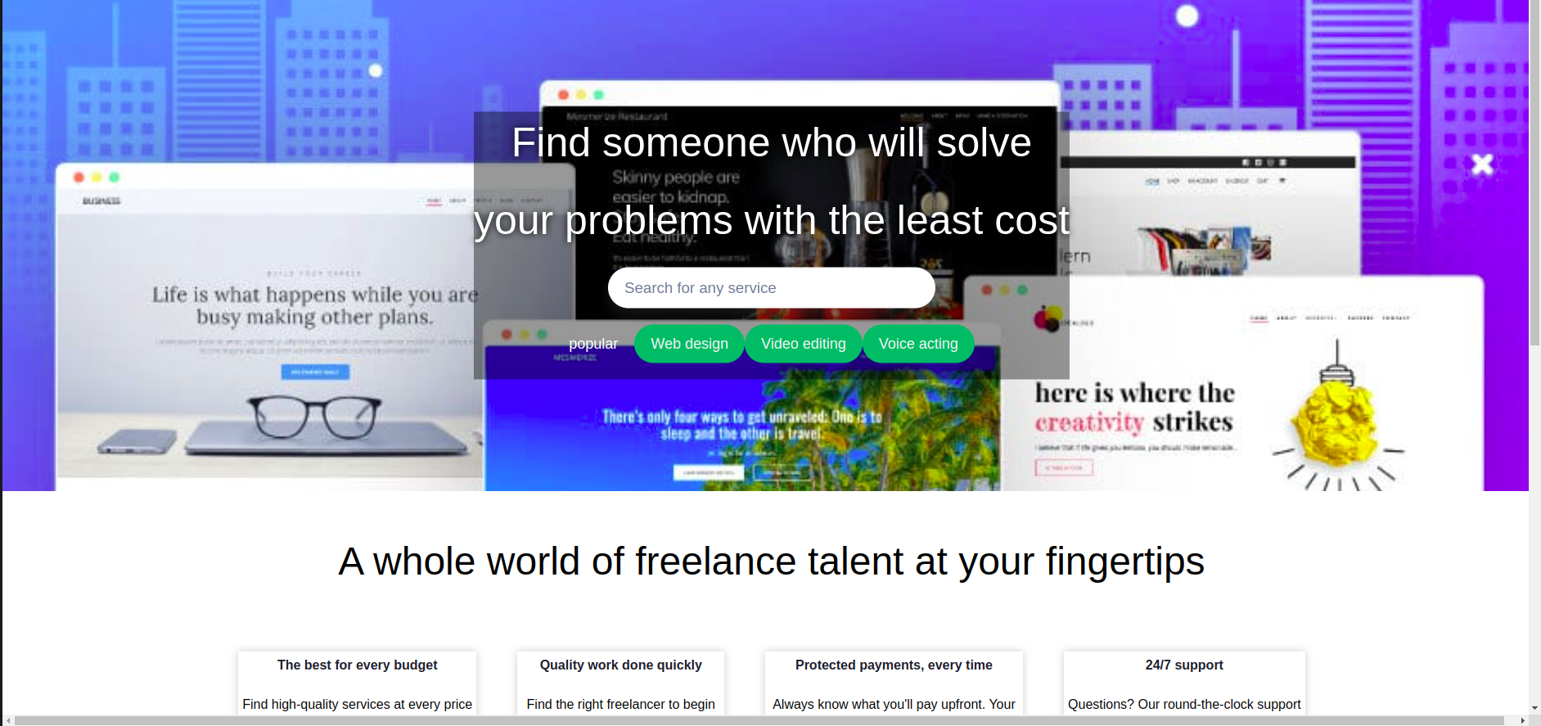
Landing page: homepage.tsx

Login page: login.tsx
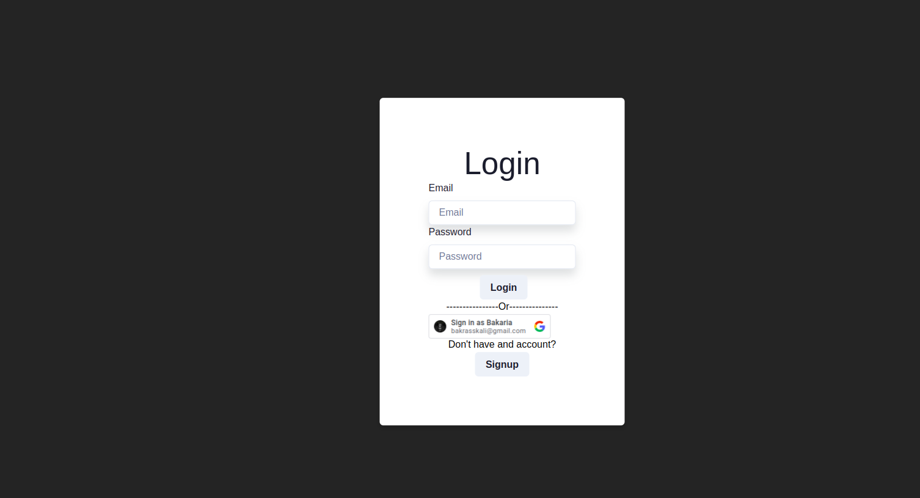
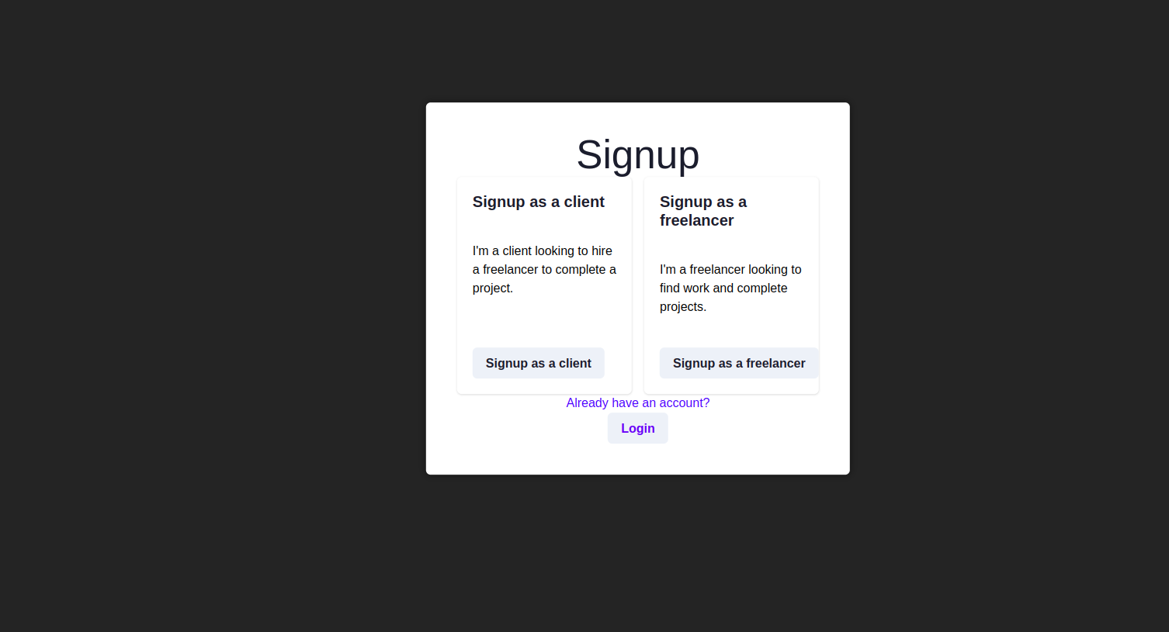
Choose account type page: signup.tsx
Signup as a client: client.tsx

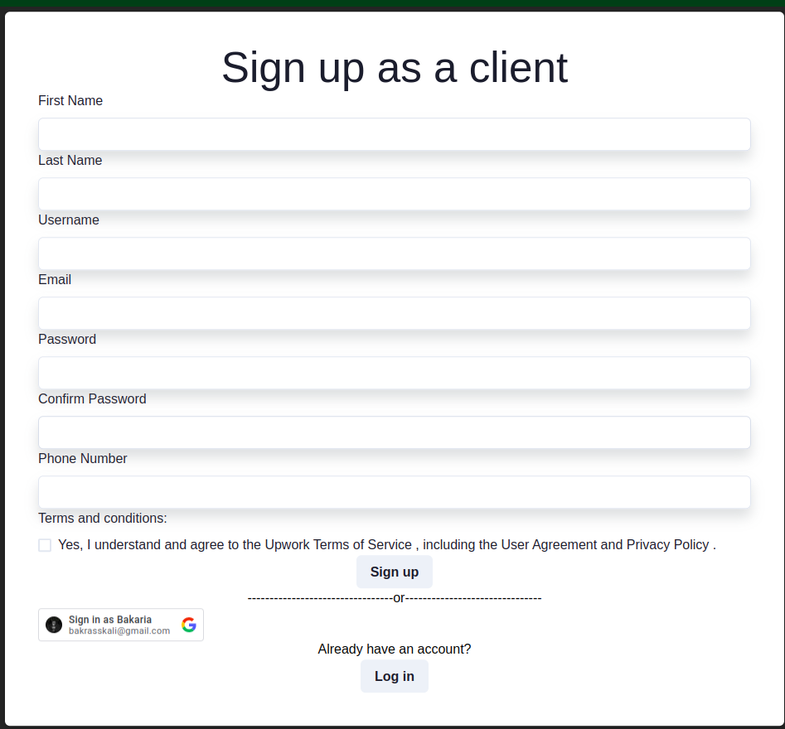
Signup as a freelancer: freelancer.tsx
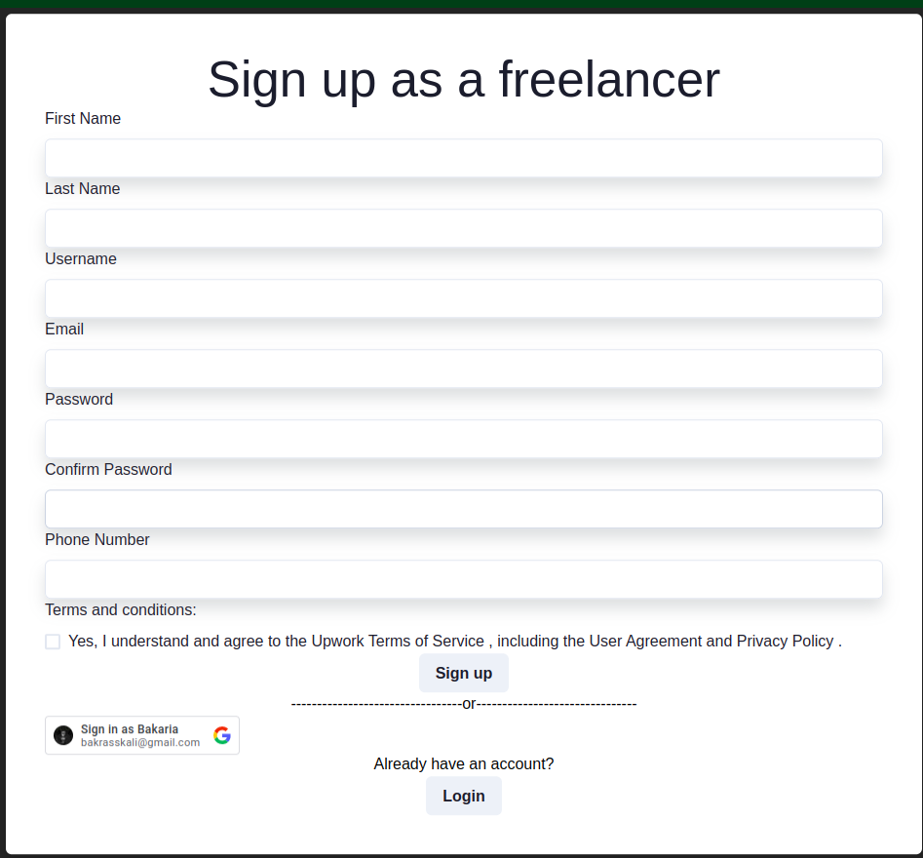
Edit personal information: editClient.tsx
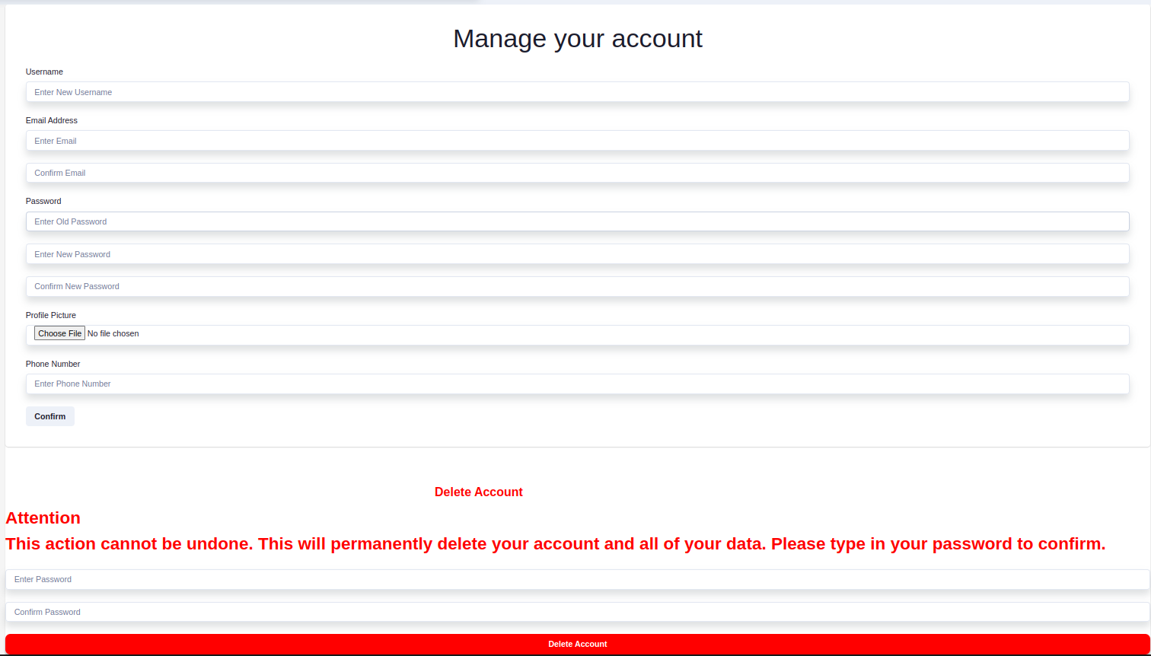
Explore all gigs: gigs.tsx
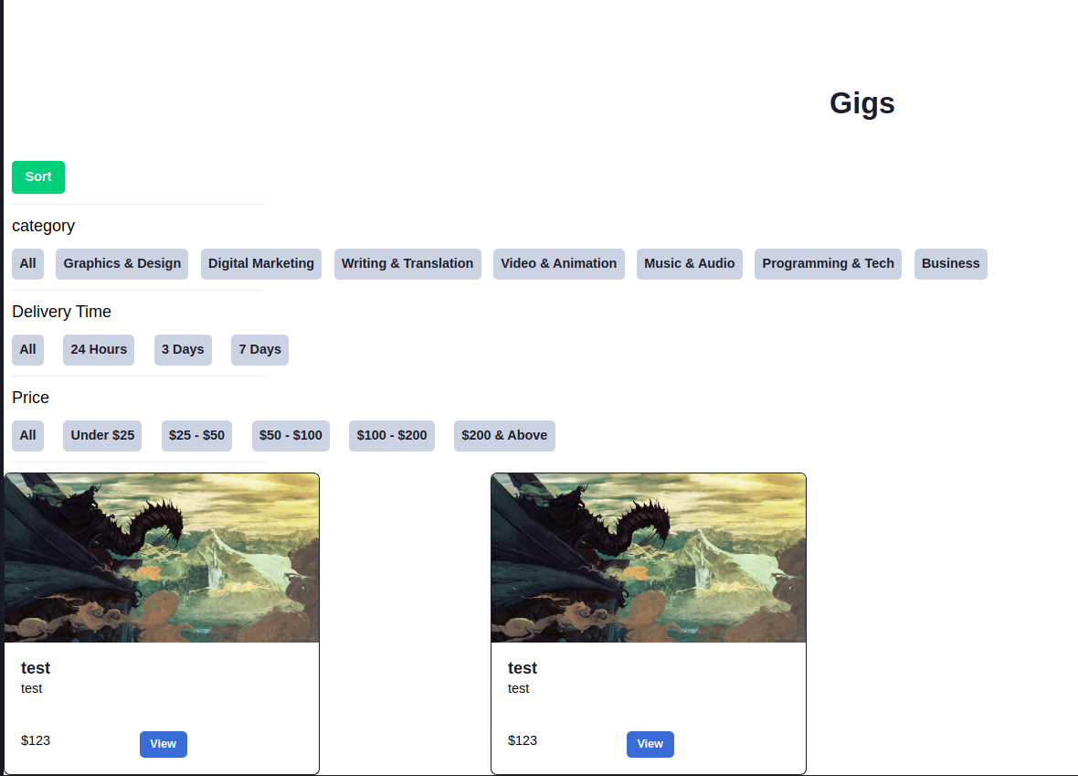
View a gig and place order: gig.tsx
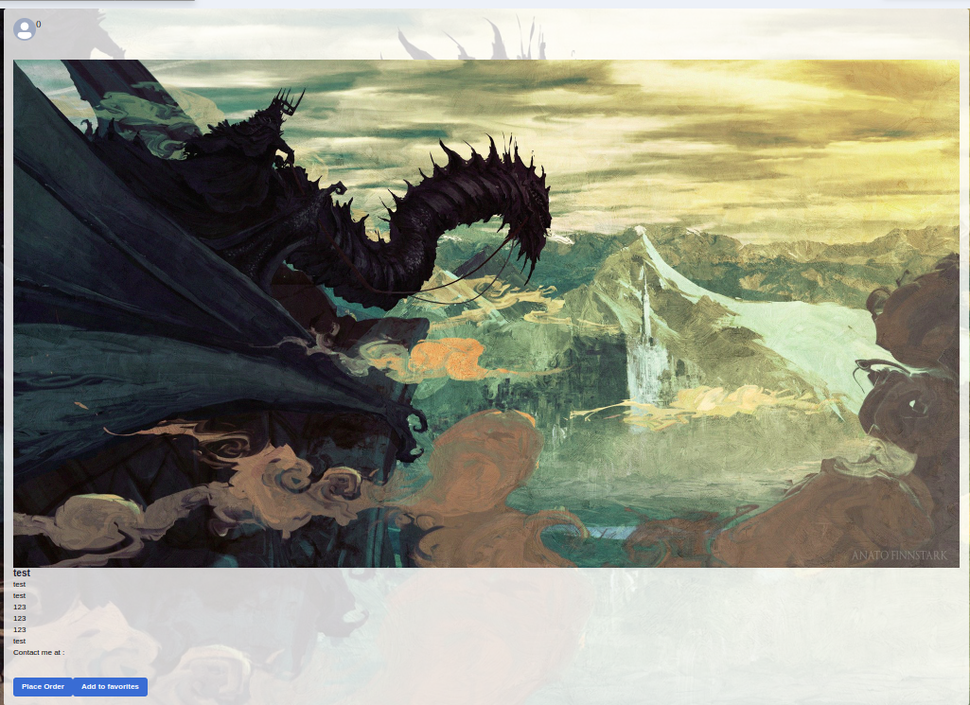
Add a gig: add.tsx
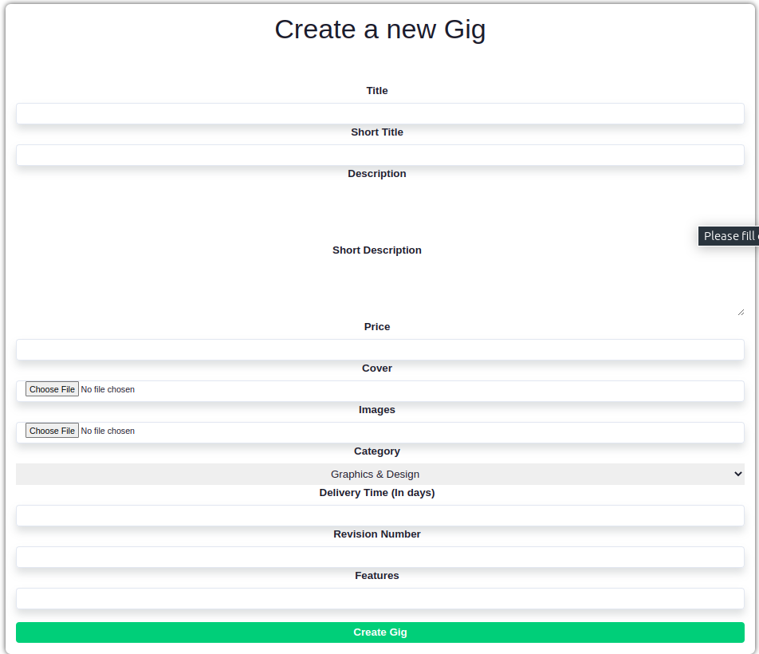
View personal gigs: myGigs.tsx (No gigs will show up if you have no gigs)
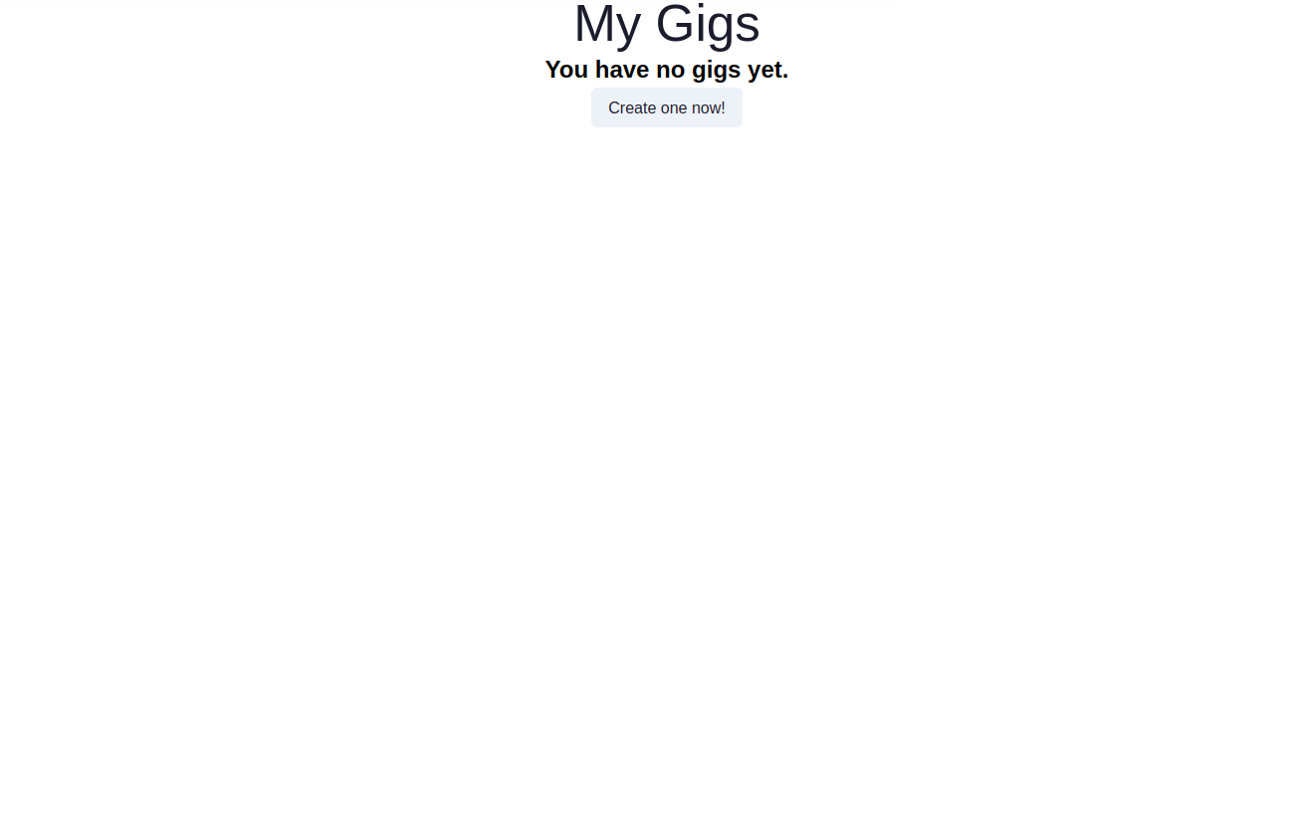
View and edit personal orders: orderDashboard.tsx
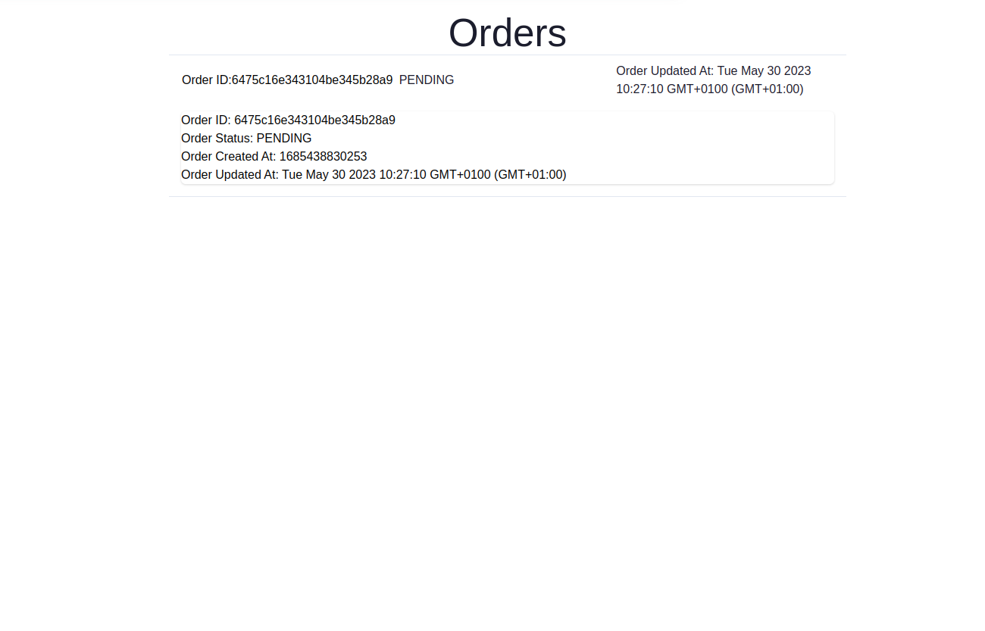
Edit a gig: editGig.tsx
Privacy policy page: privacy.tsx
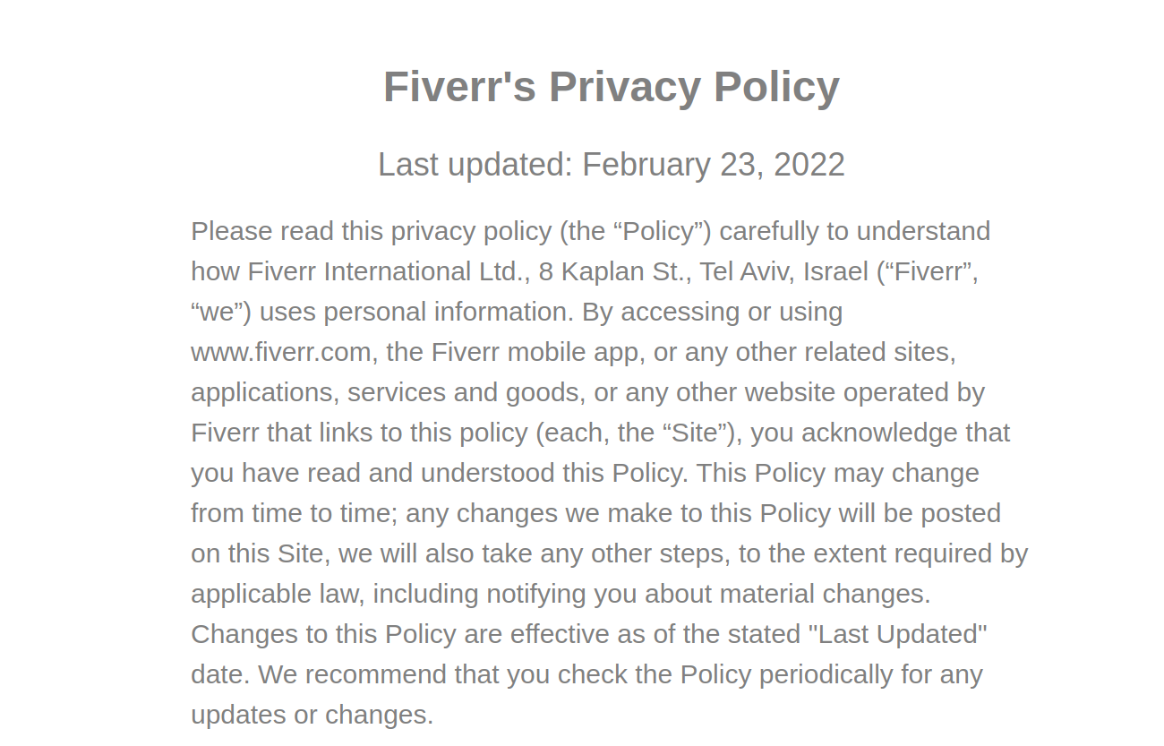
messages page: message.tsx
- Nos components:
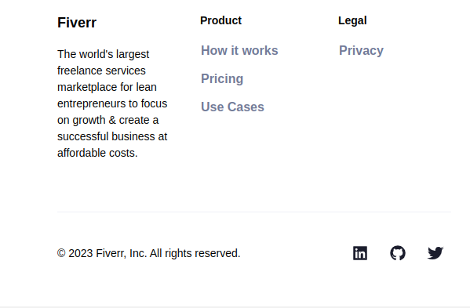
Footer: footer.tsx
Navbar pour un utilisateur qui n’est pas inscrit: navbar.tsx
Navbar pour un utilisateur inscrit: navbar2.tsx
Slide pour afficher les gigs: Slide.tsx

