Espressif IOT Development framework
„ESP-IDF is Espressif’s official IoT Development Framework for the ESP32, ESP32-S, ESP32-C and ESP32-H series of SoCs. It provides a self-sufficient SDK for any generic application development on these platforms, using programming languages such as C and C++. ESP-IDF currently powers millions of devices in the field, and enables building a variety of network-connected products, ranging from simple light bulbs and toys to big appliances and industrial devices.”
ESP-IDF uses a modified version of FreeRTOS with multicore support. ESP-IDF makes all the standard libraries of C/C++ available. The framework implements peripheral drivers for SPI, I2C, UART, GPIO, I2S, ADC, DAC, Capacitive Touch, Timers, LED and Motor PWM, RMT, Pulse Counter, CAN/TWAI, SD/eMMC/SDIO host and SDIO slave, Ethernet, Wi-Fi and Bluetooth.
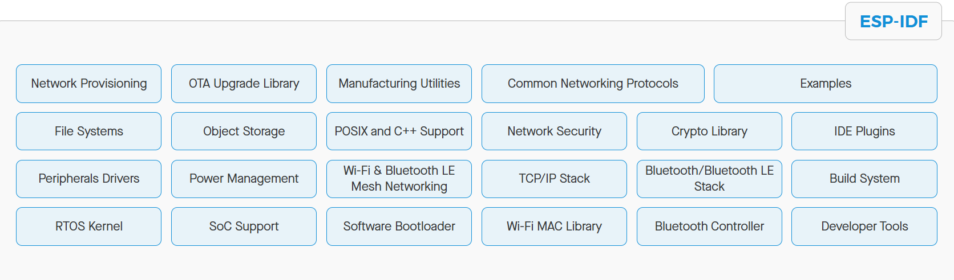
1. figure: ESP-IDF software components and features

Usage of ESP-IDF on Ubuntu
In this section we will show how to use ESP-IDF on Ubuntu in a simplistic way, without an IDE. The disadvantage of using IDEs is that they can be slow and many of its functionalities will never be used by the user. With the simplistic method you get a better understanding of how the build system works, it’s more realiable and also works faster.

Installation
- Update the repository.
sudo apt update

- Install the prerequisities.
sudo apt-get install git wget flex bison gperf python3 python3-pip python3-venv cmake ninja-build ccache libffi-dev libssl-dev dfu-util libusb-1.0-0
- Create folder in the home directory for ESP-IDF.
cd ~

mkdir esp

- Navigate to the folder and clone the newest ESP-IDF version.
cd esp

git clone -b v5.5-beta1 --recursive https://github.com/espressif/esp-idf.git esp-idf-v5.5-beta1

- Inside the cloned folder, it is necessary to install the development toolchain for the specific ESP32 chips you want to develop for. It is possible to install all of them at once.
cd esp-idf-v5.5-beta1/

./install.sh all

- To use ESP-IDF from a terminal it is necessary to set up the environment variables.
. $HOME/esp/esp-idf-v5.5-beta1/export.sh

This can be made more convenient by creating an alias in the .bashrc file.
cd ~

nano .bashrc

Insert the following at the end: alias get_idf='. $HOME/esp/esp-idf/export.sh'

After this ESP-IDF can be obtained in a terminal session by running get_idf.

More info about the installation procedure:
https://docs.espressif.com/projects/esp-idf/en/stable/esp32/get-started/linux-macos-setup.html

Setting up a project and uploading the code
- Create a folder for your project and navigate to the project folder from the terminal.
- Create a project by running idf.py create-project <PROJECT NAME>
This creates a folder with the following structure:
→ CMakeLists.txt // root CMakeLists.txt file
→ main // main component folder
→ <PROJECT NAME>.c // main component .c file
→ CMakeLists.txt // main component CMakeLists.txt file
- In the <PROJECT NAME>.c file the FreeRTOS application entry point is located.
For testing purposes print “Hello World!”.
- Run idf.py set-target <YOUR ESP32 CHIP >. This will create a build directory and an sdkconfig file.
- Build the project with: idf.py build
- Connect the ESP32 to the PC and find out the port it is connected to: ls /dev/tty* (it can be /dev/ttyUSB or /dev/ttyACM)
- Flash and monitor: idf.py -p <PORT> flash flash

After the flashing completes, “Hello World!” should be printed on the terminal. The monitoring can be quit with CTRL + ].

This process can be made easier by making a script for executing these commands. In the root directory create a shell script and add the necessary commands then make it executable.
touch upload.sh
chmod +x upload.sh

Edit the created file with the following:
#!/bin/bash

idf.py build
idf.py -p /dev/tty$1 flash monitor

Now upload.sh can be run by passing the port as a command argument, for example: ./upload.sh USB0

Modularization

To create your own components (modules) make a directory in your root folder called modules. In the modules folder create another folder with your module name (for example: name). In the name folder create a name.c, name.h and CMakeLists.txt file.
- name.h: Add include guard and put public API prototypes here.
#ifned NAME_H_
#define NAME_H_

void get_name(void);

#endif

- name.c: Include the .h file and define the API here.
#include “name.h”
#include <stdio.h>

void get_name(void) {
printf(“My name is John Smith”);
}

- CMakeLists.txt: Register the component.
idf_component_register(SRCS “name.c” INCLUDE_DIRS “.”)

- In the root CMakeLists.txt file it is necessary to register your module folder.
set(EXTRA_COMPONENT_DIRS modules)

After completing these steps it is possible to use the module’s public APIs anywhere in your software after including the header file.

Menuconfig

idf.py menuconfig launches a text-based configuration menu for ESP-IDF projects, allowing you to customize various settings before building your firmware. By default it has many settings.

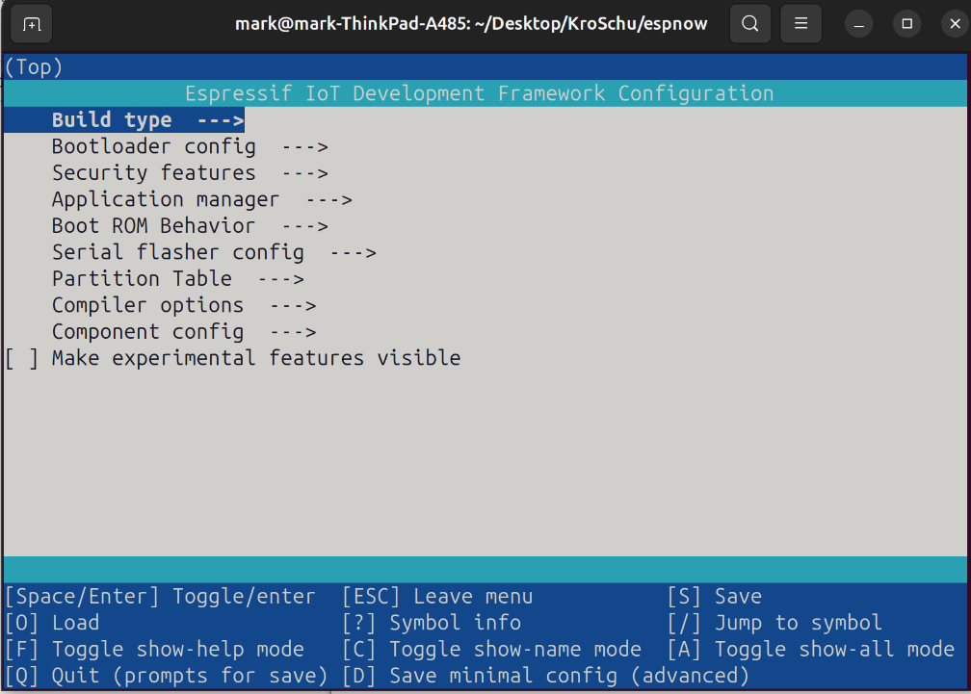
You can add your own custom settings to menuconfig which greatly increases configurability without manually modifying your source code. This can be done with Kconfig files. You can read more about Kconfig and project configuration here: https://docs.espressif.com/projects/esp-idf/en/latest/esp32/api-guides/kconfig/component-configuration-guide.html#component-configuration-guide

Example codes
Example codes for various functionalities can be found in the ESP-IDF install directory. If you followed the install instruction in this document then the examples codes can be found here:

~/esp/esp-idf-v5.5-beta1/examples

Using VSCode as a text editor
VSCode can be used as a simple text editor for writing code. You don’t have to install the ESP-IDF extension because you already installed it manually. Only extension you might want to install (it’s recommended) is a language server like the Microsoft C/C++ extension or clangd. Language server protocols (LSPs) provide you code completion, suggestions and simplify module includes. Microsoft C/C++ extension is better compatible with the toolchains used for ESP32 programming, if you use clangd you might encounter various ”false positive” include errors, these can be simply ignored or you can use a workaround with a Python script (which can be found here). The advantage of clangd over the other option is that you can use it with VSCodium.

Usage of ESP-IDF on Windows (as extension)
1. Open Visual Studio Code | 
2. Click on the Extensions Icon or press the buttons Ctrl+Shift+X . | 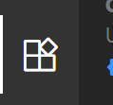
3. In the search bar type: ESP-IDF | 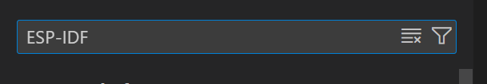
4.Click on Install | 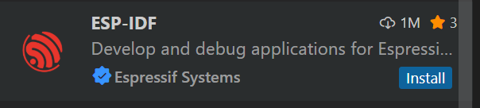
5.1 After the extension has been installed successfully, click on Open Setup wizard in the pop-up window | 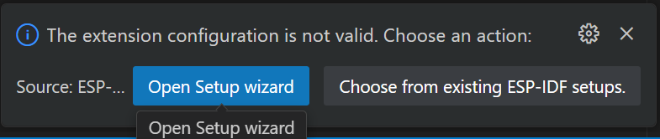
5.2 If the pop-up window does not appear, press Ctrl-Shift+P to open the Command Palette, then type the command: Configure ESP-IDF Extension, then click on it. | .
6.After the Configuration menu opens, click on Express. | 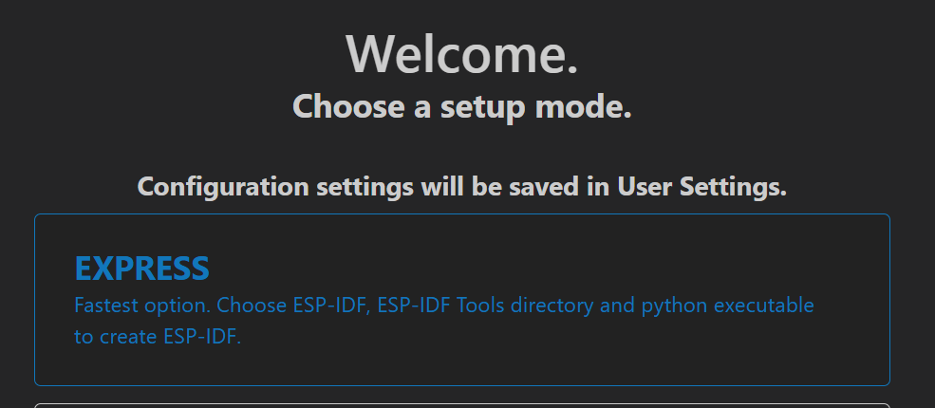
7.After the Express configuration menu opens, click on Select ESP-IDF version, select v5.5 for the newest version | 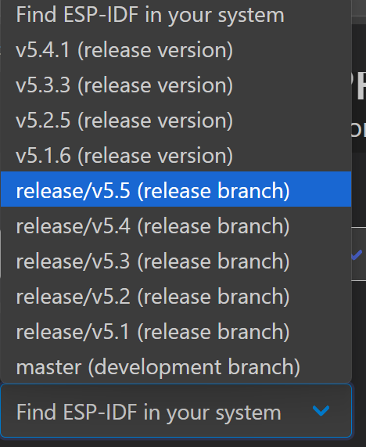
8. Select the location for the container and the Tools directory then click on Install. | 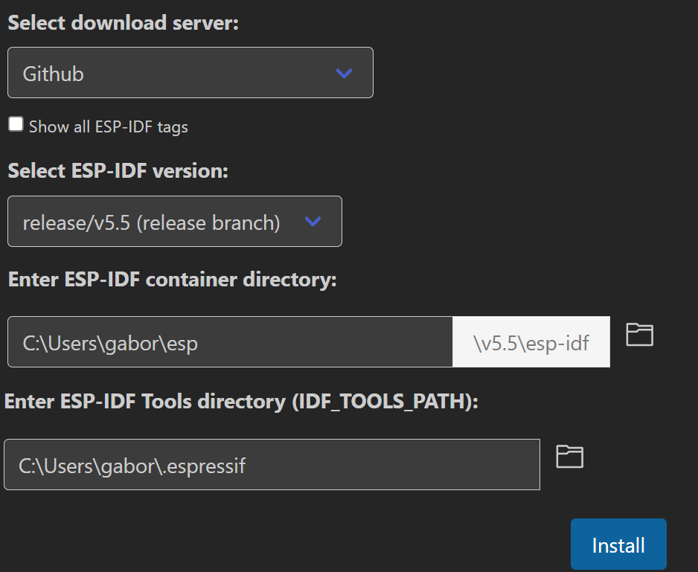
9. Wait for the installation process. | 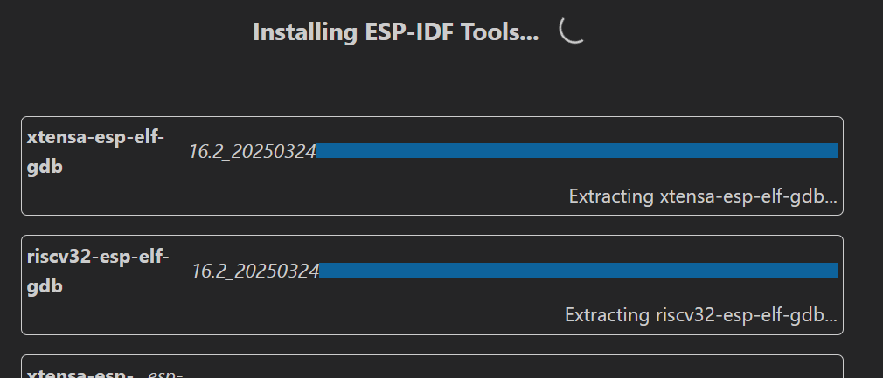
10. After the installation, it should open the ESP-IDF Welcome menu or open it via the Command Palette | 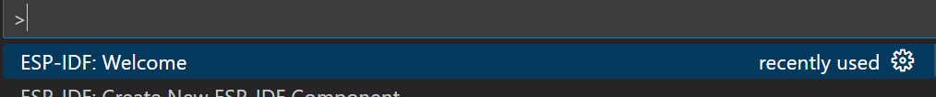
11. Click on New project | 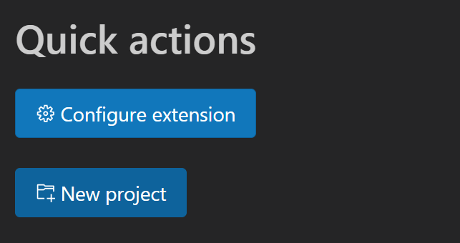
12. Name your project, choose target, board, then choose a template for your project (example code) | 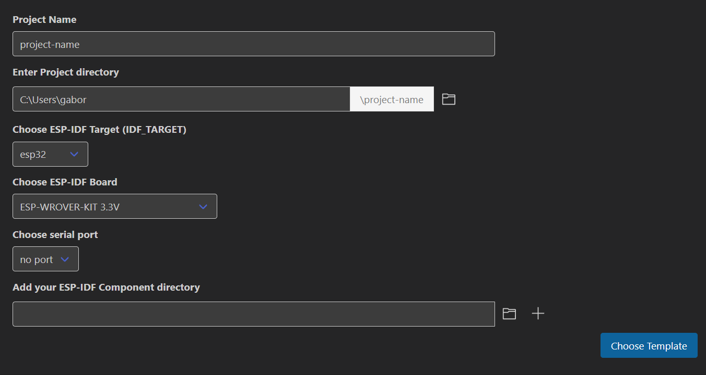
13. Choose ESP-IDF, type in espnow, then select it | 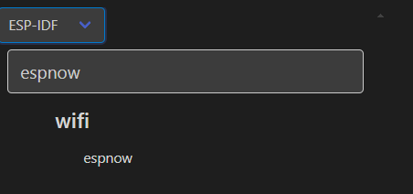
14. Click on Create project using template espnow, you can modify this code | 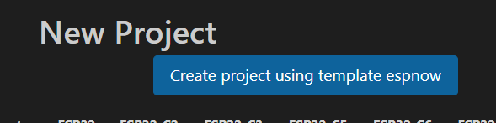
15.Click on yes | 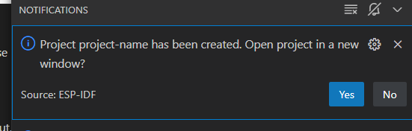
16. After the project opens in a new window, open the ESP-IDF Terminal using the Command Palette or by clicking to the icon at the bottom | 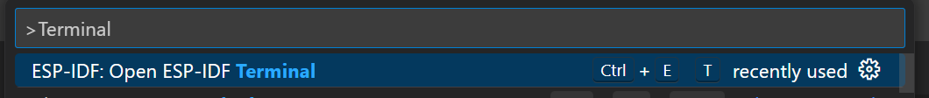  
17.You can run idf.py fullclean in the terminal to clean the previous build for example if the build fails at some point or before you want to change the device target | 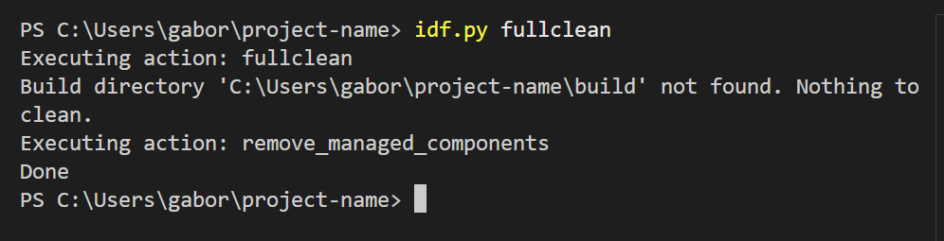
18.If you want to change the device target, click to the icon at the bottom, search for your device type, then click on it. | 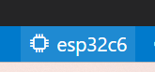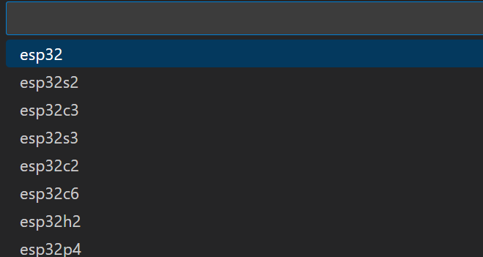
19.to build the project, type idf.py build in the ESP-IDF Terminal | 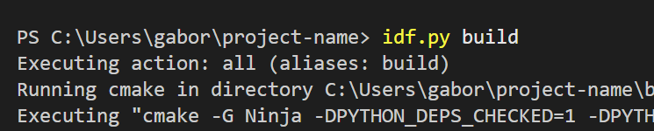
20.After successful build it should write something like this: | 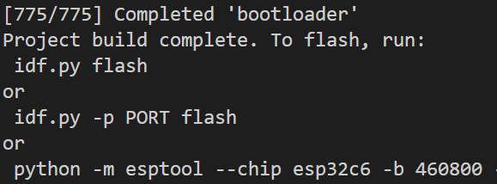
21. Now you can flash the program to your esp32 device. To do this, first plug the esp32 device to your computer
22. If you are using esp32c6, there are two type-C ports, make sure that you have appropriate drivers installed if you want to use the UART port. | 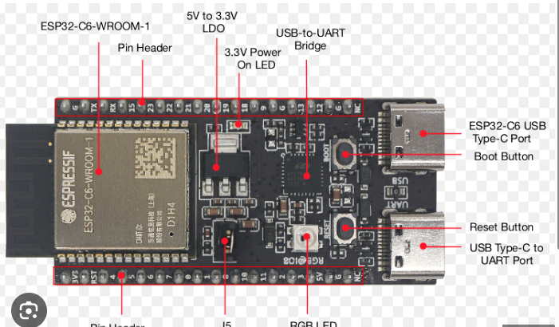
23. Click on the icon to select the port, select from the available ports | 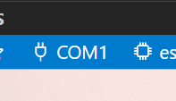
24.To flash the program to the device, first open the ESP-IDF Terminal, then type idf.py -p SELECTED_PORT flash. You can also type monitor, to open the serial monitor | 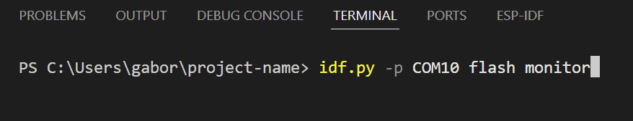
25. You can also type just idf.py -p SELECTED_PORT monitor just to open the serial monitor, if you previously flashed the program to the device. | 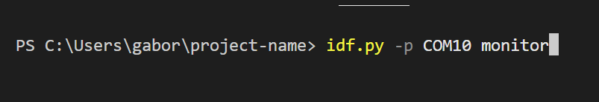

Arduino IDE ESP32 setup
To ensure proper communication between your computer and the ESP32 development board, you may need to install the appropriate USB-to-serial bridge driver.  Different ESP32 boards utilize different USB-to-serial converters. For example, the CP2102 or CH340G chips are commonly used. It is important to identify the USB-to-serial converter chip on your board before proceeding. | 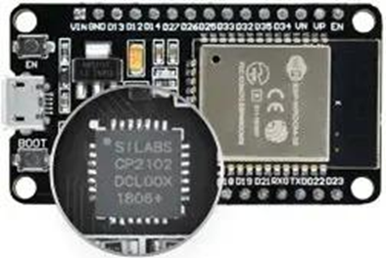
In your Arduino IDE, go to File > Preferences | 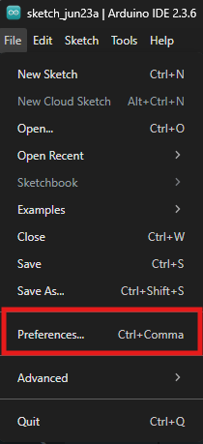
Enter the following into the “Additional Board Manager URLs” field:  https://raw.githubusercontent.com/espressif/arduino-esp32/gh-pages/package_esp32_index.json | 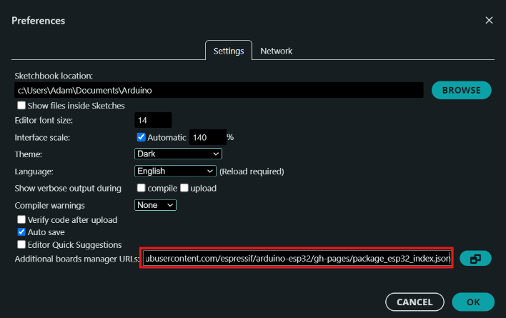

Open the Boards Manager. Go to Tools > Board > Boards Manager… | 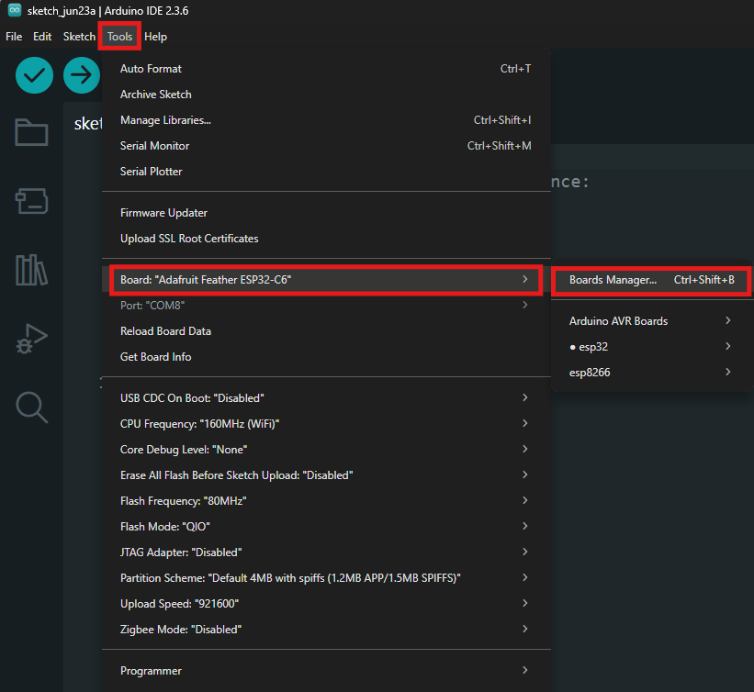
Search for ESP32 and press the install button for the “ESP32 by Espressif Systems“ | 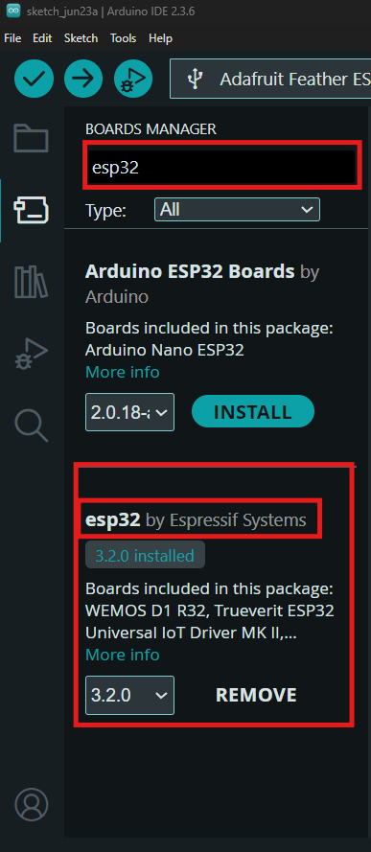
Select your board from the “Select Board” menu, choose your board and your port (in this case it’s the Adafruit Feather ESP32-C6 and COM8 serial port) | 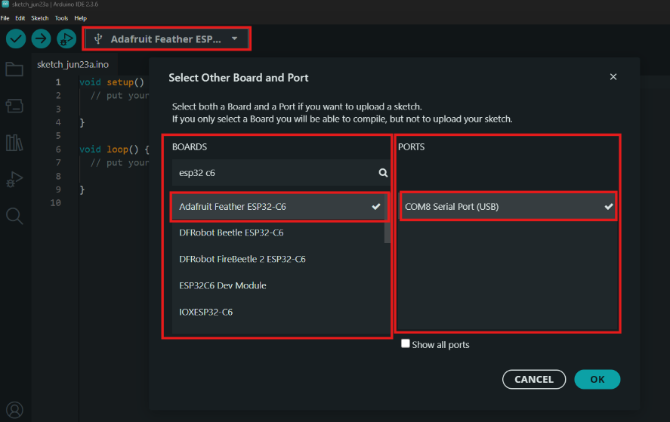
Use the following buttons to verify (left) to build the script, or upload (right) to flash the script to the ESP32 microcontroller | 