Nama : Arif Hidayah
Nim : 14090070
Kelas : 4A

TUGAS 1 SBD 2
- Nama database : Db_NilaiTugasMhs
- Table :
- Mahasiswa
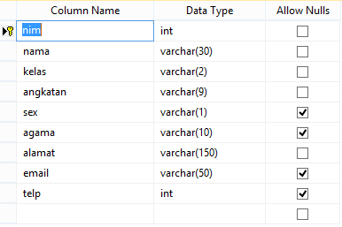
- Dosen
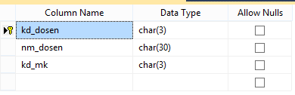
- Nilai
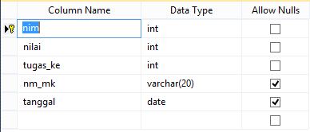

- Mk
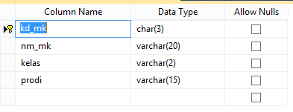
- Hasil
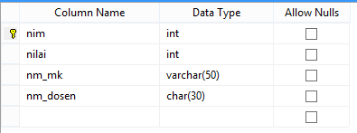

- Diagram
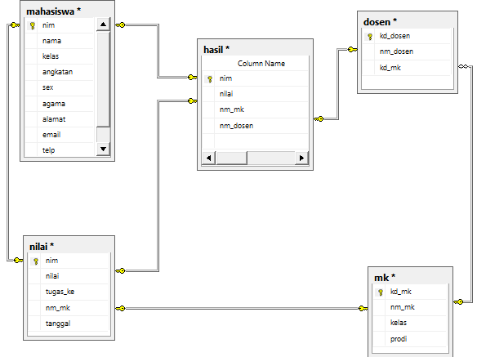

- Coding
create database Db_NilaiTugasMhs
go
use Db_NilaiTugasMhs
go
create table mahasiswa(
nim int primary key not null,
nama varchar(30) not null,
kelas varchar(2) not null,
angkatan varchar(9) not null,
sex varchar(1) default 'l',
agama varchar(10) default 'islam',
alamat varchar(150) not null,
email varchar(50) ,
telp int)
go

create table dosen(
kd_dosen char(3) primary key not null,
nm_dosen char(30) not null,
kd_mk char(3) not null )
go

create table mk(
kd_mk char(3) primary key not null,
nm_mk varchar(20) unique not null,
kelas varchar(2) not null,
prodi varchar(15) not null)
go

create table nilai(
nim int primary key not null,
nilai int not null,
tugas_ke int not null,
nm_mk varchar(20) unique not null,
tanggal date )
go

create table hasil(
nim int primary key not null,
nilai int not null,
nm_mk varchar(20) unique not null,
nm_dosen char(30) not null )

go

